**Angular**

CLI

Npm I -g @angular/cli

**Create an angular app**

ng new my-dream-app –no-strict

cd my-dream-app

**Run the Application**

ng serve

Angular app runs on port 4200 by default.

Bootstrap

Installing bootstrap for styling

npm i –save bootstrap@3

Edit angular.json file to indicate that the styling we use bootstrap.

|  |
| --- |
| "styles": [                "node_modules/bootstrap/dist/css/bootstrap.min.css",                "src/styles.css"              ], |

|  |
| --- |
| app.component.ts |
| *import* { Component } *from* '@angular/core';  *@*Component({    selector: 'app-root',    templateUrl: './app.component.html',    styleUrls: ['./app.component.css']  })  *export* *class* AppComponent {  } |

|  |
| --- |
| app.component.html |
| <h3>I'm in the AppComponent</h3> |

|  |
| --- |
| app.component.css |
| h2 {    background: violet;  } |

|  |
| --- |
| index.html |
| <!doctype *html*>  <html *lang*="en">  <head>    <meta *charset*="utf-8">    <title>MyFirstApp</title>    <base *href*="/">    <meta *name*="viewport" *content*="width=device-width, initial-scale=1">    <link *rel*="icon" *type*="image/x-icon" *href*="favicon.ico">  </head>  <body>    <app-root></app-root>  </body>  </html> |

The AppComponent is added to the app-root selector which is in the index.html file.

**Creating Components**

The next level components will be added to the selectors that are in app.component.html file.

Suppose we are creating a server component. We should create a folder under the app folder named server. Within this folder, we should create all the files that make up the ServerComponent.

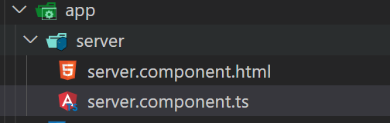

The server.component.ts is the component file written in Typescript.

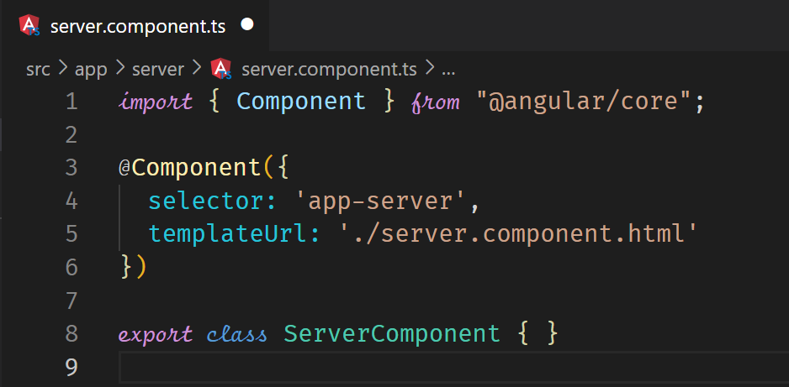

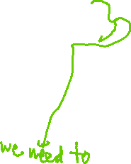

A component is a typescript class.



The component requires a template file for html as shown by the templateUrl.

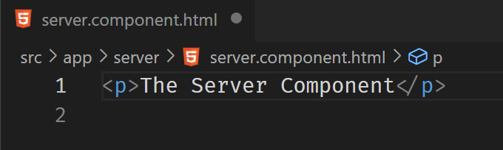

All the components we create such as the ServerComponent neeed to be registered in NgModule. This is in the app.module.ts file so that Angular scans the component and will be able to render it.

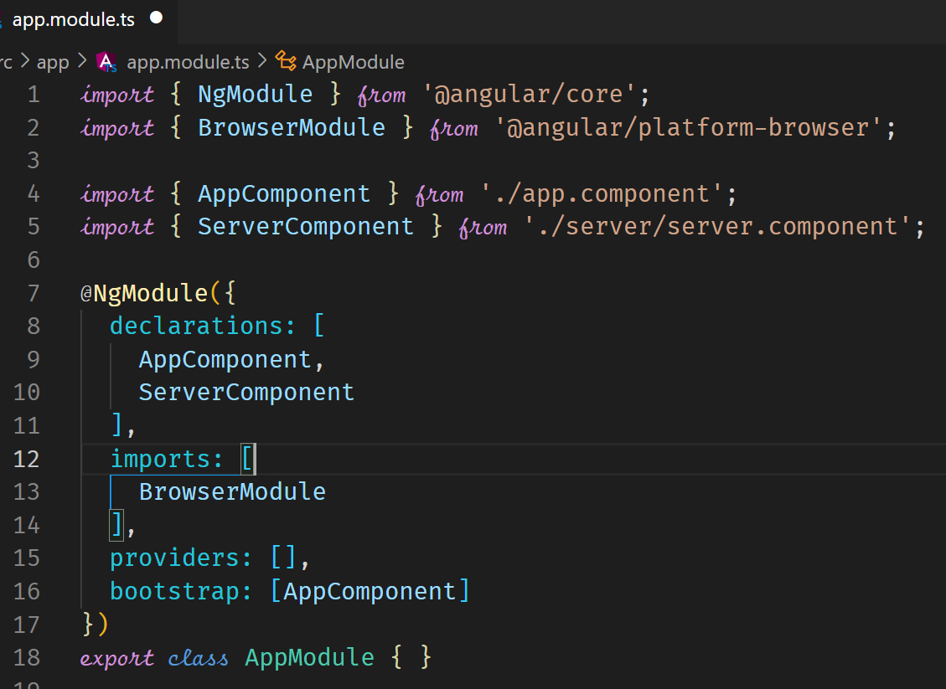



The last thing would be to insert the custom html tag in the app.component.html so that our component can be rendered.

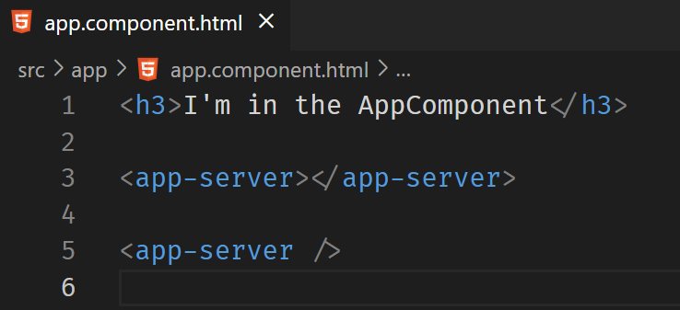



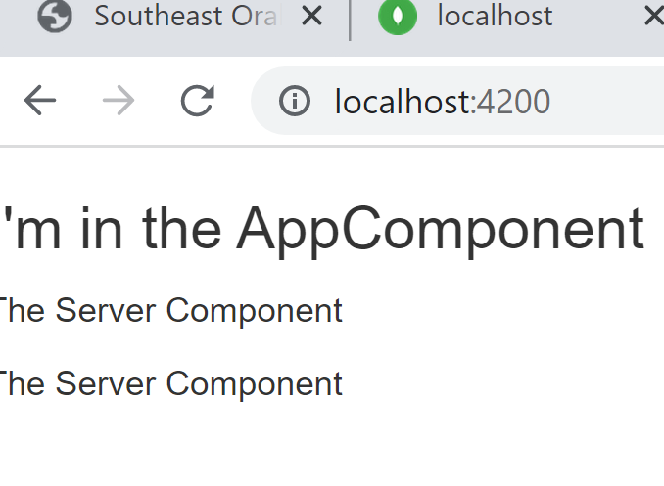

**Generate Components**

We can also create components by using the CLI.

ng generate component servers



ng g c servers



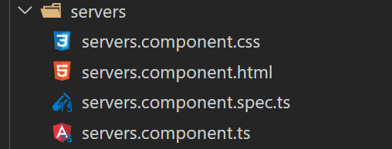



ng g c servers –skip-tests



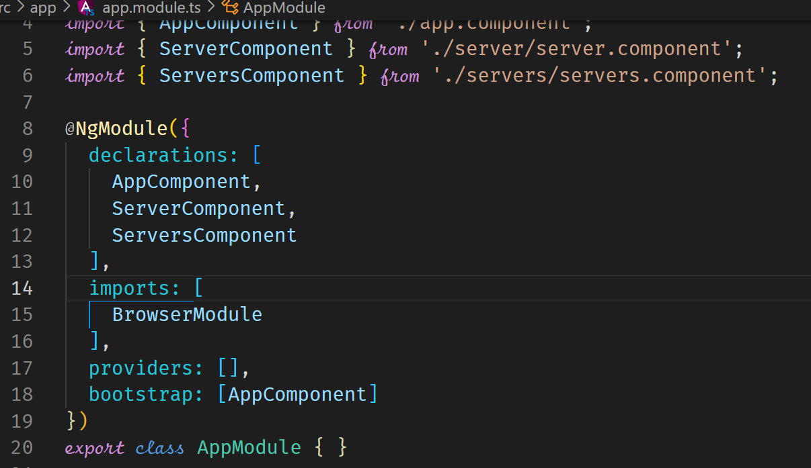



**Component Template**

In the previous examples, we have an external file for html which is referred to by the templateUrl. It is mandatory in a component to have a template. It is also possible to have an inline template as shown below.

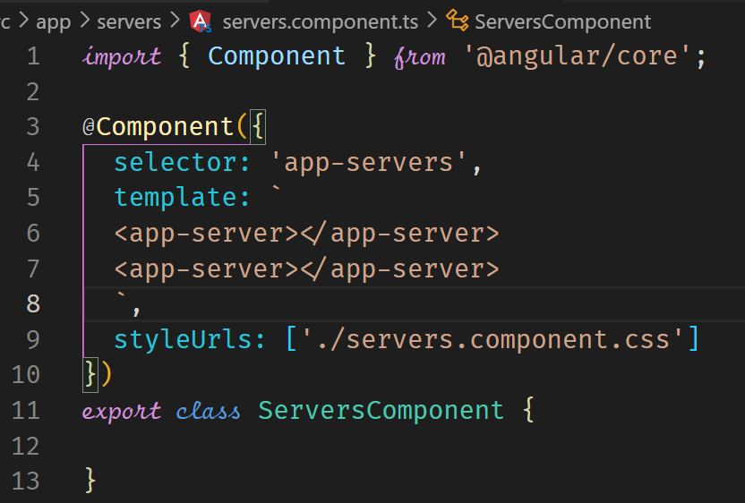

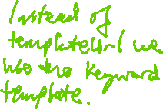

The selector and styleUrls are not mandatory.

**Component Styles**

Styles can be implemented within the html file, within CSS files or within the Component.

**html**

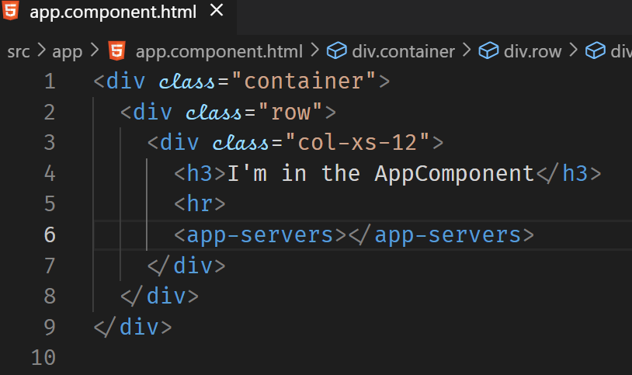

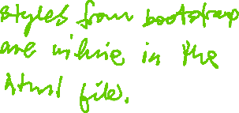

**css file**

We can use the CSS file that is specified in the styleUrls property. As this is an array, we can have several CSS files specified in the array.

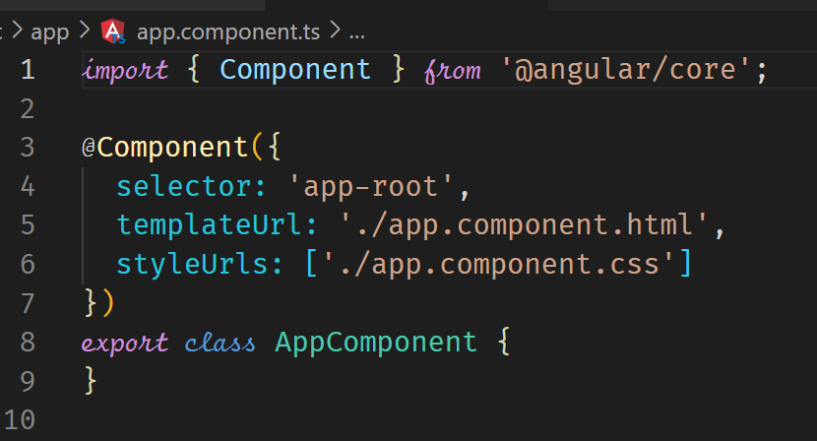

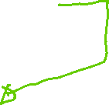

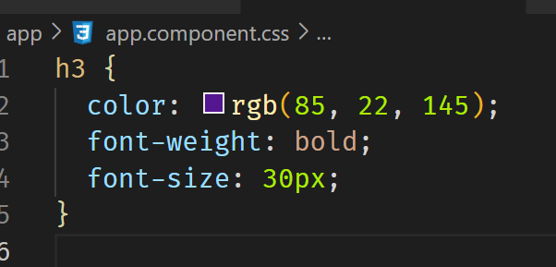



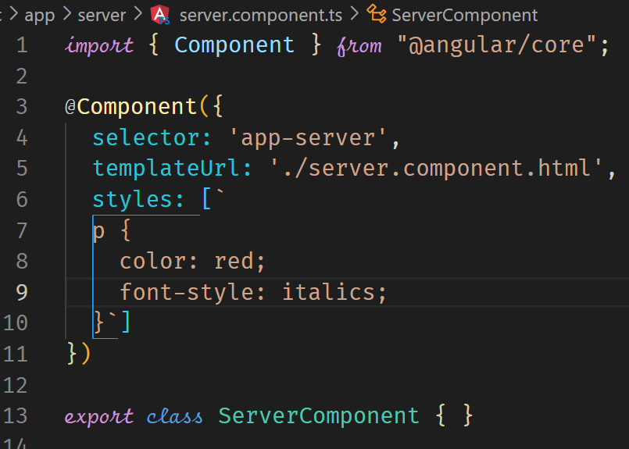



**Component Selector**

The component selector has to be unique to avoid accidentally overwriting other components. There are three ways of representing a selector, an element, an attribute and a class. An id does not work.

**An element**

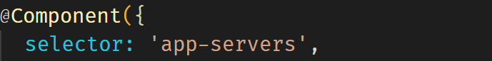



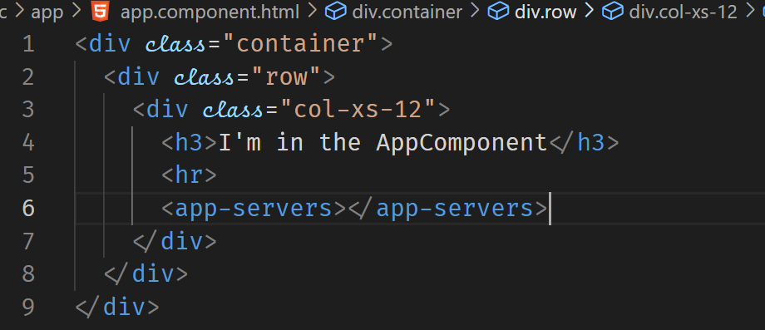



**As an Attribute**

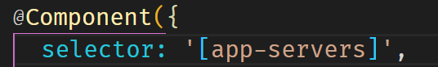

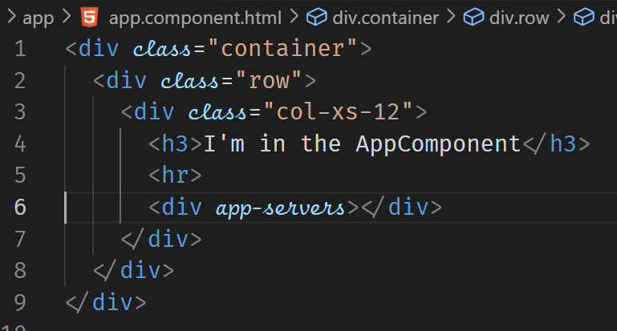



**As a class**

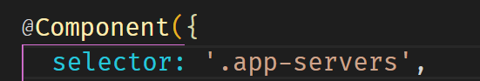



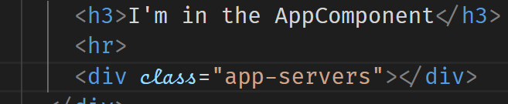



**Data Binding**

This is communication between the html template and the typescript file.

Databinding = Communication

TypeScript Code

(Business Logic)

Output Data

Template (HTML)

**String Interpolation** ( {{ data }} )

**Property Binding** ( [property] = “data” )

React to (User) Events

**Event Binding** ( (event) = “expression” )

Combination of Both: **Two-Way-Binding** ( [(ngModel)] = “data” )

**String Interpolation**

String interpolation is used to output data from typescript to the html.

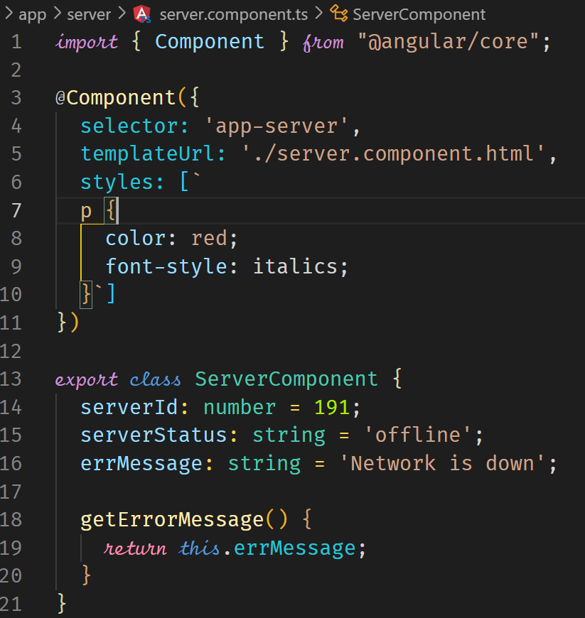

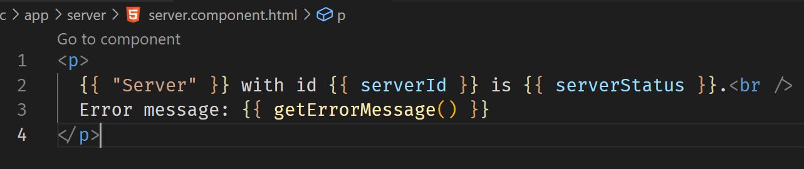

The variable or method should return a value that can be converted to a string.

**Property Binding**

Property binding allows us to change the property or attribute of an element from typescript. In the following example, we have a disabled property of the button. To implement property binding, we enclose the property into square brackets [property name]. We can then assign the property to a variable in typescript. Changes to the variable can be reflected in the element. Property binding is a one-way binding, as values go from the component to the template layer.

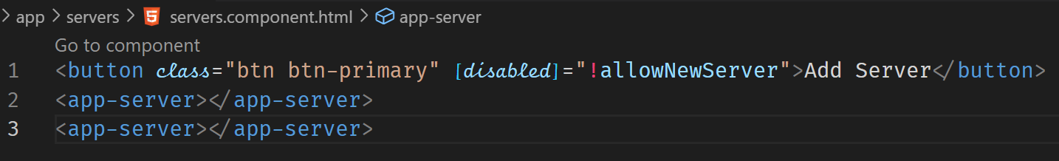



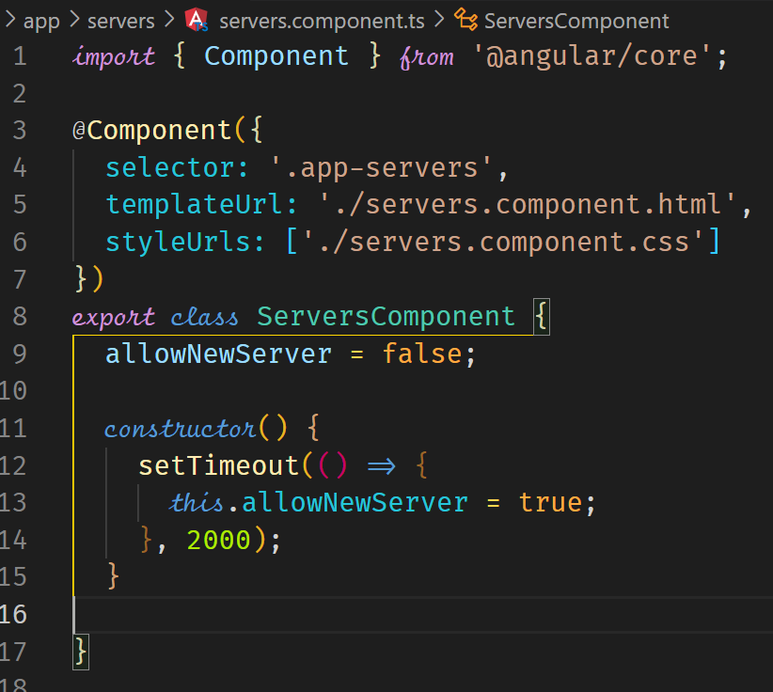



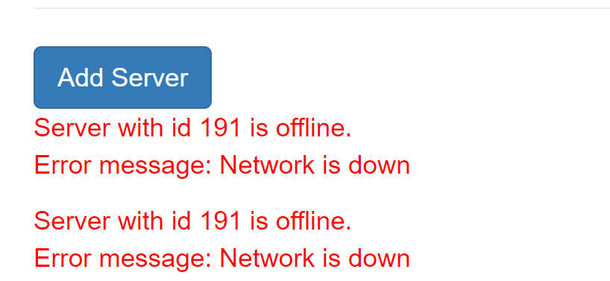

The following is another example of property binding.

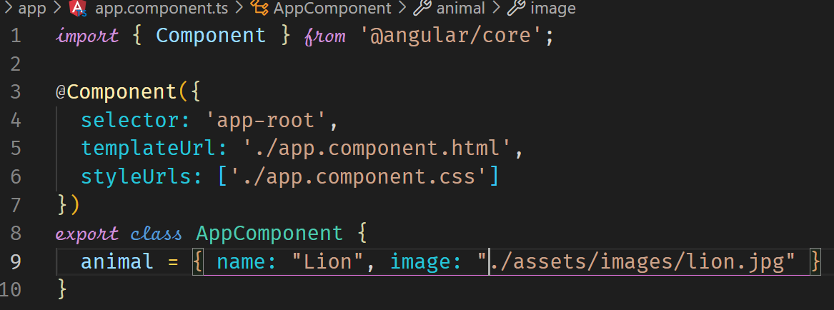



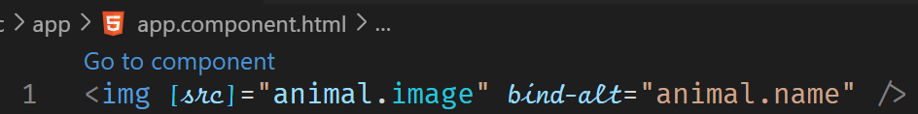



**Event Binding**

We can react to events by Event Binding. With Event Binding, we put the name of the event in parenthesis and assign that to a method enclosed in quotation marks.

(click)=”onCreateServer()”

(mousedown)=”onChangeColor()”

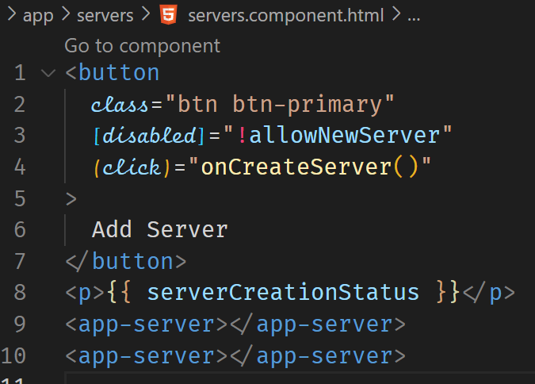



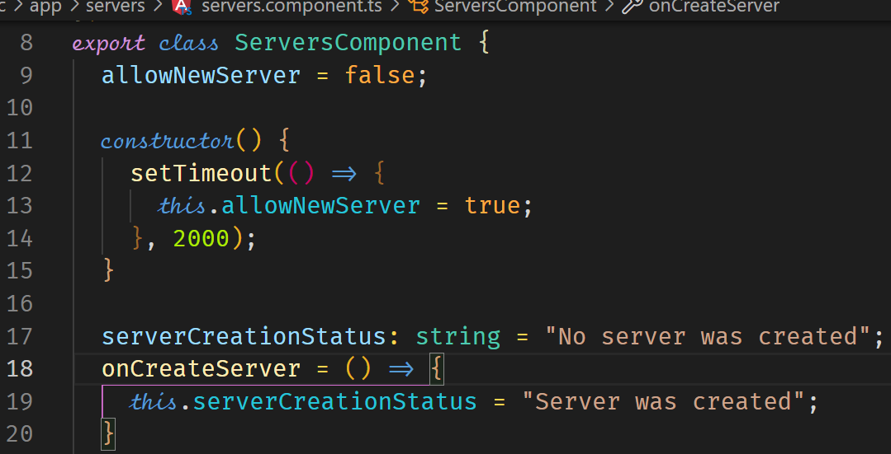



**Passing and Using Data with Event Binding**

The (input) event fires when the value of an <input>, <select> or <textarea> element has been changed. We can respond to this event by calling a method. We can pass the event object via the method to typescript. A reserved variable name is provided to capture the data emitted with the event, that is $event.







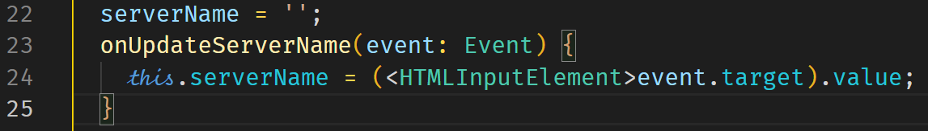



**Two-Way Binding**

For two-way-binding to work you need to enable the ngModel directive. This is done by adding the FormsModule to the imports[] array in the AppModule. You then also need to import the FormsModule from the @angular/forms.

This is a nice and easy way of reacting to events in both directions. We combine event and property-binding.

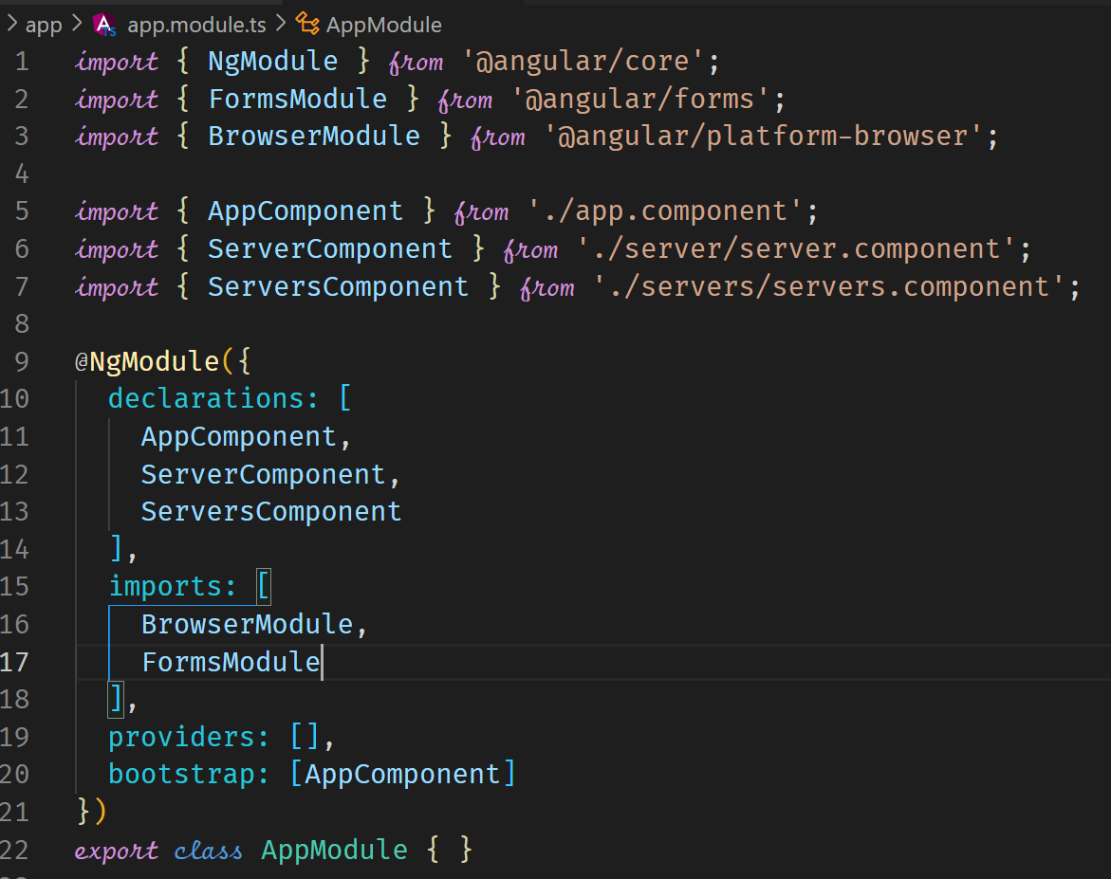



In html, you can now use the ngModel directive which allows two-way-binding.

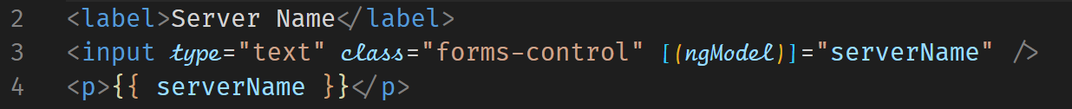

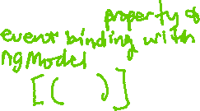

Since this is two-way-binding, the changes in the input will

be reflected in the p tag where String interpolation is used for

serverName. We can also pre-populate the input by setting a value

to it when we initialize it.

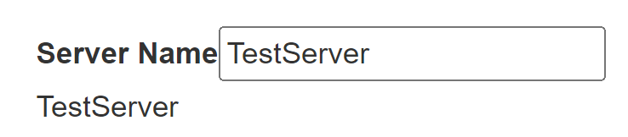



Assignment – practice two-way-binding, string interpolation, event binding

* Add input field which updates a property Registration number via two way binding.
* Output the Registration number property via string interpolation in a paragraph below the input.
* Add a button which may only be clicked if the Registration number is not an empty string.
* Upon clicking the button, the username should be reset to an empty string.

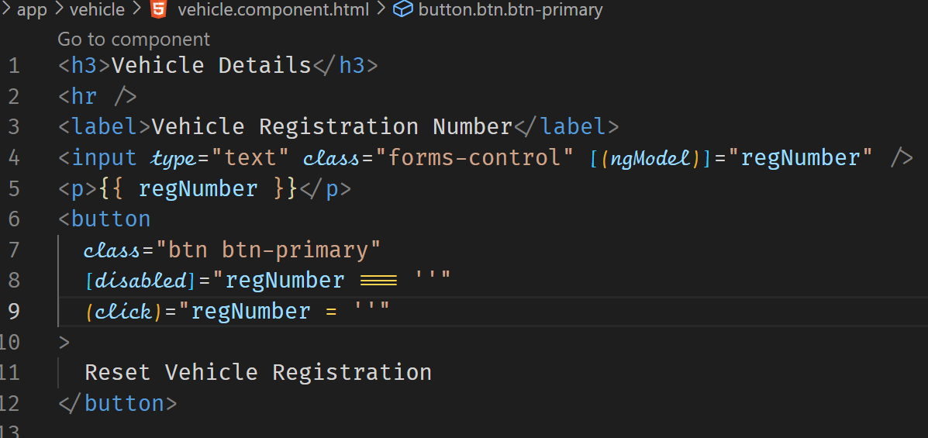

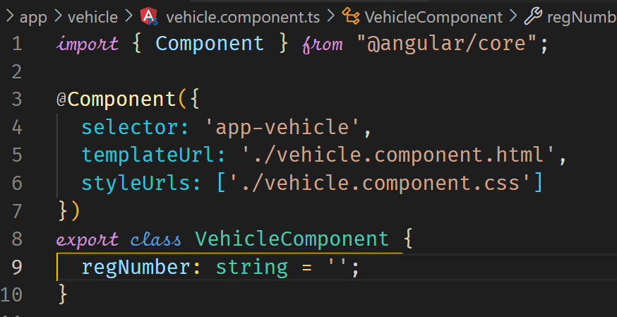

**Directives**

Directives are instructions to the DOM. For example, @Component as the DOM to add the component to the DOM. Typically, directives are added by using the attribute selector.

**ngIf**

The ngIf is a structural directive, which means it changes the structure of the DOM. Because of that, it should be preceded by *, as in *ngIf.

ngIf will add an element to the DOM conditionally when the expression assigned to it evaluates to true.

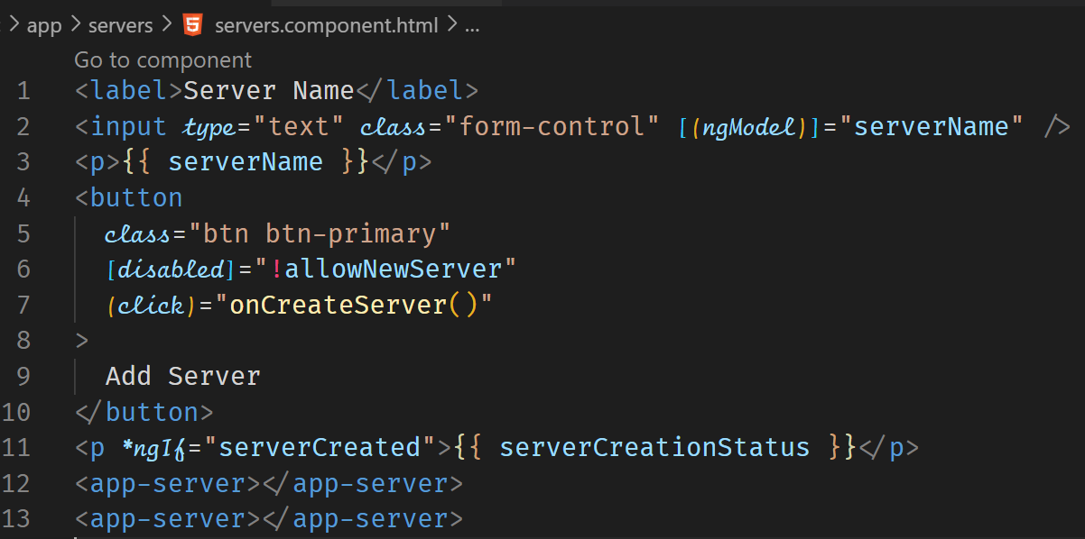



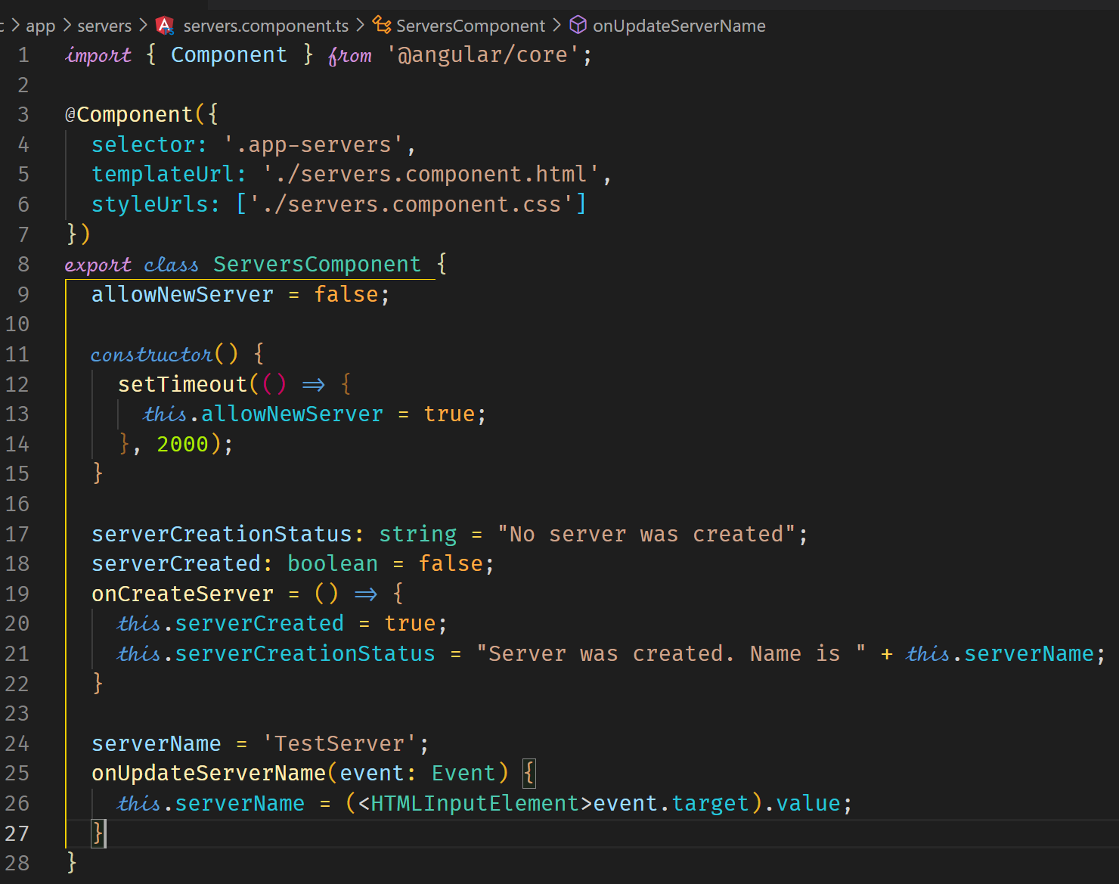



|  |  |
| --- | --- |
| Before clicking the Add Server button | After clicking the Add Server button |
|  |  |

**Enhancing the ngIf with an Else Condition**

We can mark a place where the Else condition is applied in the html template by using ng-template tag.

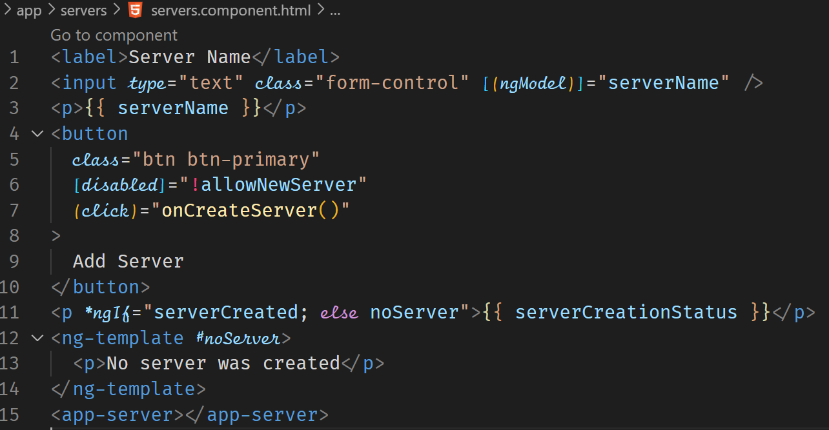



|  |  |
| --- | --- |
| Before clicking the Add Server button | After clicking the Add Server button |
|  |  |

**ngStyle**

ngStyle directive can be used to style elements dynamically. It is added as an attribute in the template using property binding to configure it. Unlike structural directives, attribute directives don’t add or remove elements. They only change the element they were placed on. Because of that, we do not need to prefix the directive with a *.

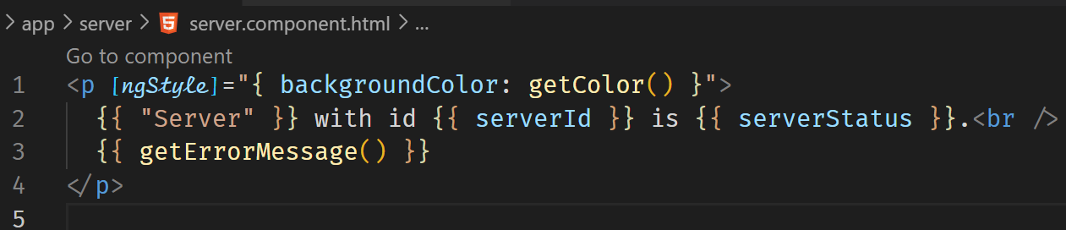



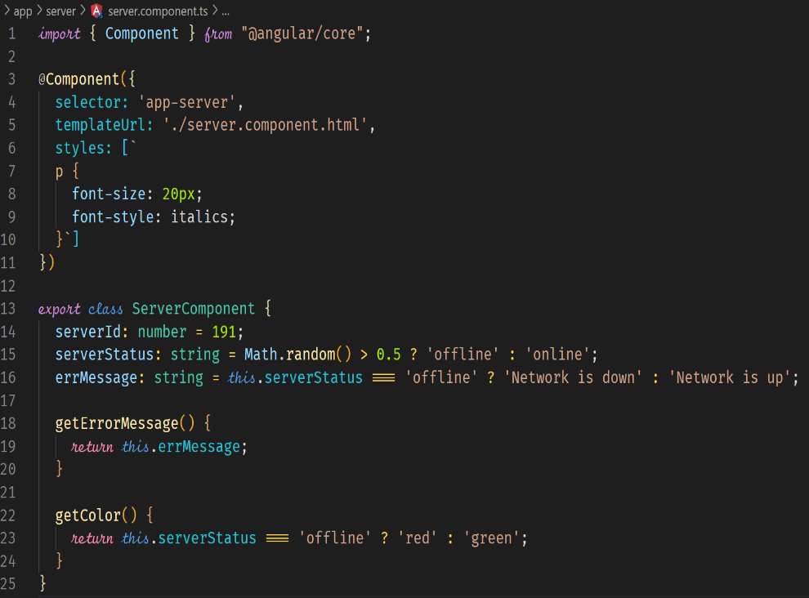

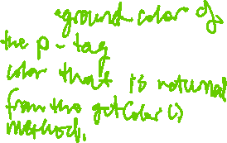

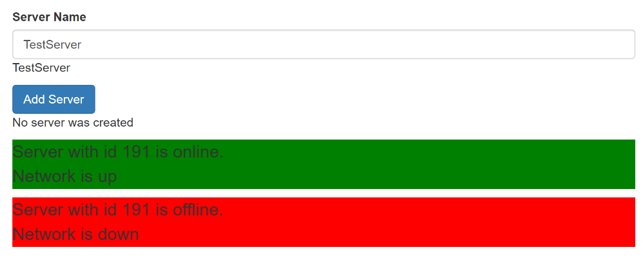

**ngClass**

We use the ngClass to apply CSS classes dynamically. ngClass will load a specified class only when the stated condition is true.

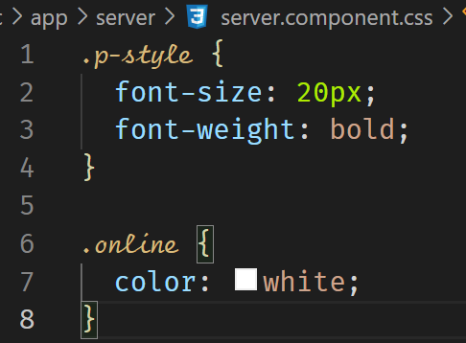



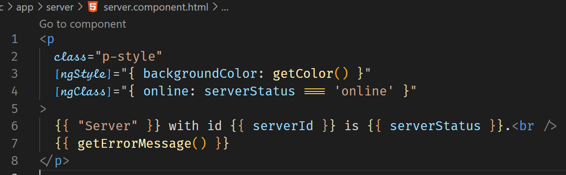



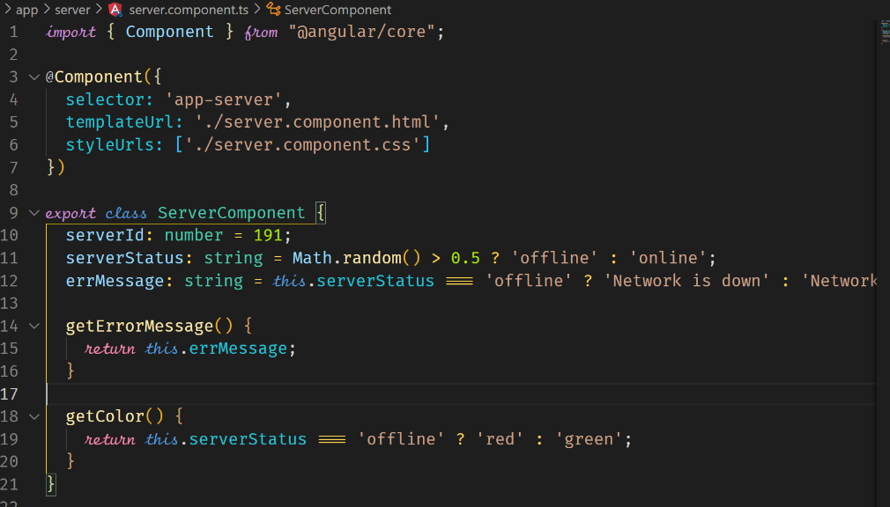

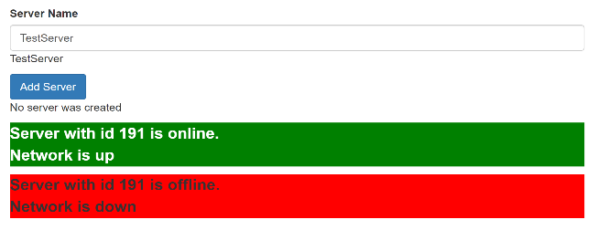



**ngFor**

ngFor is a structural directive that allows us to output lists.

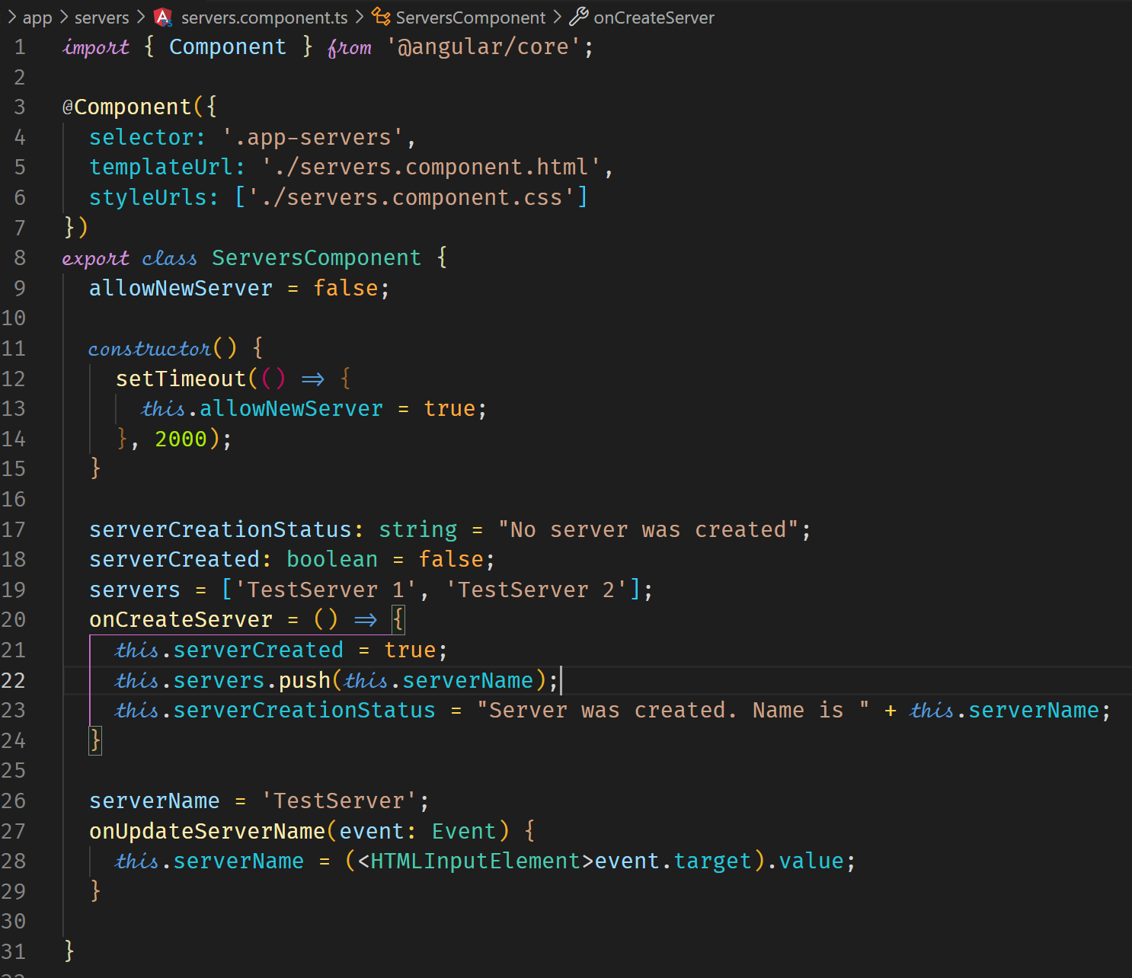

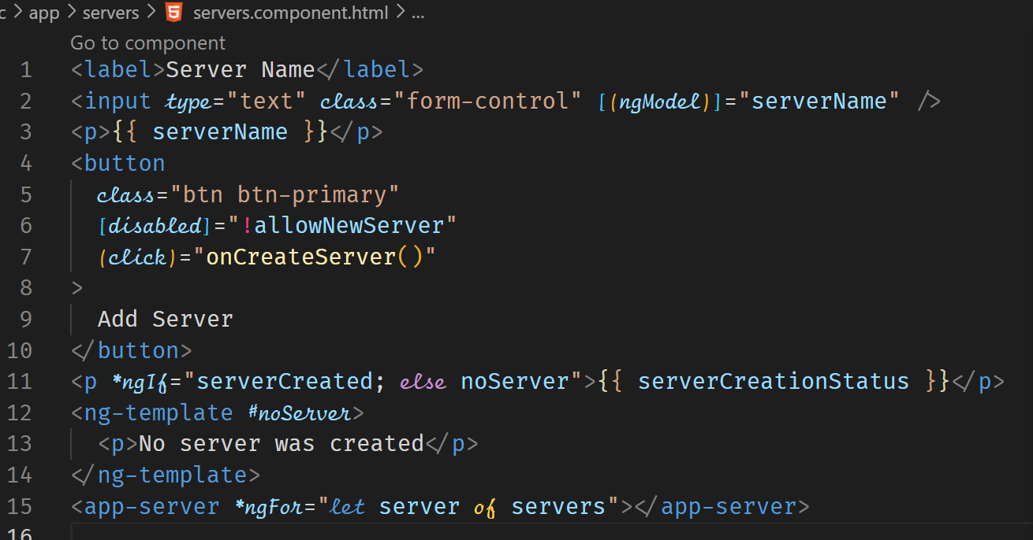

When the servers array is updated using the push() method when the Add Server button is clicked, the ngFor directive displays the new server component.

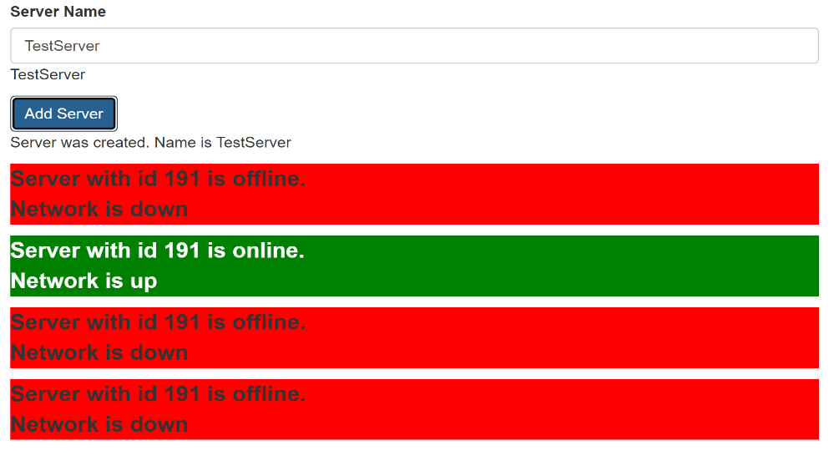

**Exercise**

Add a button which says Display Details. Add a paragraph with any content of your choice. Toggle the displaying of that paragraph with the button created in the first step. Log all button clicks in an array then output the array below the paragraph. Starting at the 5th log item give all future log items a blue background via ngStyle and white color via ngClass.

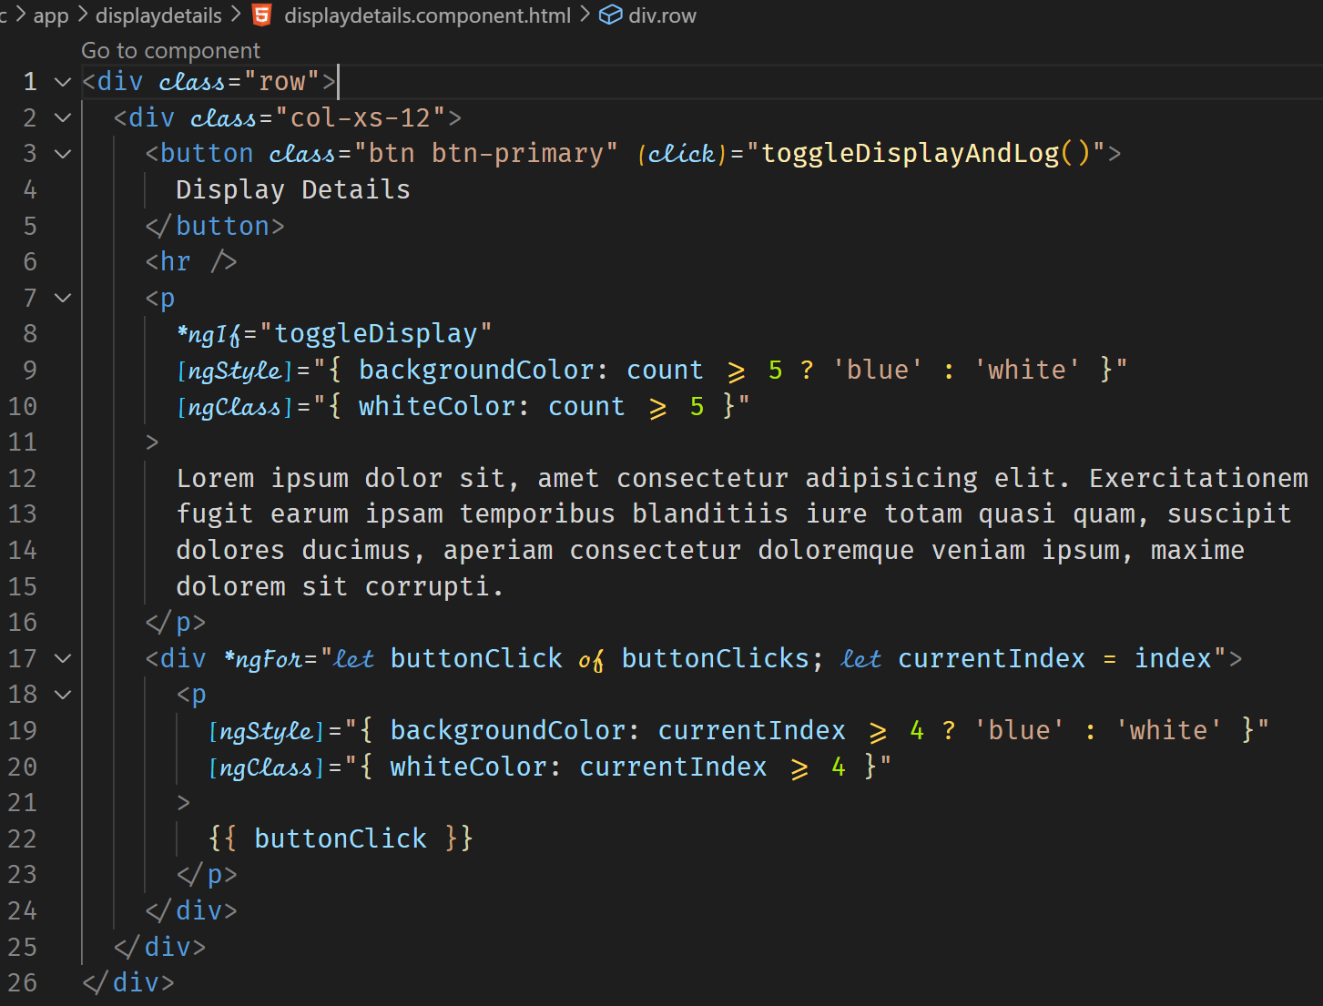



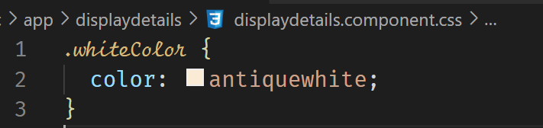

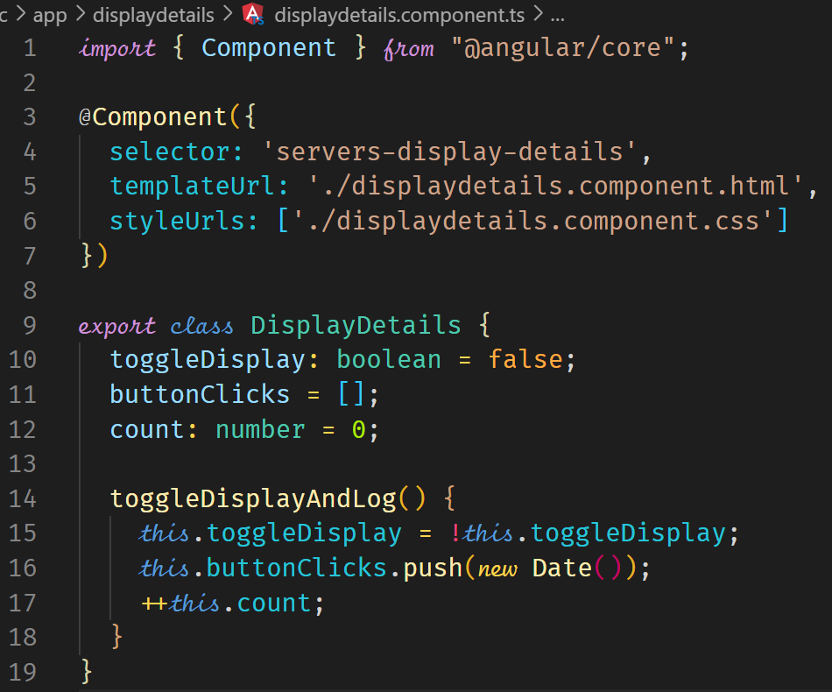

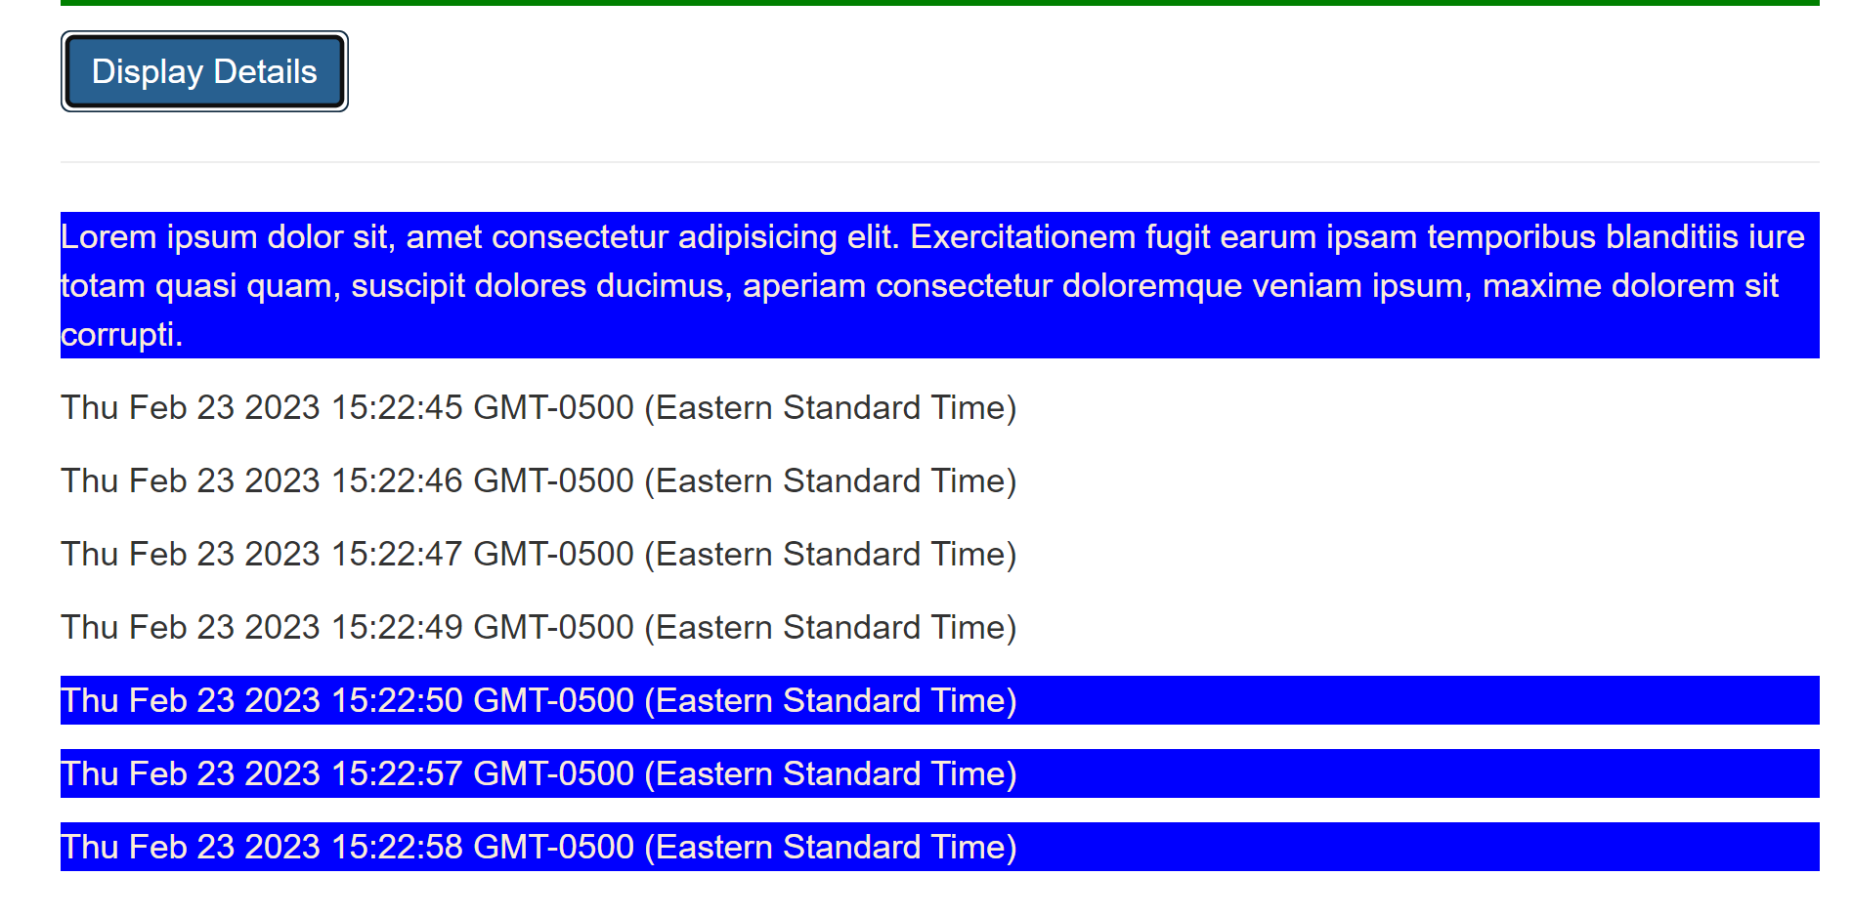

**Creating an Application**

Plan the app

|  |  |  |  |  |  |  |
| --- | --- | --- | --- | --- | --- | --- |
|  |  |  |  |  |  |  |
|  | Root | | | | |  |
|  |  |  |  |  |  |  |
|  |  | Header | | |  |  |
|  |  |  |  |  |  |  |
|  |  | Shopping List |  | Recipe Book |  |  |
|  |  |  |  |  |  |  |
|  |  | Shopping List |  | Recipe List |  |  |
|  |  |  |  |  |  |  |
|  |  | Shopping List Edit |  | Recipe Item |  |  |
|  |  |  |  |  |  |  |
|  |  | **Ingredient** |  | Recipe Detail |  |  |
|  |  |  |  |  |  |  |
|  |  |  |  | **Recipe** |  |  |
|  |  |  |  |  |  |  |
|  |  |  |  |  |  |  |
|  |  | **Model** |  |  |  |  |
|  |  |  |  |  |  |  |
|  |  | Component |  |  |  |  |
|  |  |  |  |  |  |  |
|  |  | Feature |  |  |  |  |
|  |  |  |  |  |  |  |

**Create an angular app**

ng new my-dream-app –no-strict

cd my-dream-app

Bootstrap

Installing bootstrap for styling

npm i –save bootstrap@3

Edit angular.json

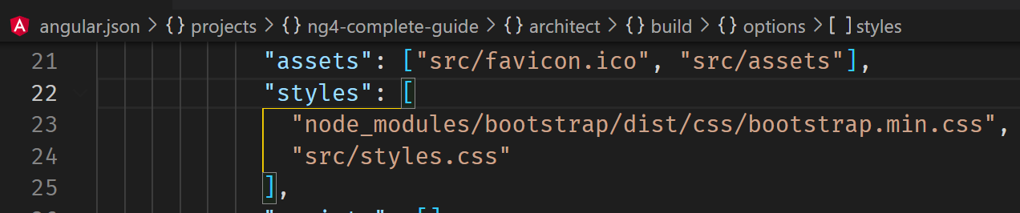

Model

A model represents a data class that is commonly used in the application.

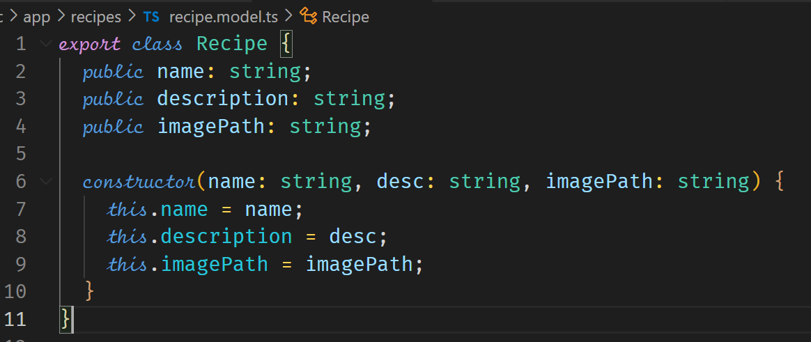

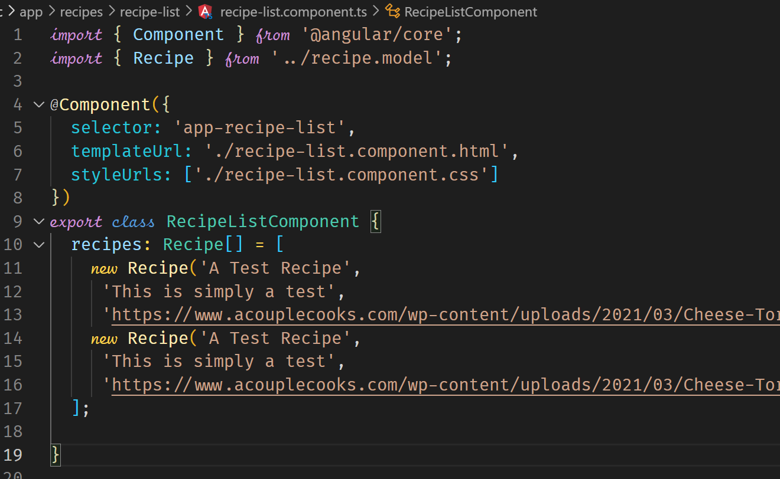



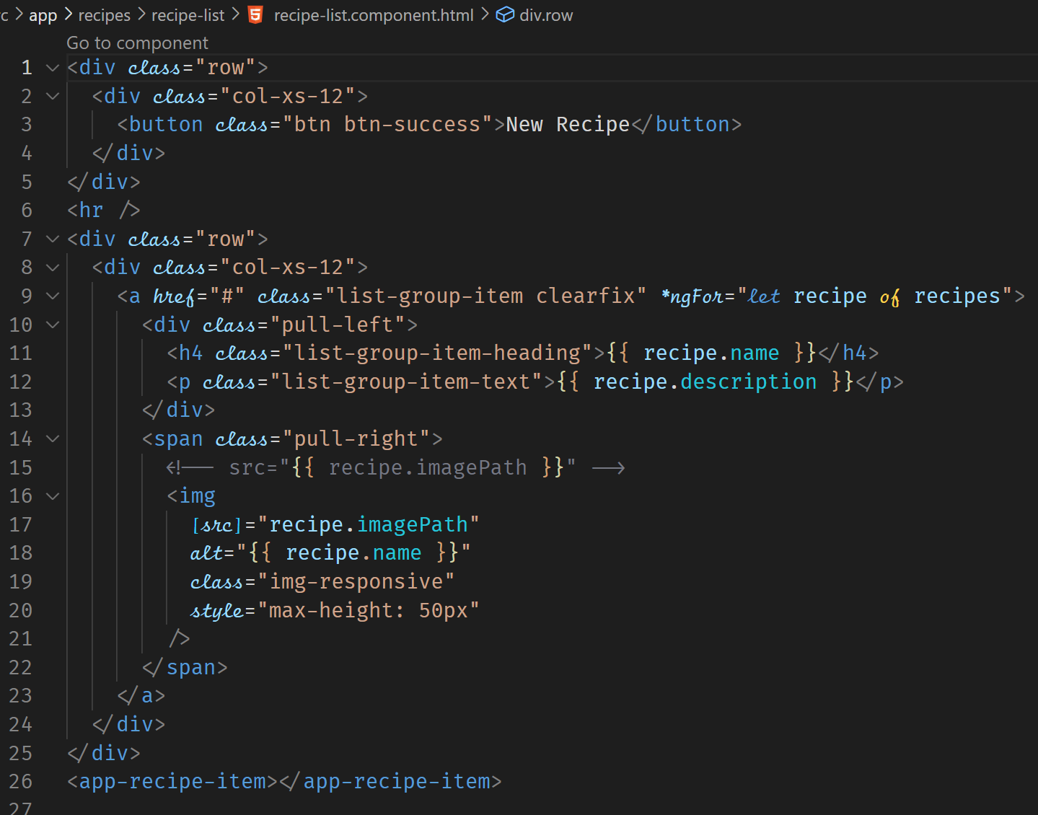



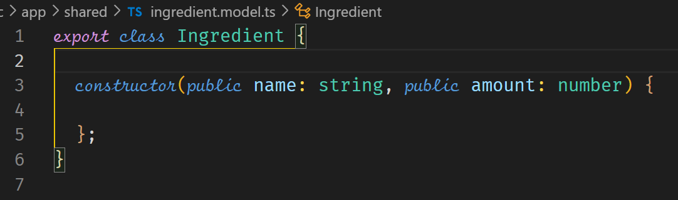



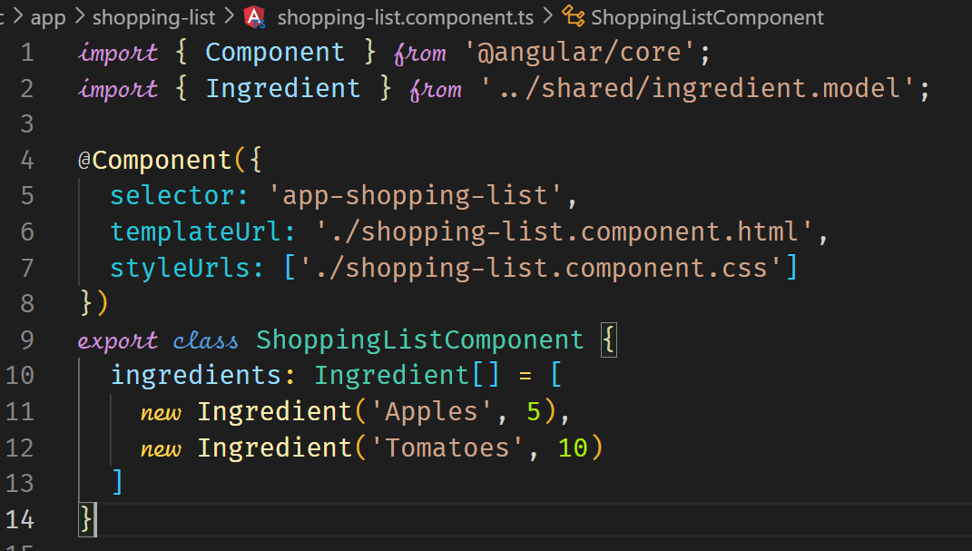



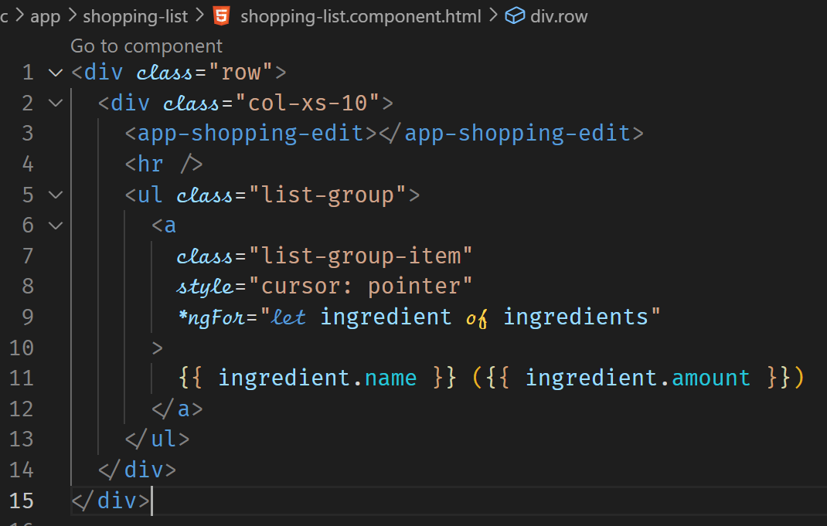

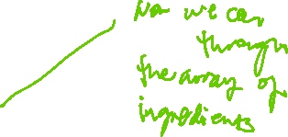

**Debugging**

Syntax error messages are displayed in the browser console. A stacktrace can show which files and areas in your code that is the source of the error. An analysis of the error message can help to fix the error.

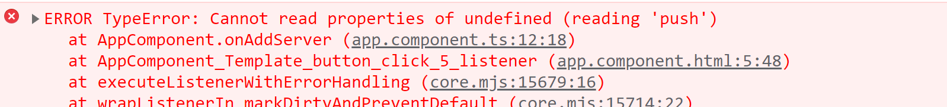

Looking at our code in the app.component.ts on line 12,

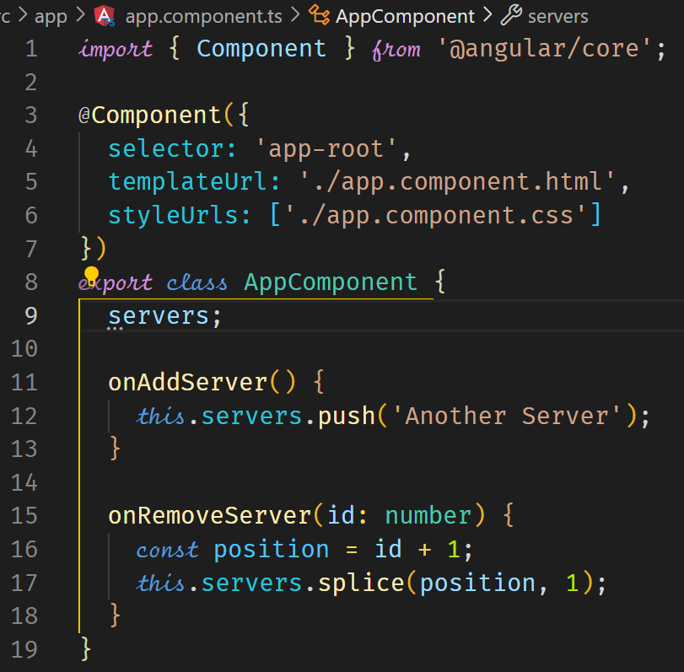



We fix the error by defining the servers property.

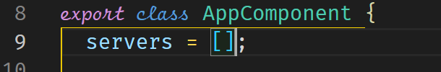

The code now does not thrown errors but it is not working as we expected.

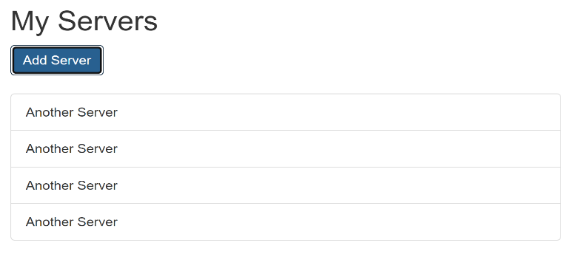



This type of error in logic requires debugging. We use Source Maps in Developer Tools.

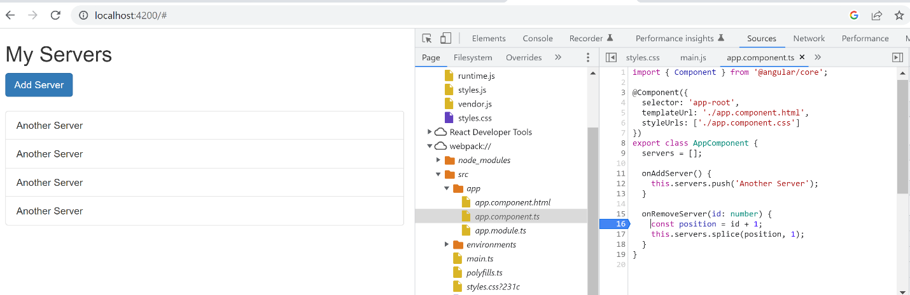



**Components and Data Binding Deep Dive**

Custom Property Binding helps us to pass data from the root component to the child component.

ROOT COMPONENT

HOME COMPONENT



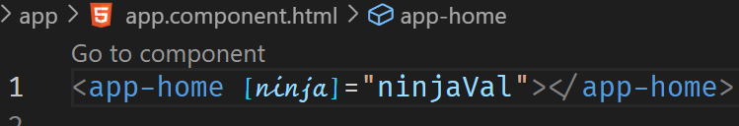



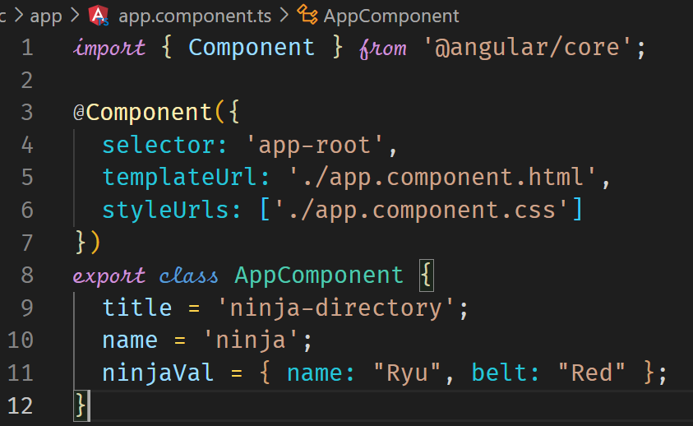



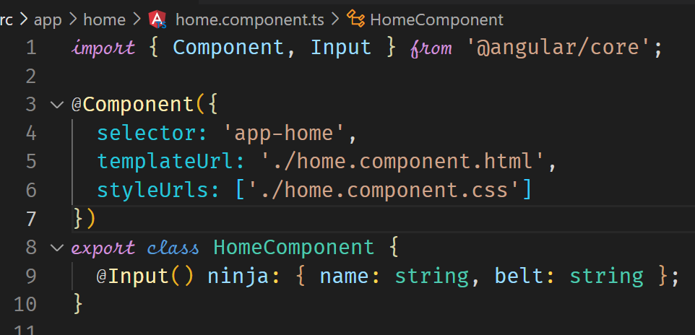



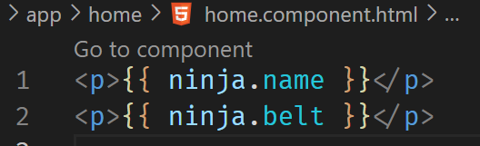



Another example of Custom Property Binding

|  |  |
| --- | --- |
|  | element is custom property in the template. We bind by enclosing it in [] and assign it a value from the AppComponent. In this example, the value is derived from the *ngFor which creates the variable element and assigns values to the variable as it loops through the serverElements. |

|  |  |
| --- | --- |
|  | serverElements is the array which is passed to the template and is then used to create the variable element which is assigned to t property binding [element] |

So far so good. We are still in one component, the AppComponent. We now need to move the value of element to the ServerElementComponent. This is done in the app.component.html template. The ServerElementComponent should be configured to receive the value. This is where @Input() decorator is used.

|  |  |
| --- | --- |
|  | The @Input decorator is used to tell the ServerElementComponent that the value of the property element will come from the parent template. The rest of the code after the variable name specifies the structure of the data that should be received. |

|  |  |
| --- | --- |
|  | We can now use the element variable in the template. |

In the output that is displayed in the ServerElementComponent, we can see the values passed in the serverElements javascript array.

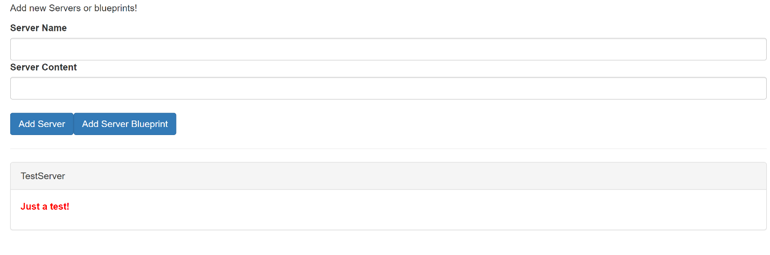

**Assigning an alias to Custom Properties**

We can assign an alias to the property of the child component. When we do the custom property binding, we should then use the alias.

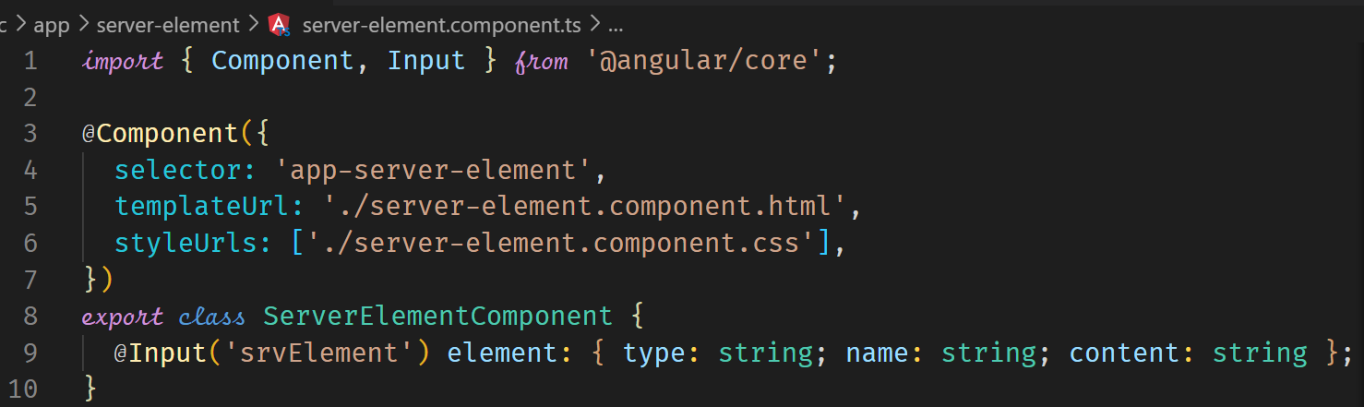



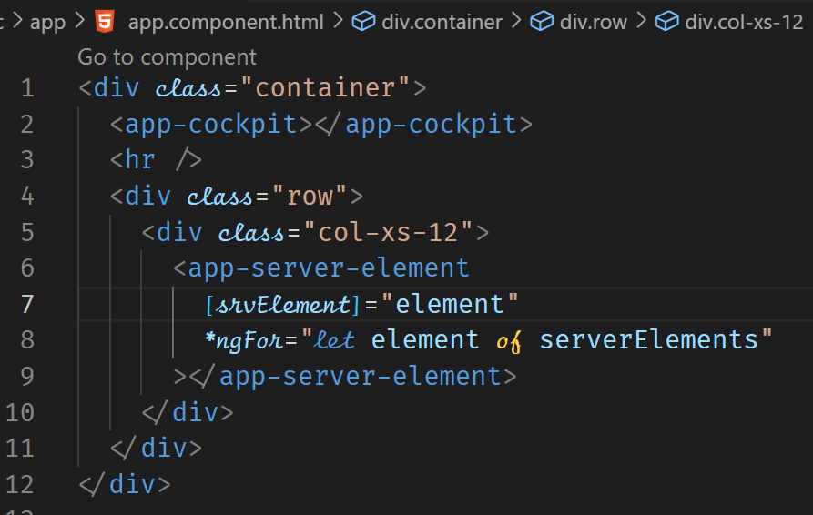



**Binding to Custom Events**

Binding to custom events allows us to send data from a child component to the parent component. The parent component is able to handle events emitted from the child component.

Root Component

Child Component

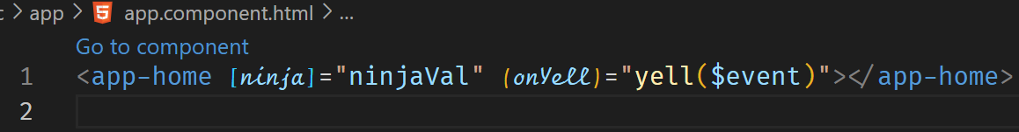

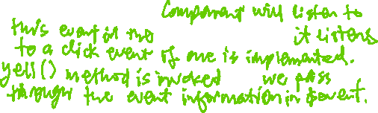

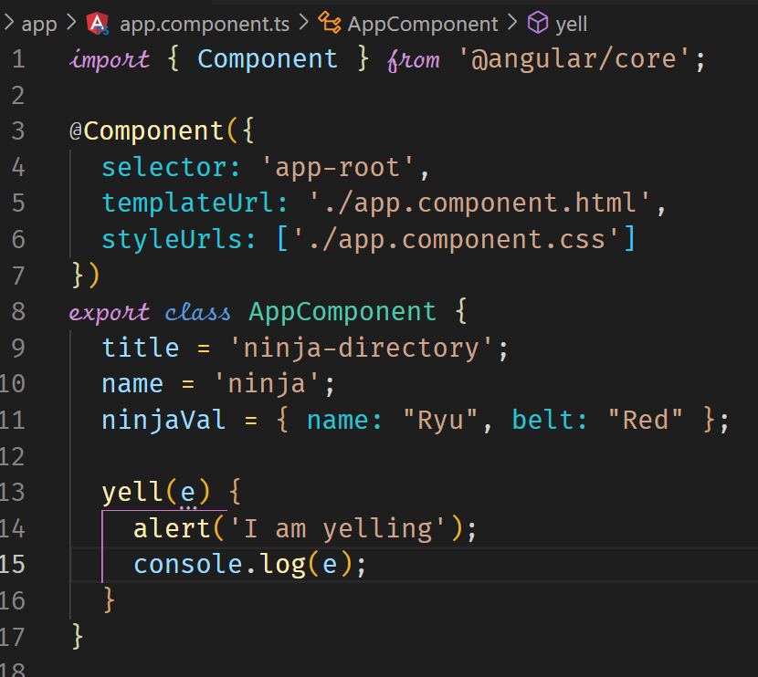



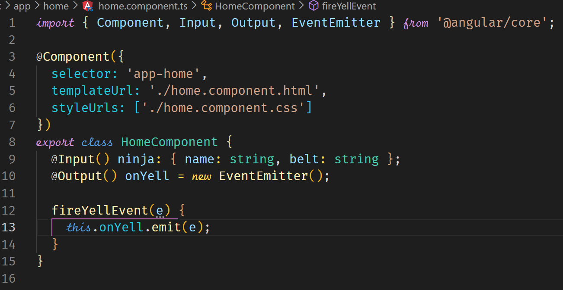



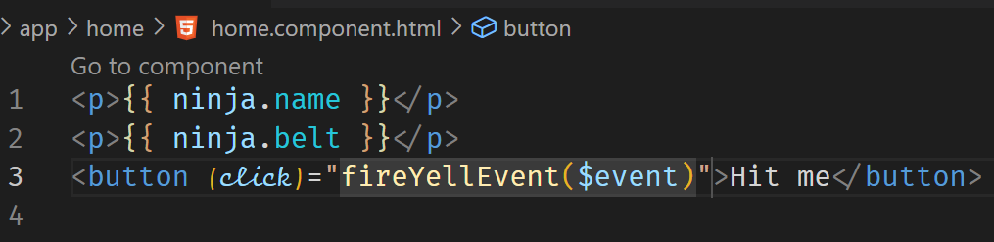



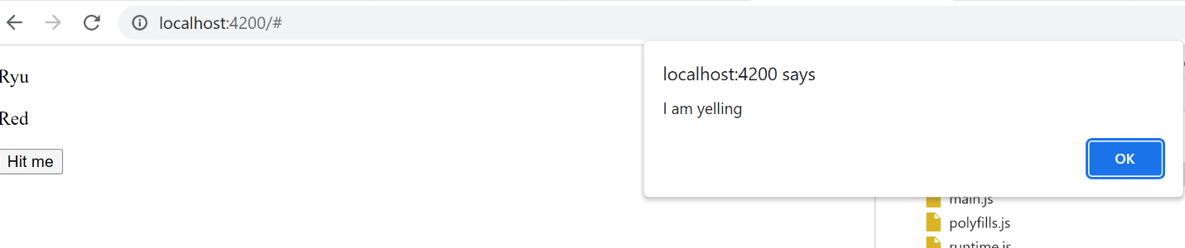

Another example of Custom binding

**Child Component**

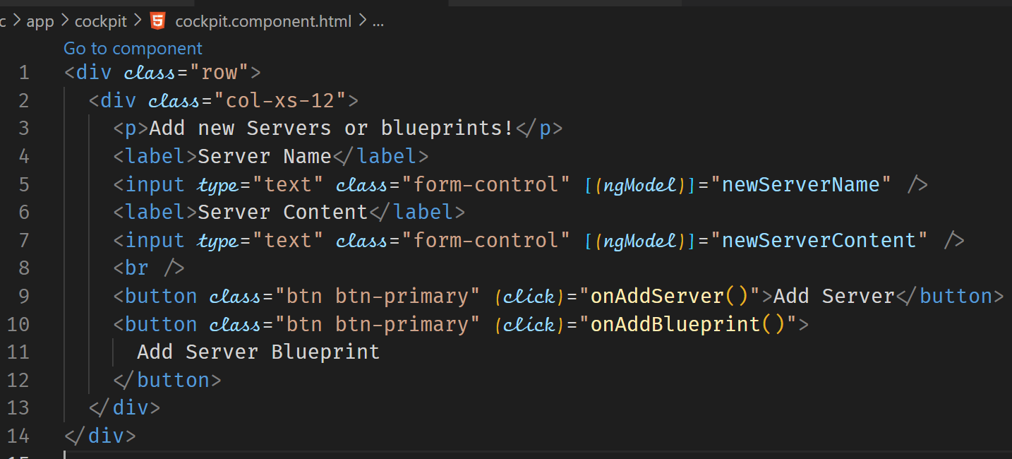



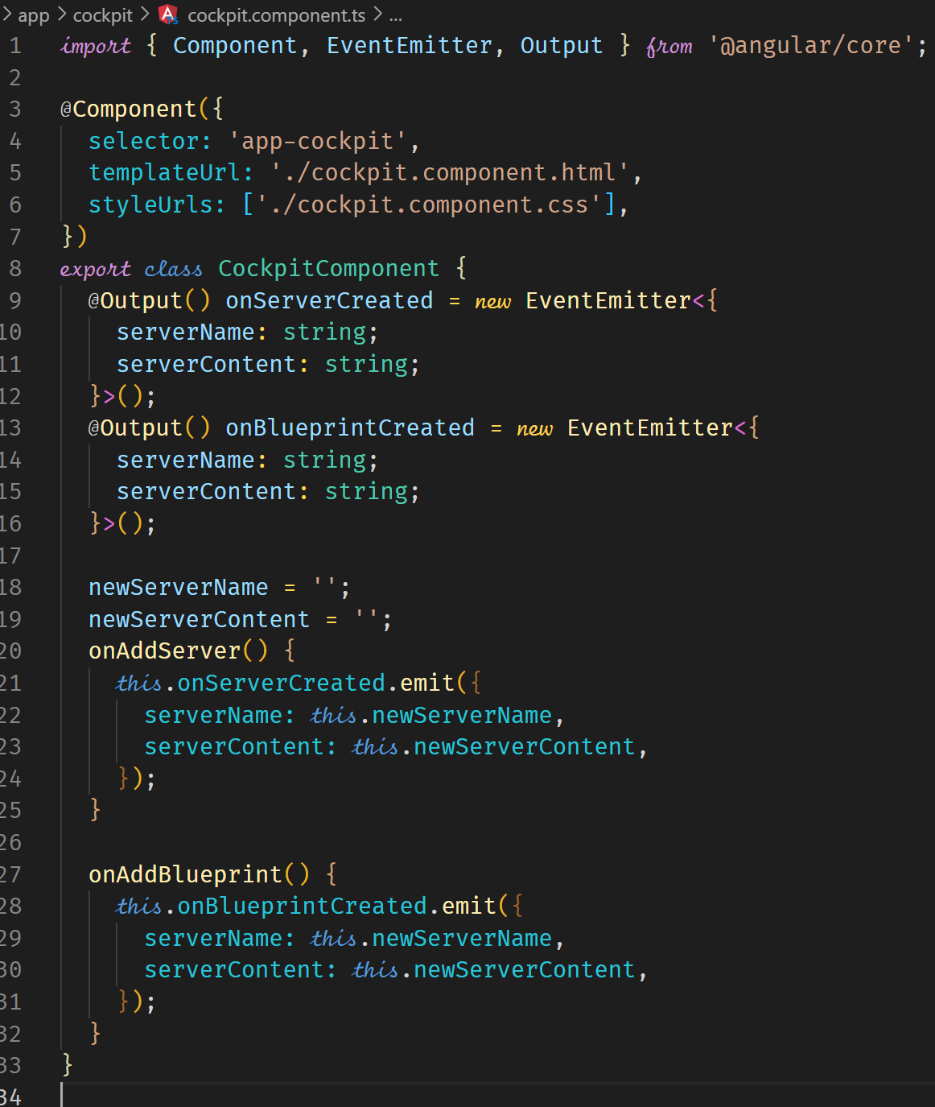

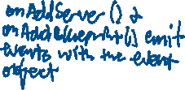

Parent Component

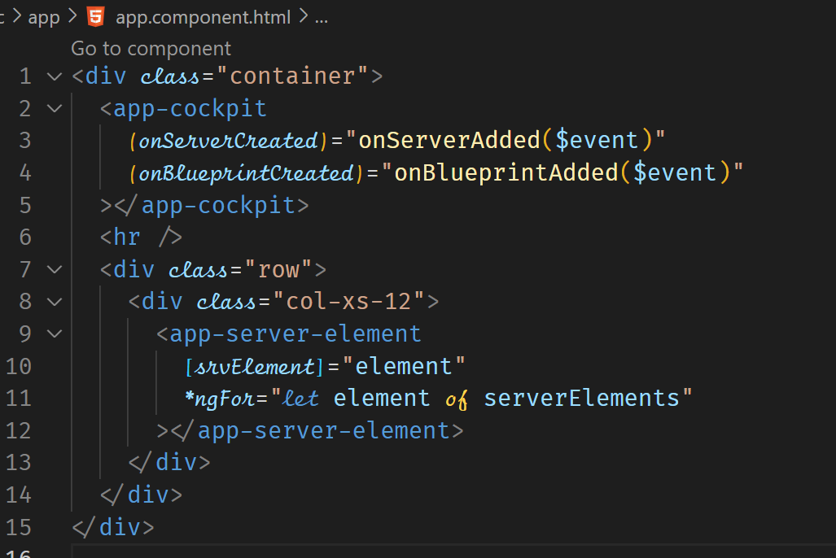

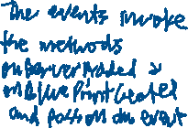

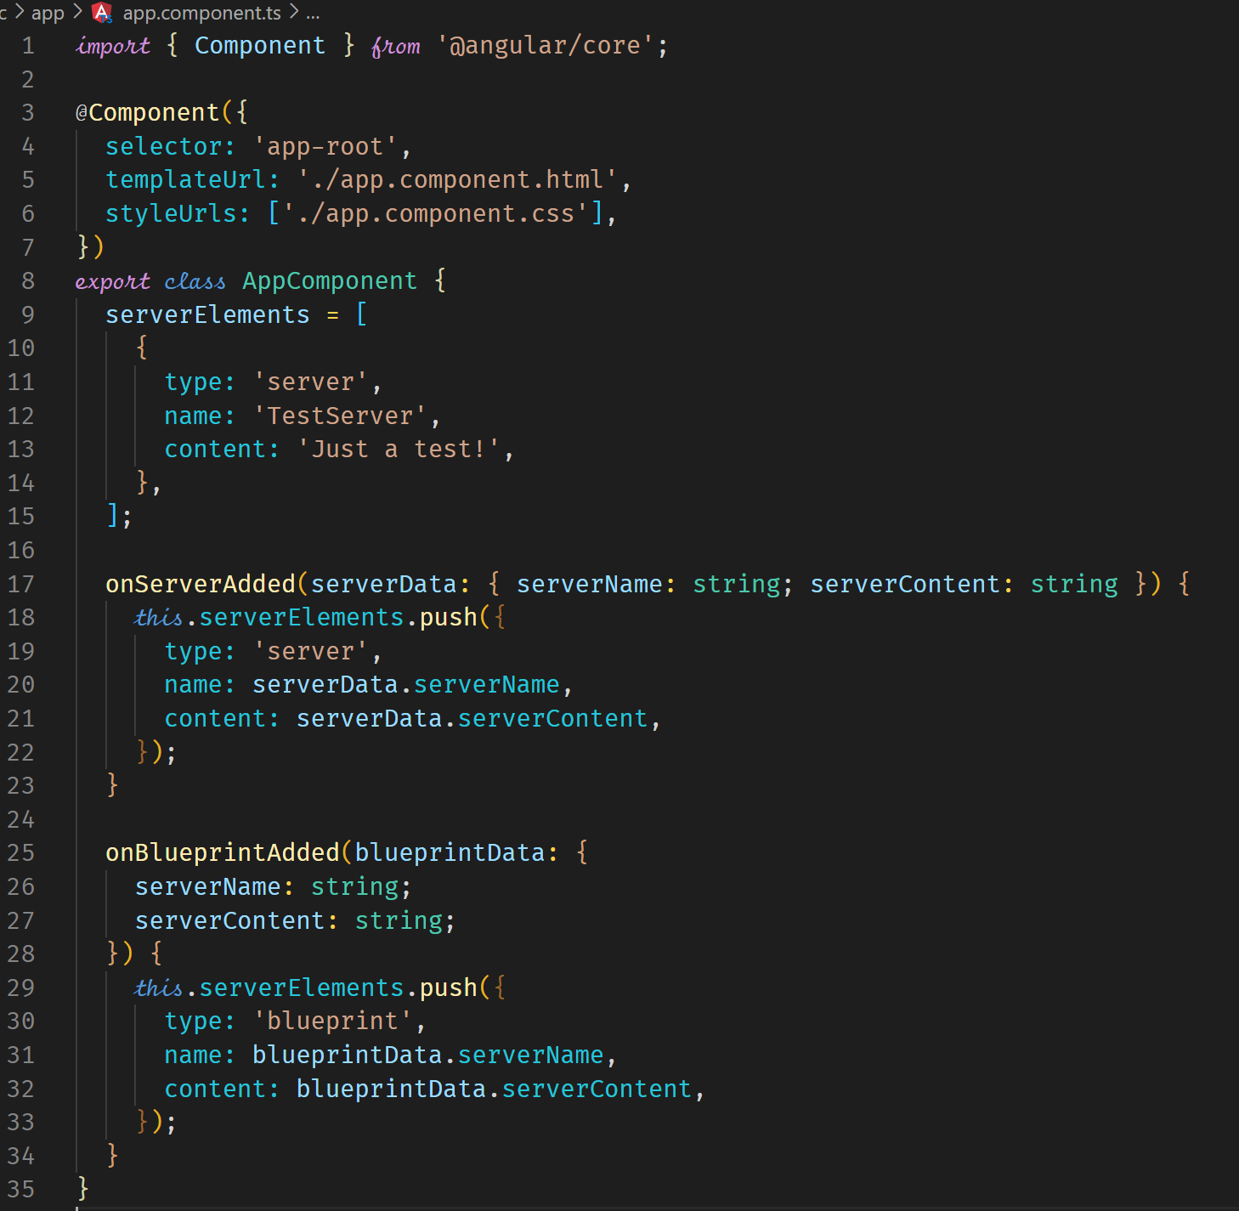



**Assigning an alias to custom events**

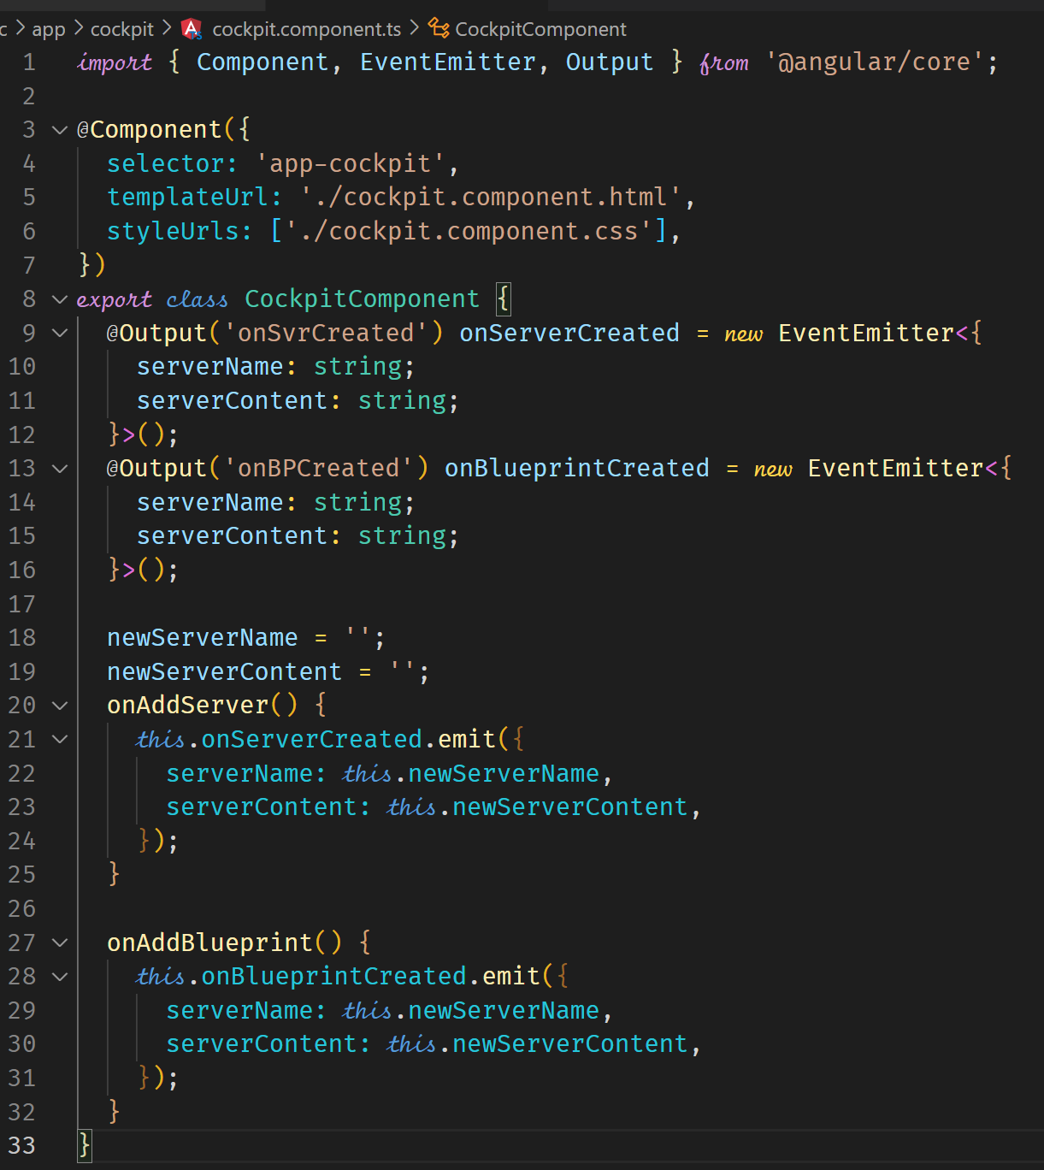



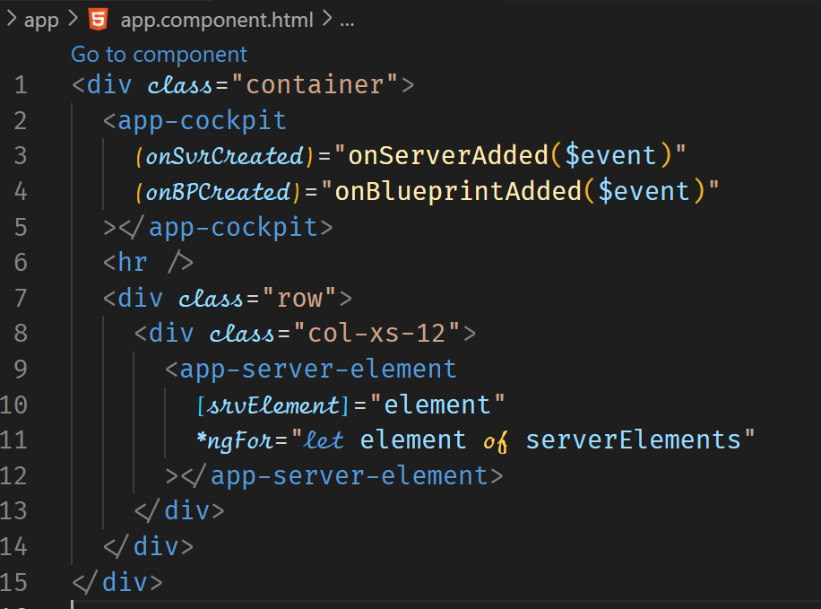

**View Encapsulation**

View Encapsulation affects how CSS styles are applied across the application. The default behavior, which is

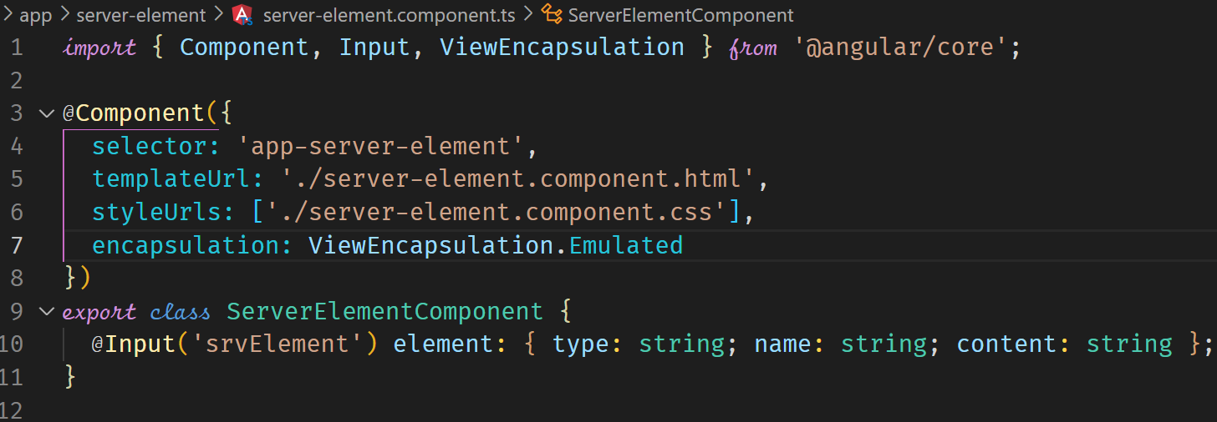

ensures that CSS styles are limited to the component in which they are defined. This is effected by angular. Each DOM element for a component gets the same attribute

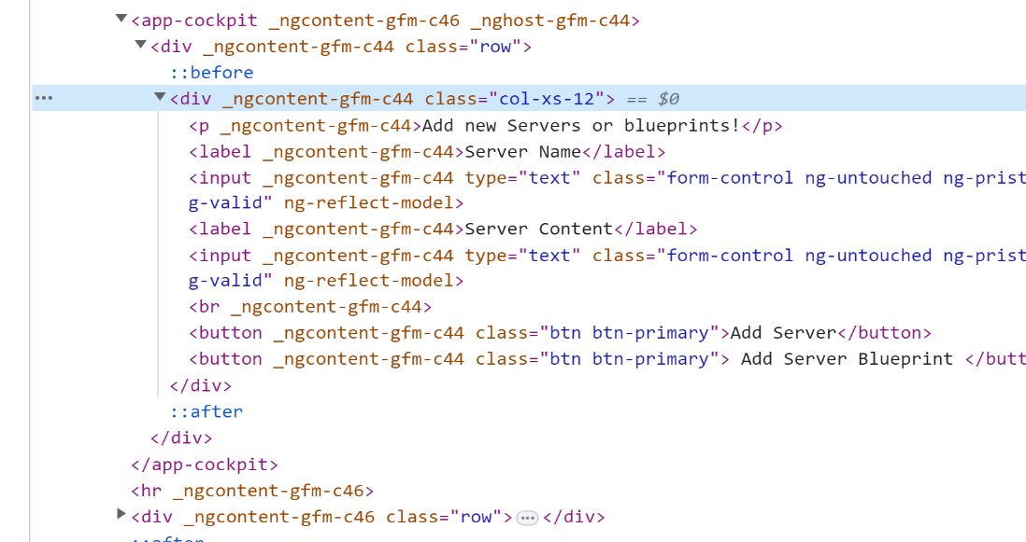



This default behavior can be changed to allow CSS in one component to be applied to the whole application. This may not be ideal however but the option is there if required.

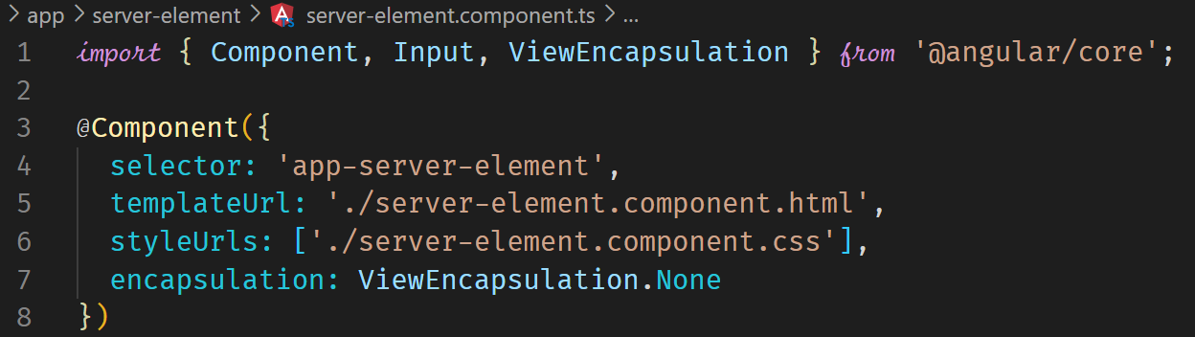

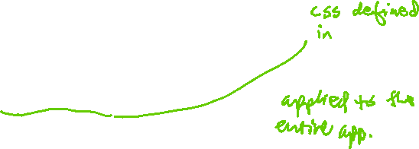

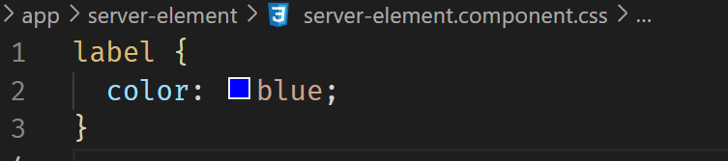

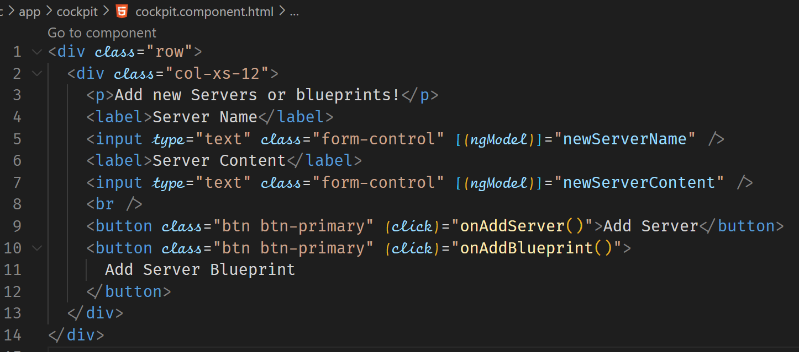



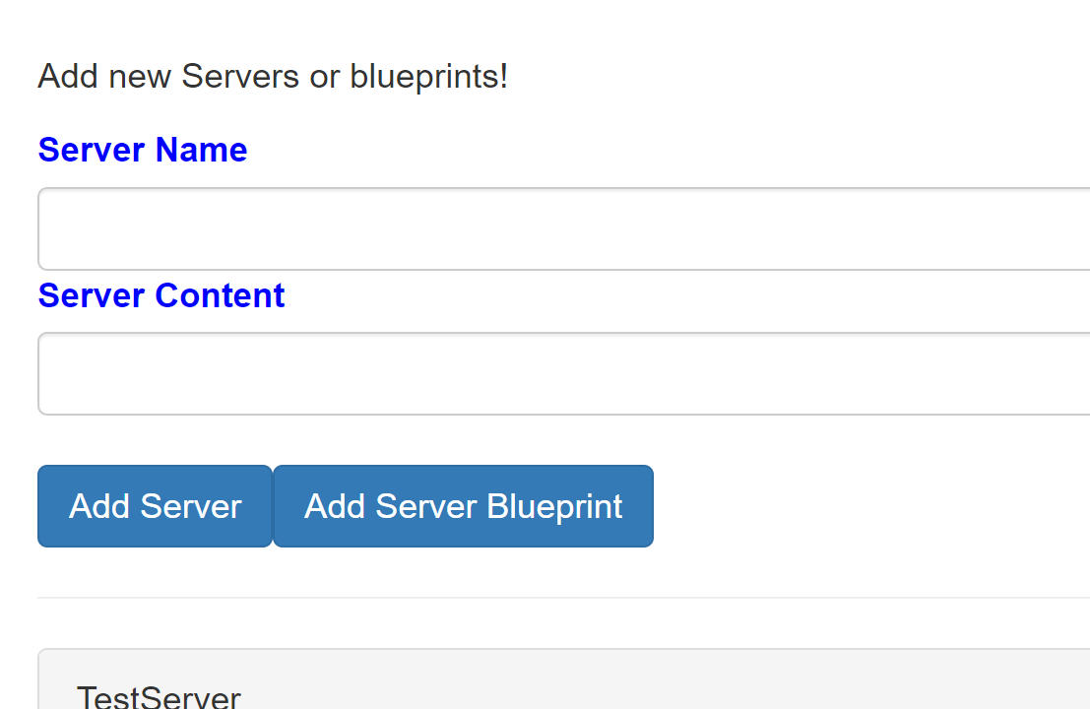

**Using Local References in Templates (not recommended)**

We can use Local References in templates to pass data to typescript instead of the two-way binding.

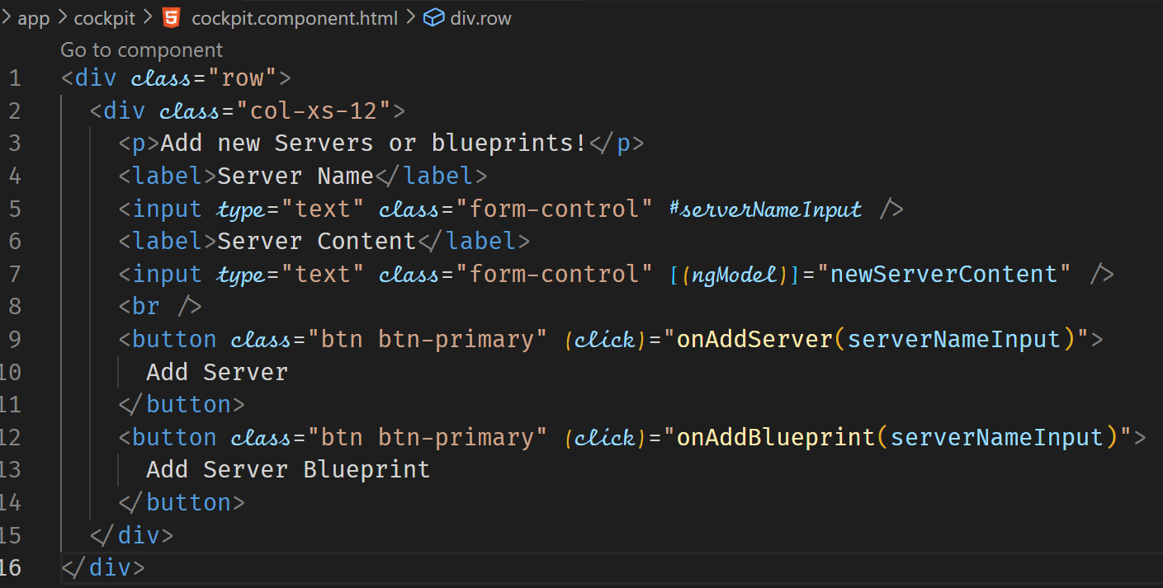



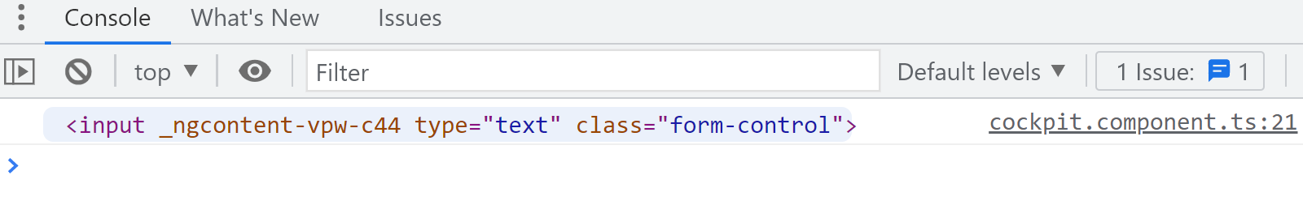



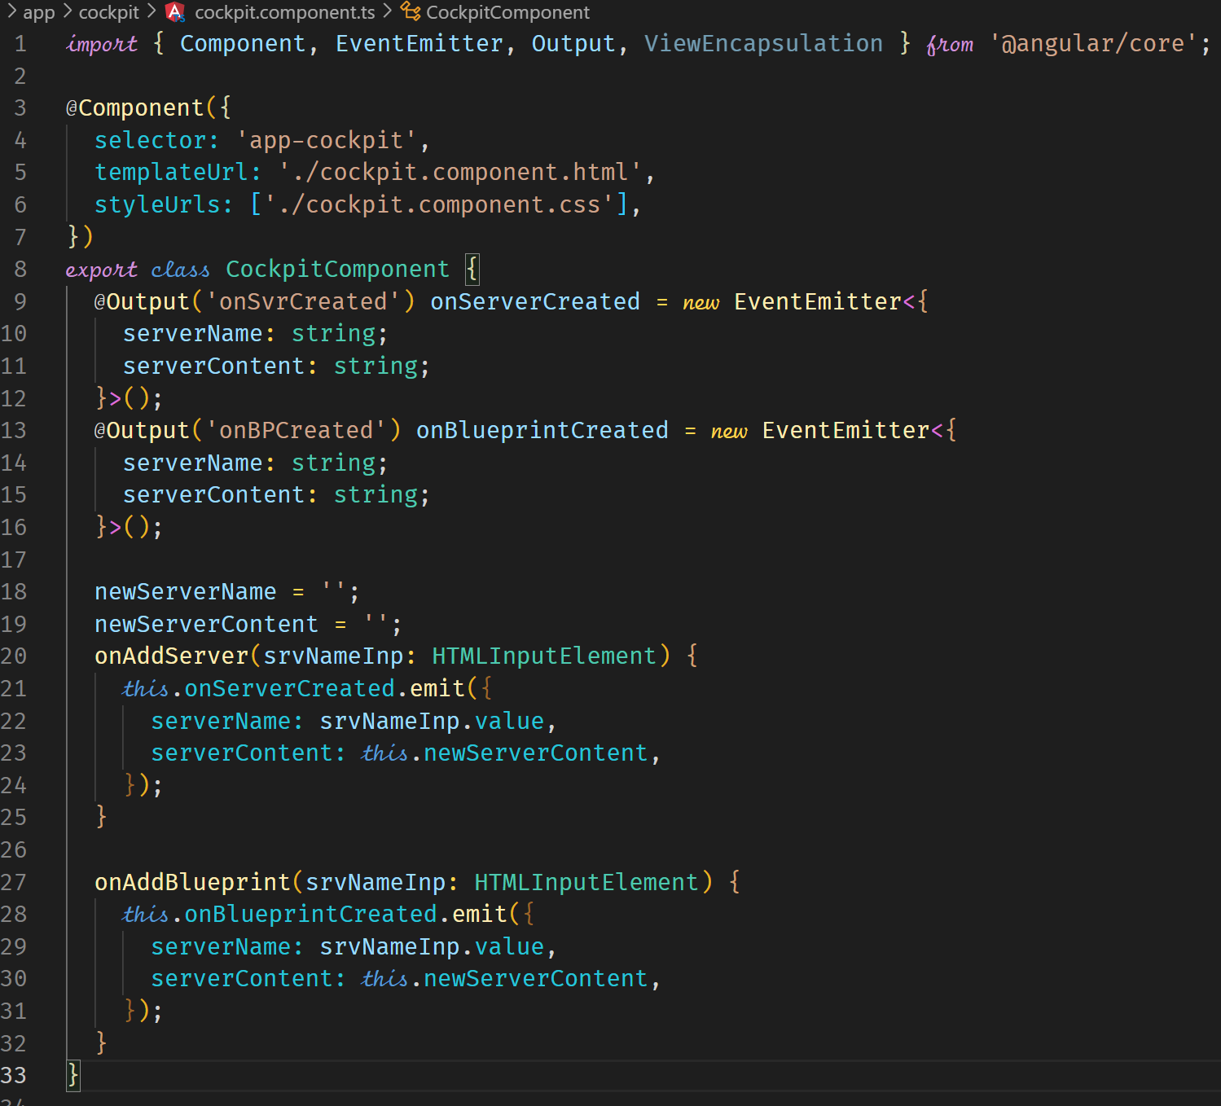

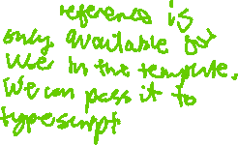

**Getting Access to the Template & DOM with @ViewChild**

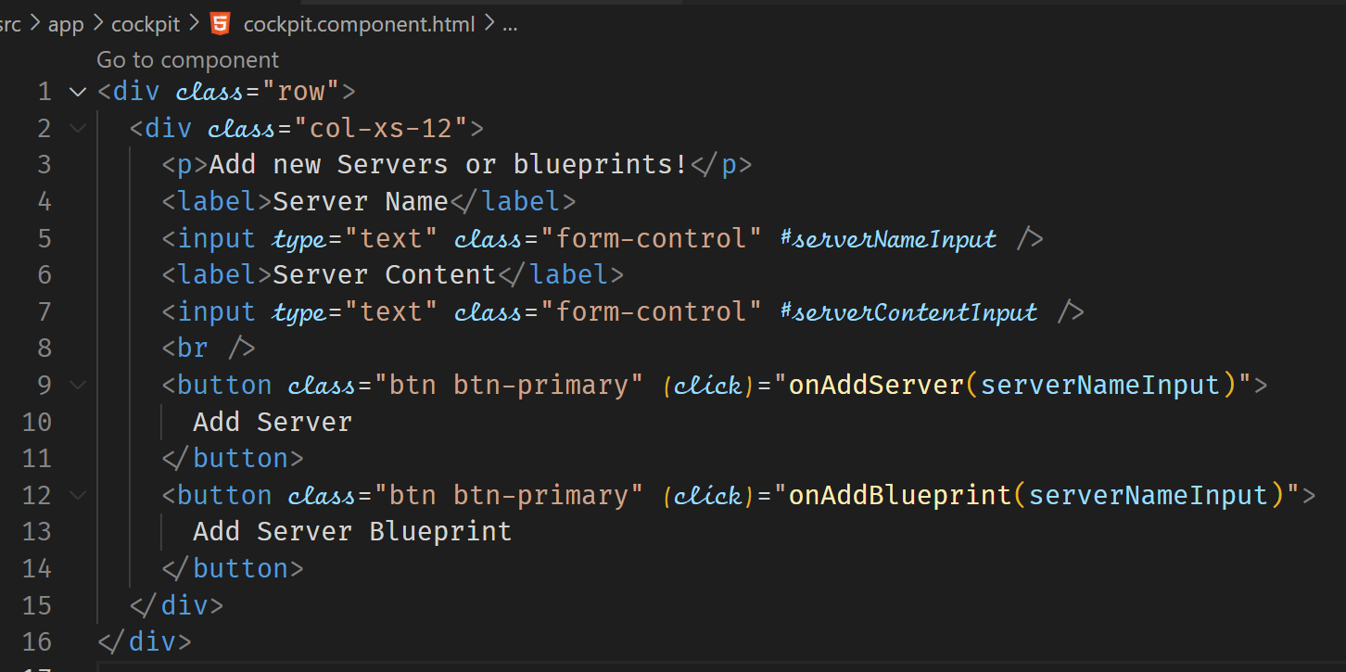

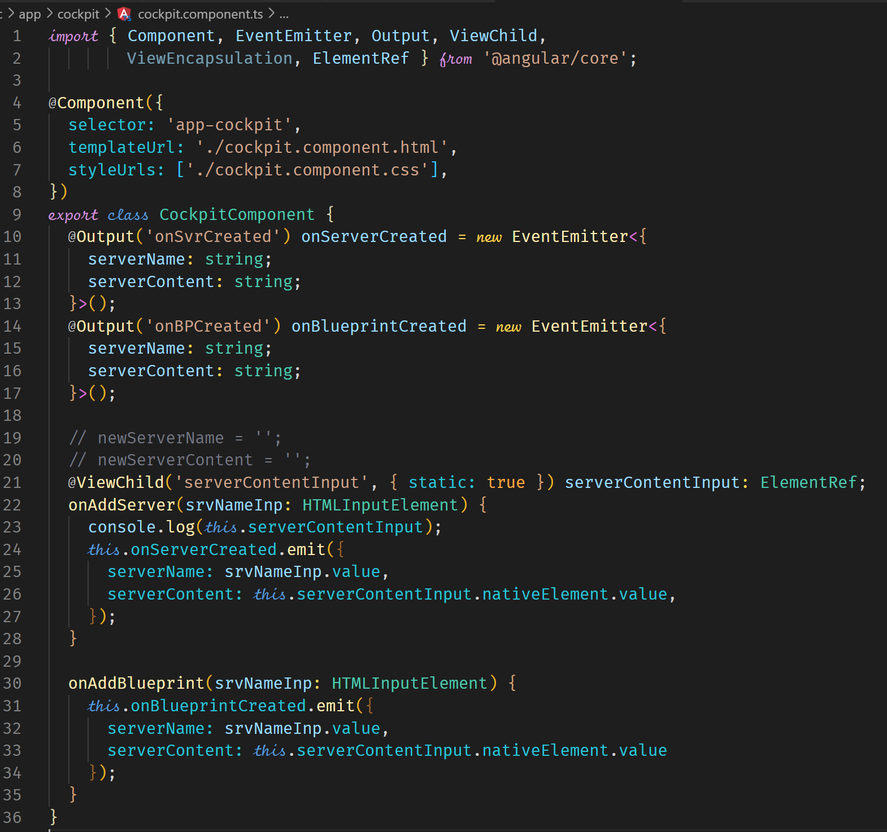



**Projecting Content into Components with ng-content**

As a general rule, content that is placed between custom elements (i.e. component selectors) is not rendered. You should use ng-content directive to render text from a parent to the child component.

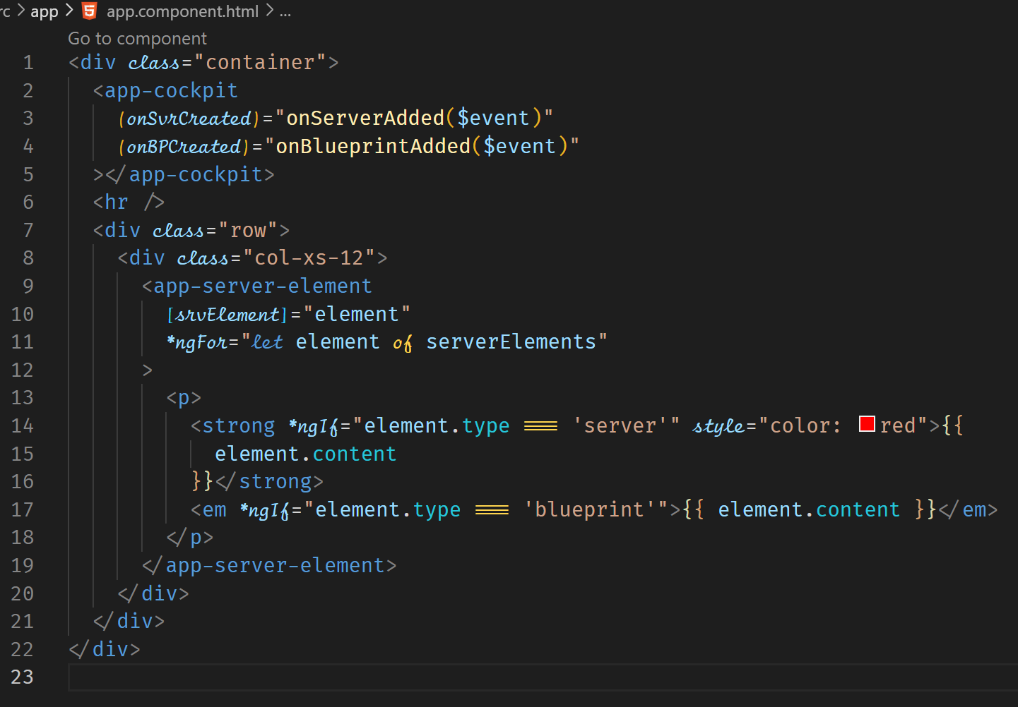



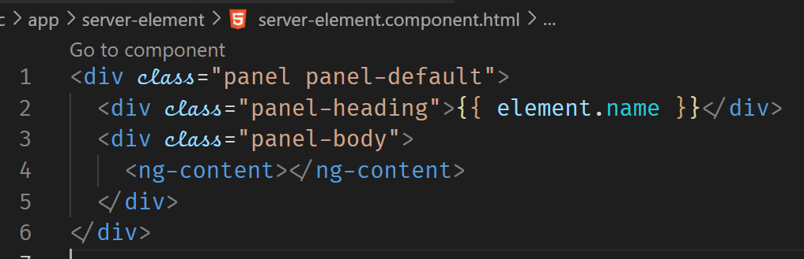



**Component Lifecycle**

ngOnChanges

called after a bound input property changes

ngOnInit

called once the component is initialized

ngDoCheck

called during every change detection run

ngAfterContentInit

called after content (ng-content) has been projected into view

ngAfterContentChecked

called every time the projected content has been checked

ngAfterViewInit

called after the component’s view (and child views) has been initialized.

ngAfterViewChecked

called every time the view (and child views) have been checked

ngOnDestroy

called once the component is about to be destroyed.

The following code demonstrates how these lifecycle hooks operates. Logic can be put in each of the lifecycle hooks to perform some action.

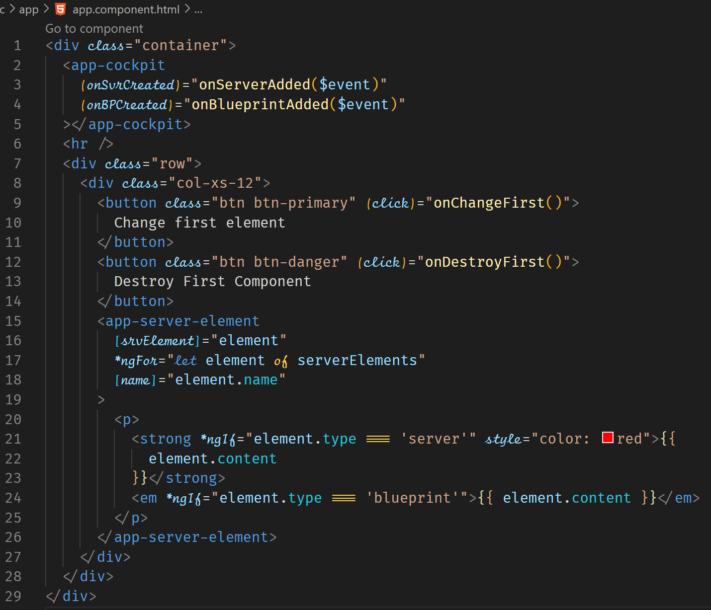

Destroy First Component button shows the LifeCycle hook that is fired if a component is about to be destroyed or removed from the DOM. You can hook up to the hook to do some cleanup tasks. ngOnDestroy is invoked before the component is destroyed.

Change first element button shows the LifeCycle hook that is fired if a component changed a property that is on the template. he change is rendered to the view. ngOnChanges is therefore invoked. The hook takes in a parameter with a type of SimpleChanges which has the previousValue and the currentValue.

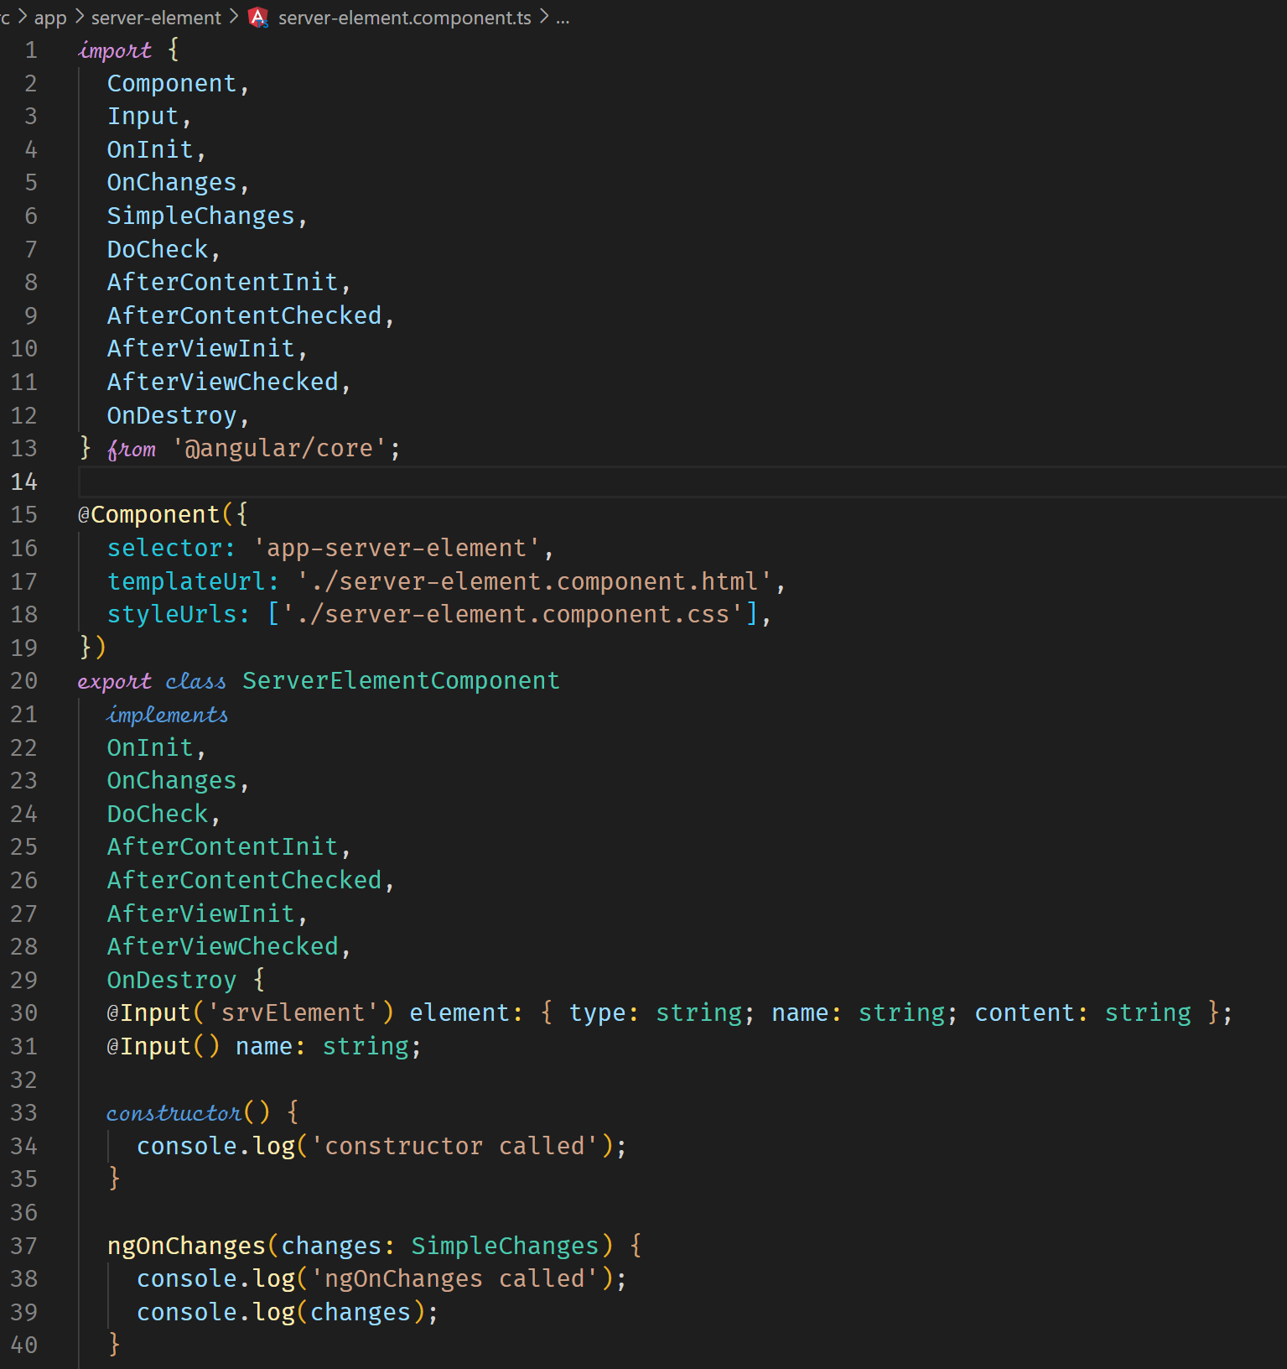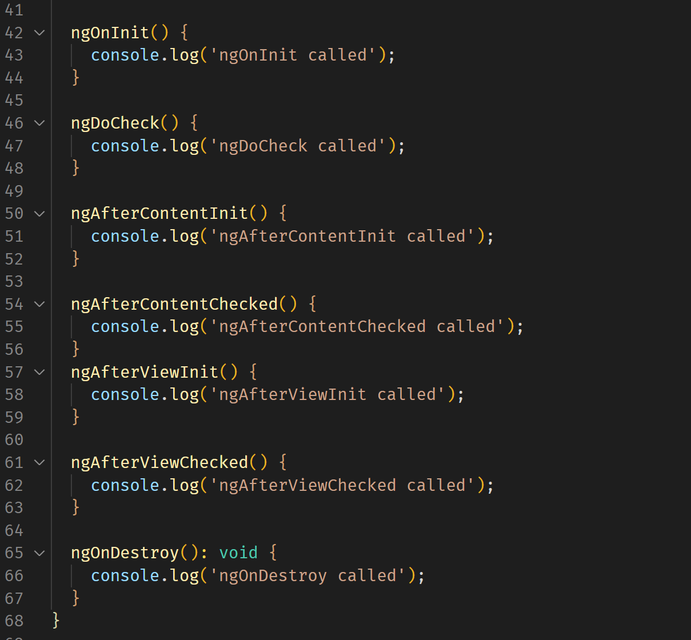



**Lifecycle Hooks and Template Access**

The template elements are accessible only after the ngAfterViewInit has been invoked. This is because it is at this point that the component view and child views have been initialized.

For example, in the following code, we can access the heading local reference using the ViewChild property in the ServerComponent.

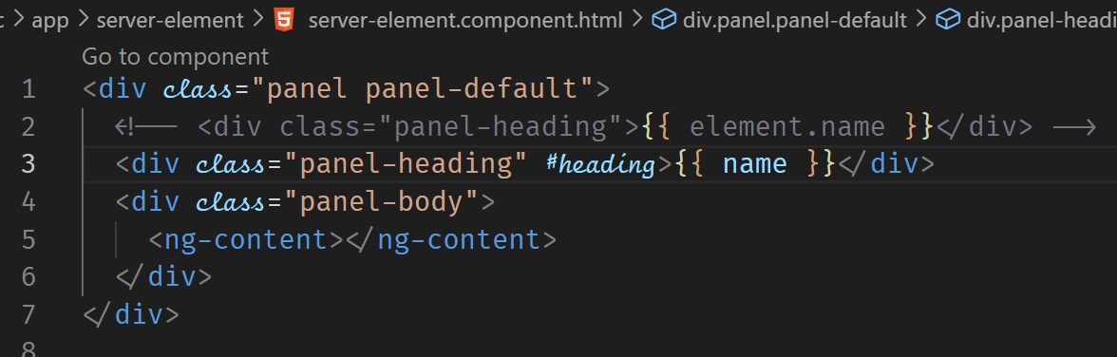



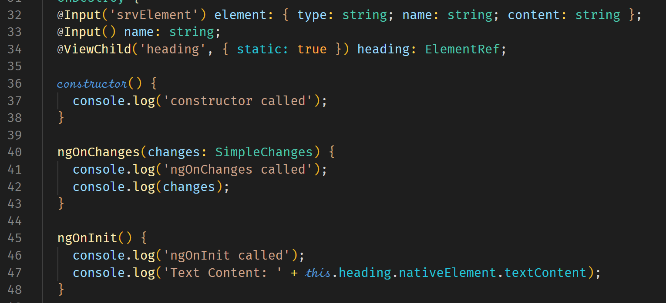



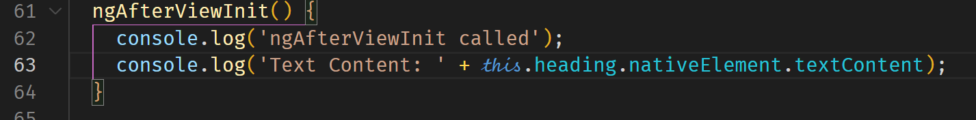











We can also use @ContentChild only after the ngAfterContentInit hook has been invoked. Before that, content that is passed through the ng-content marker tag is no accessible. Such content is not available when using the @ViewChild property as this applies for content within the same component.

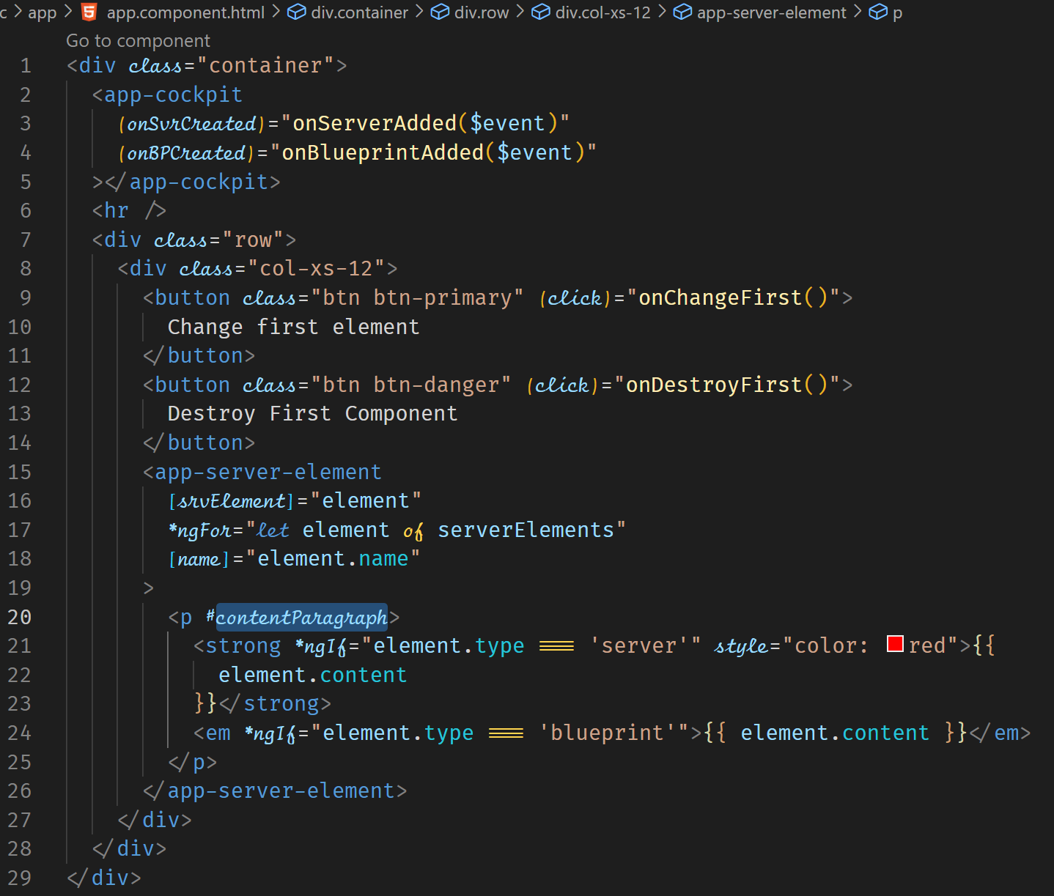



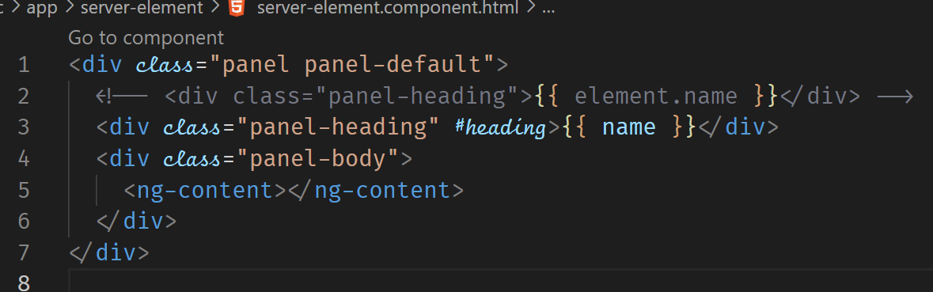





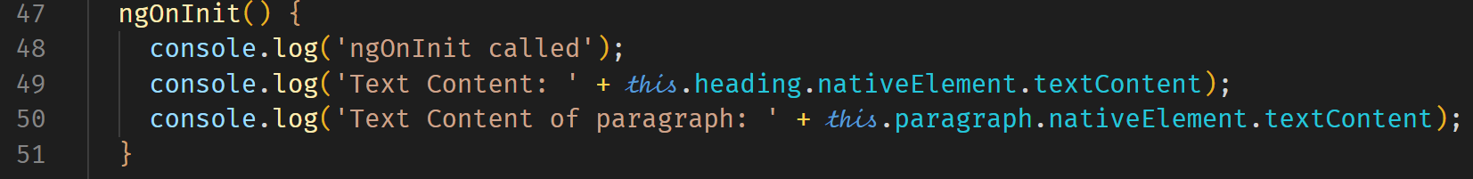



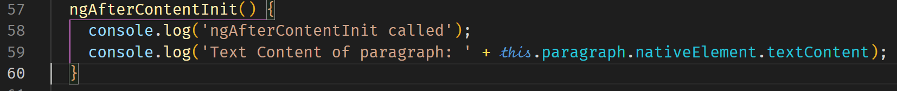



Exercise

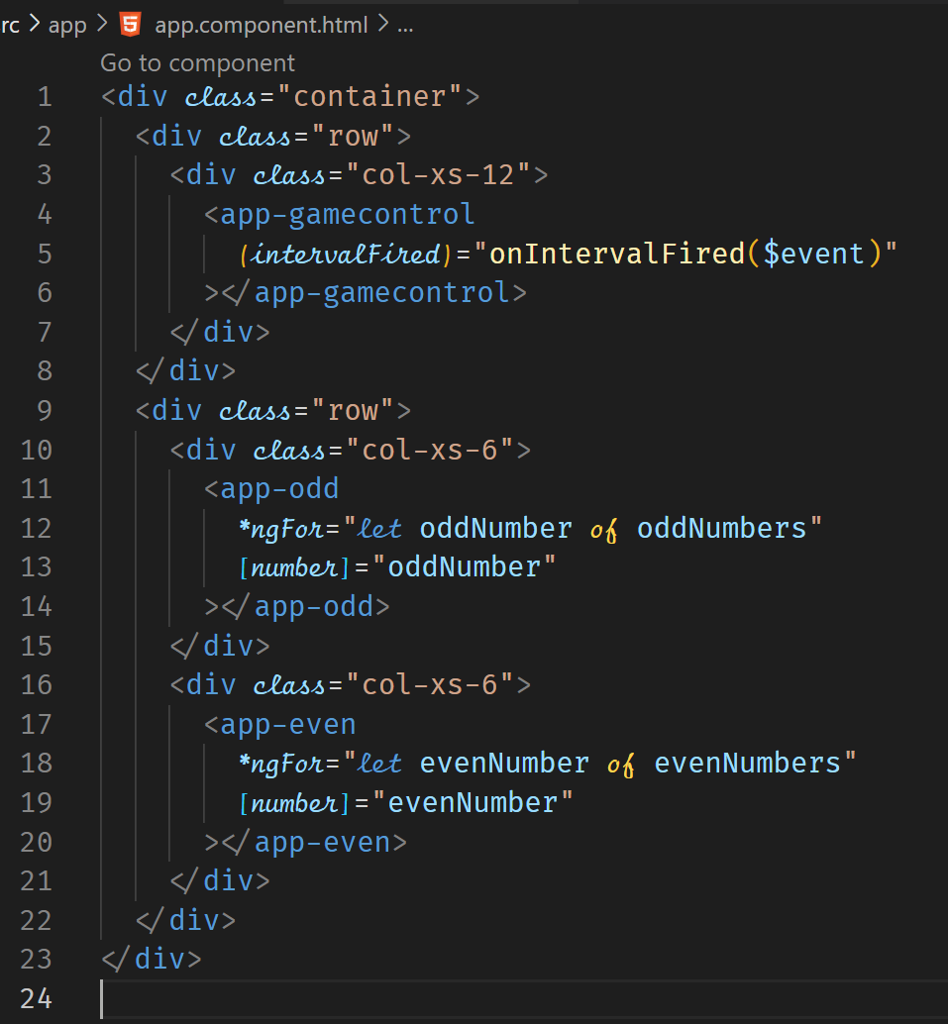

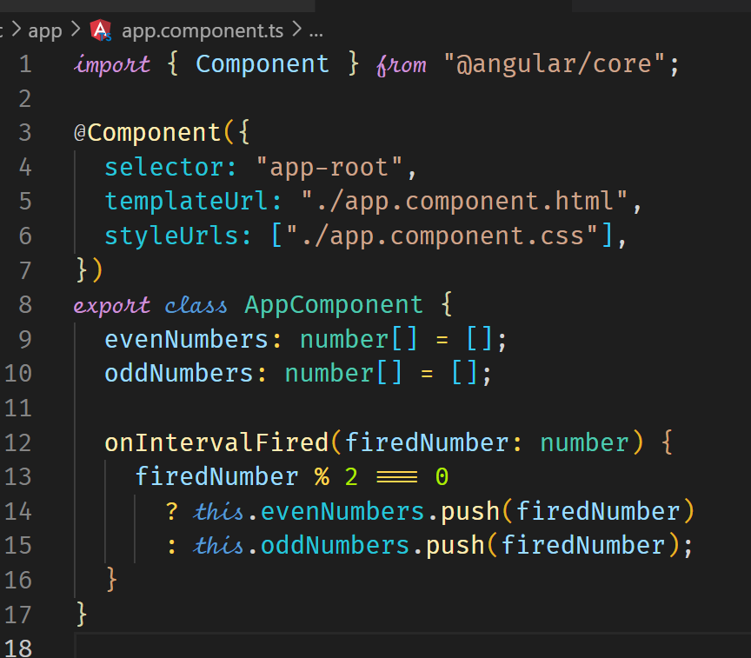

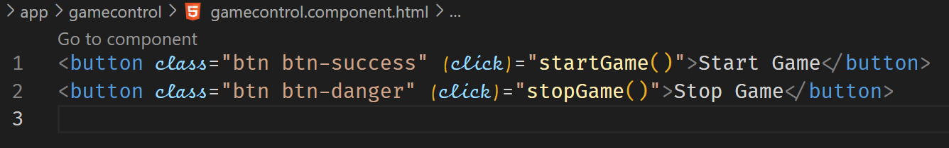

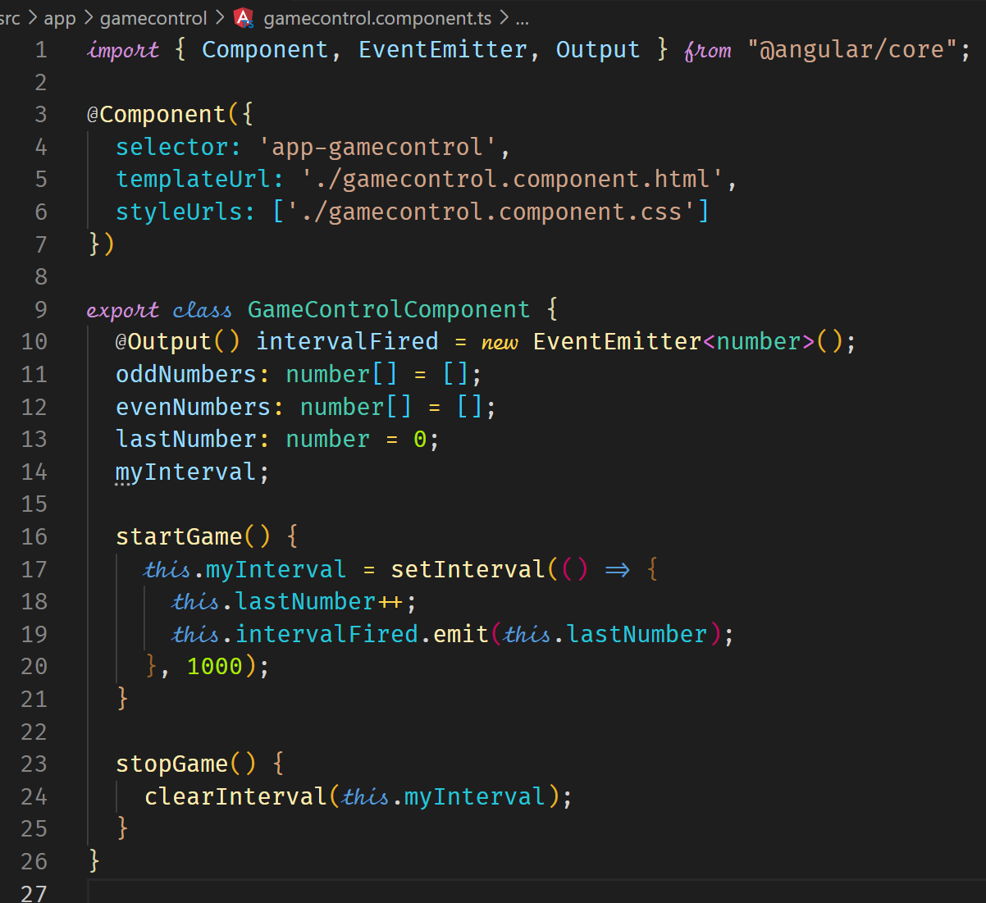

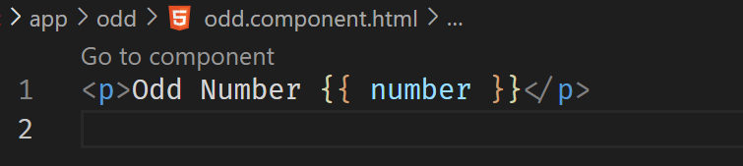

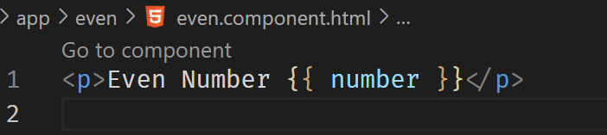

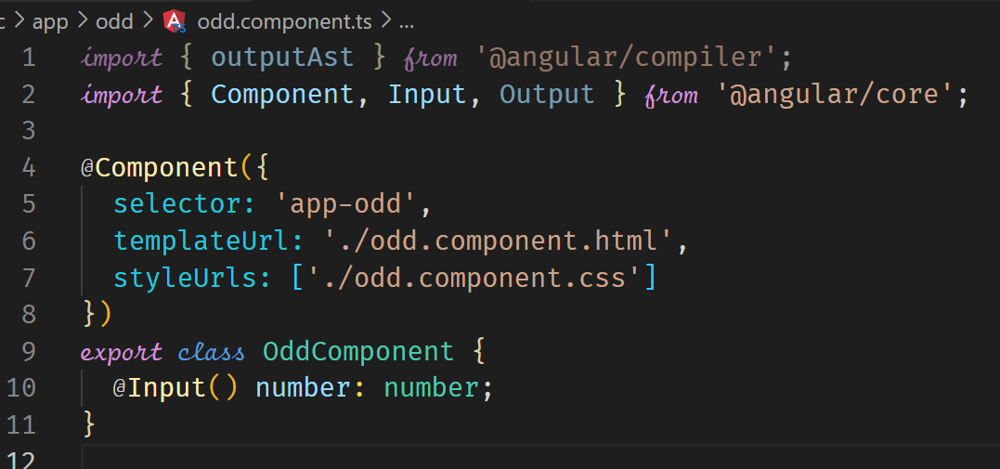

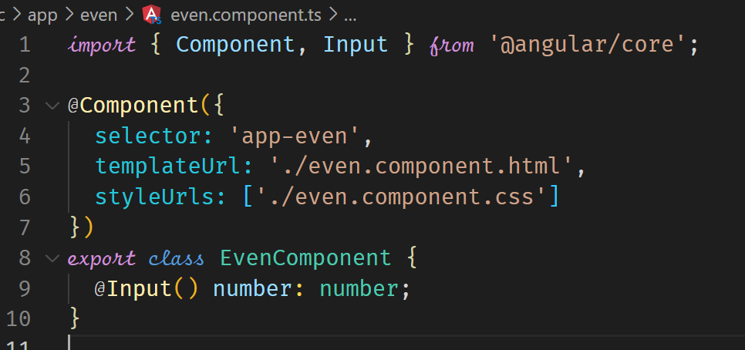

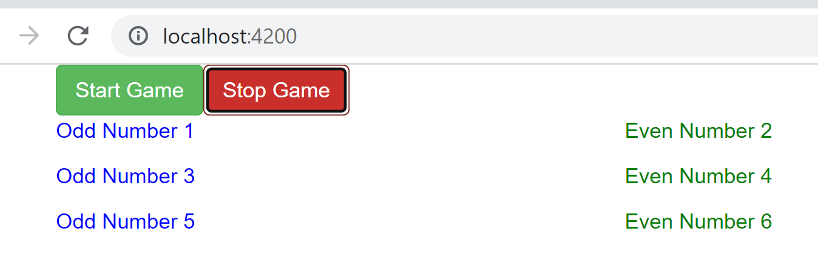

**Use Case: Adding Navigation with Event Binding and ngIf**

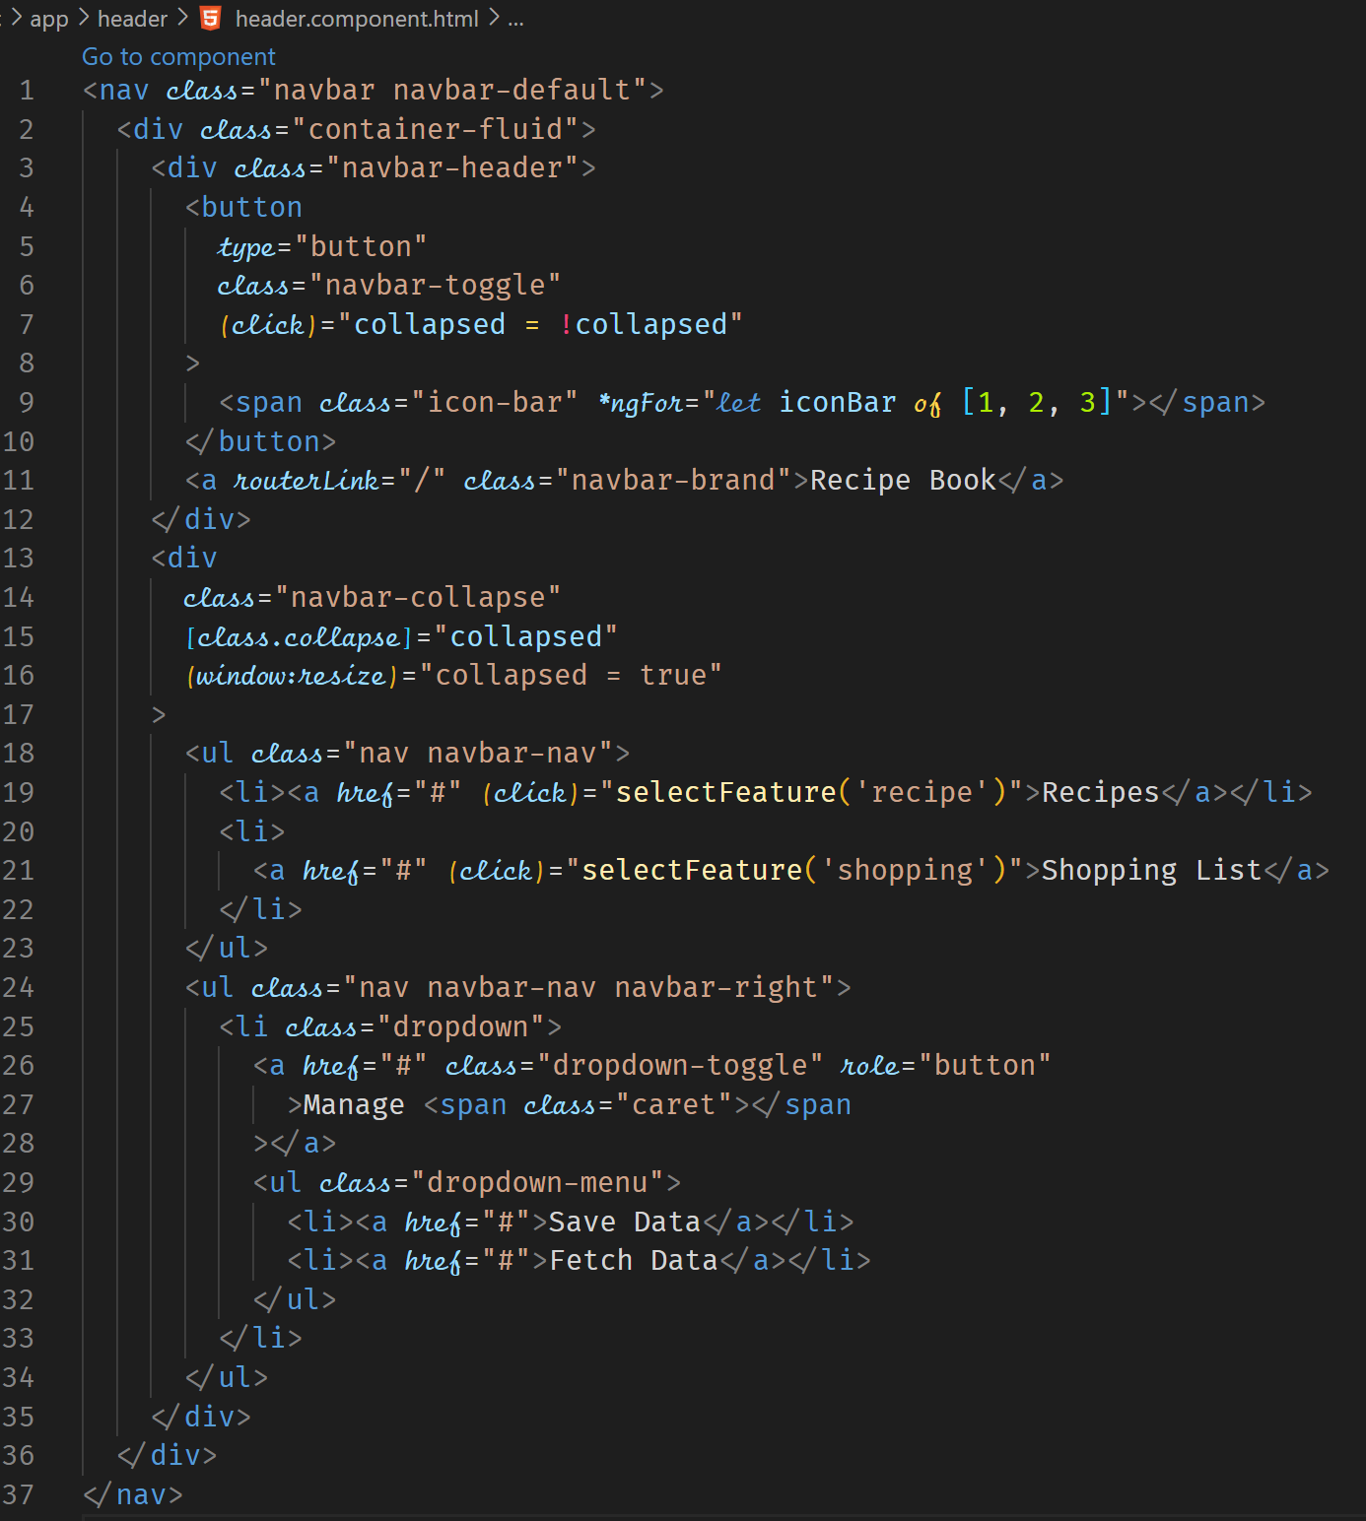



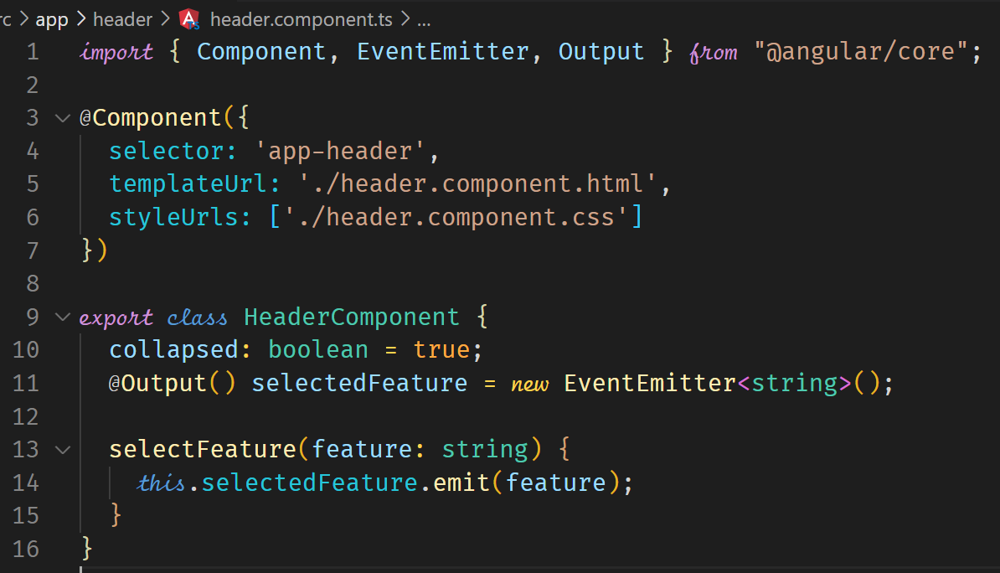



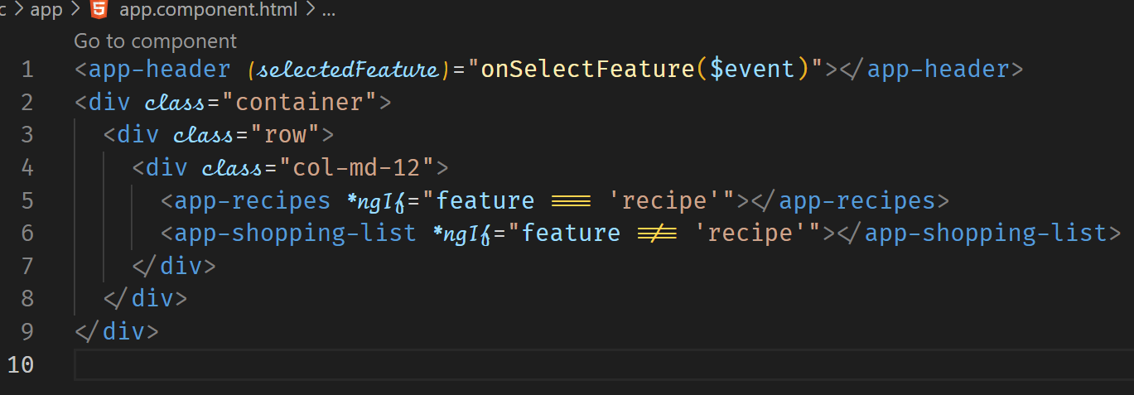

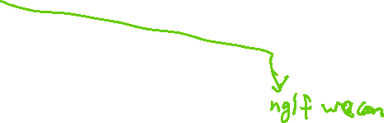

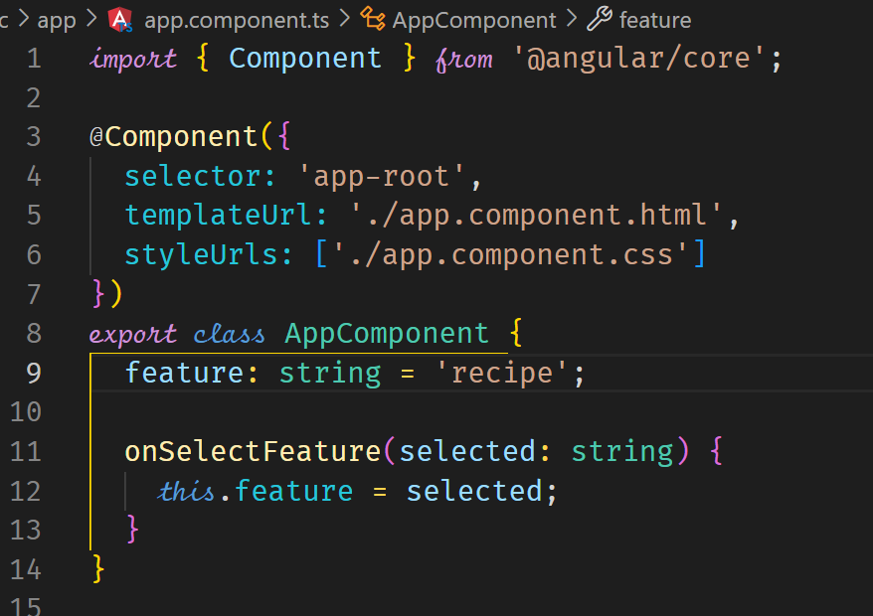



Again passing down data to a child component, we should have the data with @Input() decorator. We need iterator through an array of recipes and pass each recipe to the recipe item.

The recipe-list.component.html code will change as shown below.

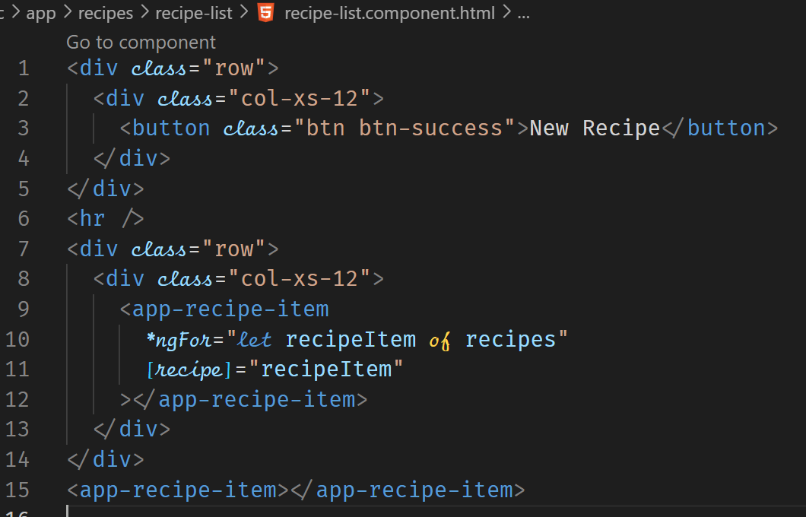



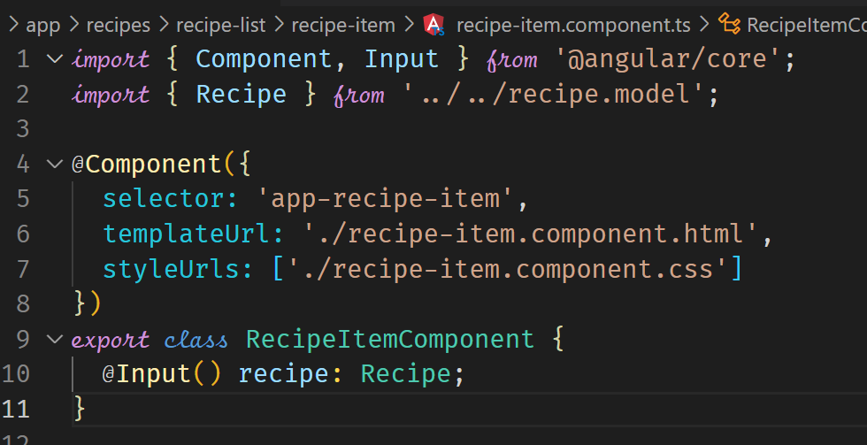



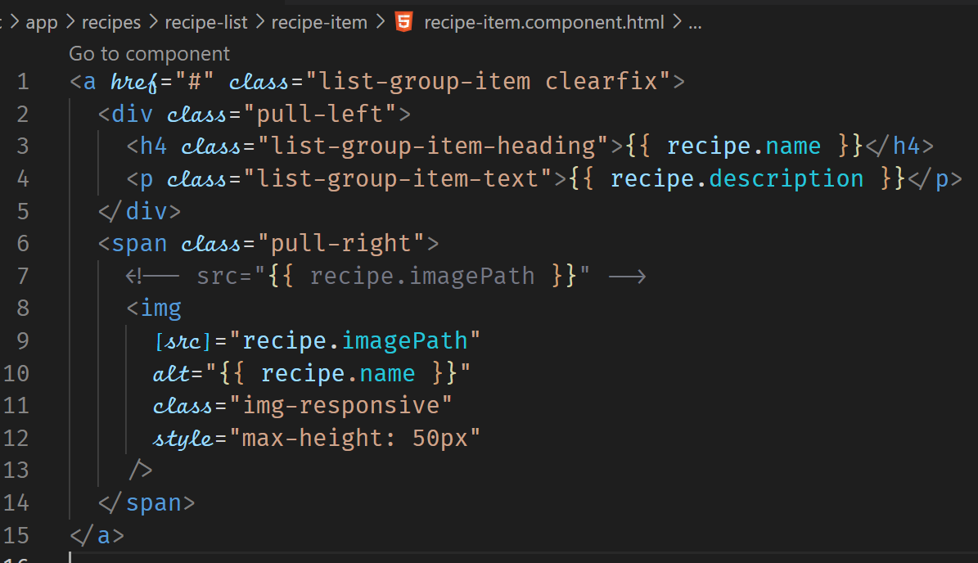

**Passing Data with Event and Property Binding**

This example demonstrates how data is passed between components in a parent child relationship using event binding and property binding.

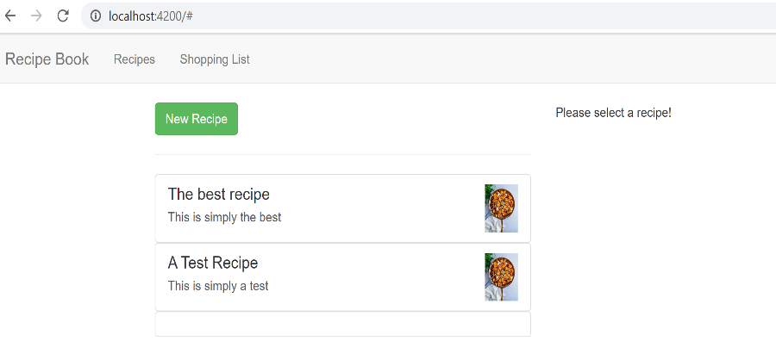

When a recipe is clicked, we want the recipe details populated in the other component which is currently displaying the “Please select a recipe!” text. Since the recipe is a tag in a RecipeItemComponent which is a child component of the RecipeListComponent, which is also a child of the RecipesComponent where we eventually want the data to be passed to, we should use events. The data can then flow to the RecipeDetailComponent which is a child of the RecipesComponent.

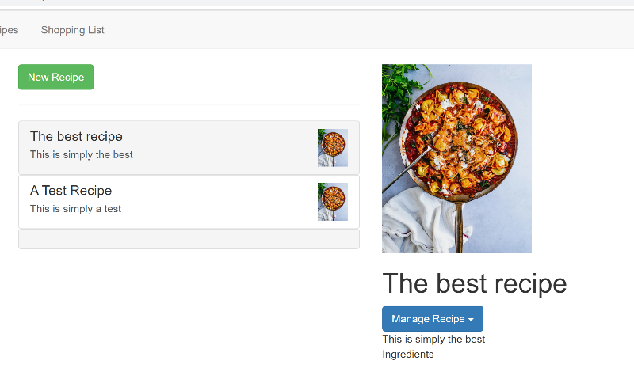

RecipeDetail

Component

RecipeList

Component

RecipeItem

Component

Recipes

Component

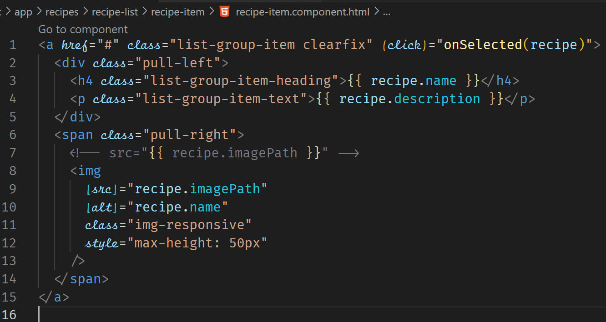



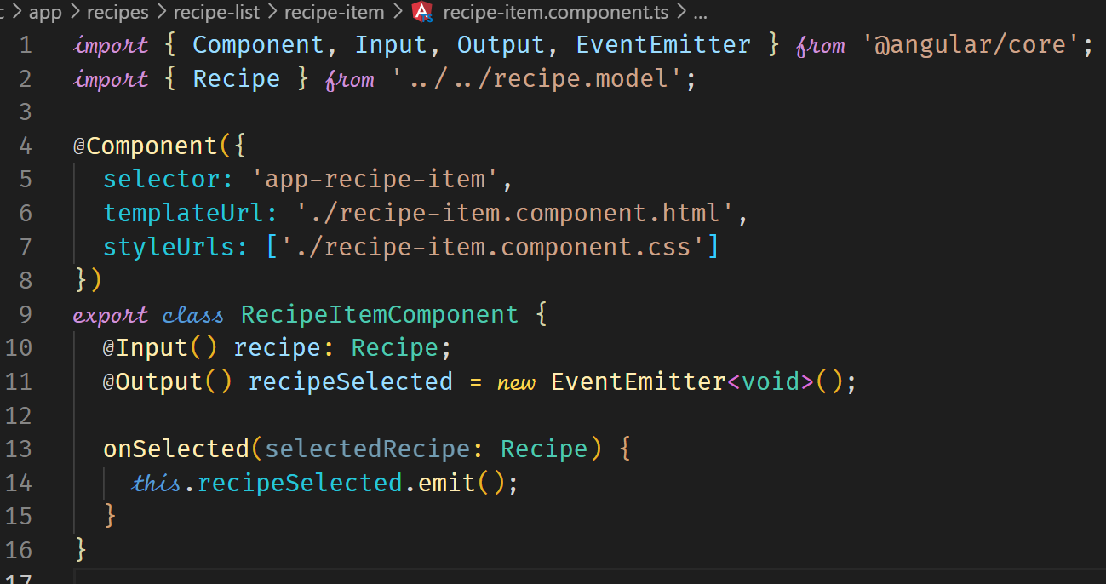



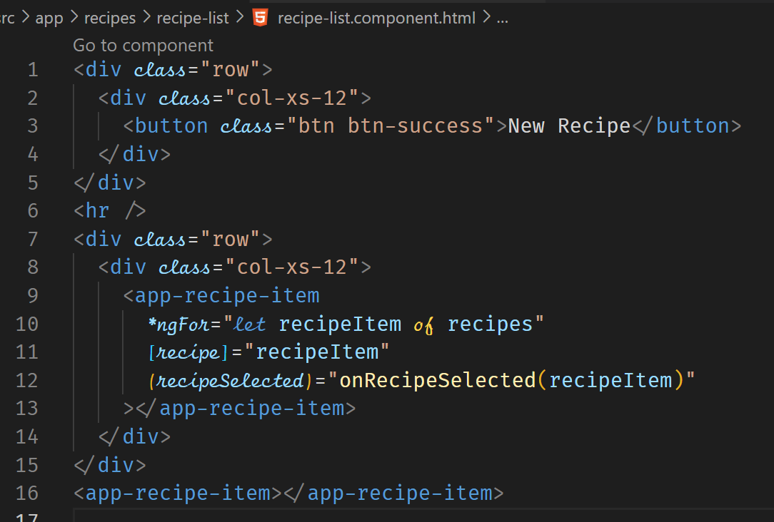

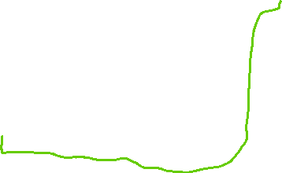

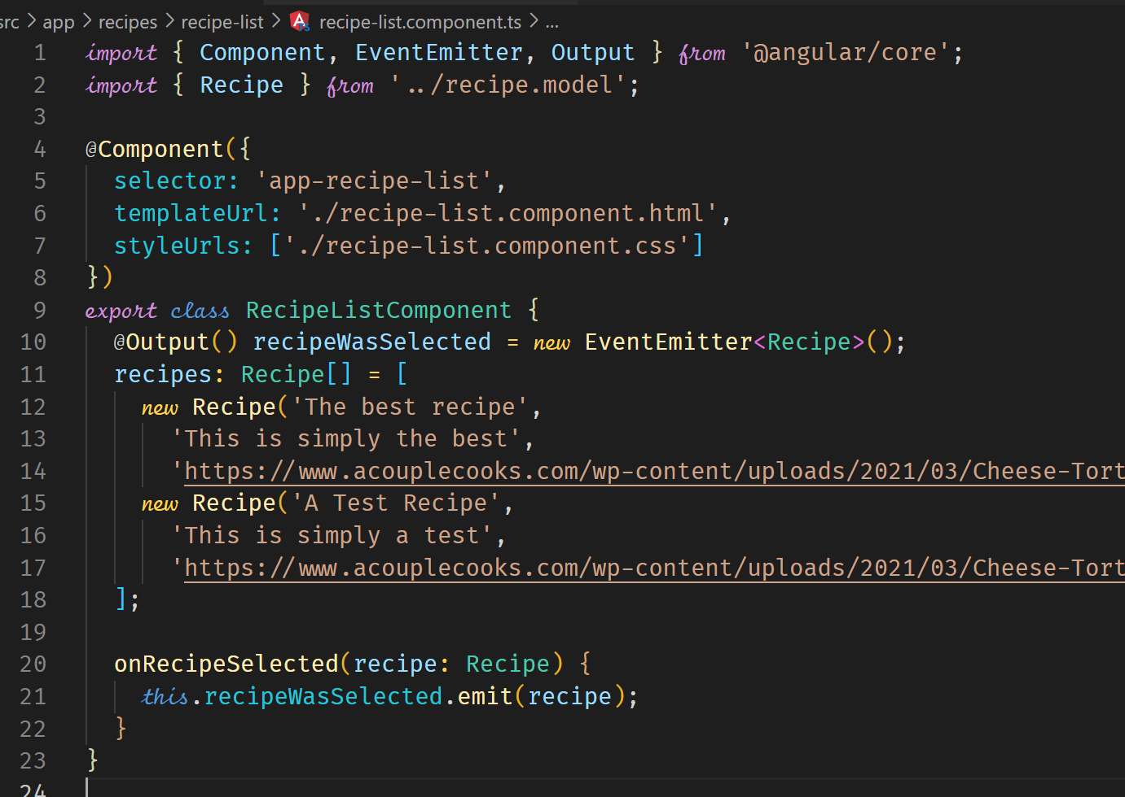



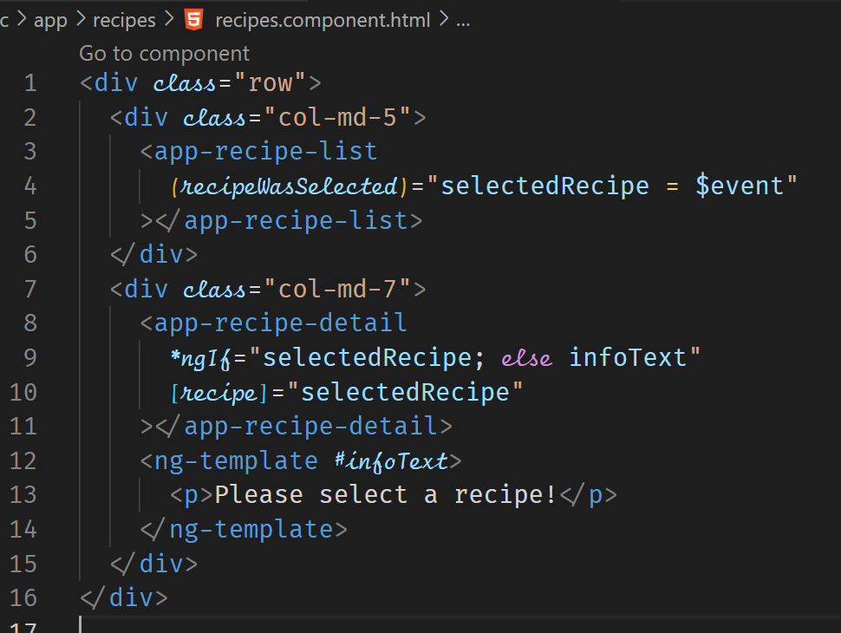



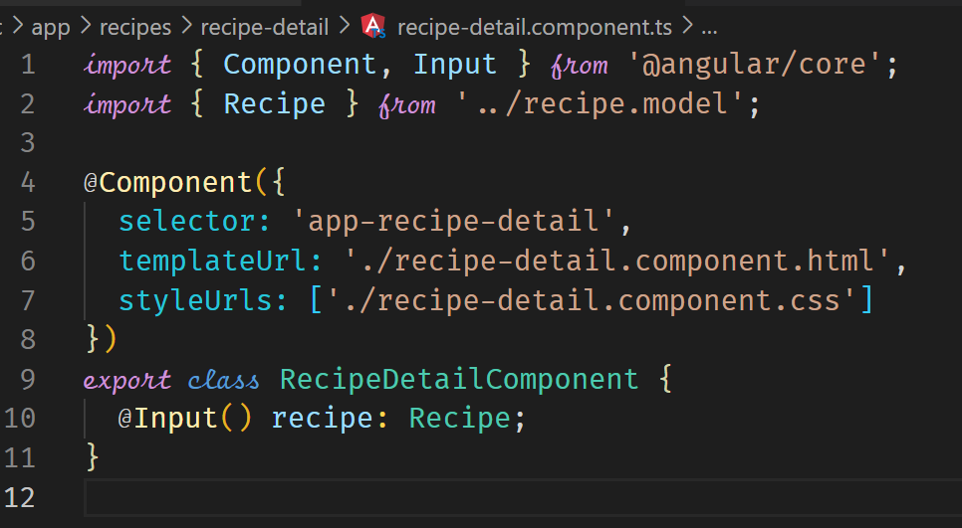

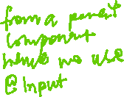

**Adding Ingredients to the Shopping List (Local References)**

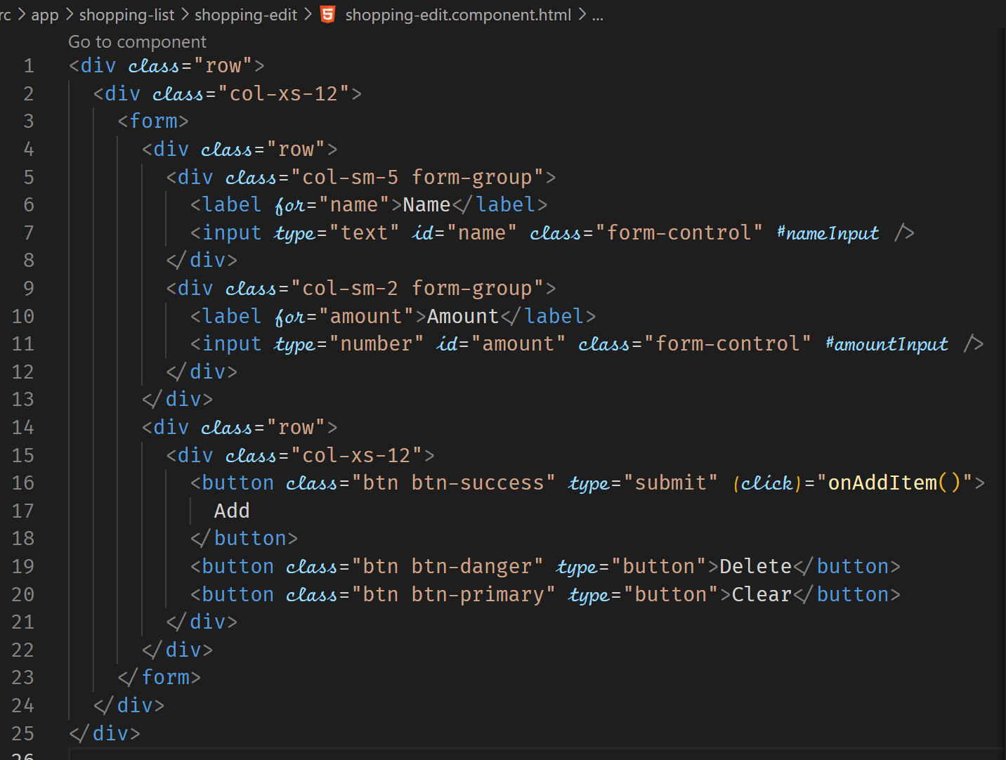



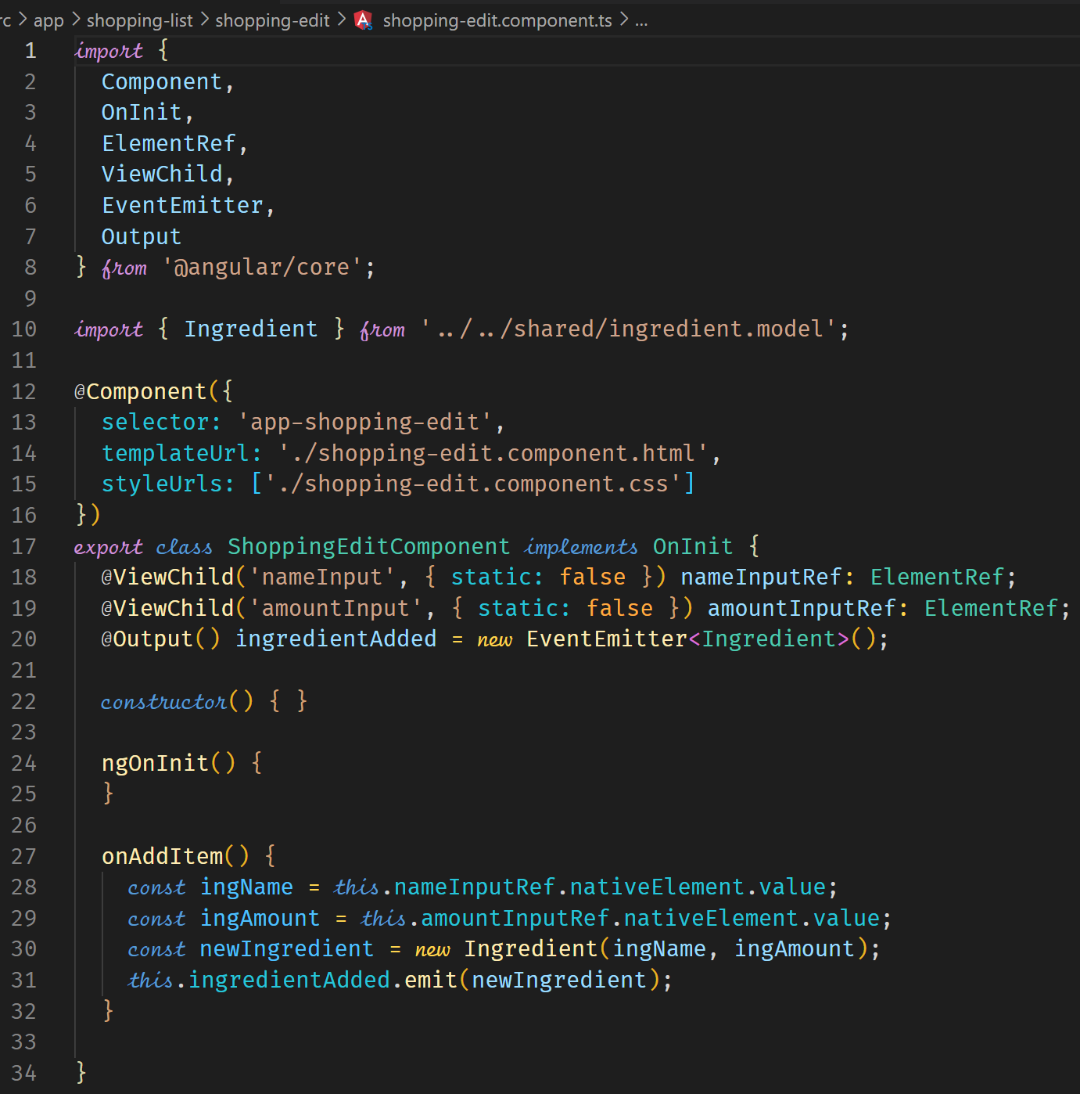



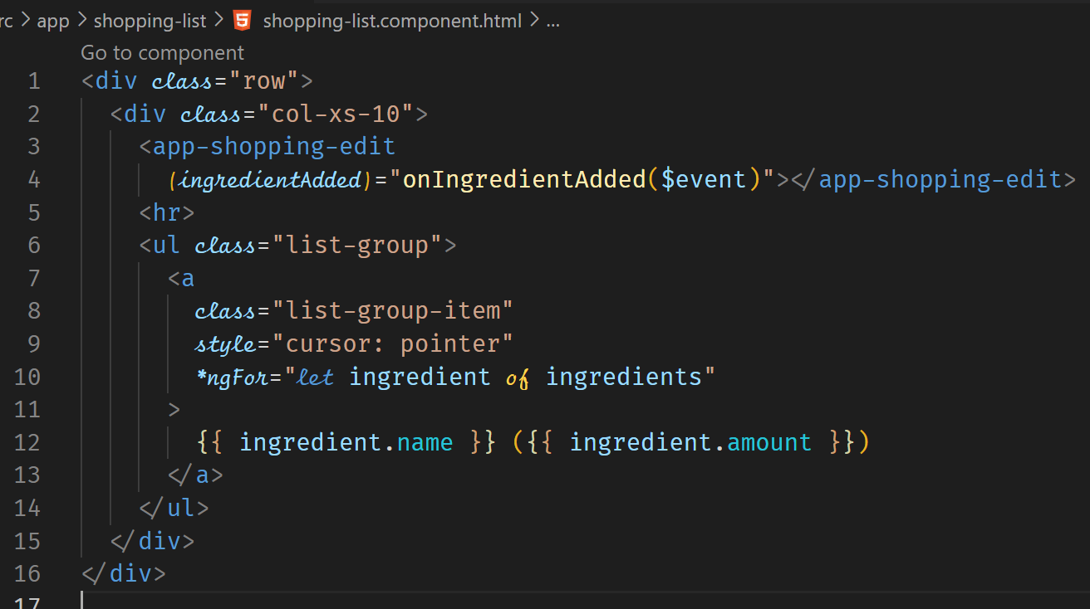



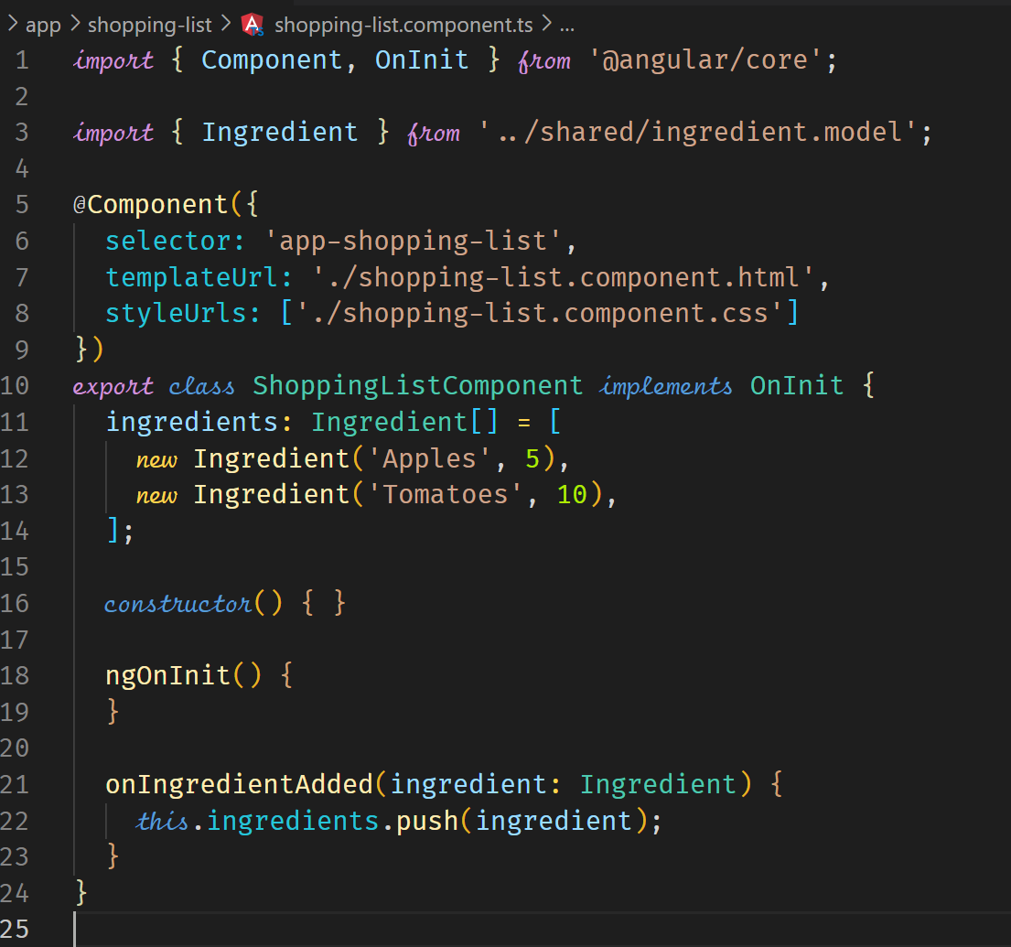

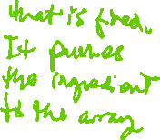

**Directives Deep Dive**

To recap, we have two types of directives, Attribute and Structural.

|  |  |
| --- | --- |
| Attribute Directives | Structural Directives |
| Look like a normal HTML attribute (possibly with the databinding or event binding) | Look like a normal HTML attribute but have a leading * (for desugaring) |
| Only affect or change the element they are added to | Affect a whole area in the DOM (elements get added or removed) |

**Structural Directives ngIf and ngFor**

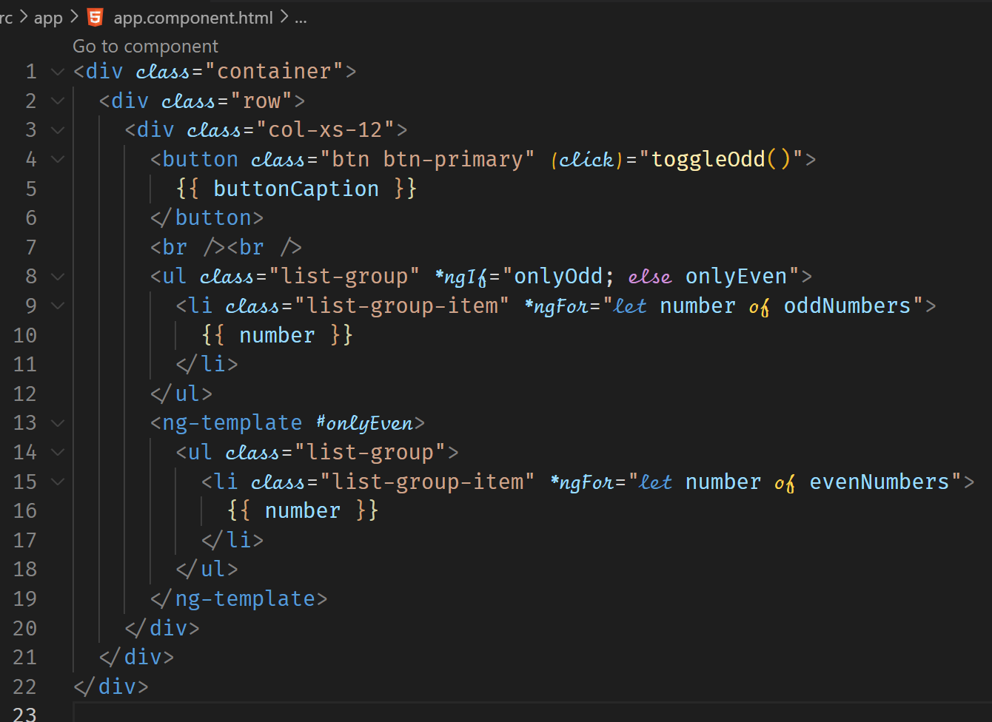



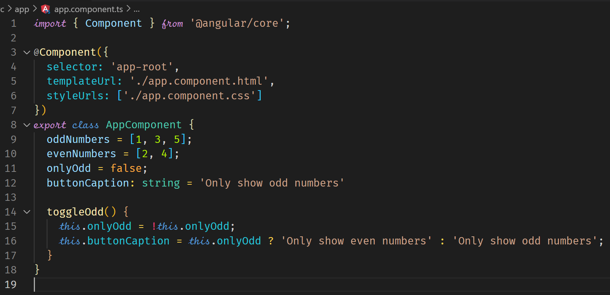

**Attribute Directives ngClass and ngStyle**

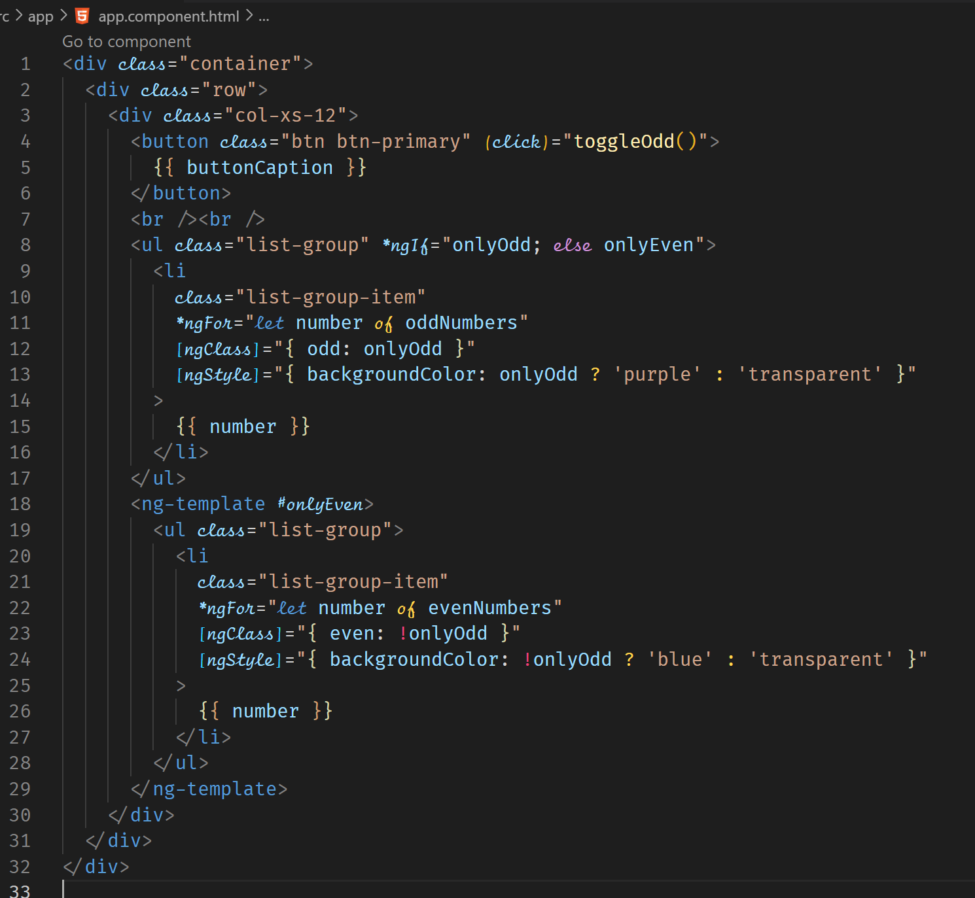



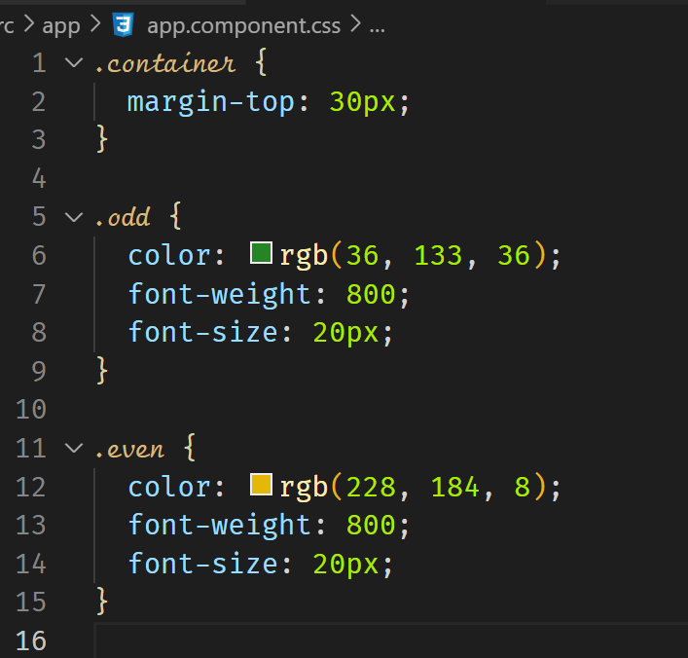



**Create a custom basic directive**

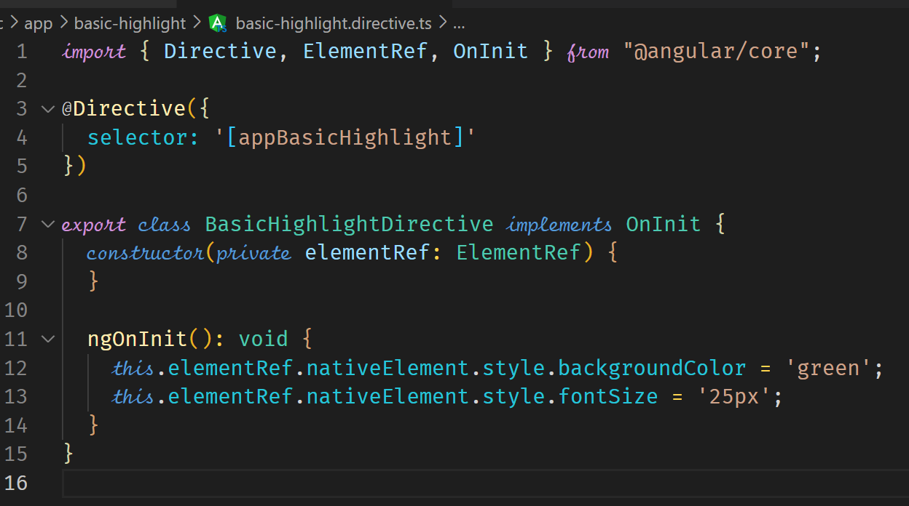

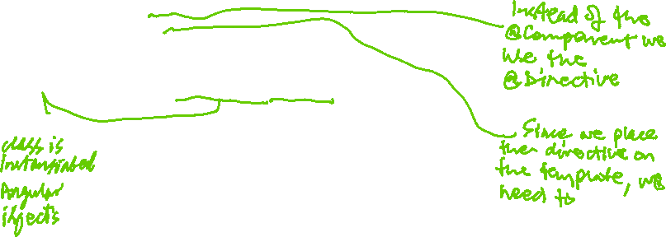

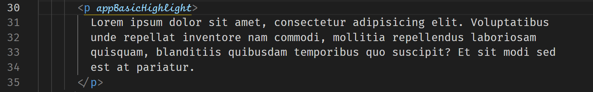



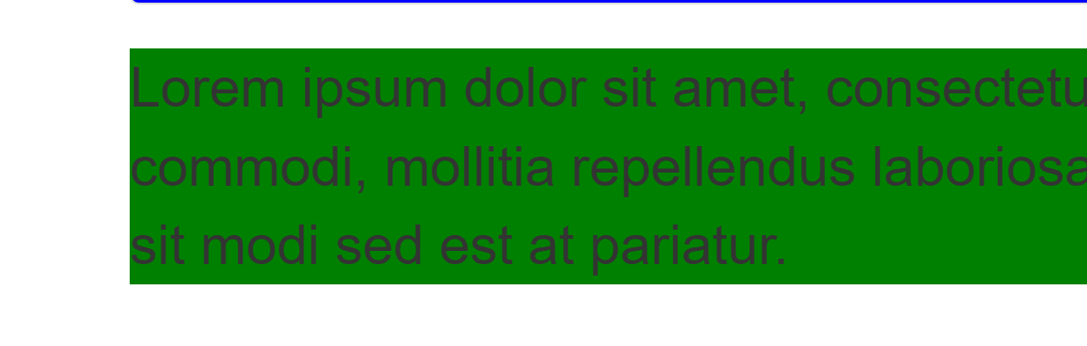



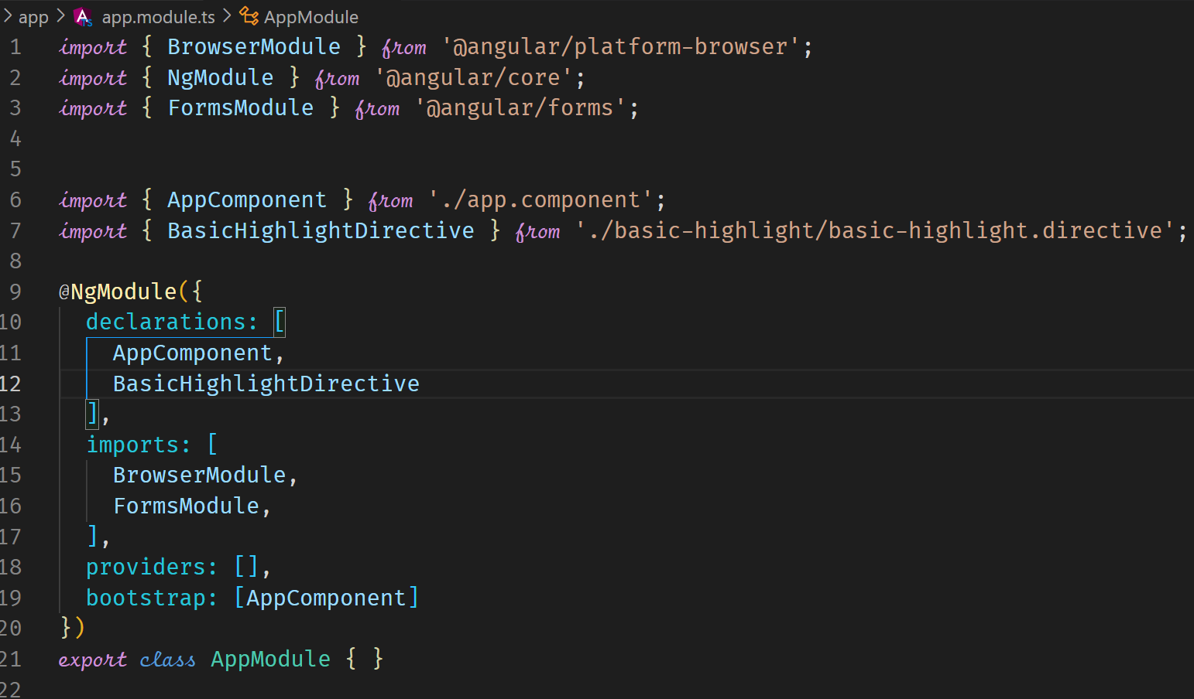

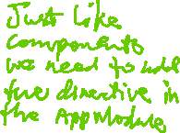

A directive can be created by using the CLI as follows

ng g c better-highlight –skip-tests

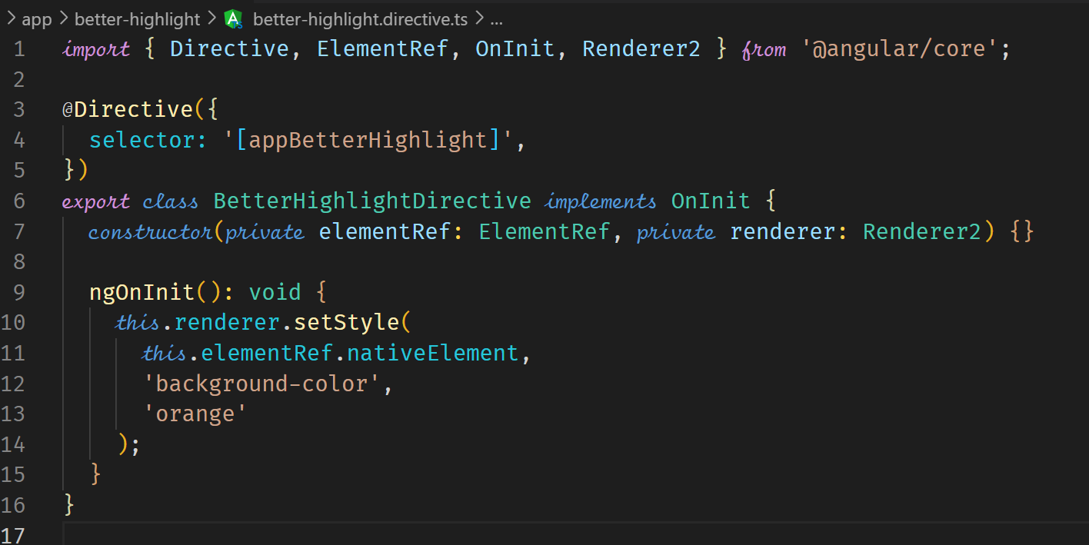



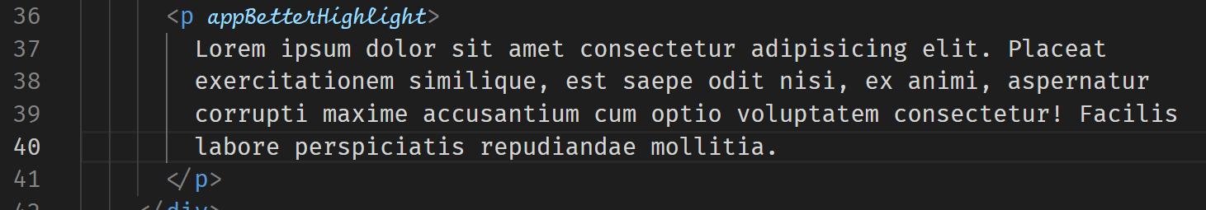



**Using HostListener to listen to host events**

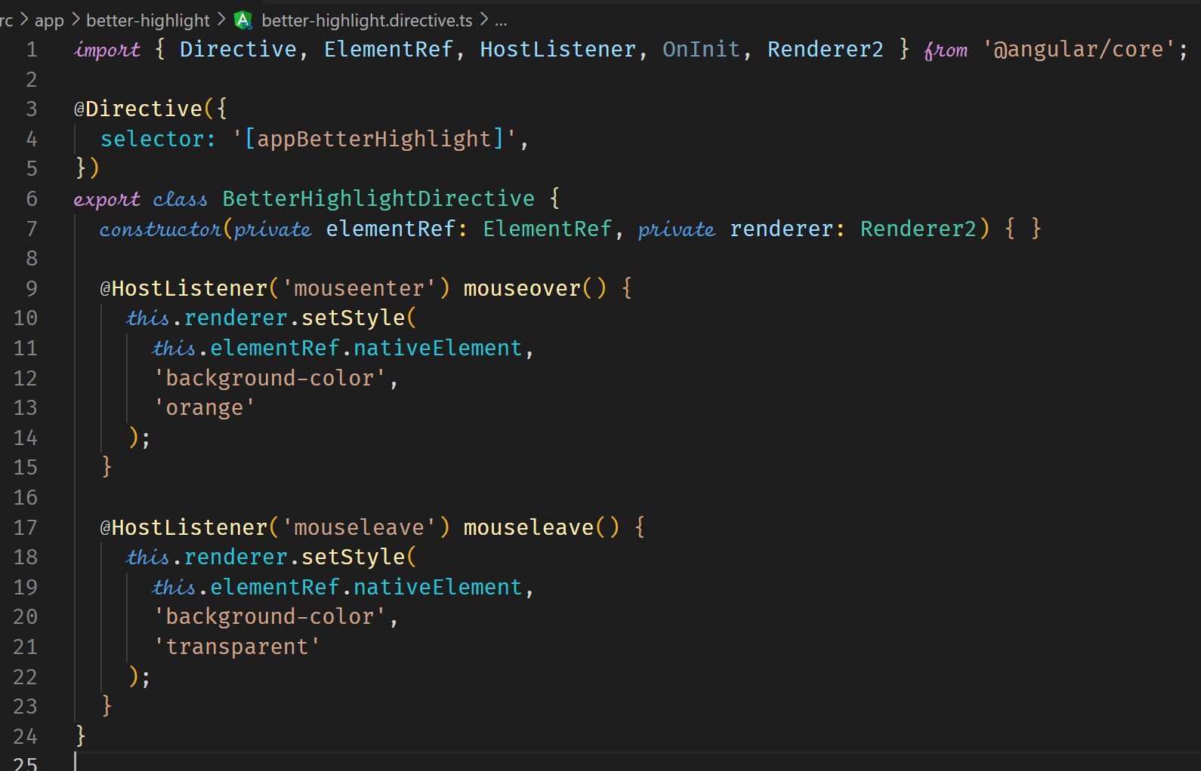



**HostBinding**

A simpler way would be to use HostBinding instead of the renderer. The HostListener is still use to listen to events from the host.

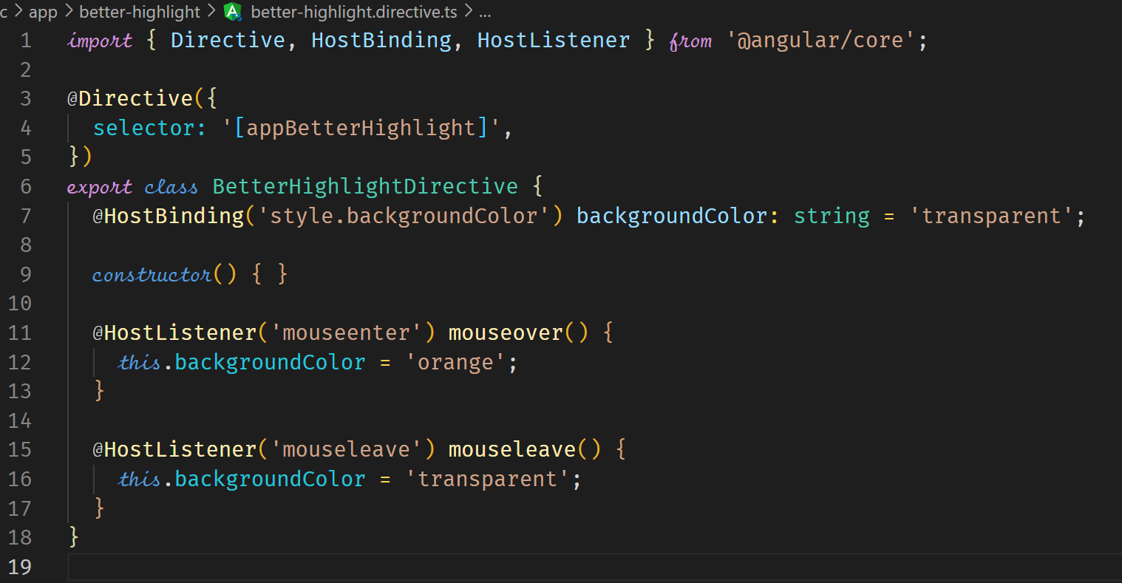



**Binding to Directive Properties**

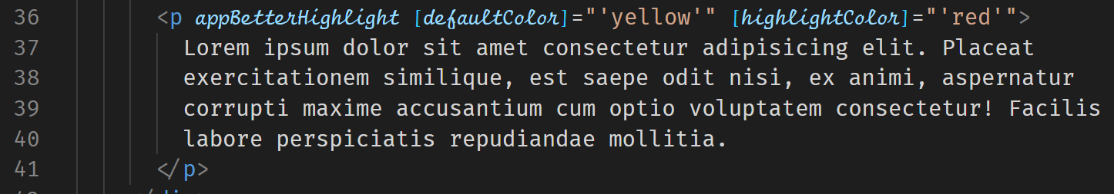



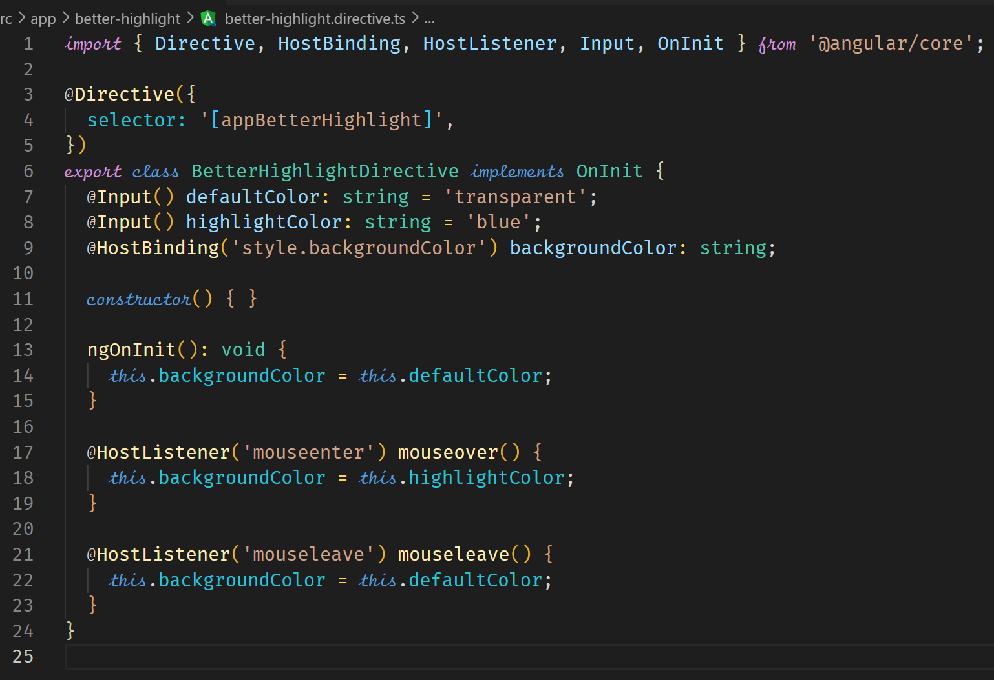



In property binding, if passing a string such as shown above when passing the color name, you can omit the square brackets [] and the single quotes. This still remains property-binding.



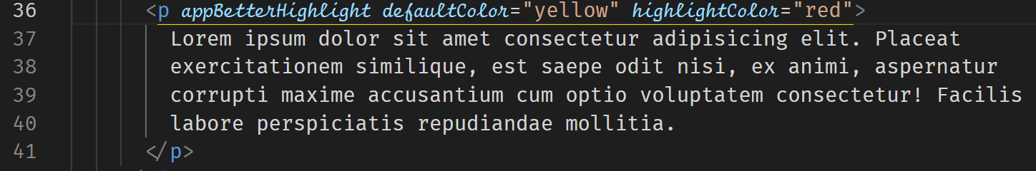

**What happens behind the scenes on Structural Directives**

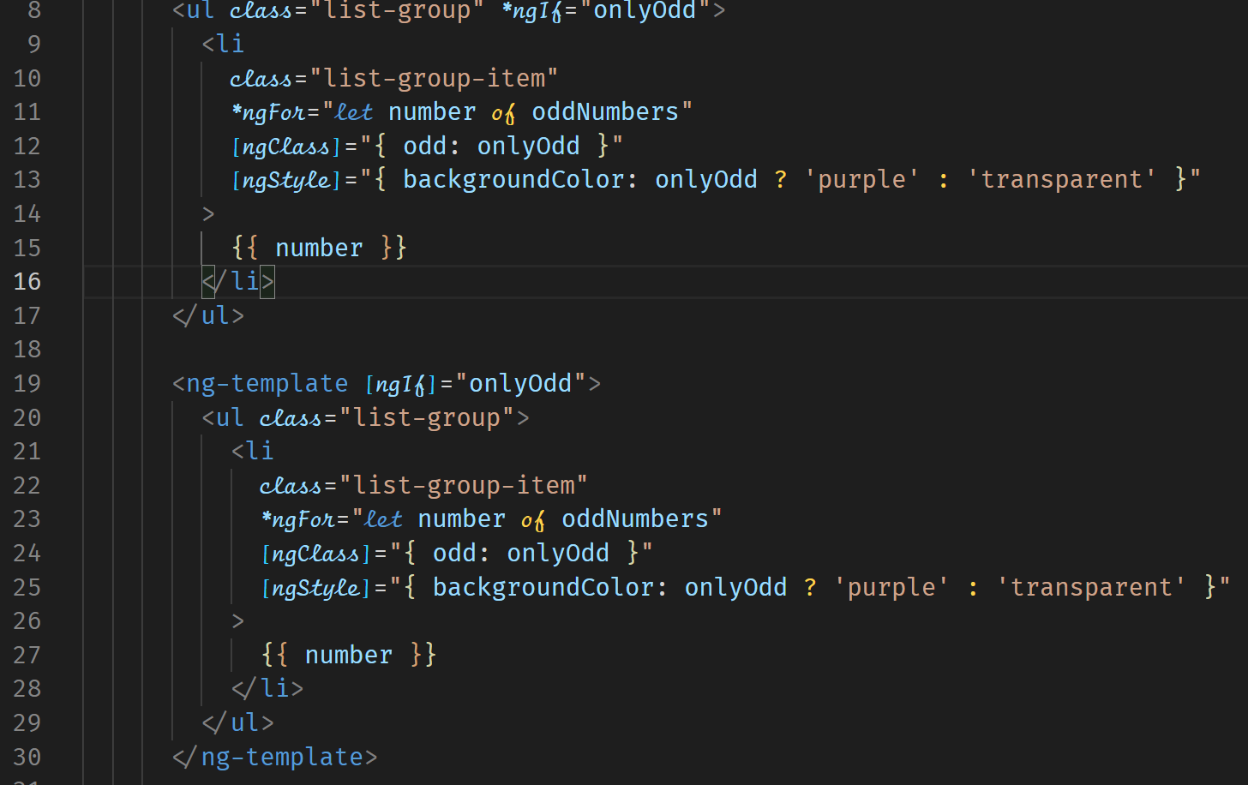



**Building a Structural Directive**

The following is an example of a custom structural directive.

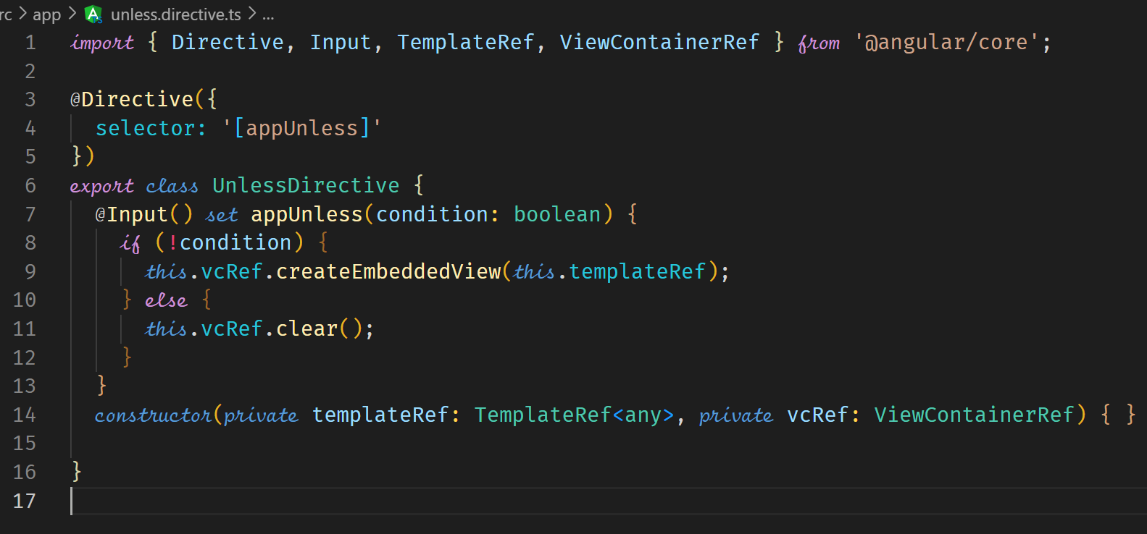



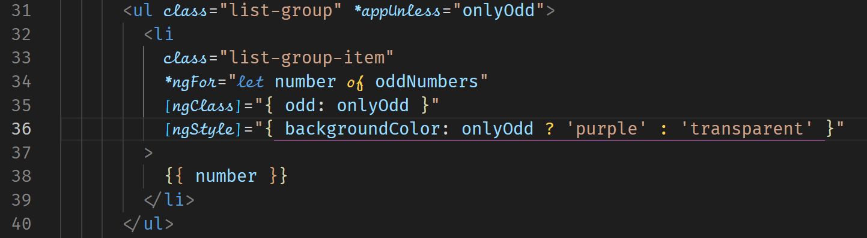



**ngSwitch**

ngSwitch is used when you have multiple conditions that need to be evaluated before an element is rendered.



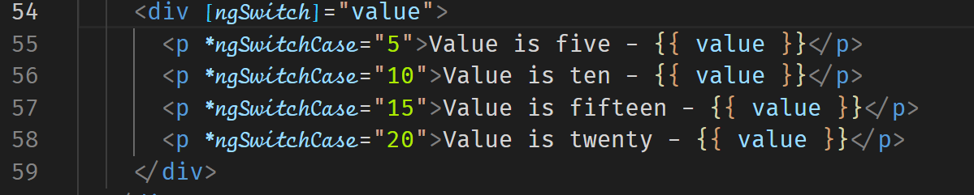



For the default case, use



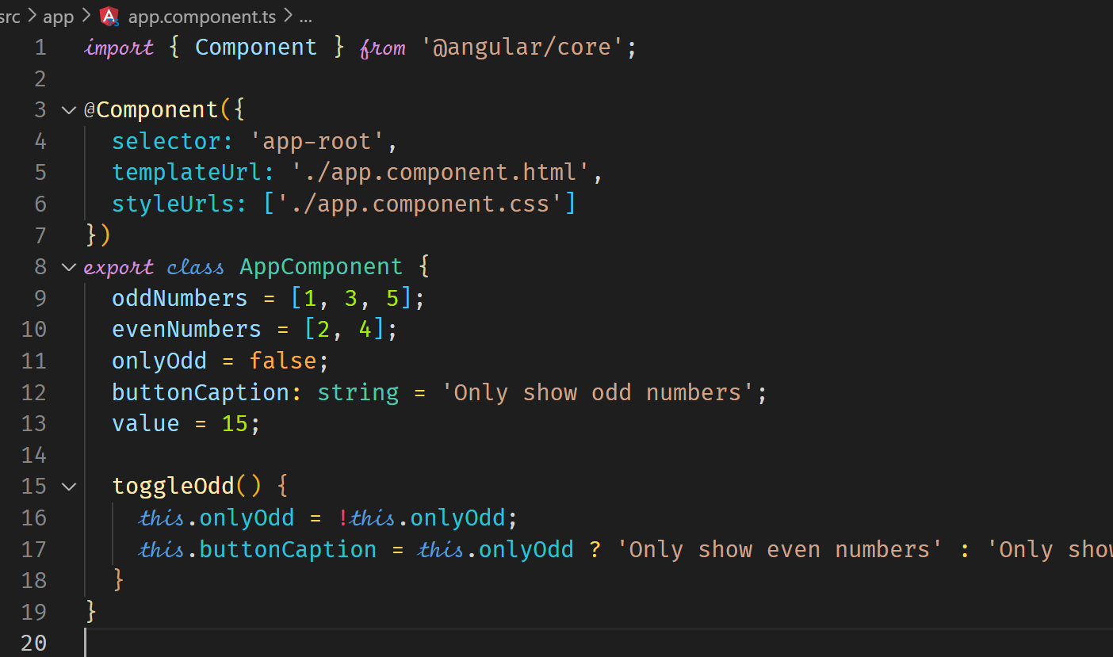

**Building and using a DropDown Directive**

@HostBinding can manipulate the properties, attributes and classes of a DOM element.

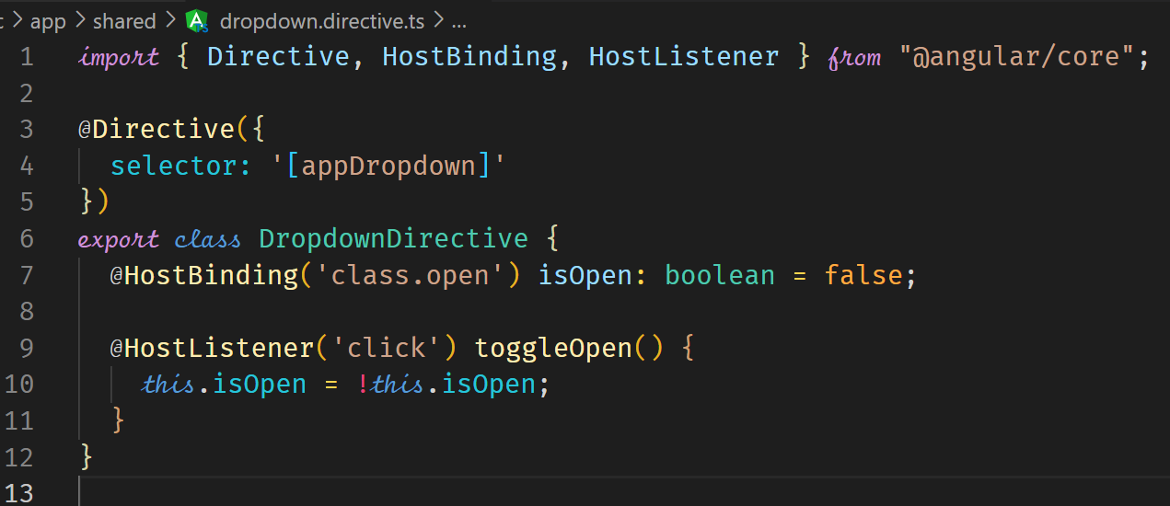

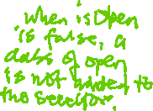

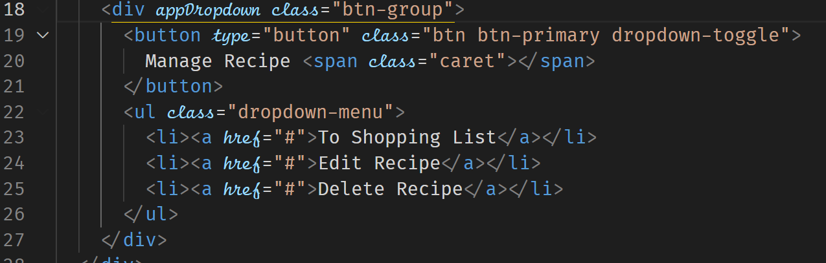



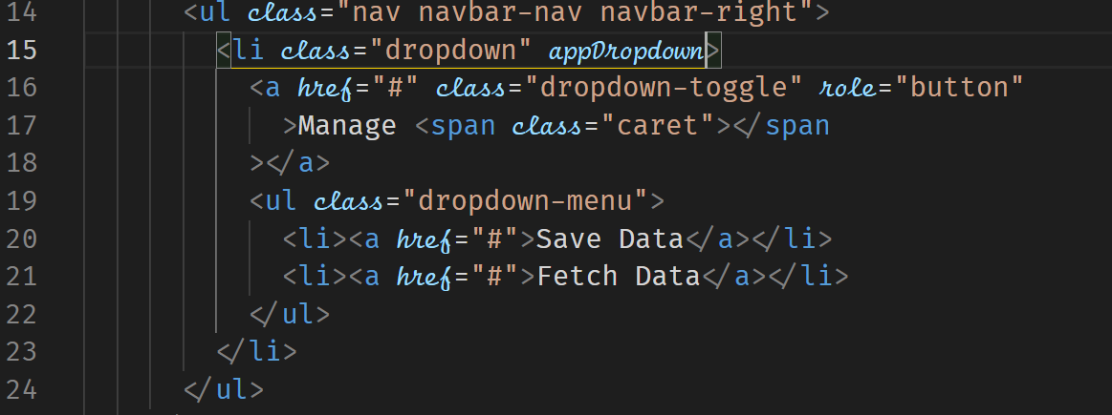



The dropdown can also be closed by a click anywhere outside (which also means that a click on one dropdown closes any other one, btw). Instead of placing the listener on the dropdown, we place it on the document.

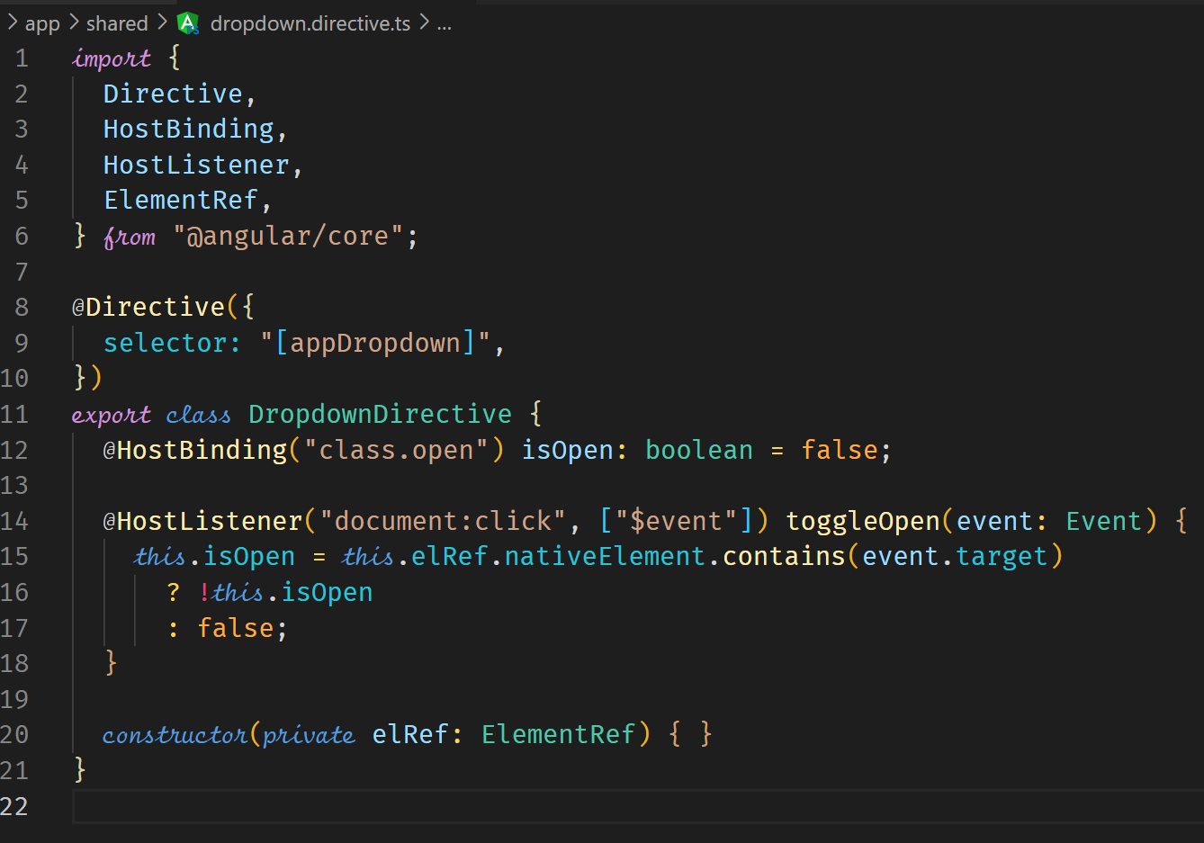

**Services and Dependency Injection**

**Creating a Service**

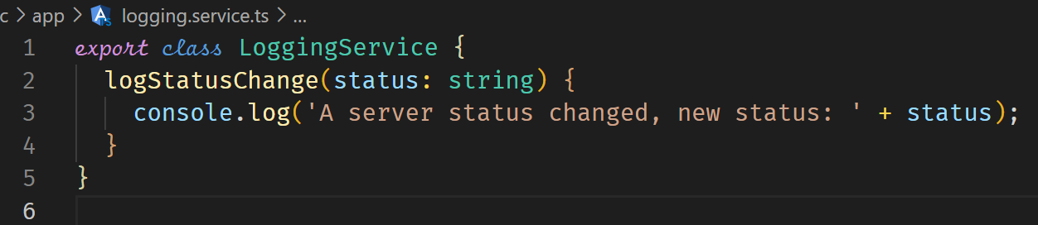



We now need to inject the service into our components using dependency Injection.

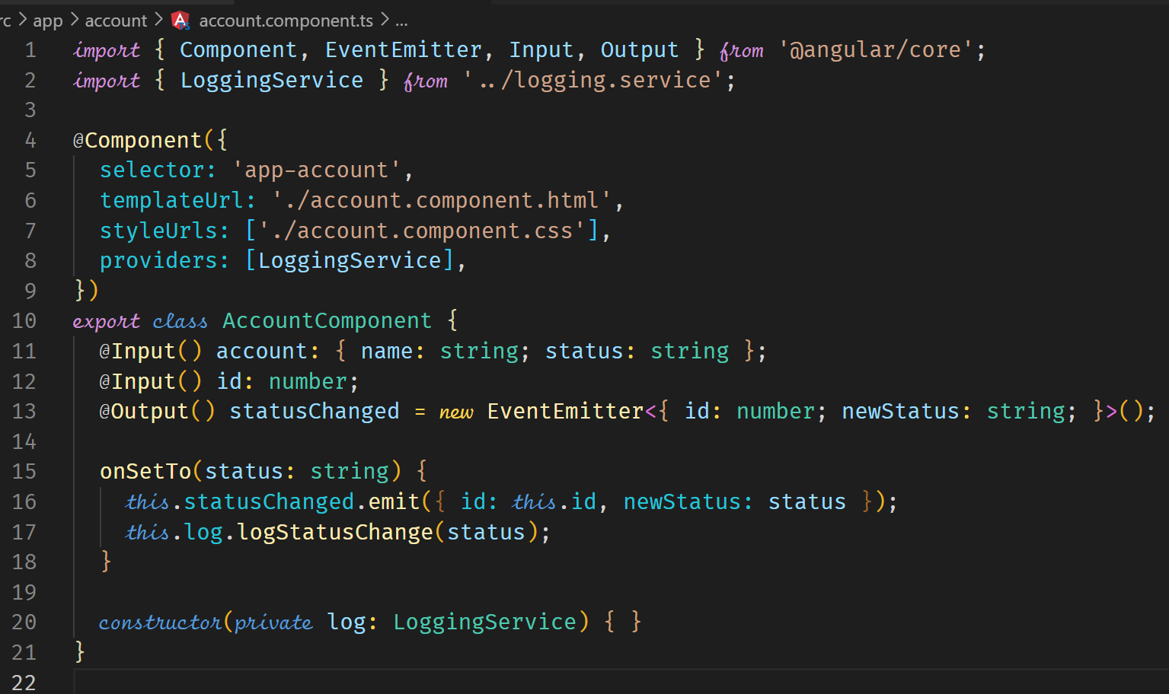



**Creating a Data Service**

A data service will be used to store and manage our data.

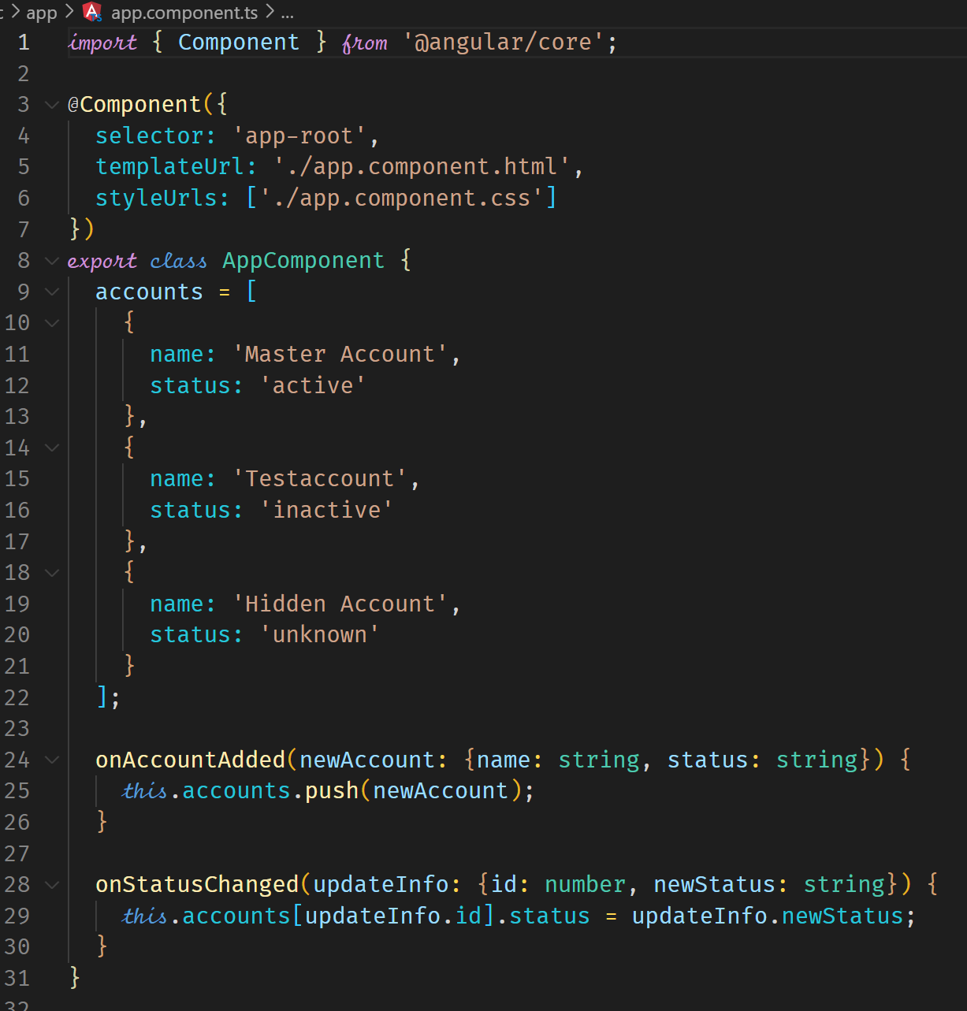

**Injecting and using the data service**

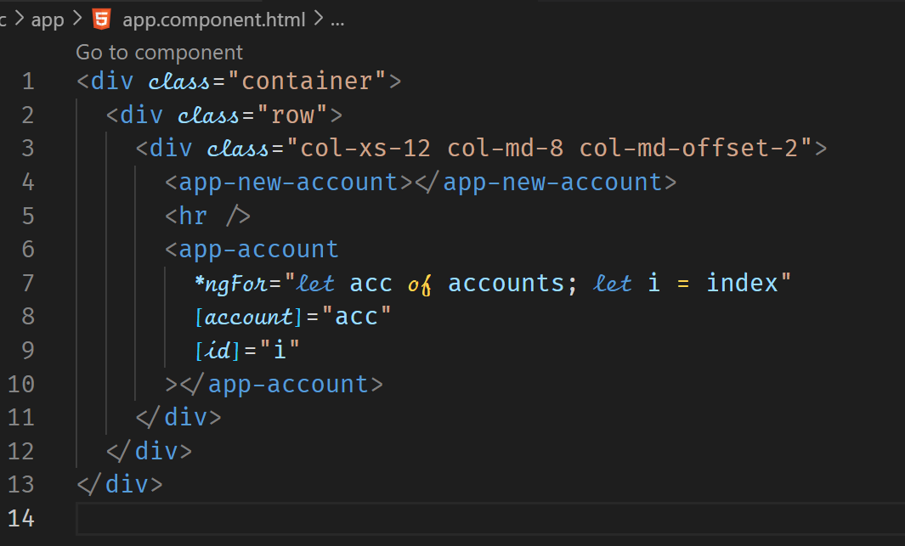

The AccountService has the data and methods to maintain the data.

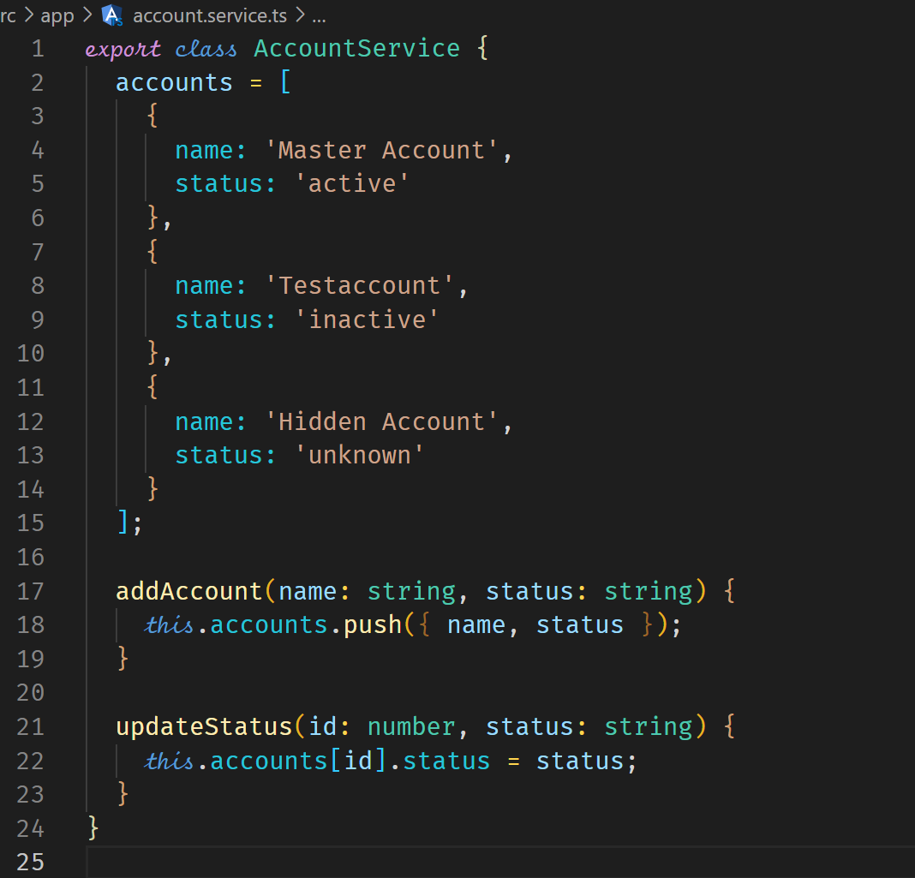

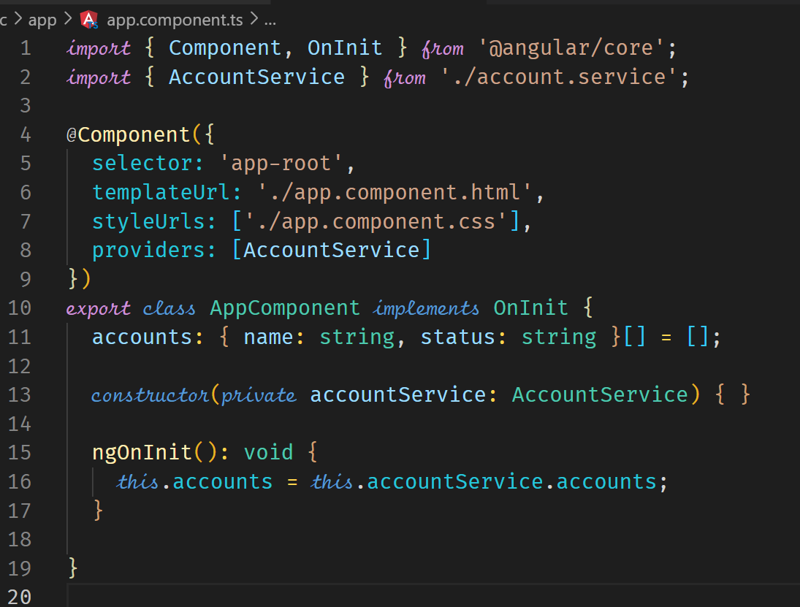



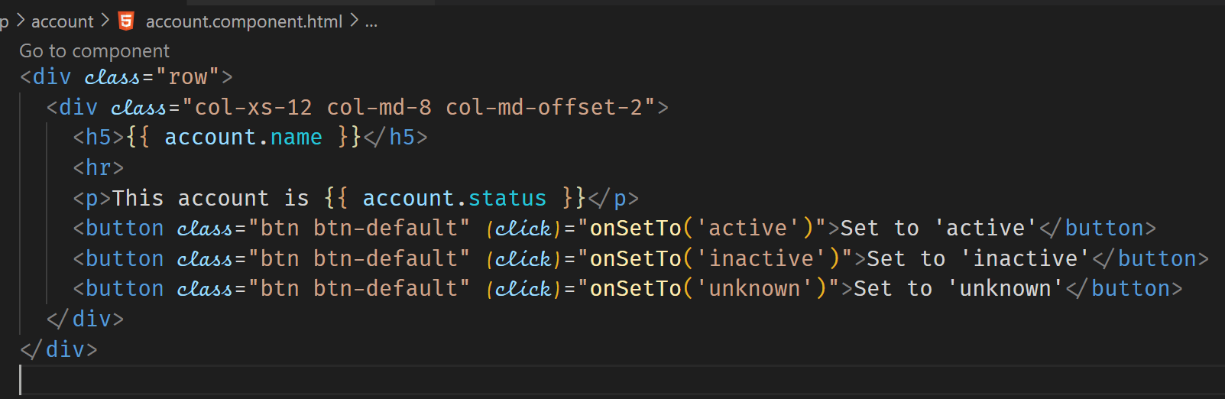

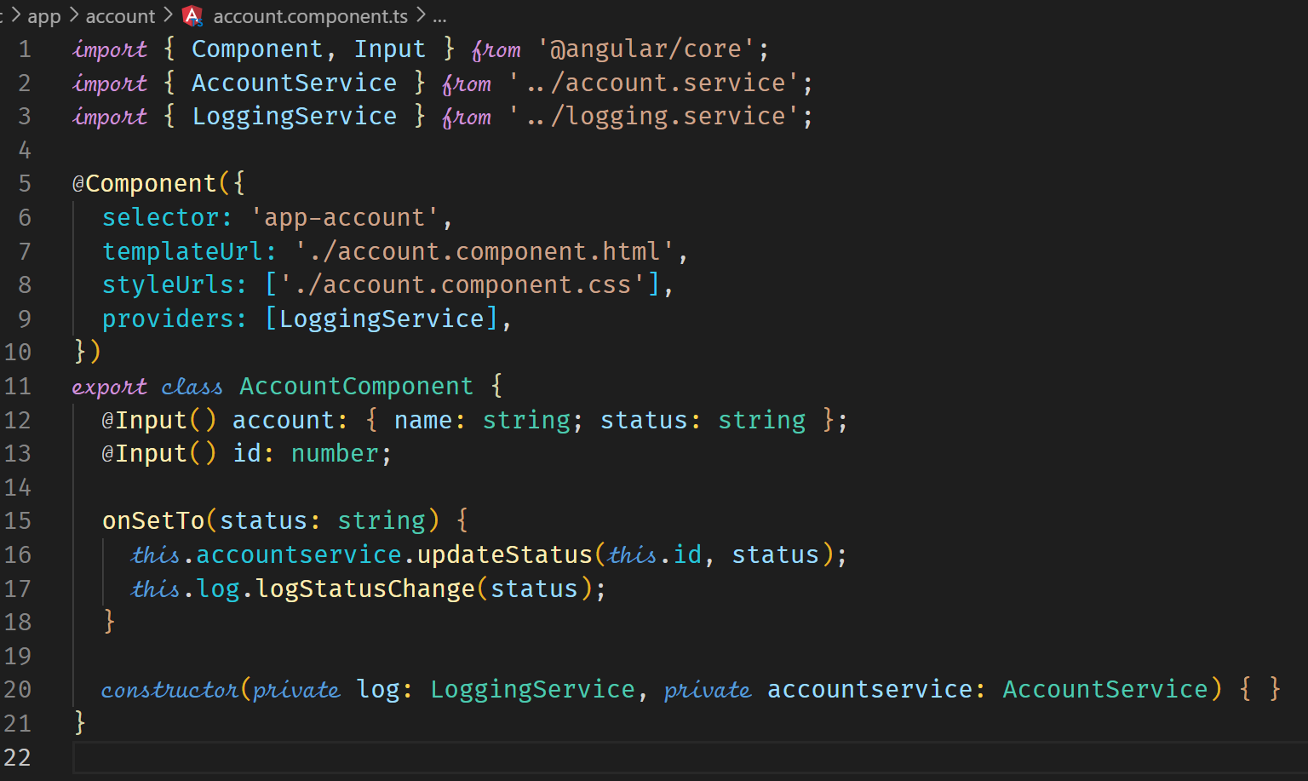



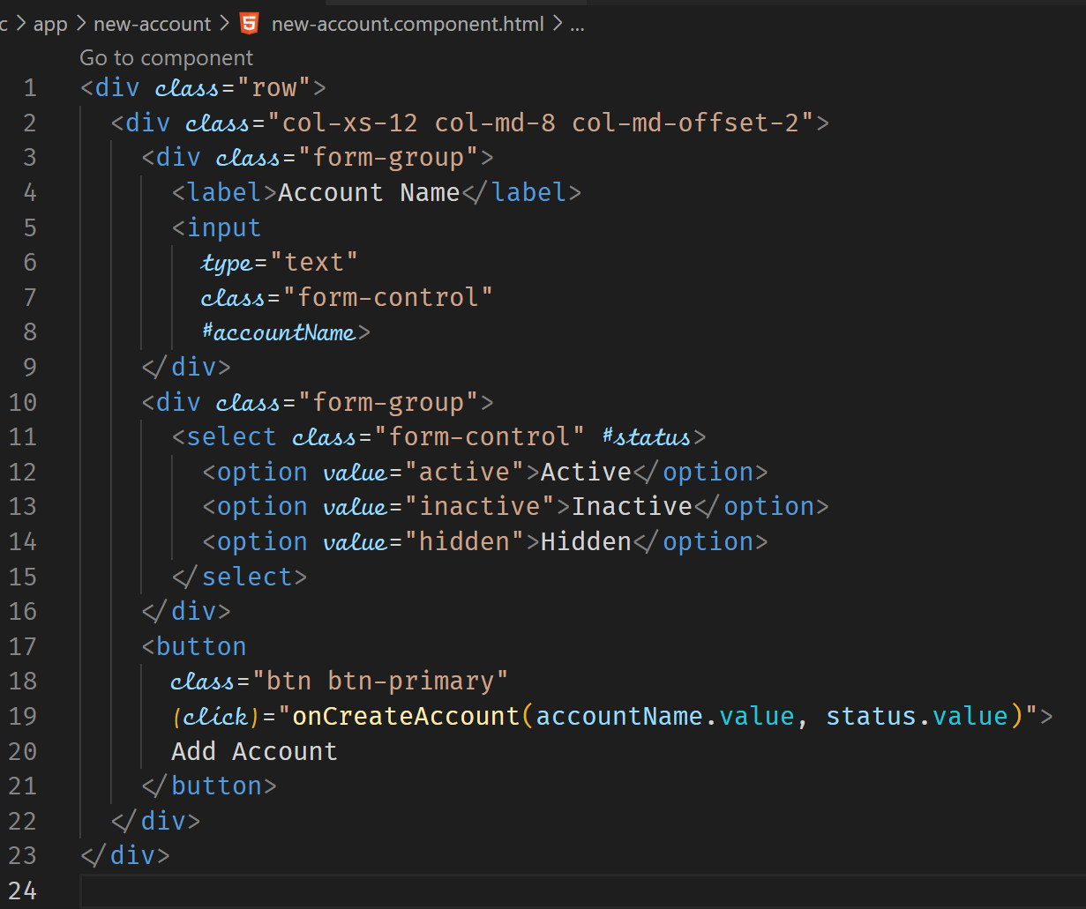

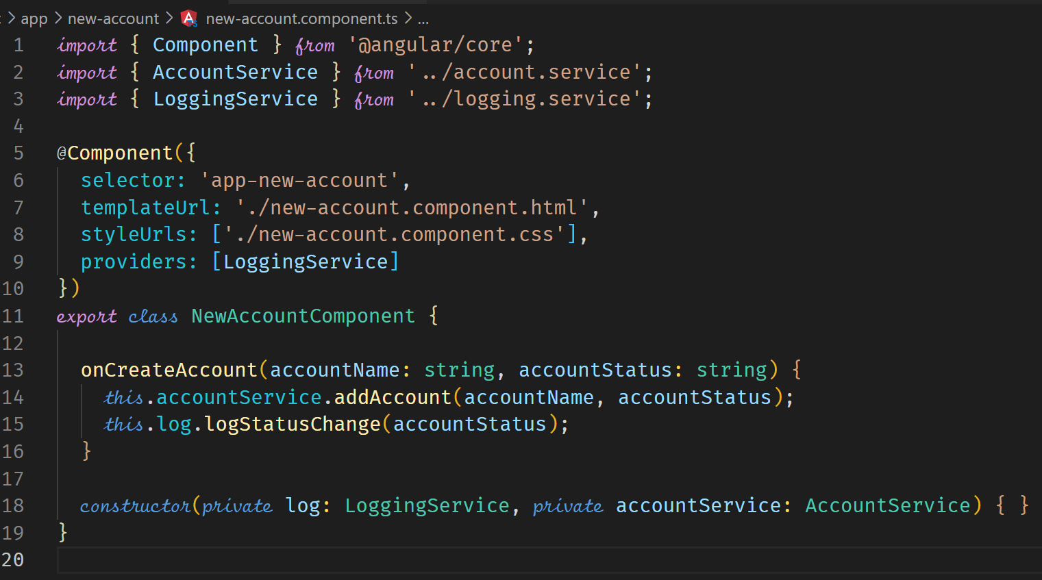

By introducing the use of services, we eliminated the use of event listening in the template and the @Output decorator and emitting events in the typescript.

**Injecting Services into Services**

When a service requires another service to be injected, you should make sure the dependant service has the decorator @Injectable(). Angular recommends all services have this decorator in newer versions but it currently is about indicating that a service has a dependency from another service.

The services should be specified in the providers property of the AppModule which is the highest level in the Hierarchical Injector. There should be no providers property in the child components.

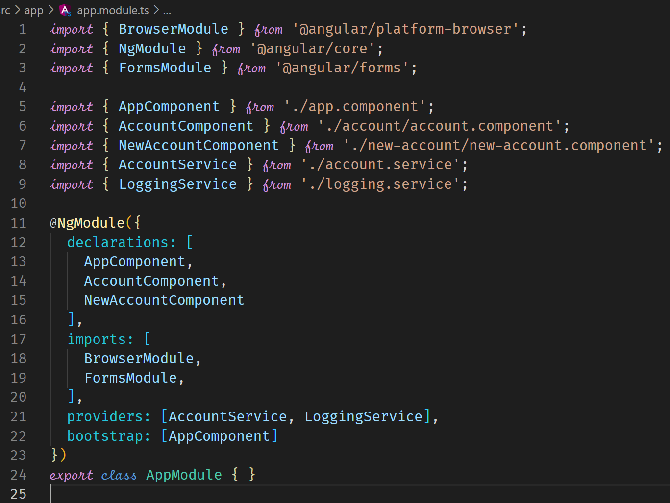



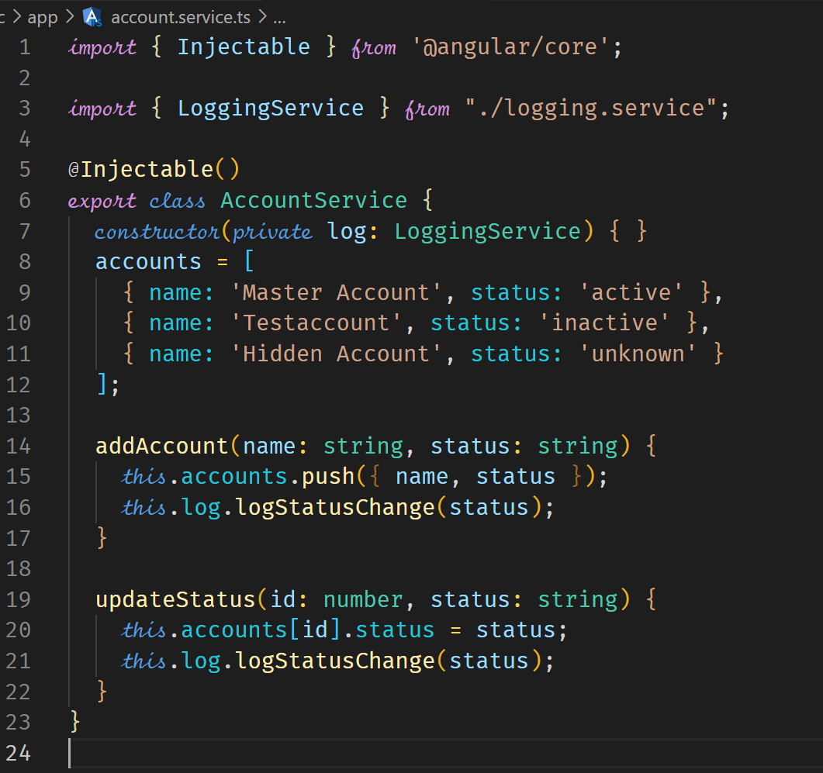



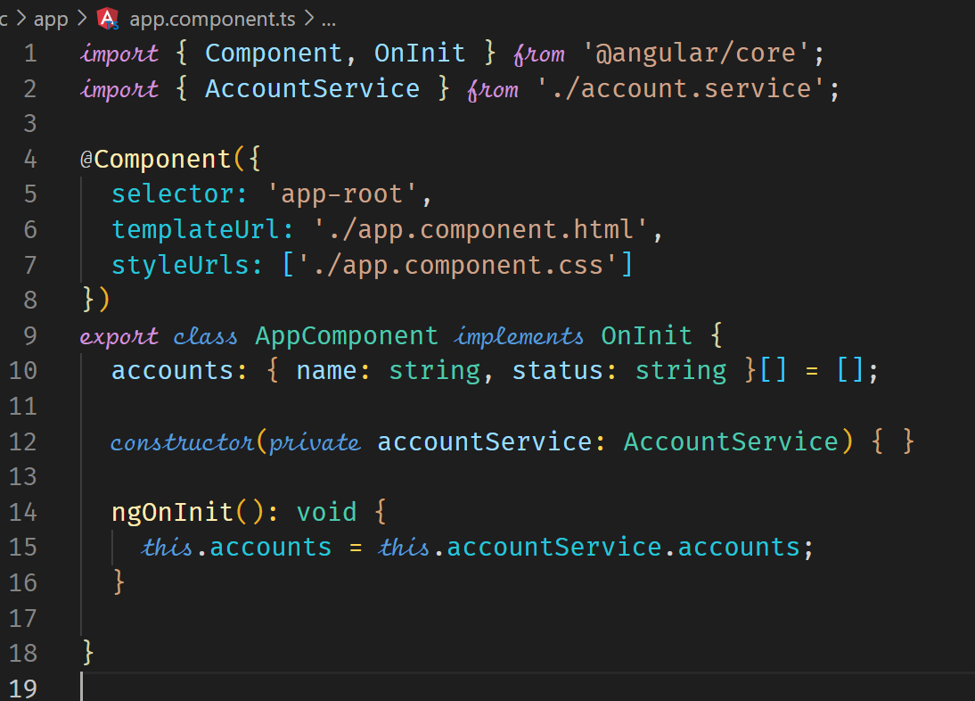



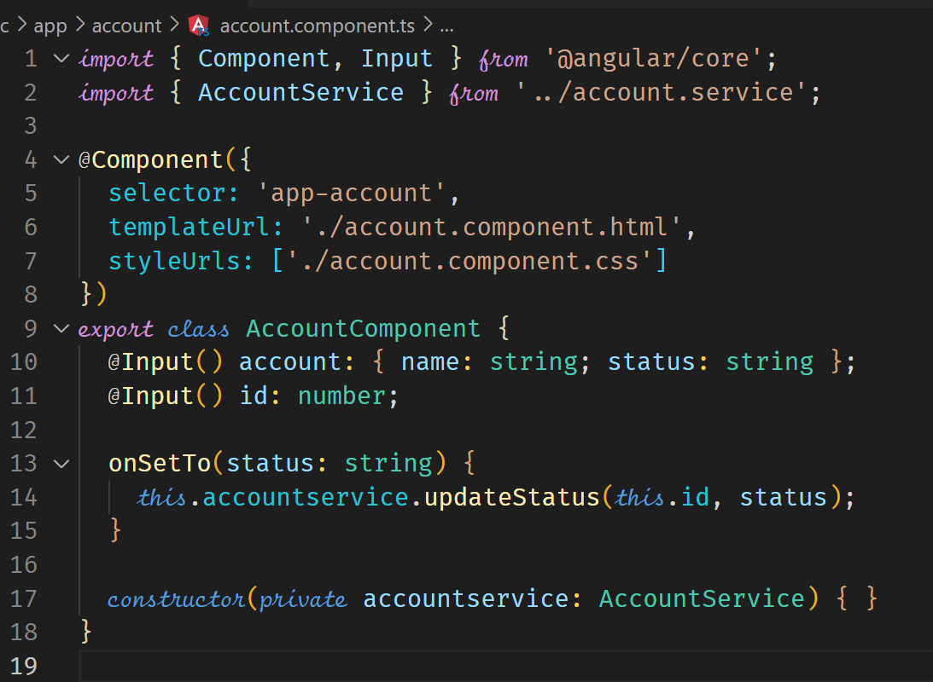

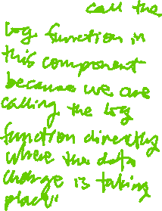

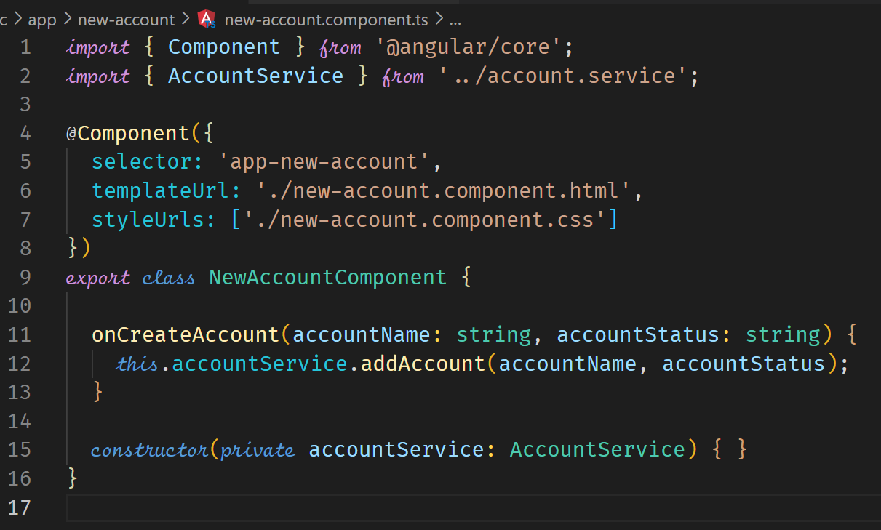

**Using Services for Cross-Component Communication**

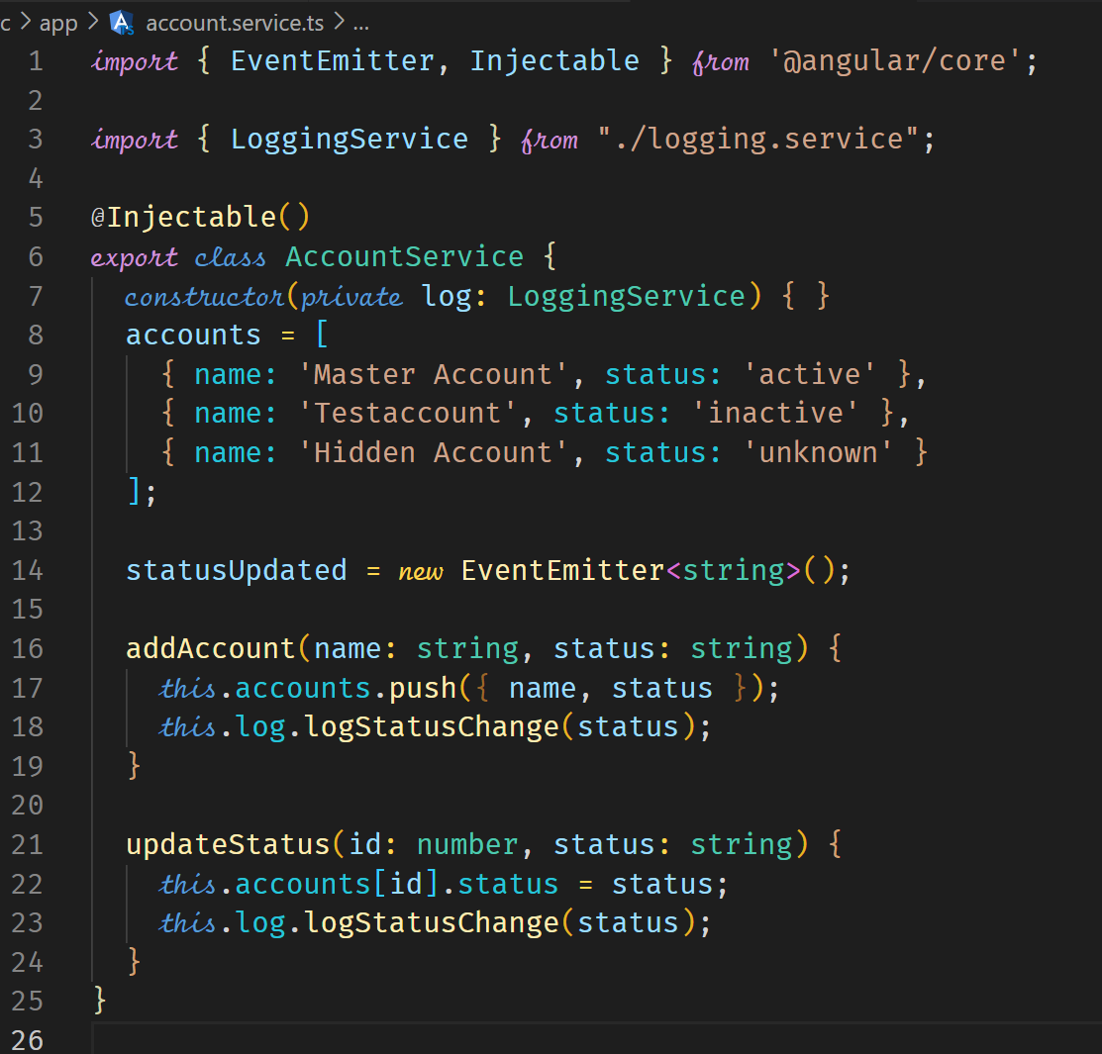



Using the service, we can allow cross-component communication.

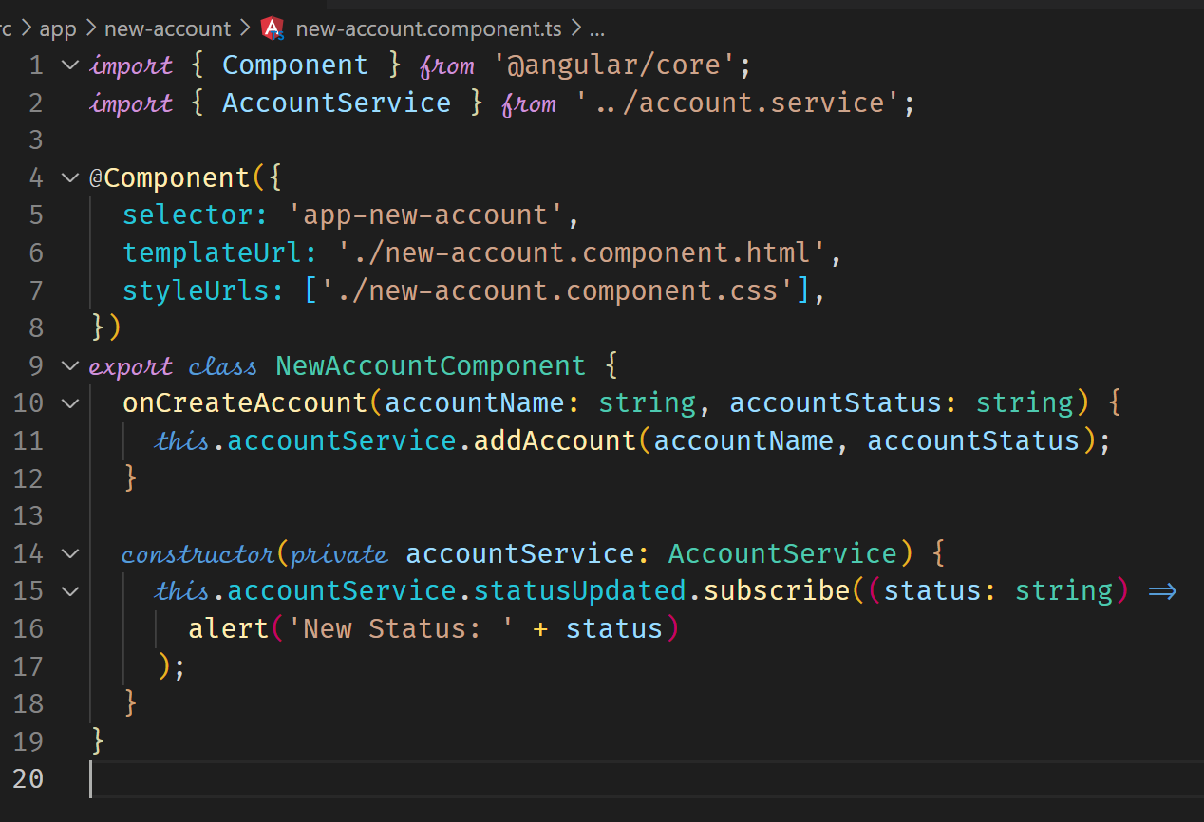



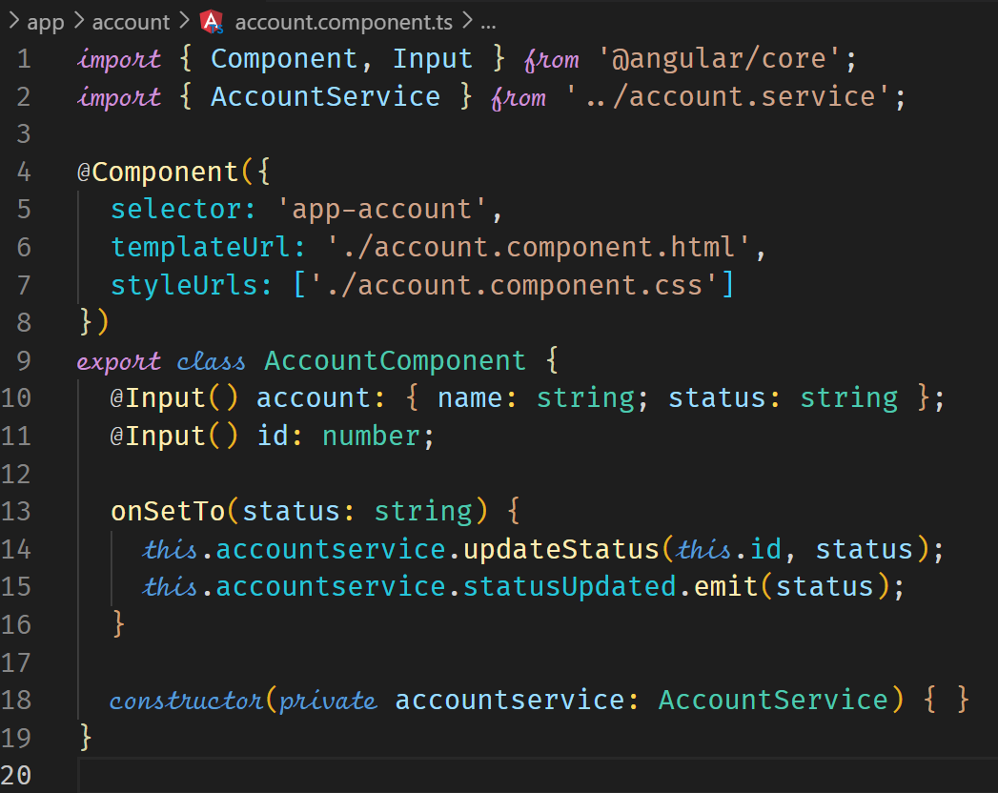



**Another Way of Injecting Services**

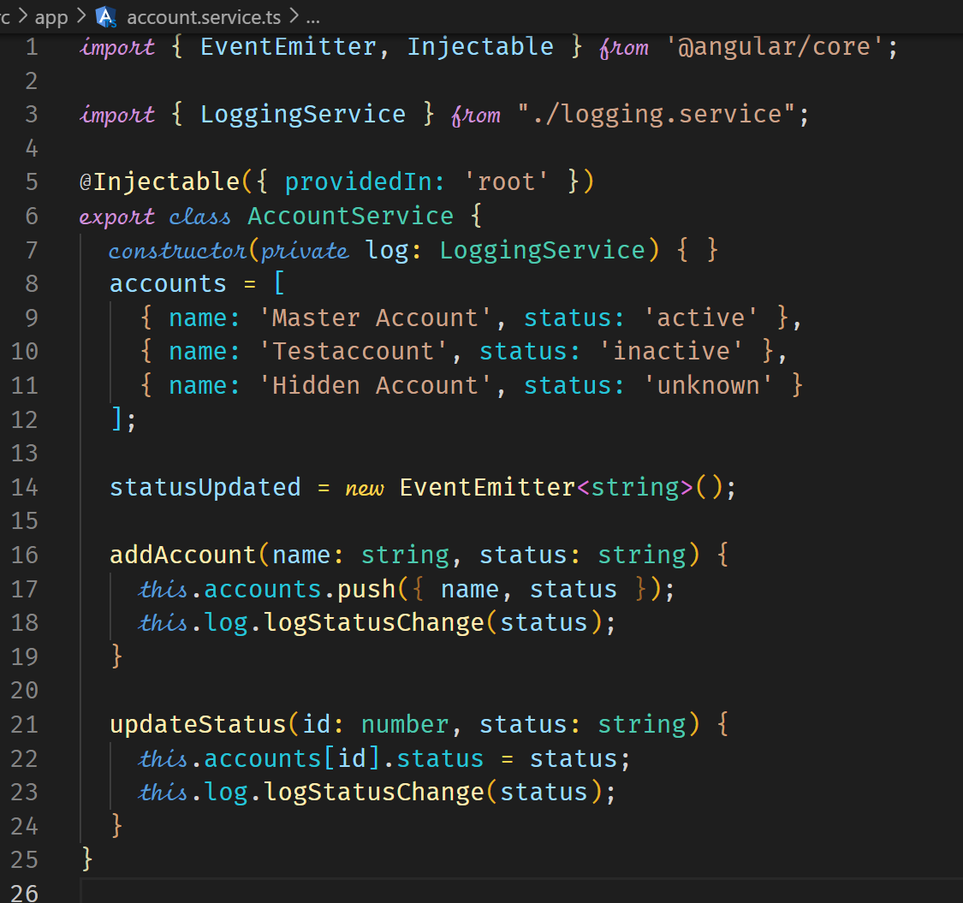



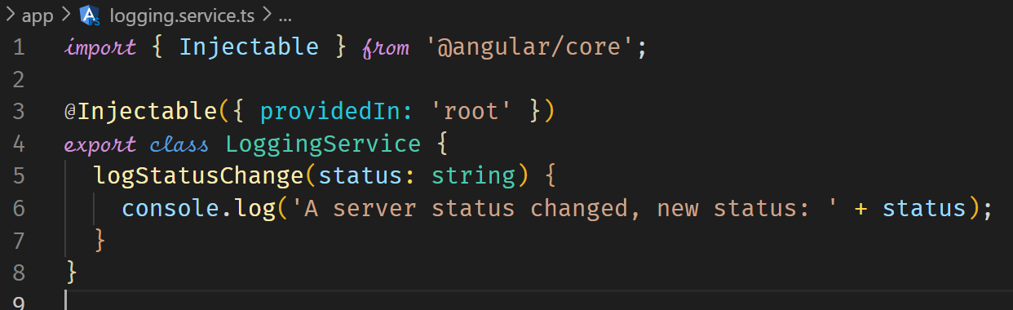

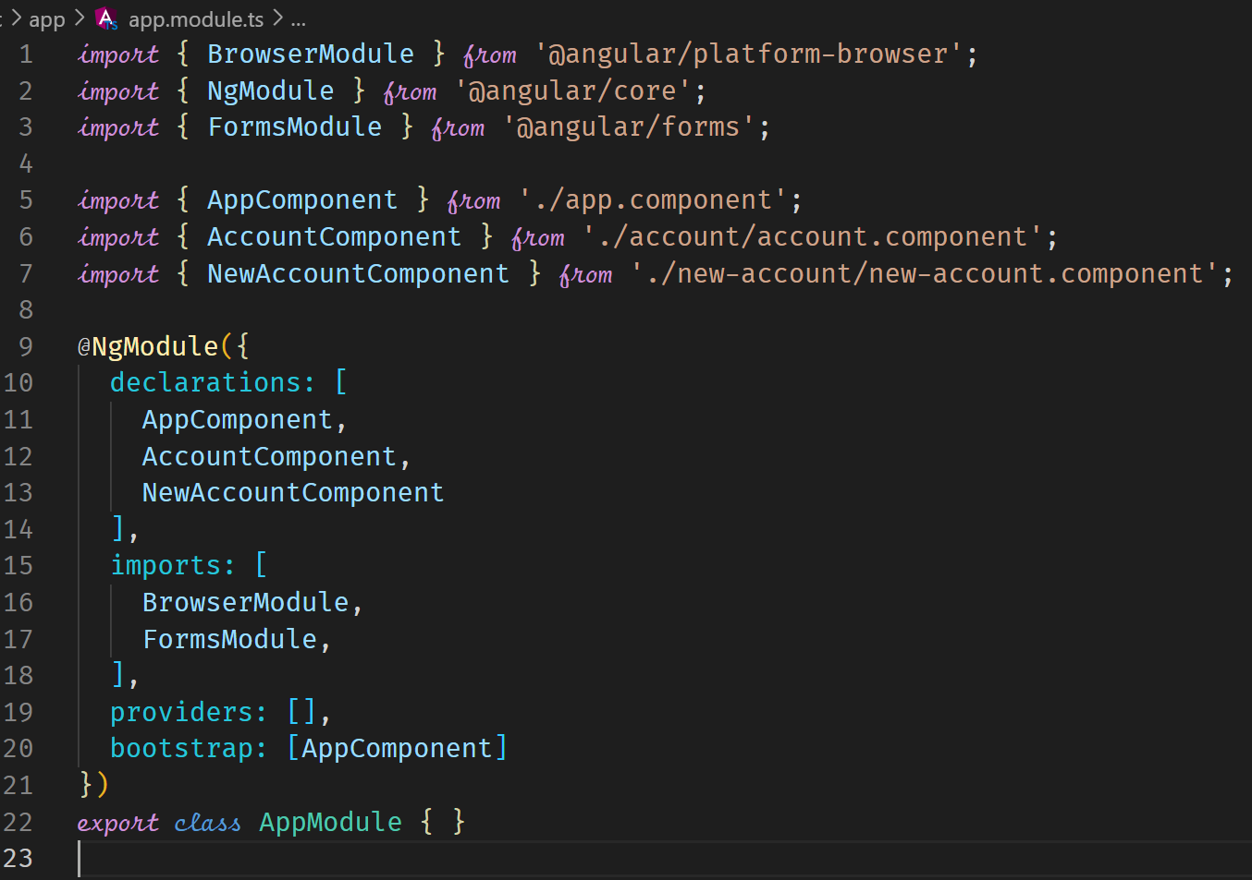



**Back to our project – Managing Recipes in a Recipe Service**

We create a service that manages the recipes. The best place to put the file is in the folder where the Recipes component is defined.

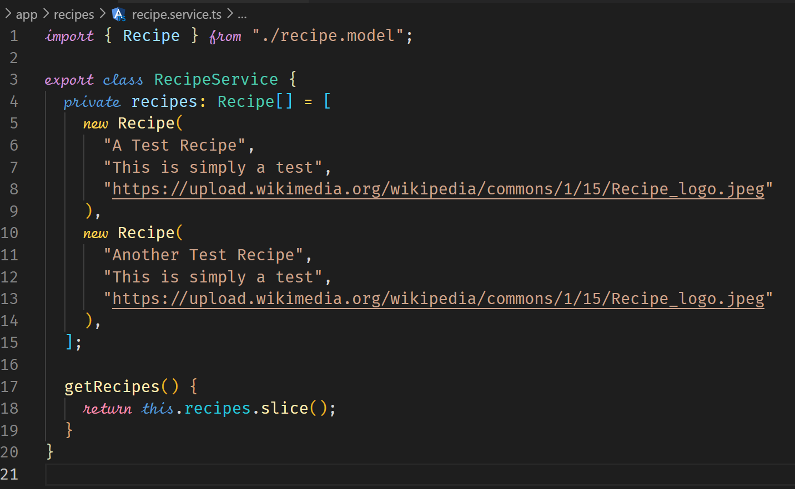



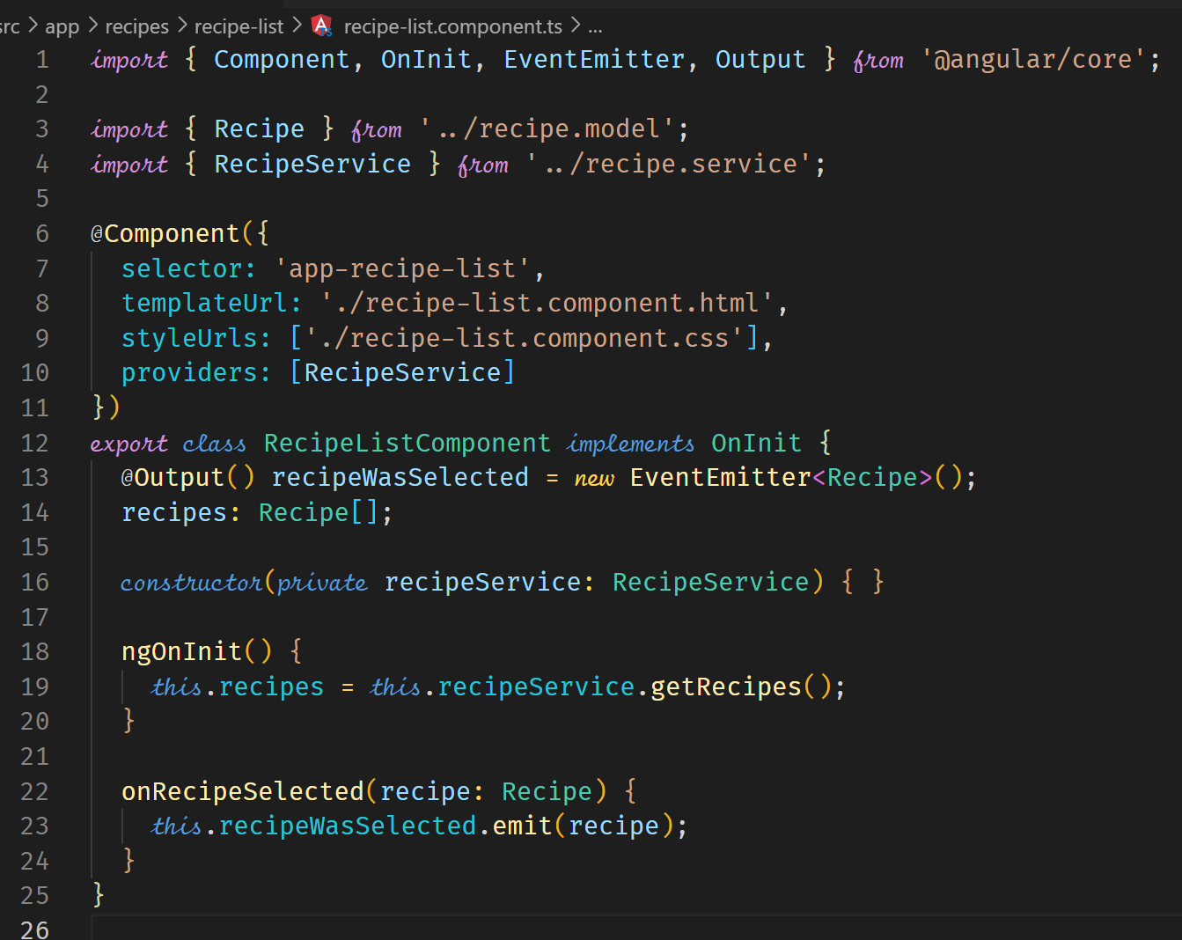



To allow cross-component communication which is currently being done by emitting events in typescript and then listening for the events in the template and calling the related method, we can now use a service.

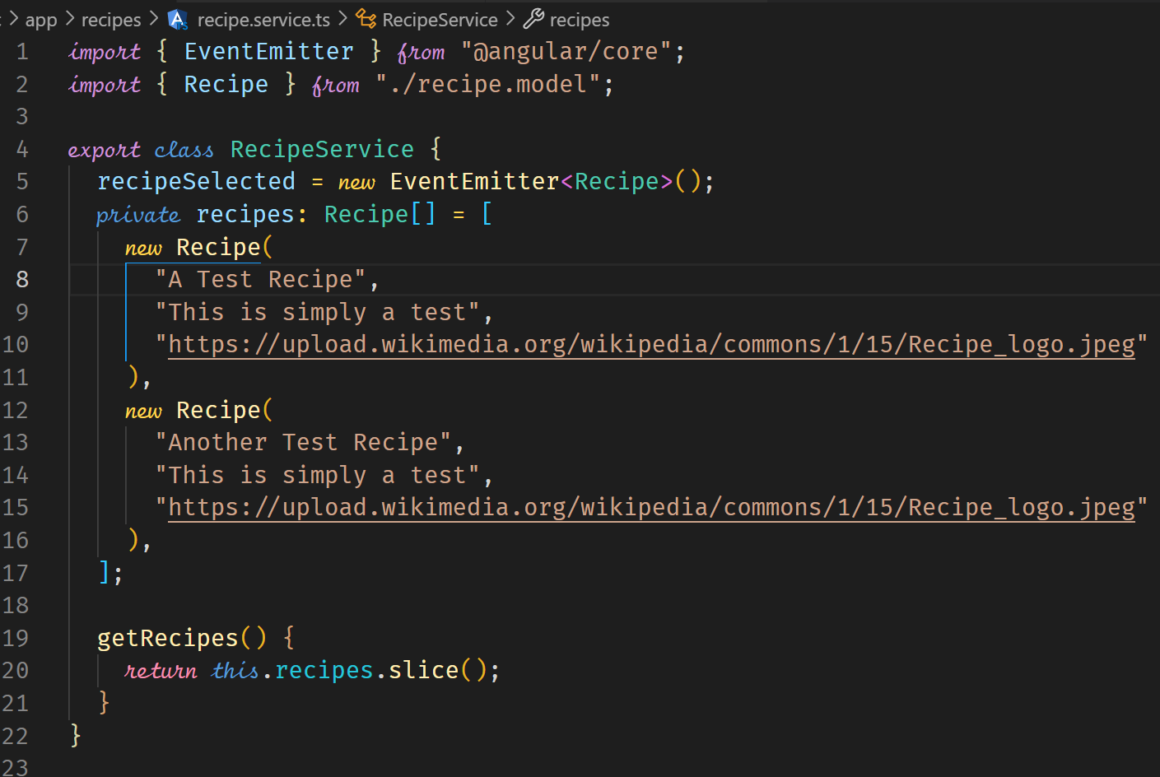



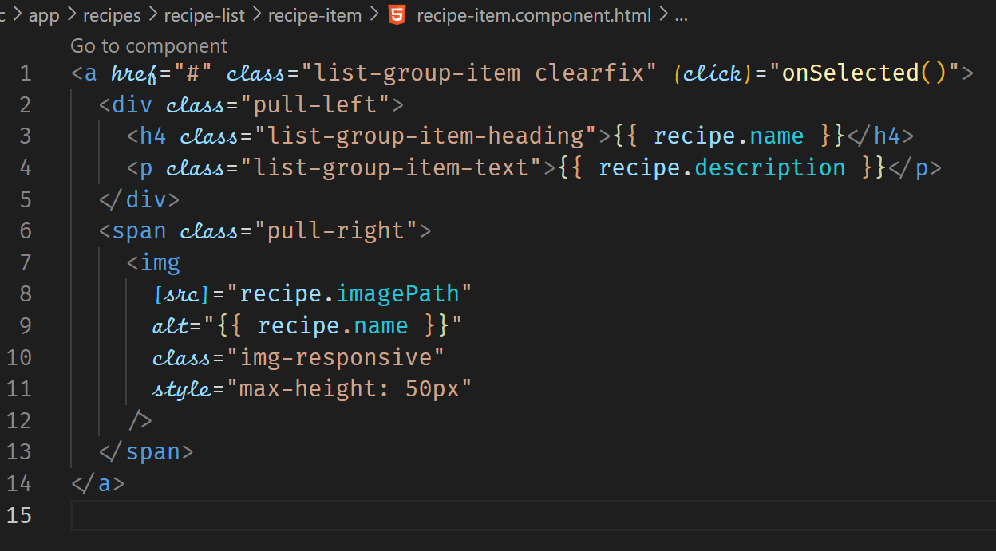



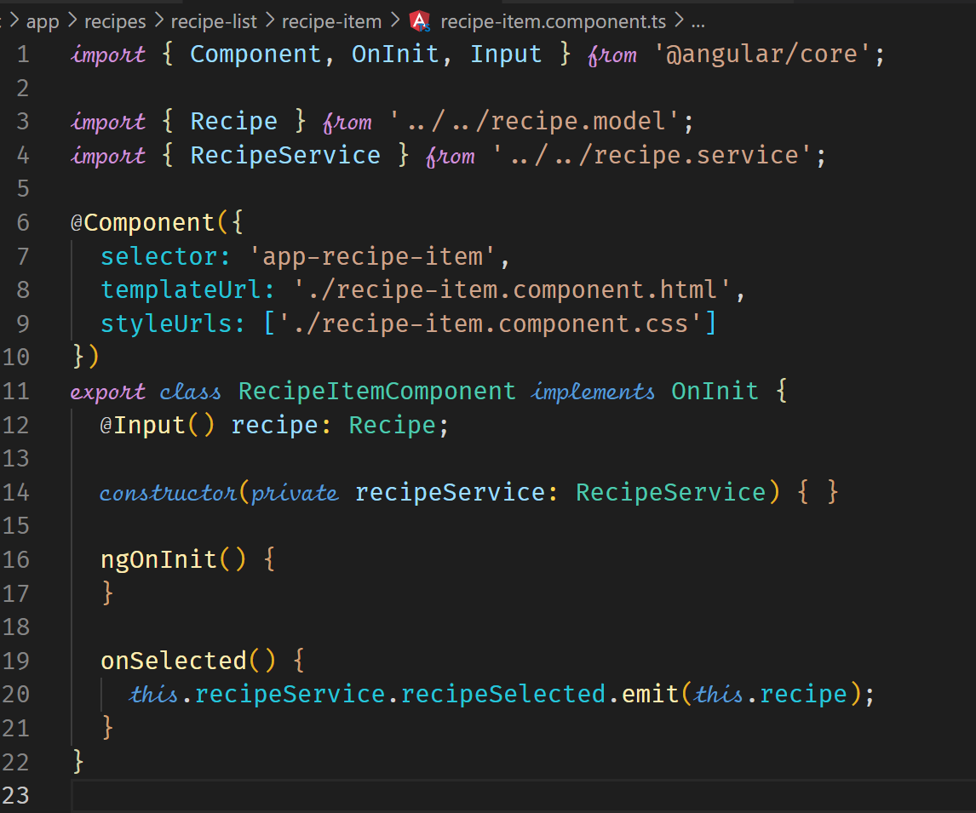



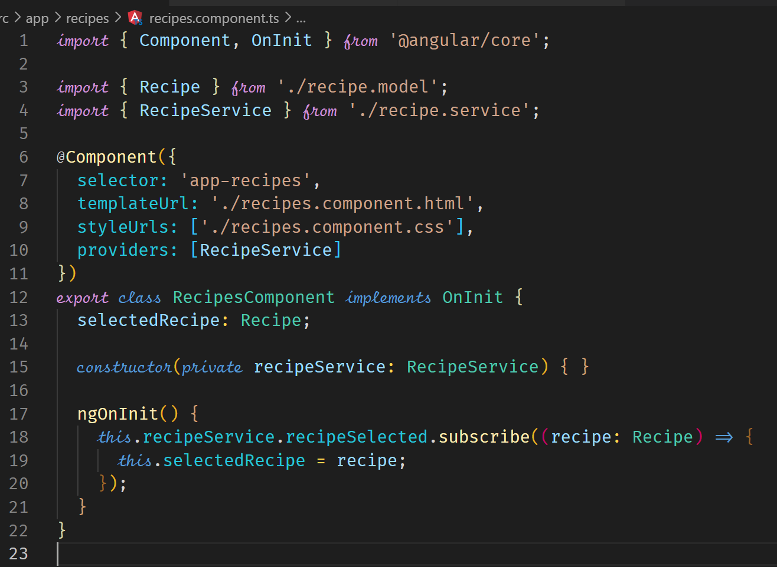



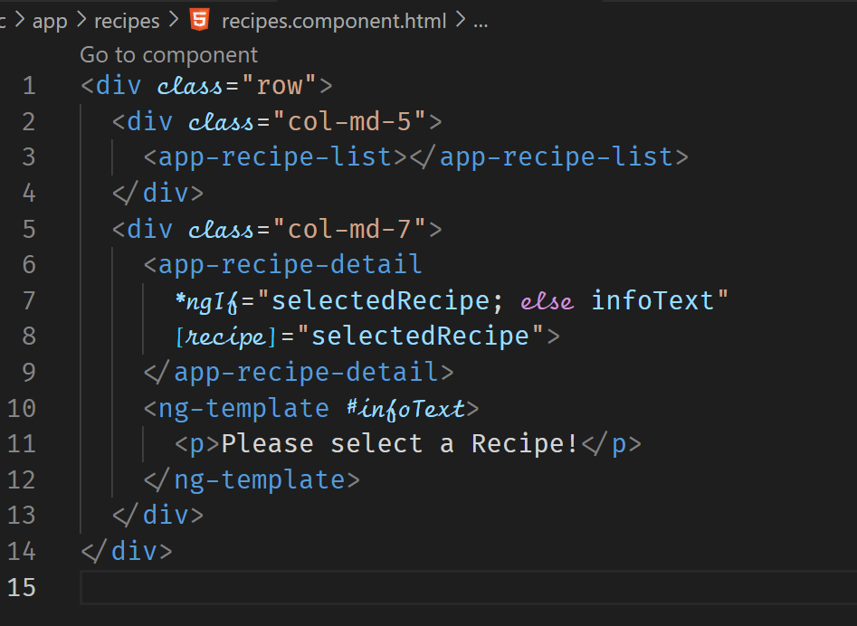



**Adding the Shopping List Service**

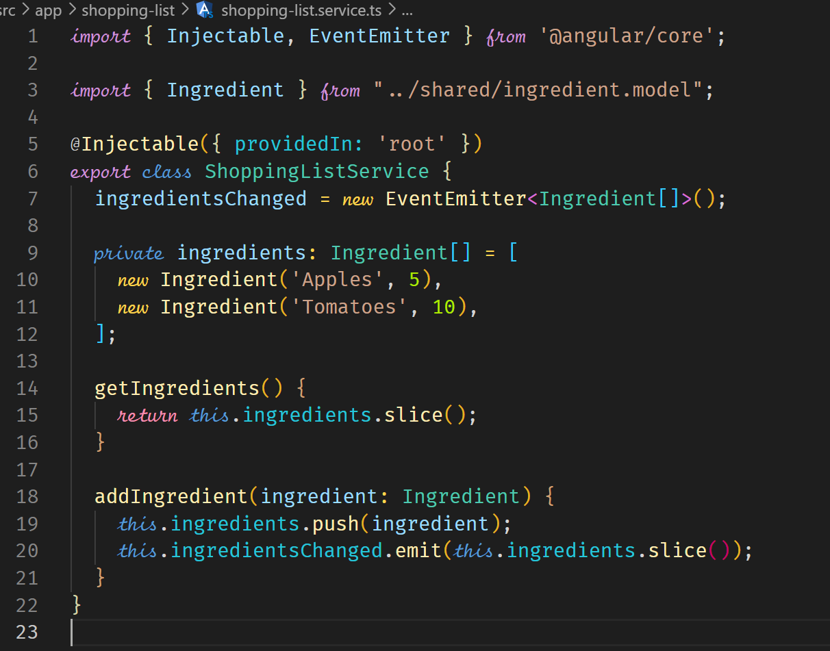

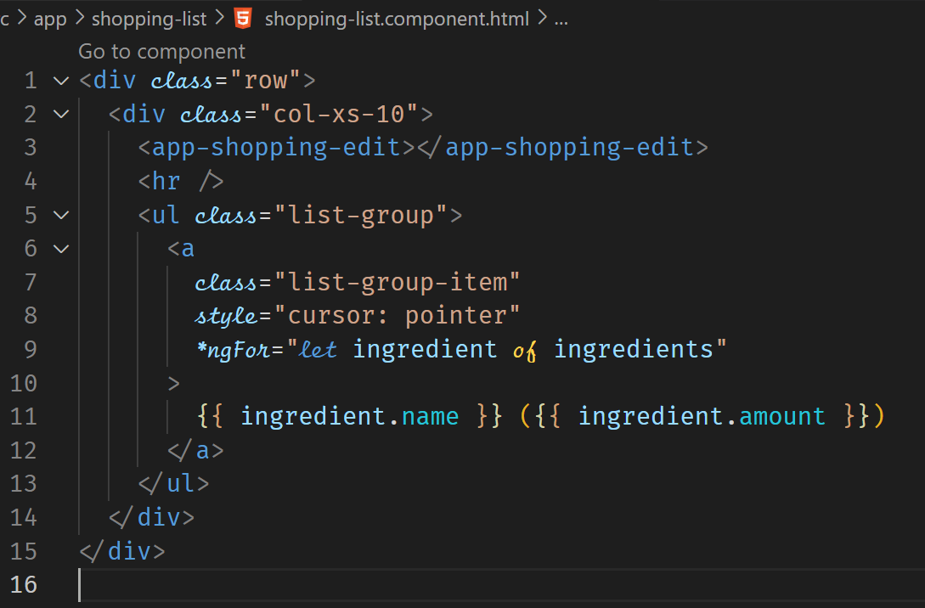

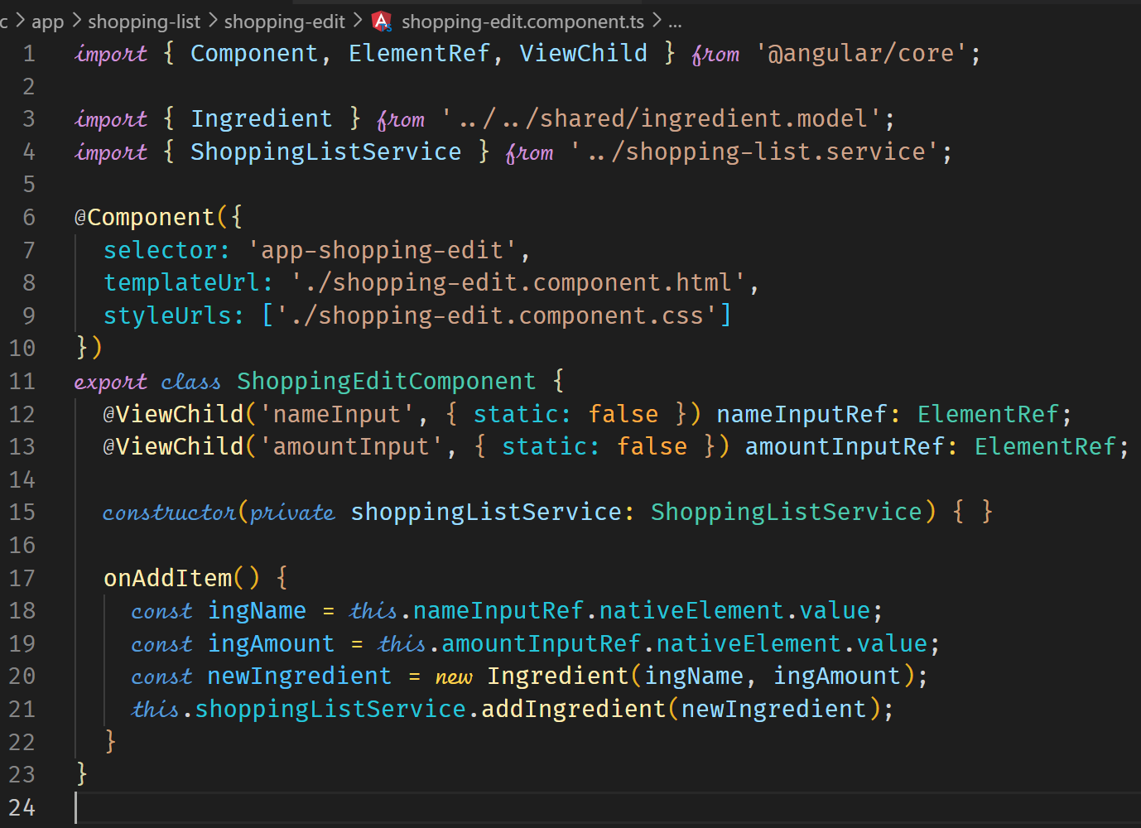

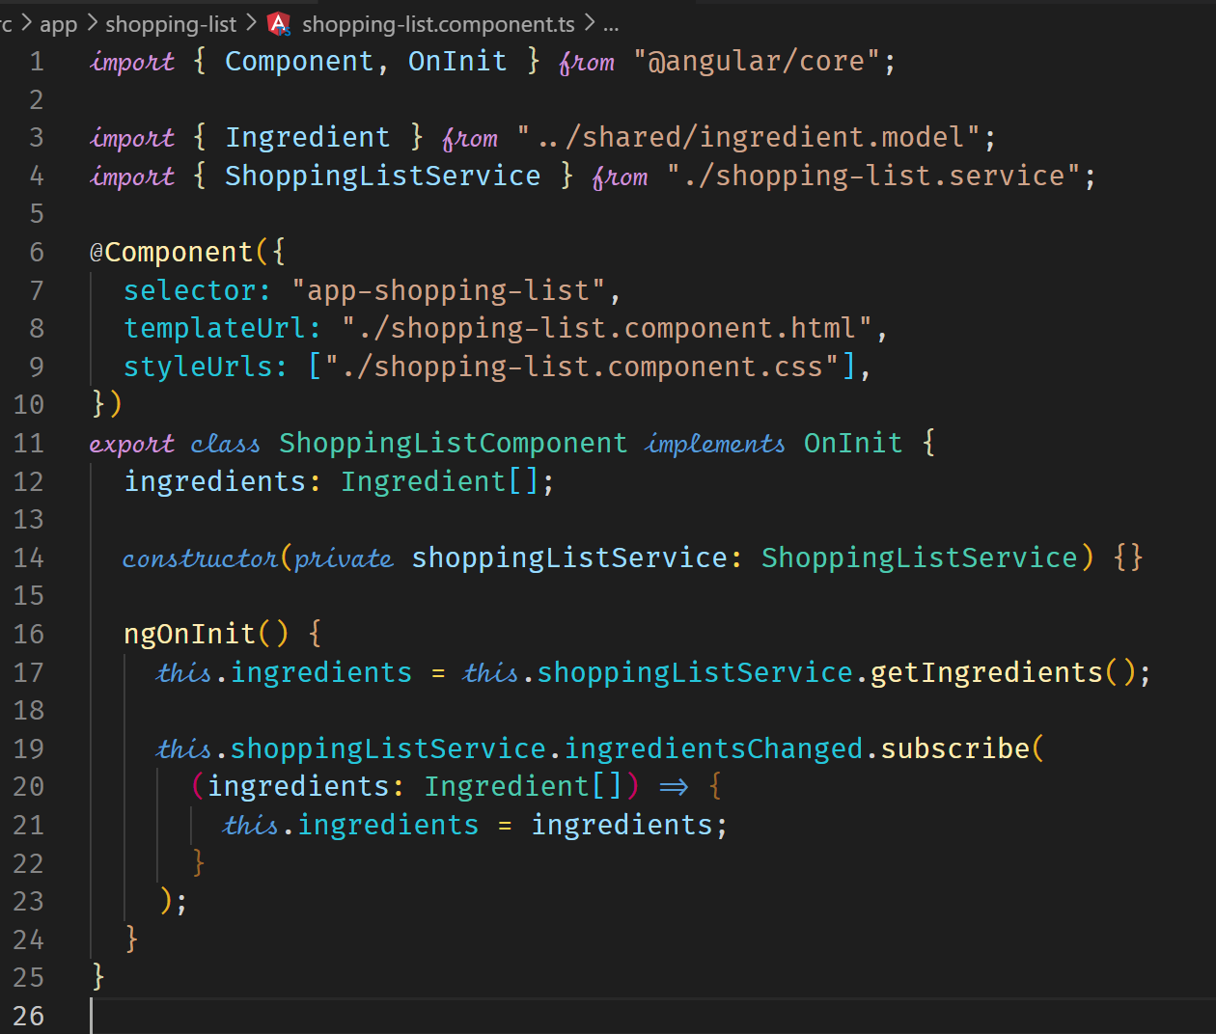

**Routing**

**Setting up and Loading Routes**

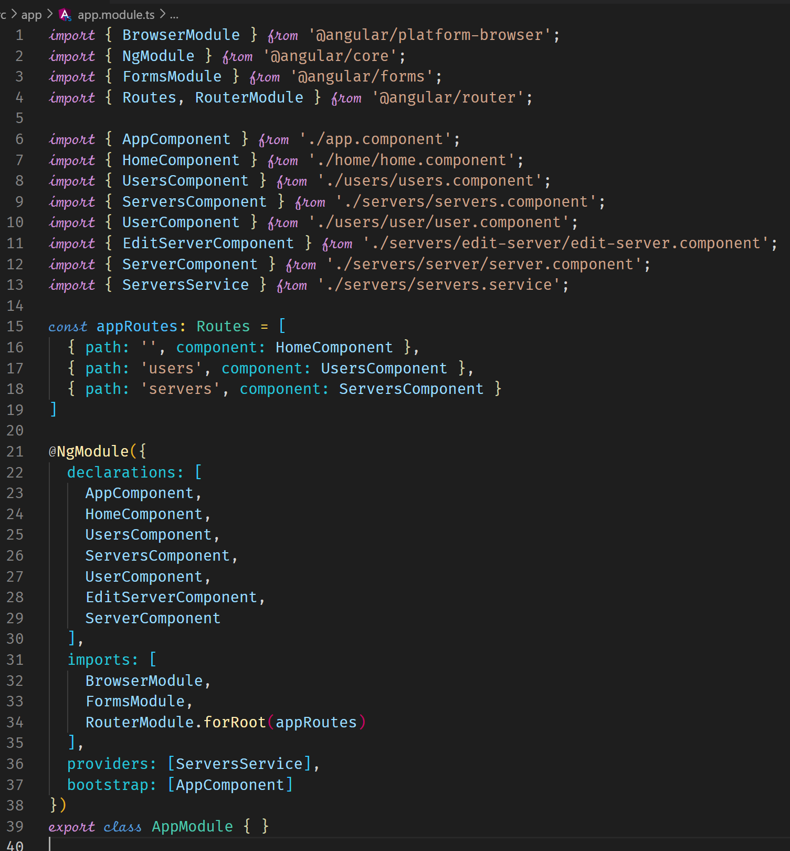



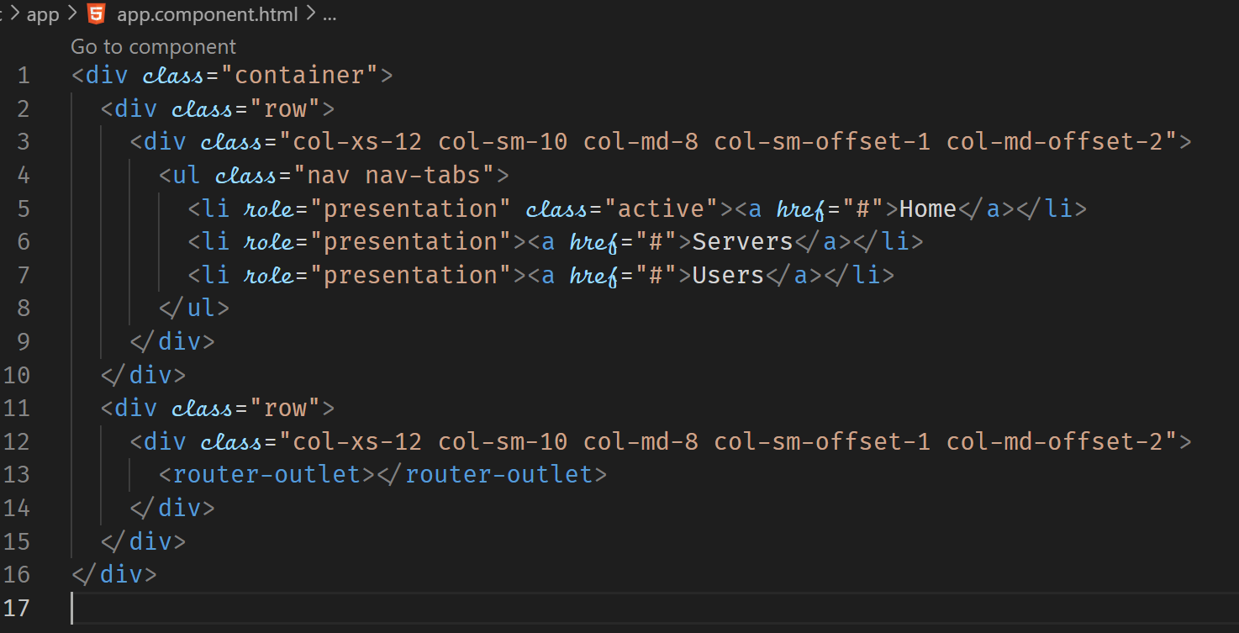



**Navigating with Router Links**

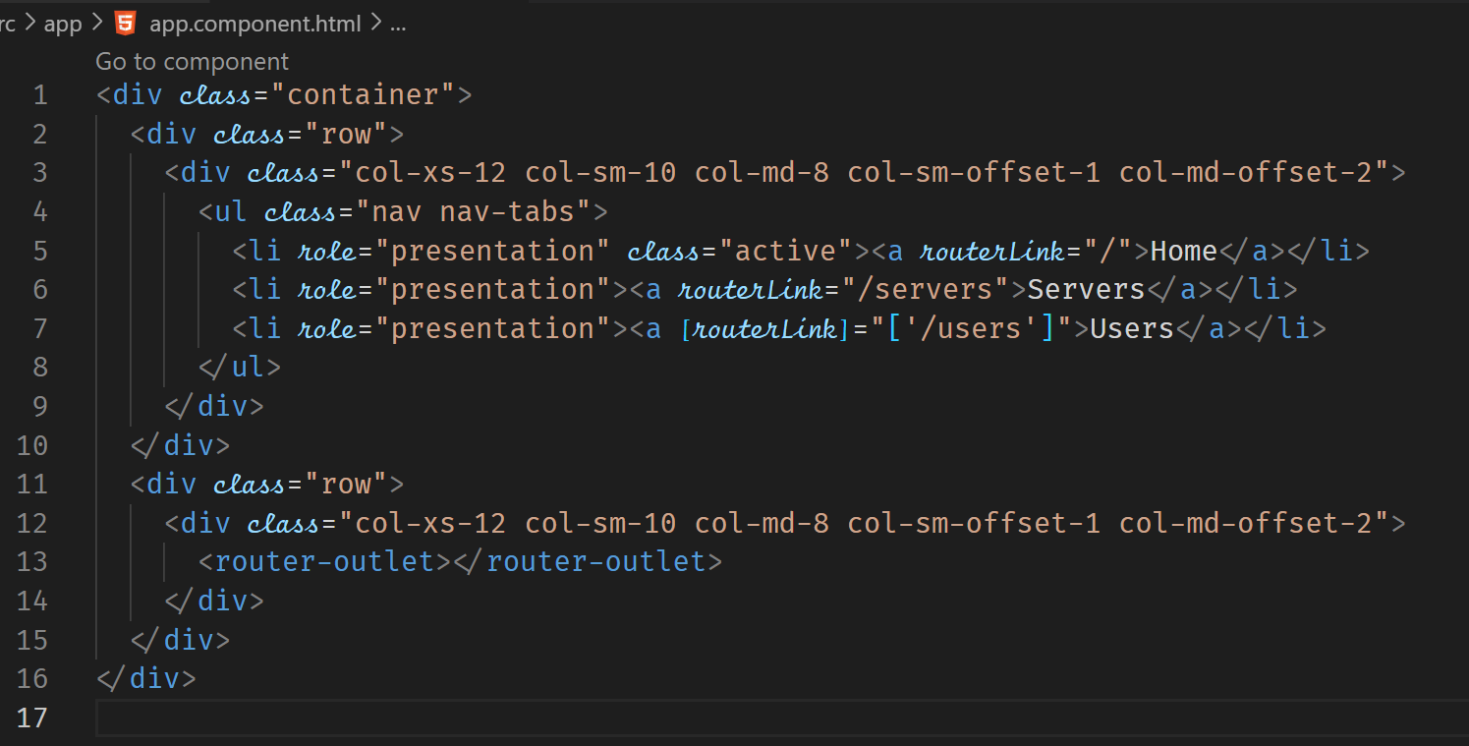

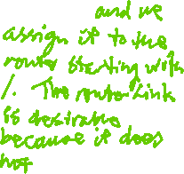

**Understanding Navigation Paths**

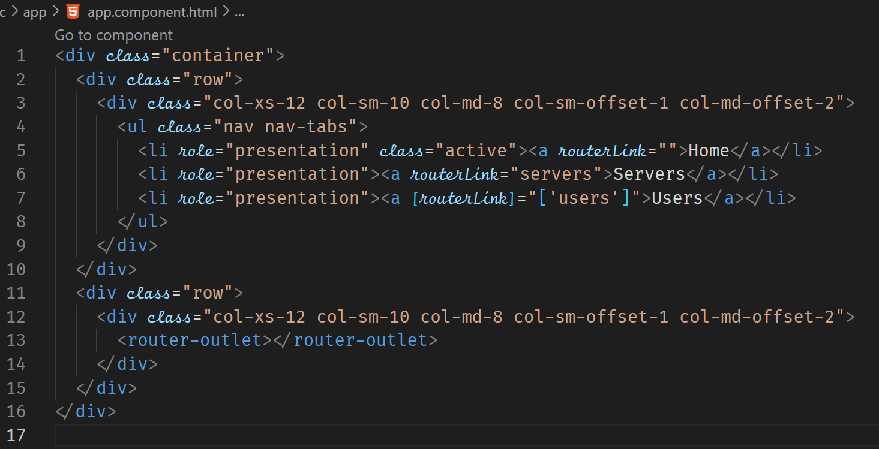



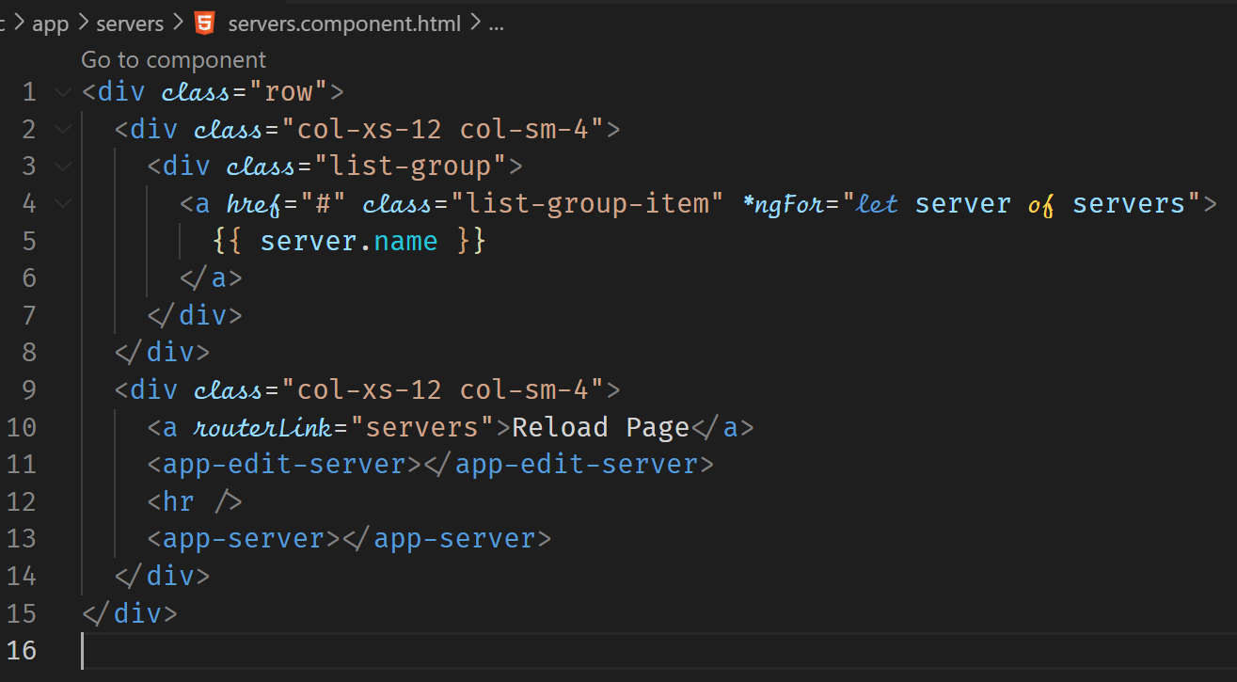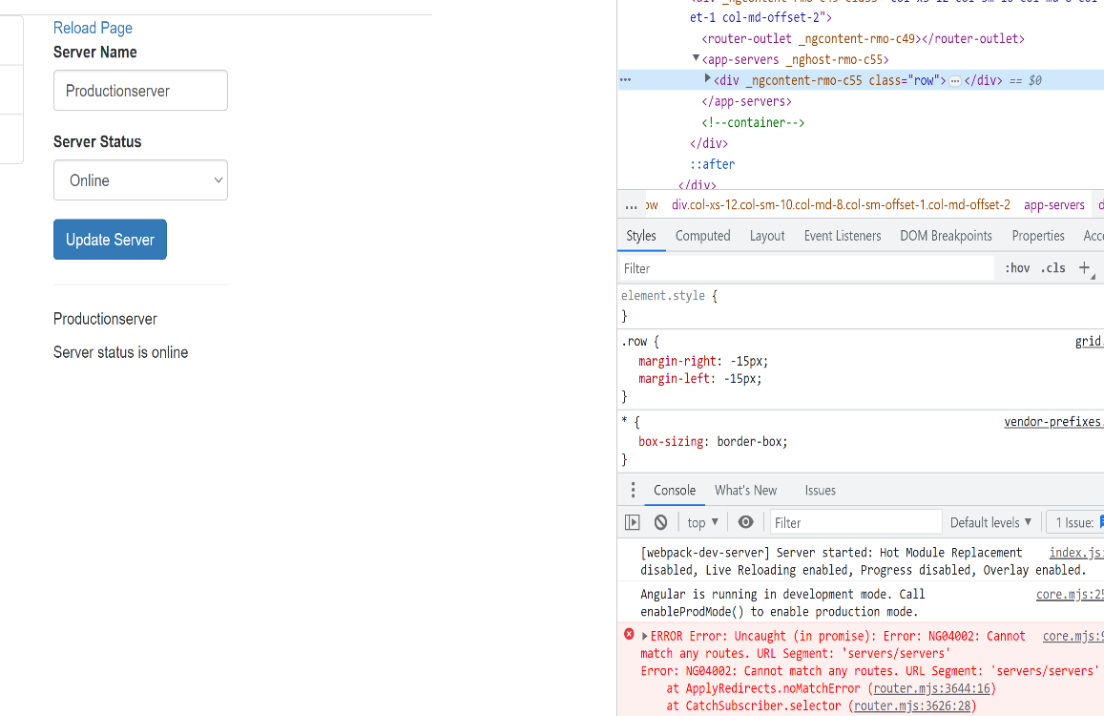

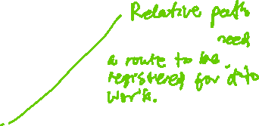

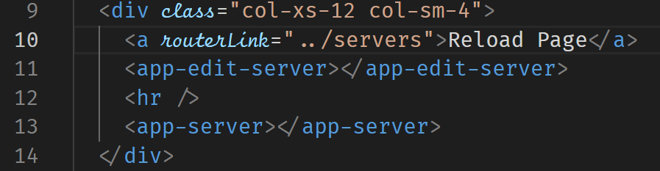



**Styling Active Router Link**

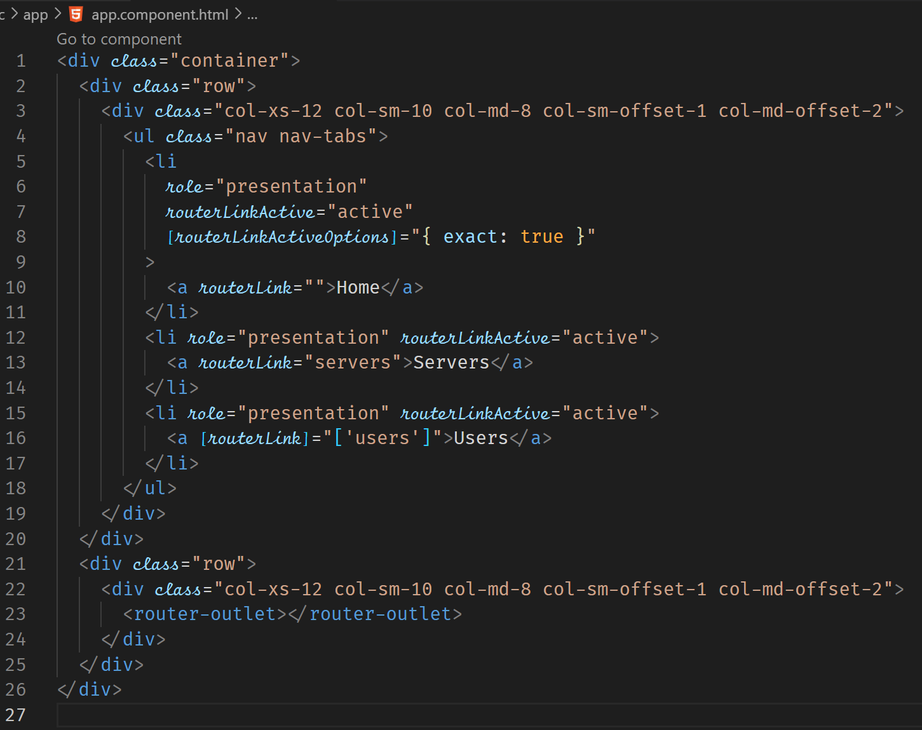



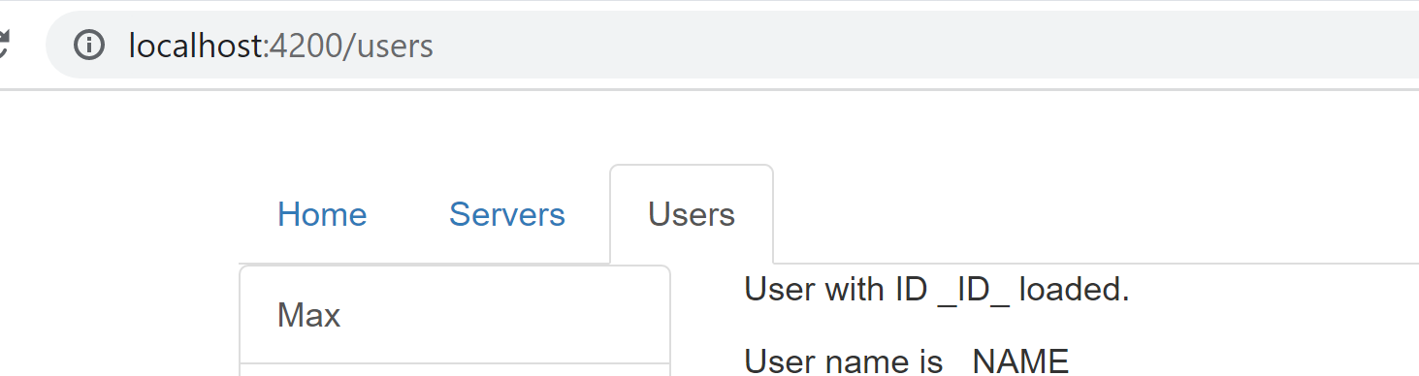



**Navigating Programmatically**

Navigating programmatically can be done when a user clicks a button to carry out a certain process and then another component is displayed.

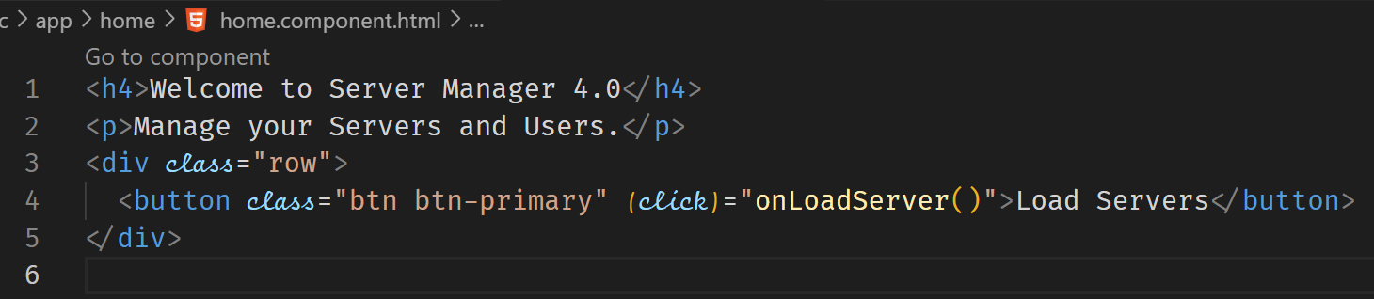

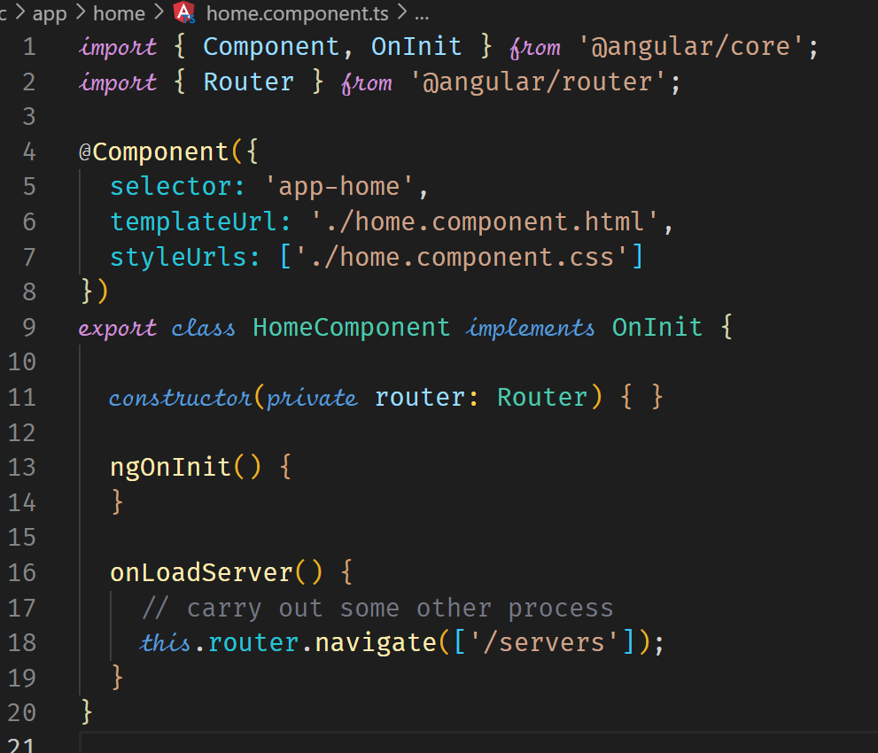



**Using Relative Paths in Programmatic Navigation**

When using relative paths, we also need to pass information as to the current path so that the program can navigate to the correct page. When we are at the root page, relative path may work without us providing information on the current path. So our navigation should be relative to the current path.

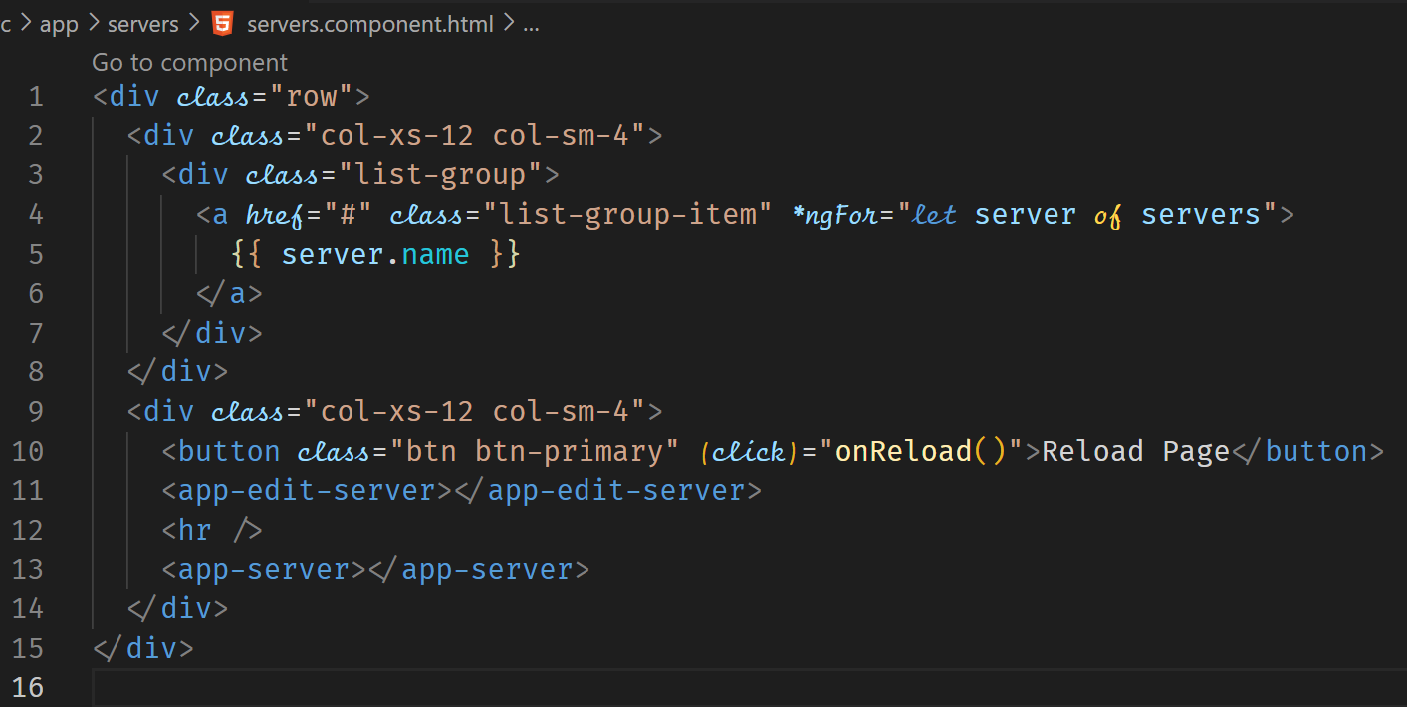

The ActivatedRoute is a javascript object that provides metadata on the currently loaded route.

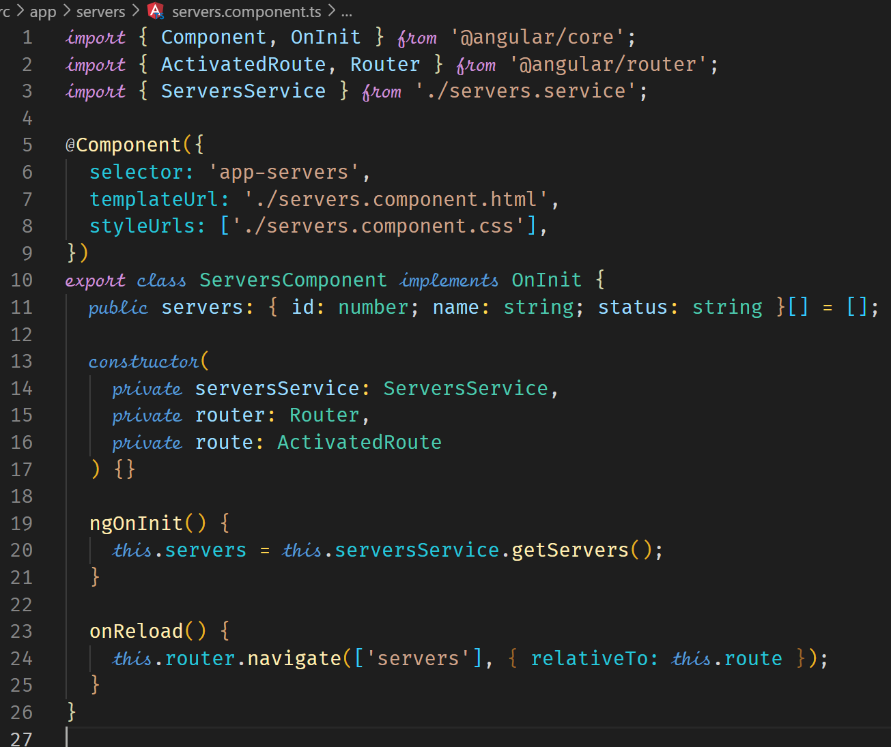



**Passing Parameters to Routes**

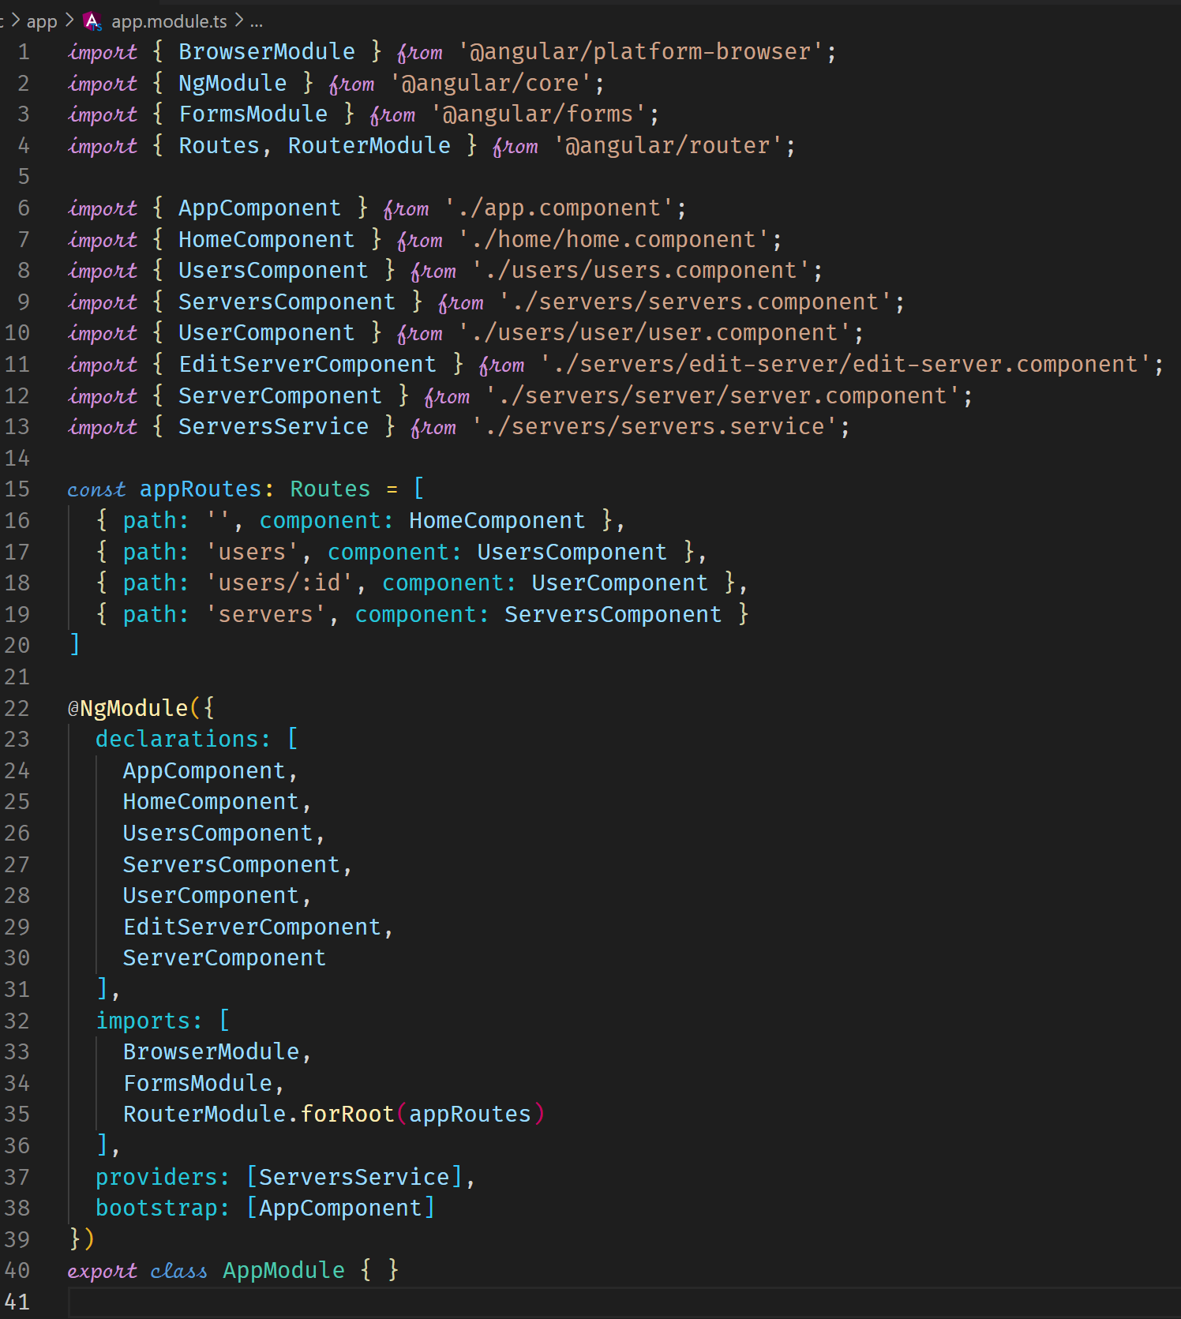



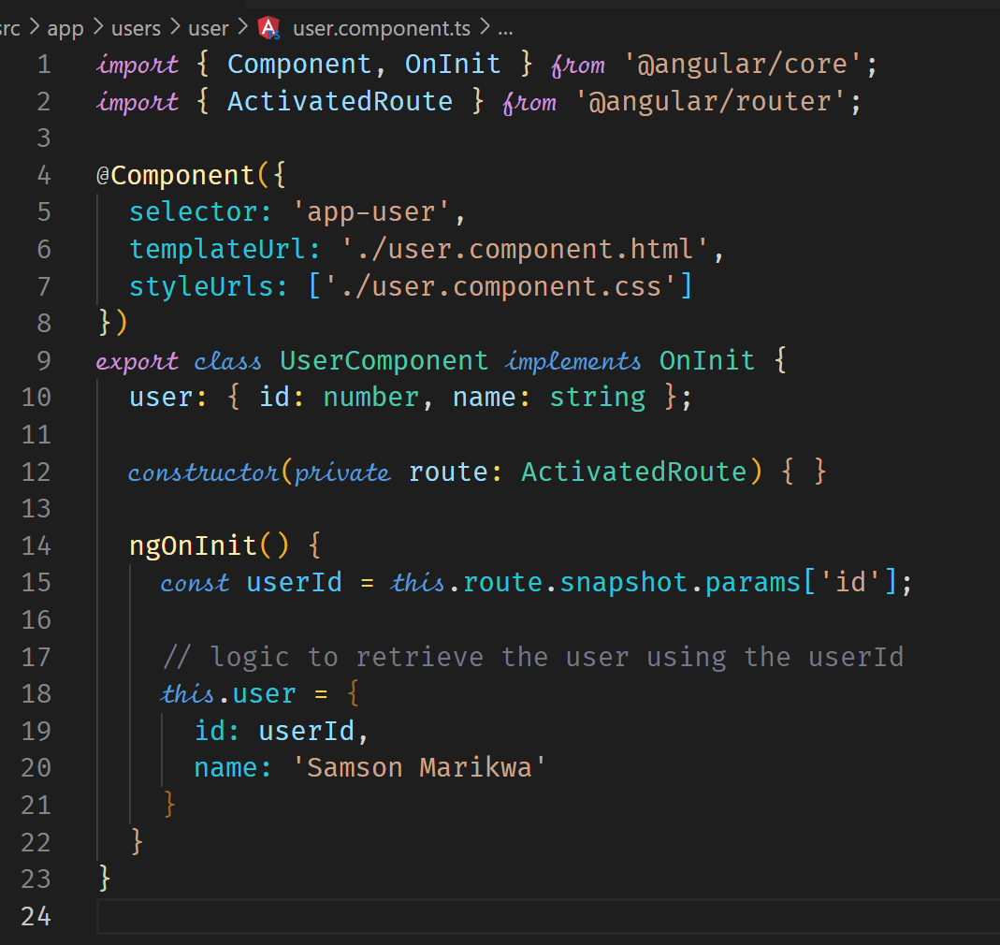



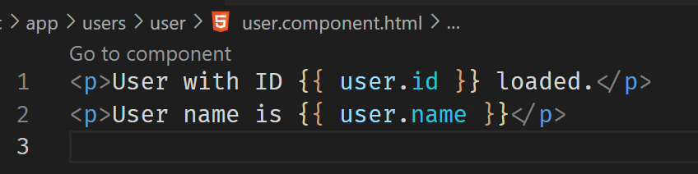

**Fetching Route Parameters Reactively**

A problem exists in the above code where if a reload of the page was to take place with new path variables, the page would not be updated. The following is the demonstration.

In app.module.ts, suppose we have the following code for the Routes.

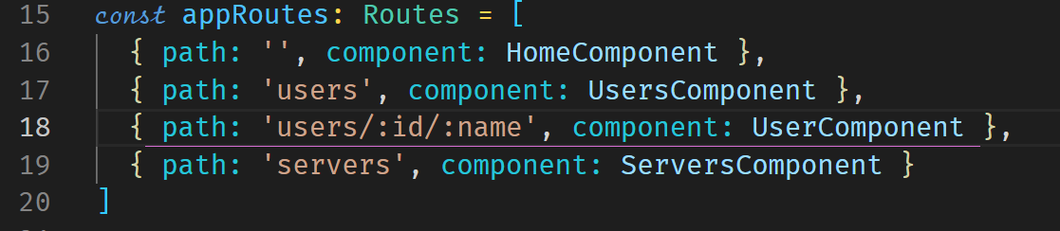

In the UserComponent

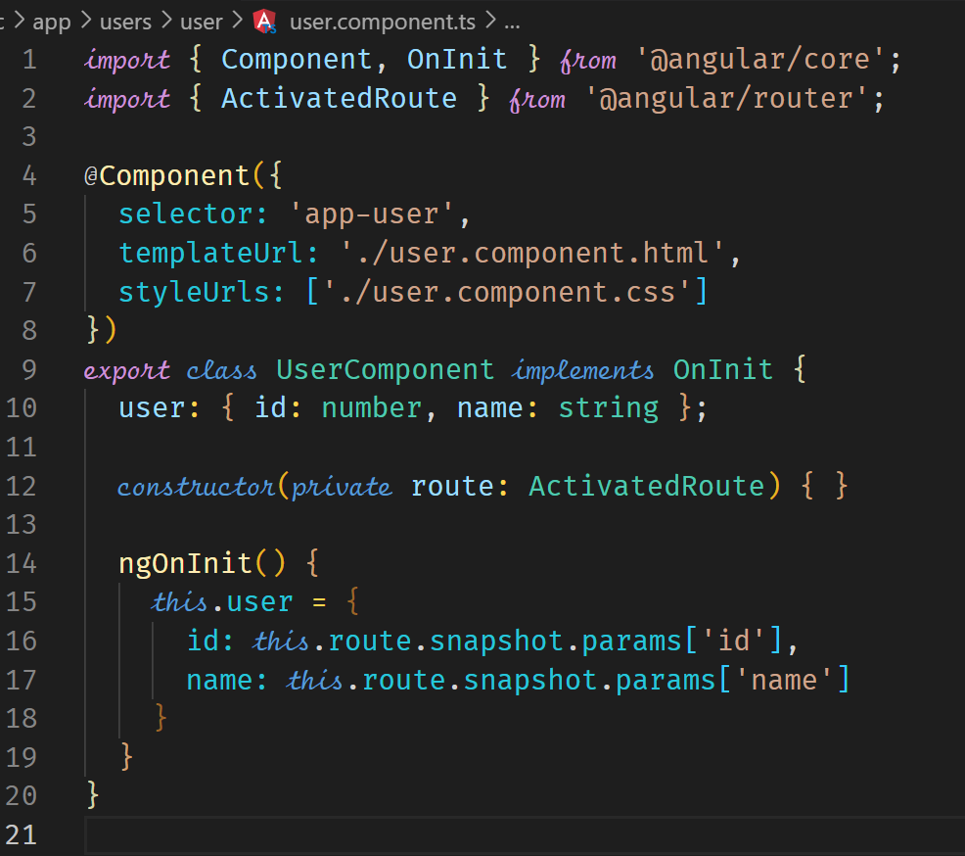

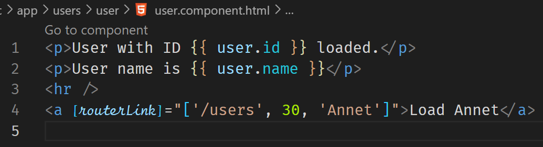



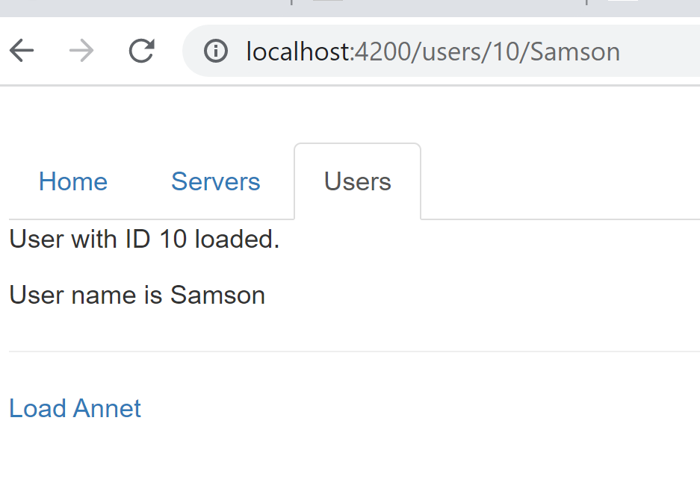

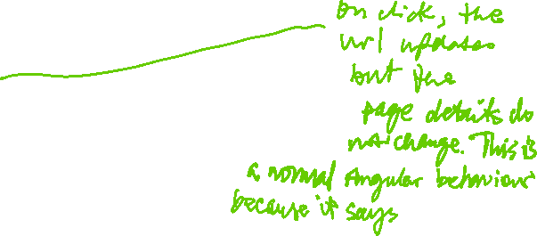

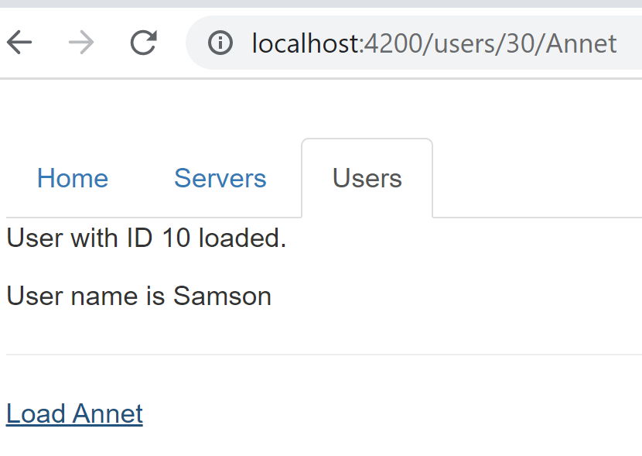



To fix this, we need to work with observables to handle a situation where some parameters on the URL may change in the future and that change needs to be reflected on the page.

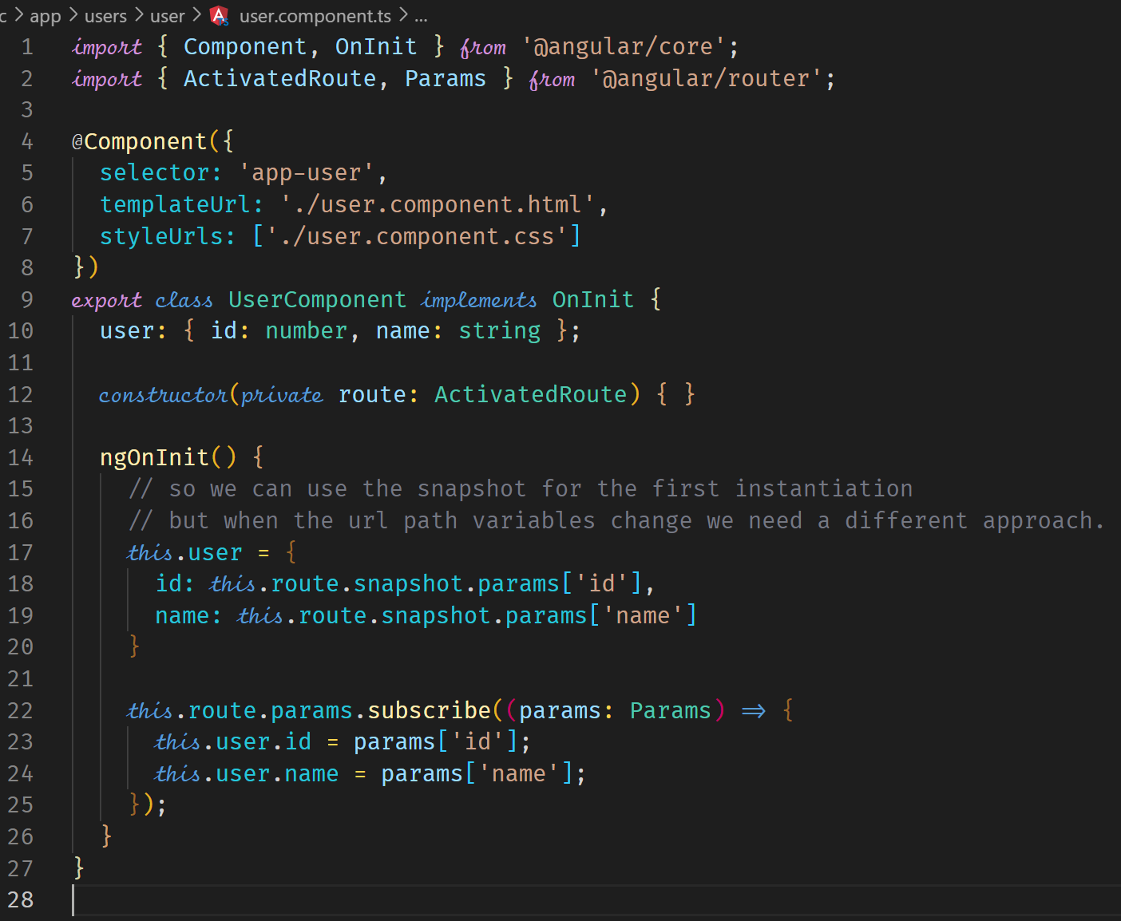



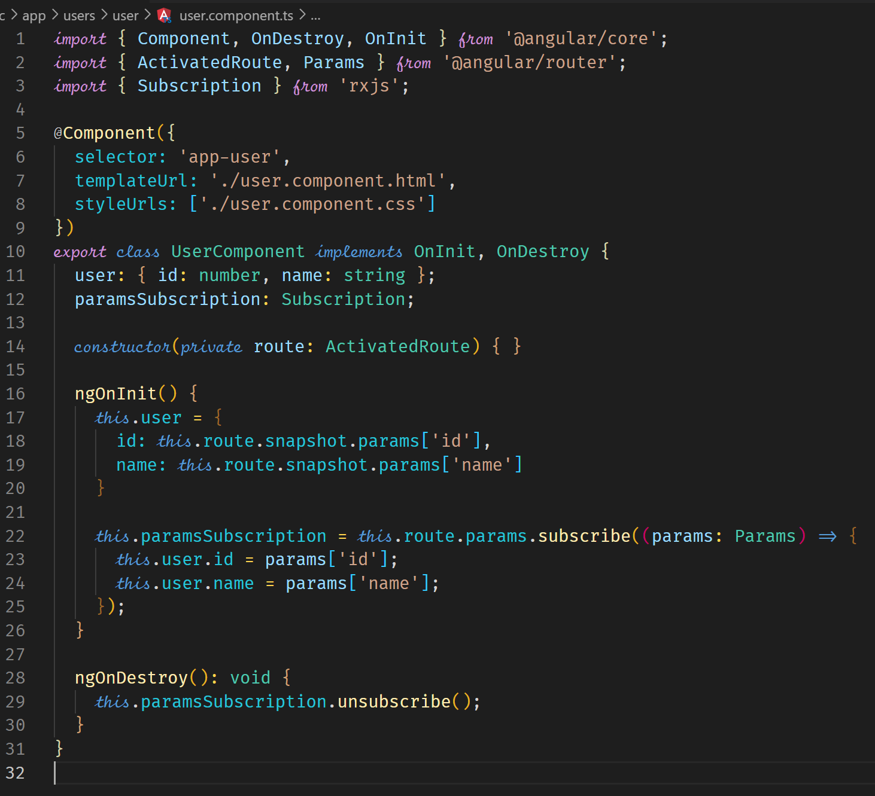



One thing to note, a subscription gets destroyed by Angular when a component is destroyed. However, as good practice, it does not hurt to manually destroy the subscription as shown below. We do this by implementing the life cycle hook ngOnDestroy. We can then close all resources used in the component.

**Passing Query Parameters and Fragments**

Using Template

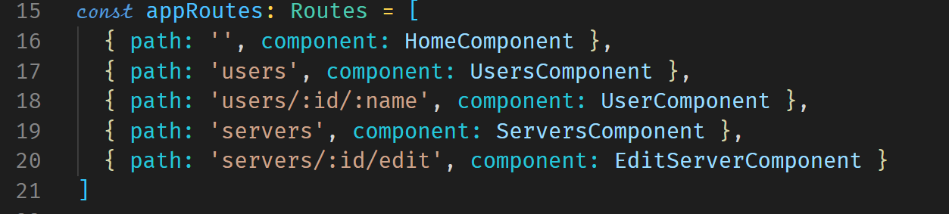



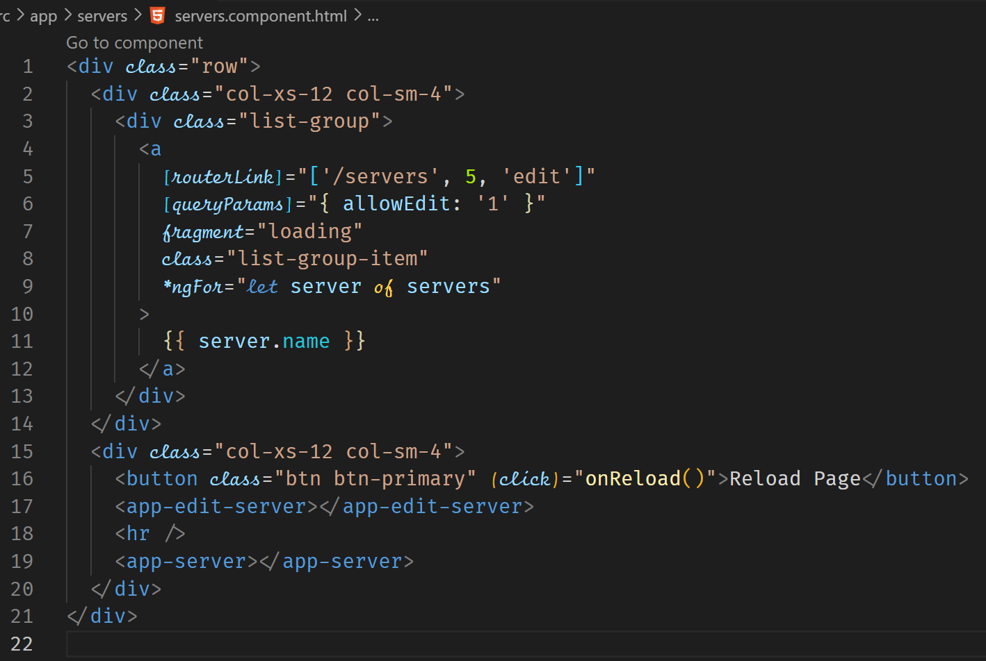



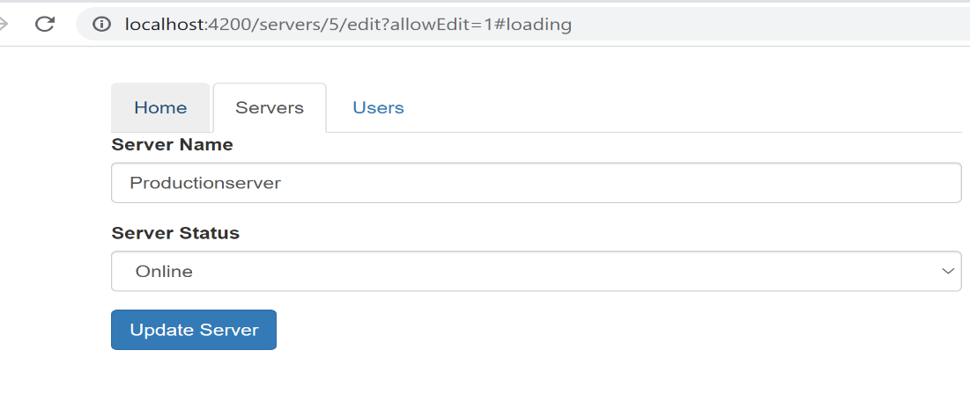



Using code to navigate programmatically with query parameters

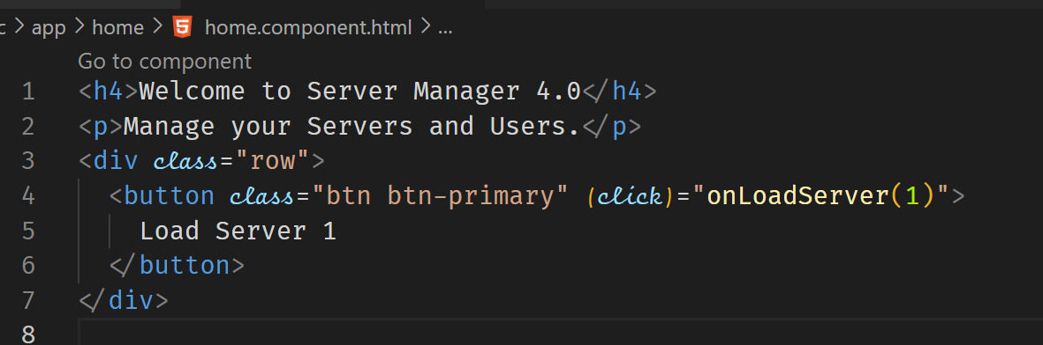

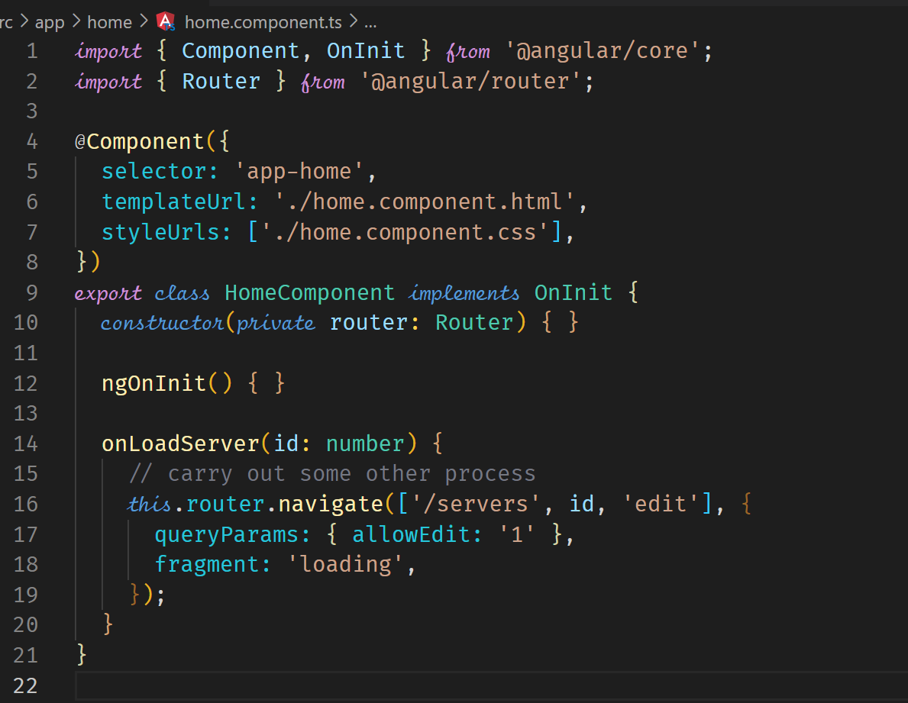



Retrieving Query Parameters and Fragments

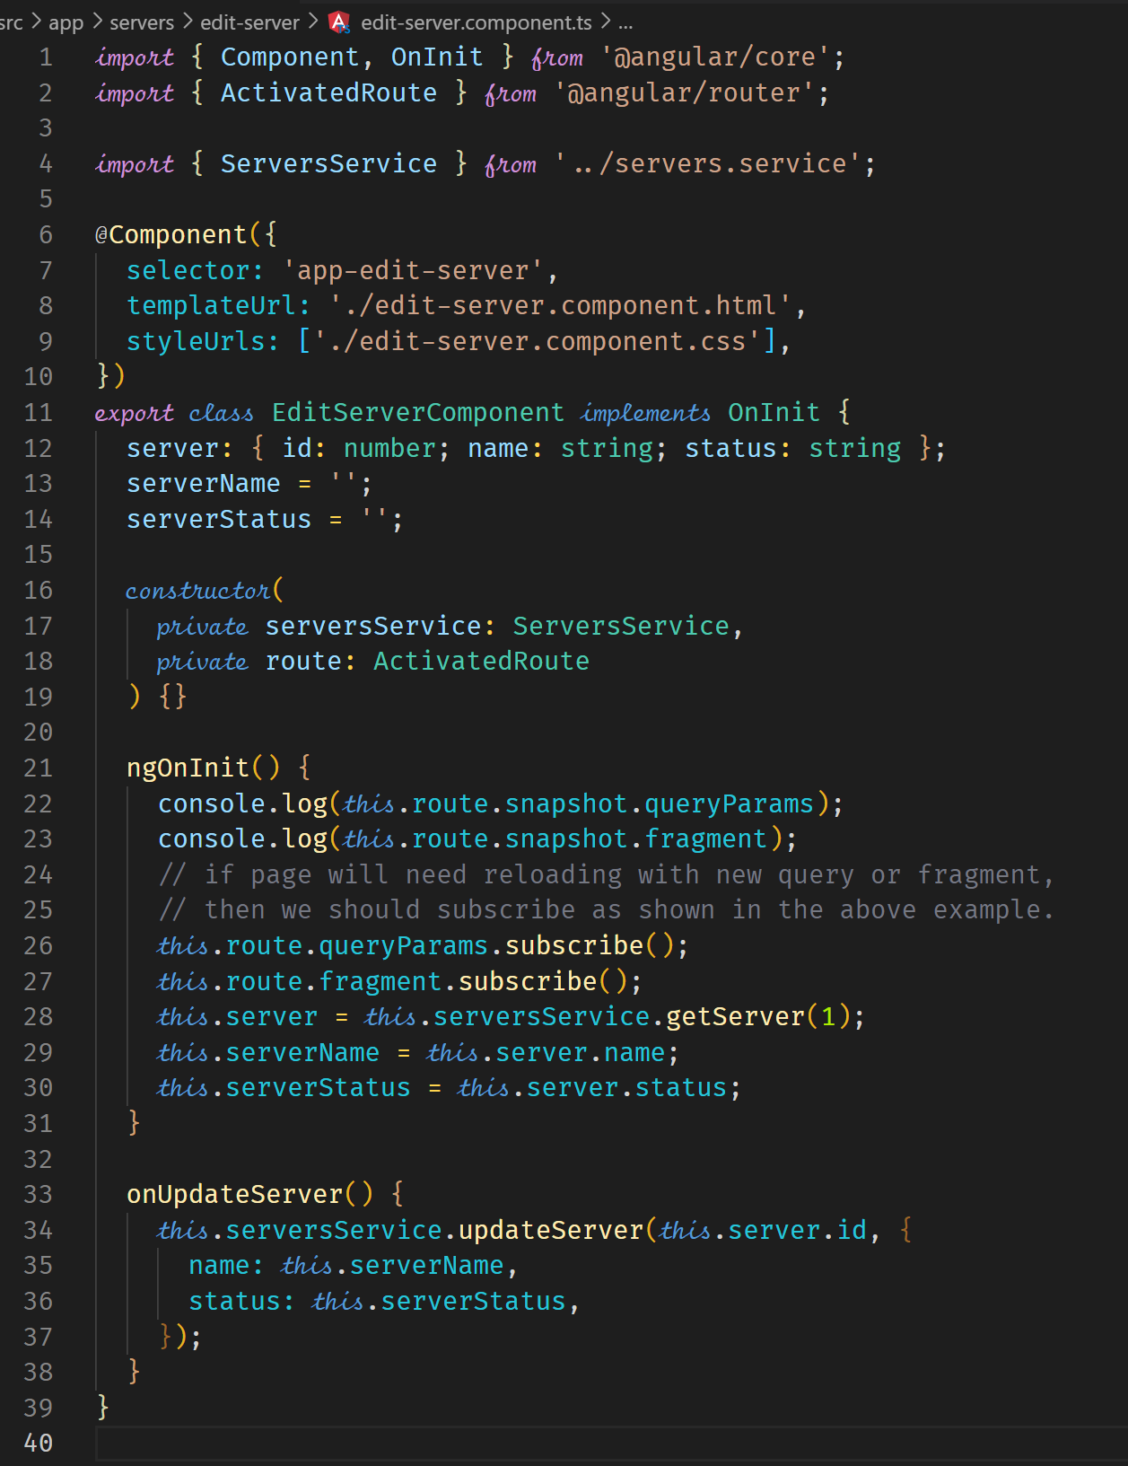



**Setting up Child (Nested) Routes**

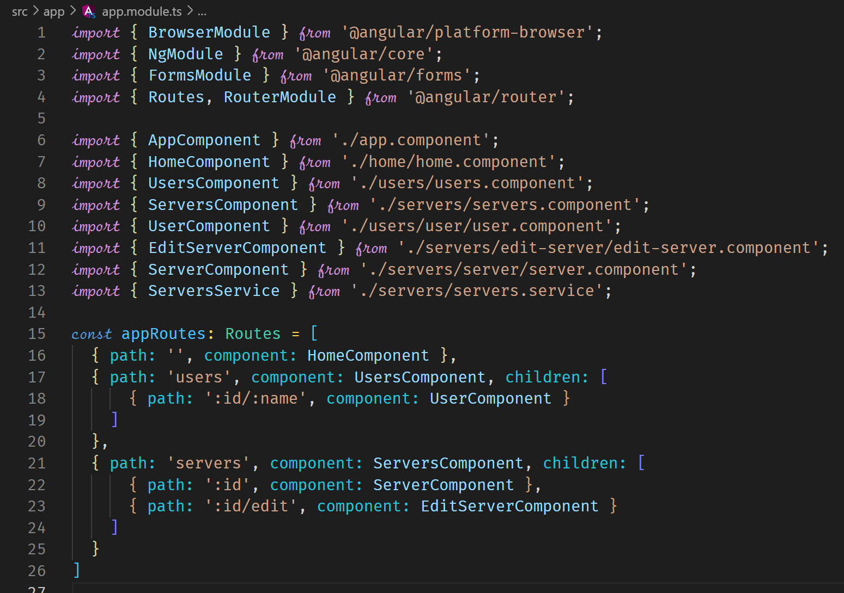



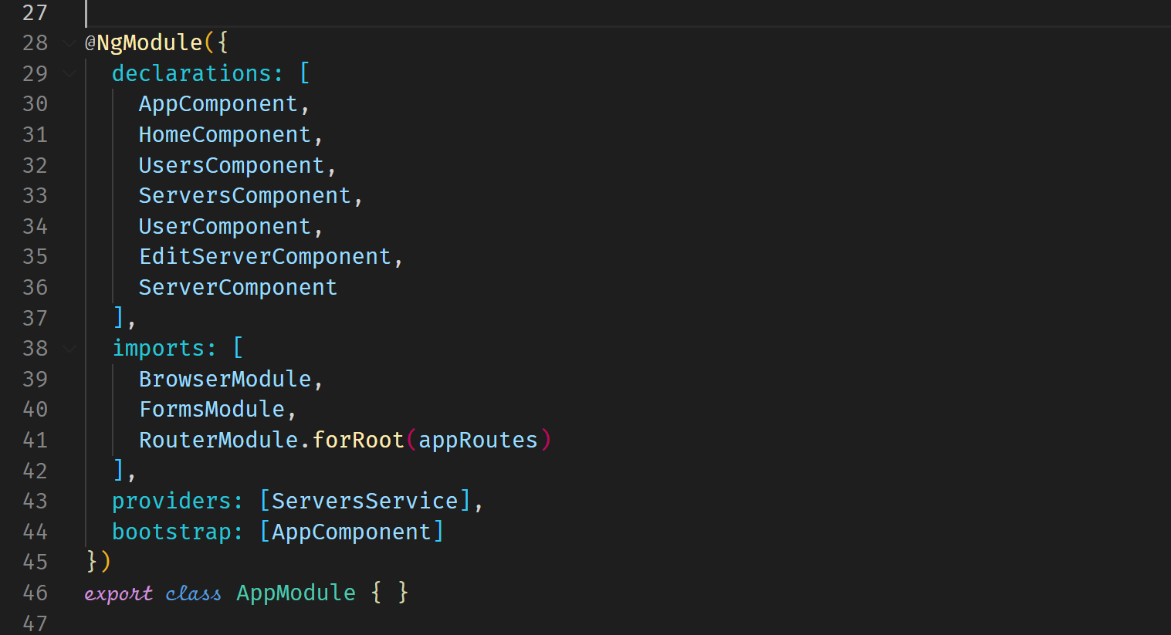

The child components will now be displayed in the router-outlet of the parent component. We do not specify them directly in the parent component but we need a router-outlet element.

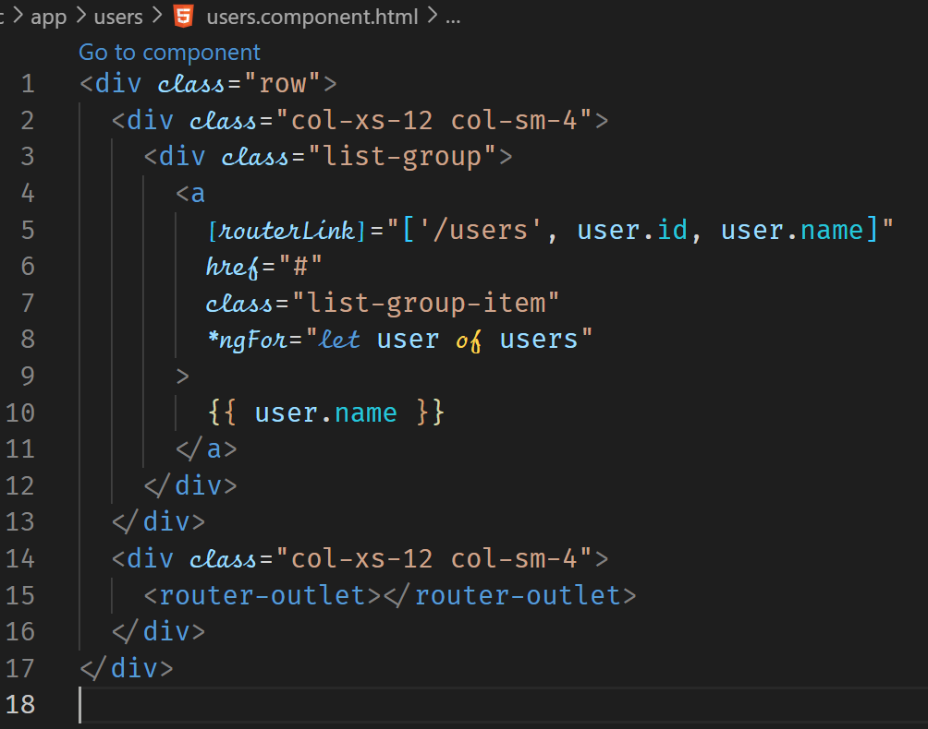



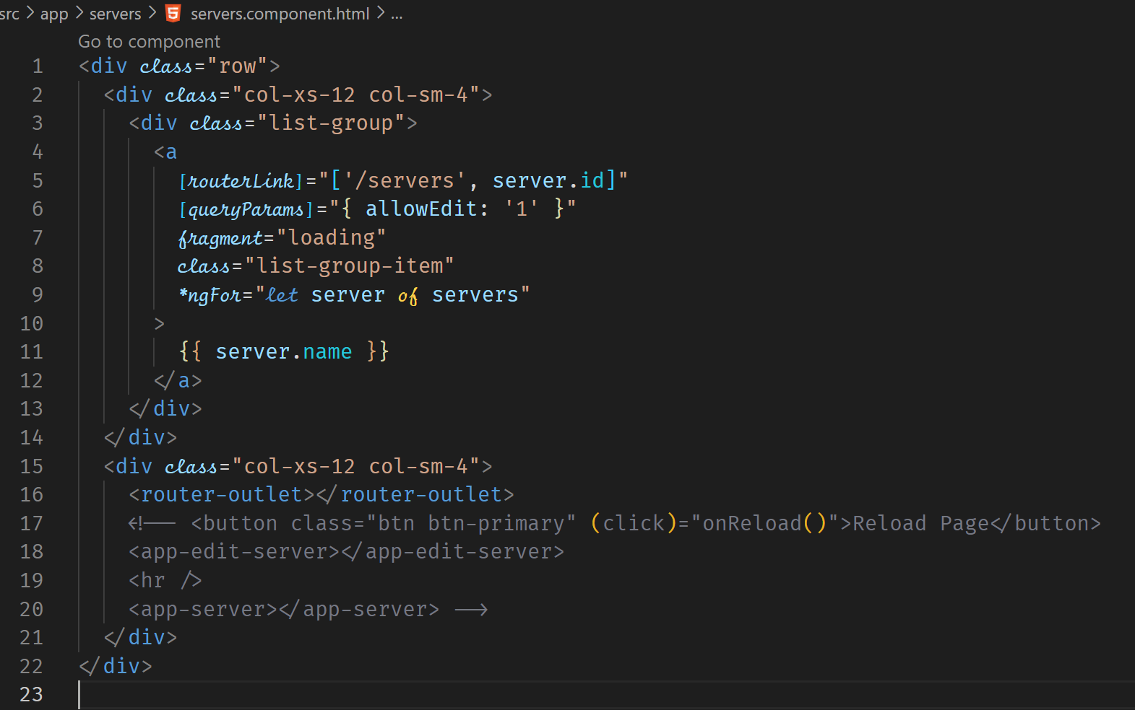

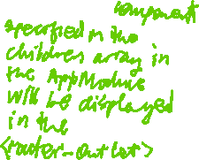

**Using Query Parameters – Practice**

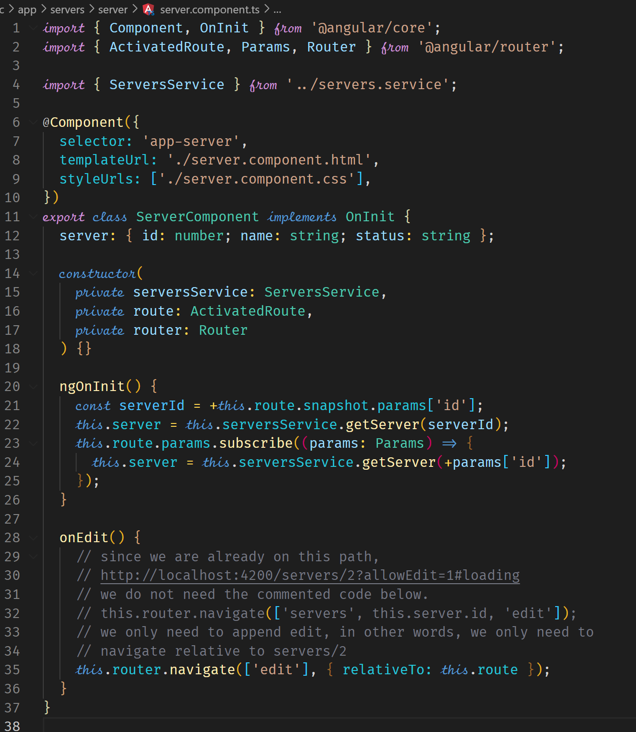

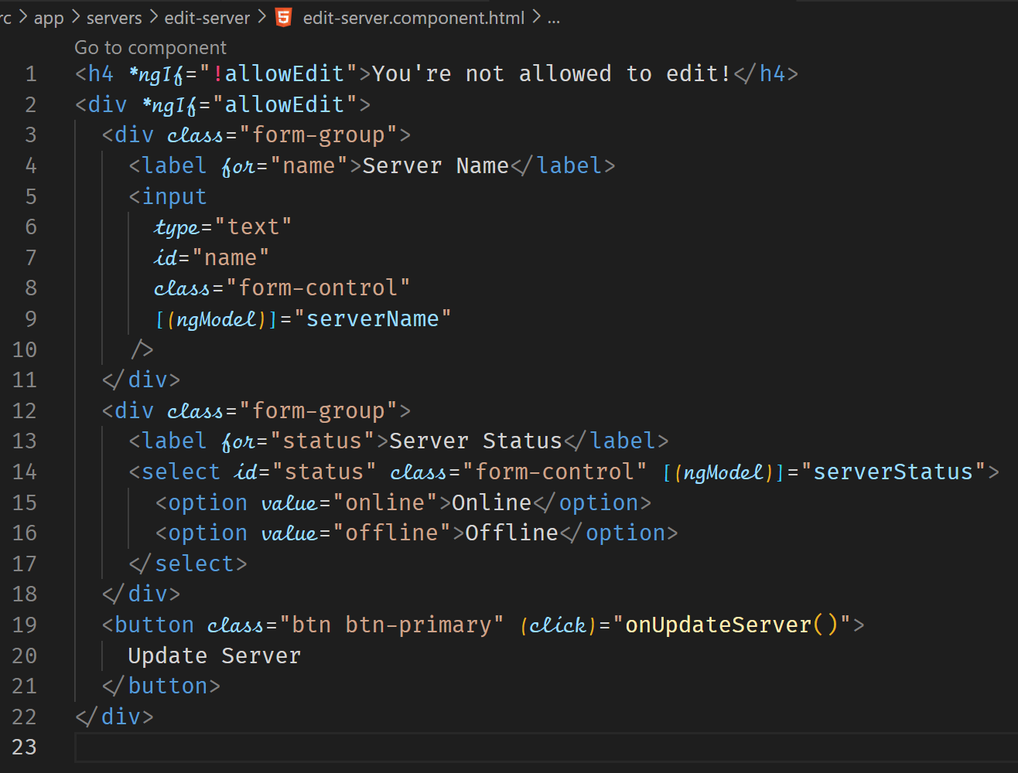

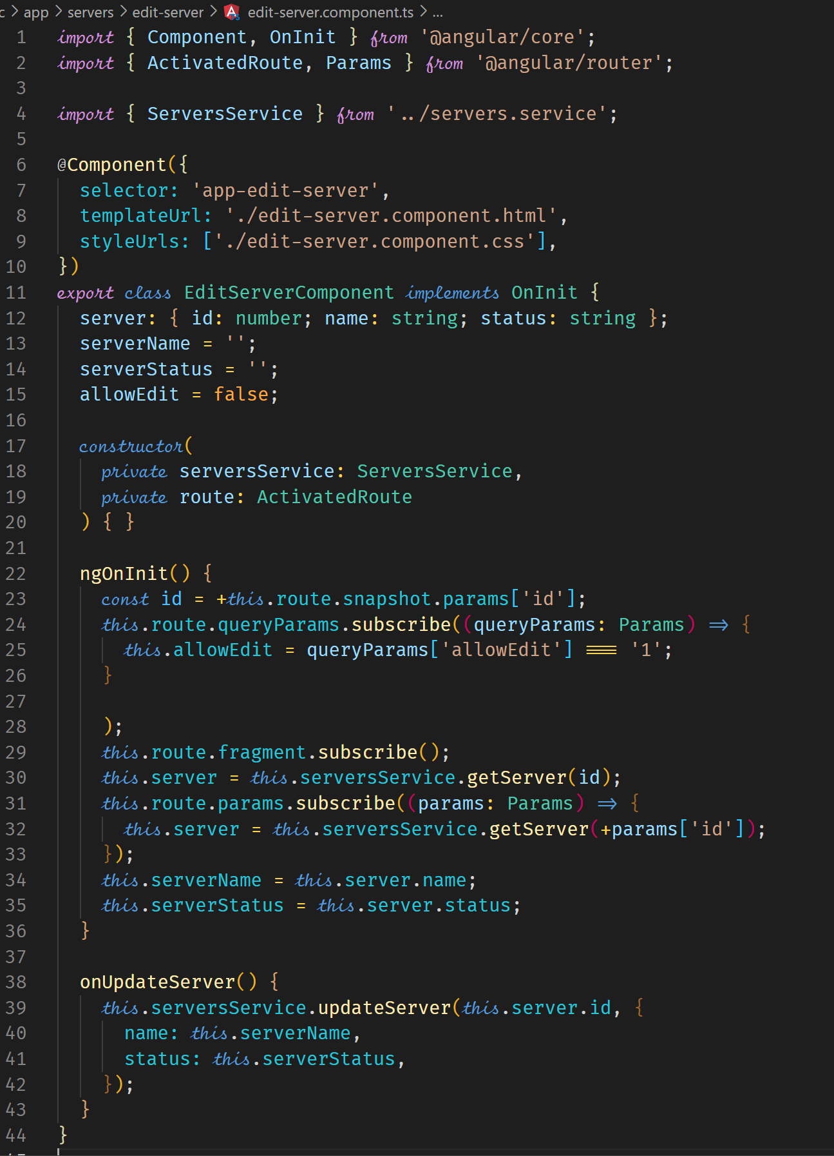

At this point, query parameters are not preserved when we open the EditServerComponent. We should find a way of preserving them.

**Configuring the Handling of Query Parameters**

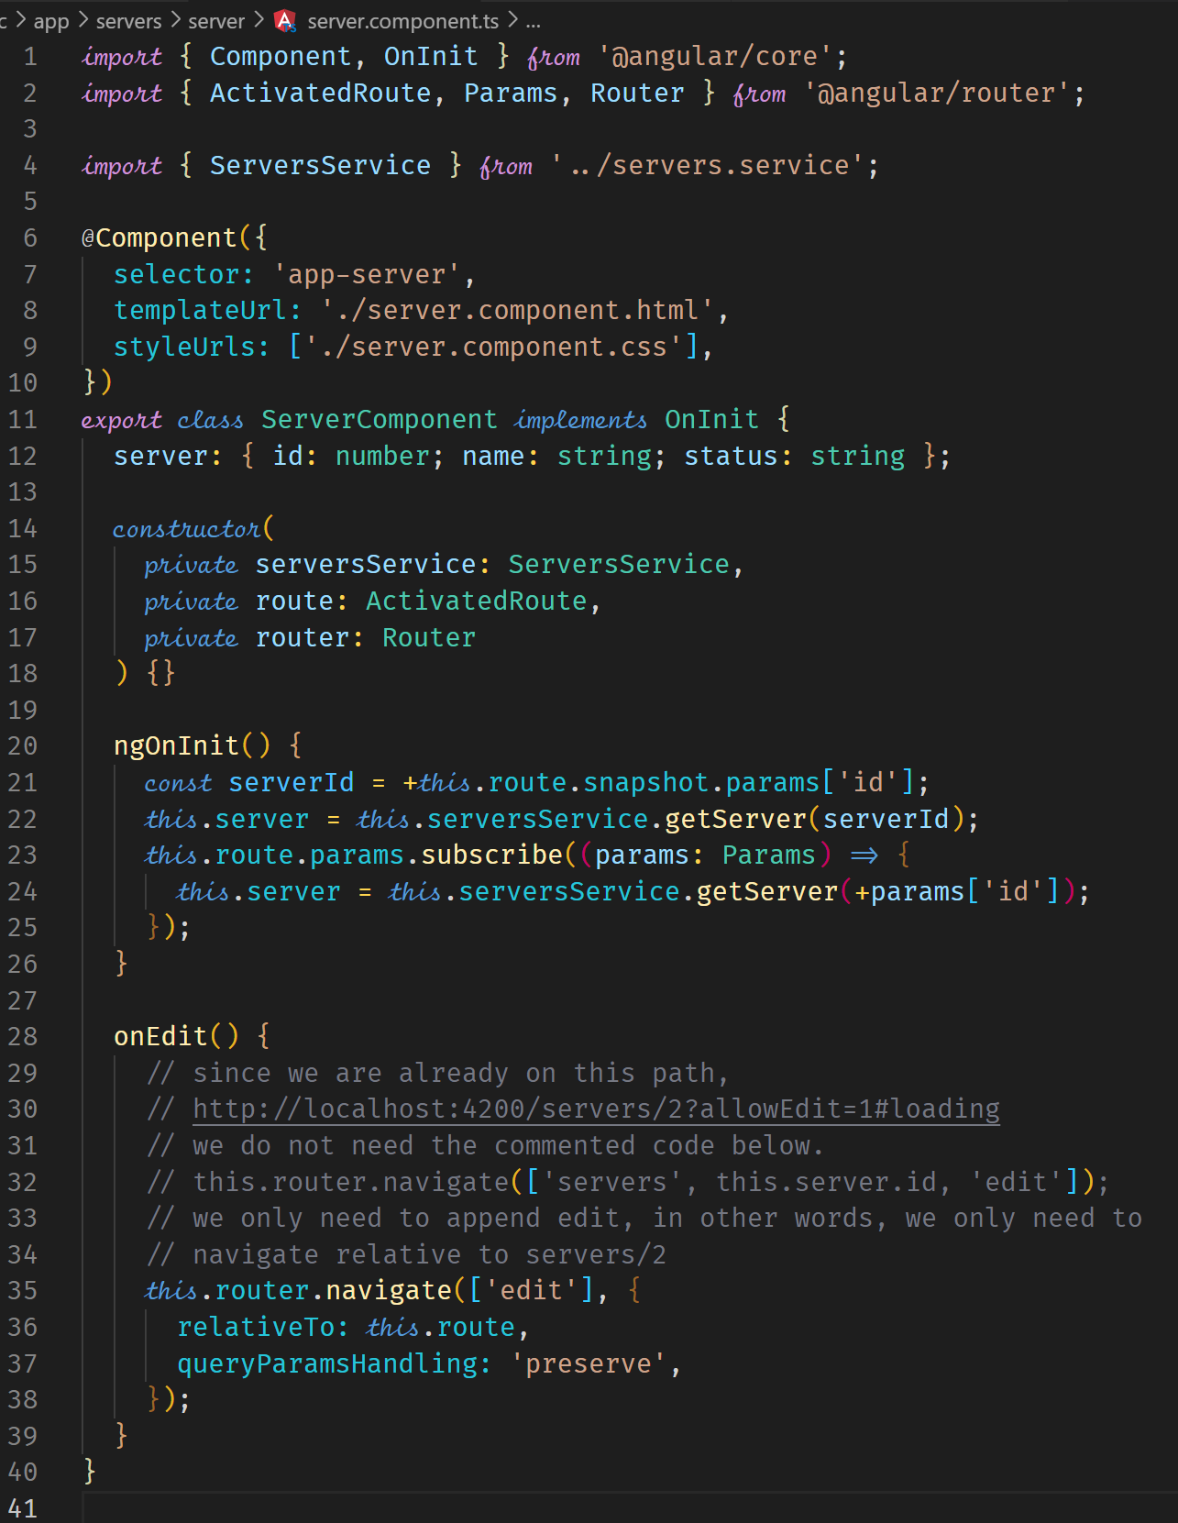



**Redirecting and Wildcard Routes**

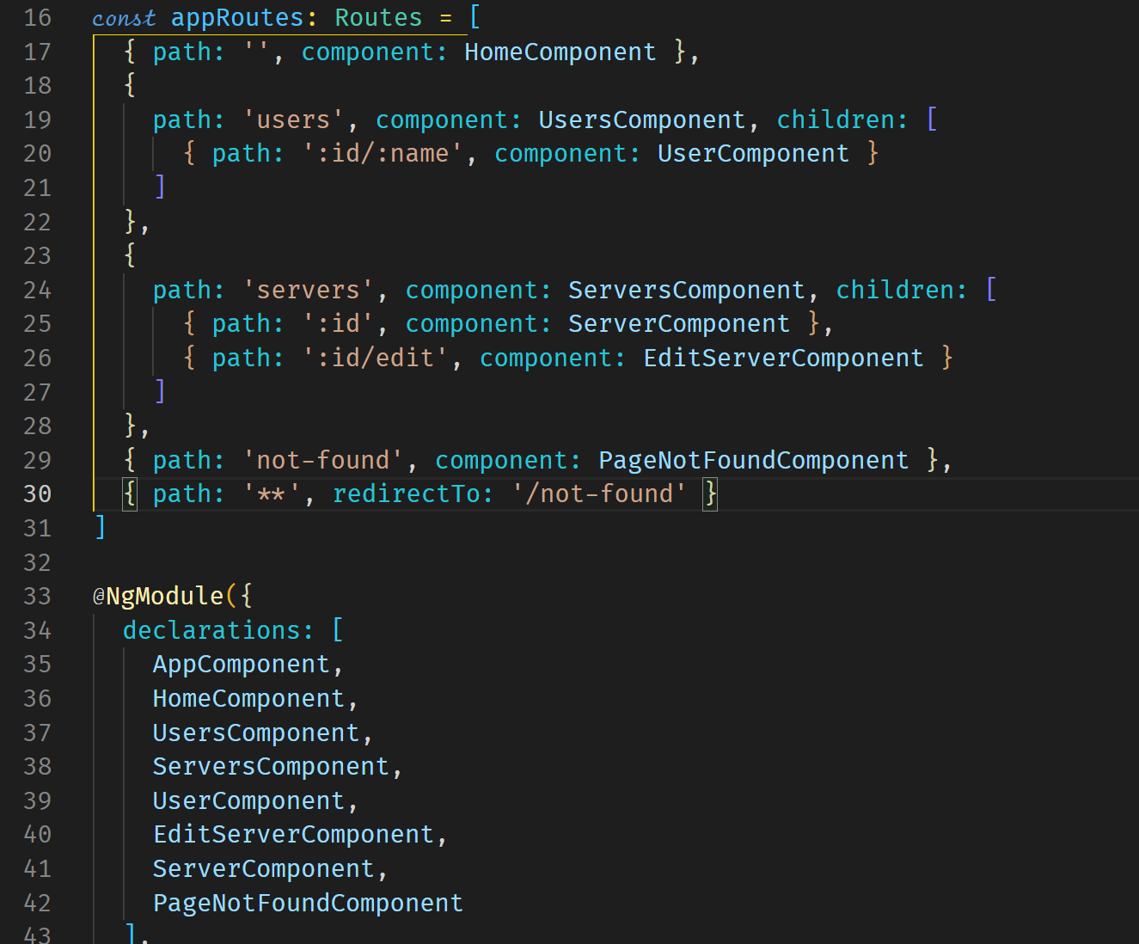



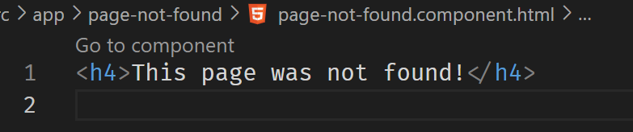

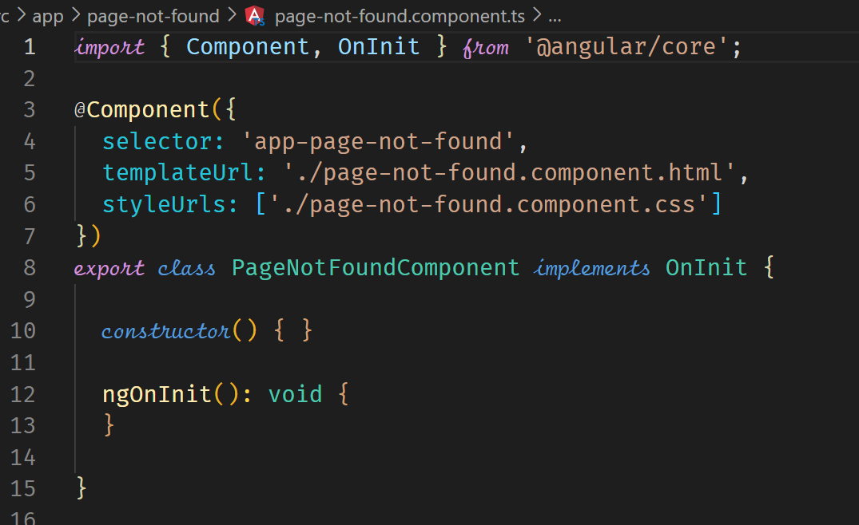

**Outsourcing the Route Configuration**

Outsourcing the router configuration is a best practice if the application has many routes configured. It makes the code organized, readable and easier to maintain.

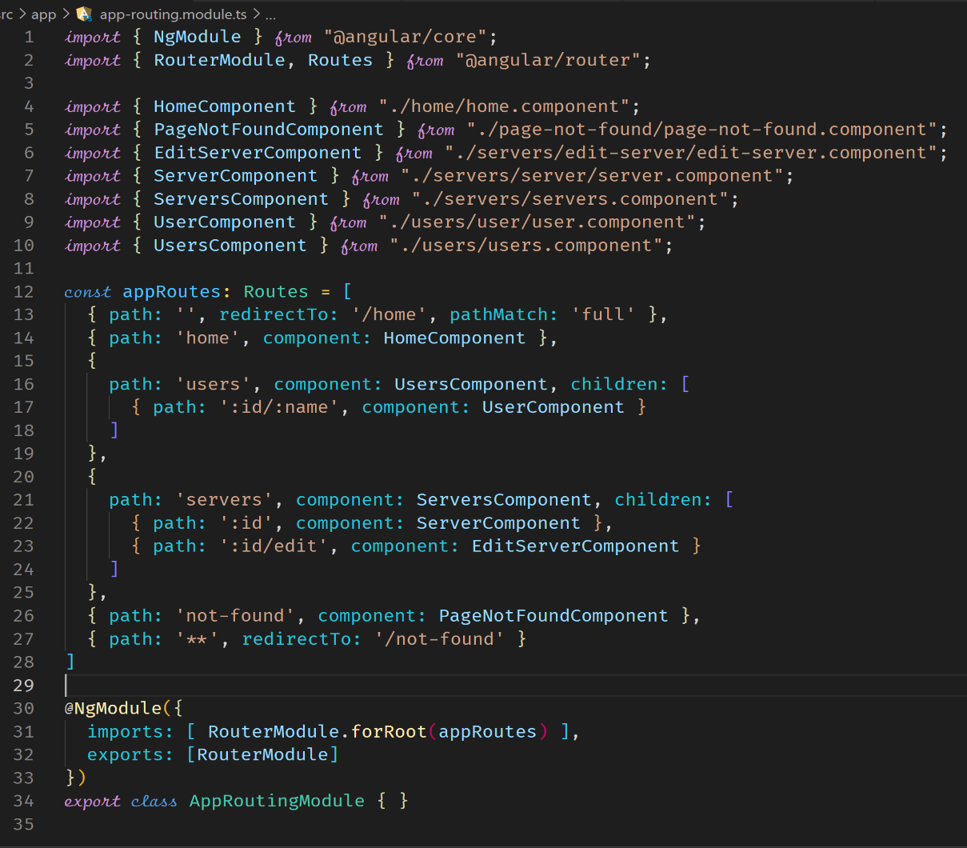



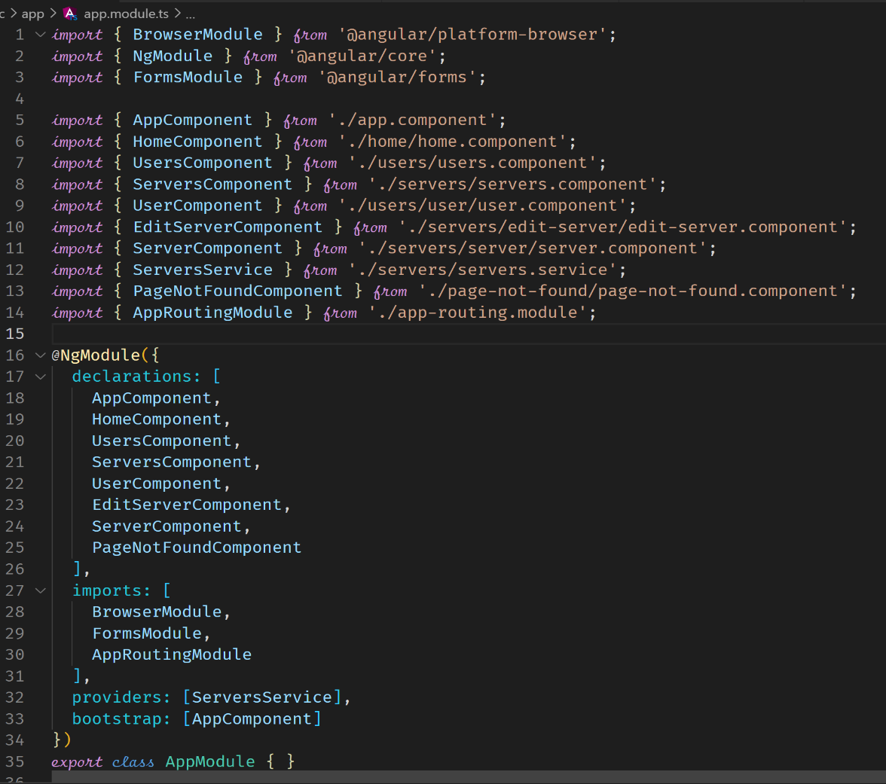



**Route Guards**

These allow us to run some code before or after our route is accessed. This helps to protect routes, for example in making sure a route is only available to authenticated users.

**Protecting Routes with canActivate**

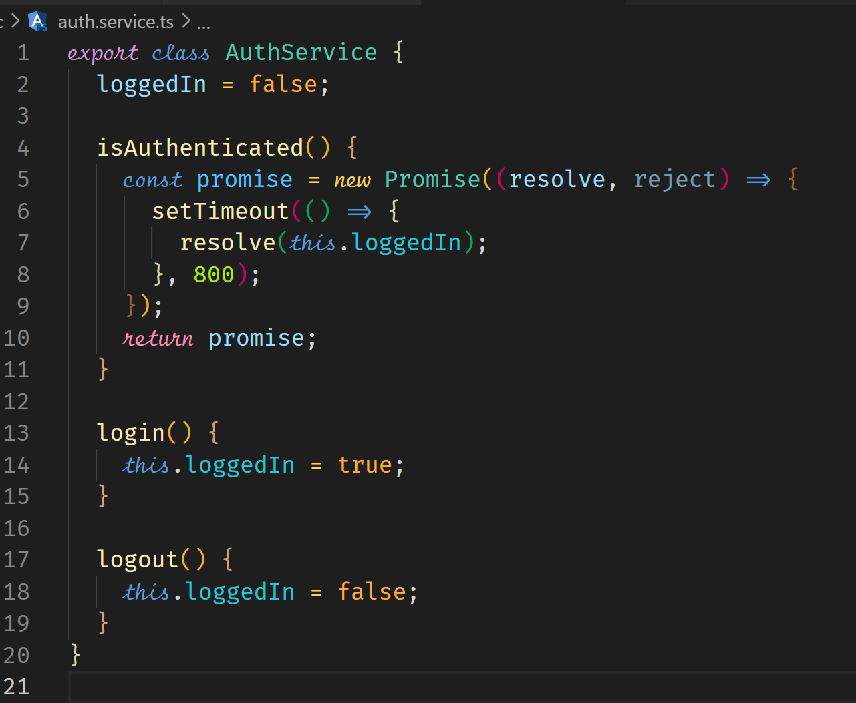



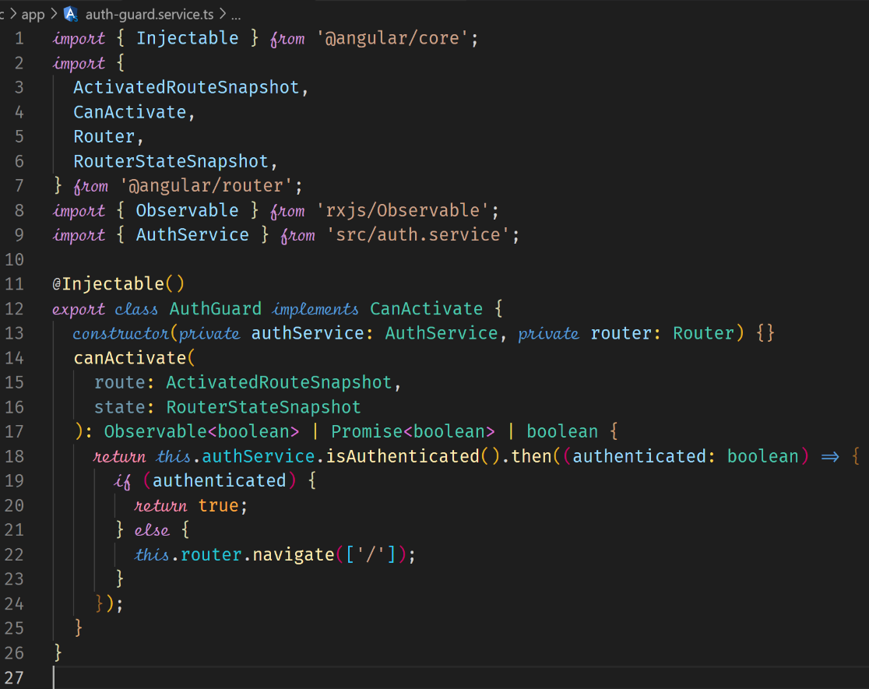



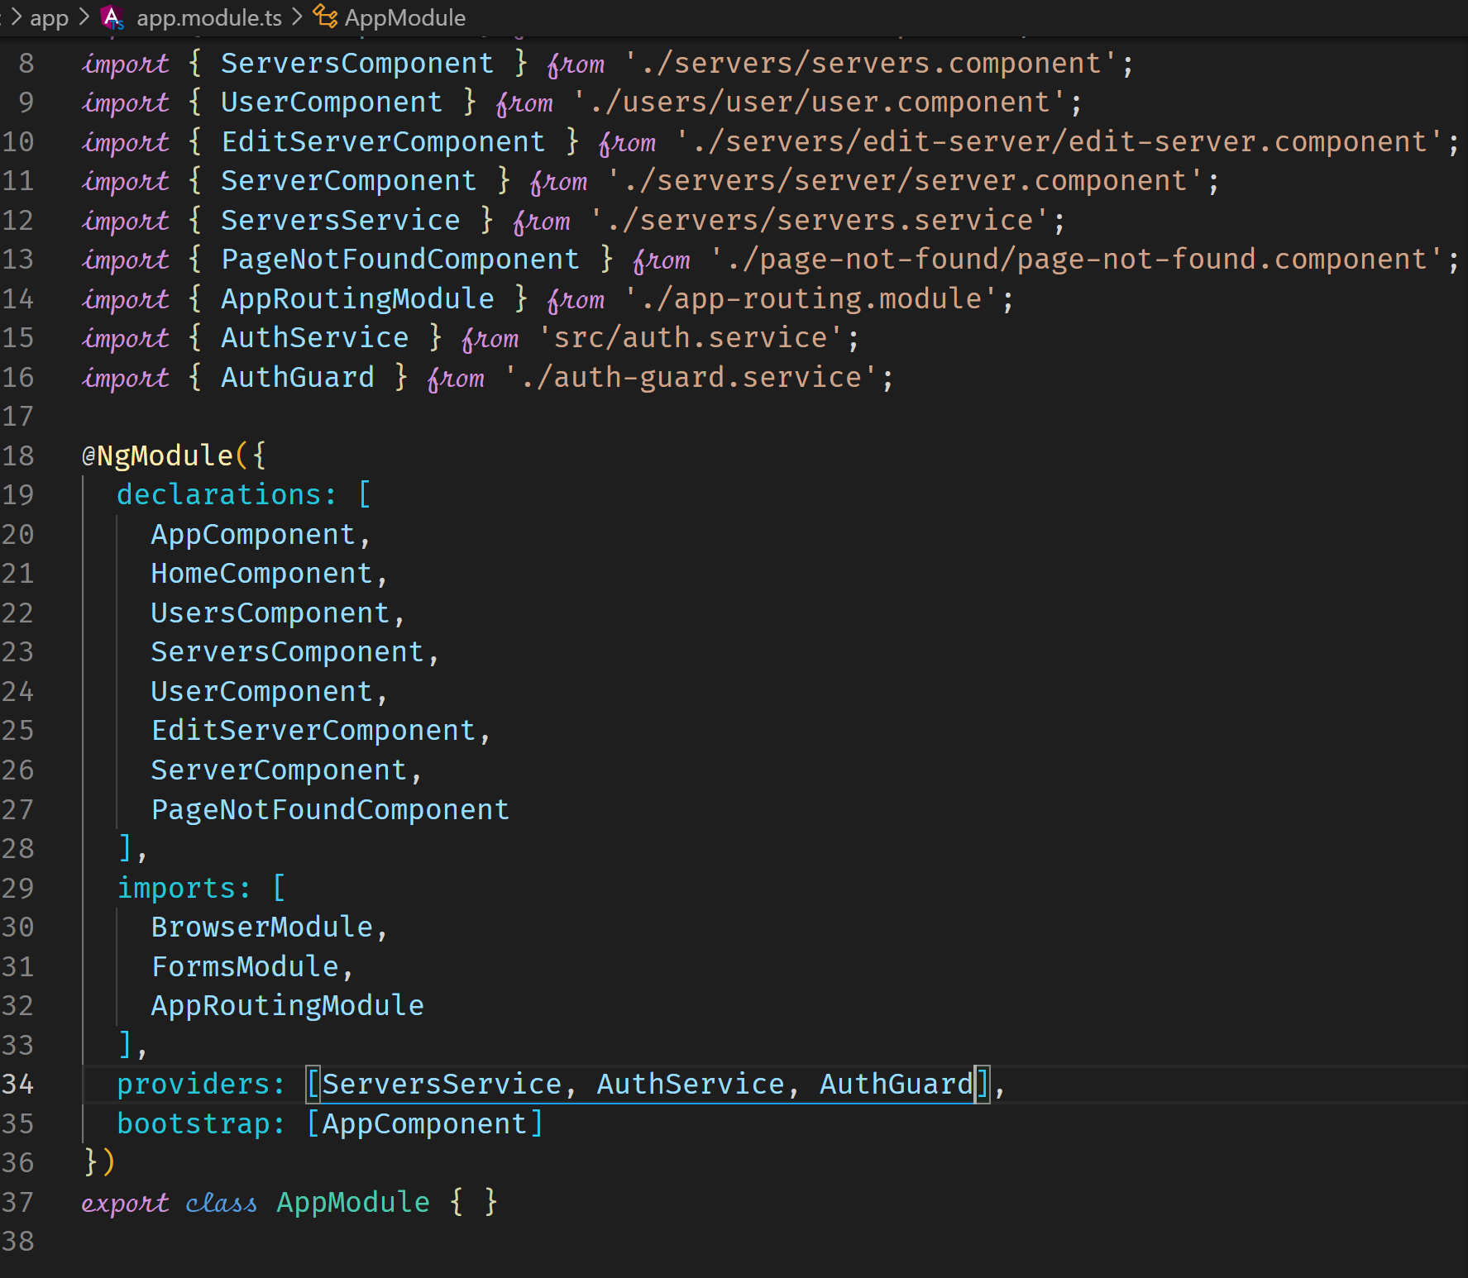



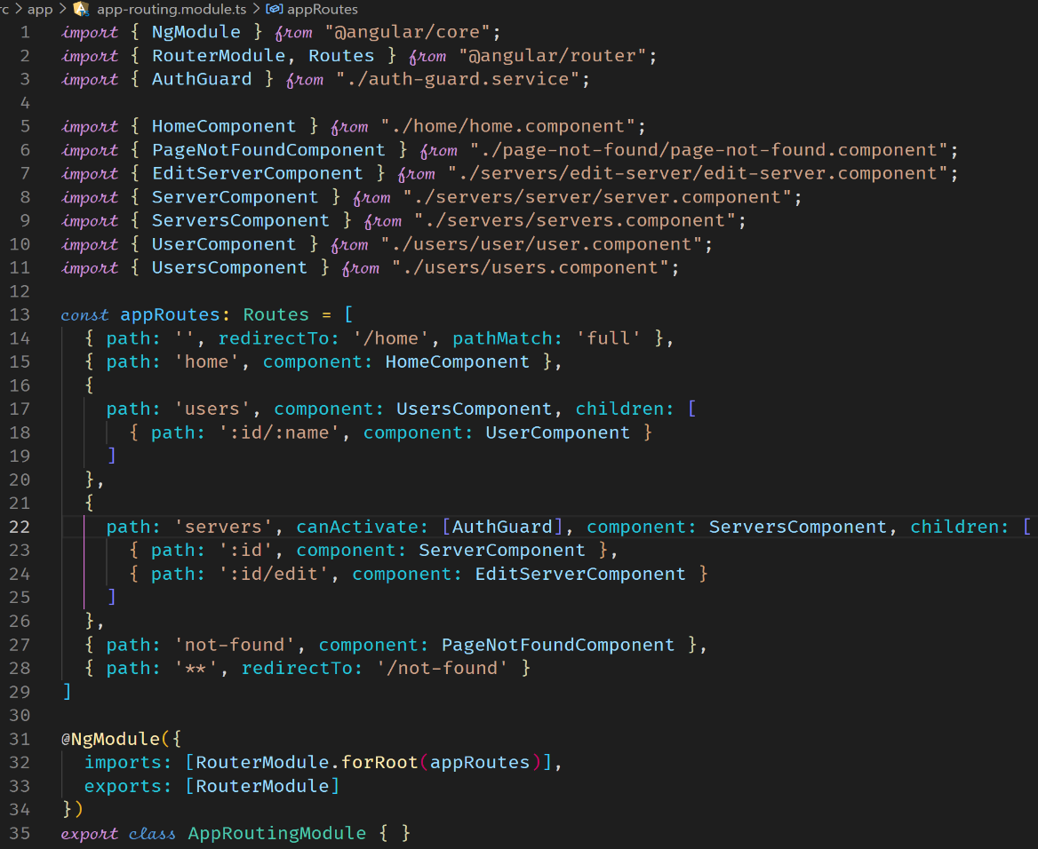



**Protecting Child (Nested) Routes with canActivateChild**

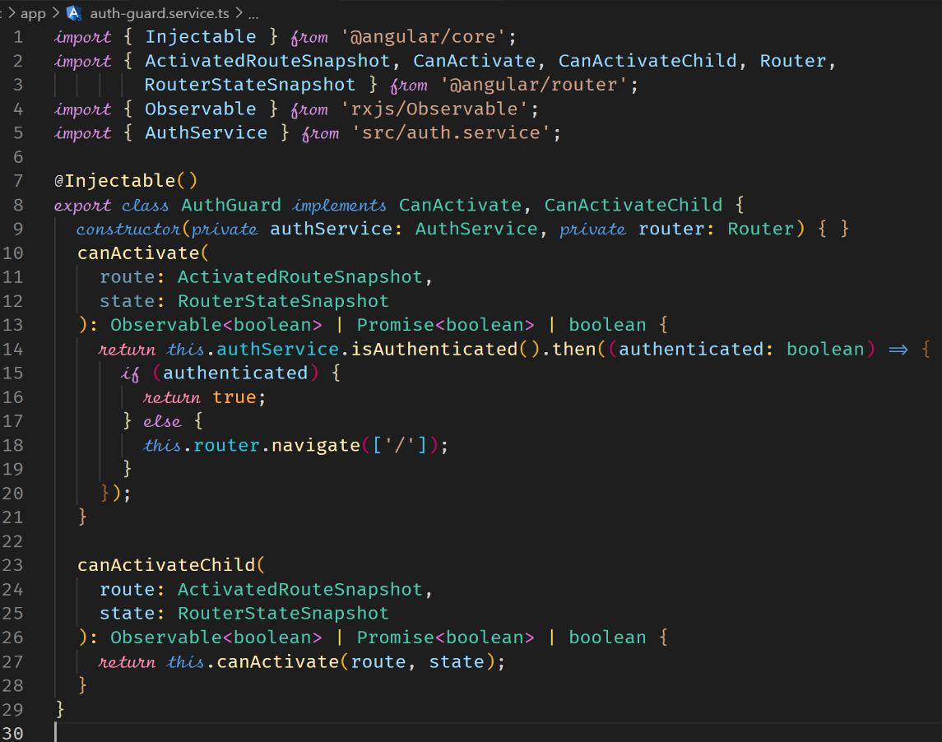



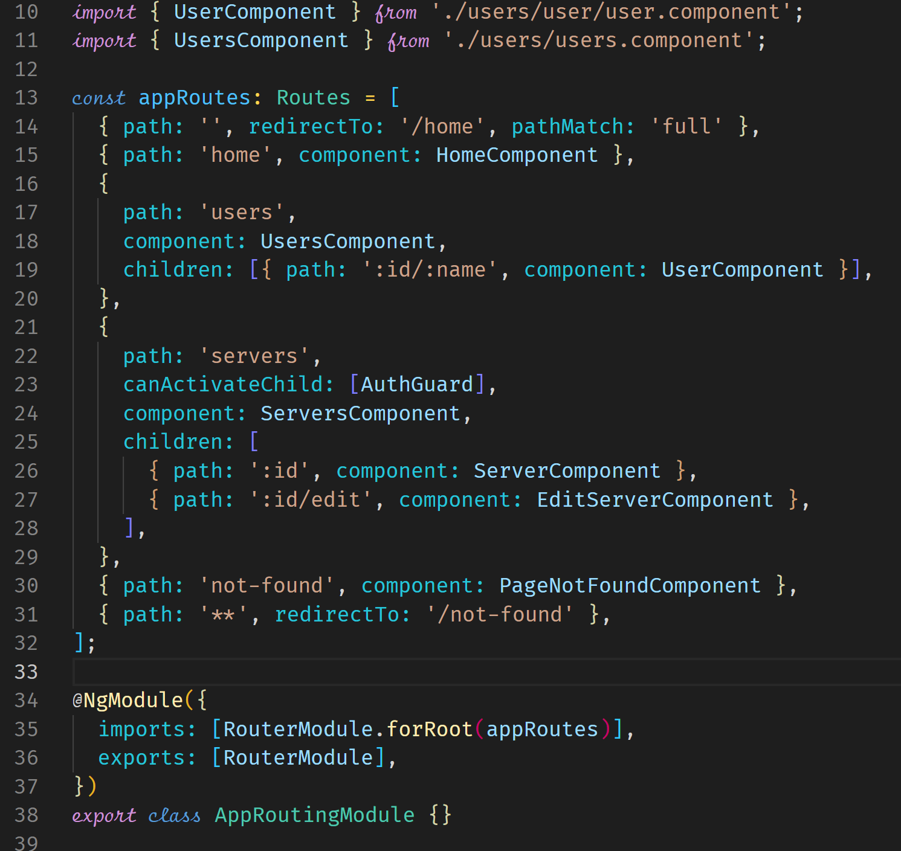



**Using a Fake Auth Service**

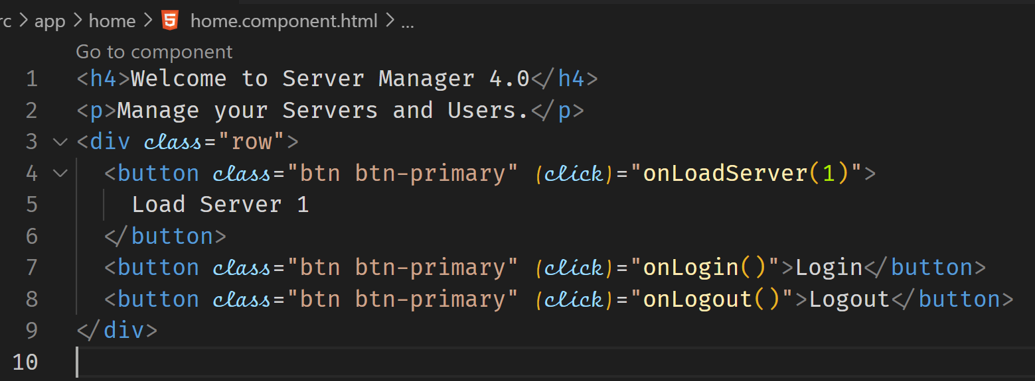

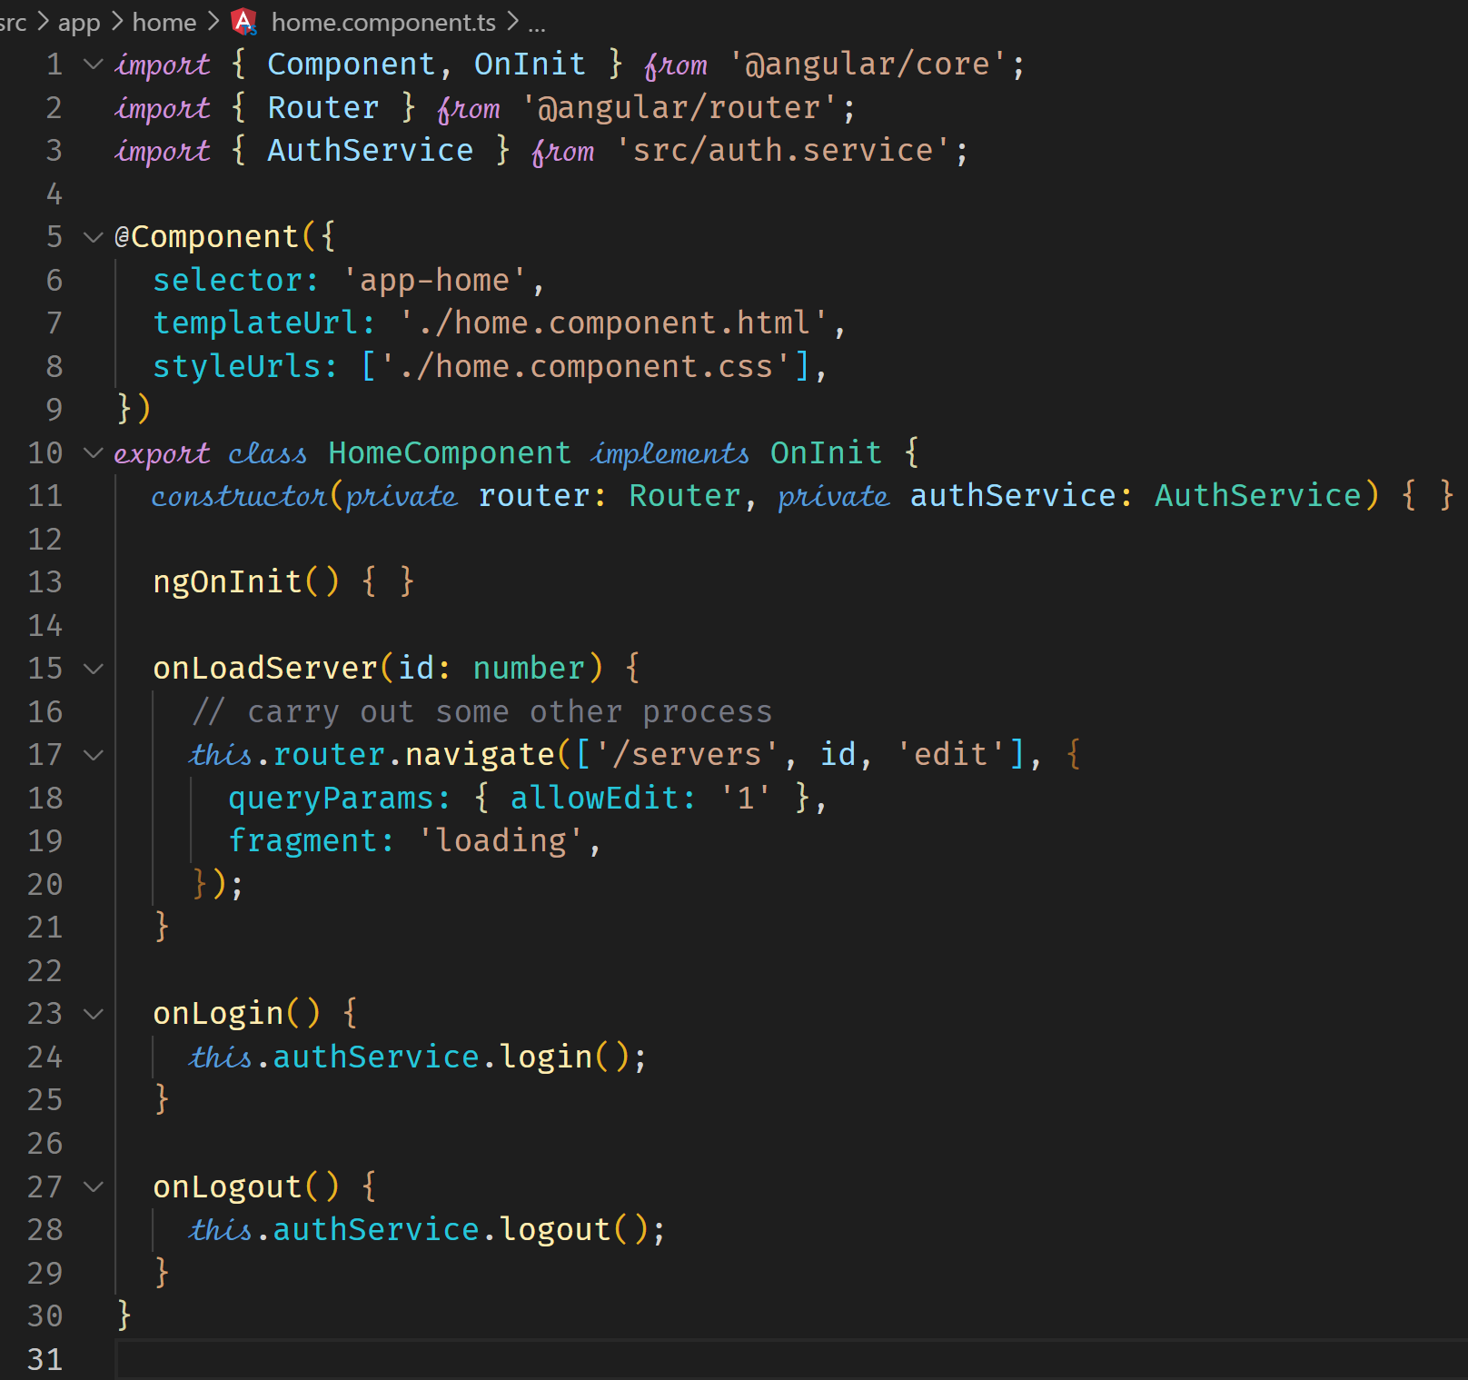

**Controlling Navigation with canDeactivate**

This allows us to control a user if he can leave or navigate away from a route. This can help prevent a user from accidentally navigating away, suppose the user was in the middle of input.

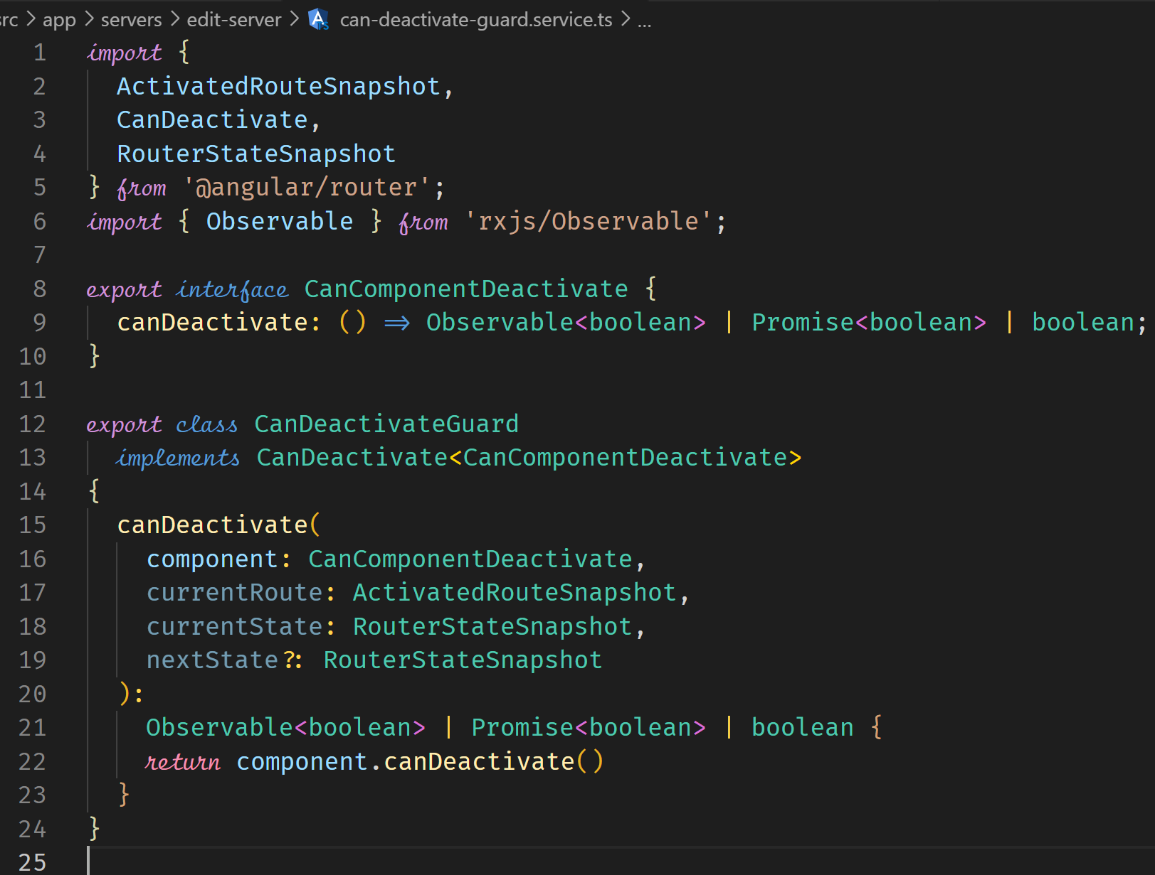



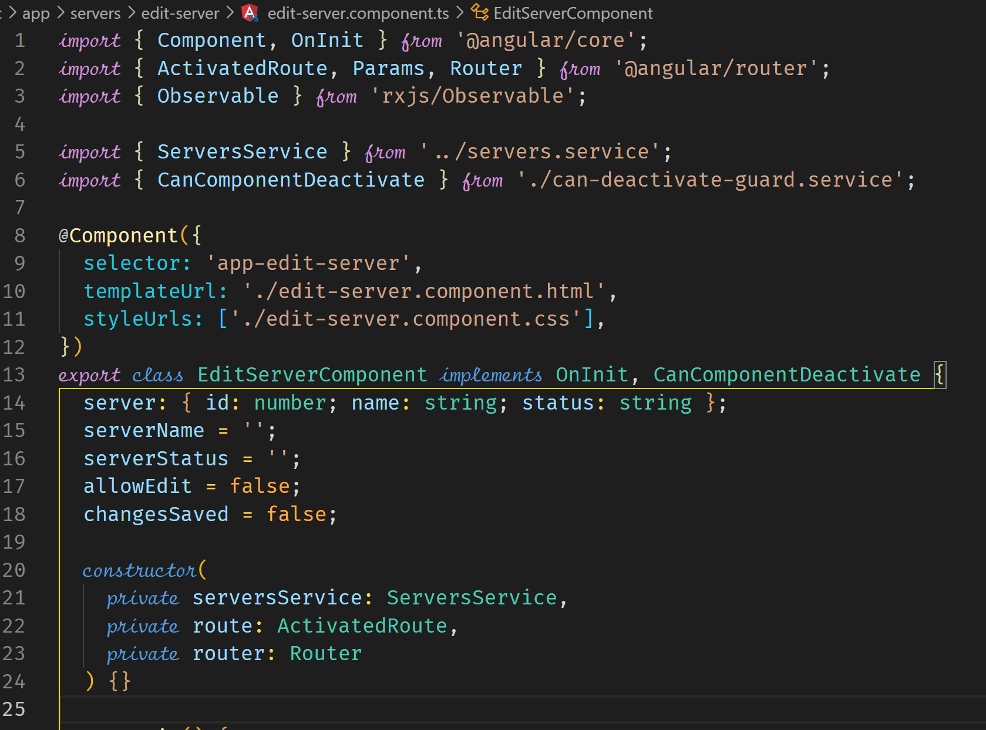

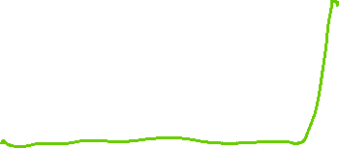

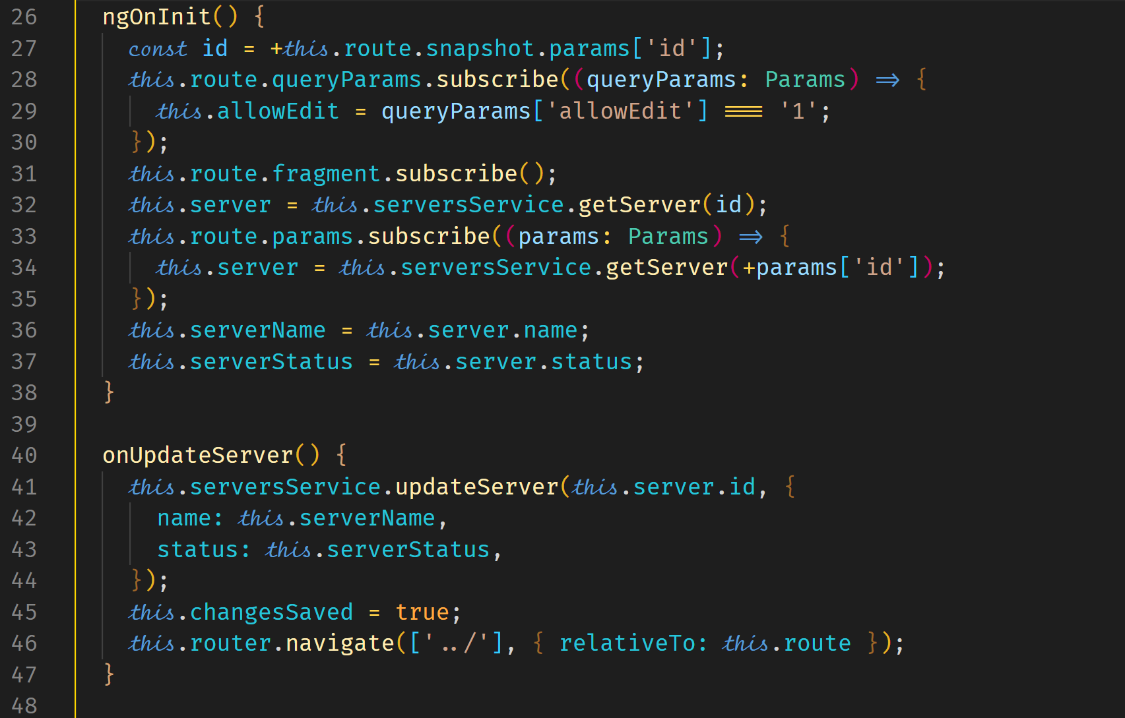



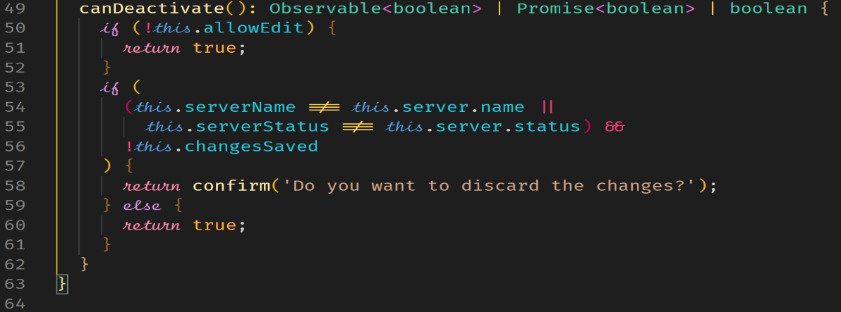



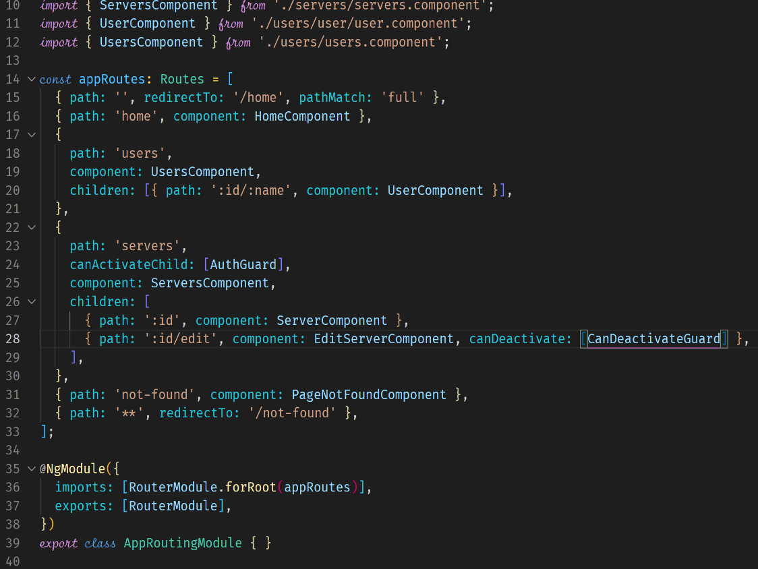



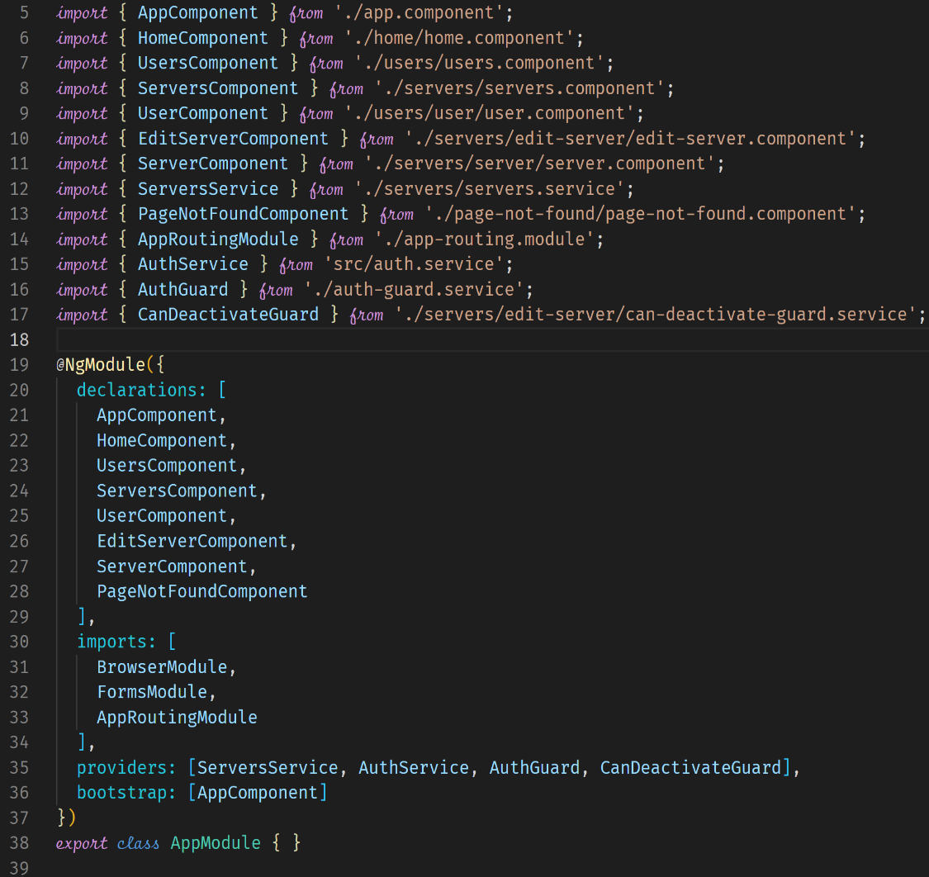



**Passing Static Data to a Route**

We use the error-page to demonstrate how to pass static data to a component via the route. Such data could be dynamic as the next example will show.

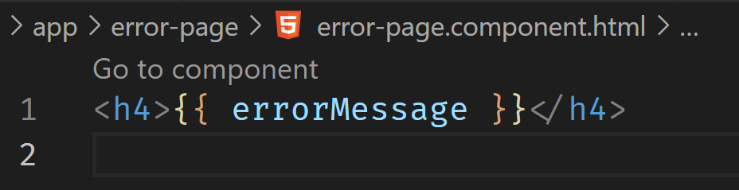

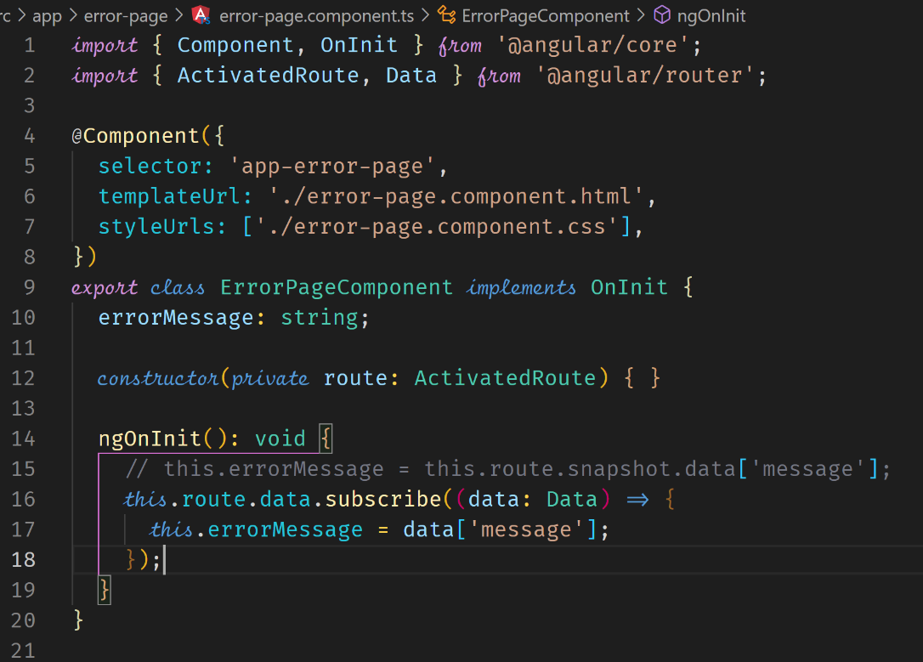

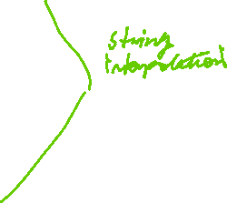

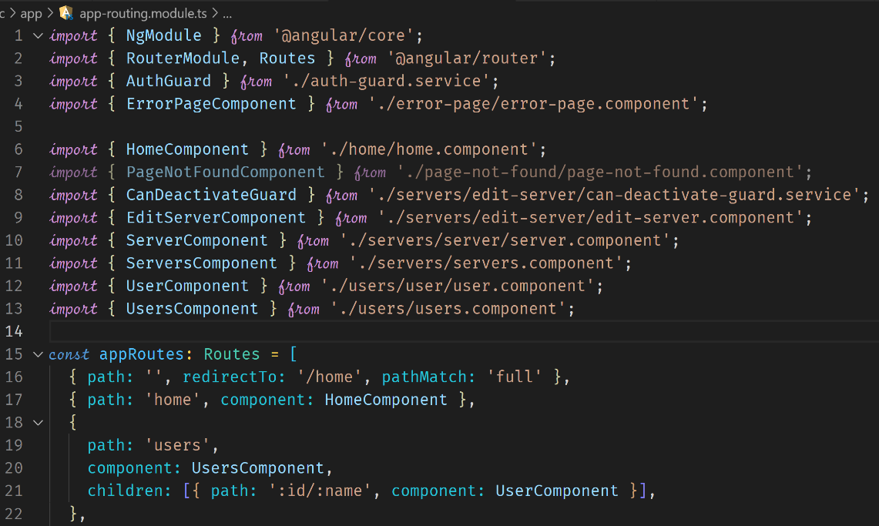

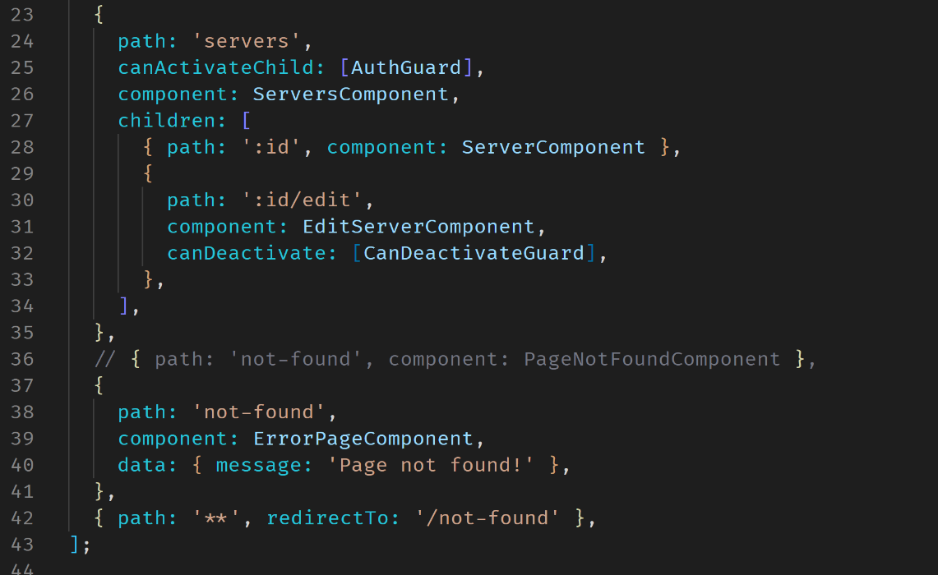



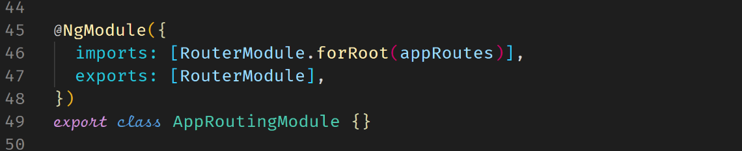

**Resolving Dynamic Data with the resolve Guard**

This is an example where data is fetched before it can be displayed in a router. The data can be fetched from the backend.

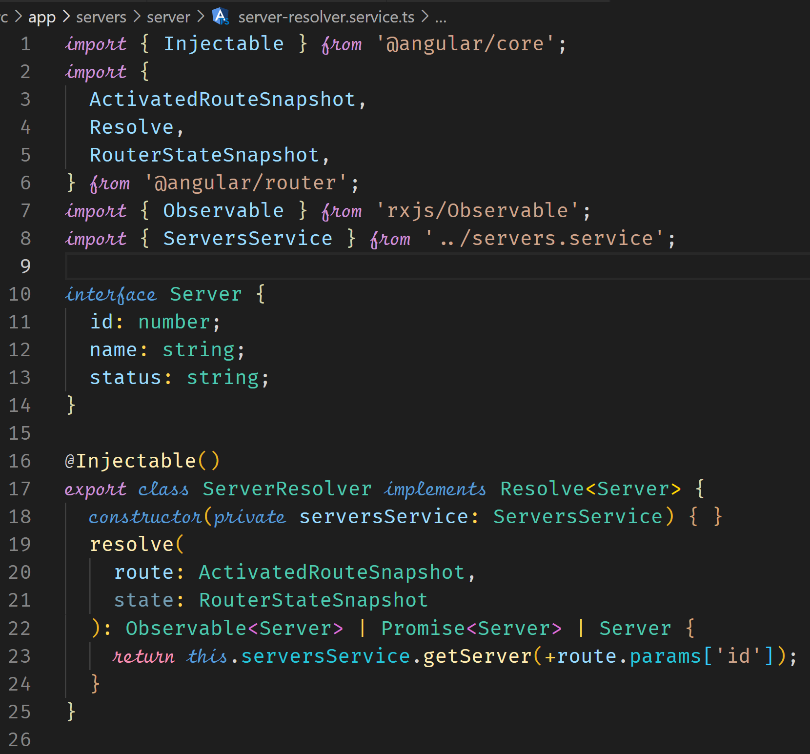

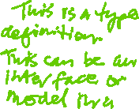

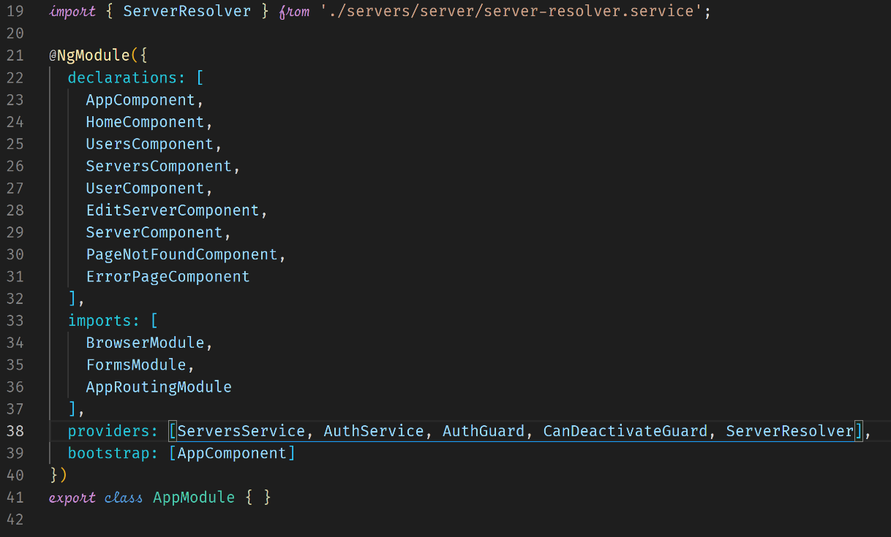



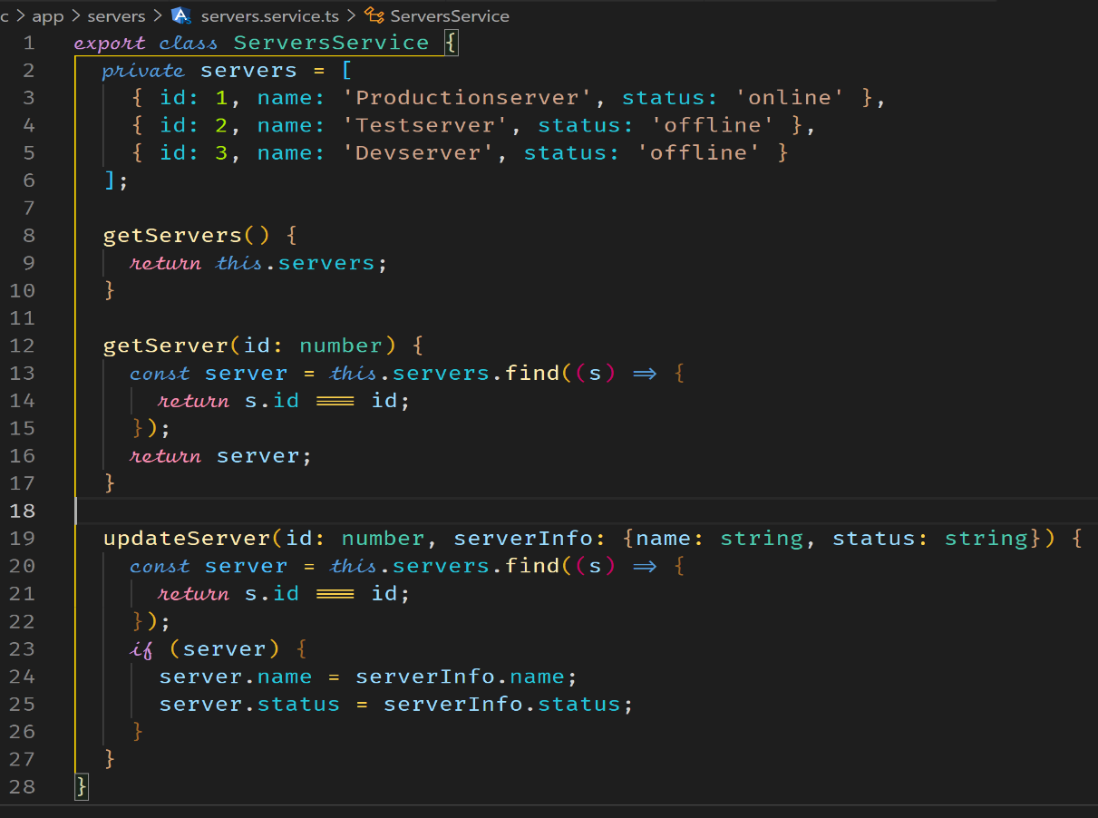



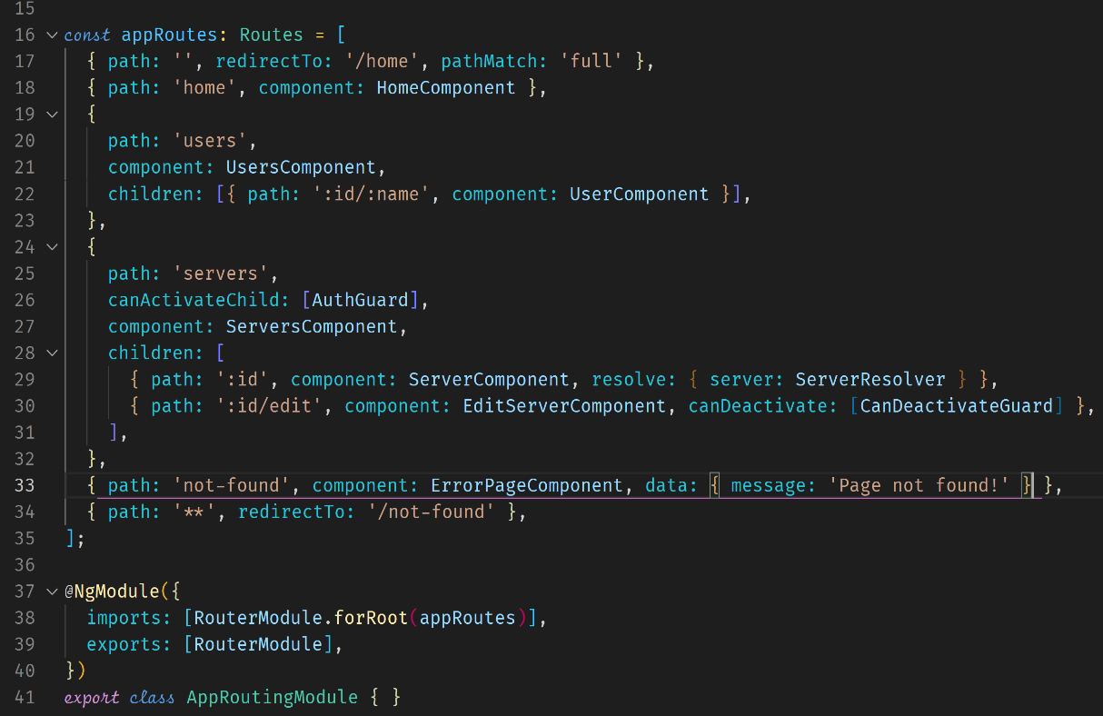



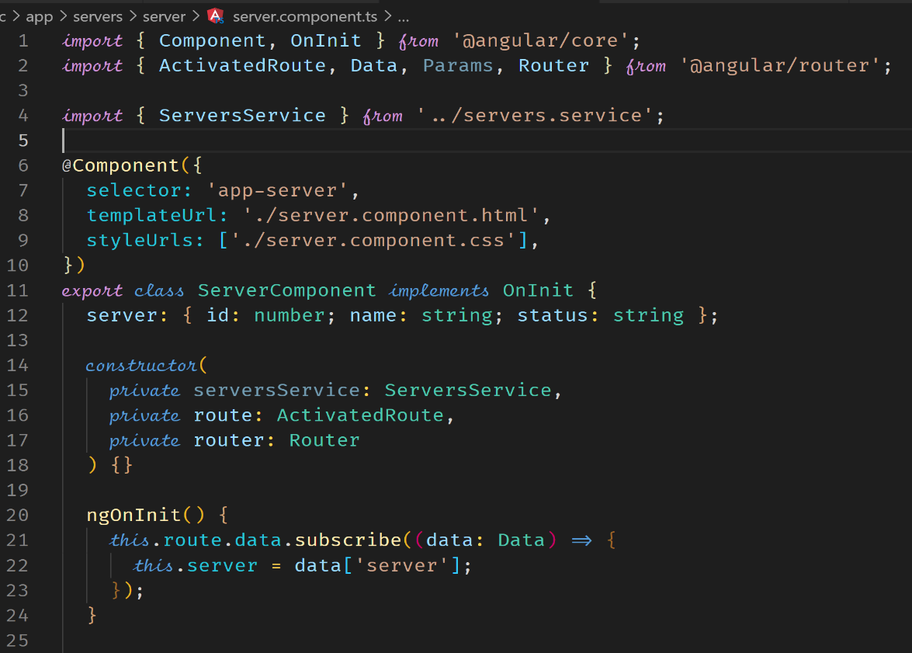



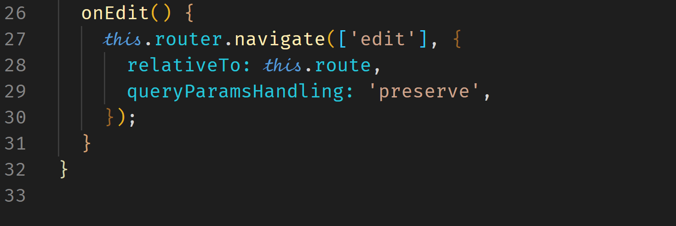

**Course Project - Routing**

**Setup Main Routes**

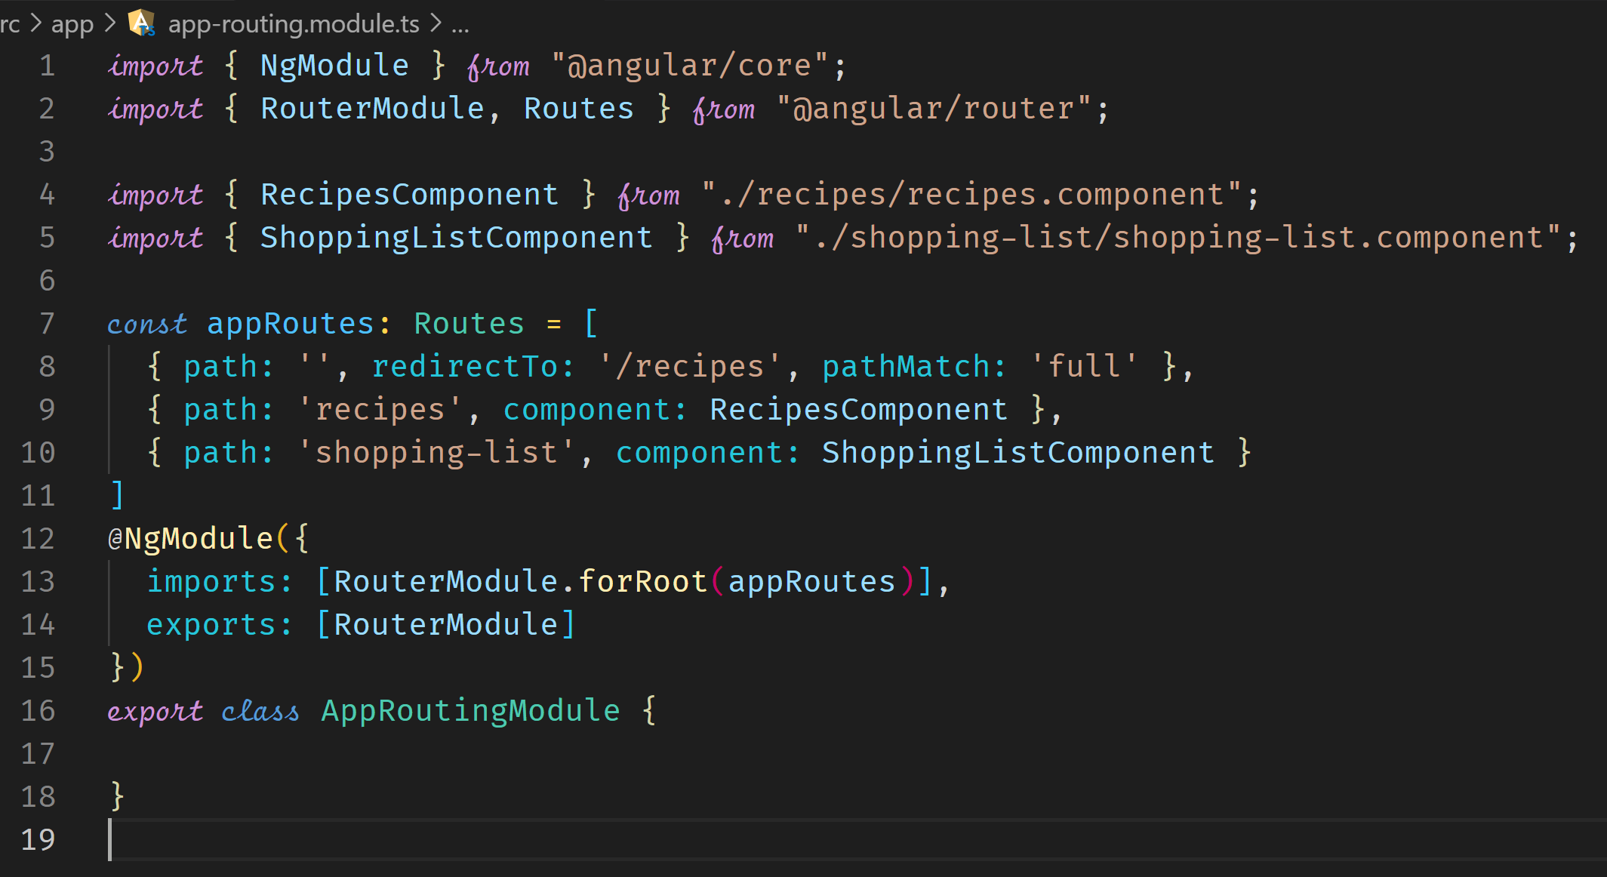

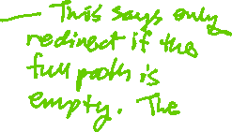

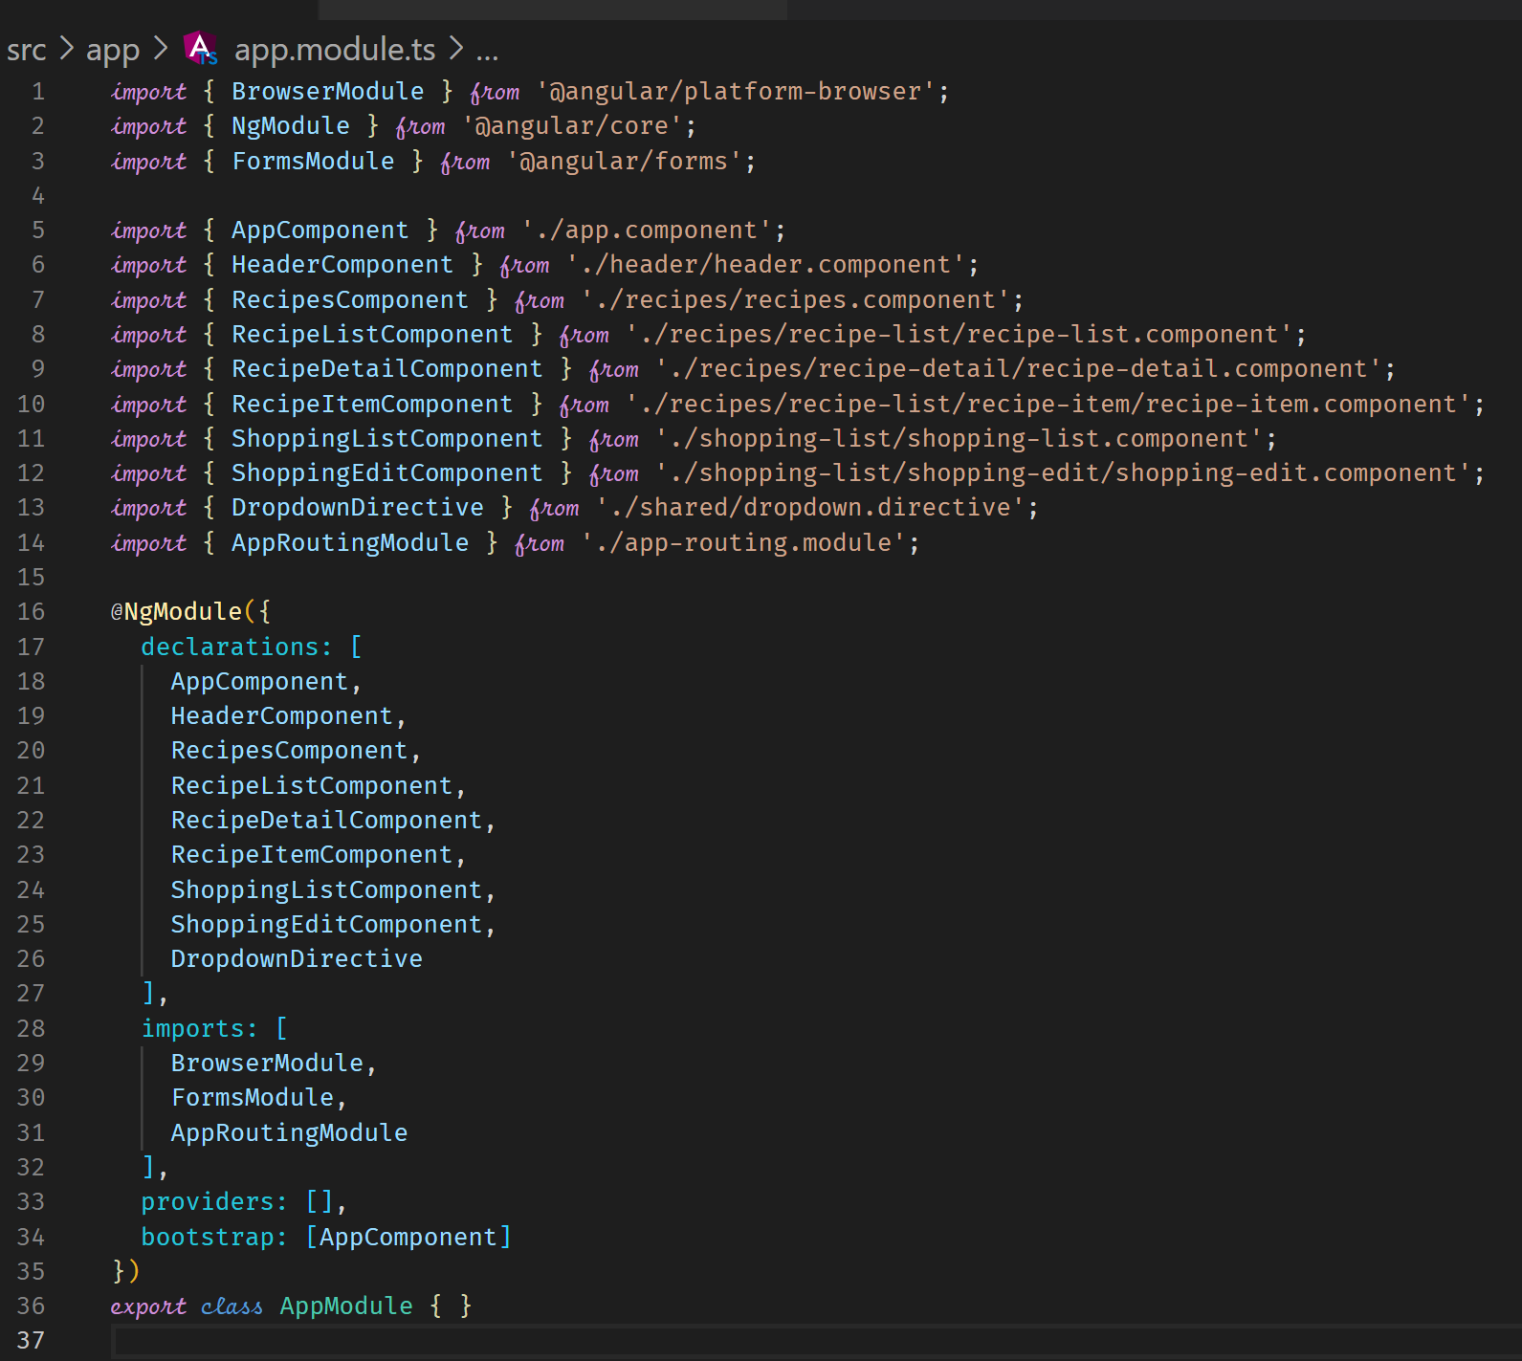

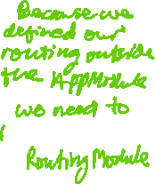

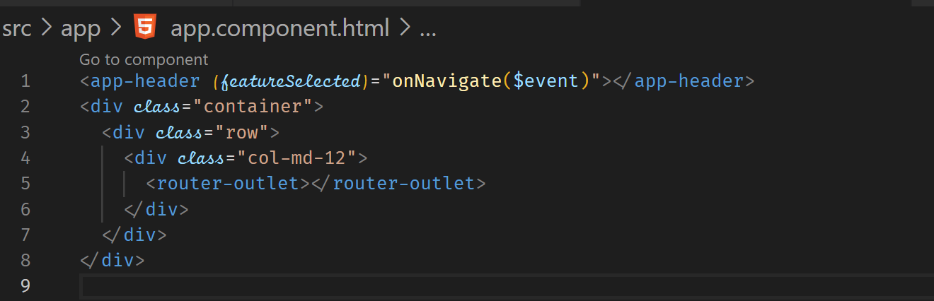



**Adding Navigation and Marking Active Routes**

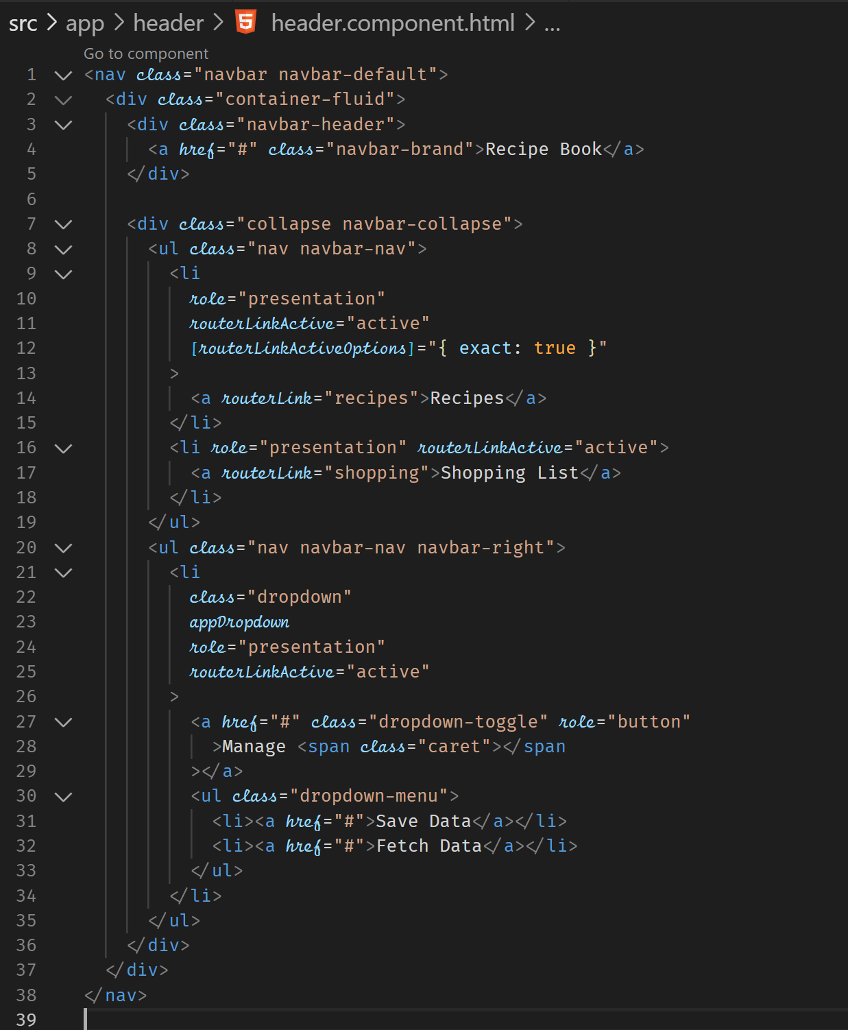



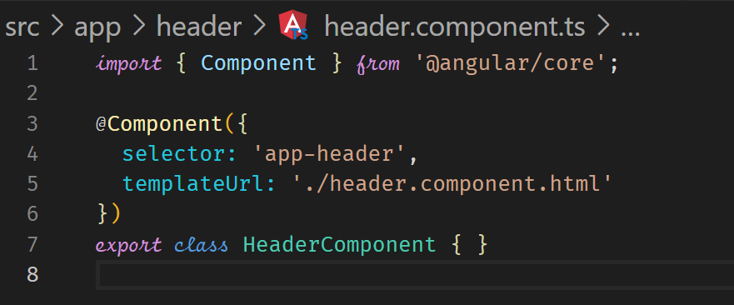

**Fix Page Reload Issues**

The href=”#” causes the browser to reload the page. So, we need to remove this attribute in the a-tag.

**Child Routes**

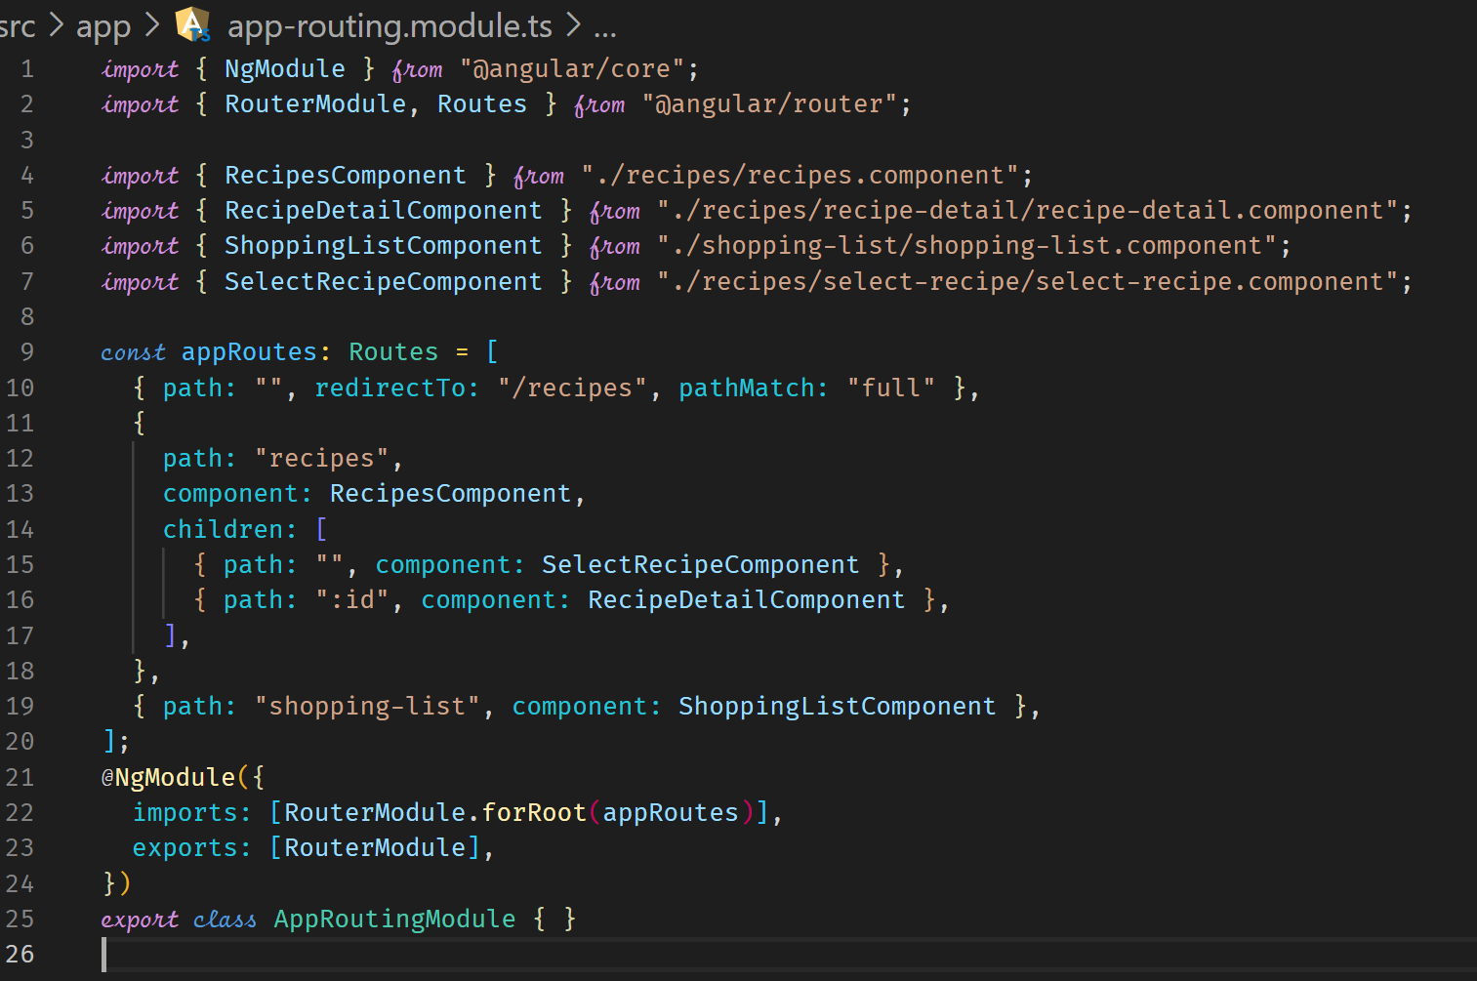



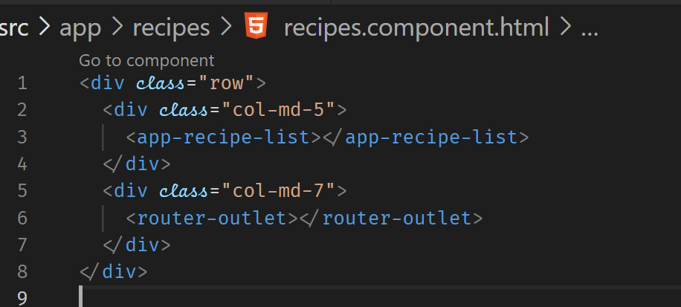

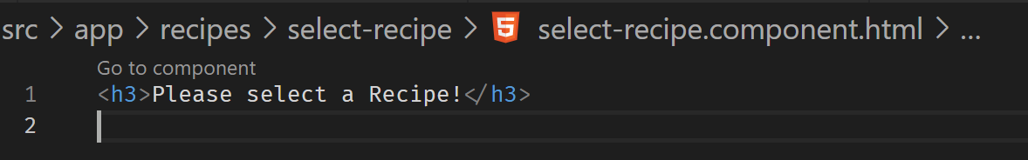

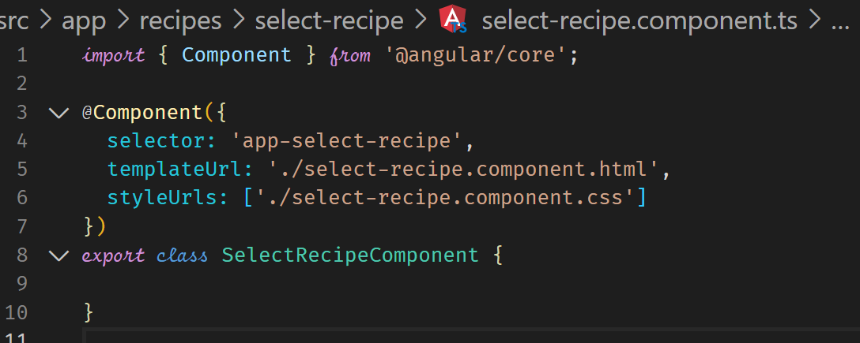

**Configure Route Parameter**

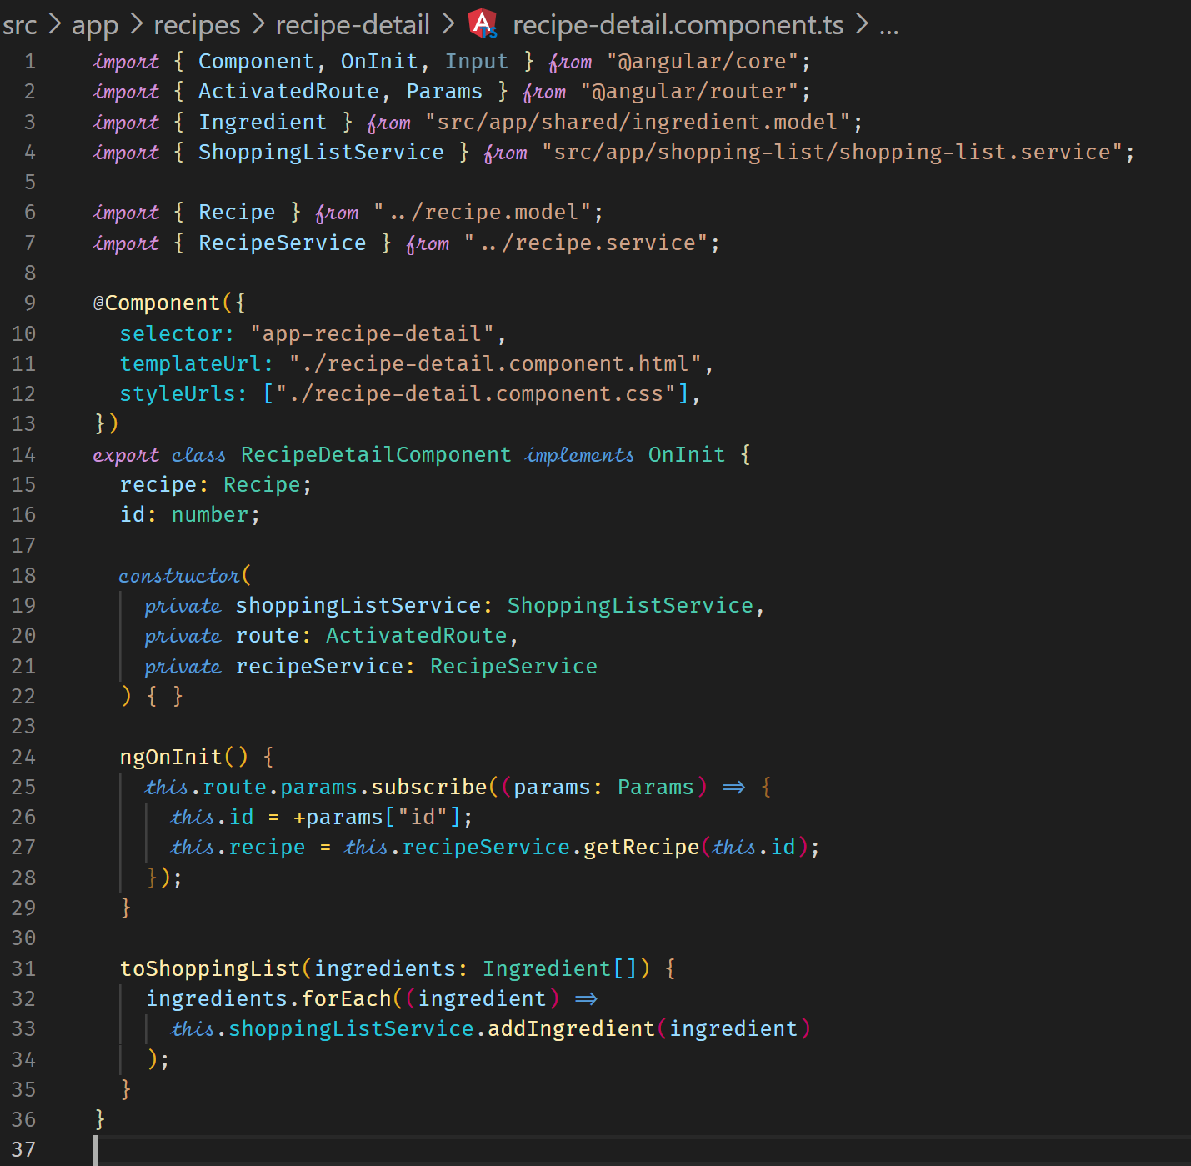

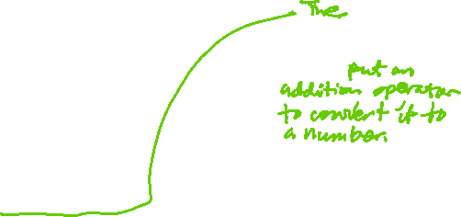

**Passing Dynamic Parameters to Links**

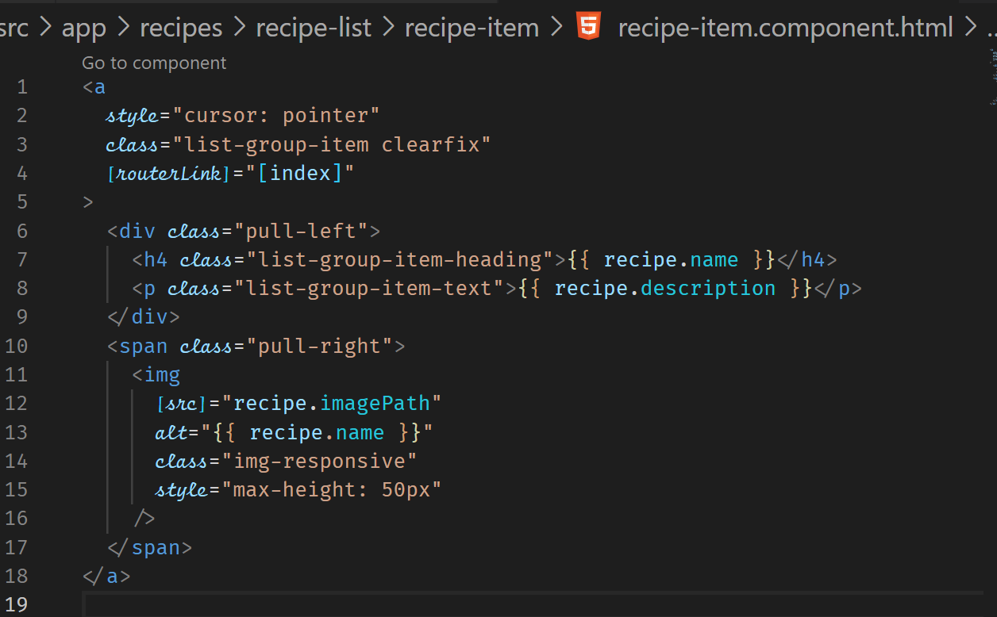



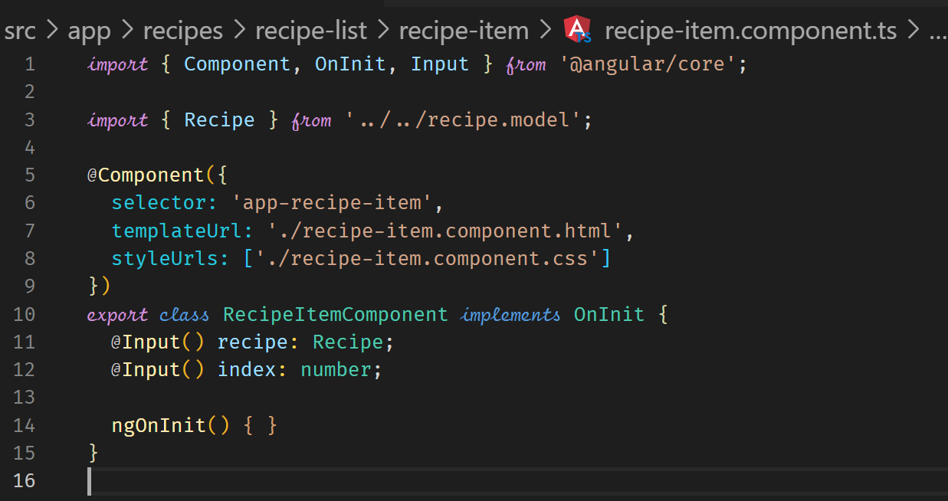



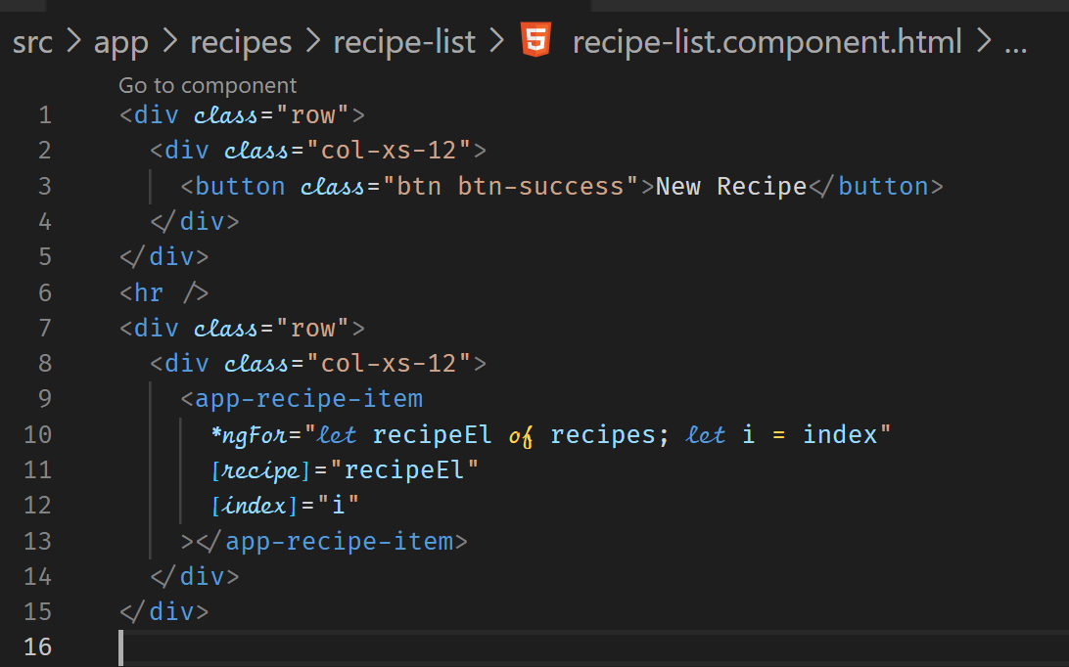



**Styling the Active Recipe Item**

Applying an active class will visually help us see which recipe is selected.

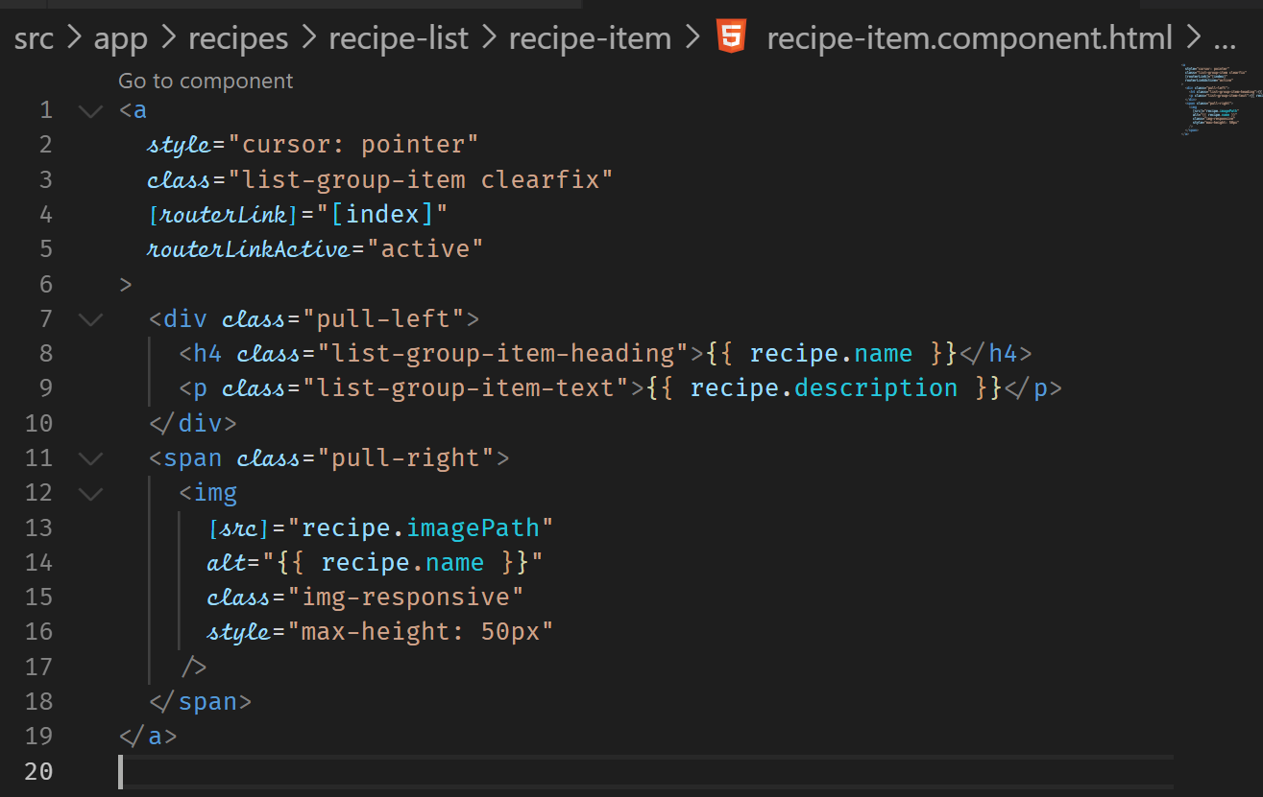



**Adding Editing Routes**

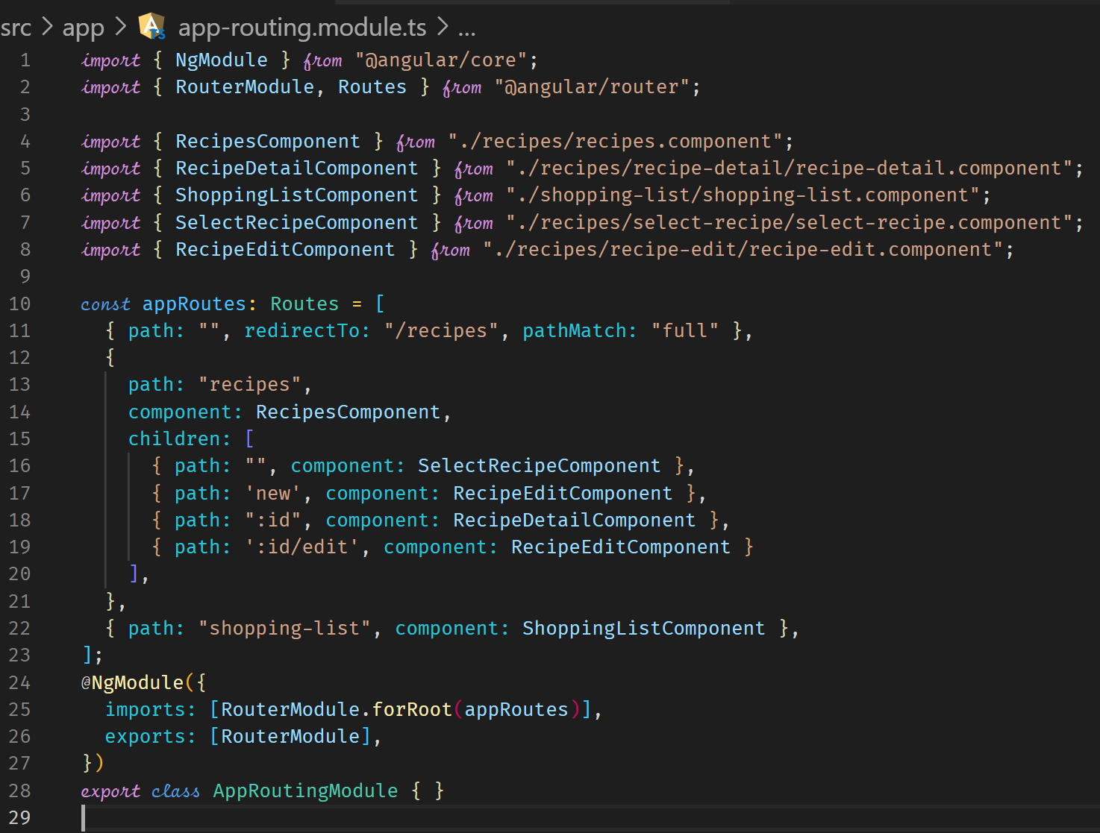



**Retrieving Route Parameters to determine edit mode**

We need to determine whether we are in edit or new mode. We look at the route parameters. If we have recipes/new that will mean we are in new mode and if we are in recipes/0/edit, that is the edit mode.

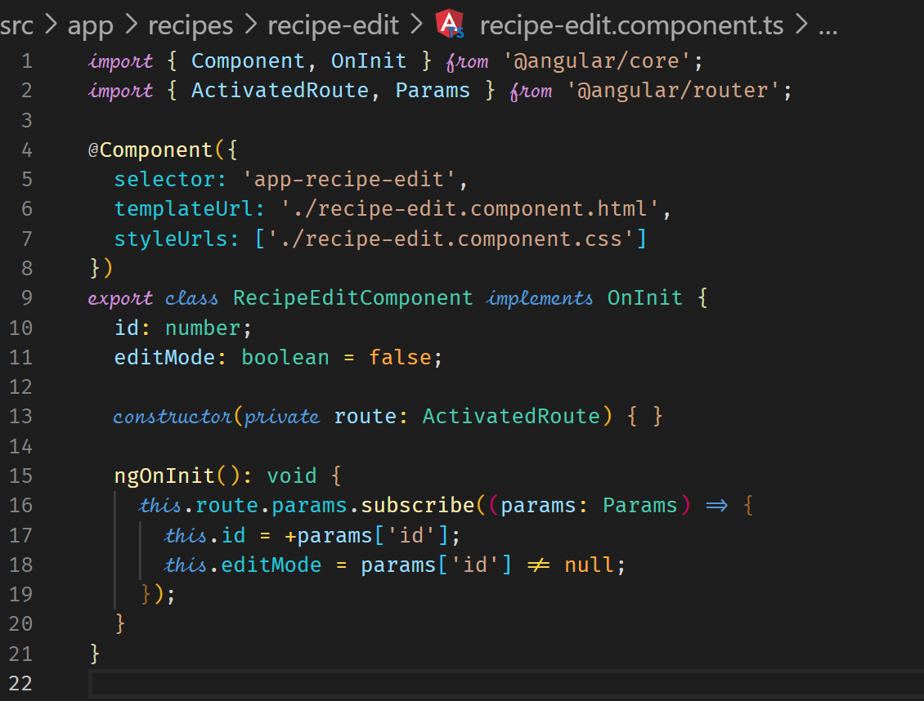

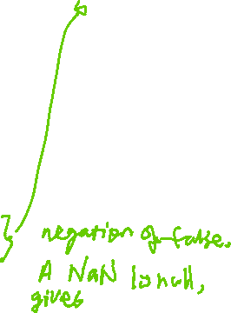

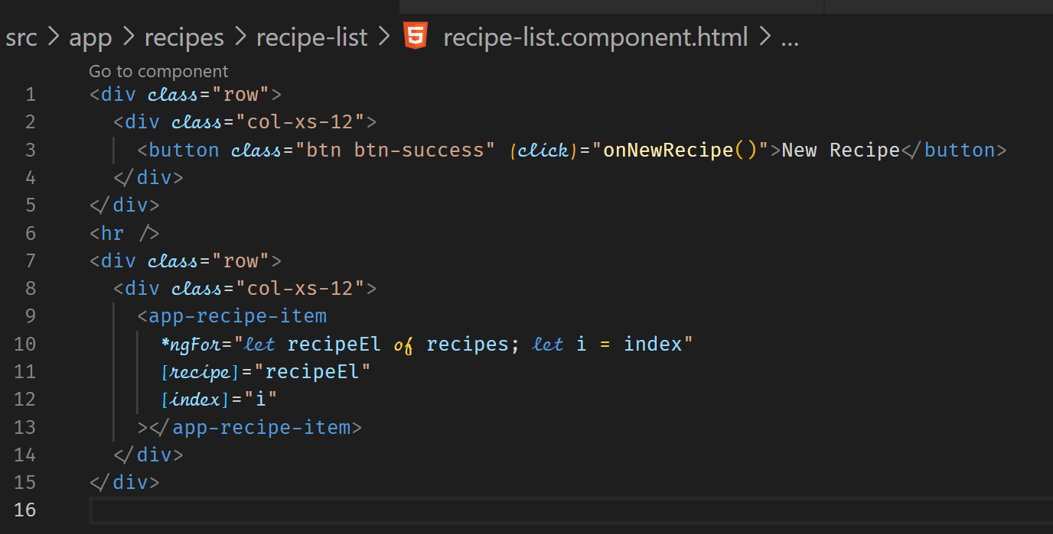

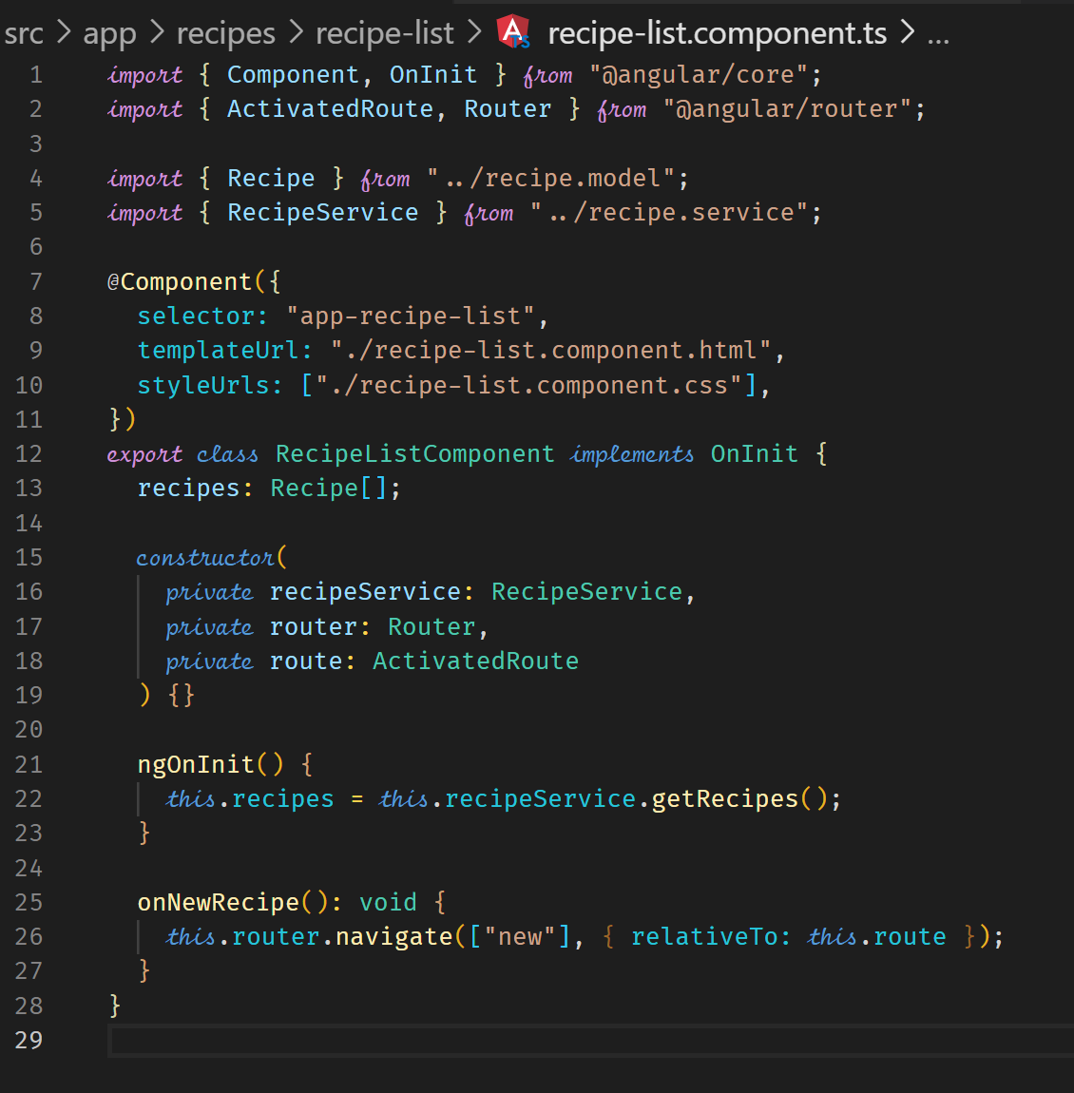

**What is an Observable?**

Observable

Various Data Sources

(User Input) Events, HTTP Requests, Triggered in Code …

Handle Error

Handle Data

You write the Code which gets executed

Handle Completion

Observer



**Core of Observables – use the interval method in rxjs**



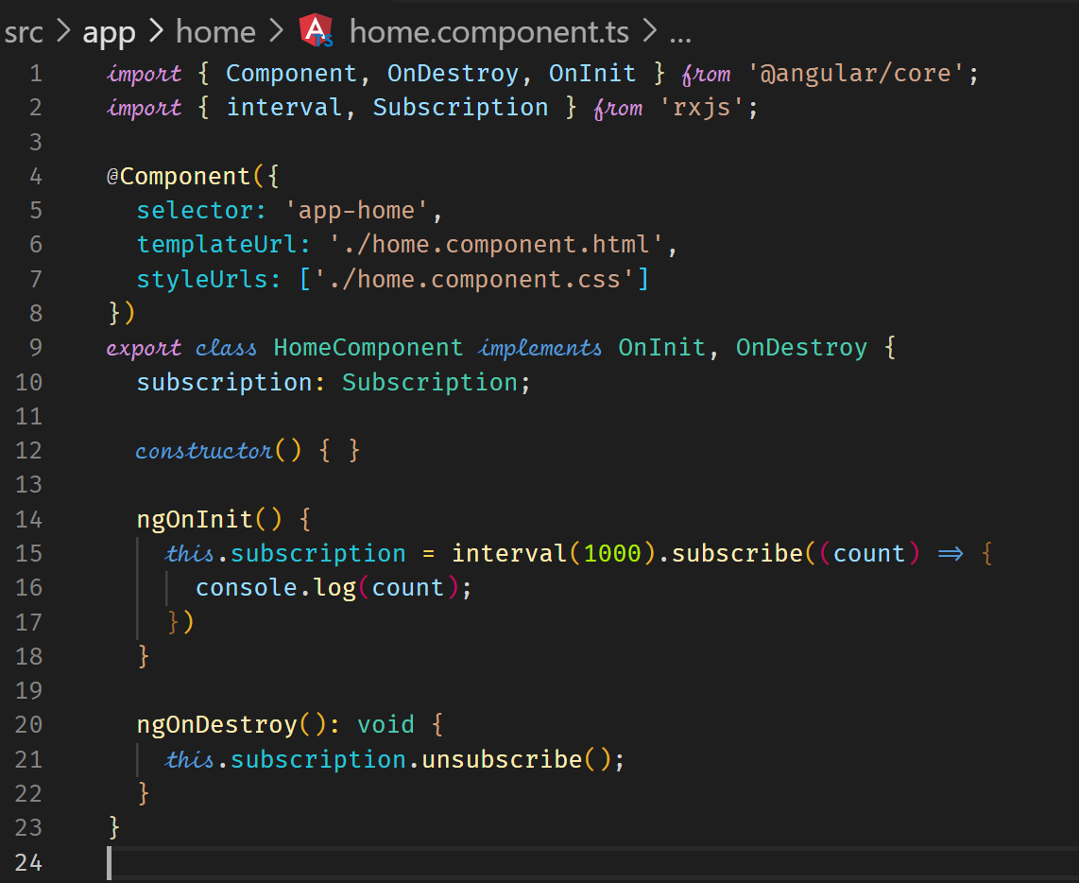

**Building a Custom Observable**

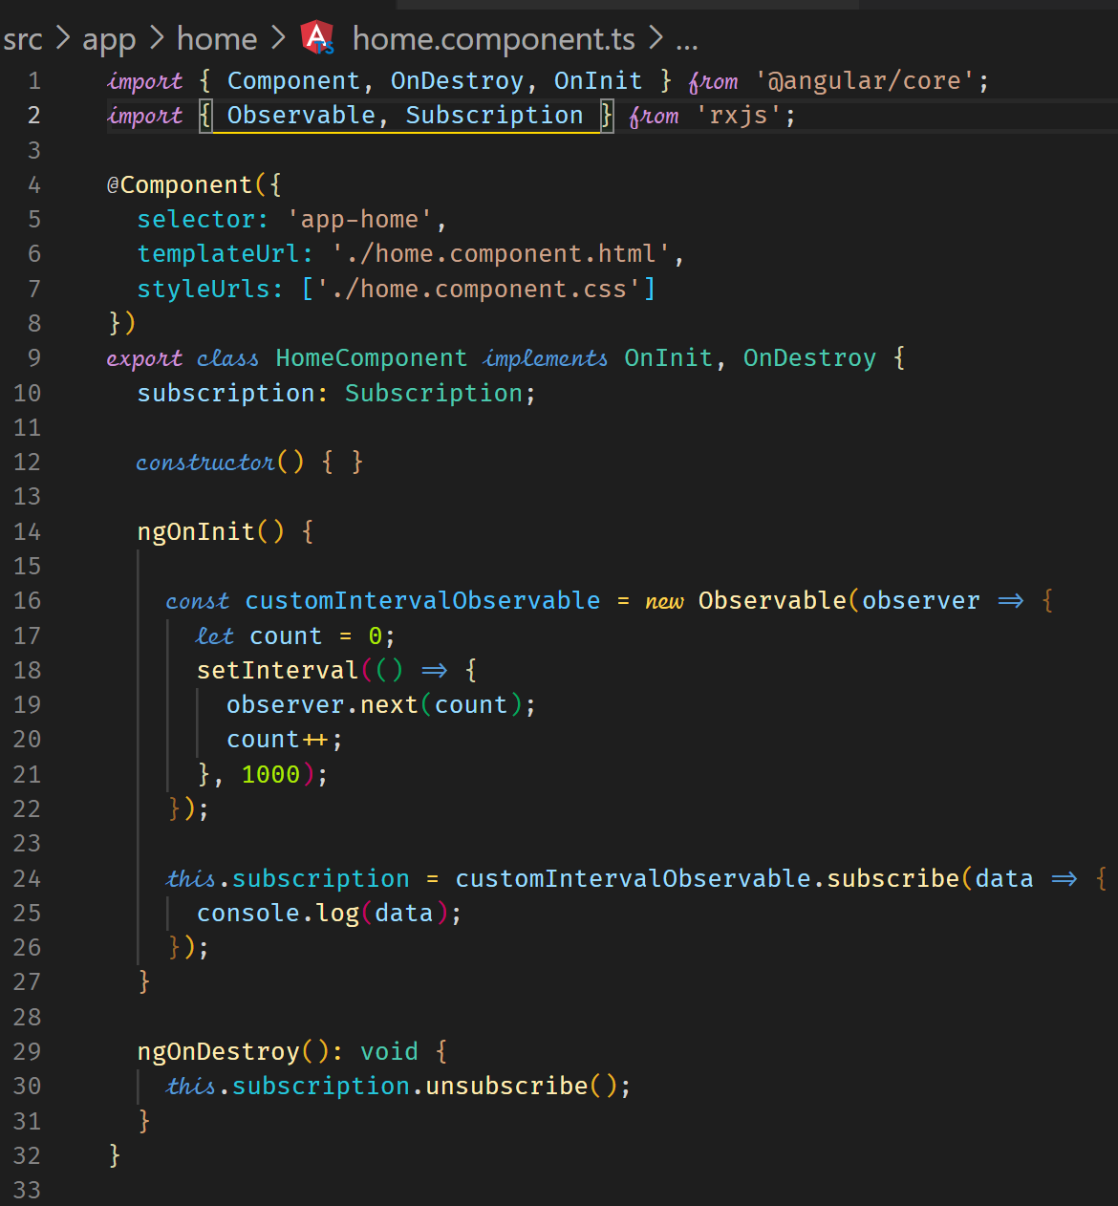

**Errors and ErrorHandling**

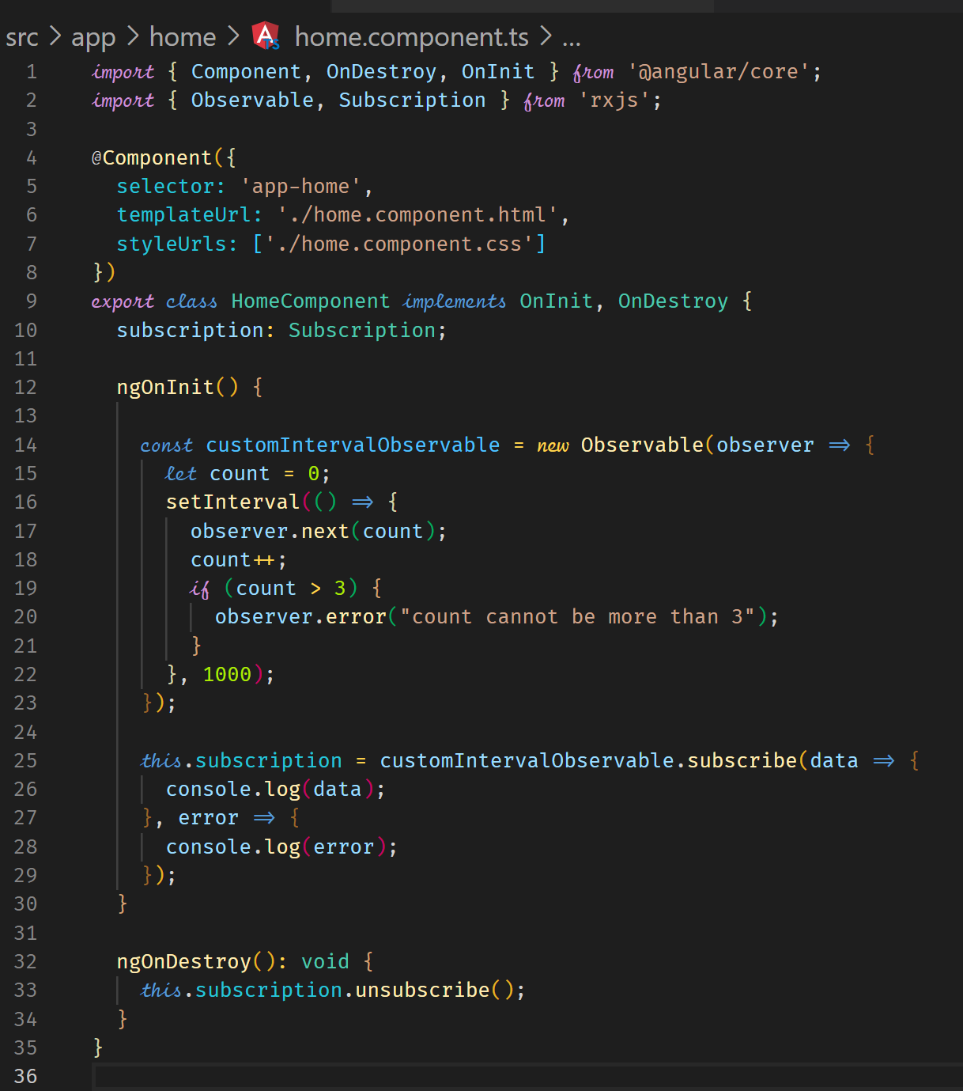



**Completion**

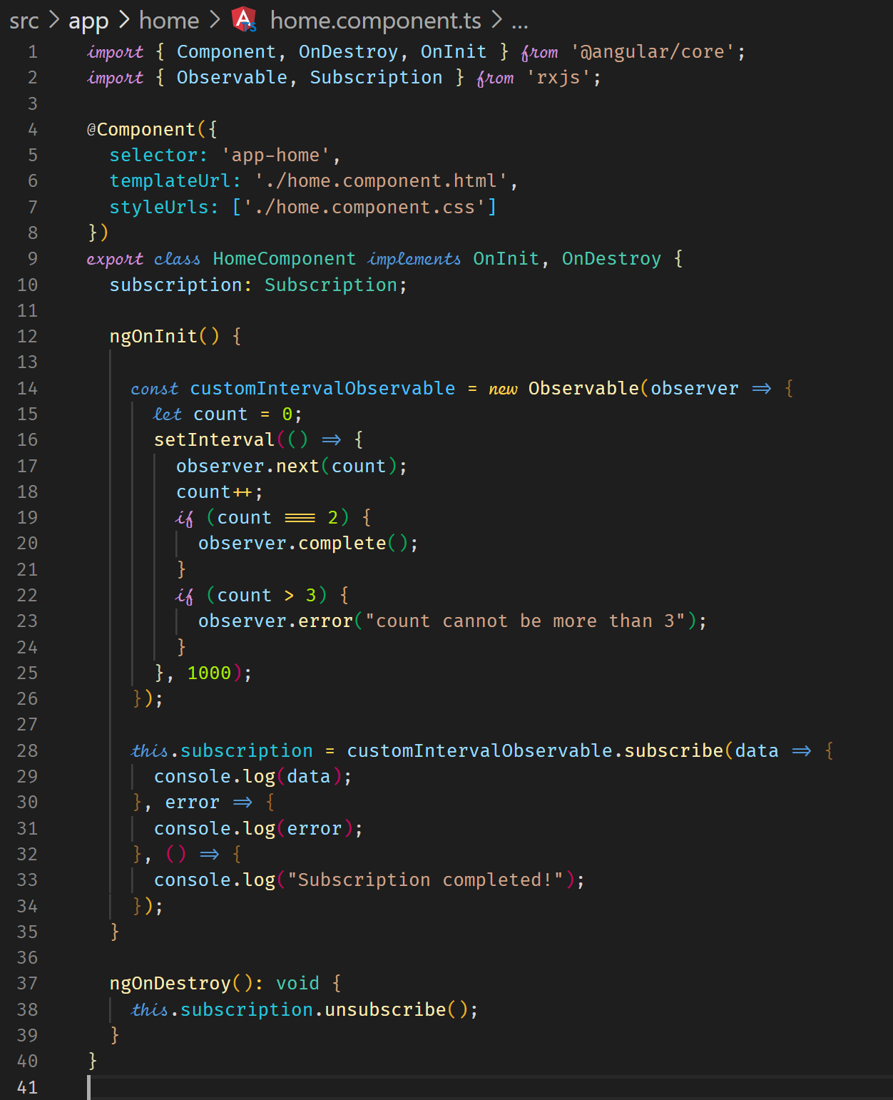



**Understanding Operators**

We can transform data from an observable before it is processed in a subscription using pipe and then operators like filter and map.

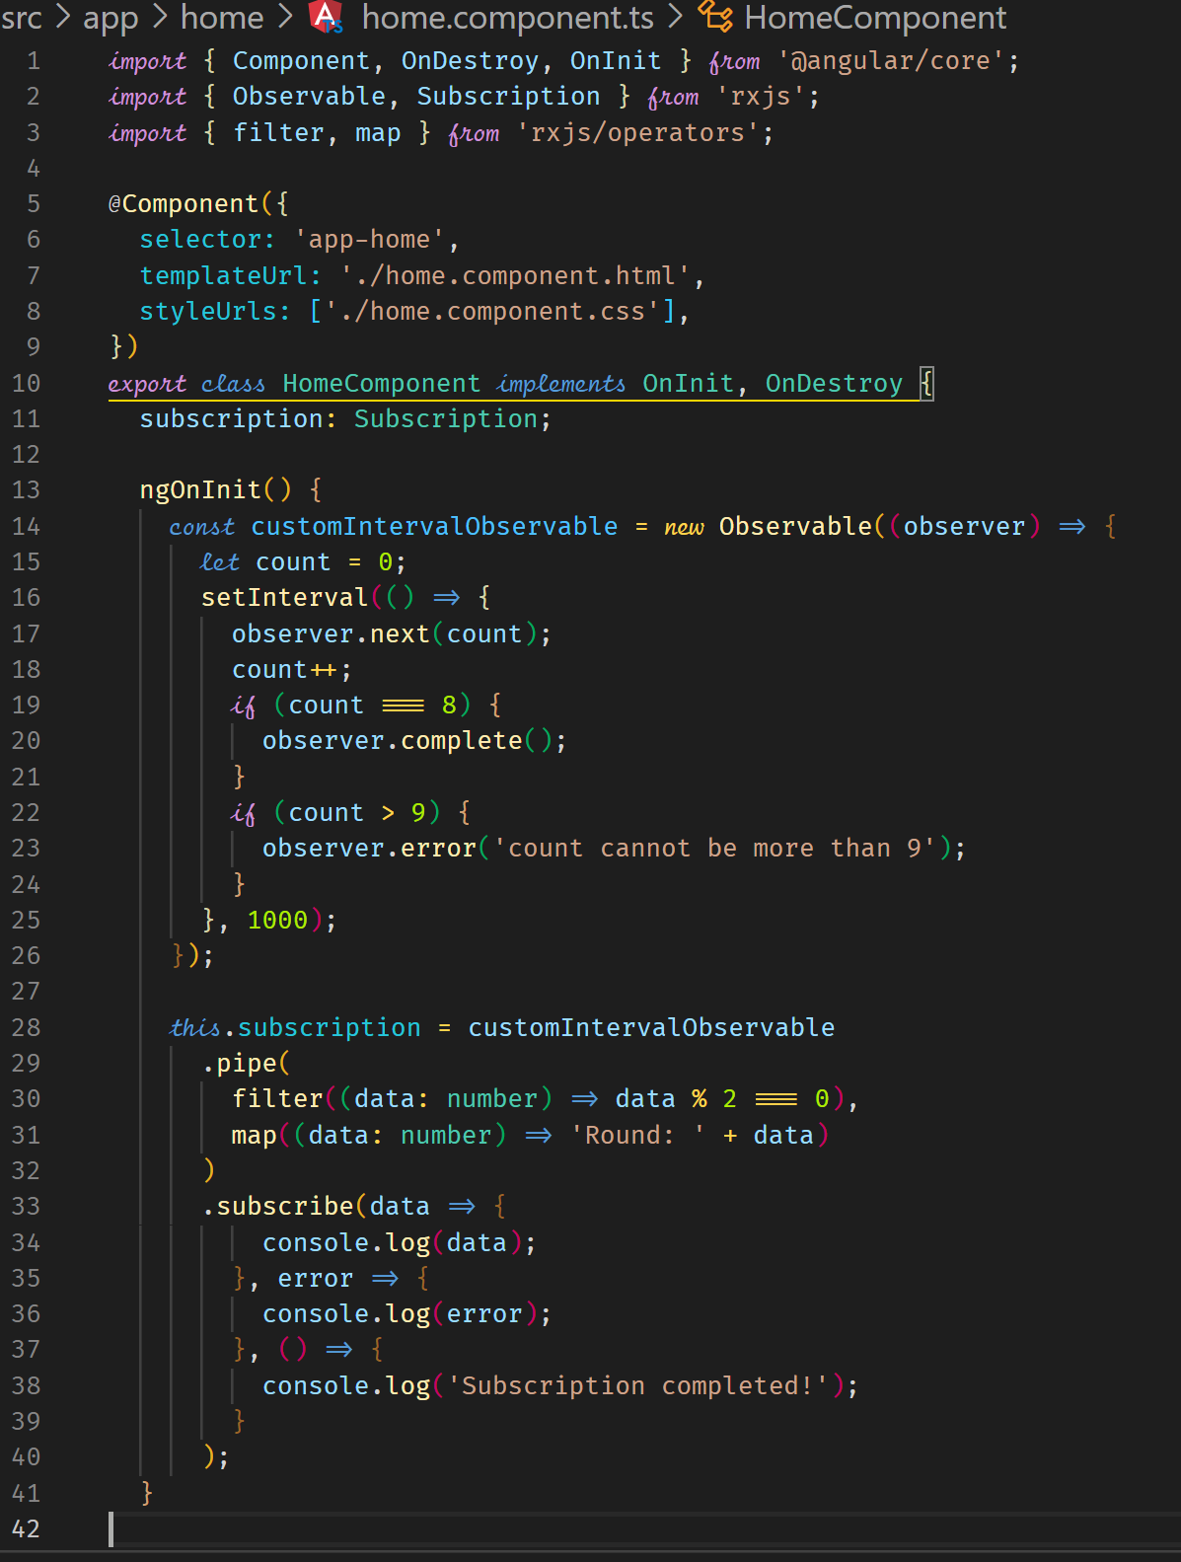

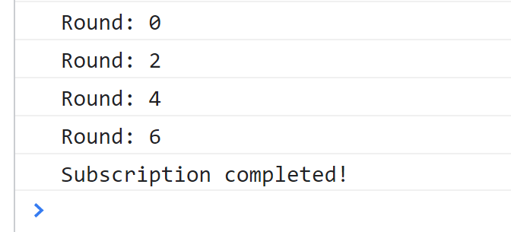

**Subjects**

Using a subscriber and a subject is recommended than using an EventEmitter.

The below code shows an implementation which updates a parent component from a child component using an event emitter.

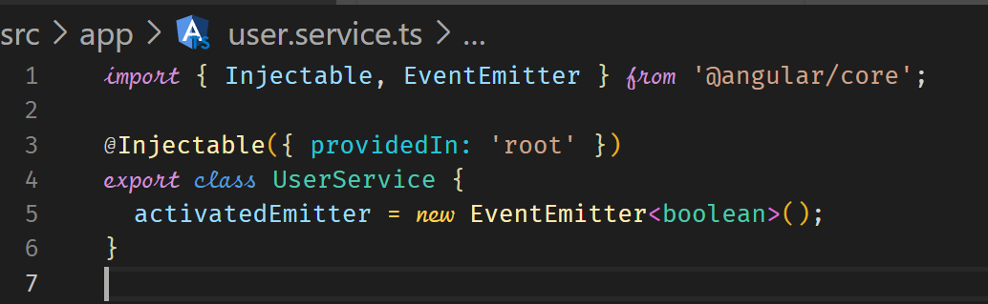

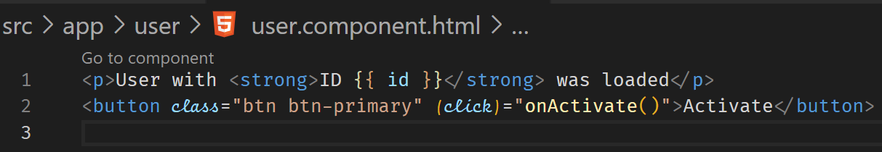

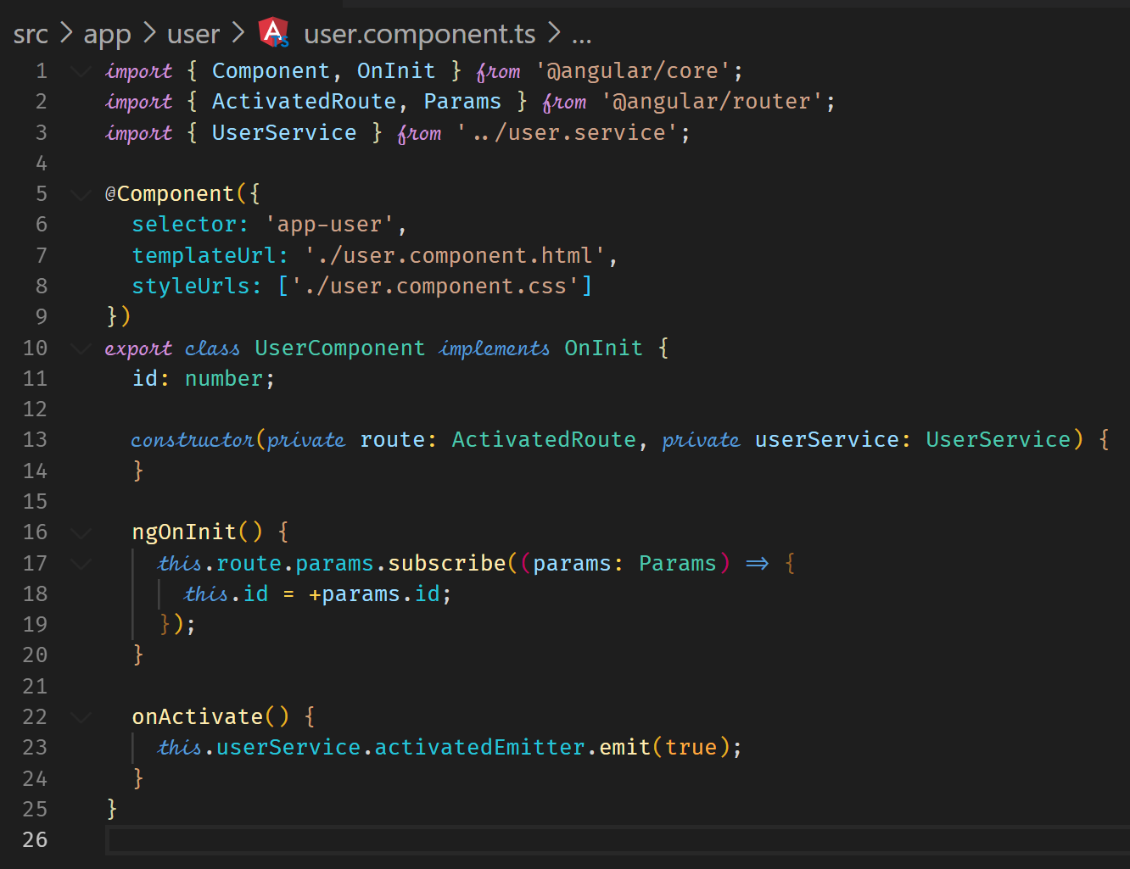

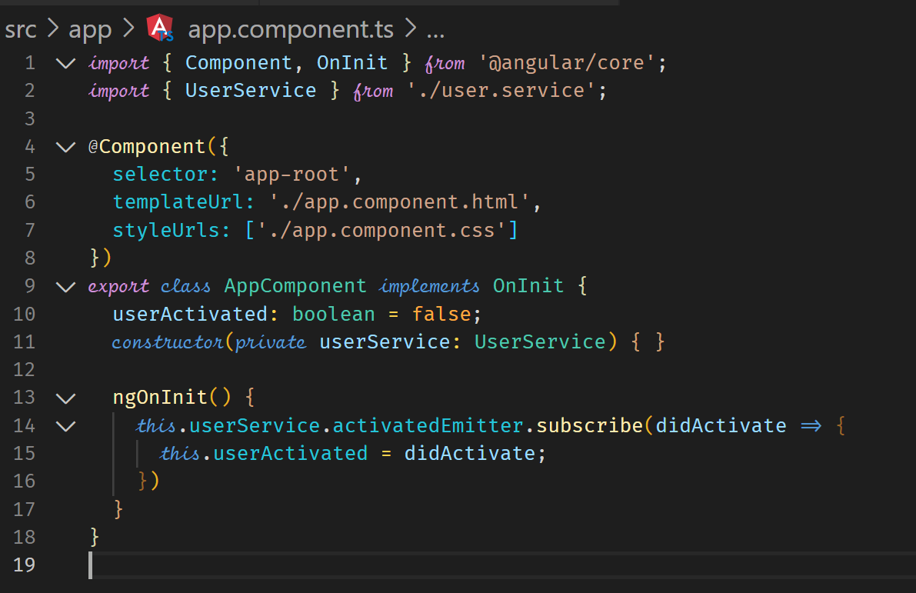



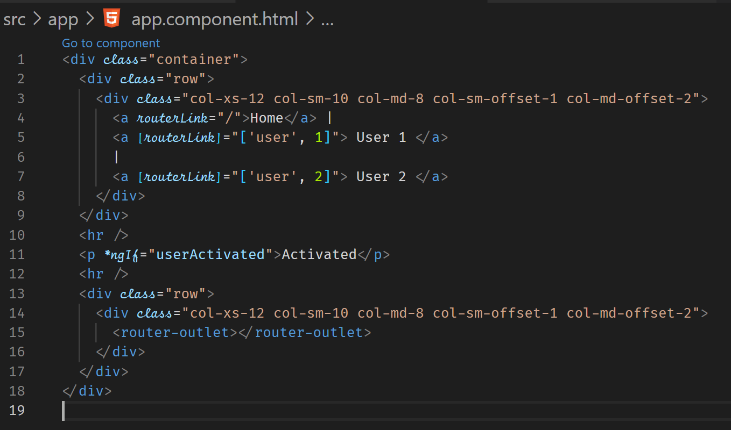

Using a Subject instead of an EventEmitter

Although the setup is the same, using a Subject is the recommended way because it is efficient behind the scenes.

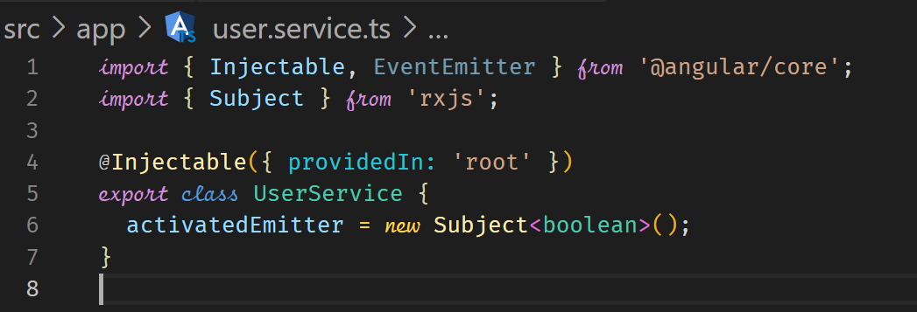

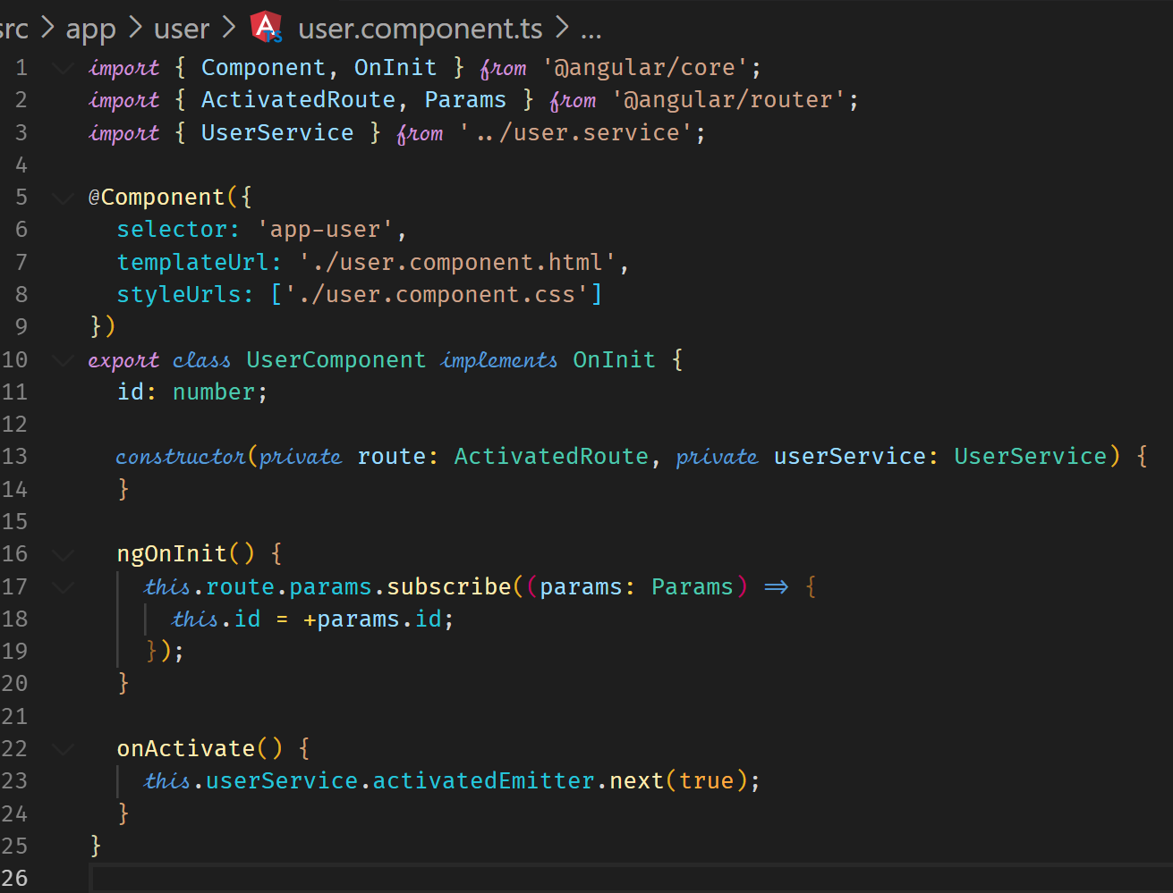

UseEventEmitter if you are using @Output() for cross component communication.

**Forms**

There are two approaches in Form handling in Angular.

Template-Driven and Reactive.

Template-Driven – Angular infers the form Object from the DOM.

Reactive – Form is created programmatically and synchronized with the DOM.

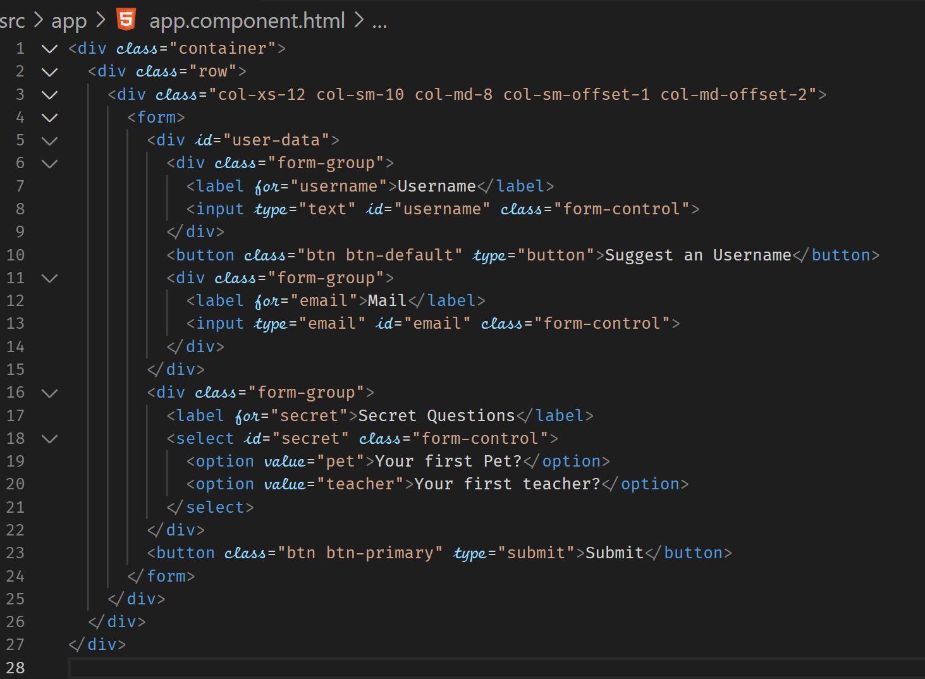



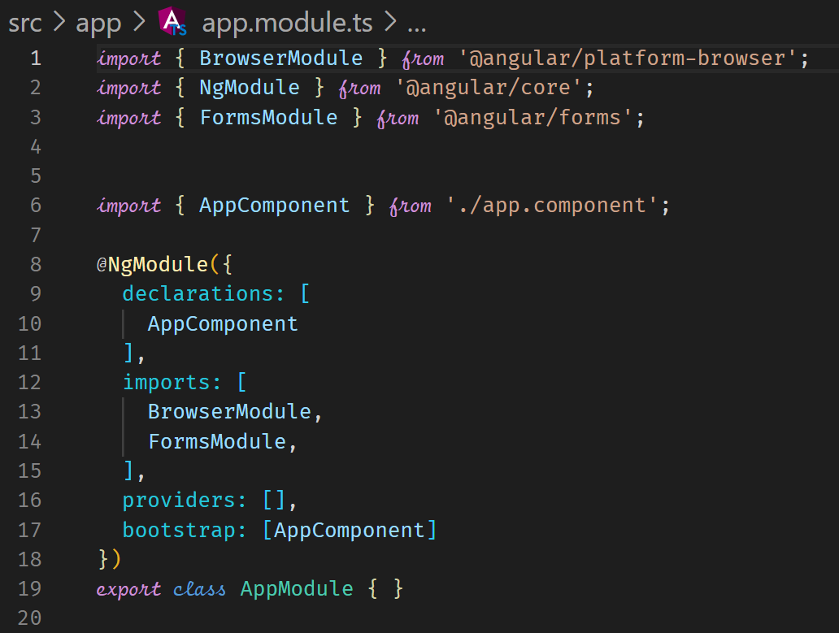



**Register the Controls**

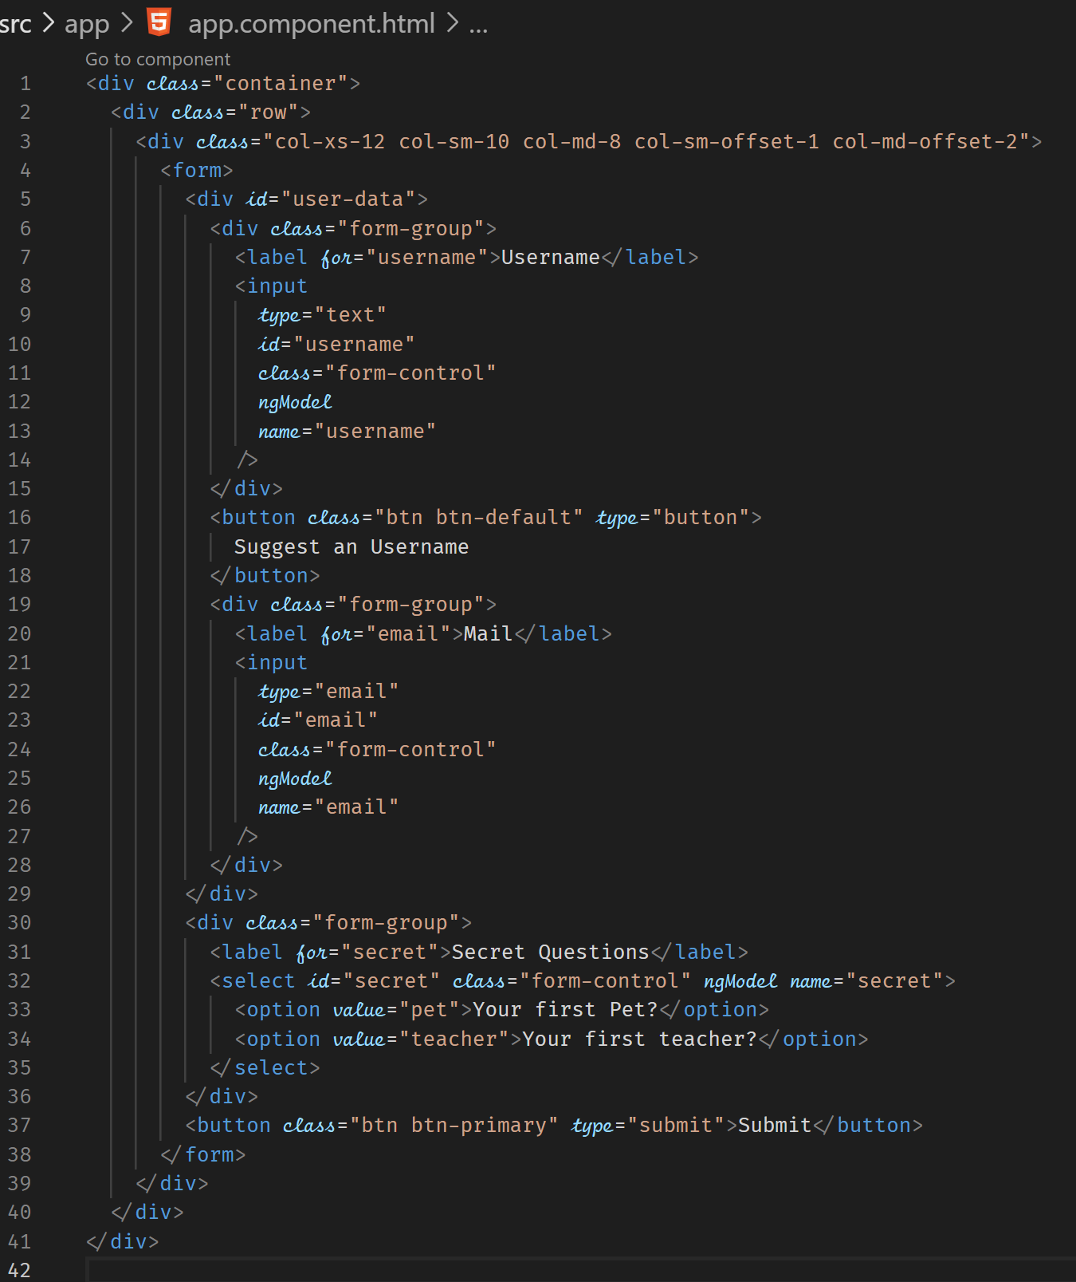



**Submitting and Using the Form**







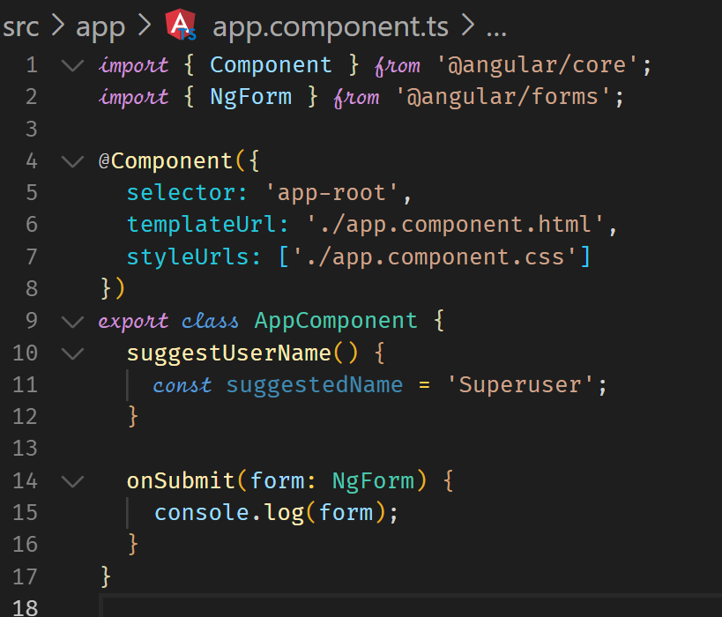



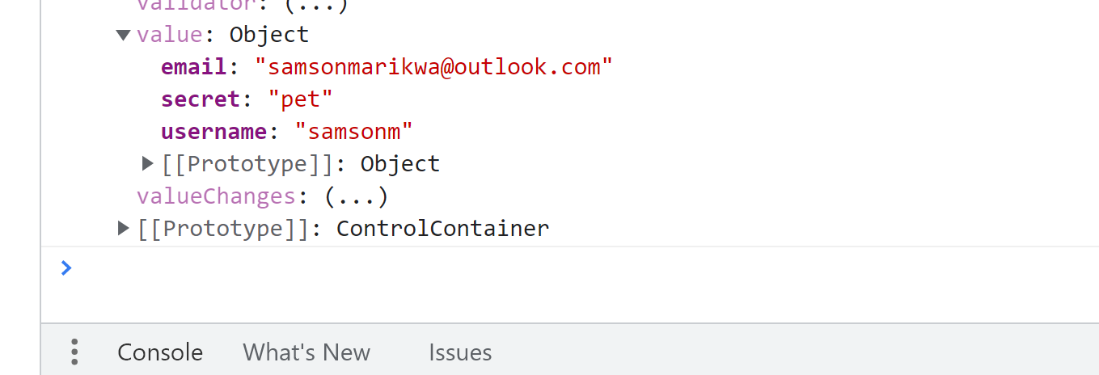



**Understanding Form State**

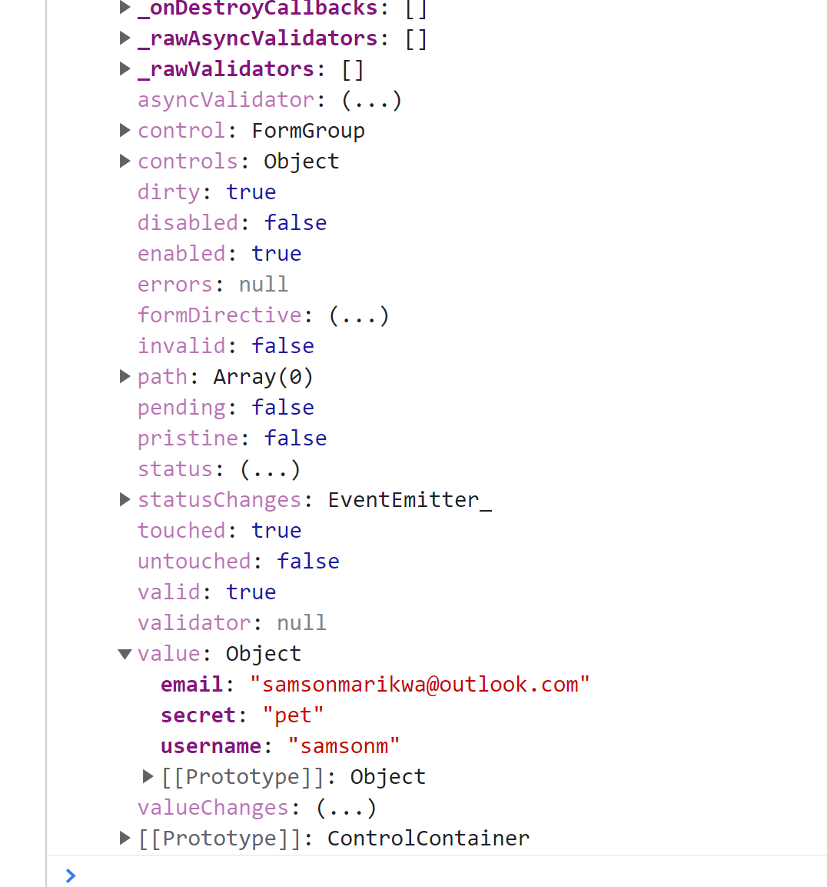

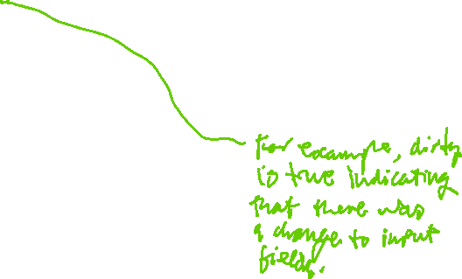

**Accessing the Form with @ViewChild**

We have an alternative way of accessing the form using @ViewChild which allows us to access a local reference on the form. This way of accessing the form is especially useful if you need to access the form before submission.

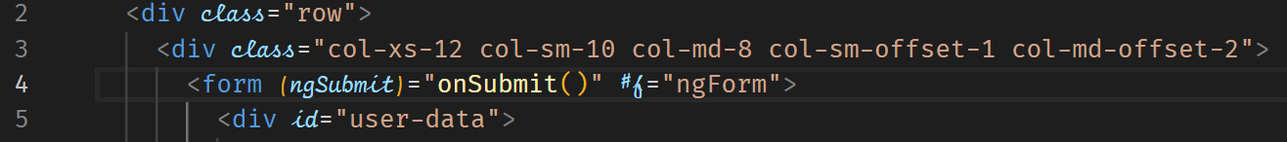

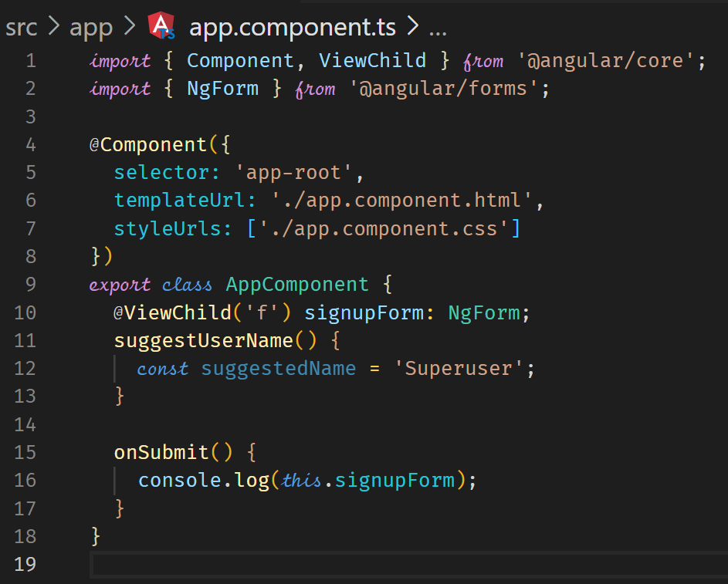



**Adding Validation to check User Input**

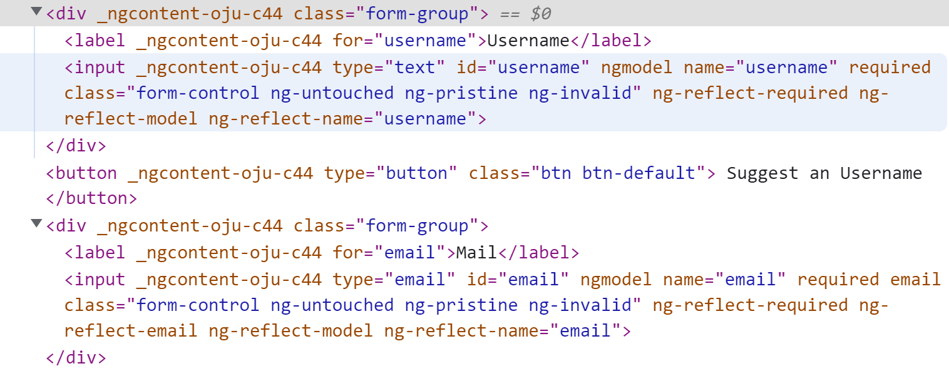

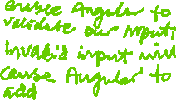

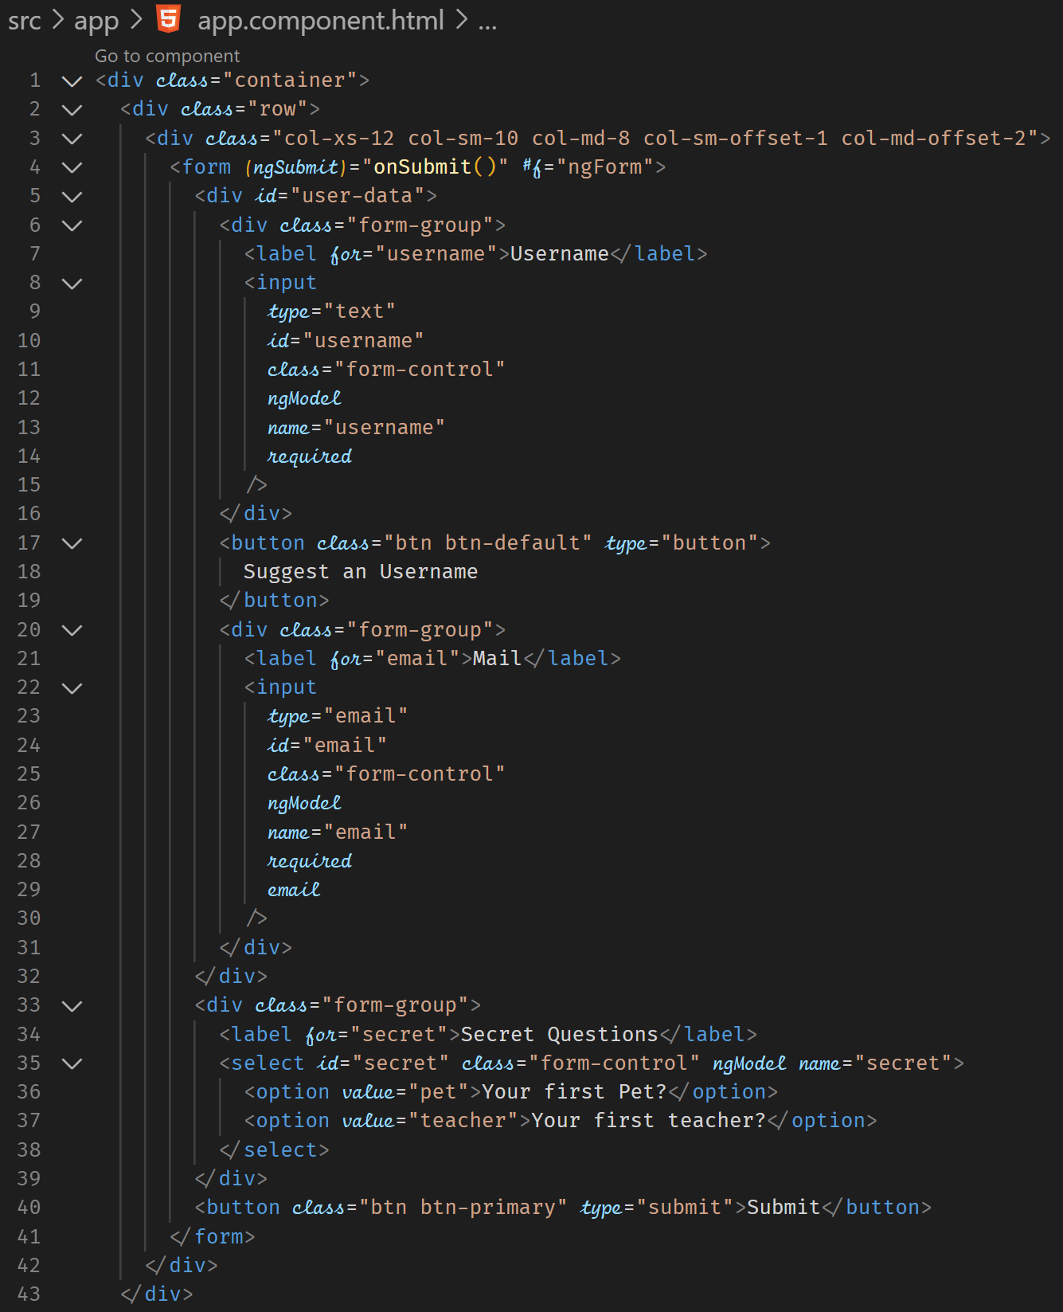



The following directives can be added on the form to perform validation

<https://angular.io/api?type=directive>

**Using the Form State for User Experience**

We can utilize the classes that are assigned to show thata control is invalid.



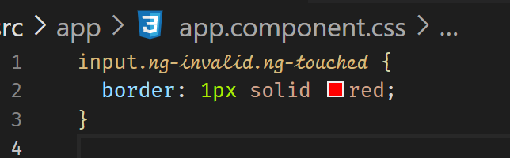

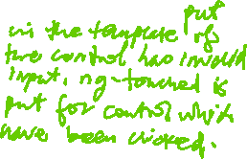

**Outputting Validation Error Messages**

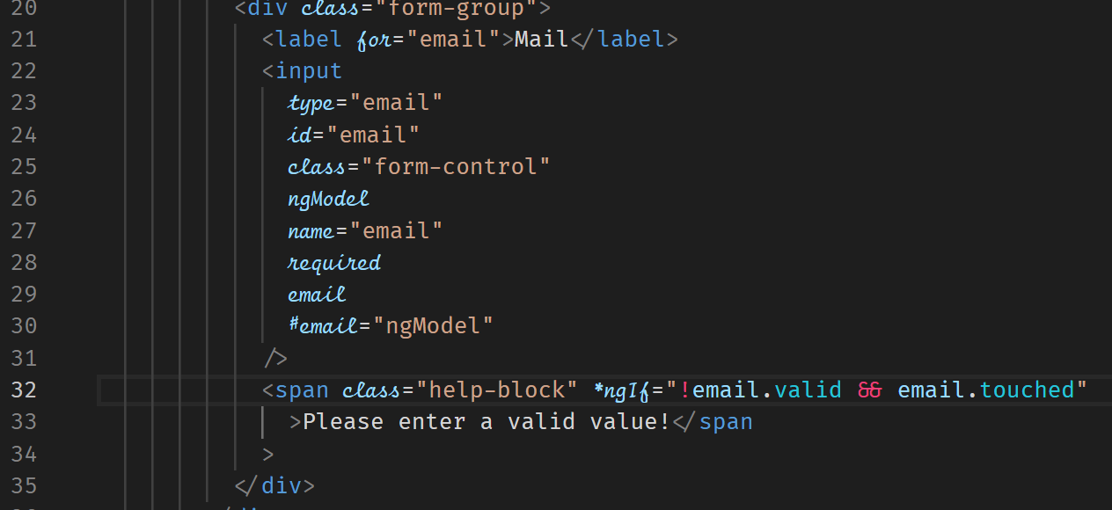



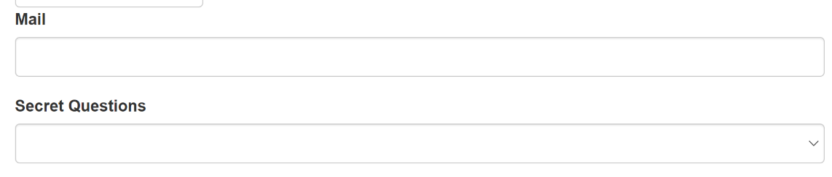



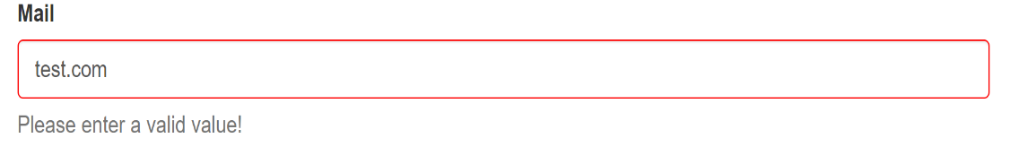



**Default Values with ngModel Property Binding**

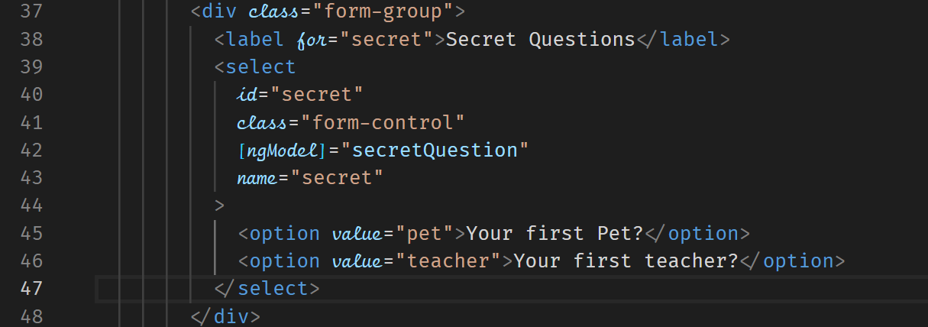



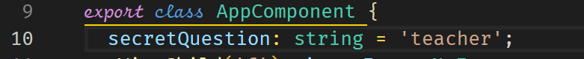







**Using ngModel with Two-Way-Binding**

Two-Way Binding allows you to instantly react to changes made to the controls. You may want to repeat what the user entered or validate immediately before the user clicks the submit button.

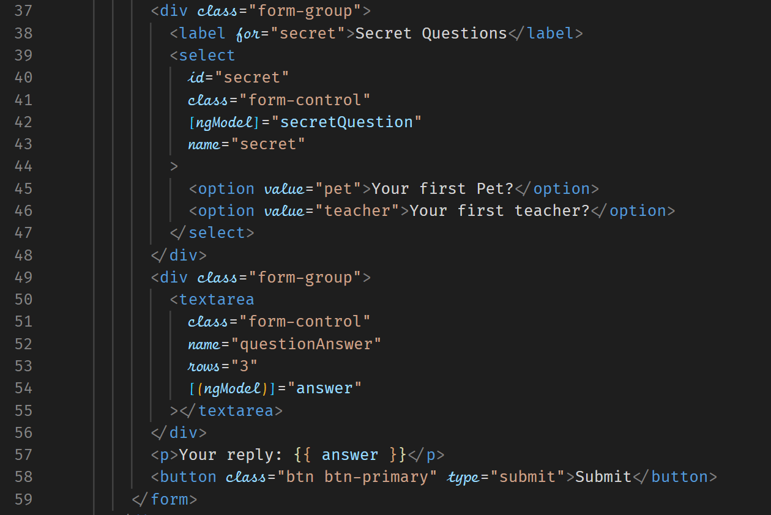



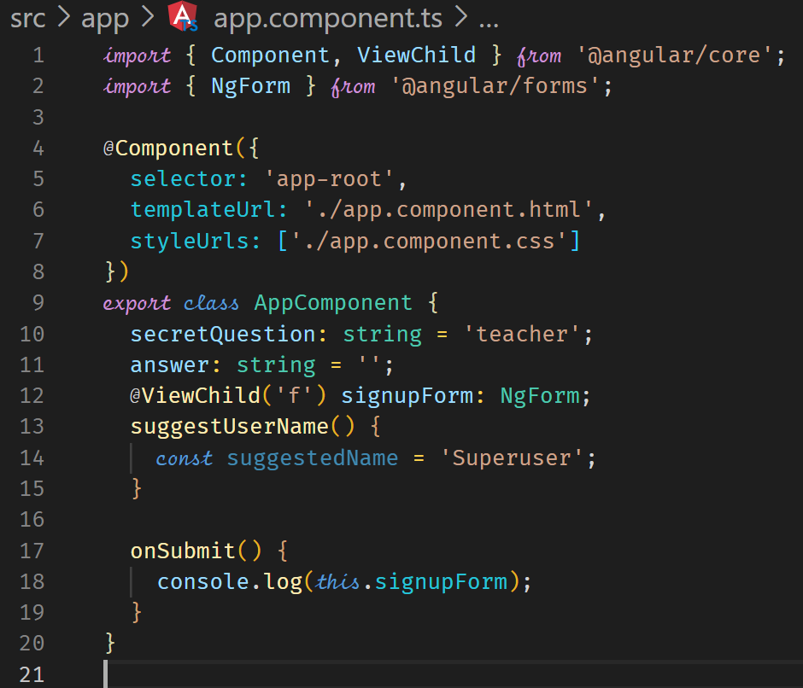



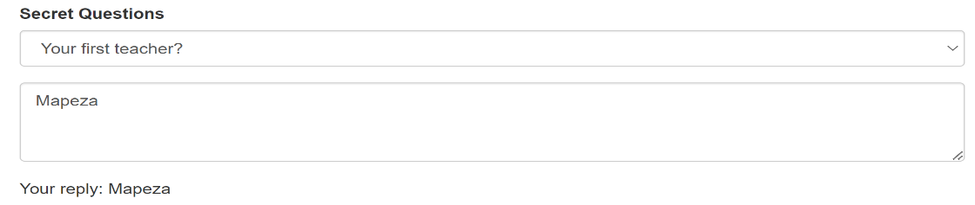



**Grouping Form Controls**

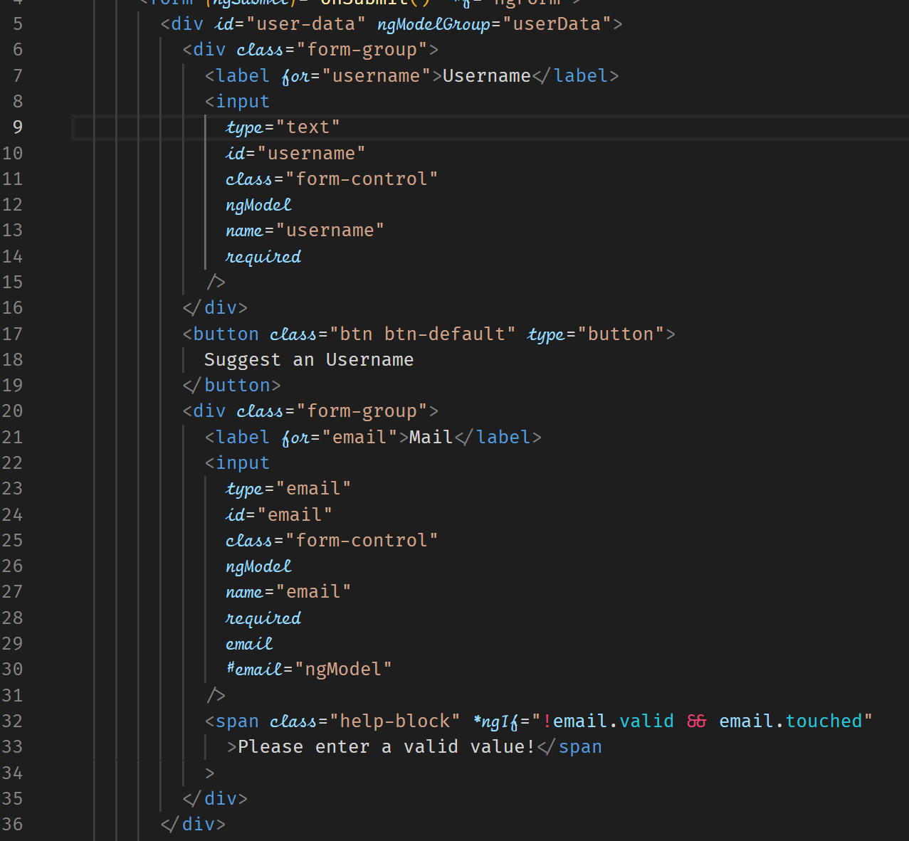

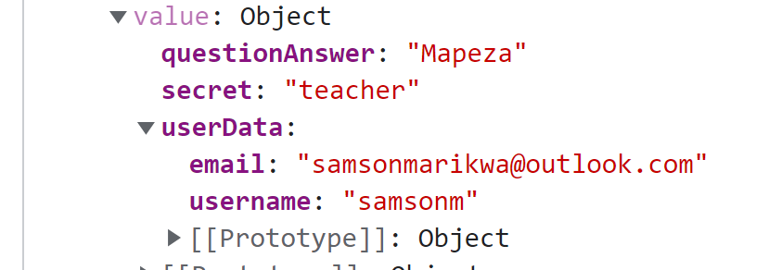



On submitting the form, we have a userData as a key with key/value pairs of the grouped data items.

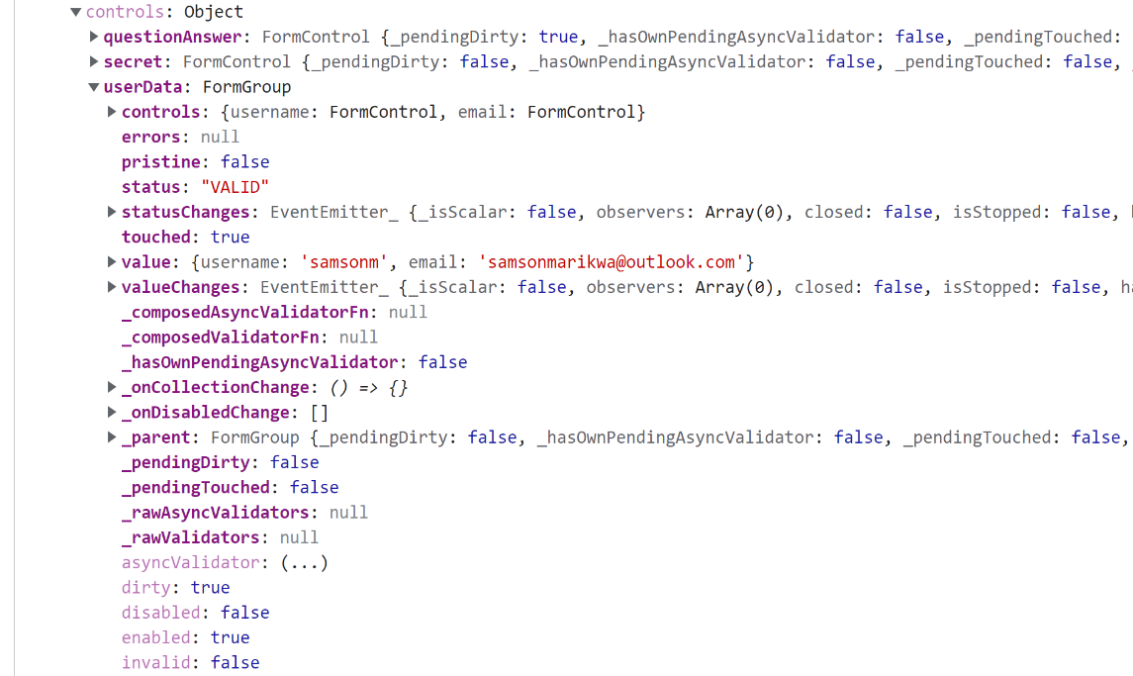



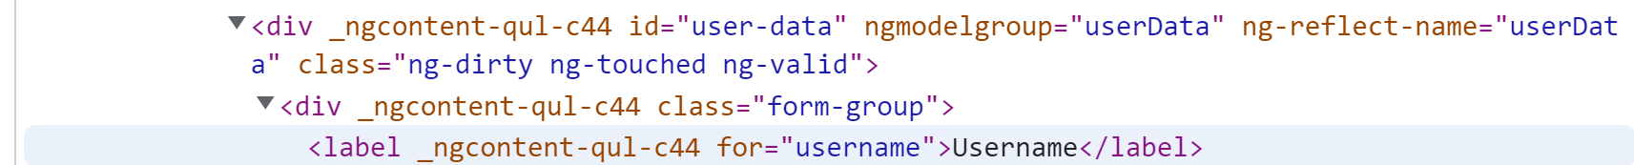

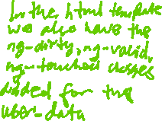

You can also get a javascript representation by adding a local reference to the group.

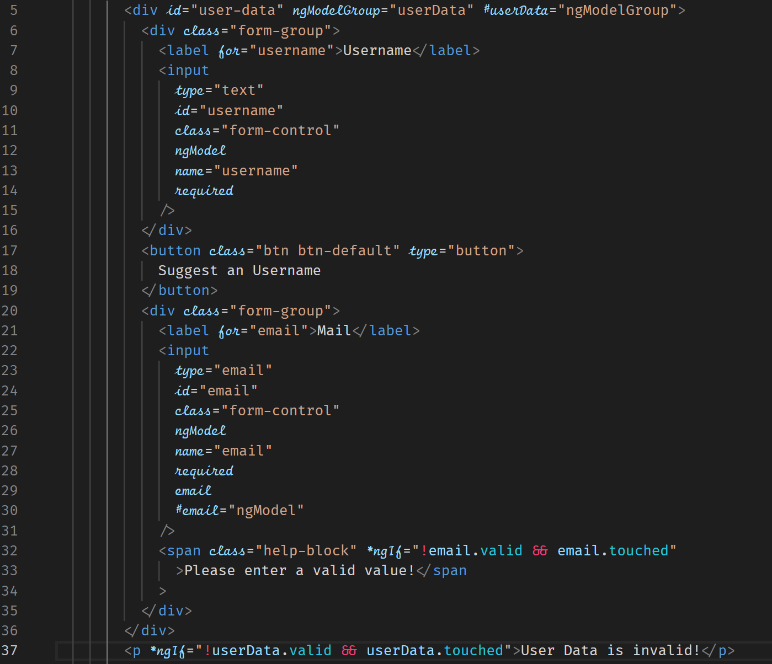



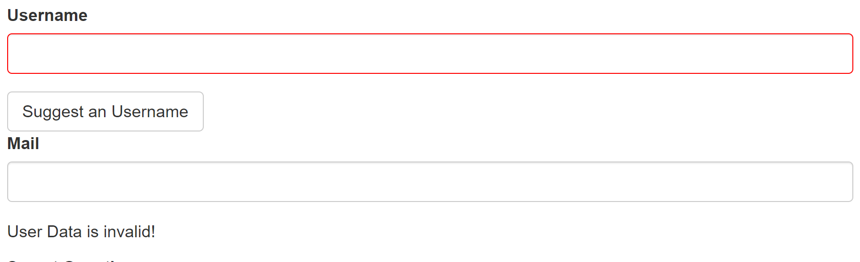

**Handling Radio Button**

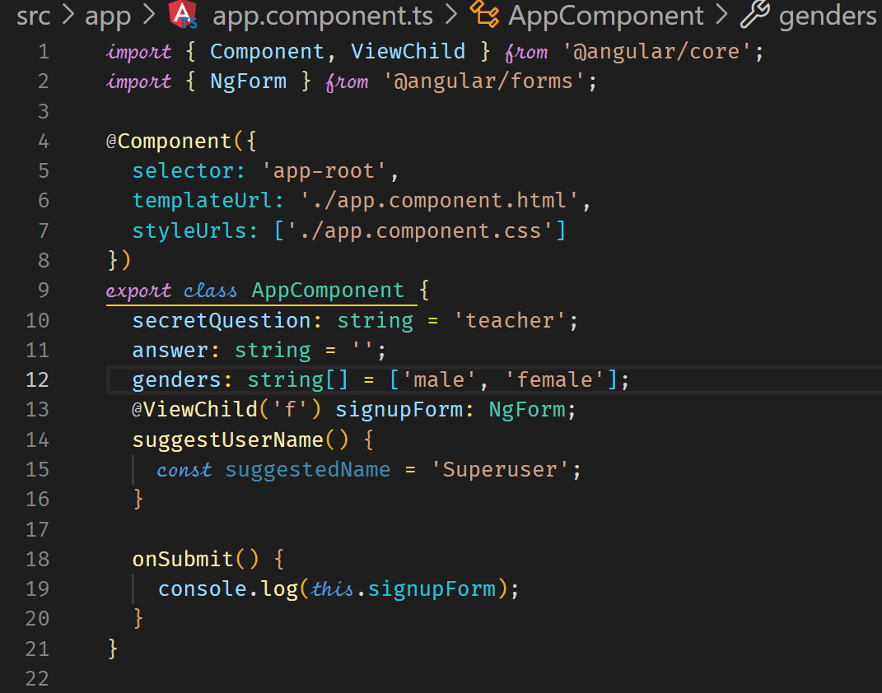



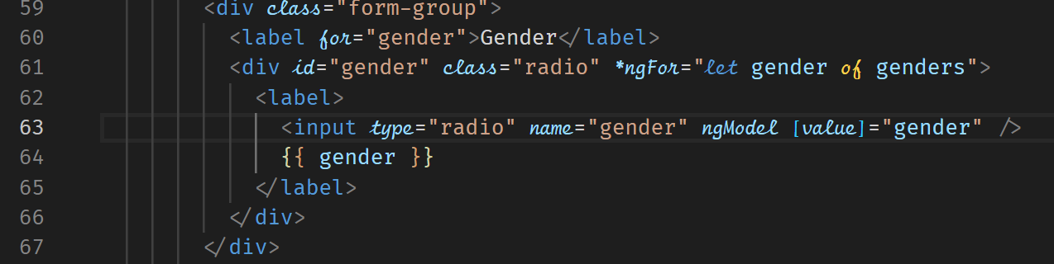







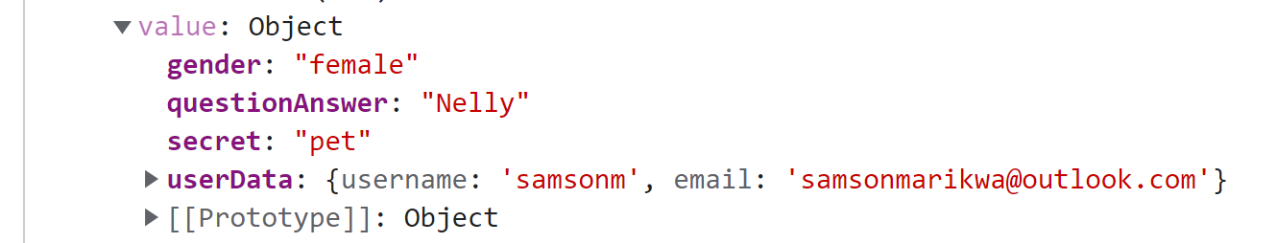



We can also set the default value by using one way binding and setting the default value in TypeScript.

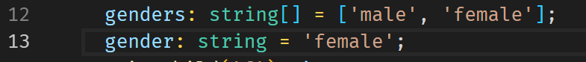



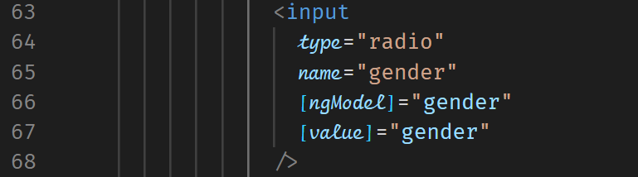



**Setting and Patching Form Values**

setValue can allow us to assign values to a form.

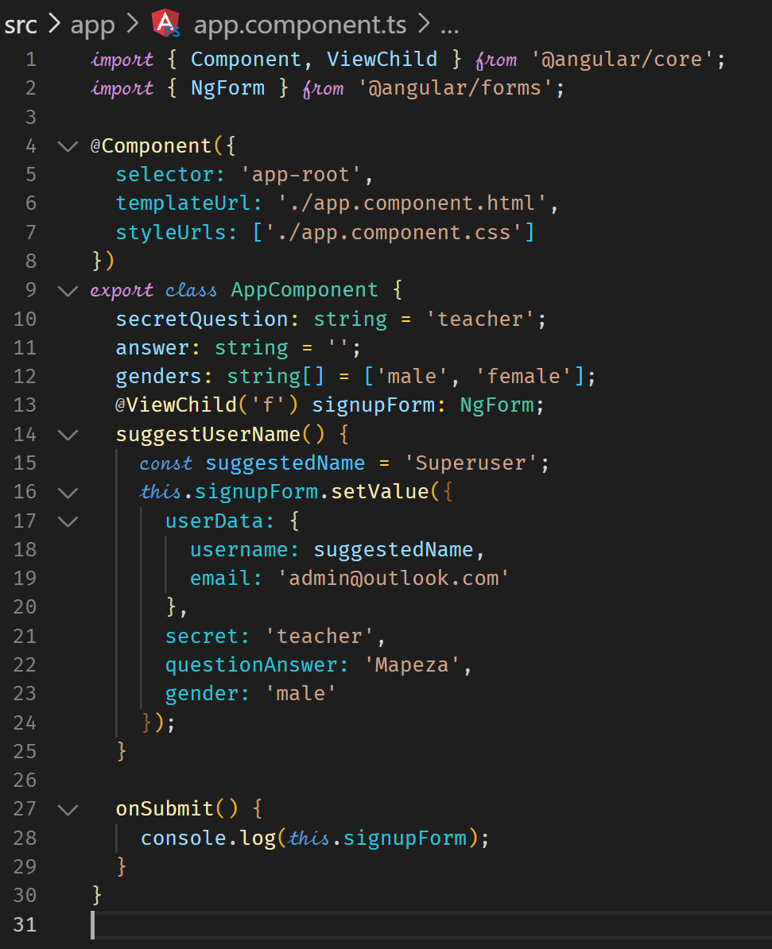

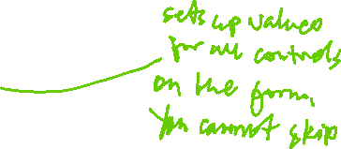

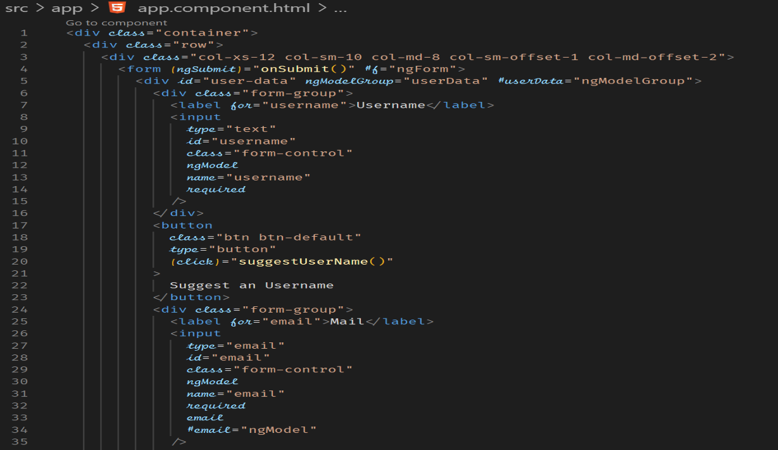

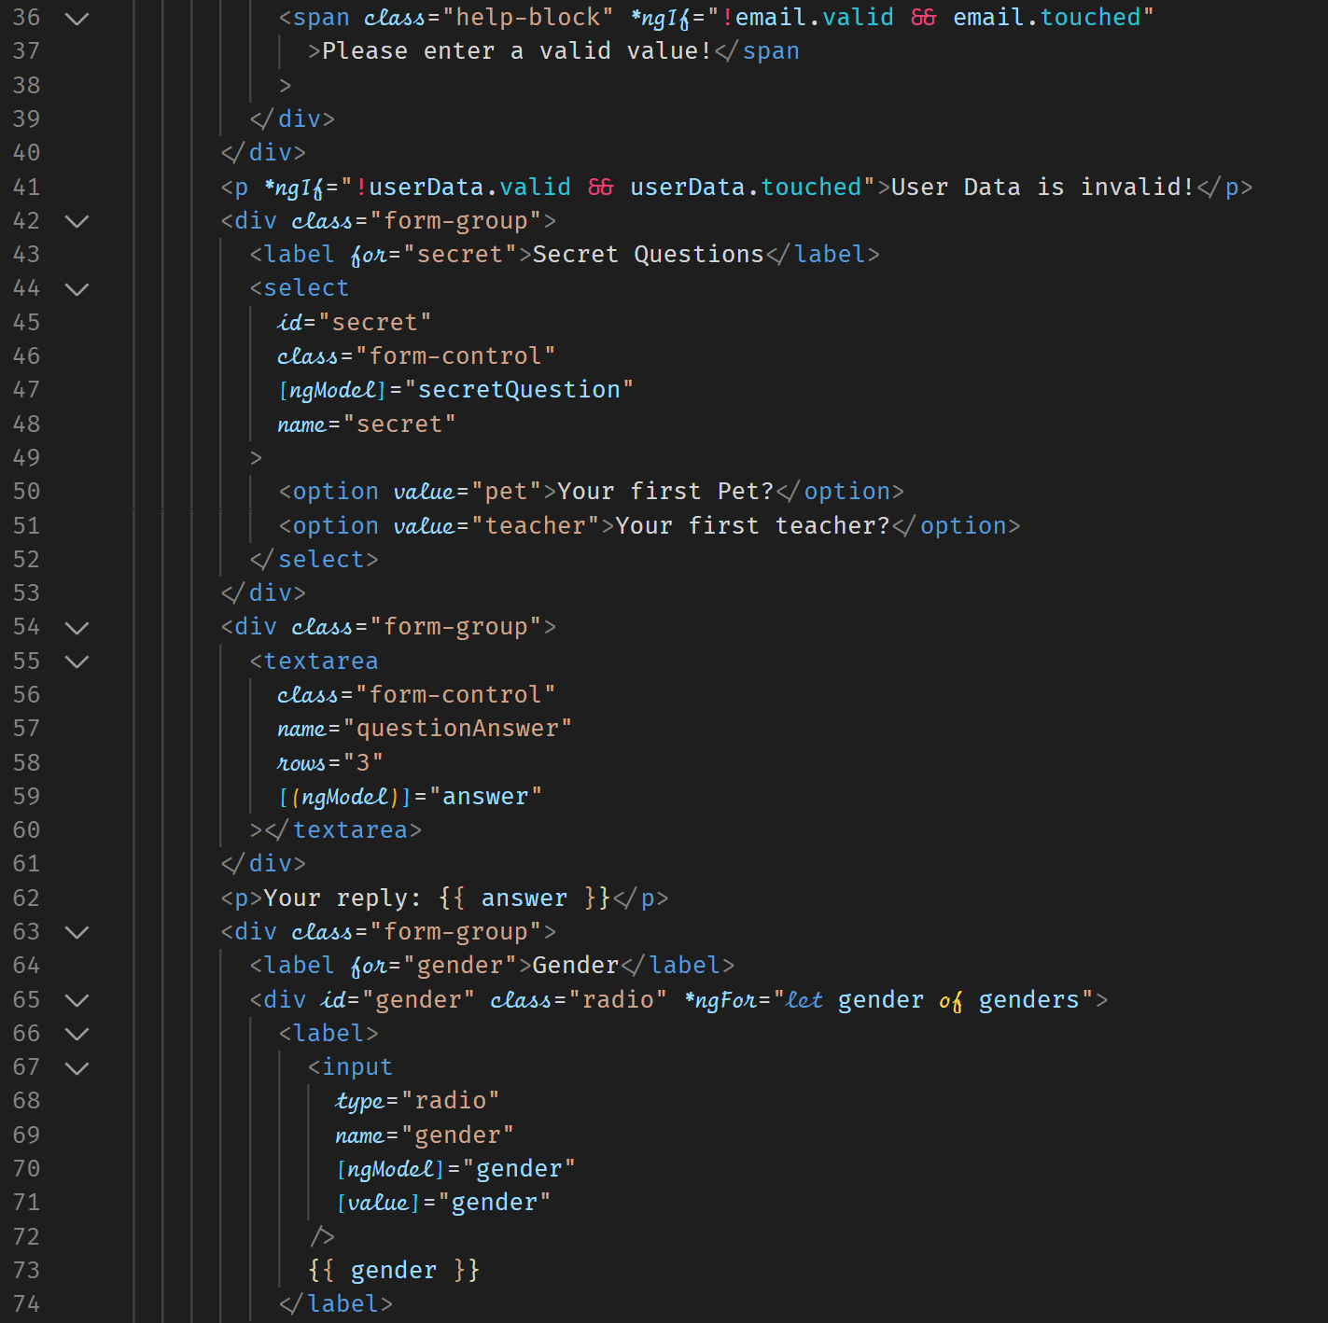

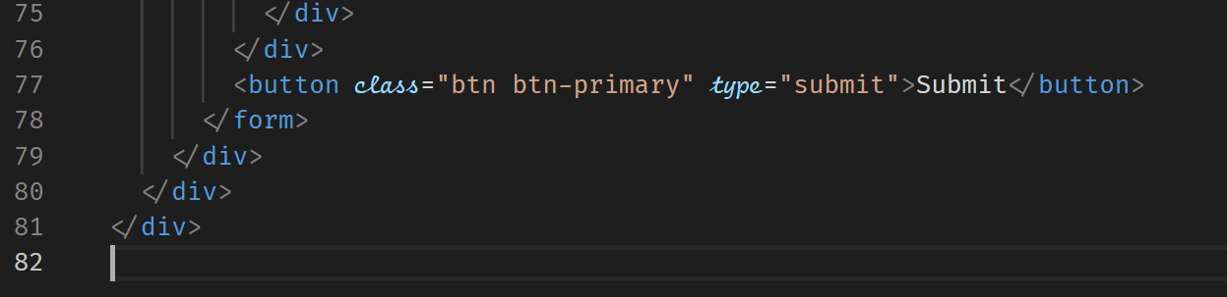

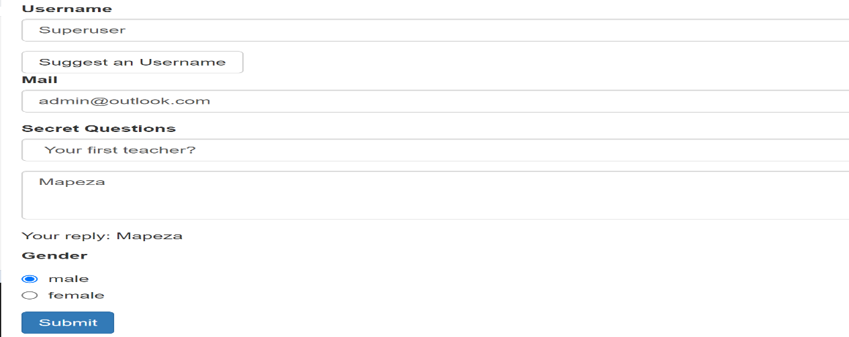

setValue() will replace all values for the controls in the form. You cannot skip fields which can be a disadvantage. When you wish to set value for single field, you should use patching.

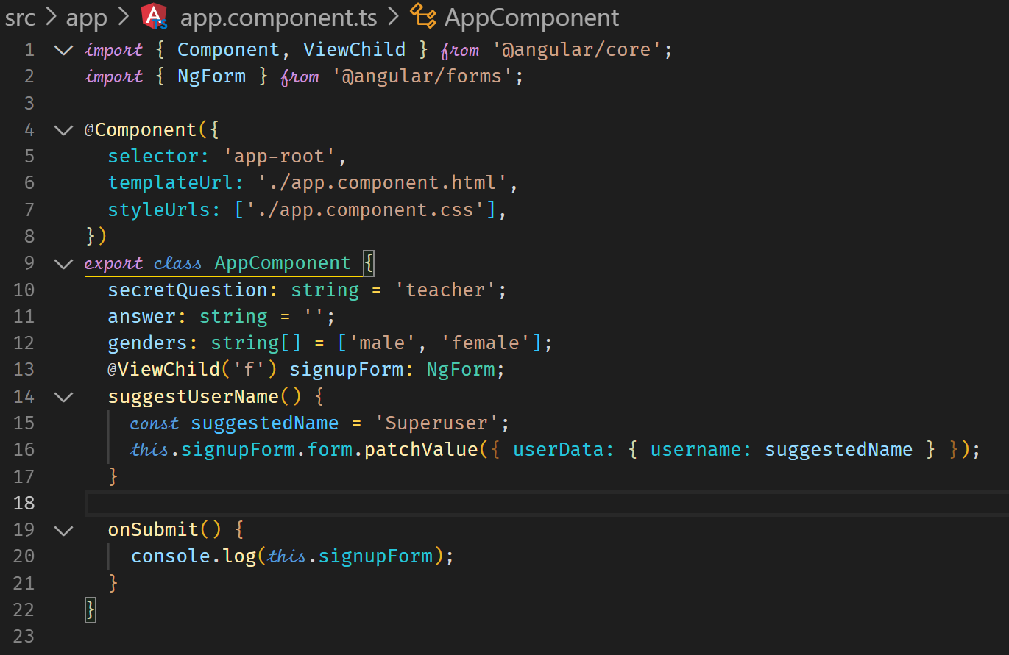

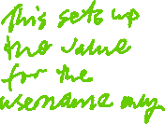

**Using Form Data**

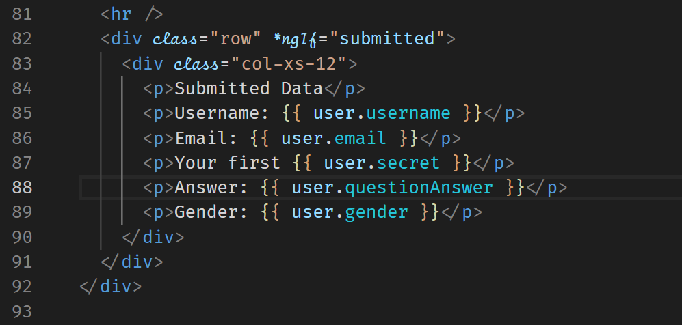

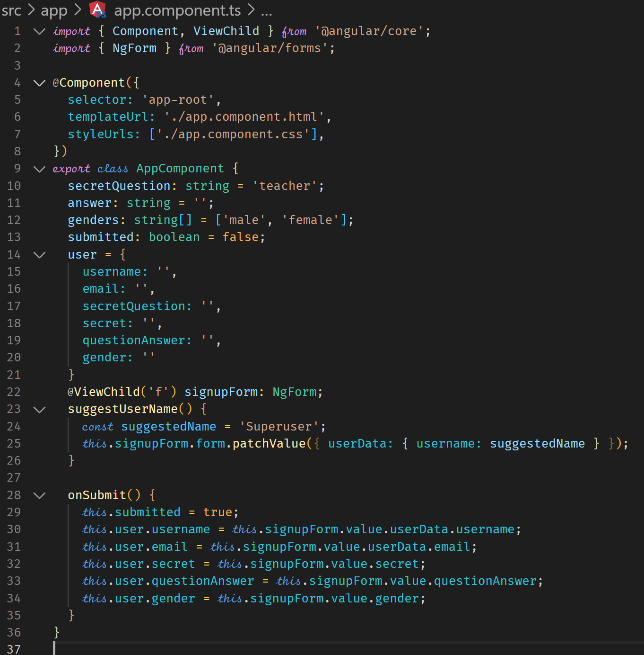

**Reactive Approach**

Form is created programmatically and synchronized with the DOM.

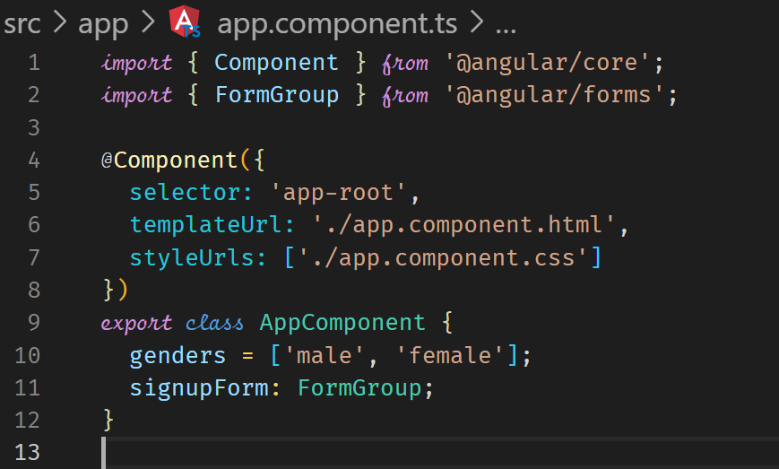



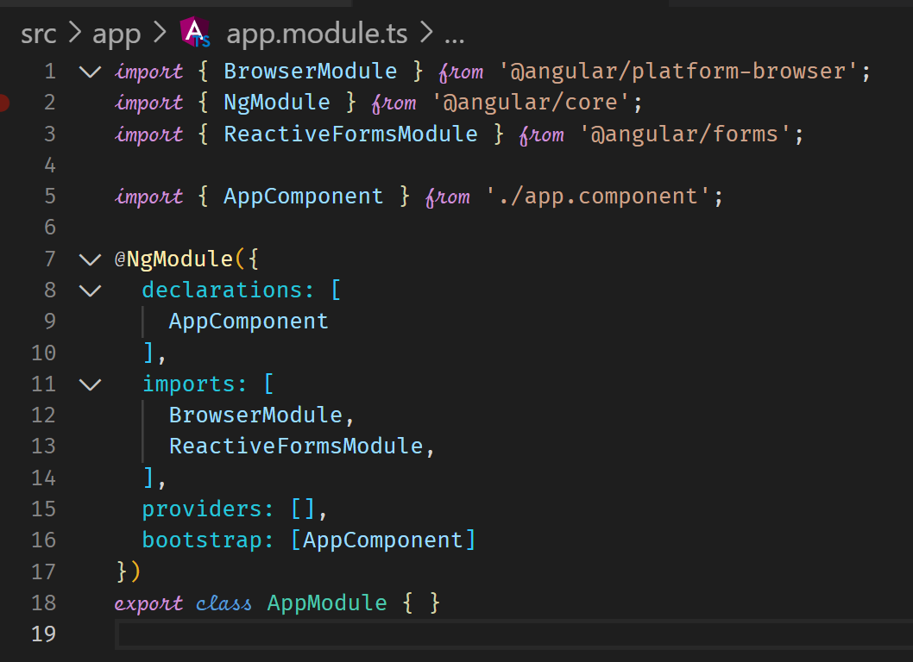



**Creating a Form in Code**

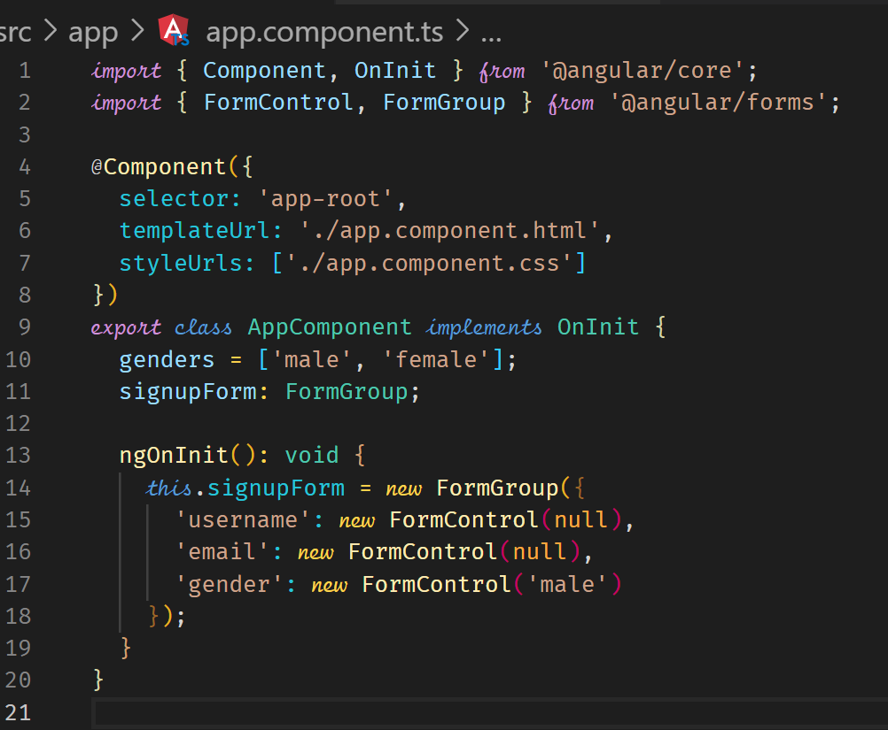



**Syncing HTML and Form**

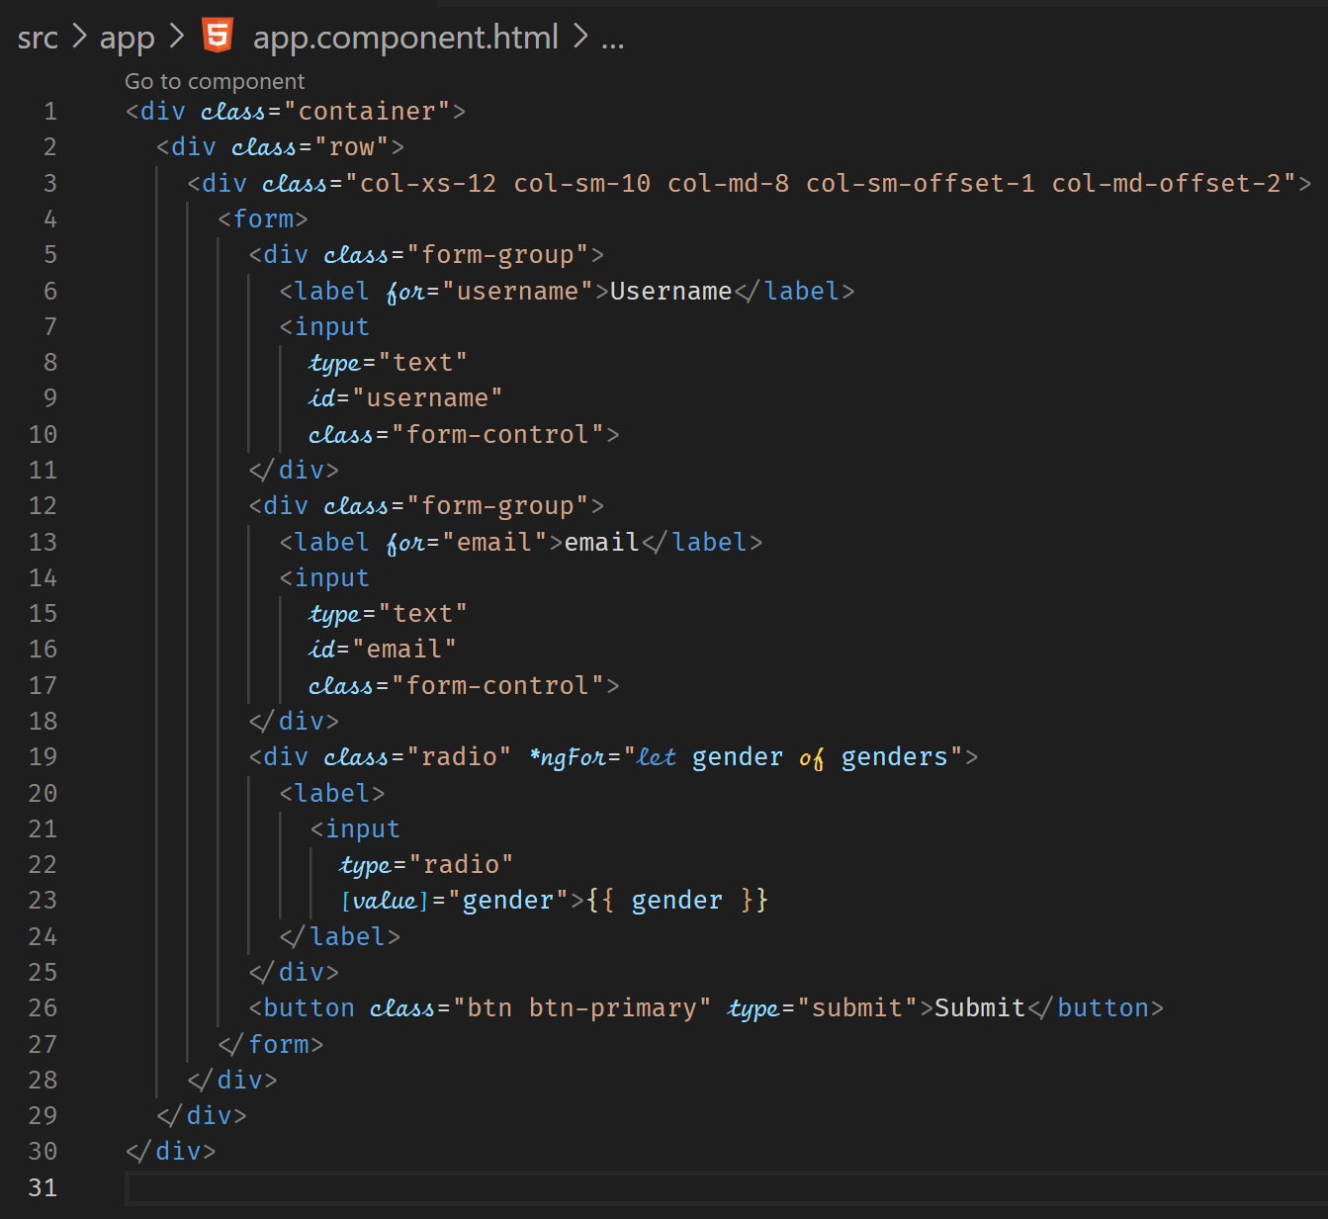



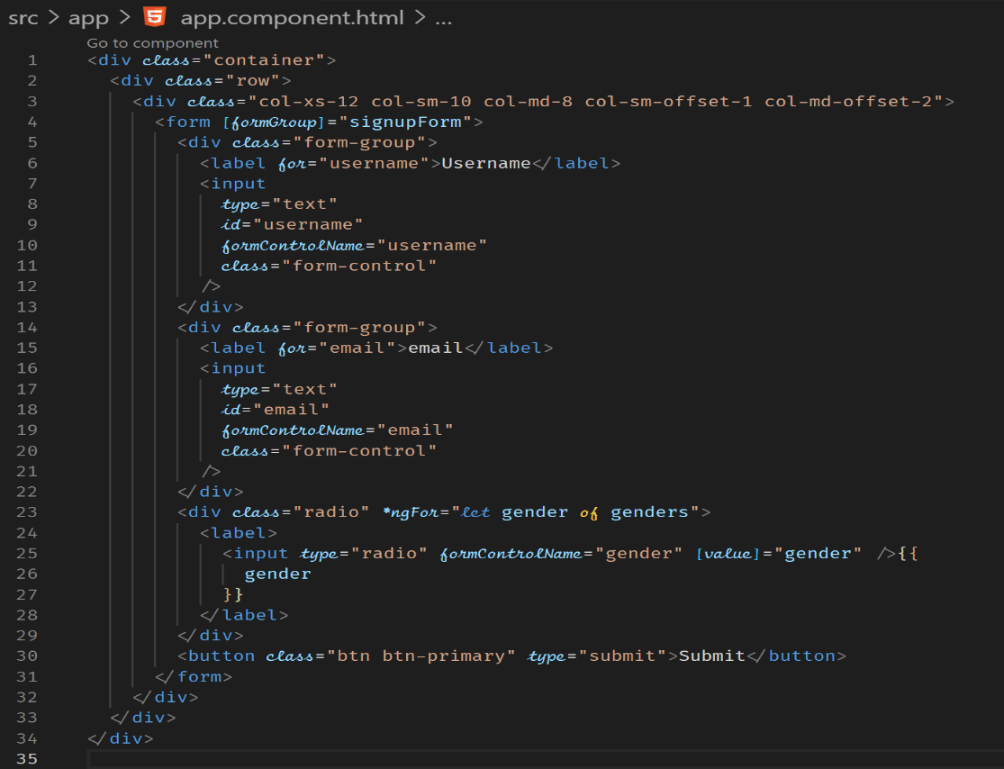



**Submitting the Form : Reactive**

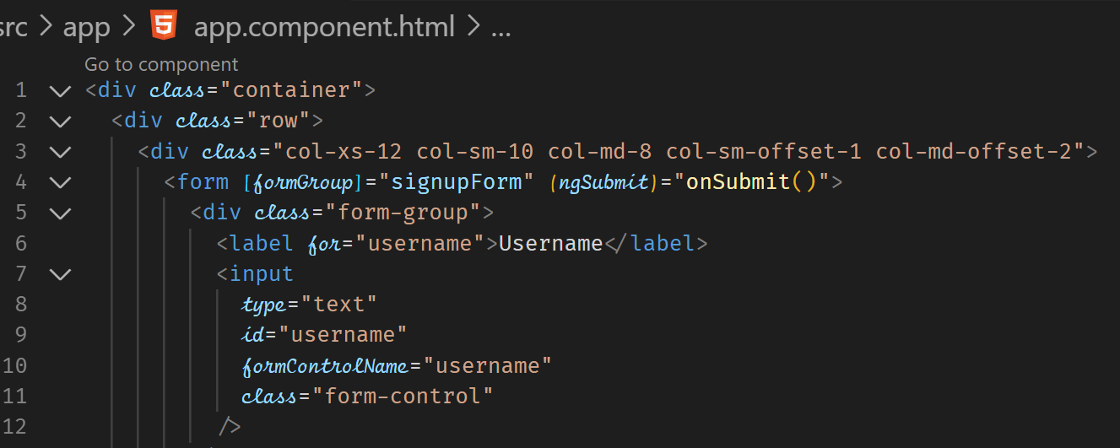

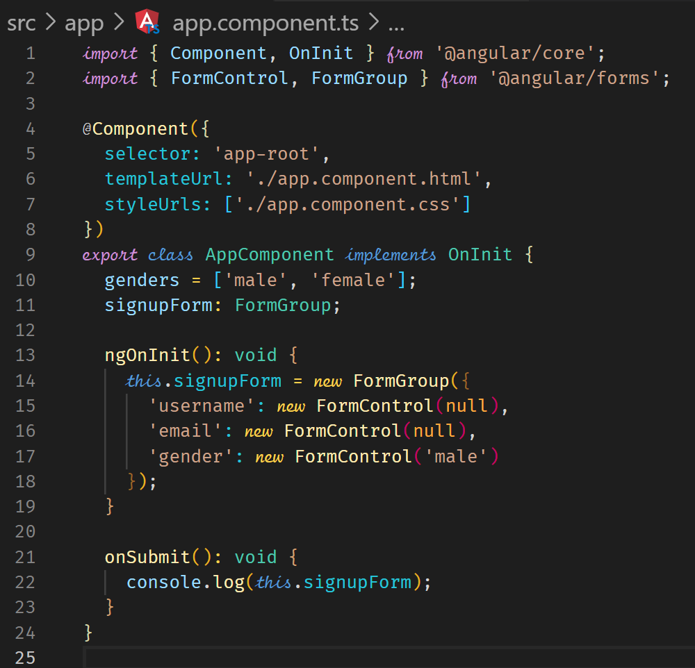

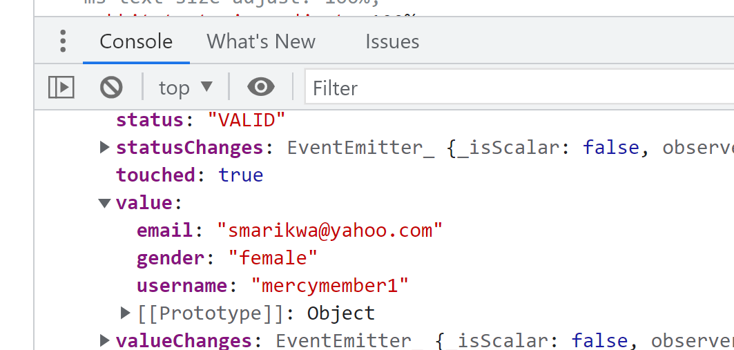

**Reactive: Adding Validation**

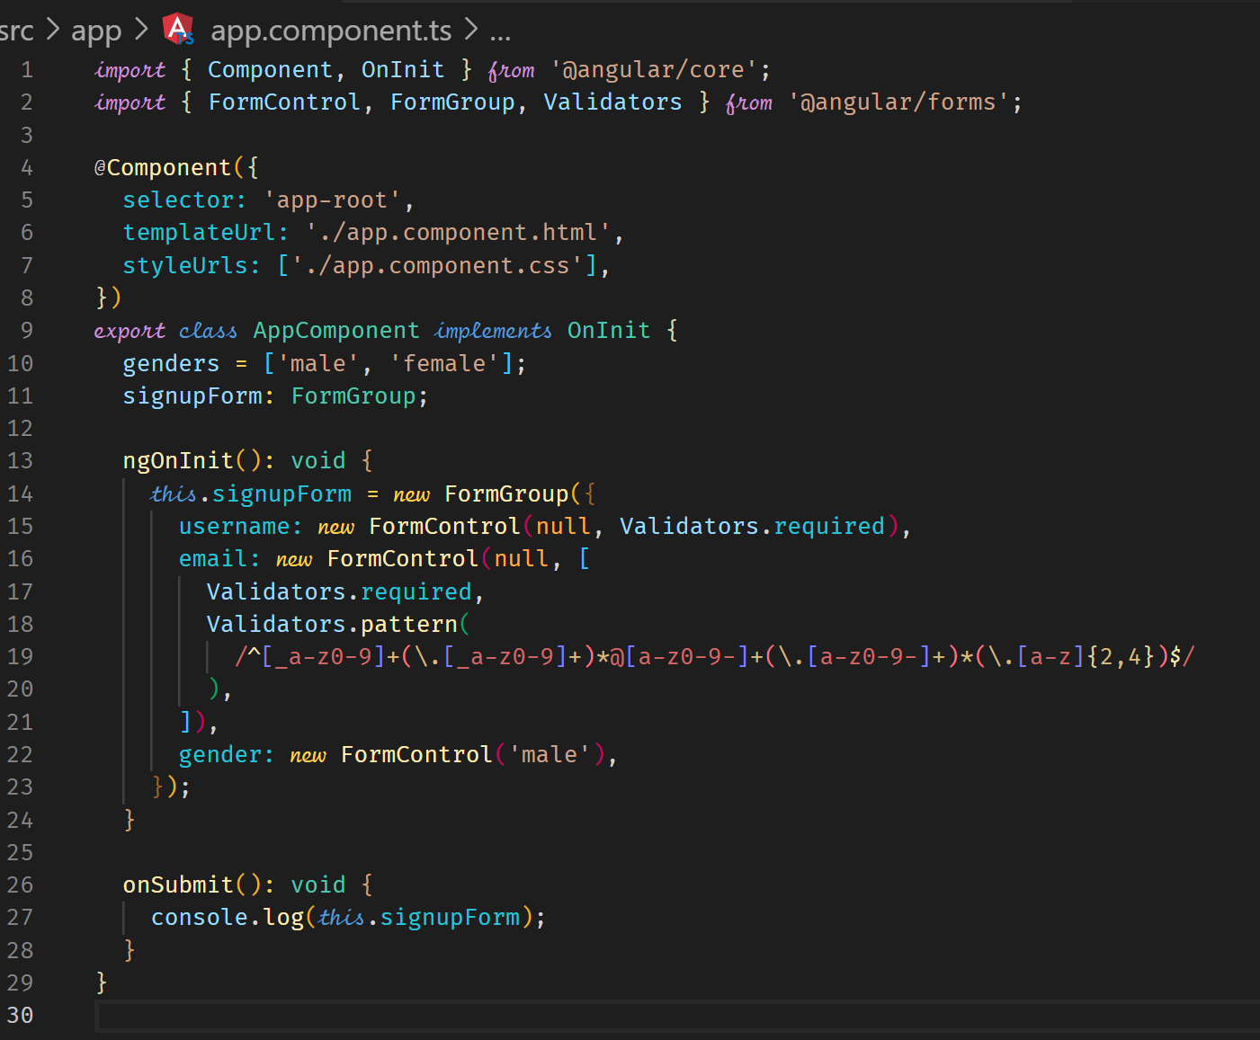

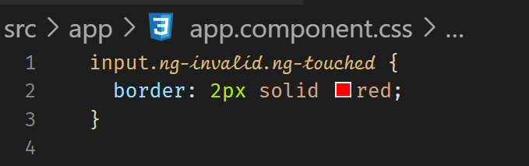

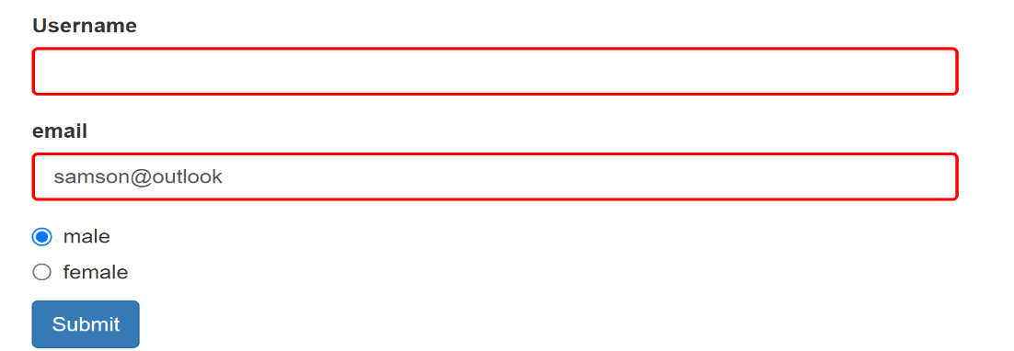

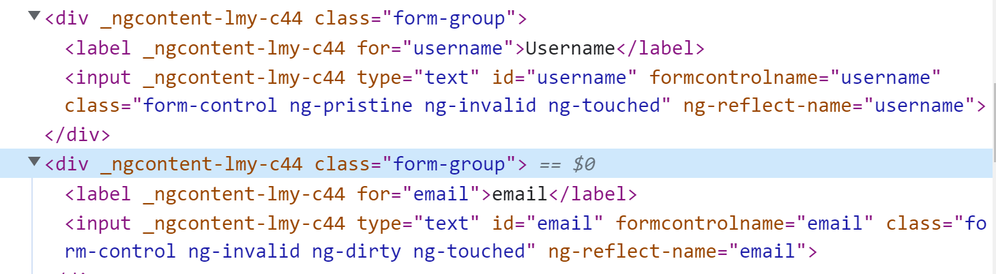

**Getting Access to Controls**

We can display error message by accessing control properties.

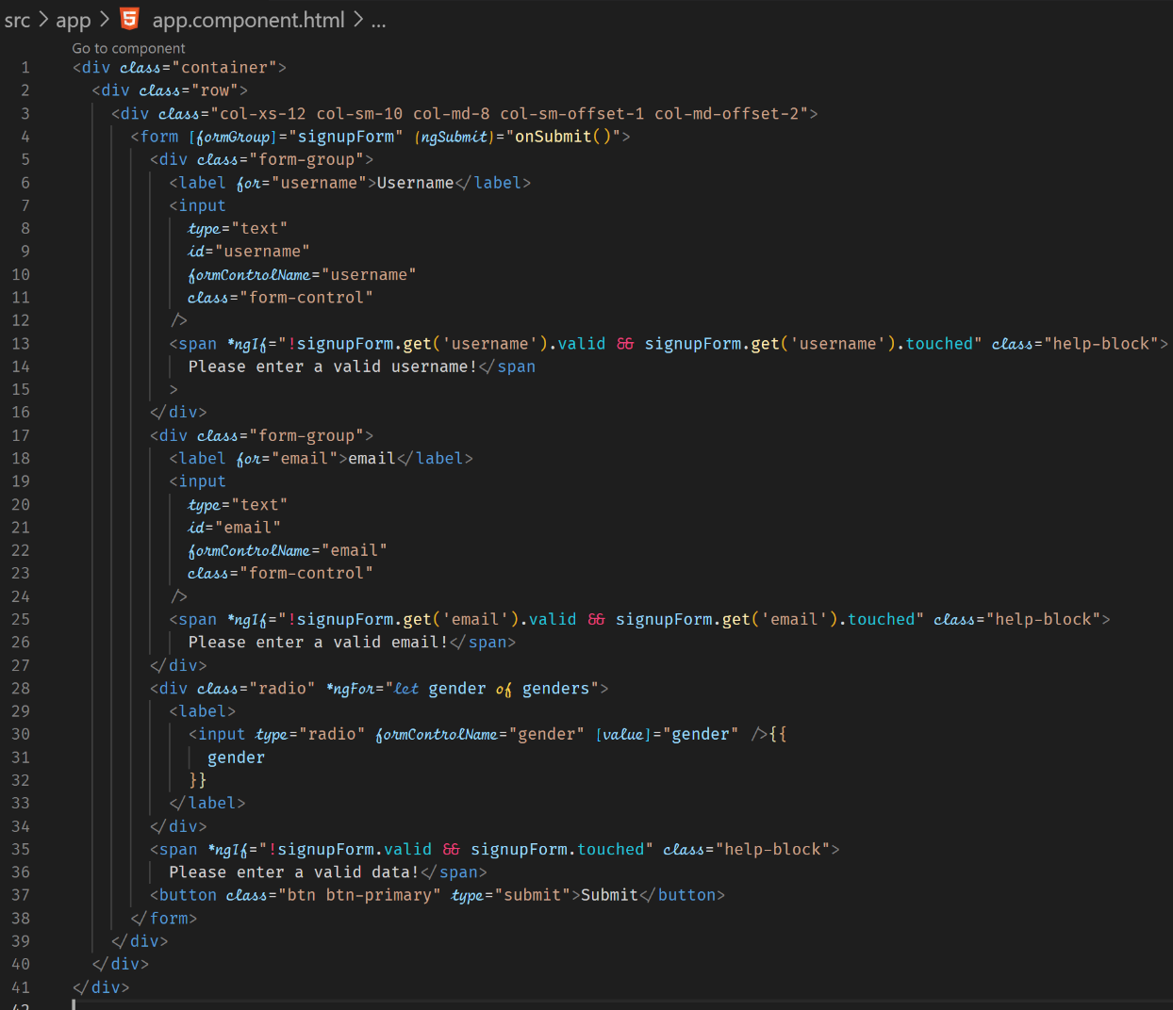



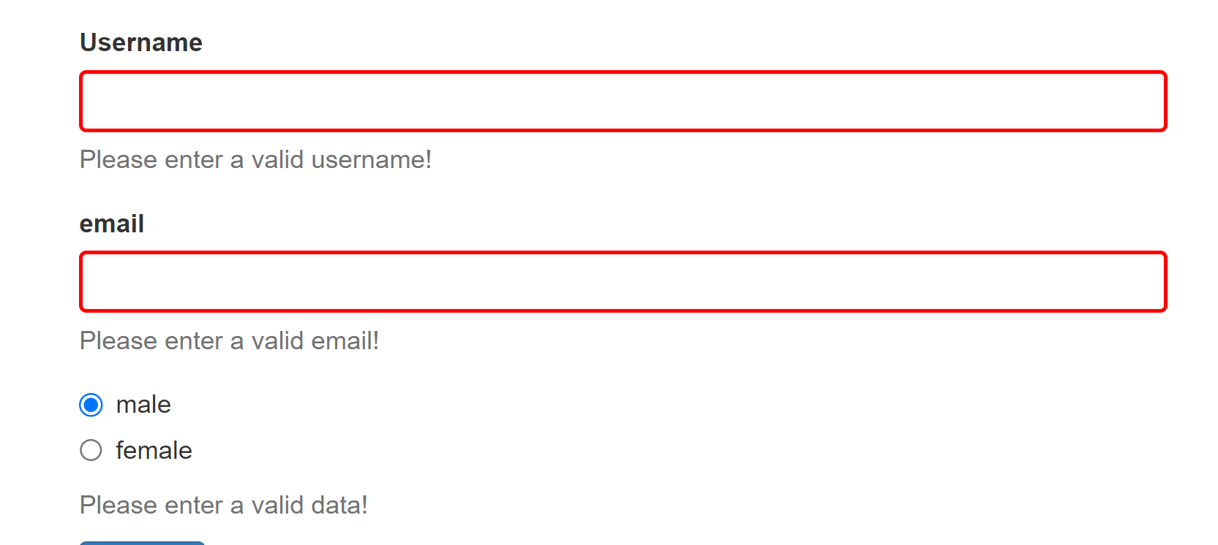

**Grouping Controls – Form Groups / Nested Controls**

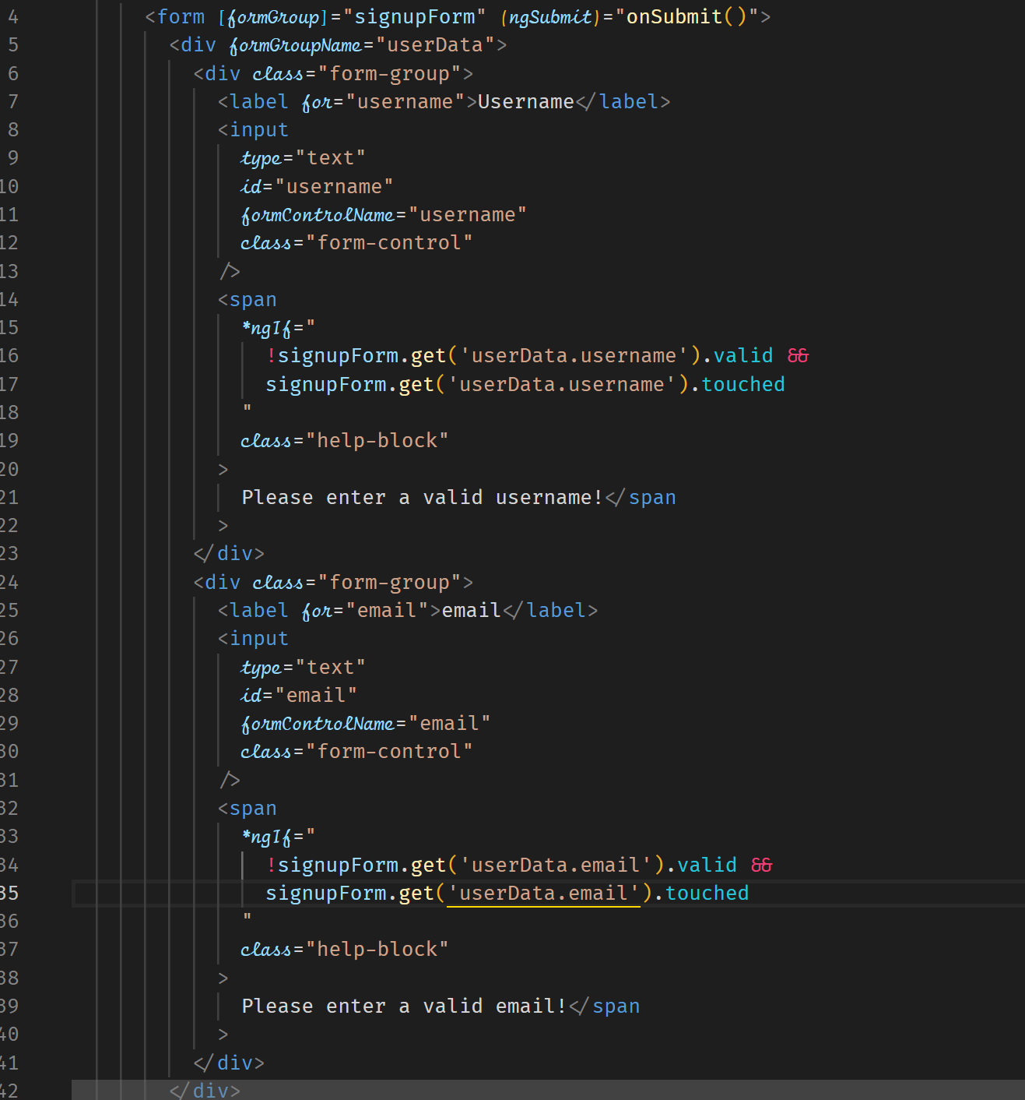



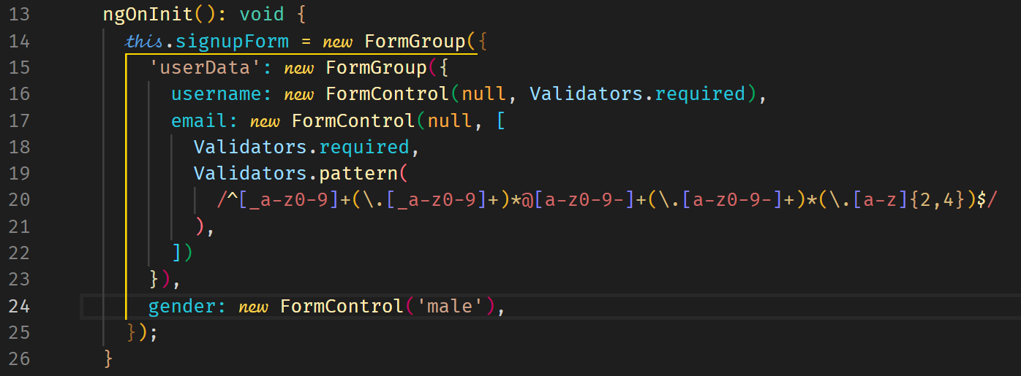

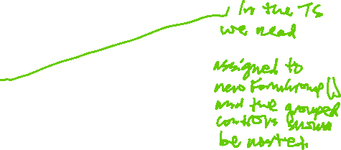

**Array of Controls**

We can have an array of controls to capture an array, example, hobbies

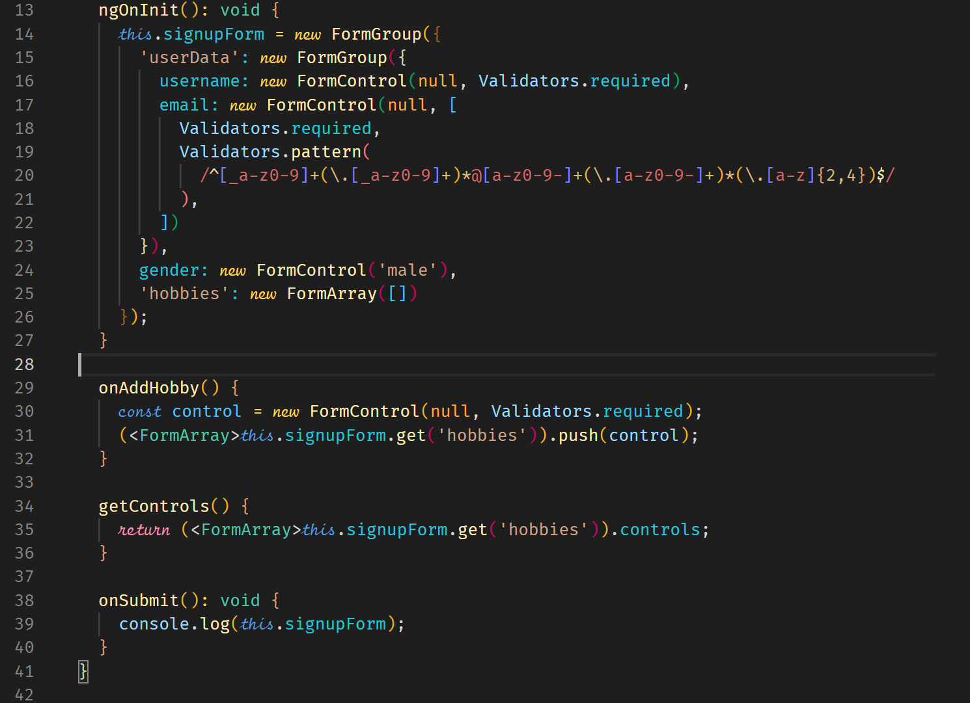



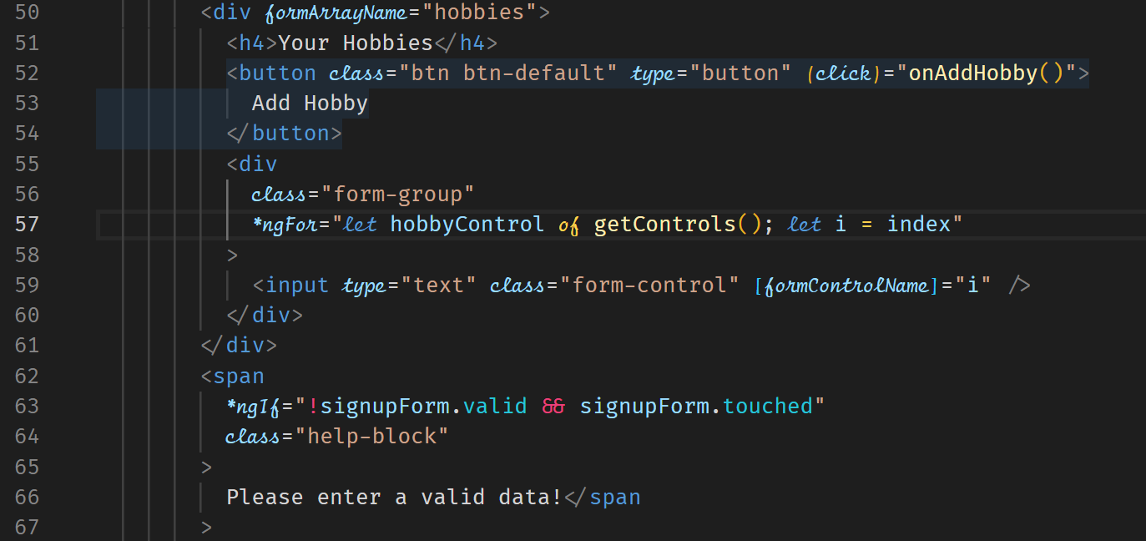

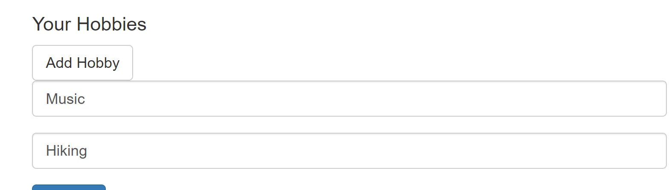

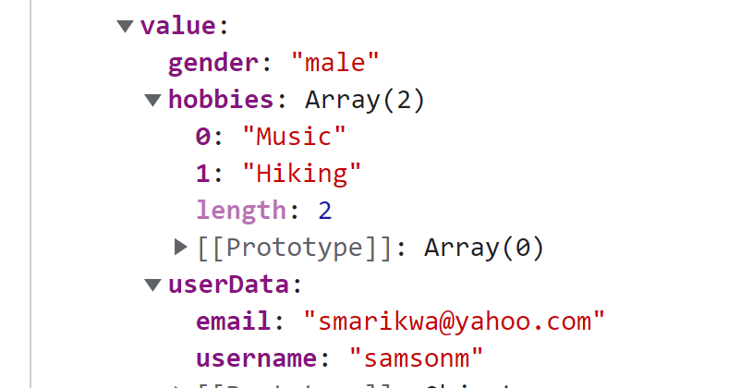

**Reactive: Creating Custom Validators**

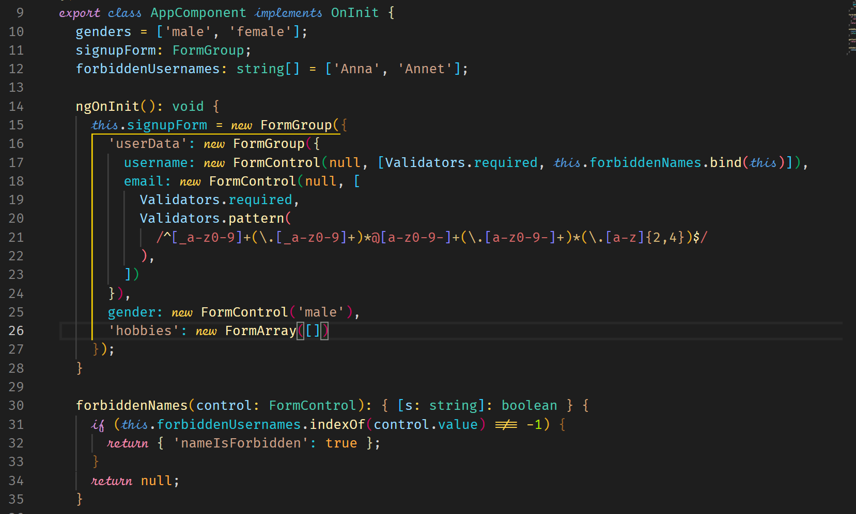

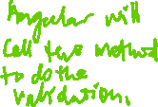

**Using the error Codes**

We can use the error codes from the control.

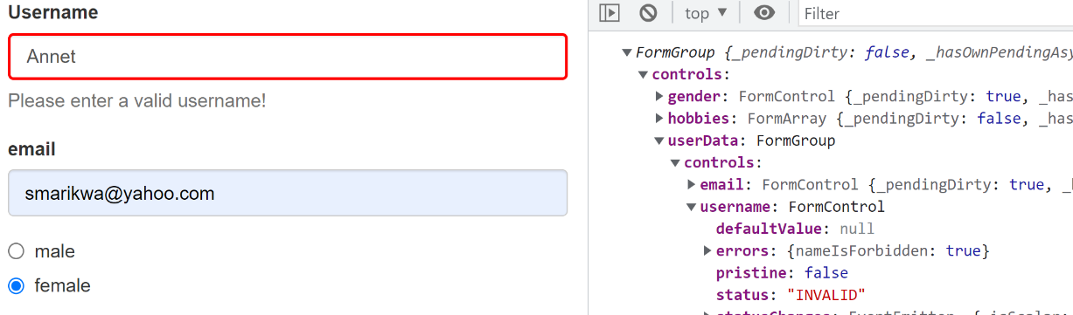



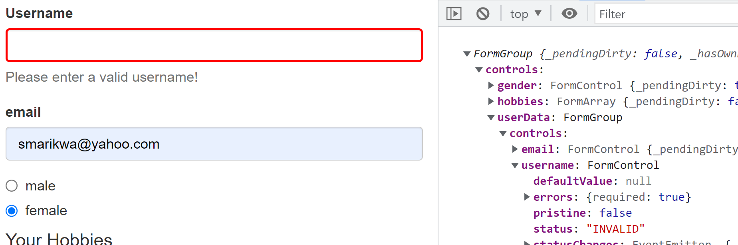



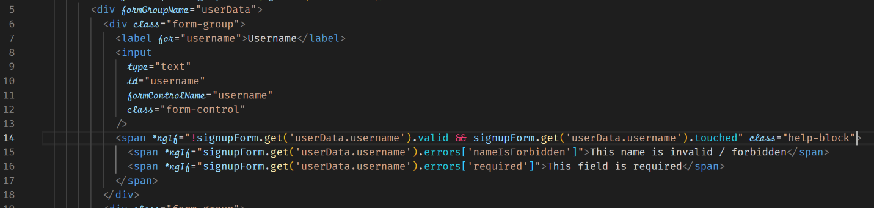



**Creating a Custom Async Validator**

This is ideal when the validation is taking place in the backend.

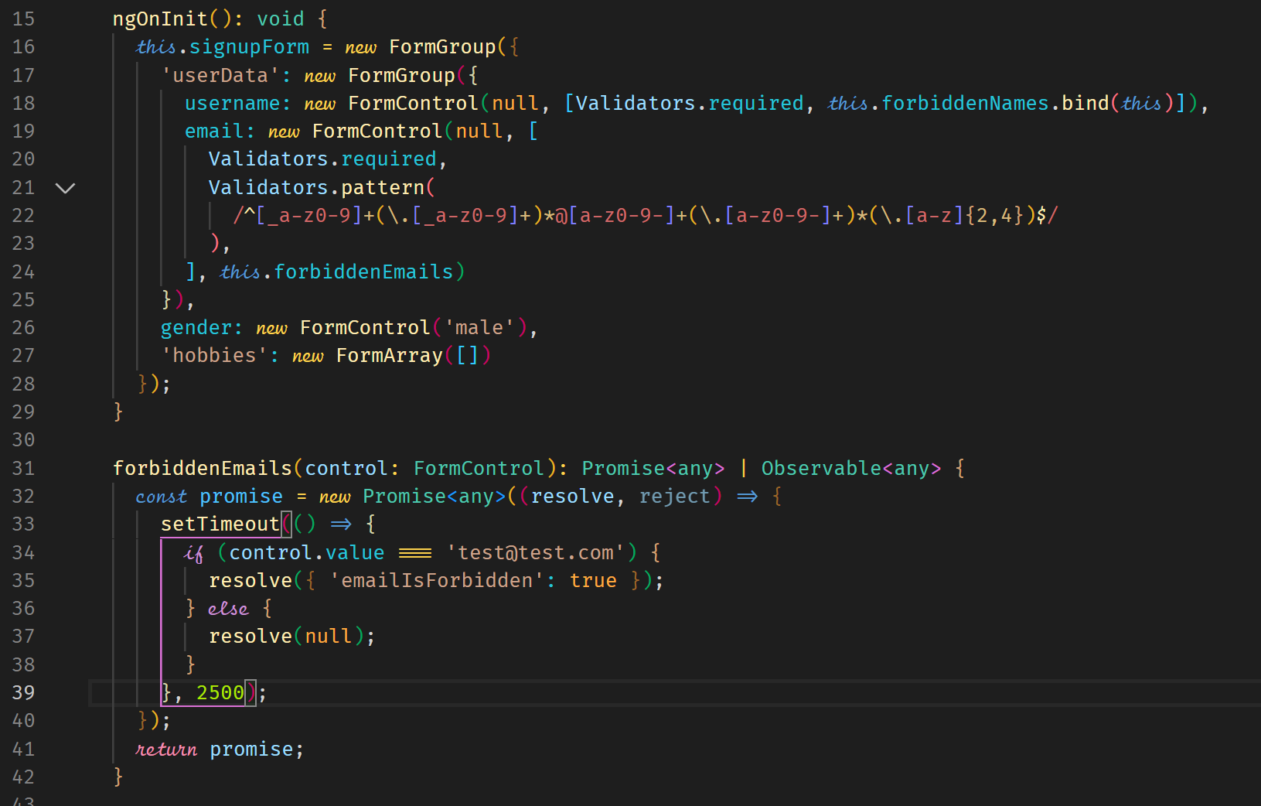



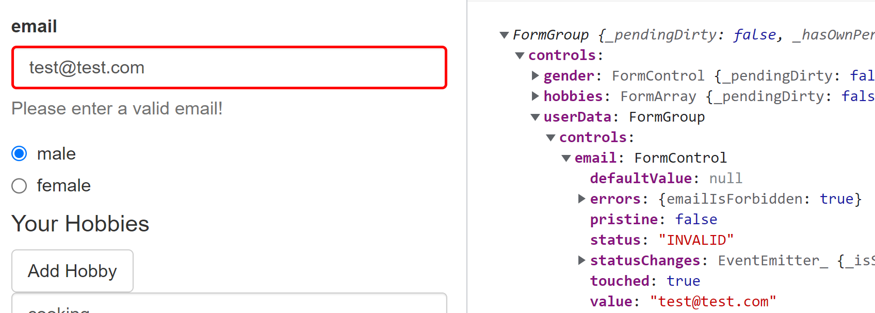



**Reactive: Reacting to Status or Value Changes**

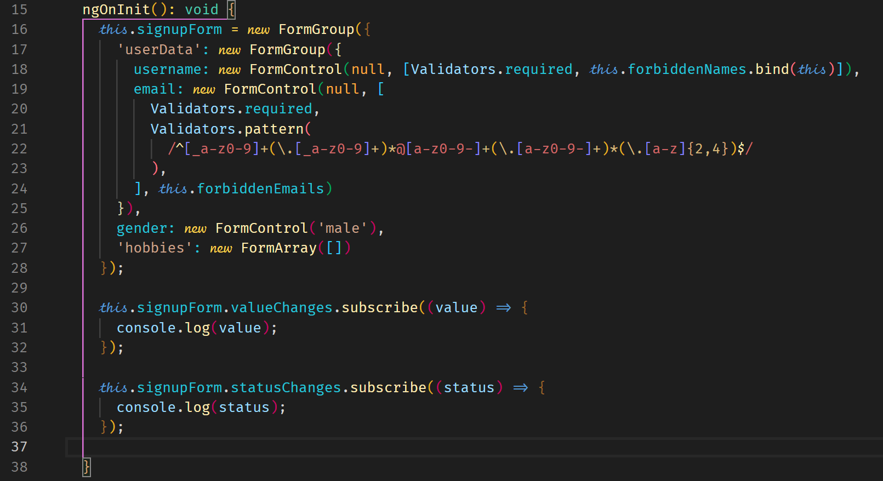



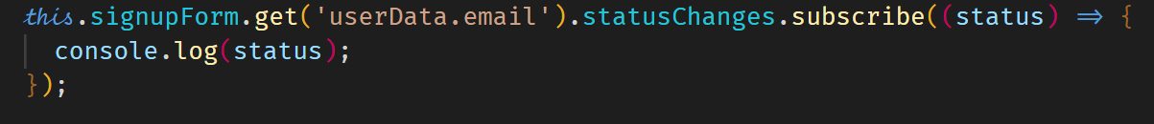

**Setting and Patching Values**

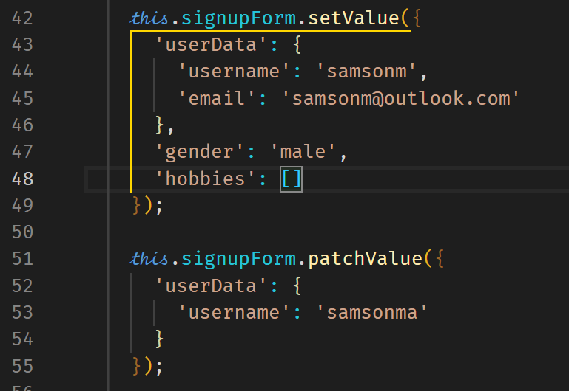

**Resetting Form**

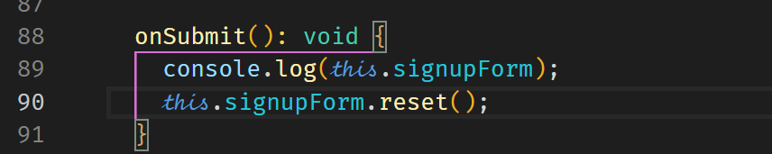

**Project**

**Adding the Shopping List Form**

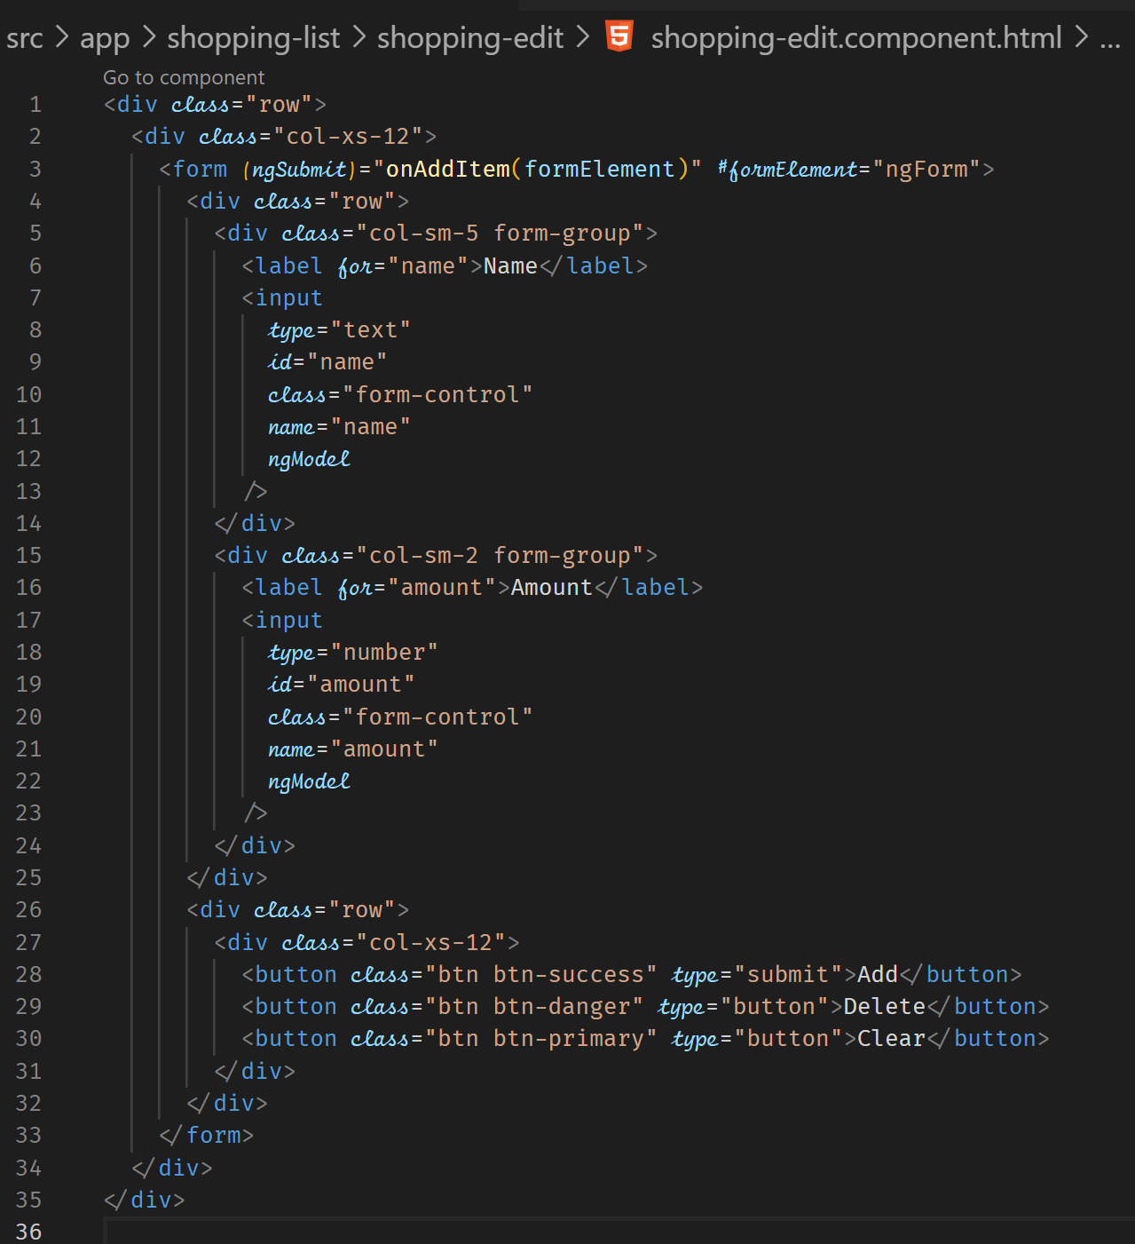

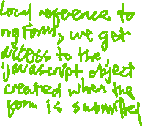

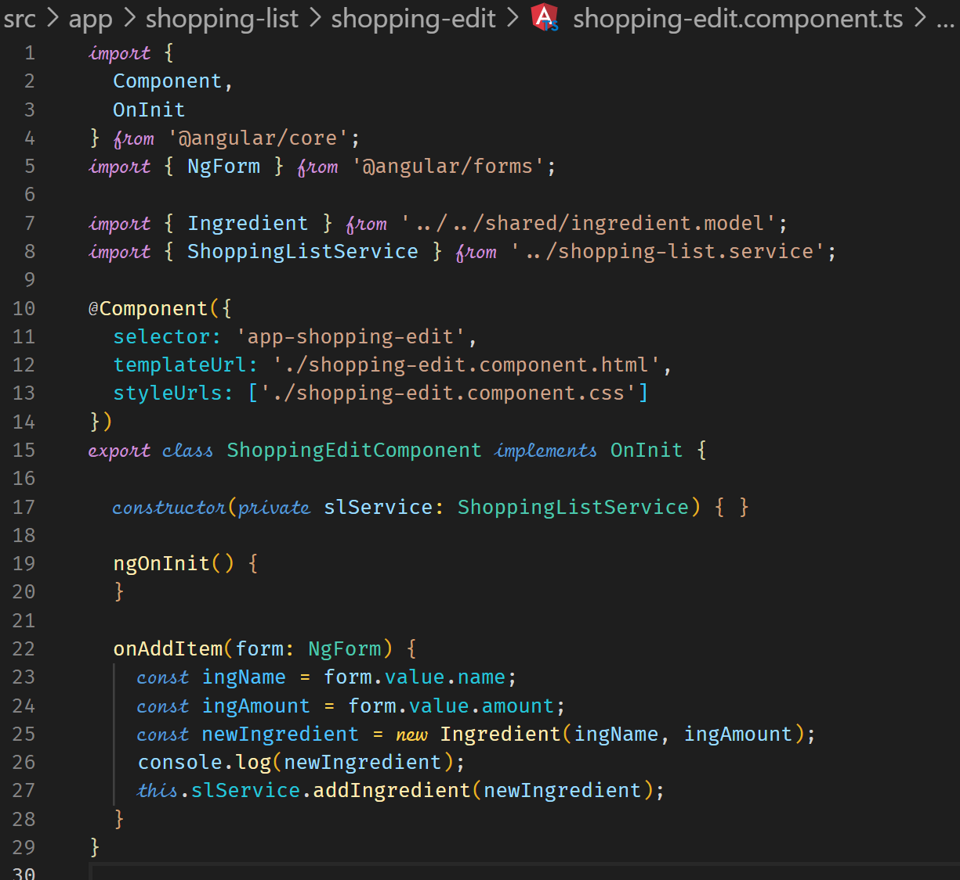



**Add Validation**

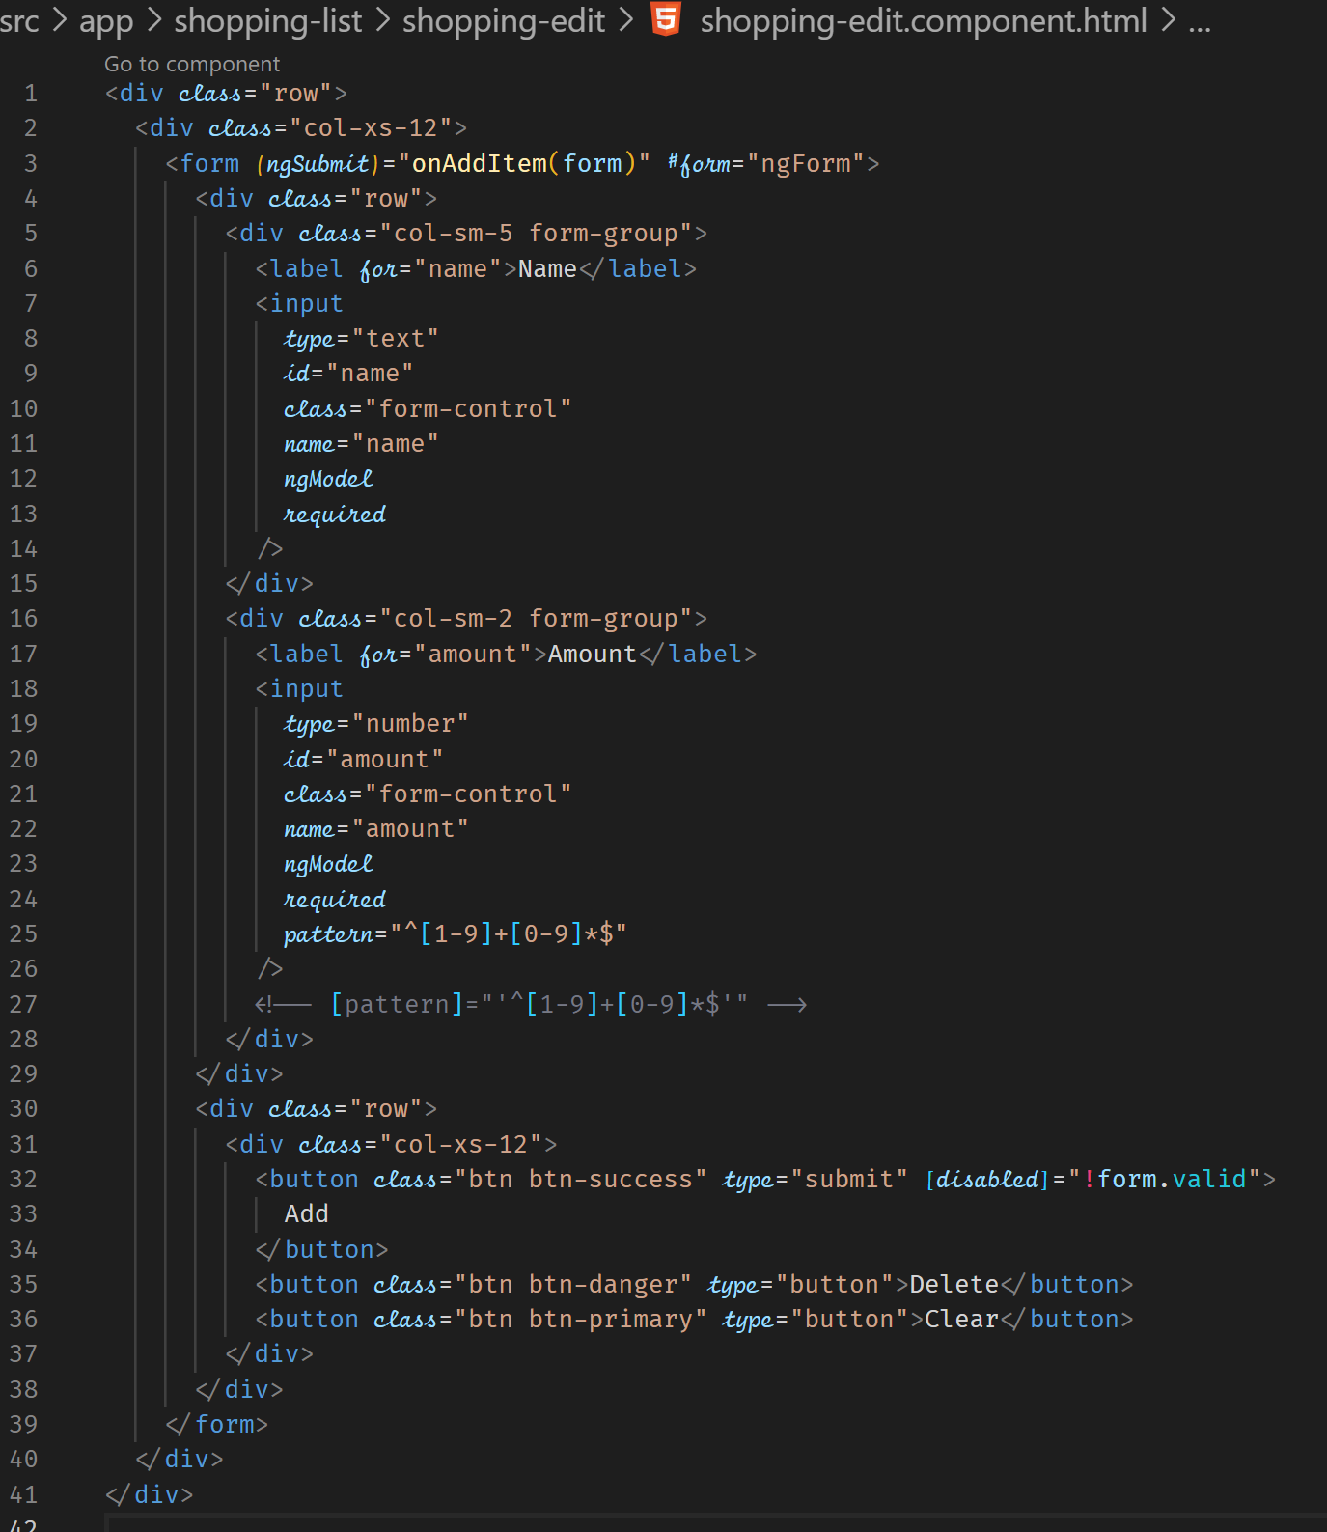



**Allow the Selection of Items in the List**

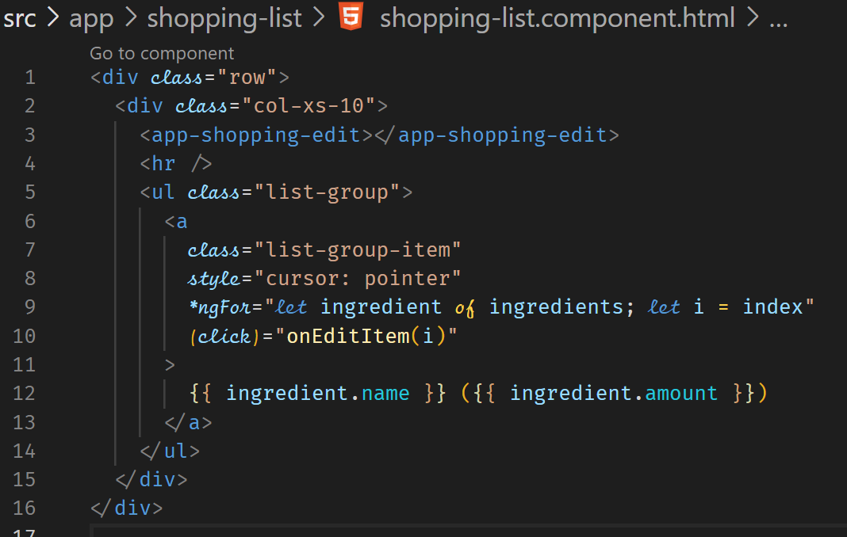



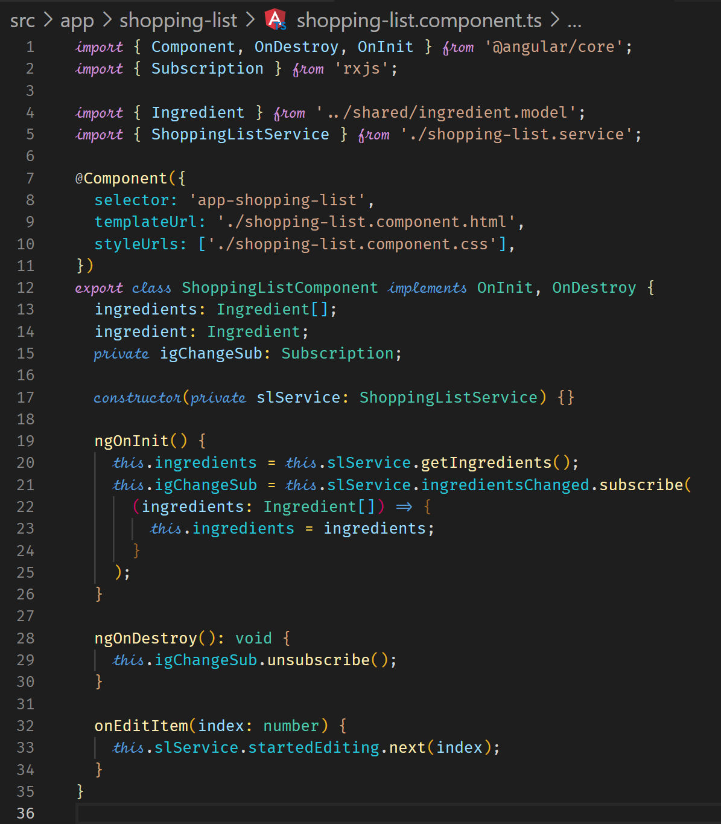



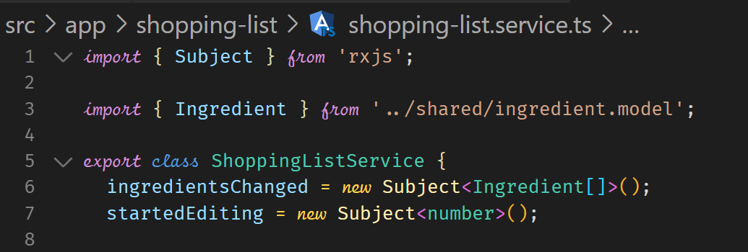



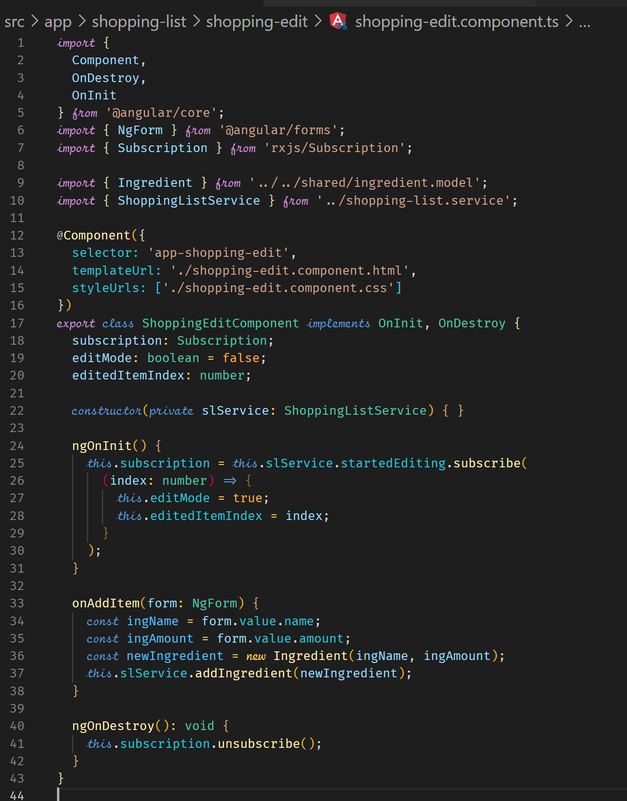



**Loading the Shopping List Items into the Form**

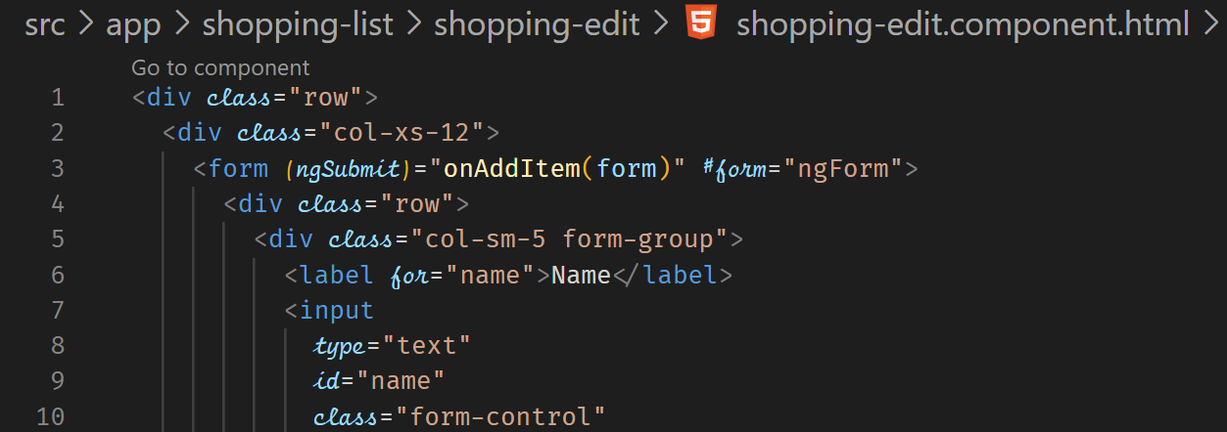



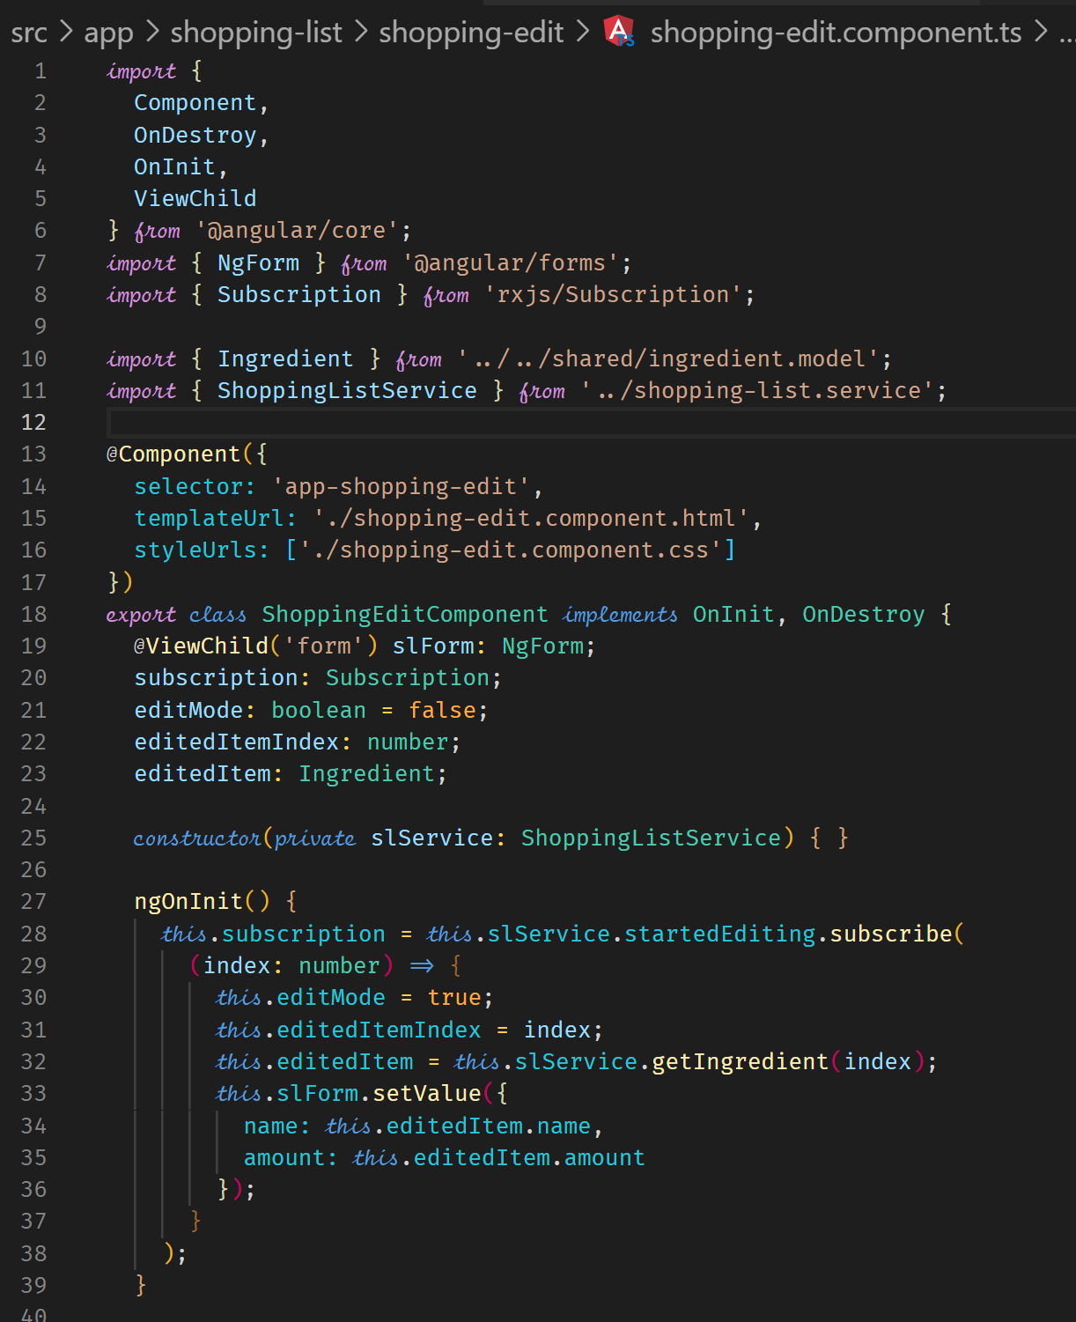



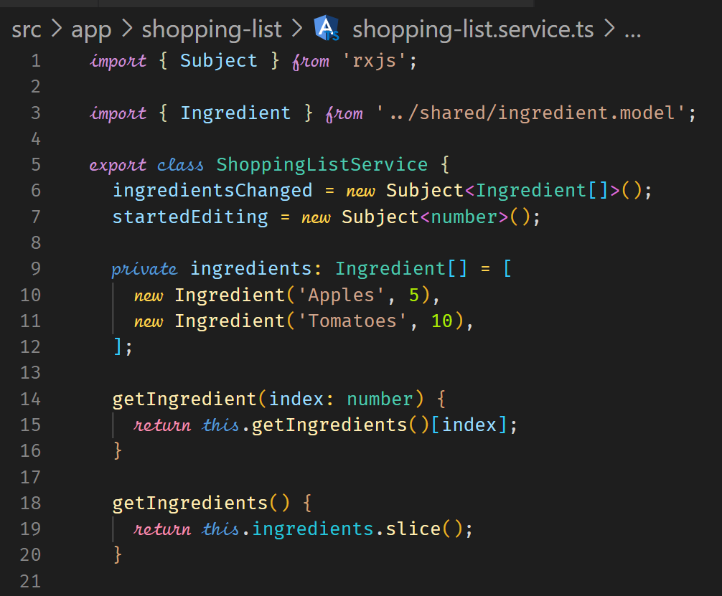



**Update Existing Items**

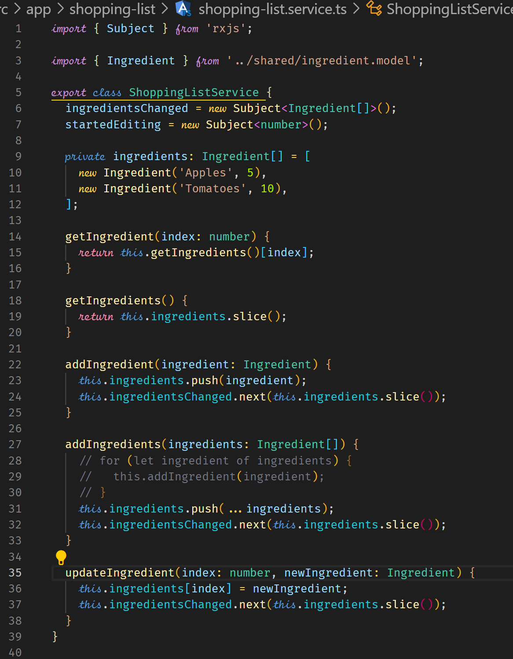



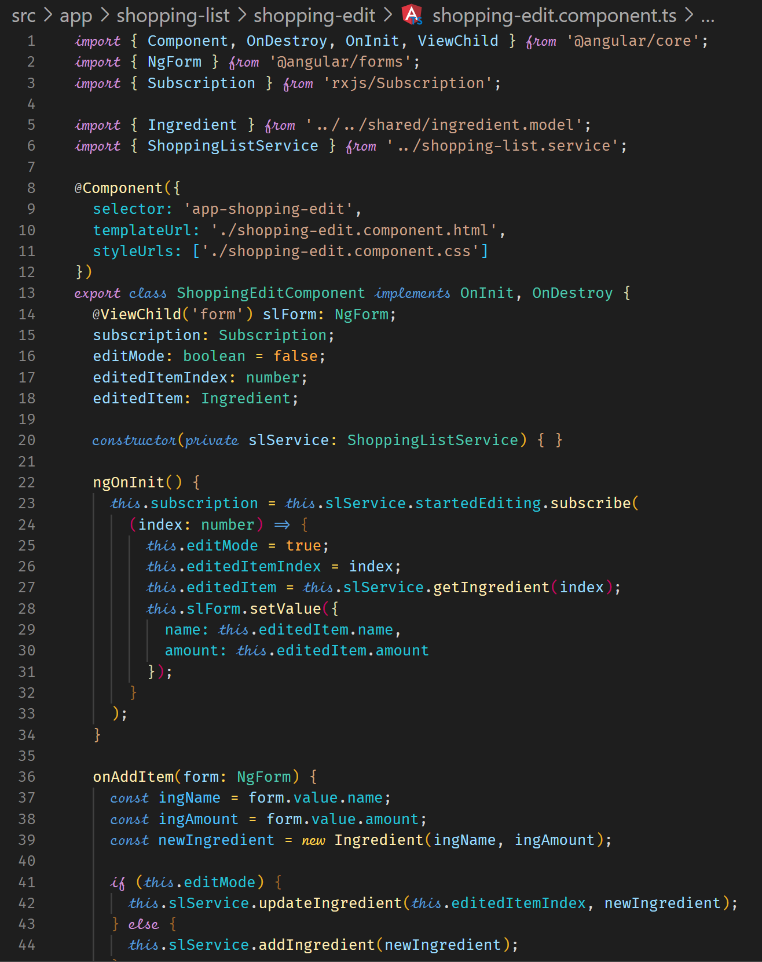



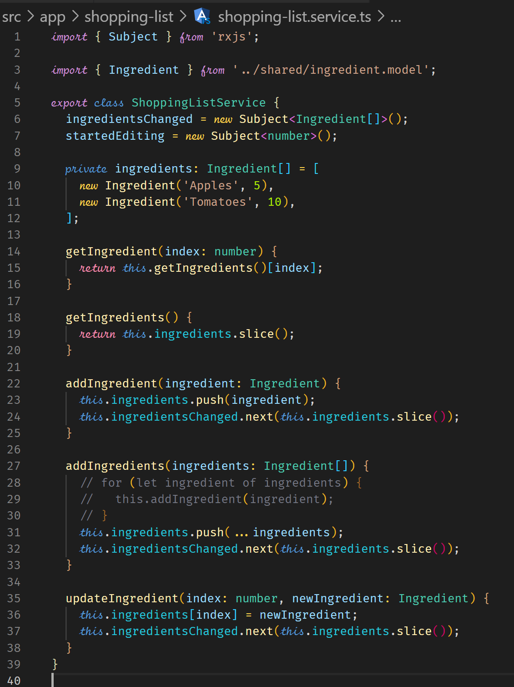

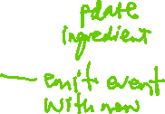

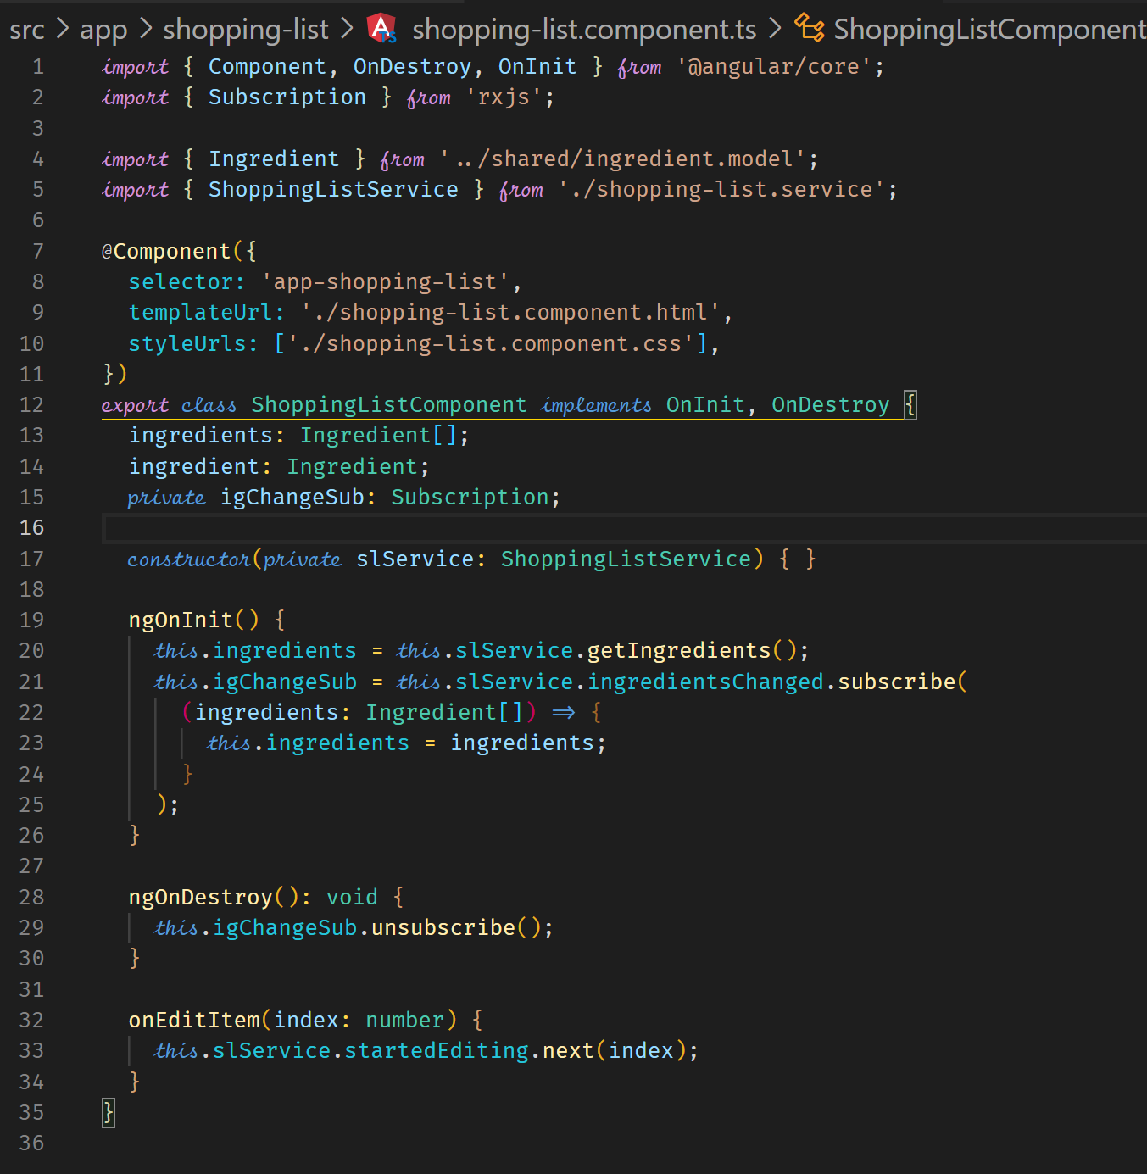



**Resetting the form**

After editing or adding an ingredient, we call the following two lines.

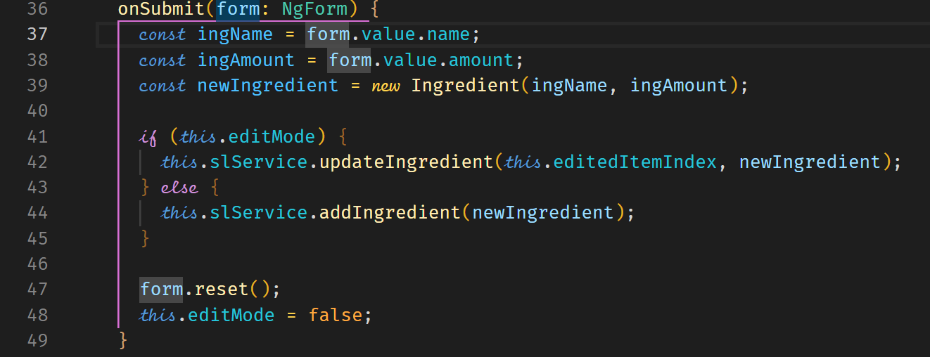



**Template for Reactive Recipe Edit Form**

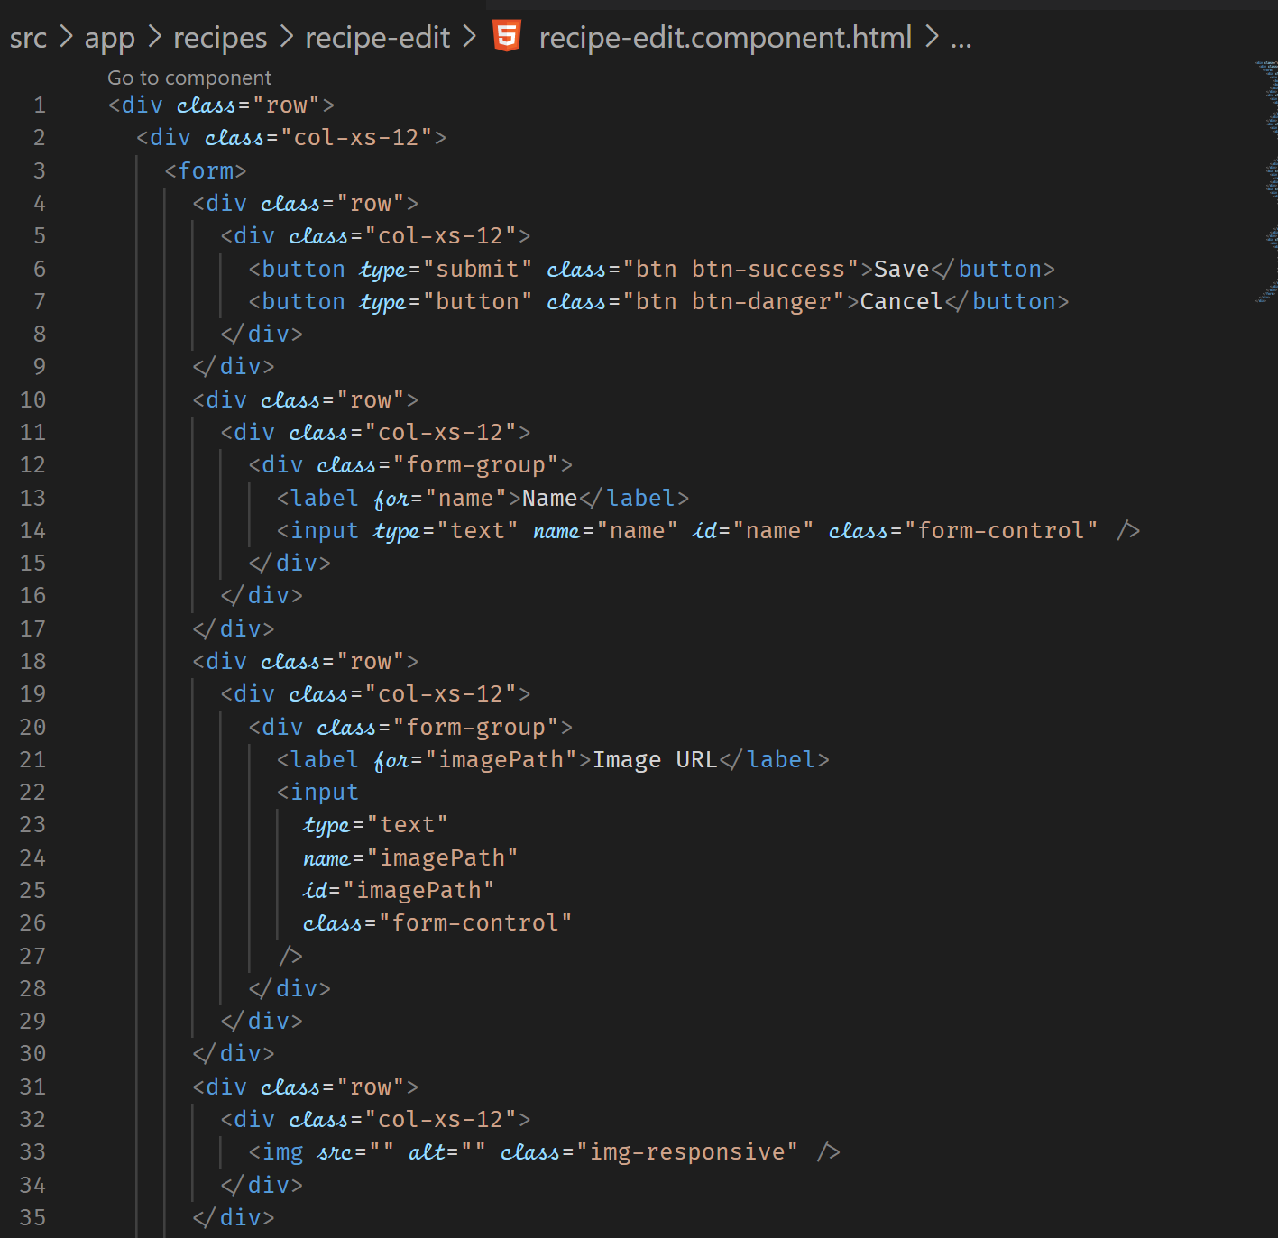

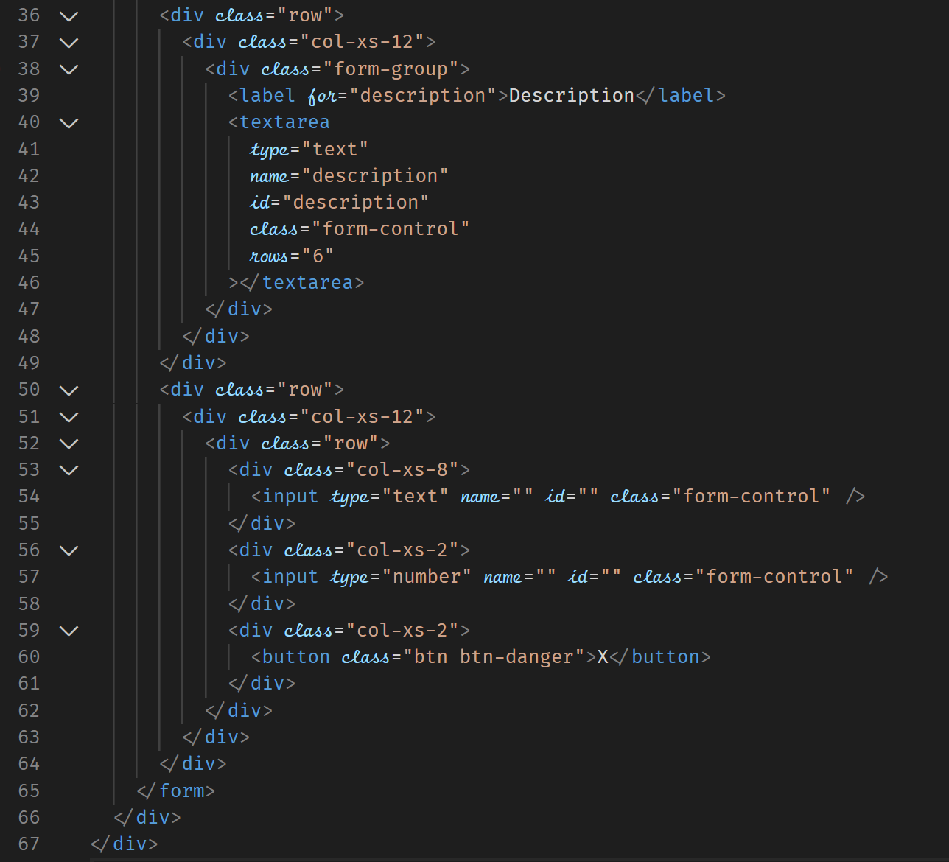

Creating the Form for editing recipes

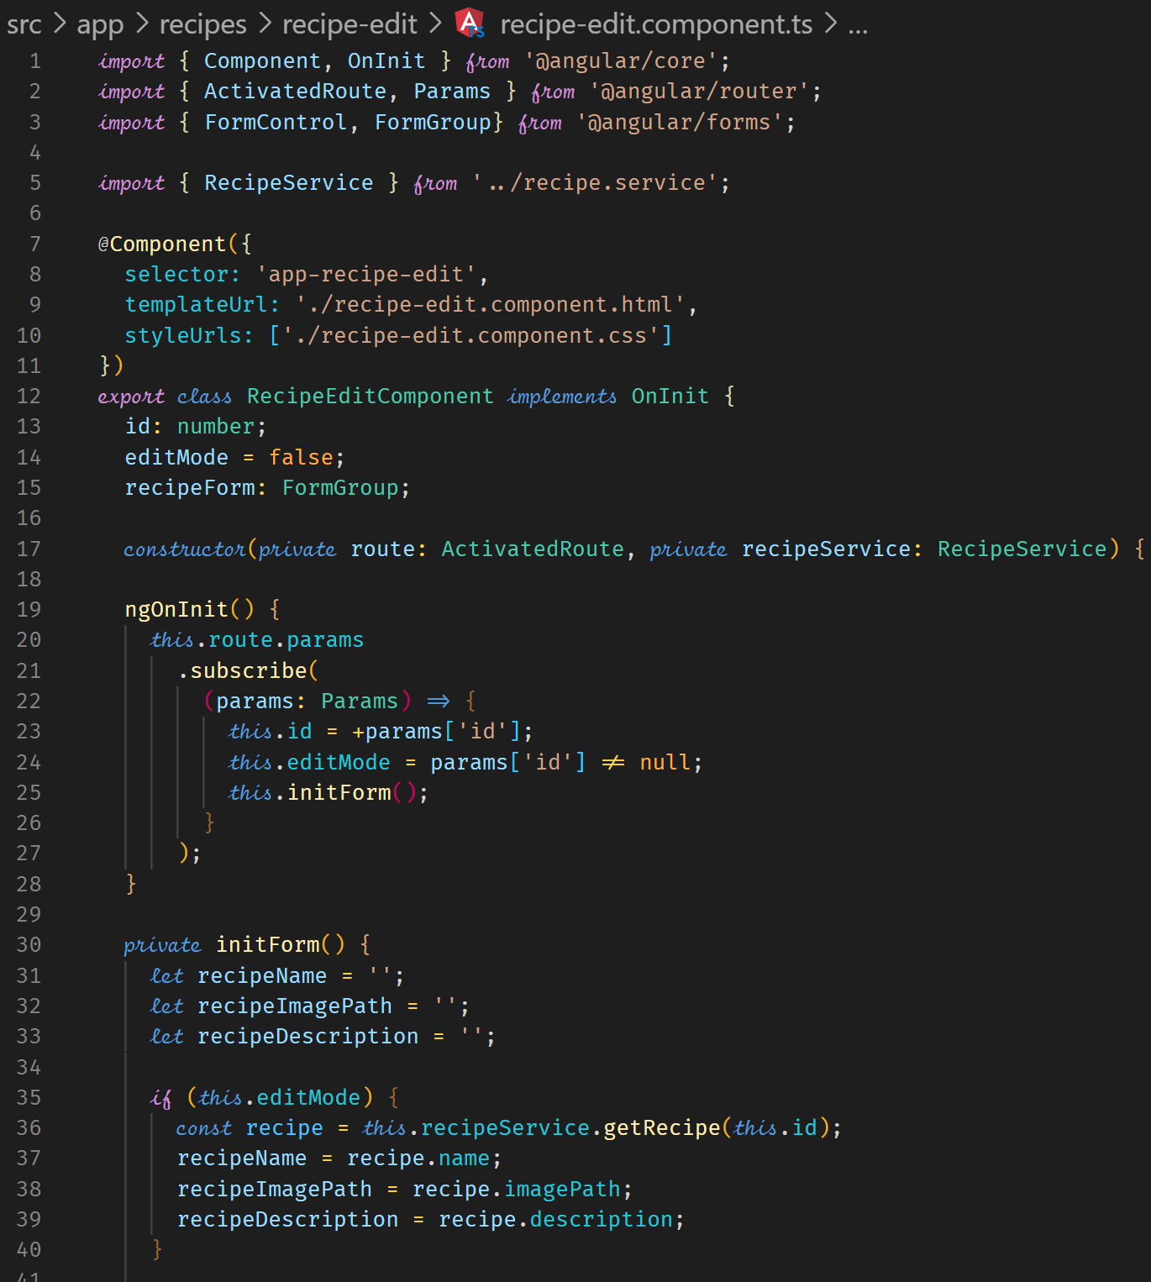



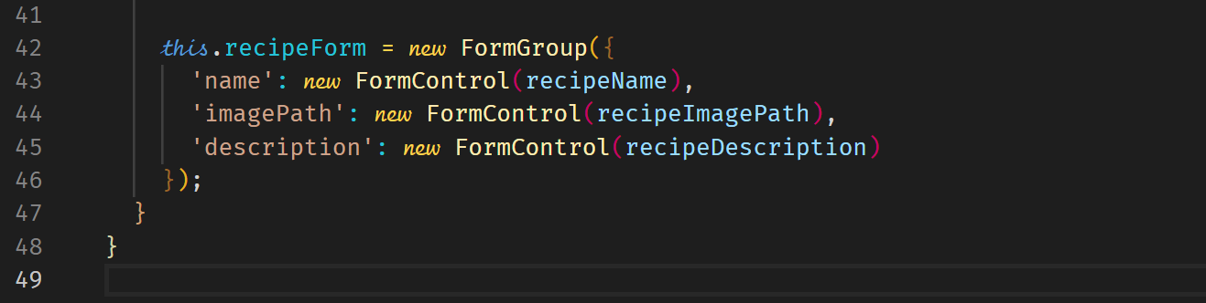



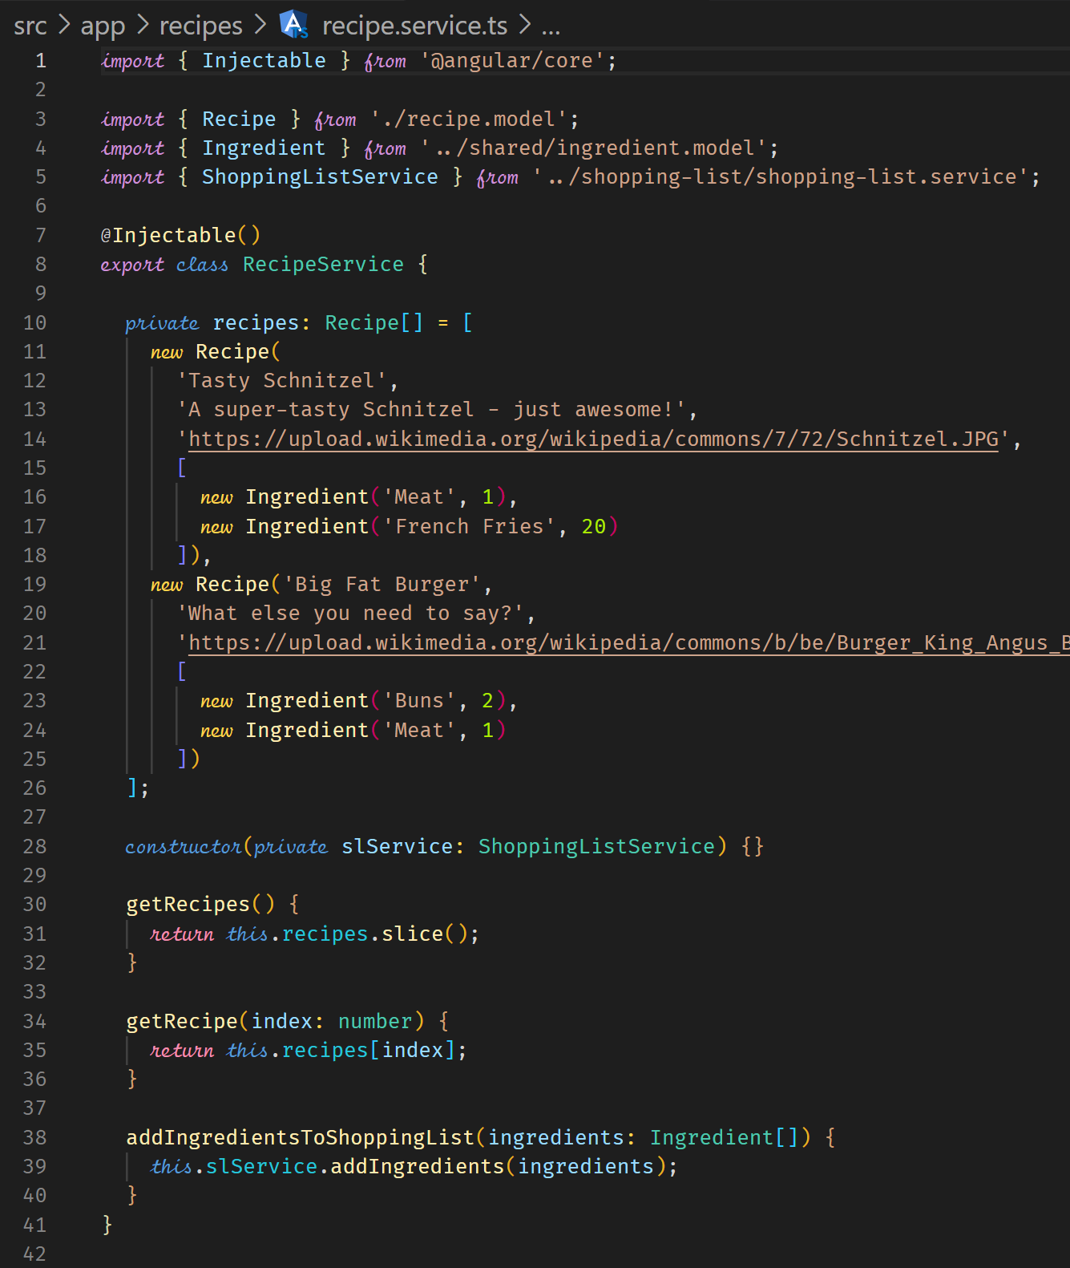



**Syncing the HTML with the Form**

Syncing the HTML with the form in TS requires the addition of formControlName and the formGroup. The Recipe Ingredients require a FormArray in TS, which will consist of one or more FormGroup. Each FormGroup will have FormControl.

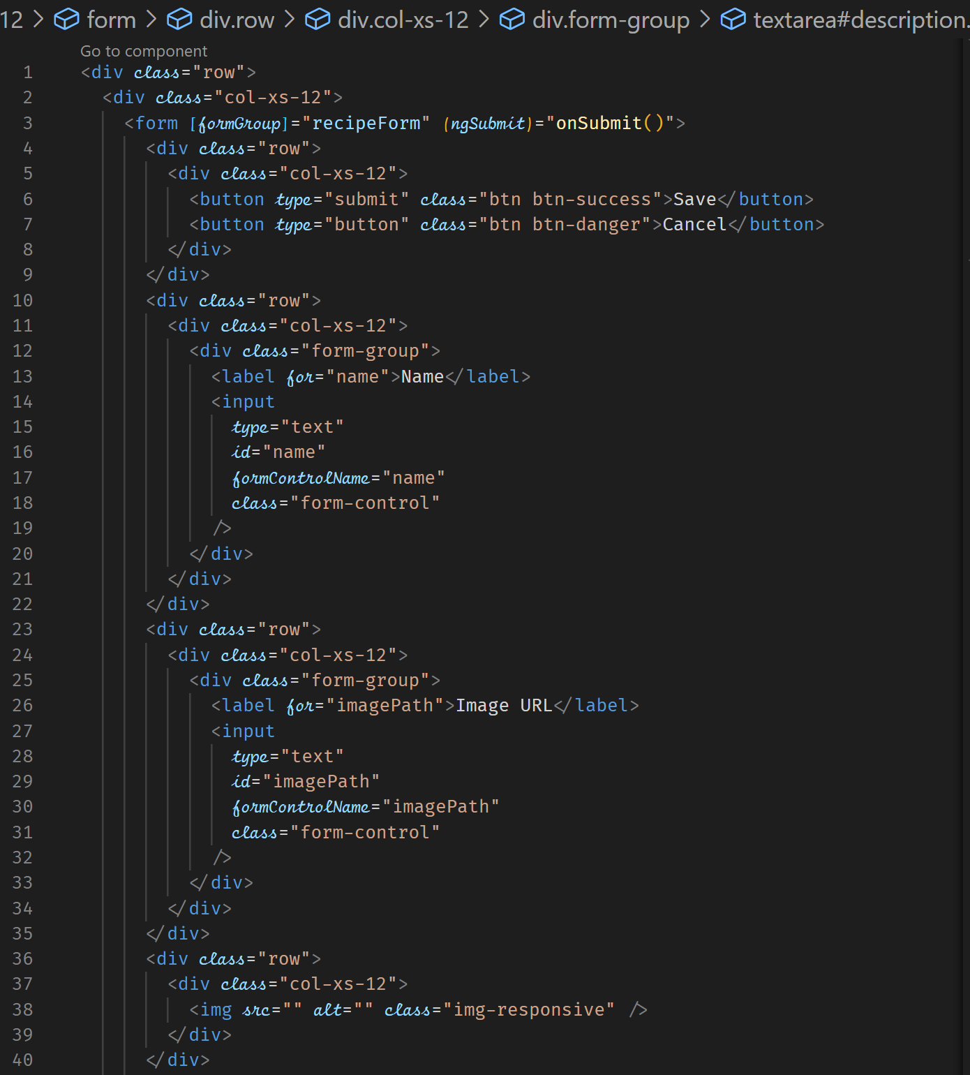



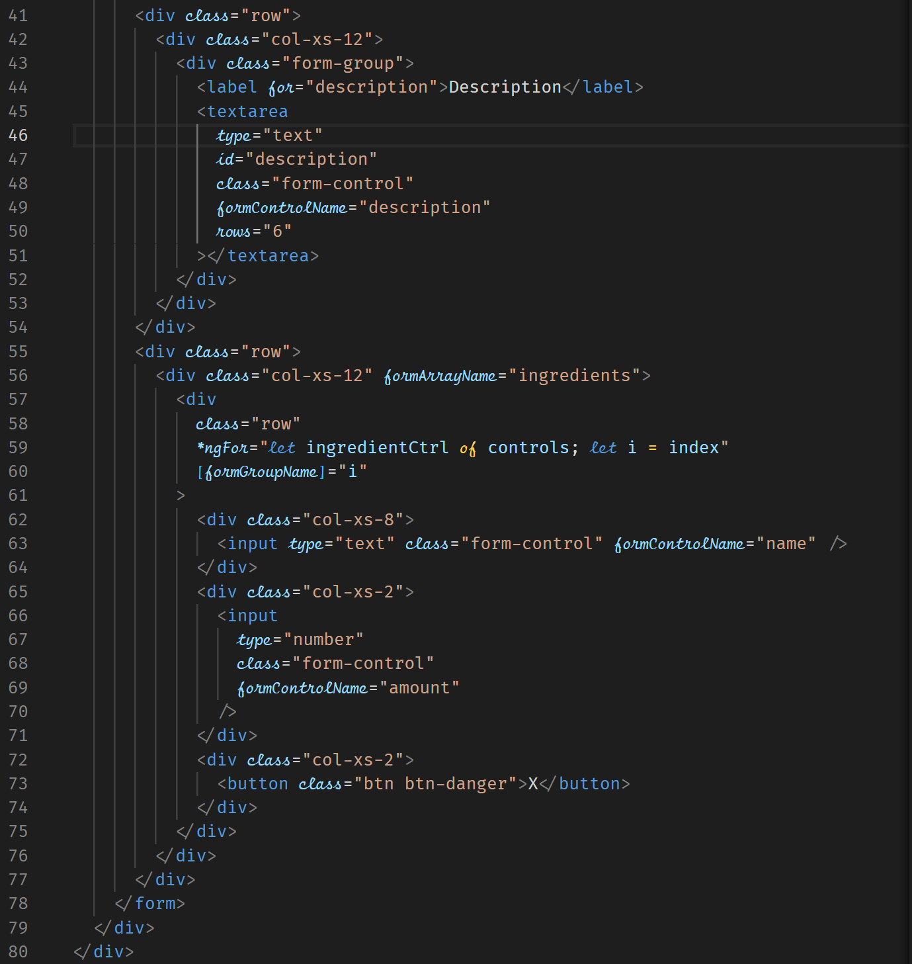



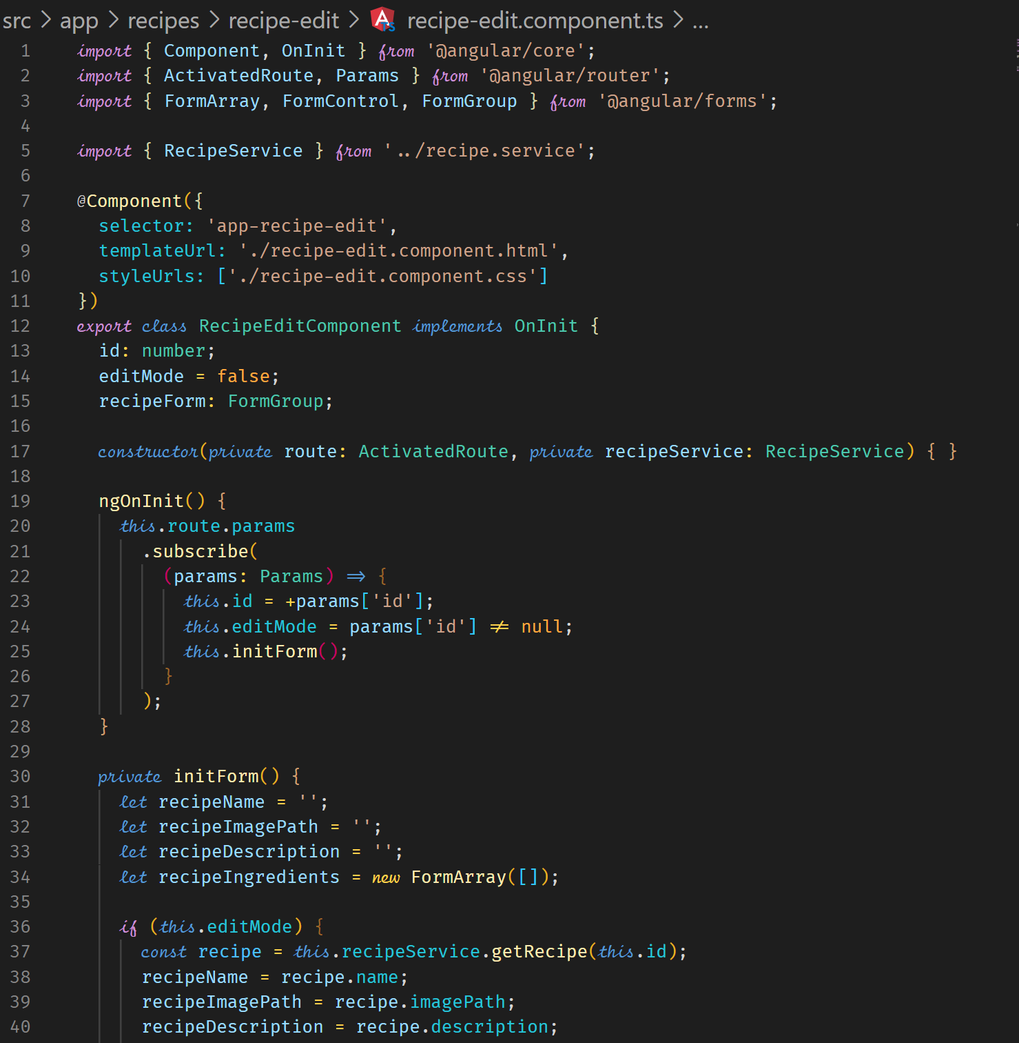

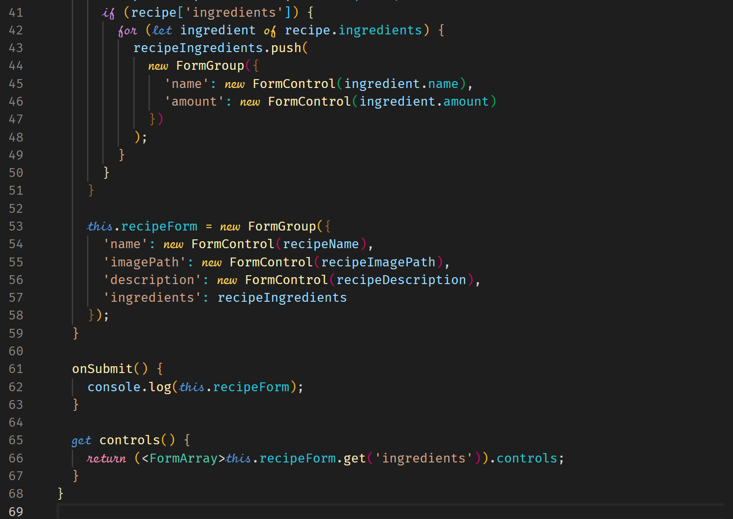

**Adding new Ingredient Controls**

In the recipe-edit.component.html file, we want to be able to add new ingredients.

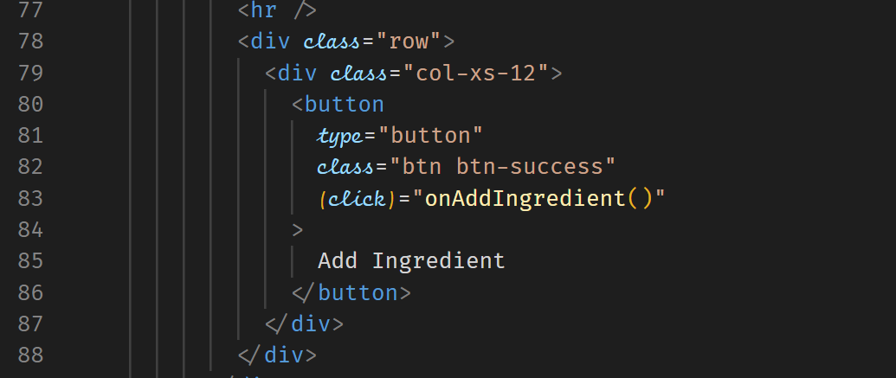



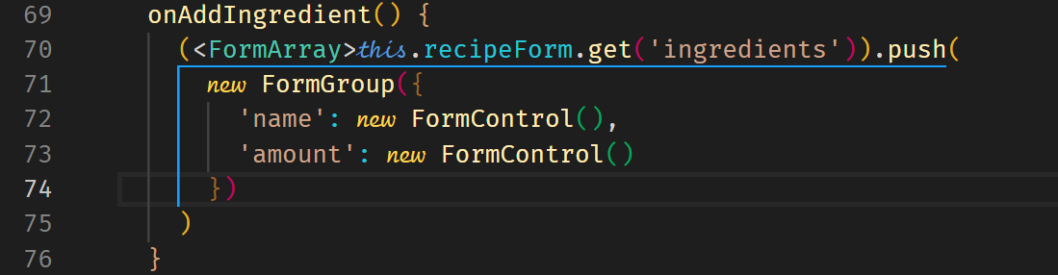

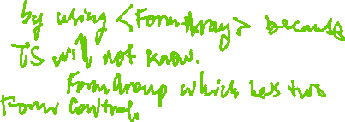

**Validating User Input**

To validate the form, we should add Validators and we should also disable the Submit button. We can also add CSS to style the control that is invalid.

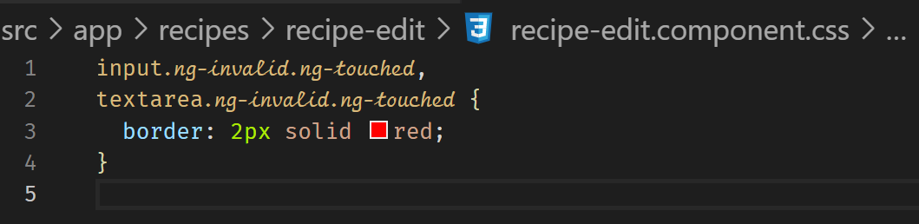



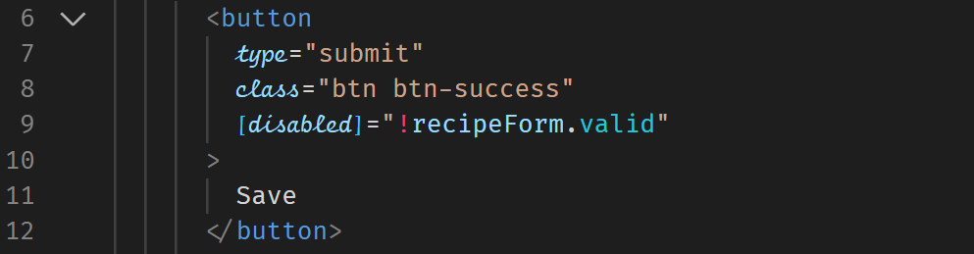



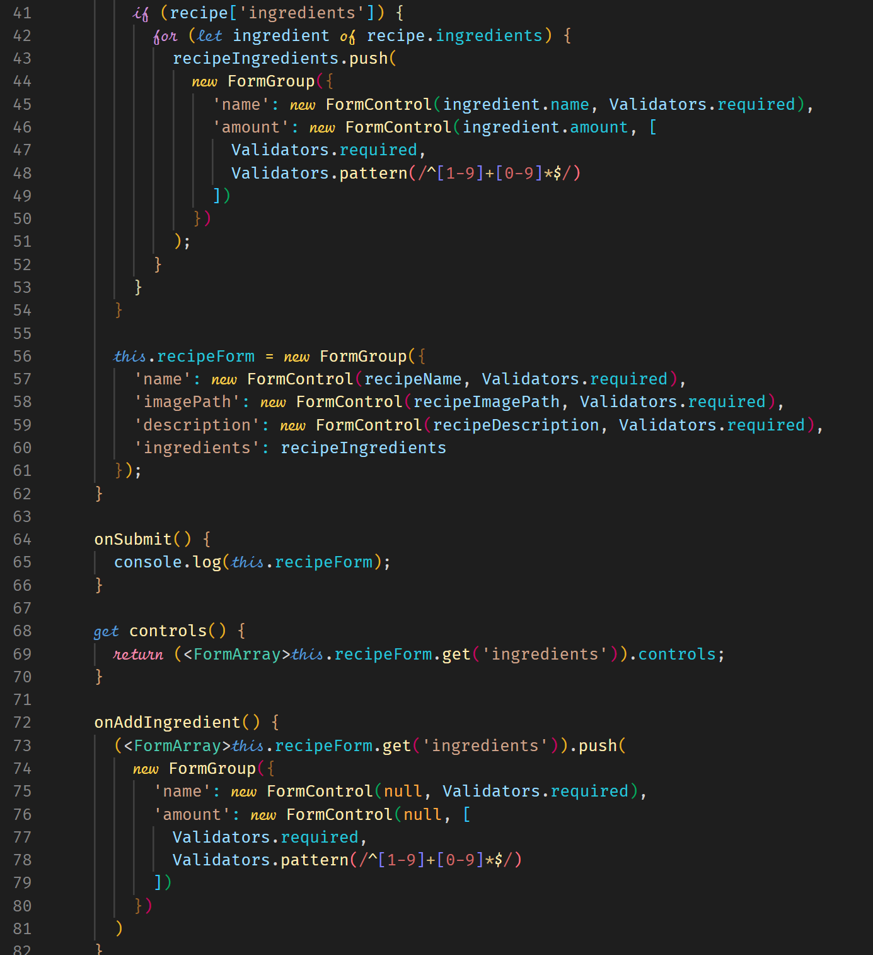



**Delete Ingredients**

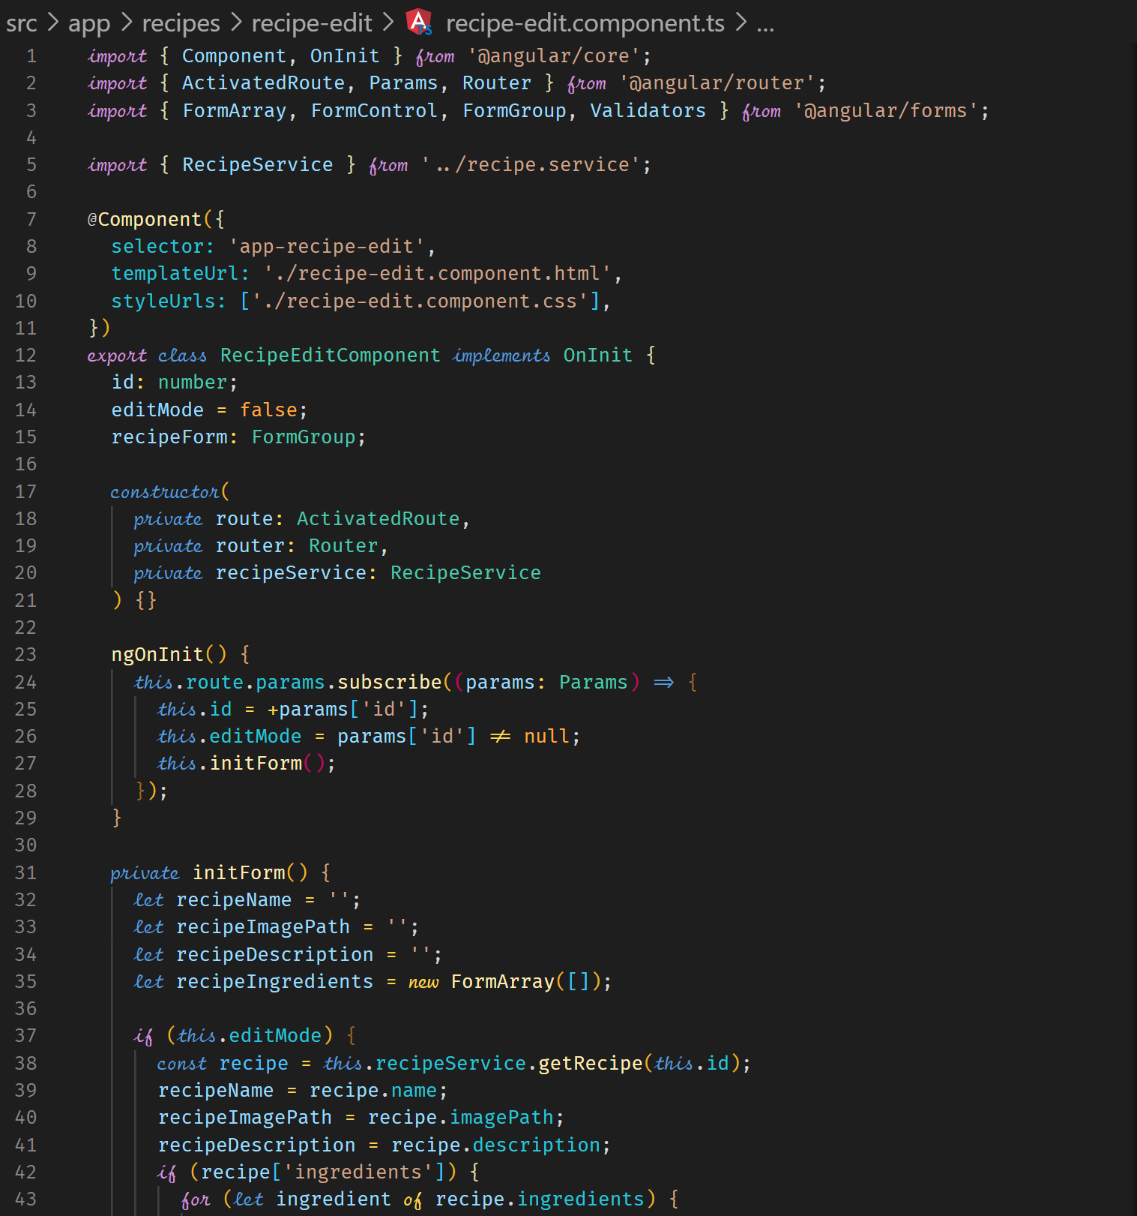

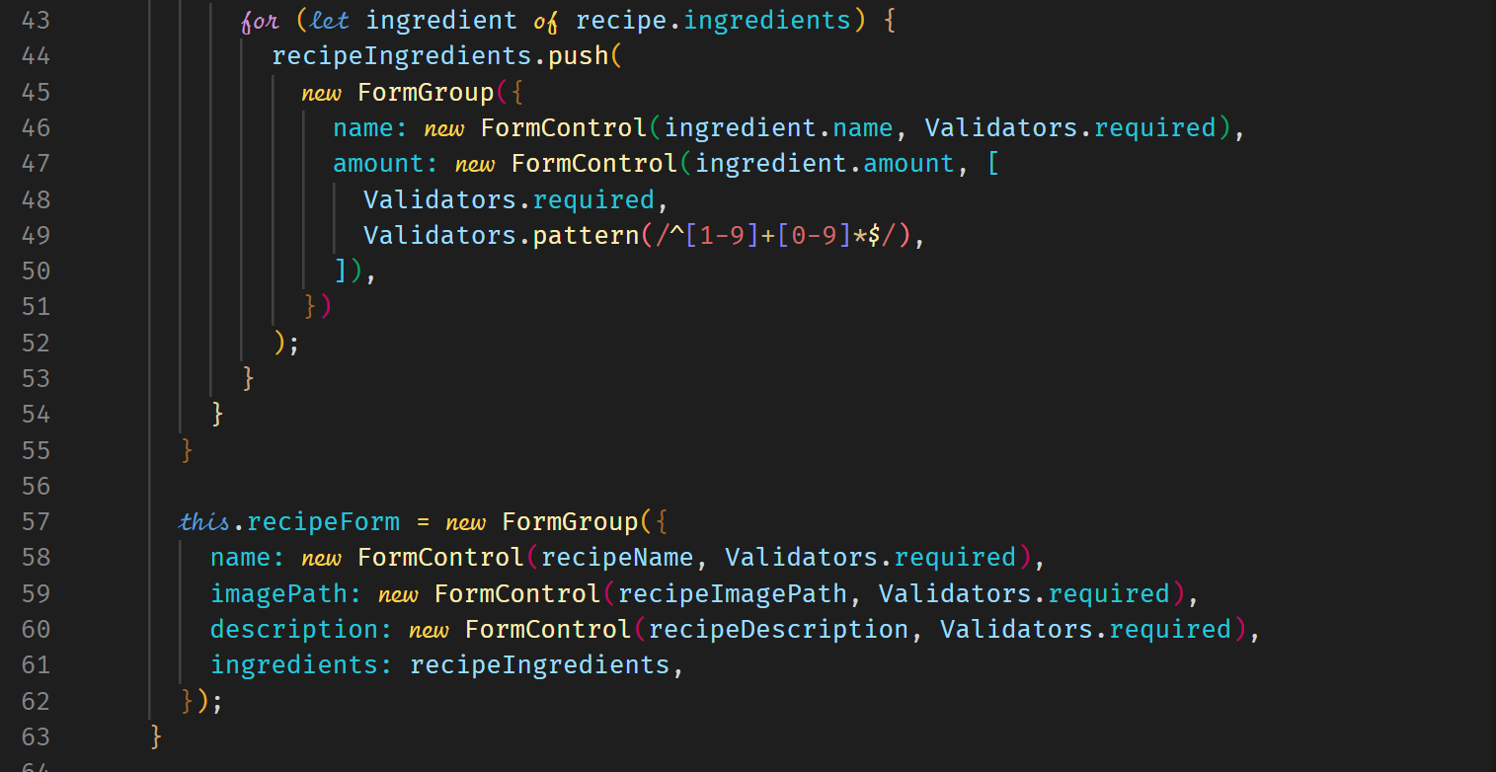



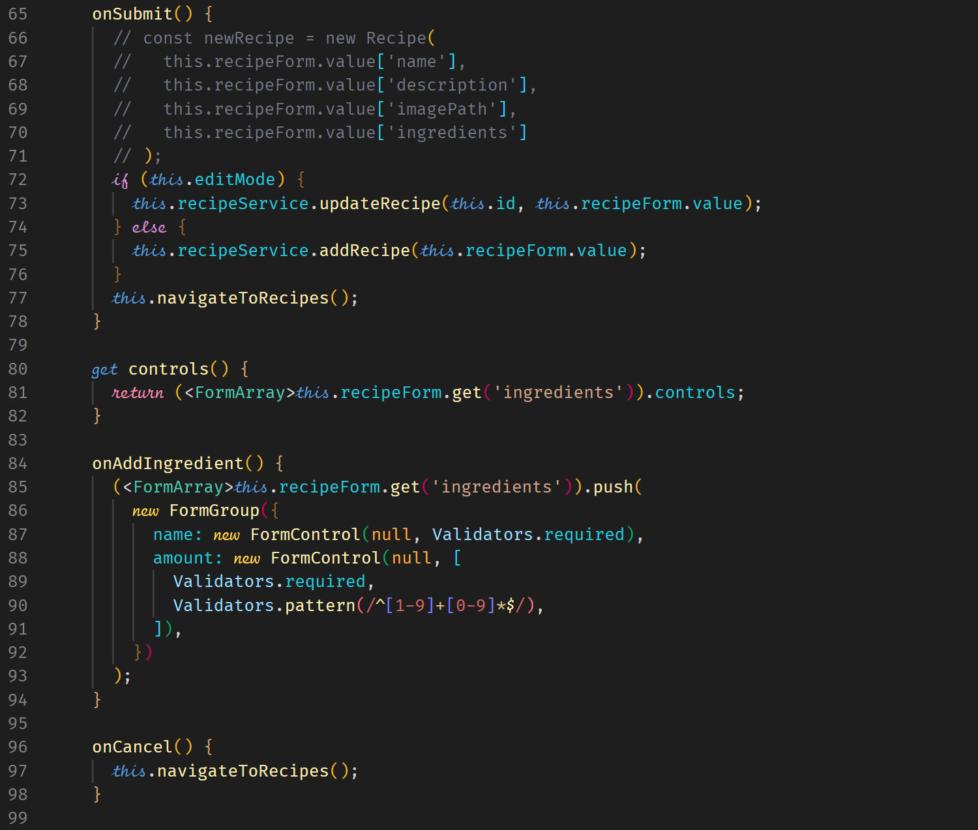

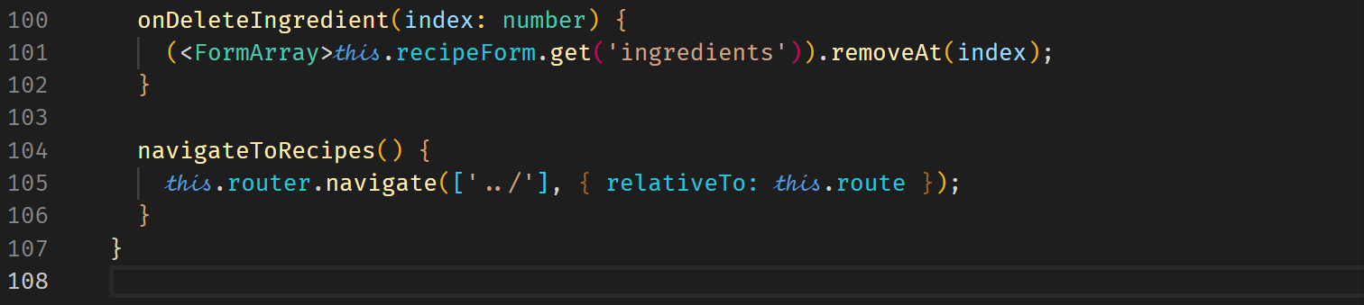

**PIPES**

**What are Pipes?**

Pipes are used to transform values before output.

username = ‘Samson’

<p>{{ username }}</p> Samson

<p>{{ username | uppercase }}</p> SAMSON

We have built-in pipes and we can also build our own.

**Using Pipes**

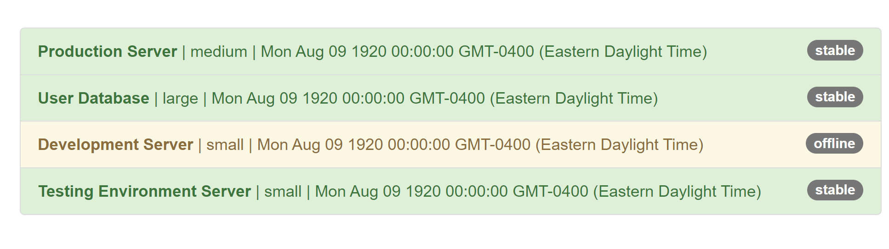

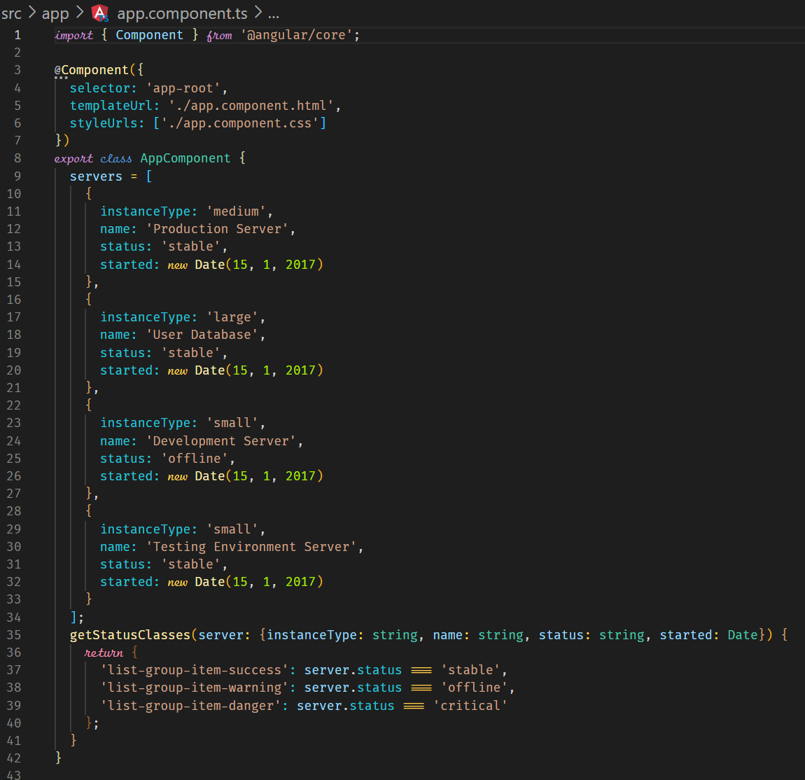

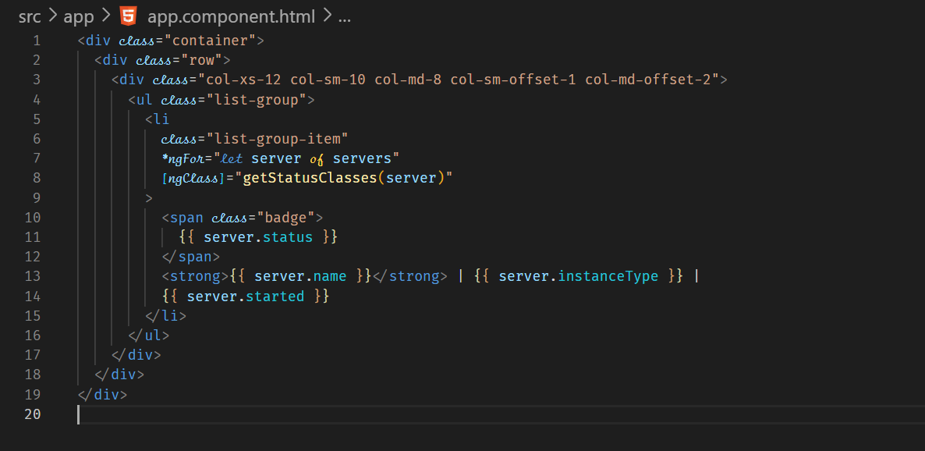

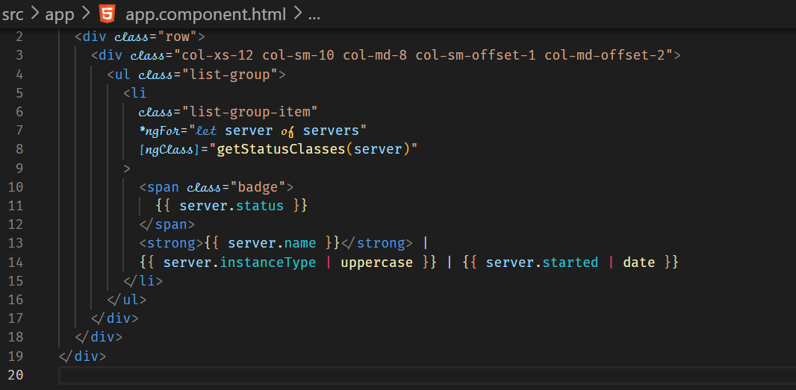

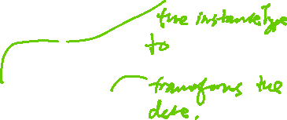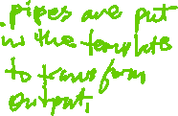

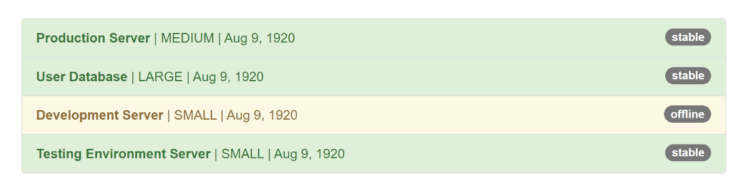

**Parameterizing Pipes**

We can pass parameters to a pipe. We separate the data variable with a colon and the parameter. You can add additional parameters by additional colon followed by the parameter.

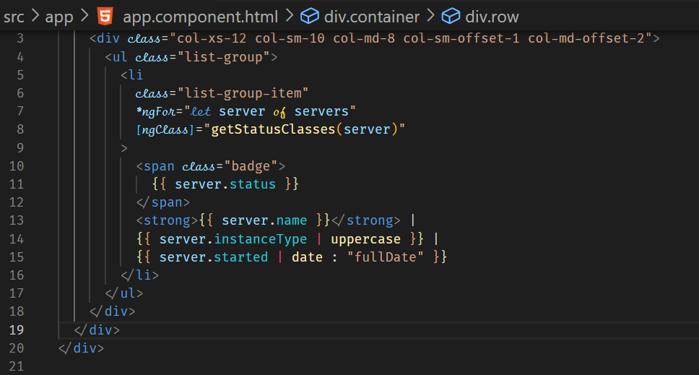



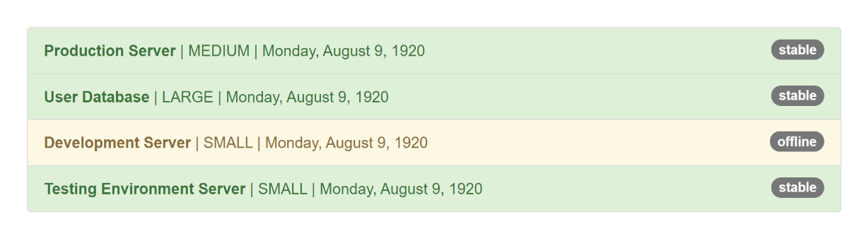

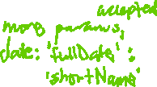

Further information on pipes can be found on <https://angular.io/api?query=pipe>

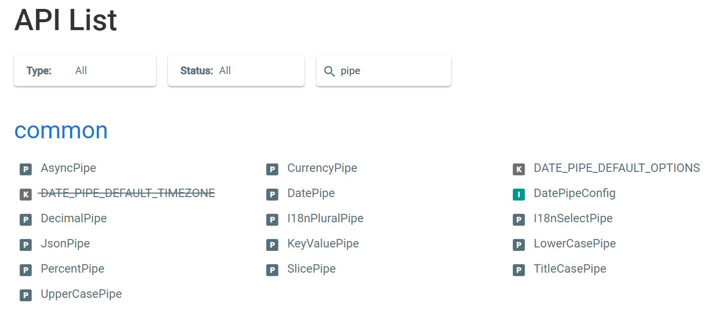

**Chaining Multiple Pipes**

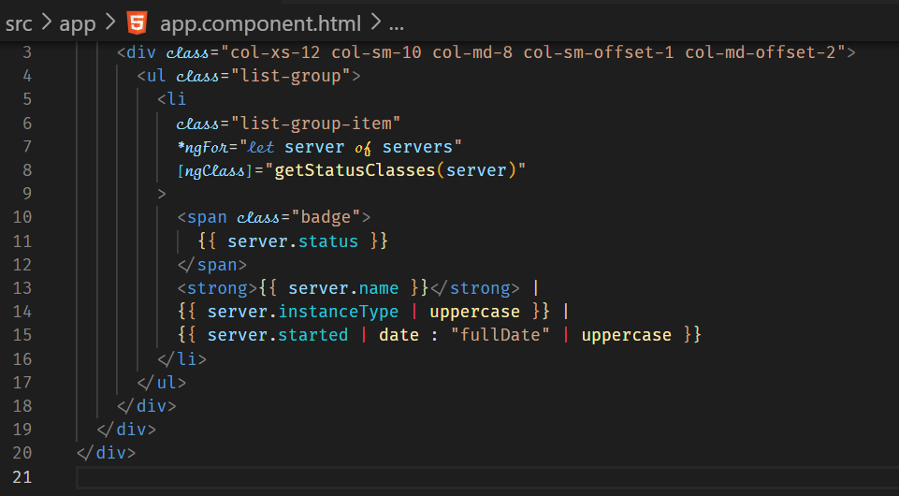



**Creating a Custom Pipe**

The custom pipe will shorten or truncate a string to 15 characters. For a truncated string, we will add three dots to visually show that the value has been truncated.

1. Create a TS file.

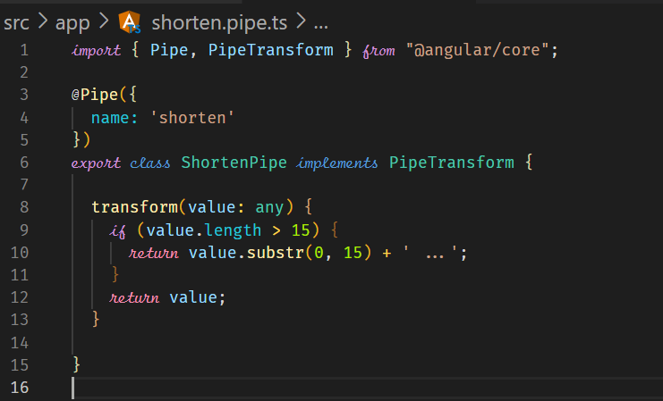

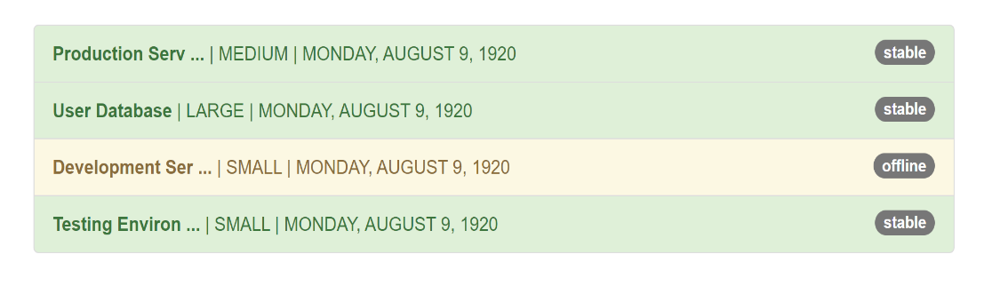



1. Add the classname to the declarations in AppModule.

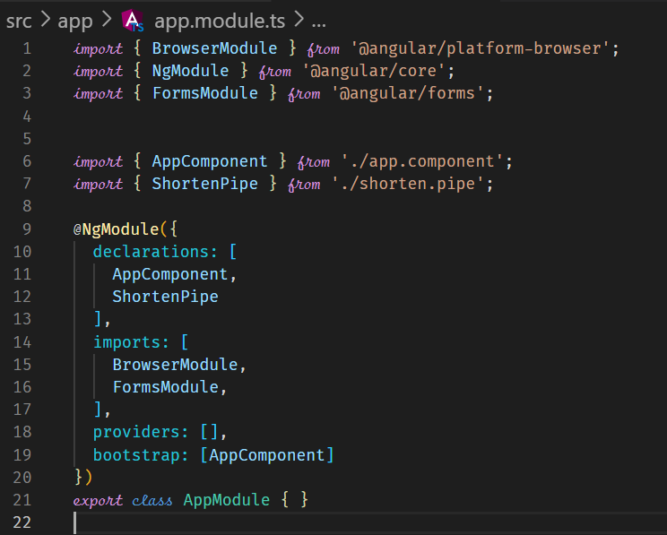



1. In the template file, use the custom pipe as named in the @Pipe directive in the TS class.

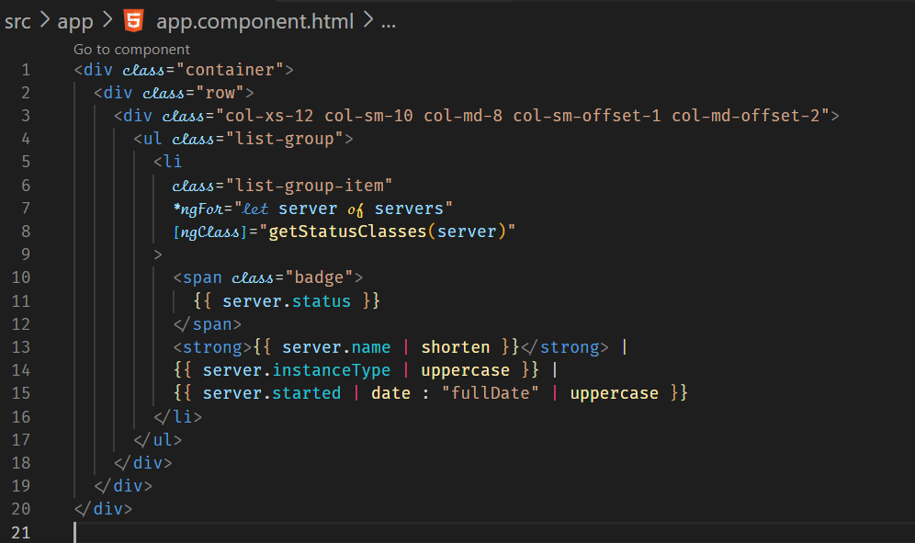



**Parameterizing a Custom Pipe**

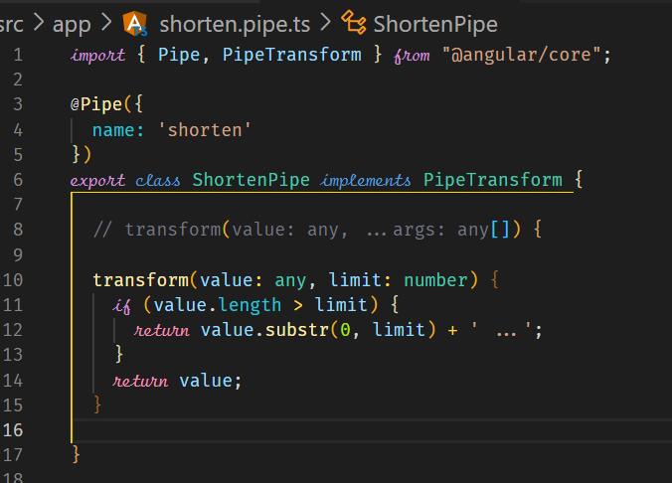



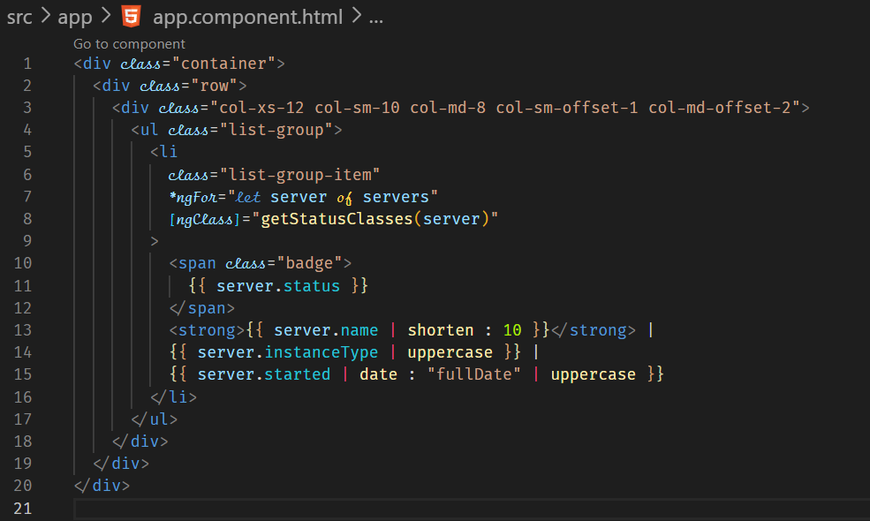



**Another example - Creating a Filter Pipe**

You can also create a pipe component by using the CLI.

ng g p filter –skip-tests

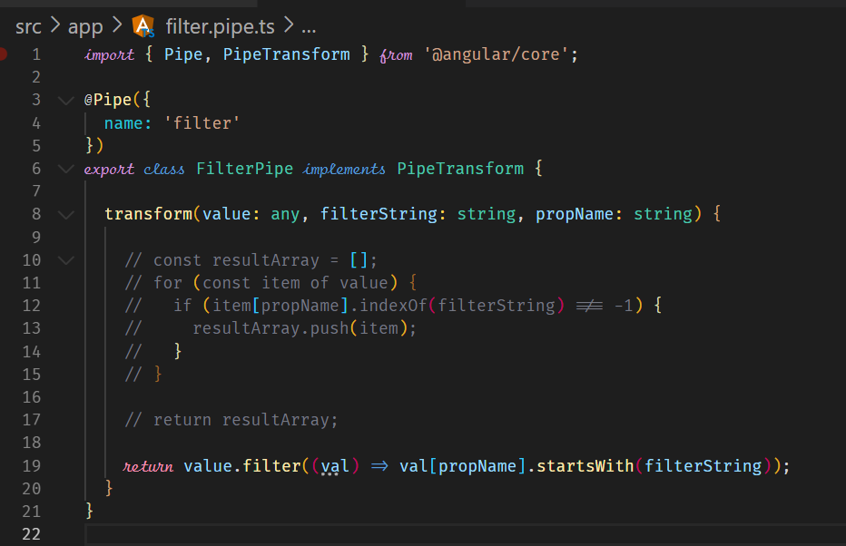



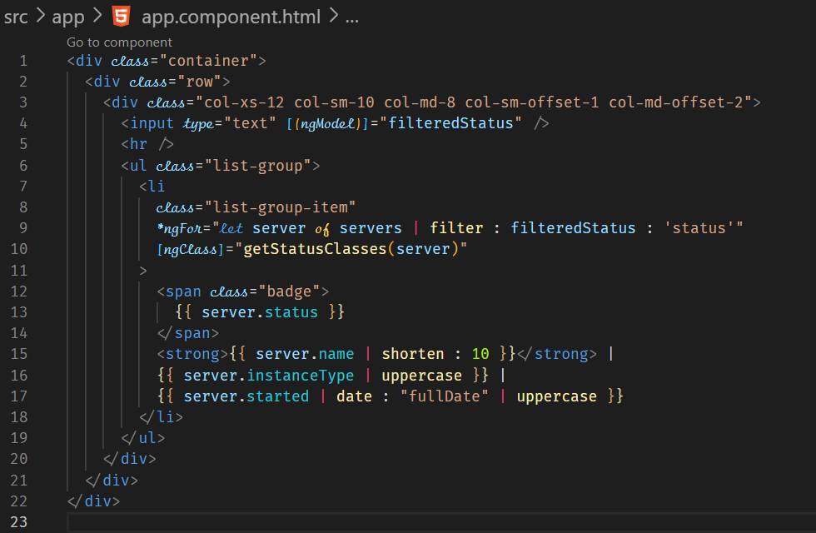

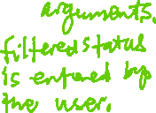

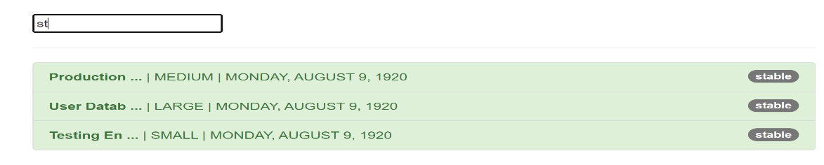



**Pure and Impure Pipes**

By default, a pipe is pure, that is, it is not re-evaluated when input used in the filter changes. For example, adding a server in the previous example does not re-evaluate the filter, hence the output does not change.

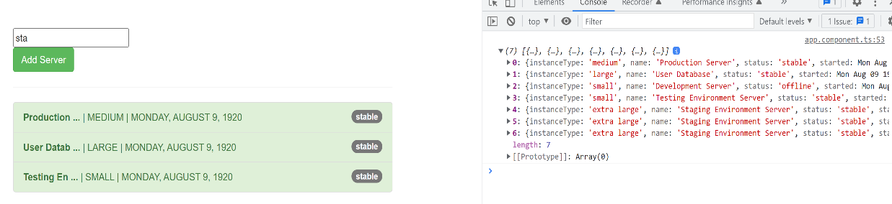



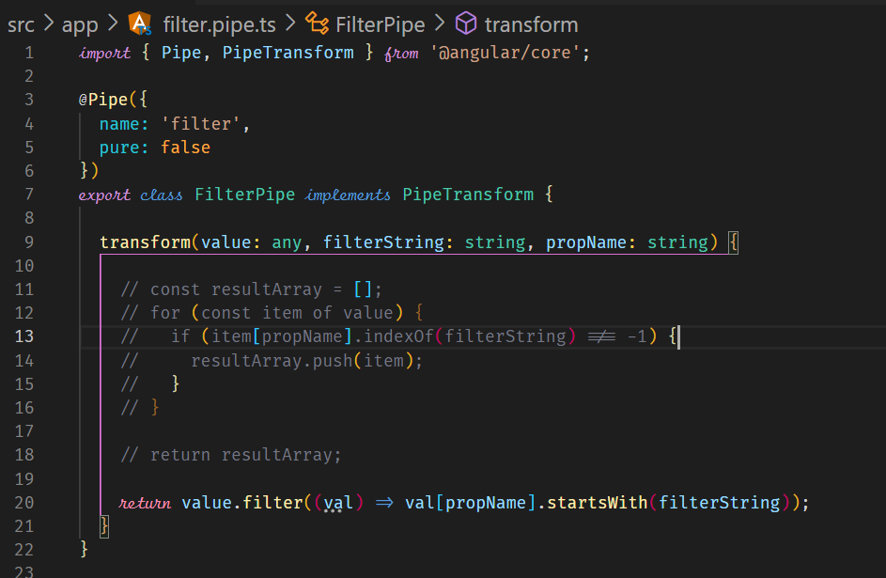



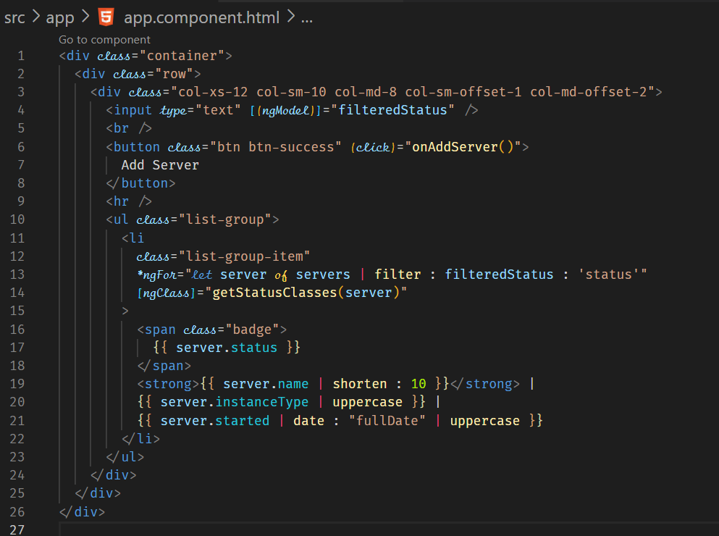

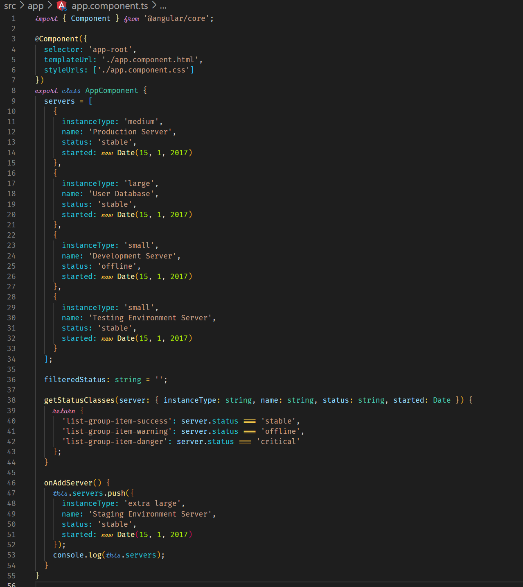



**Working with async data**

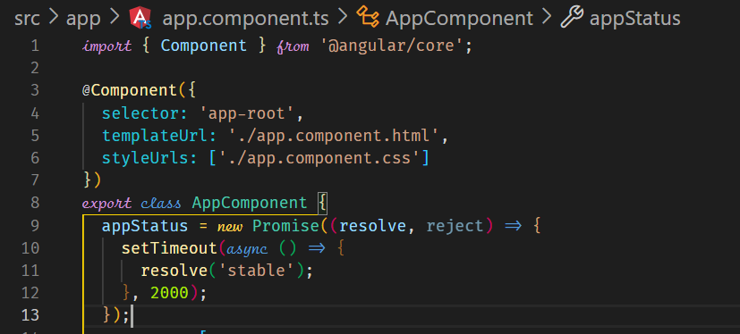



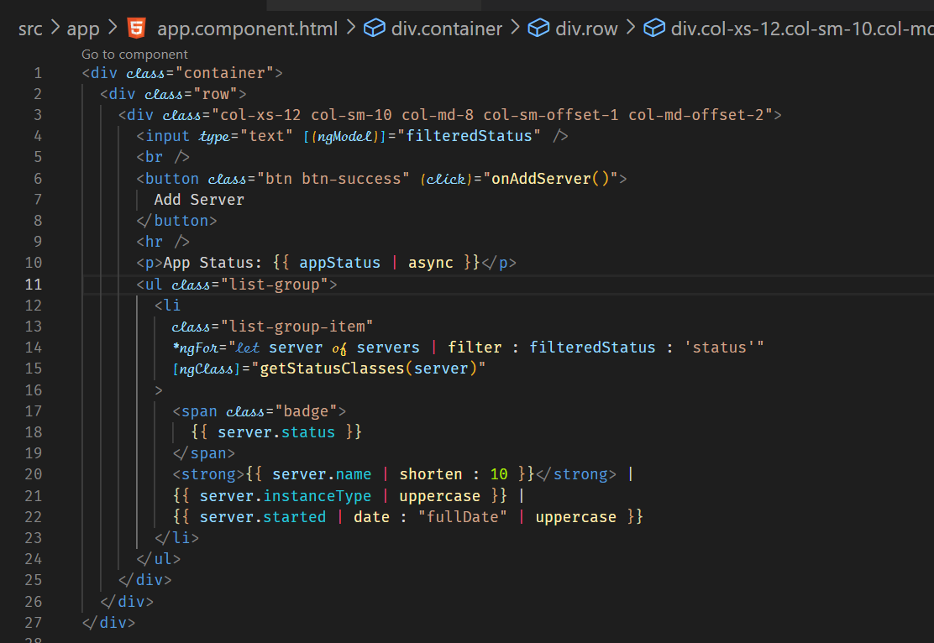



**Making Http Requests**

**Sending a POST Request**

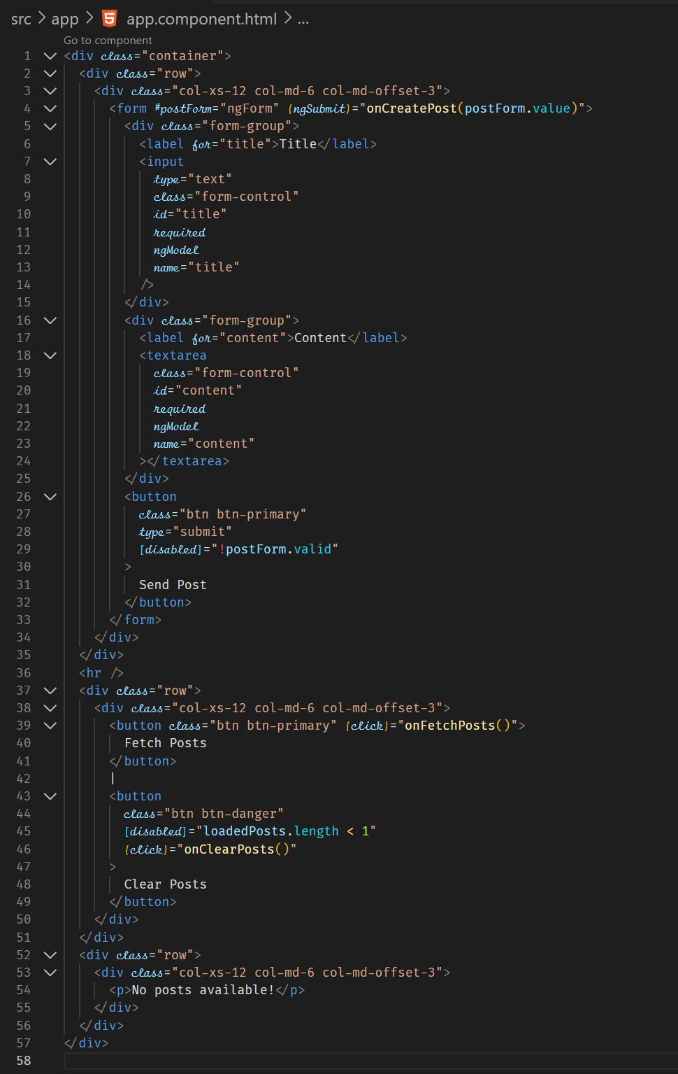



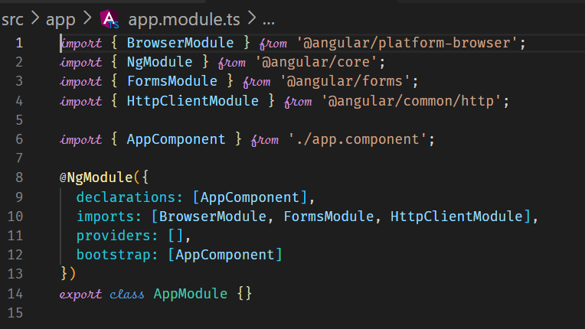



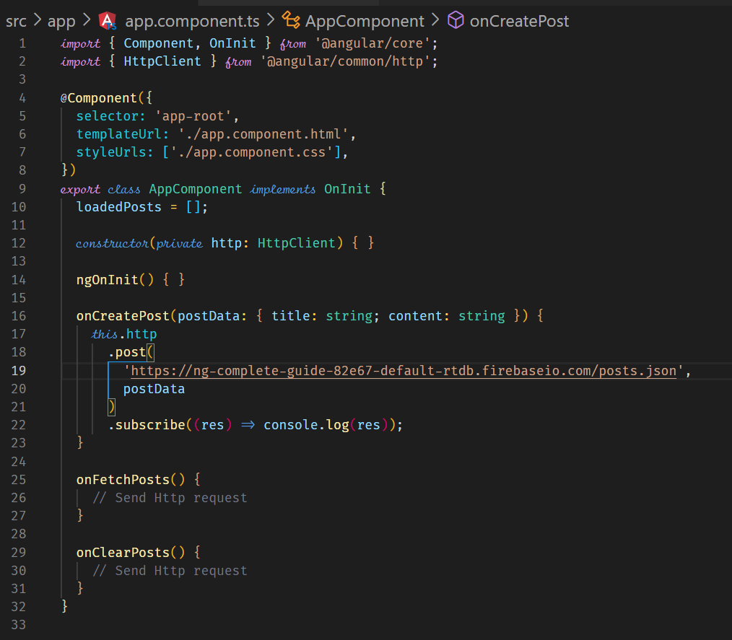



Firebase result

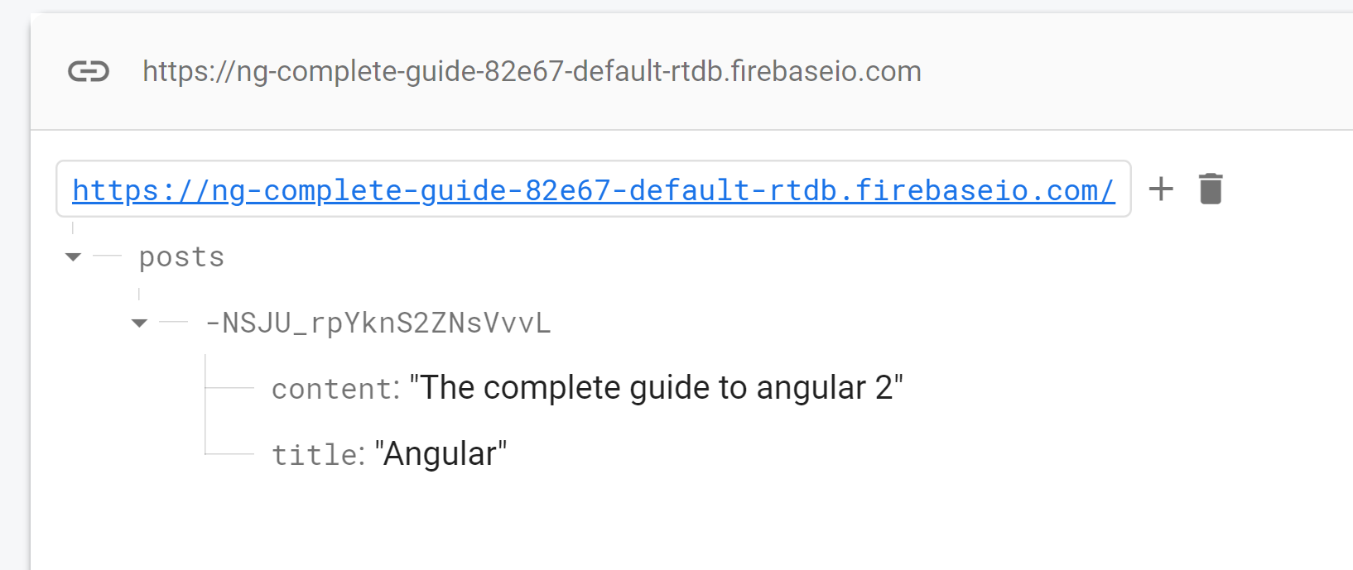

**Getting the Data**

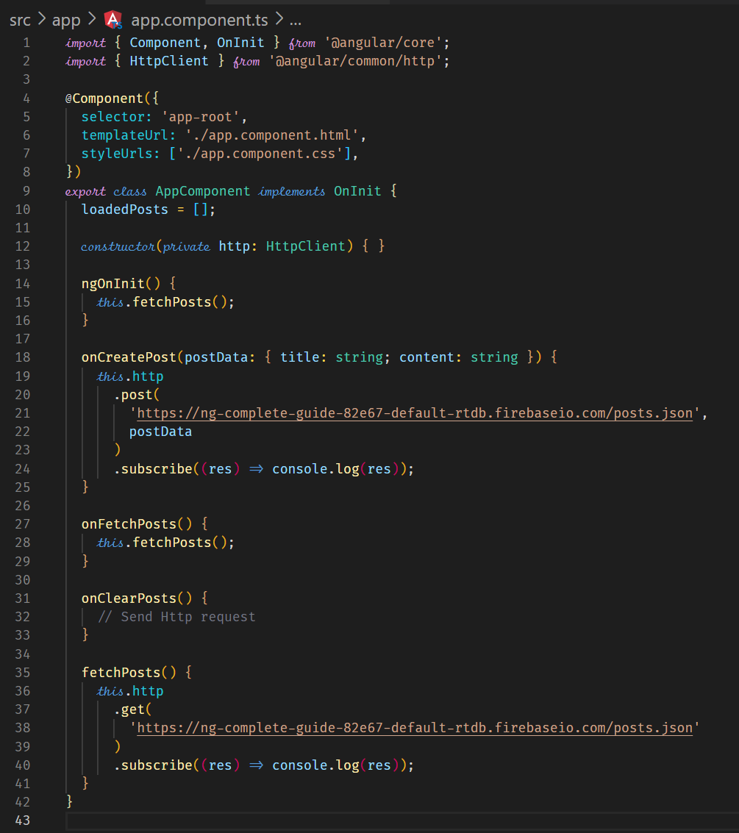



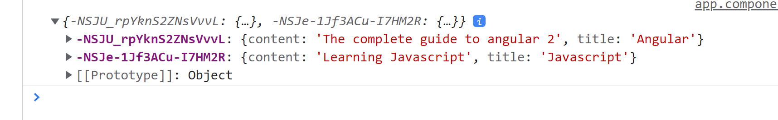



**Using RxJS Operators to Transform Response Data**

As shown in the above console log, we need to transform the data so we can push it to the array. We use the map observable operators for transforming the data.

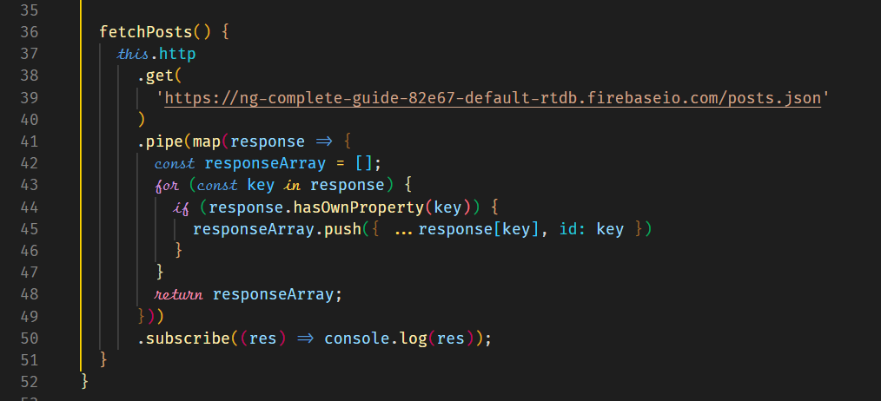



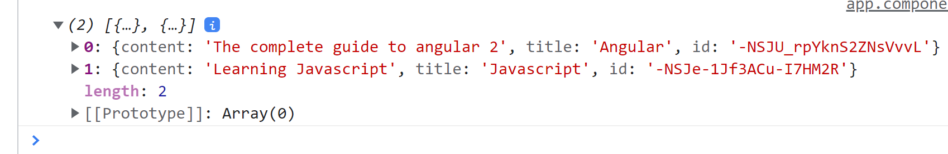

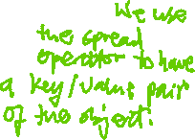

**Using Types with the HttpClient**

Http methods for HttpClient are generic which allows us to specify types. This is optional but very helpful. In the above code examples, the return data is given a type of any, we can change this to a specific type. It also helps in code completion.

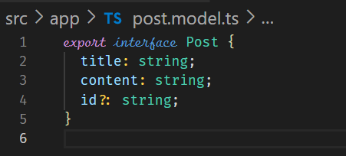



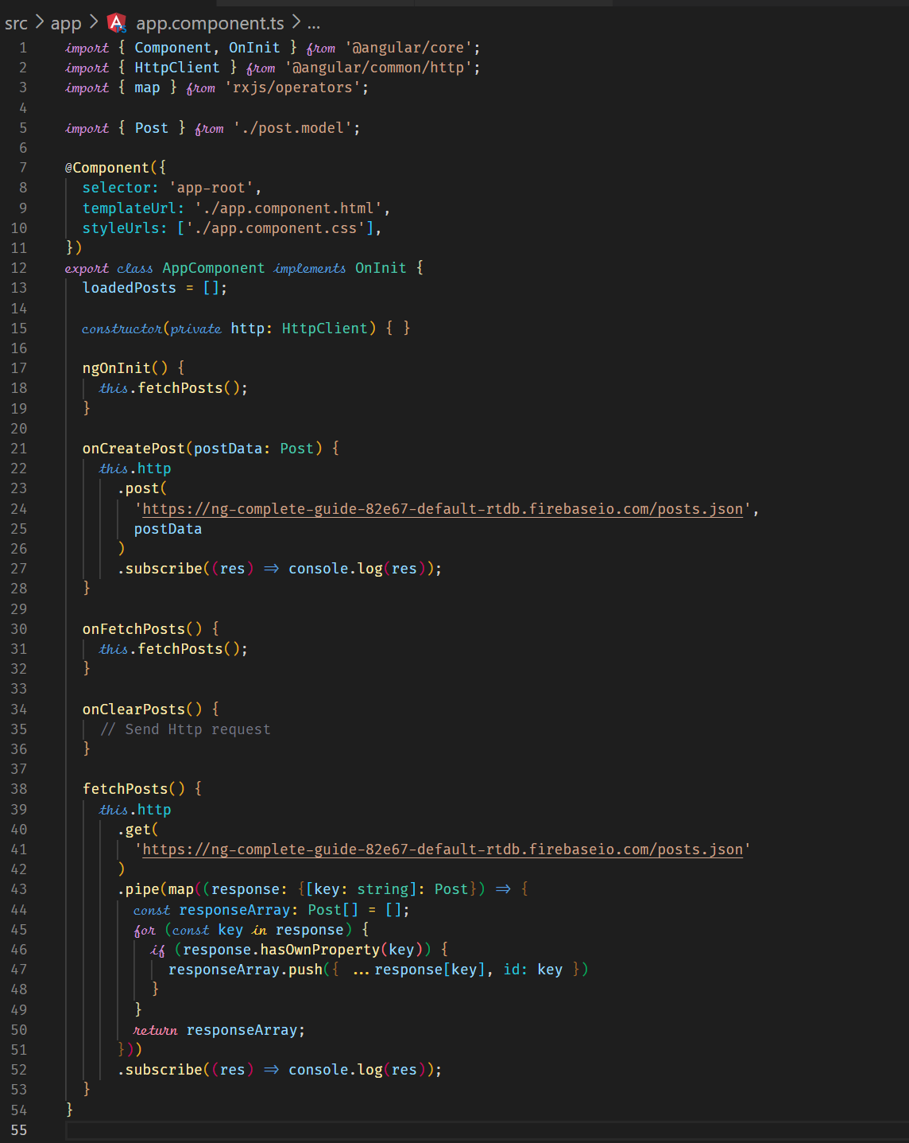



However, with Angular http client, there is a more elegant way of assigning the type. The return type can be declared as a generic.

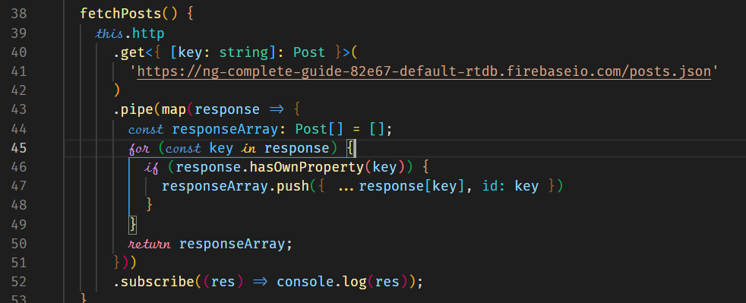



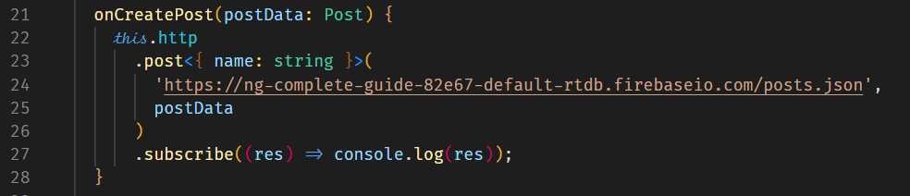



**Outputting Posts**

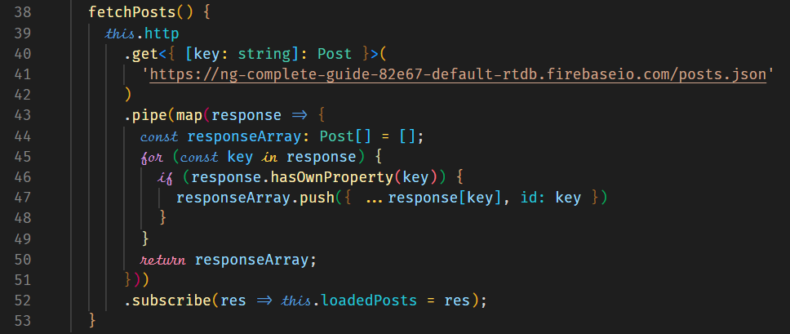



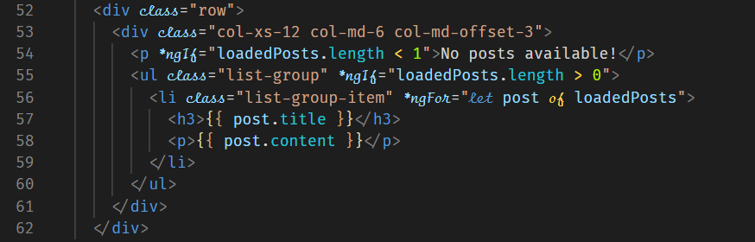

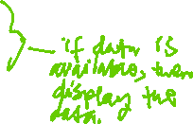

**Showing a Loading Indicator**

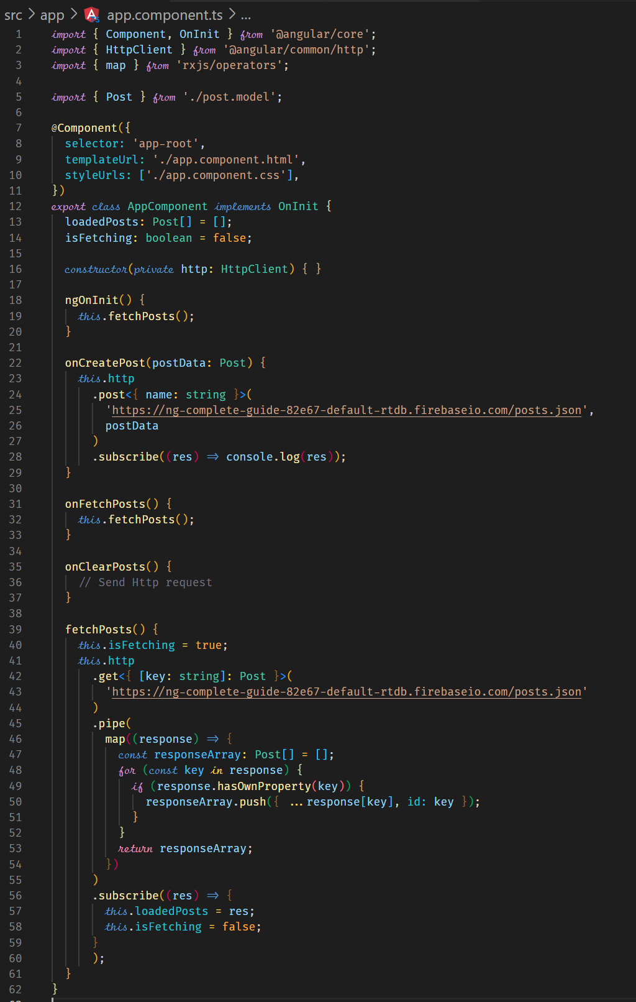



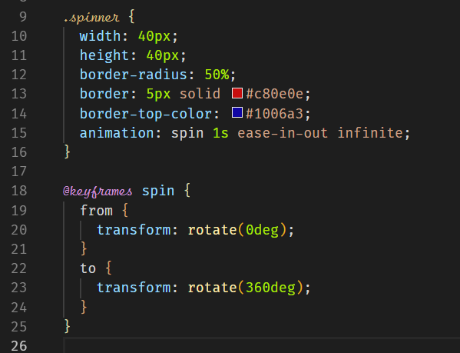



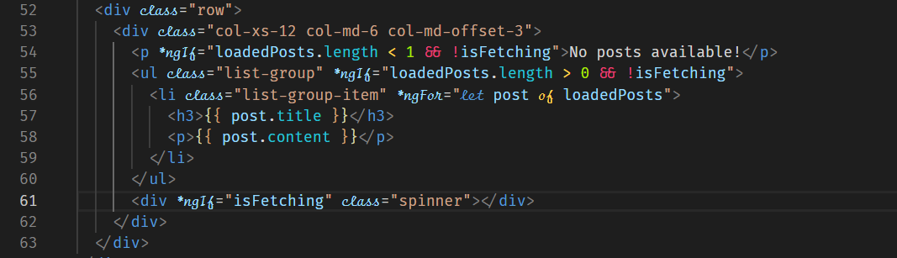



**Using a Service for Http Requests**



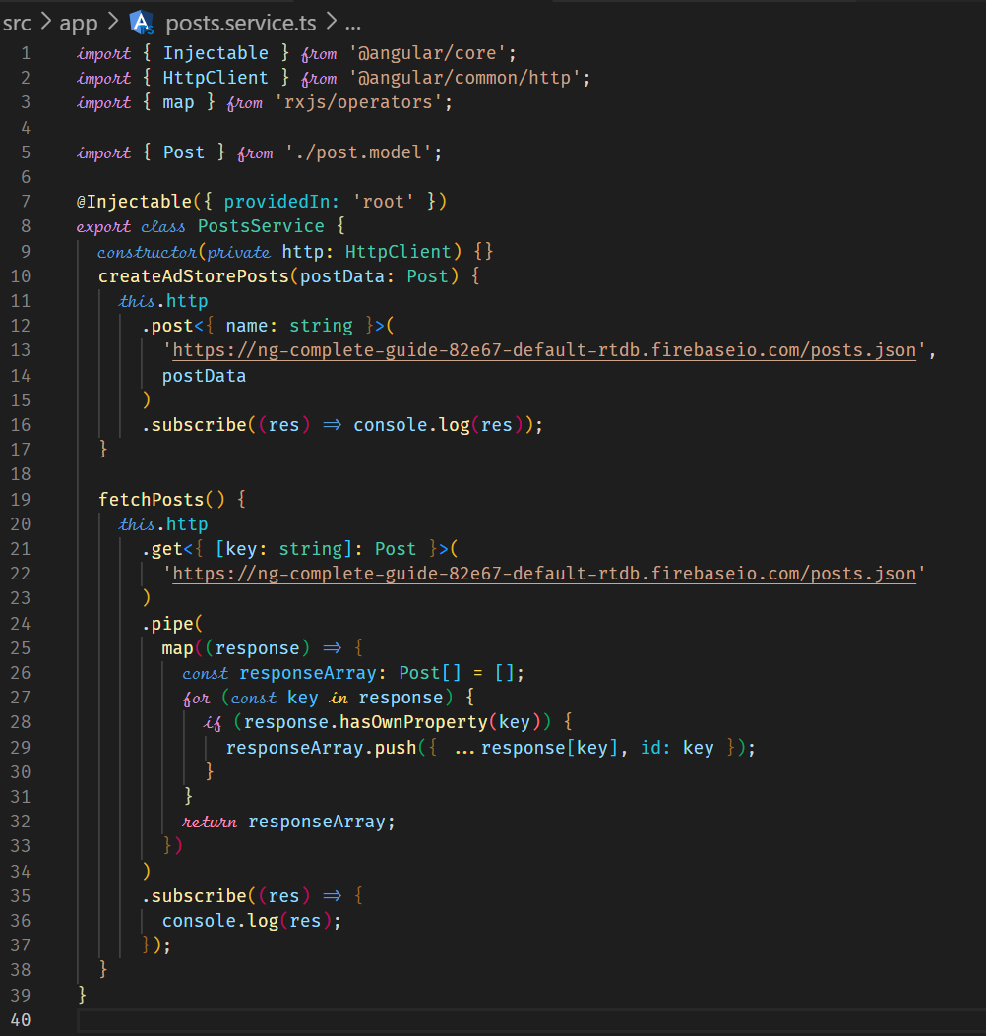



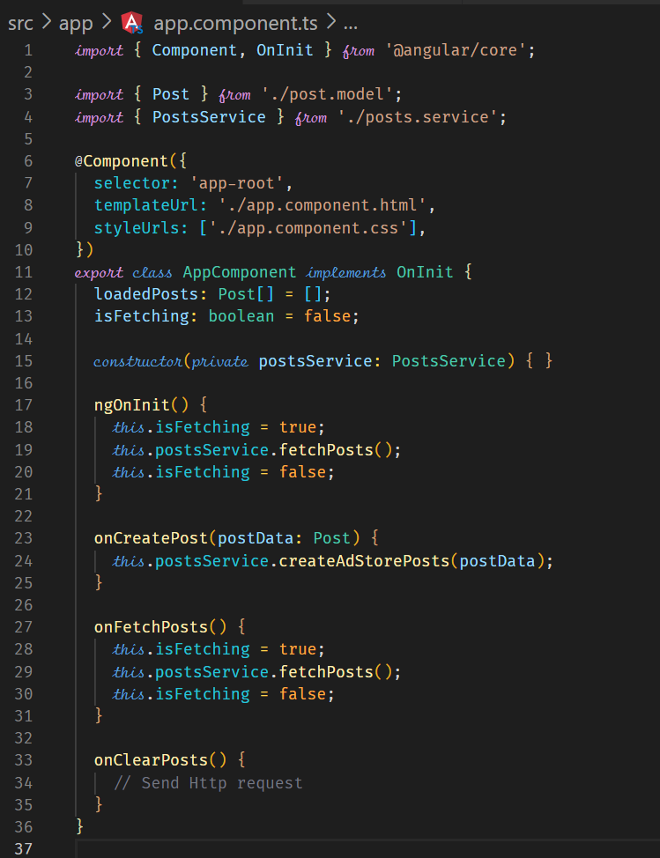



**Services and Components Working Together**

When we have the http calls from the services file, we should not call the subscribe() method within the services file. We call the subscribe from the component. Theis will allow us to get a response in the component from the service. If we had several components requiring data from the service, we can use a subject so that the components can subscribe to that subject.

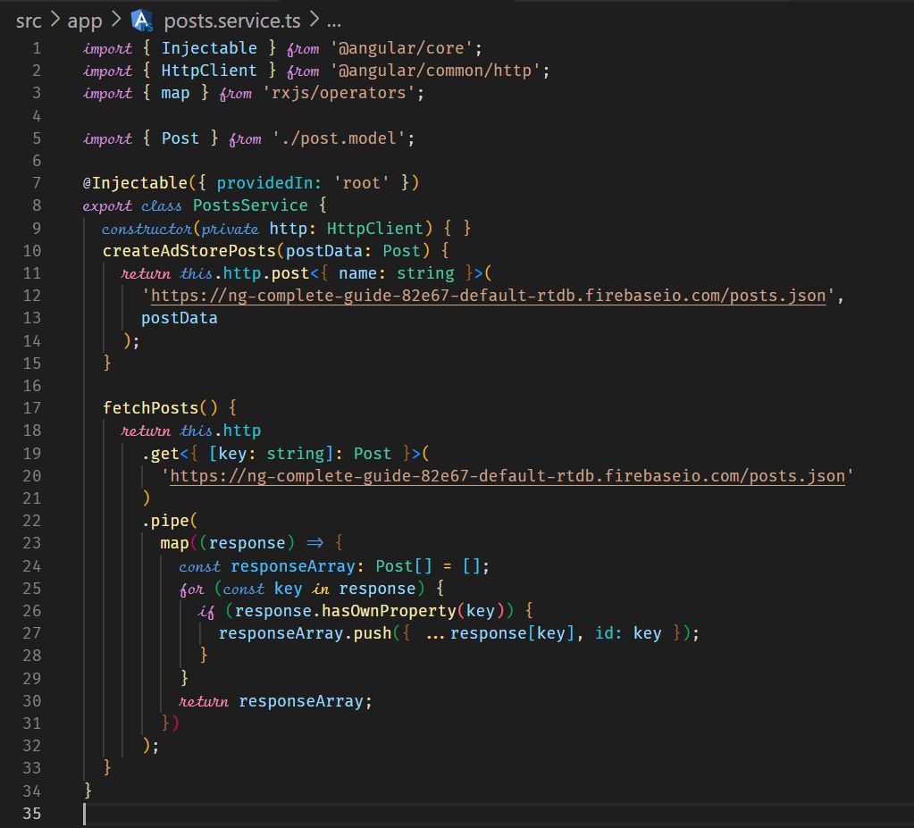

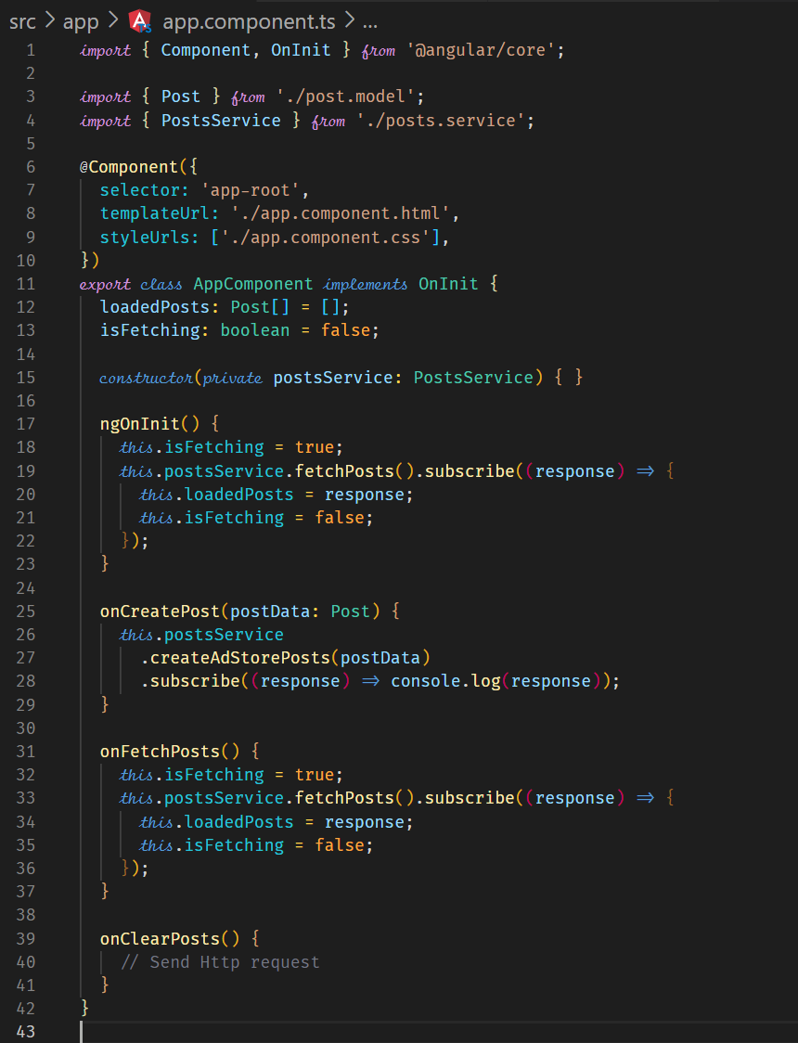



**Handling Errors**

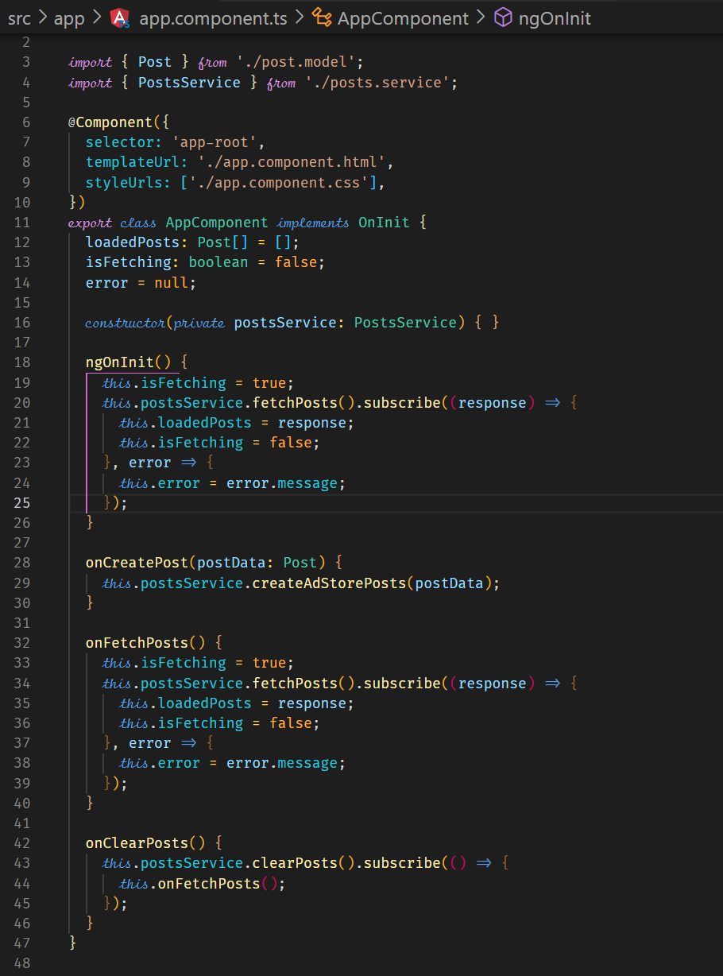



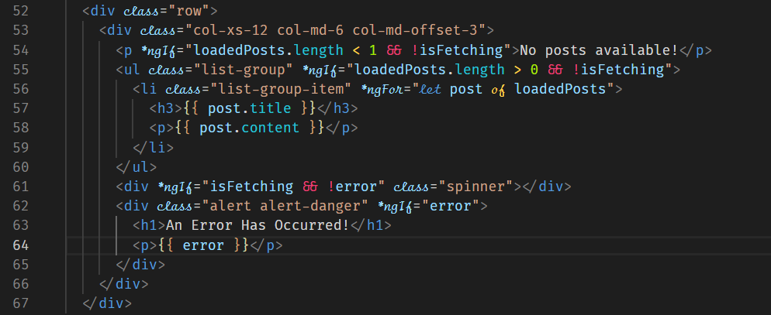



**Using Subjects for Error Handling**

This type of error handling can be applied if you are sending your request to a service and don’t subscribe to it in your component.

You can use a subject in your service. If an error occurs in the service, you can emit the error message. This may be useful if you have multiple places that may be interested in knowing if an error has occurred. You then need to subscribe to the subject so that you get notified of the error.

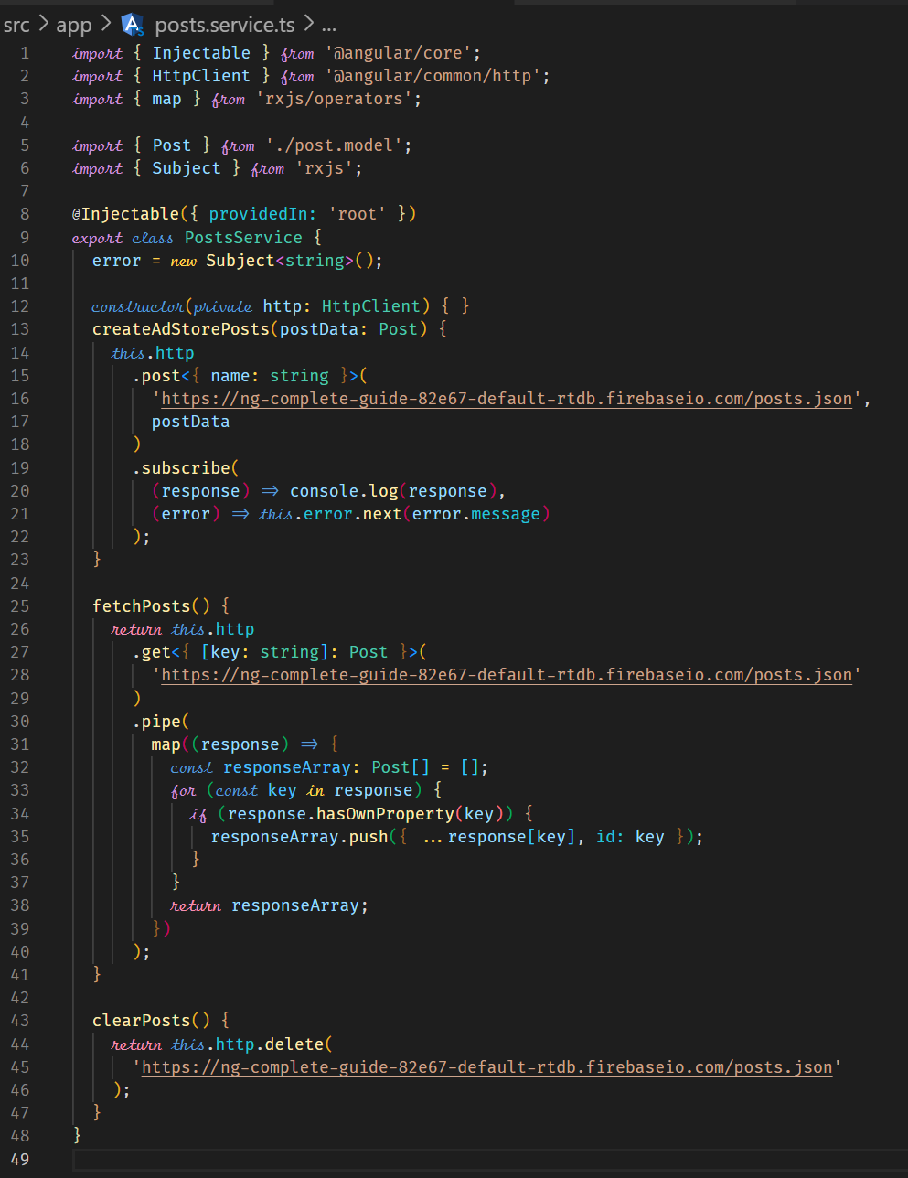



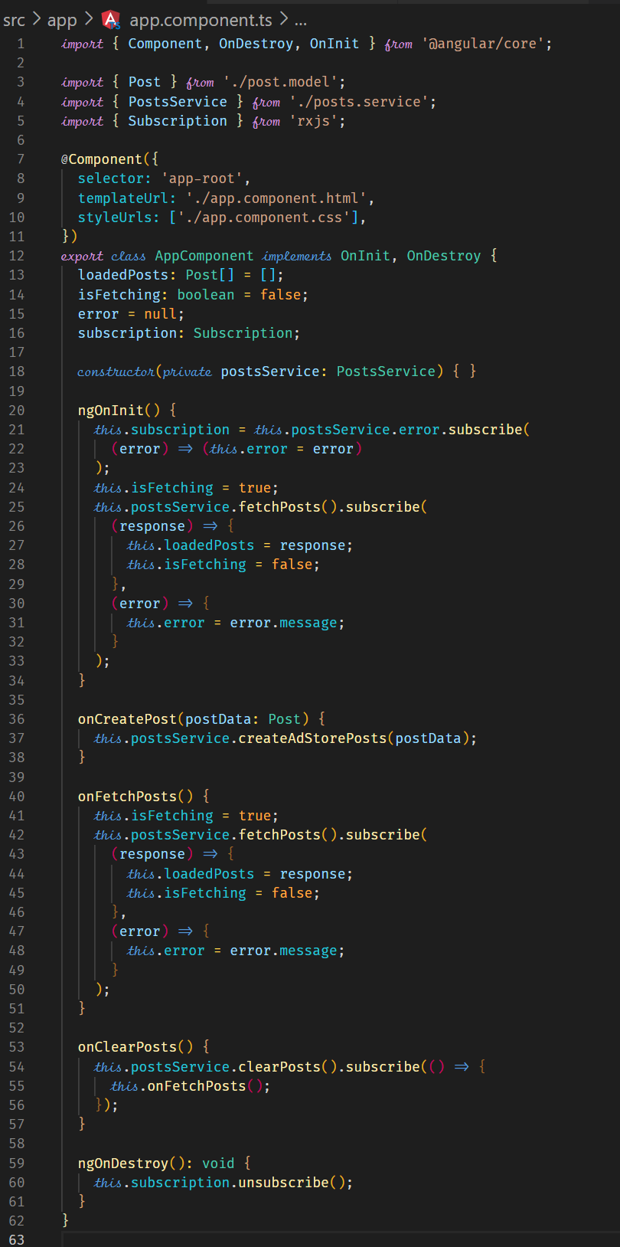



**Using the catchError Operator**

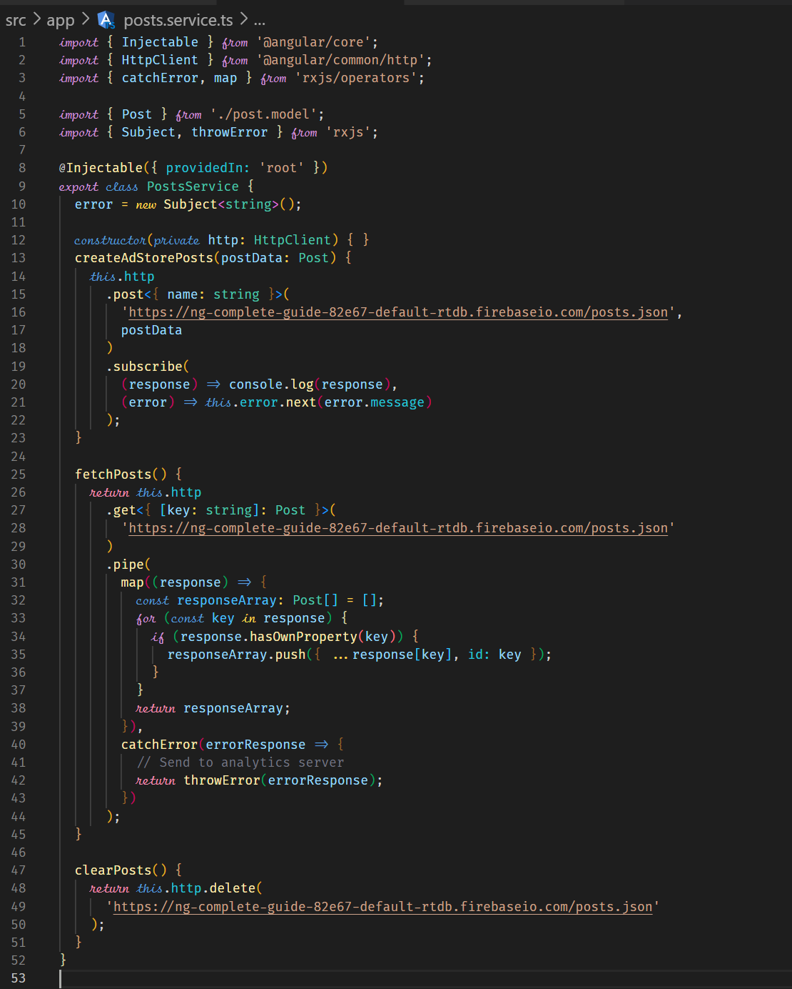

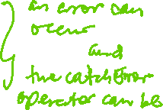

**Error Handling and UX**

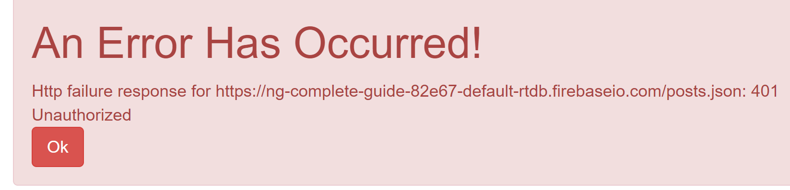

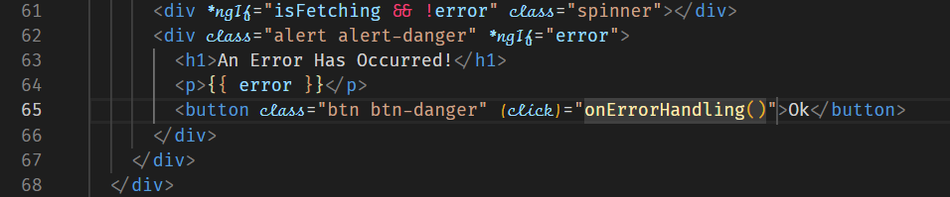

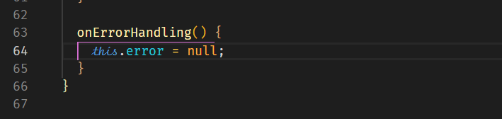

**Setting Headers**

You can set header values such as authentication or authorization. These are key/value pairs. Headers can be set in all HTTP methods.

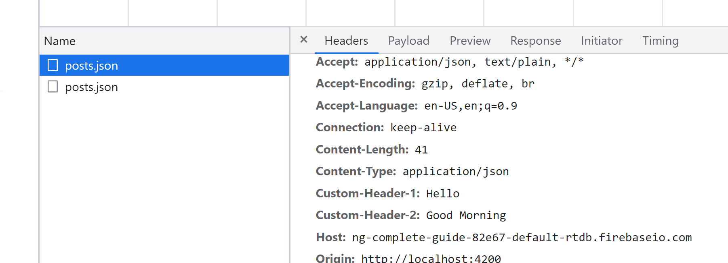



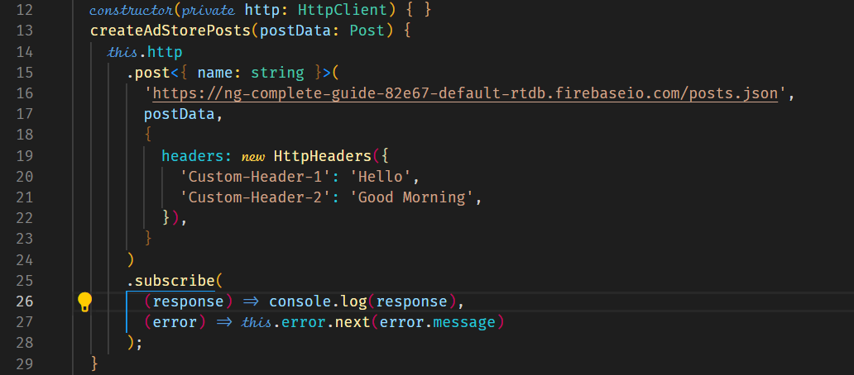



**Adding Query Params**

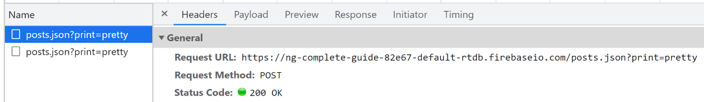



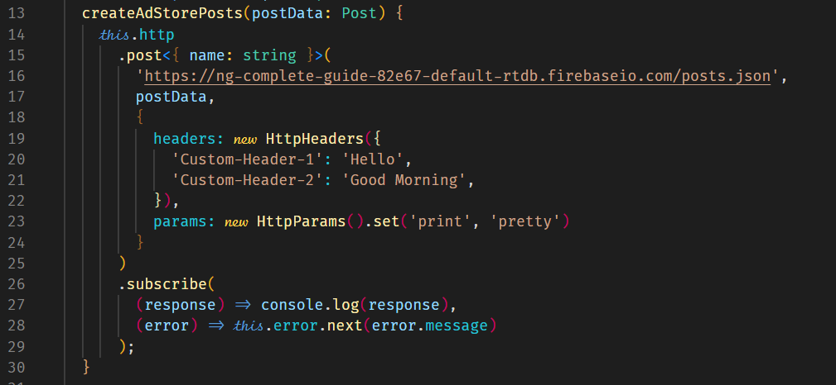



Multiple query parameters can be added as shown below.

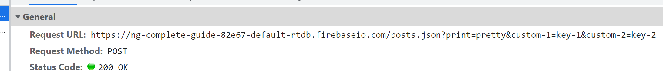



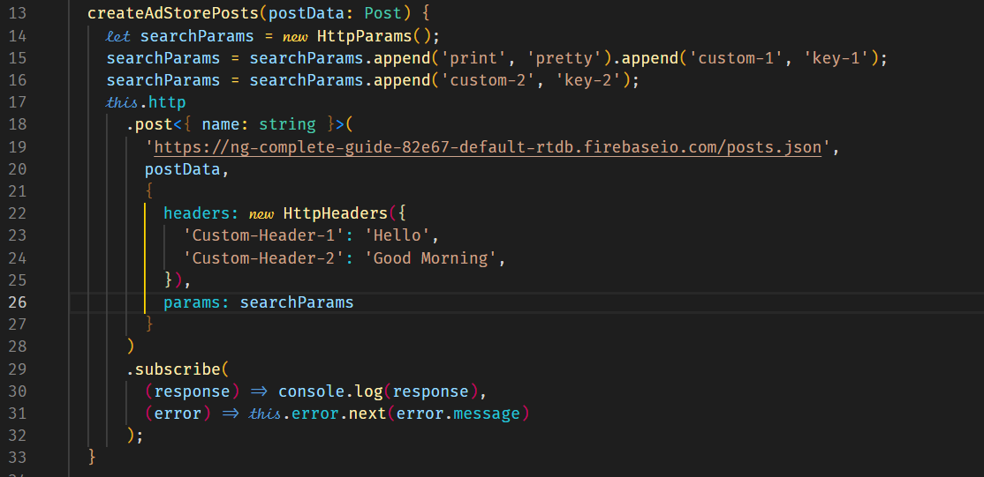



**Observing Different Types of Responses**

There may be times when you need access to the entire response data or sometimes just the status code. This is where we need to change how the response is parsed.

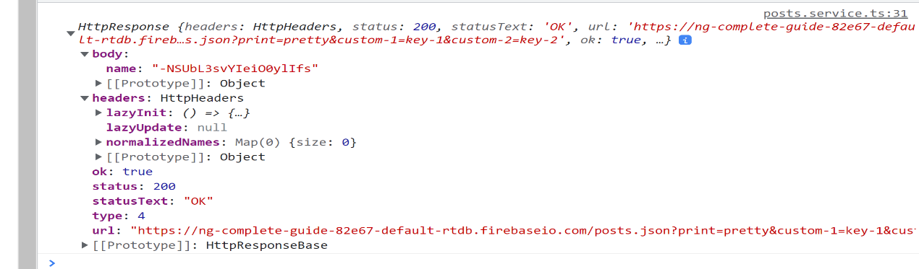



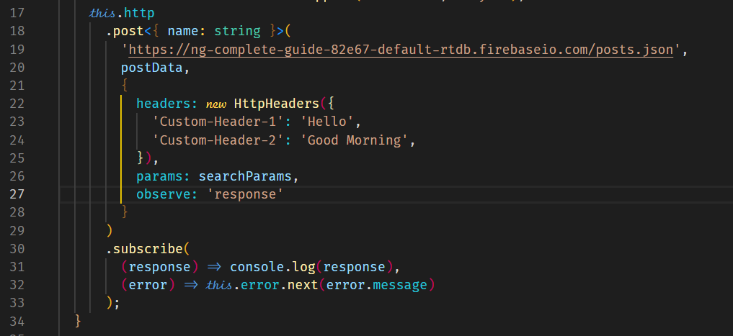



To print the body, and other data, we would now have to have the following.

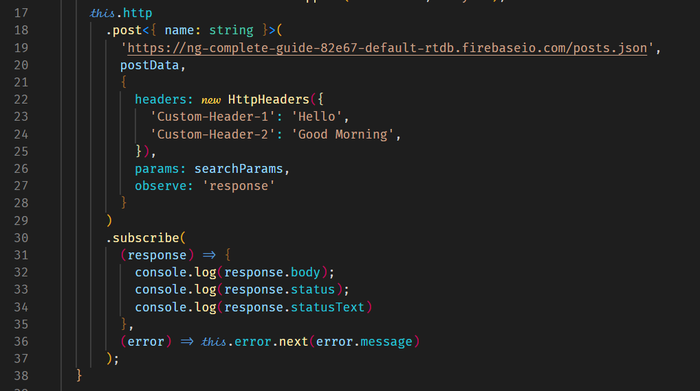

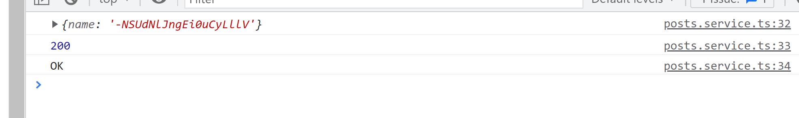

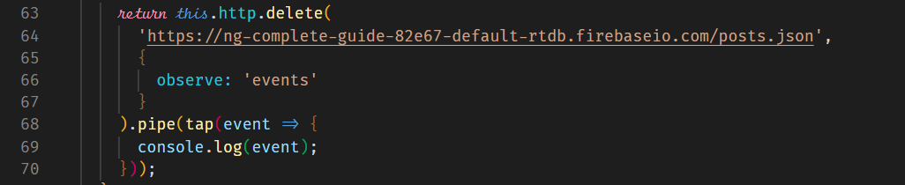



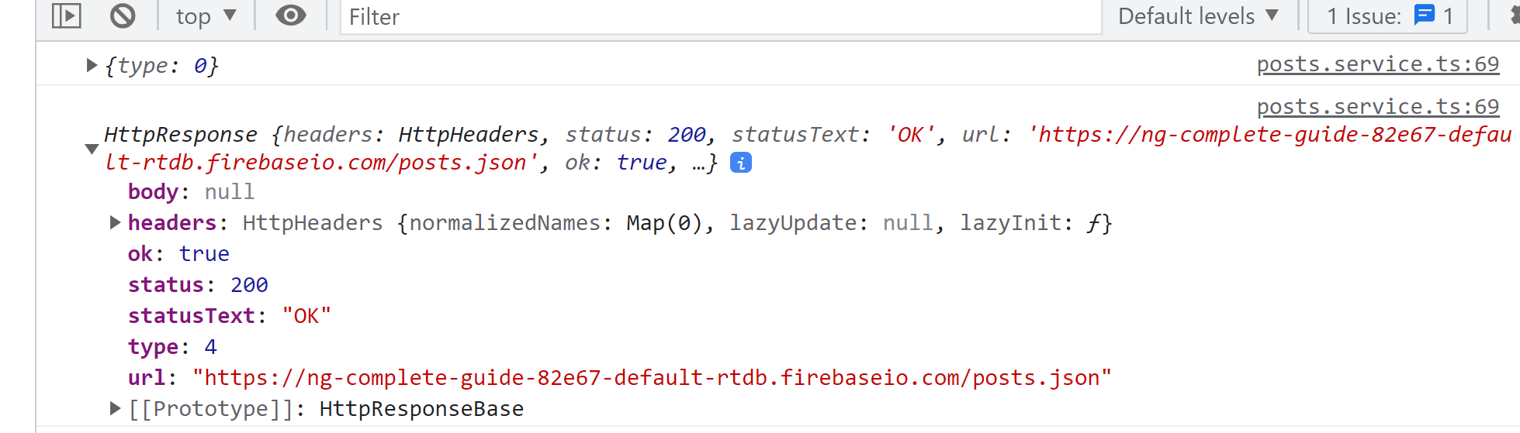



**Introducing Interceptors**

Interceptors allow us to process our outgoing HTTP requests before they leave our application on their way to the backend. An example can include including certain header information with all outgoing requests. This could be header information required for authorization.

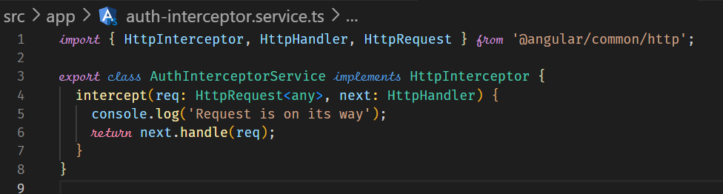



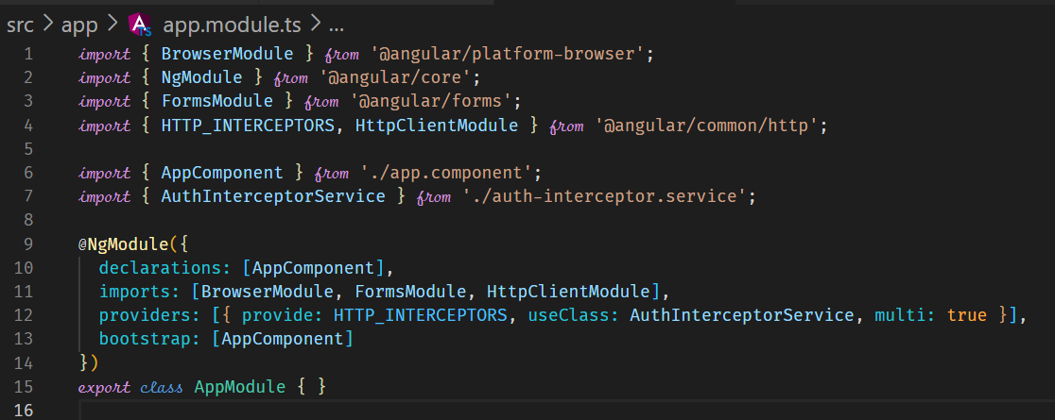



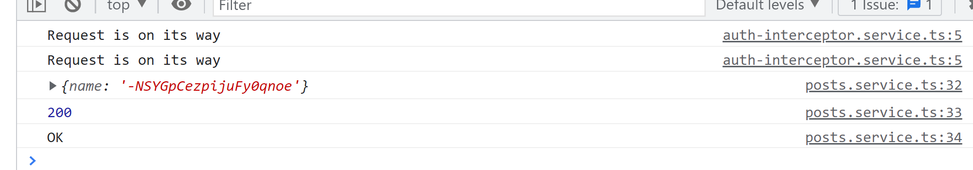



**Manipulating Request Objects**

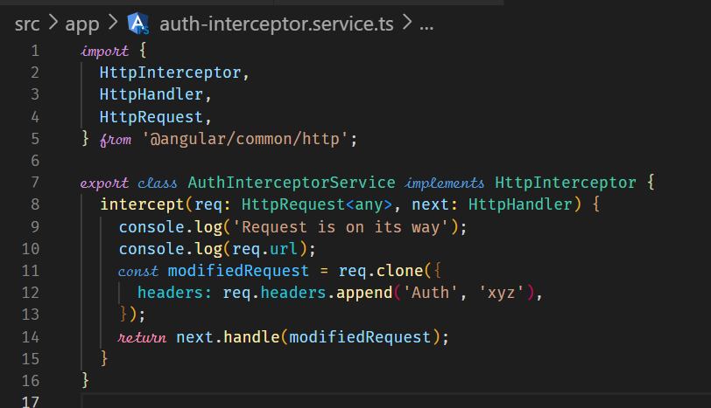



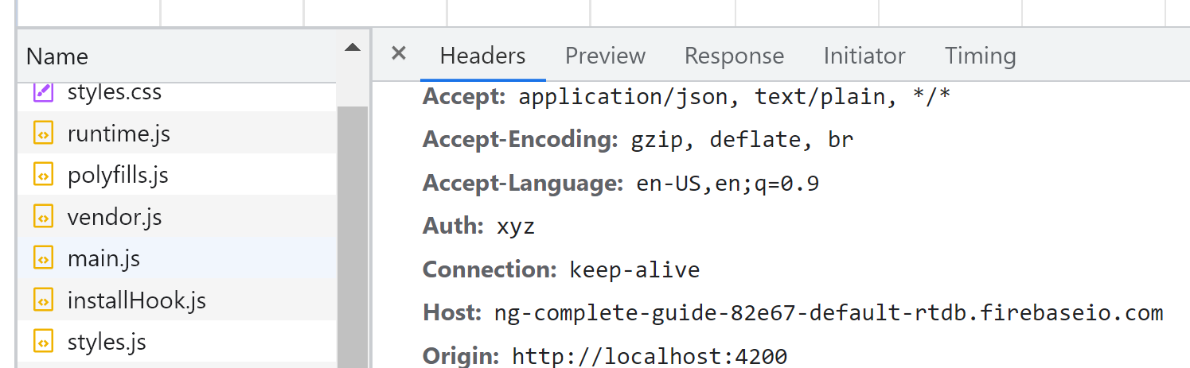



**Response Interceptors**

We can also intercept responses globally by using the HttpInterceptor.

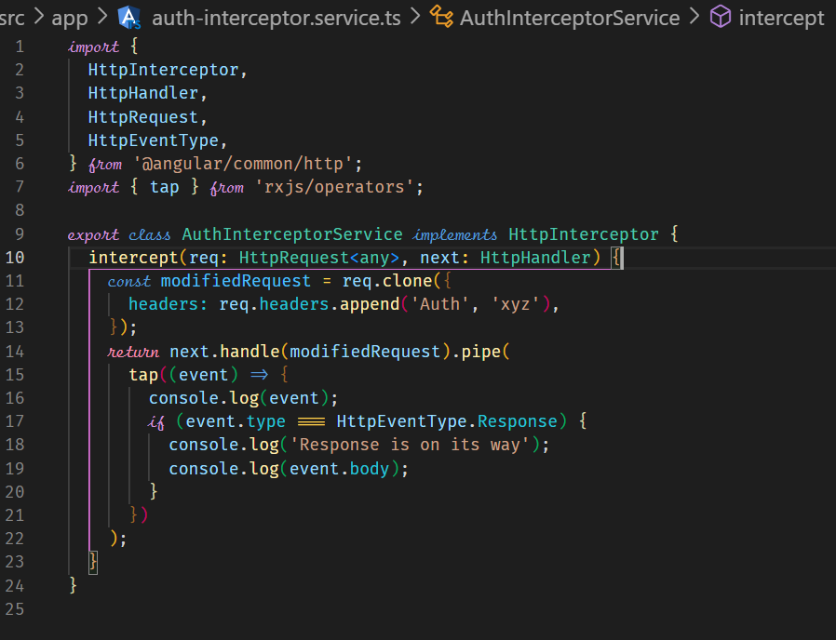



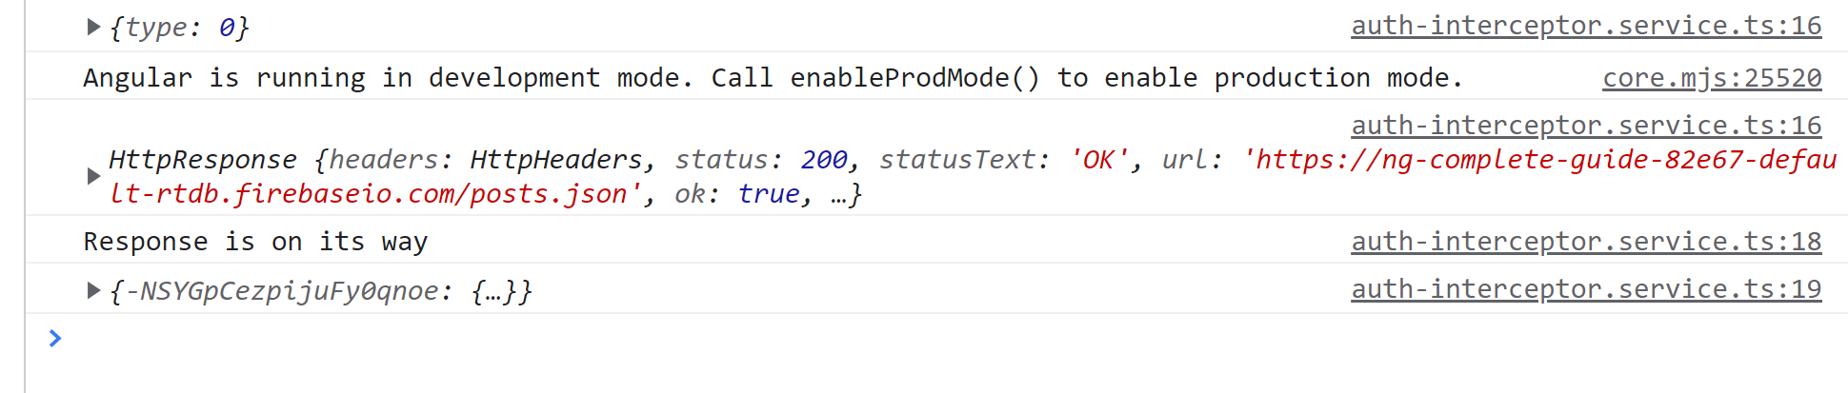



**Multiple Interceptors**

We can also have multiple interceptors.

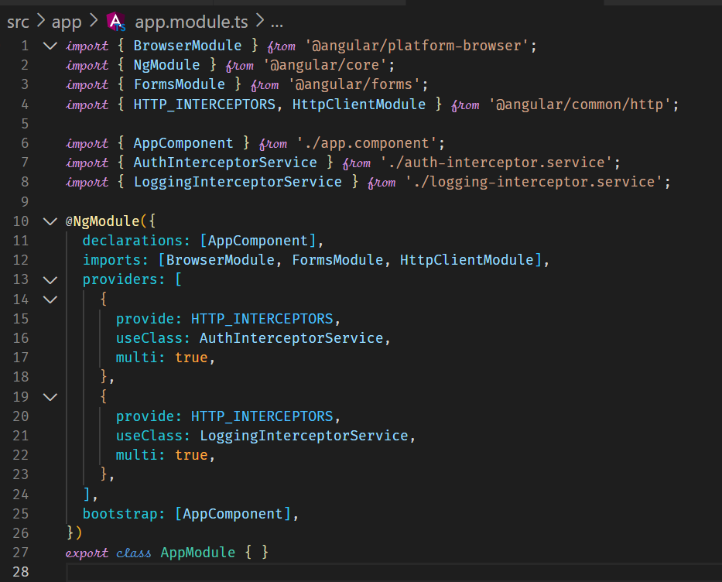

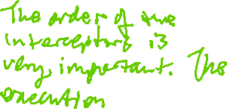

**Course Project Http**

We create a dedicated service to handle HTTP communication to the backend. For this, we need to inject the HttpClient into the service. To get the HttpClient to work, we need to have the HttpClientModule imported in the AppModule.

**Setting up the DataStorage Service**

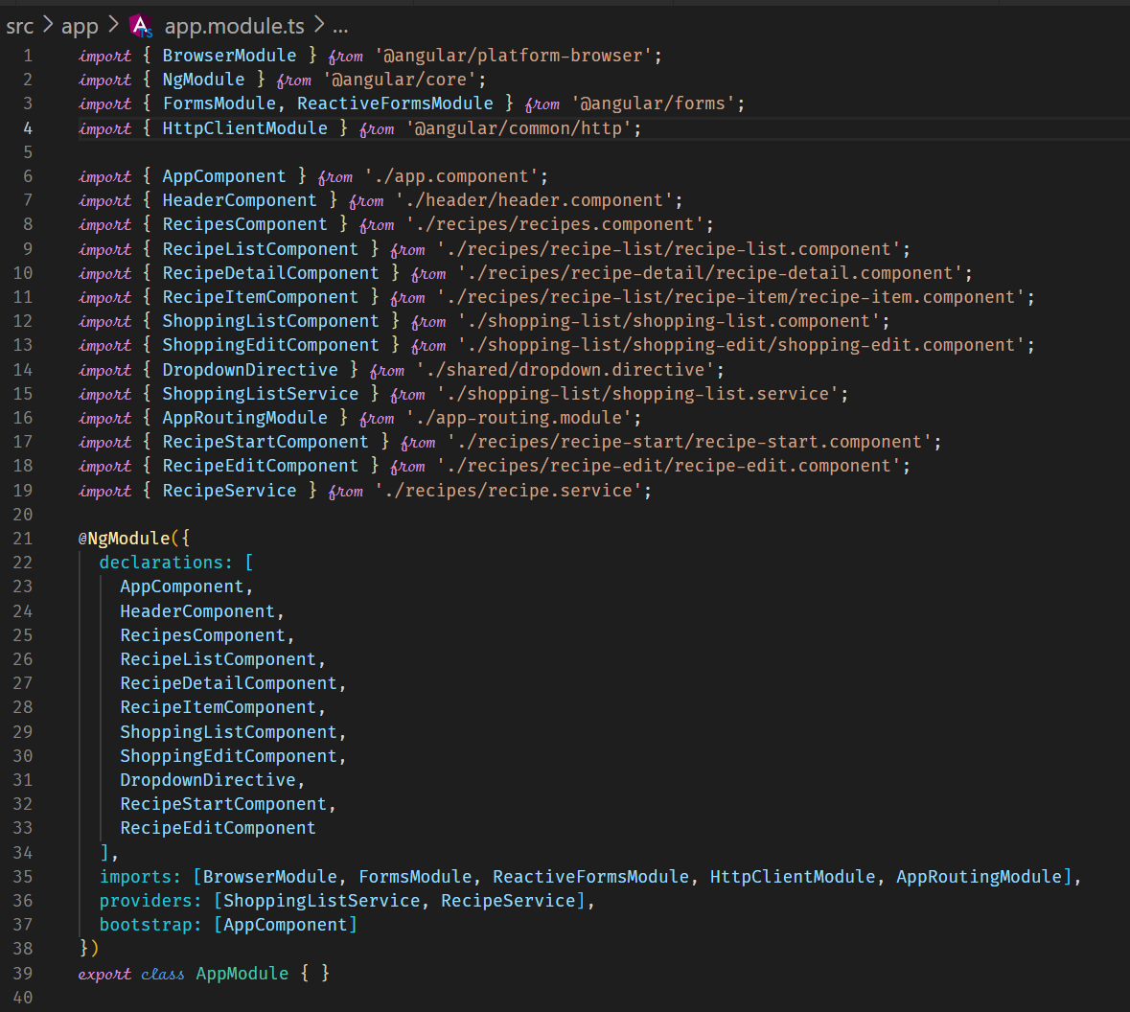



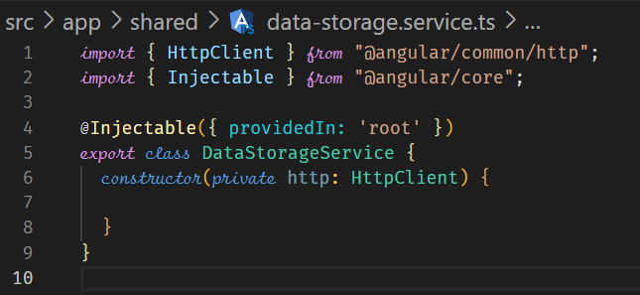



**Storing Recipes**

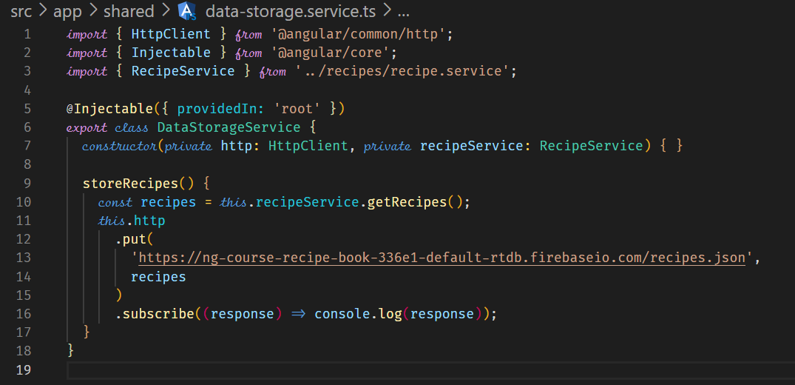



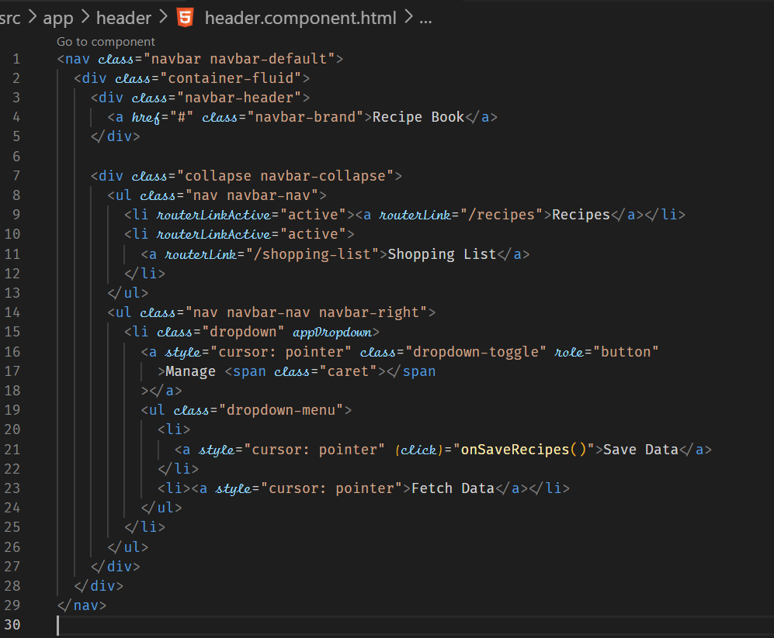



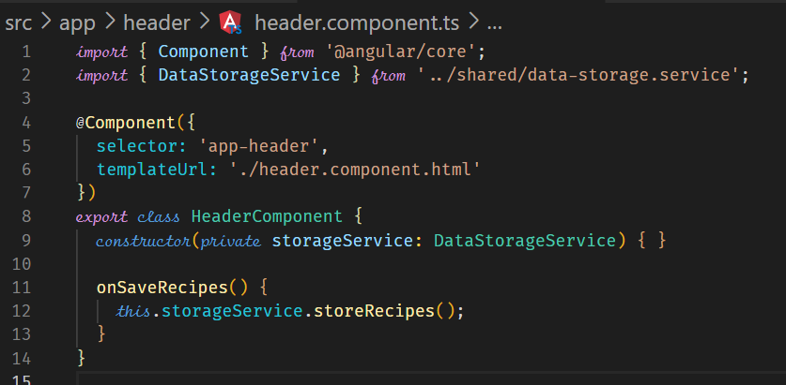



**Fetching the Recipes**

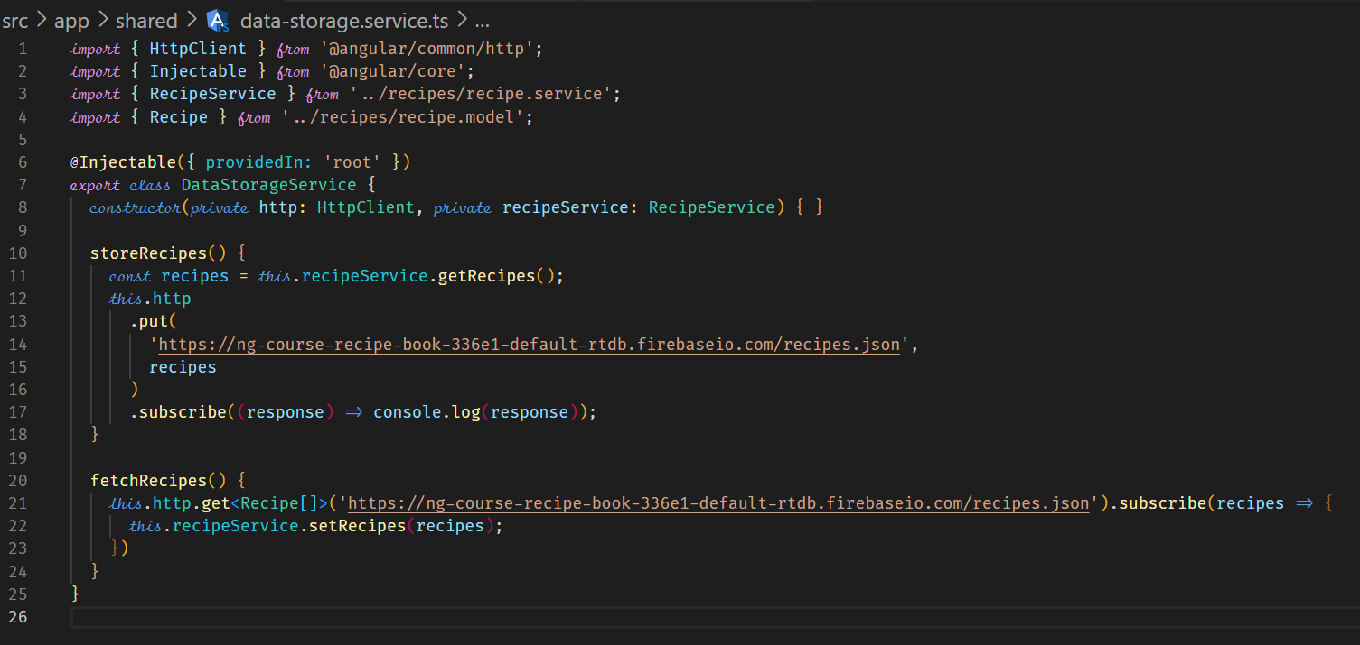



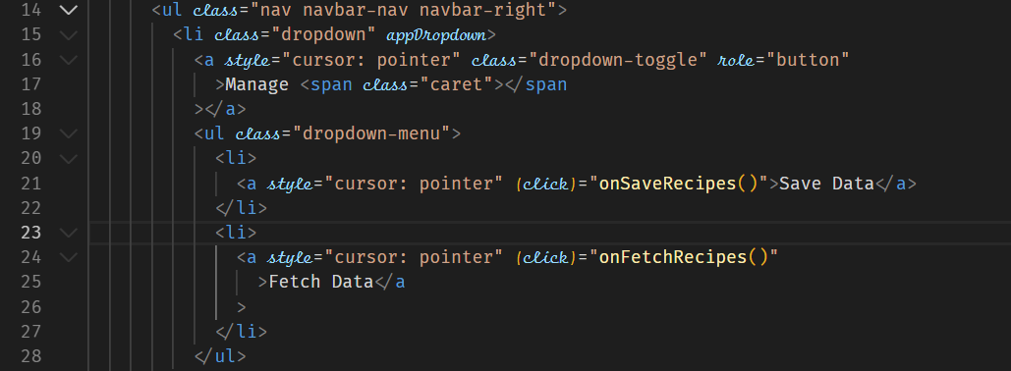

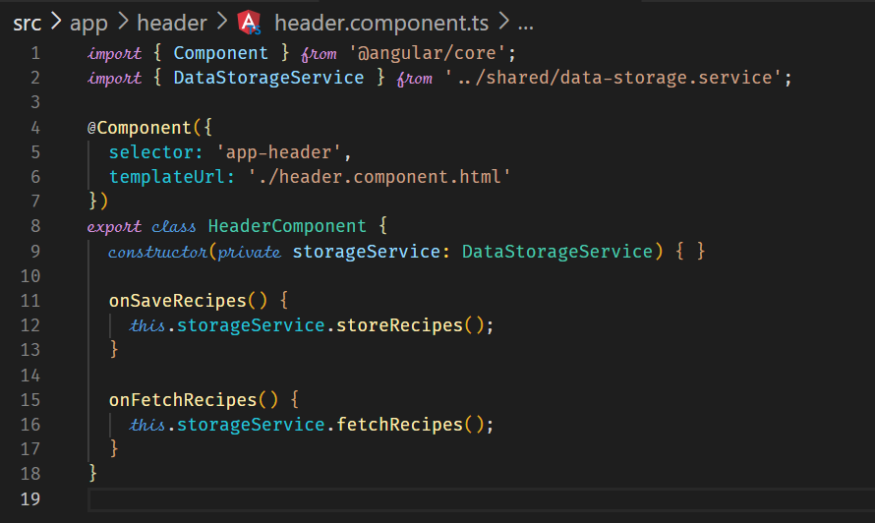



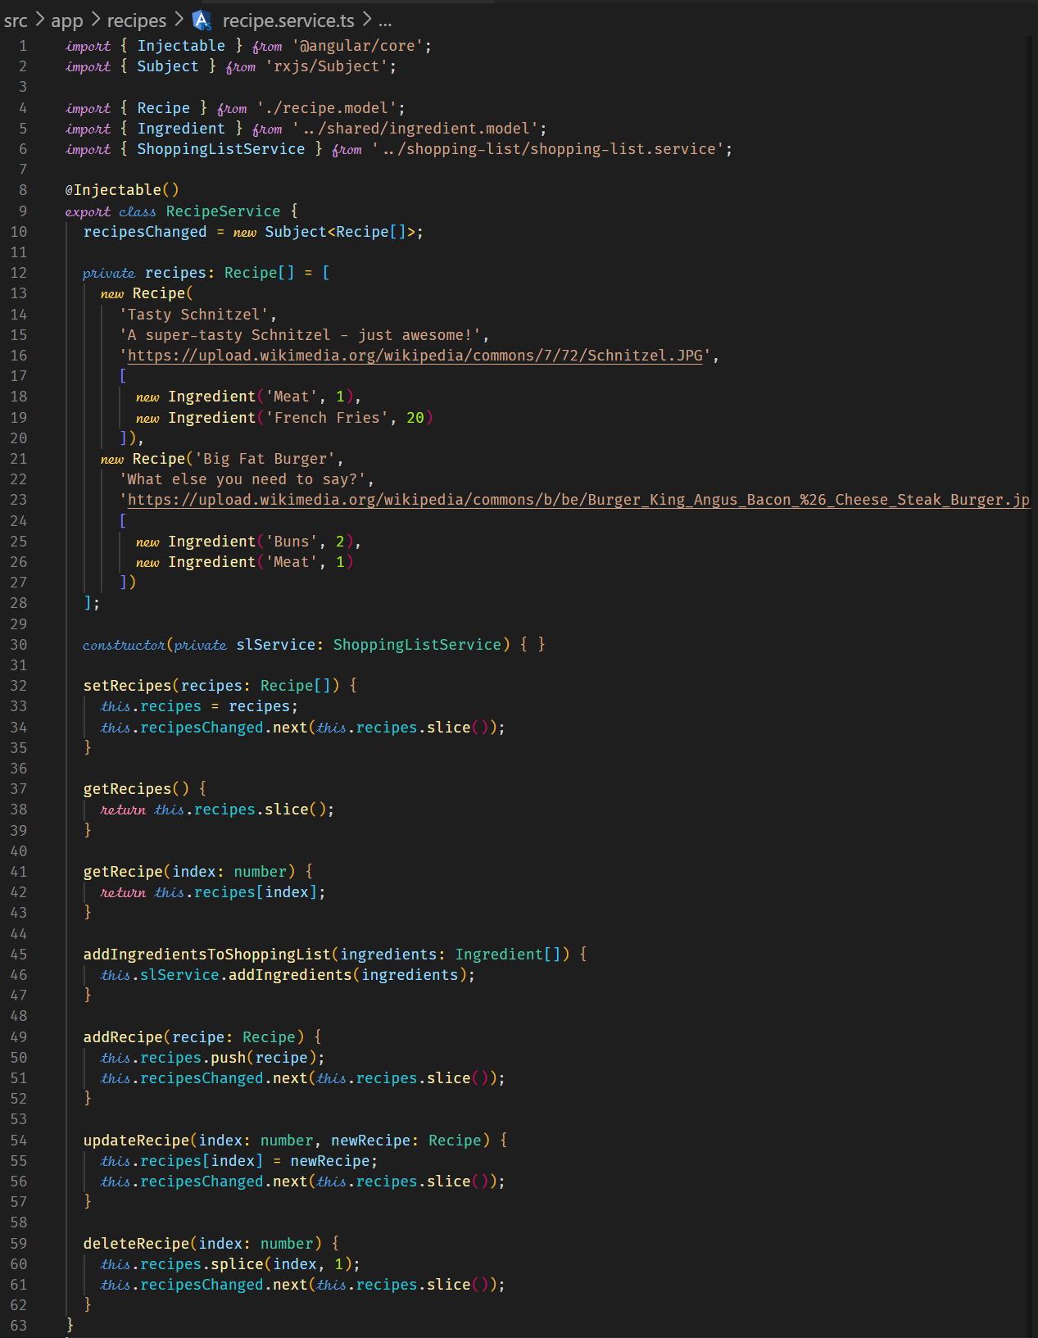



**Transforming Response Data**

An recipe can be saved without some ingredients. This will cause the structure of the record to be different to when a recipe is saved with ingredient. This can cause unforeseen bugs in our code when retrieving the recipes in GET. Because of this we need to transform the recipe to add an empty array of ingredients if the recipe does not have ingredients.

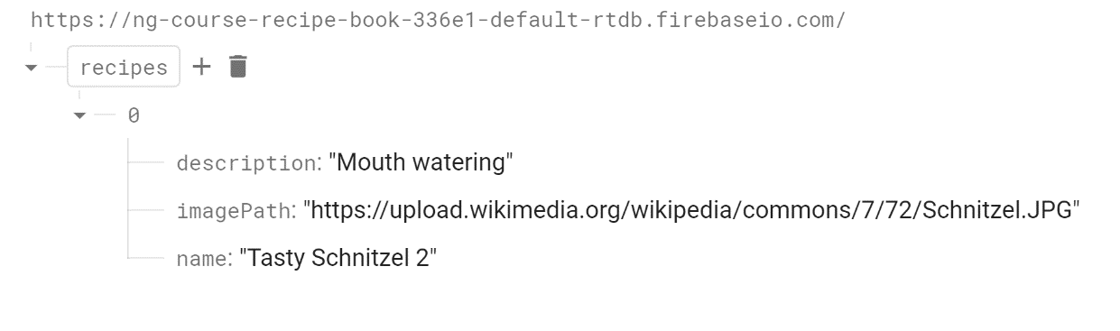

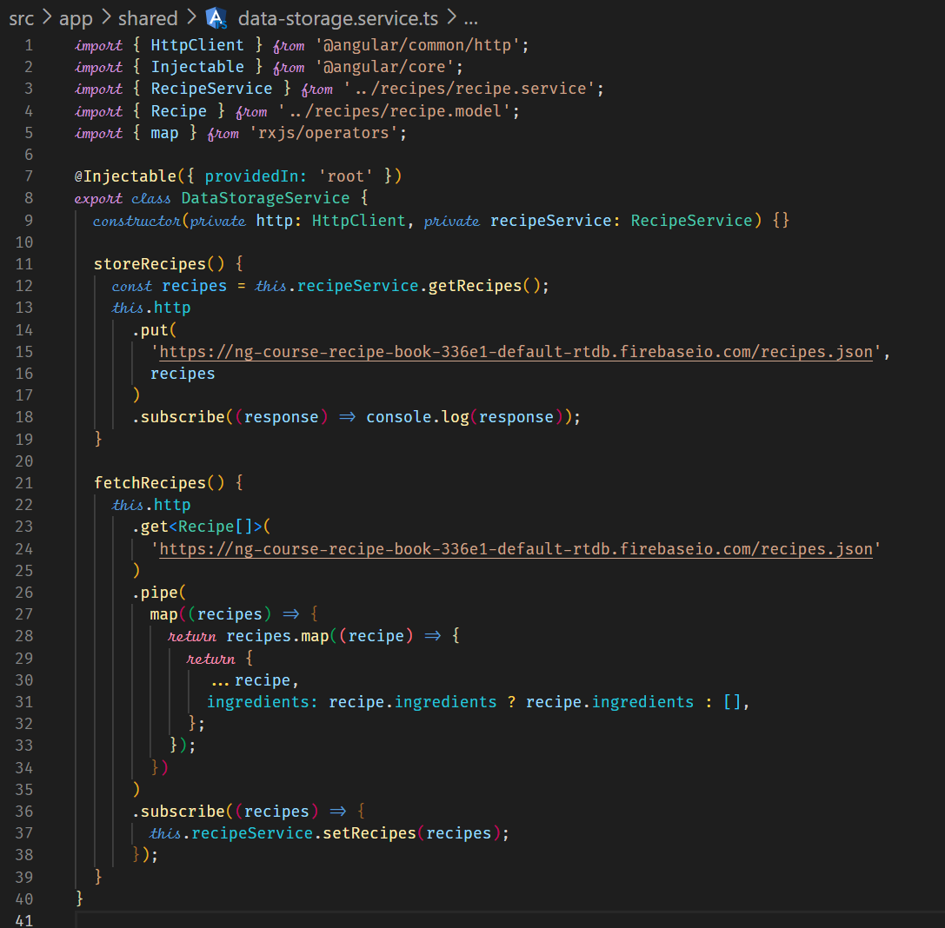



**Resolving Data Before Loading**

A resolver is code that is executed before a route is loaded to ensure that certain data that the route depends on is there, otherwise we can have errors when the component is loaded.

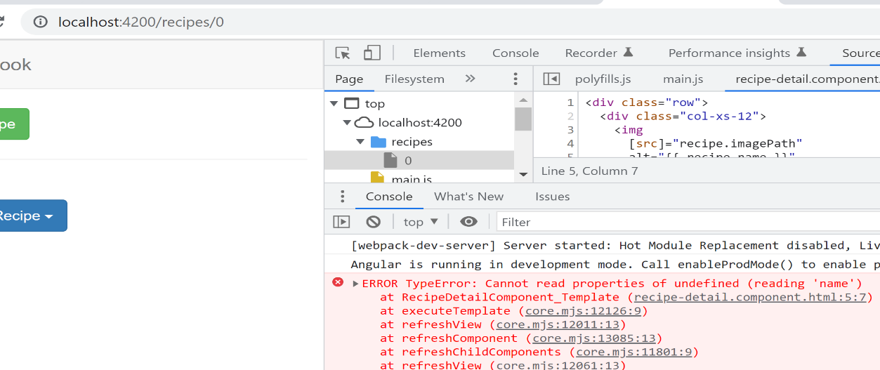

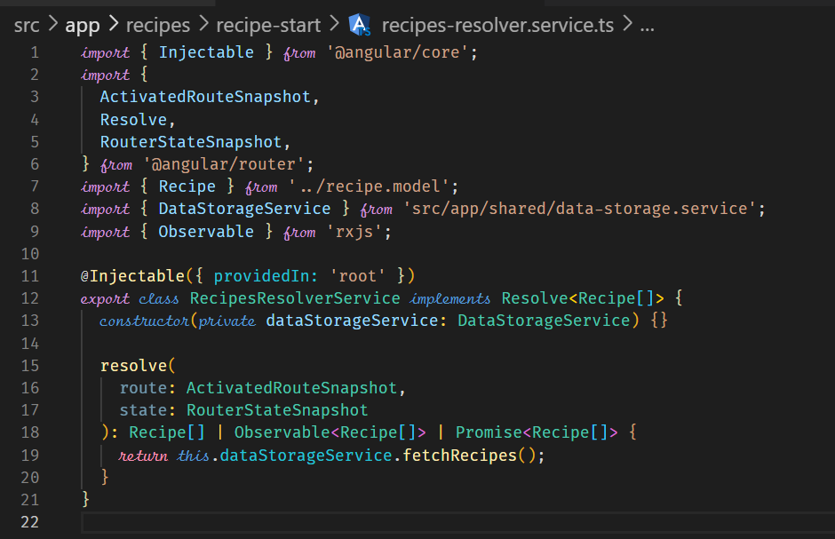

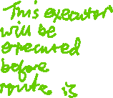

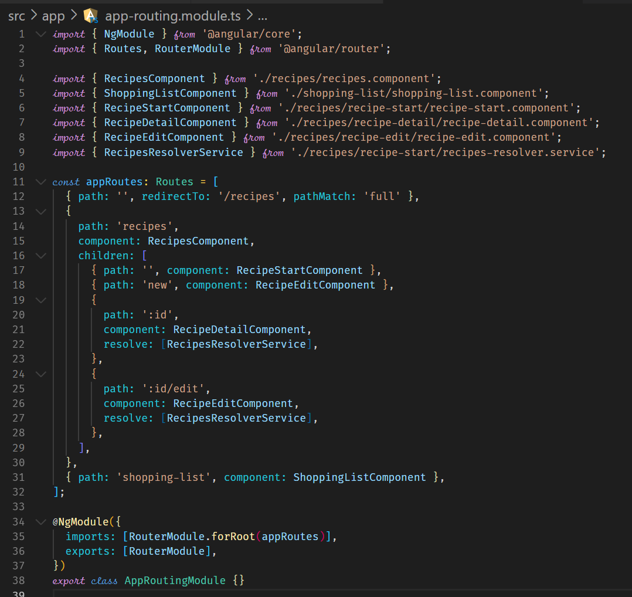



**Authentication & Route Protection in Angular**

**Adding the Auth Page**

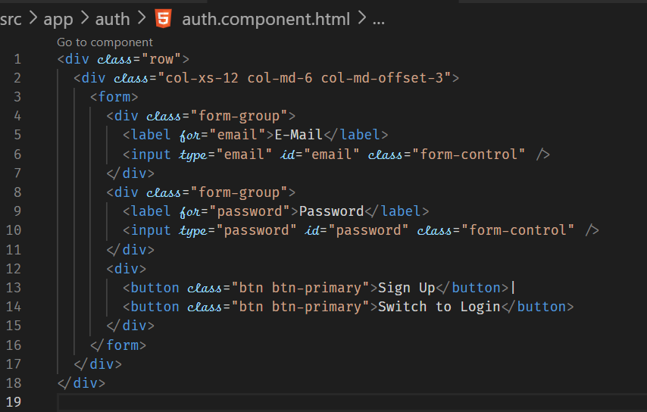

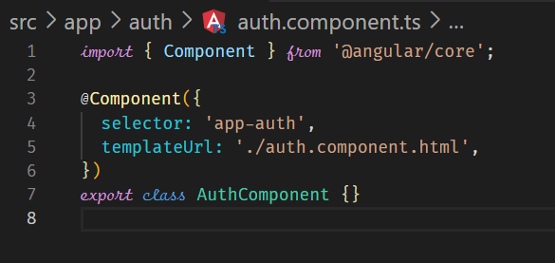

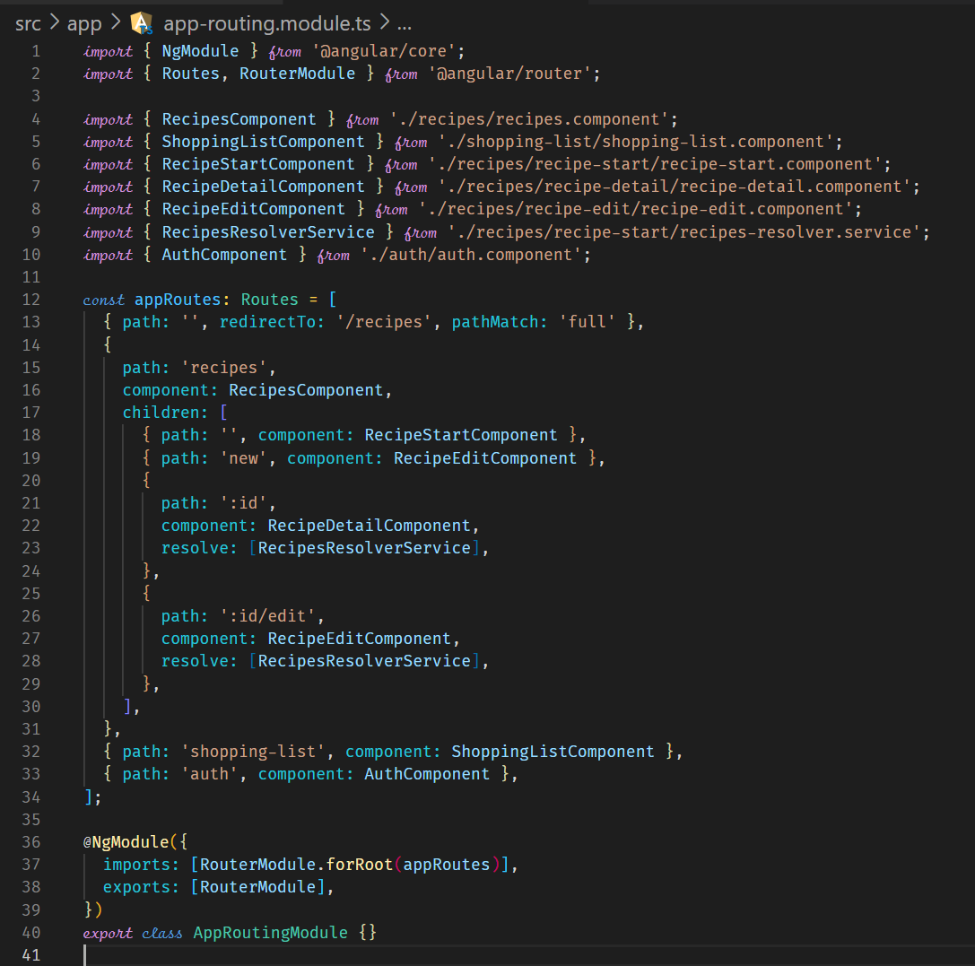



**Handling Form Input**

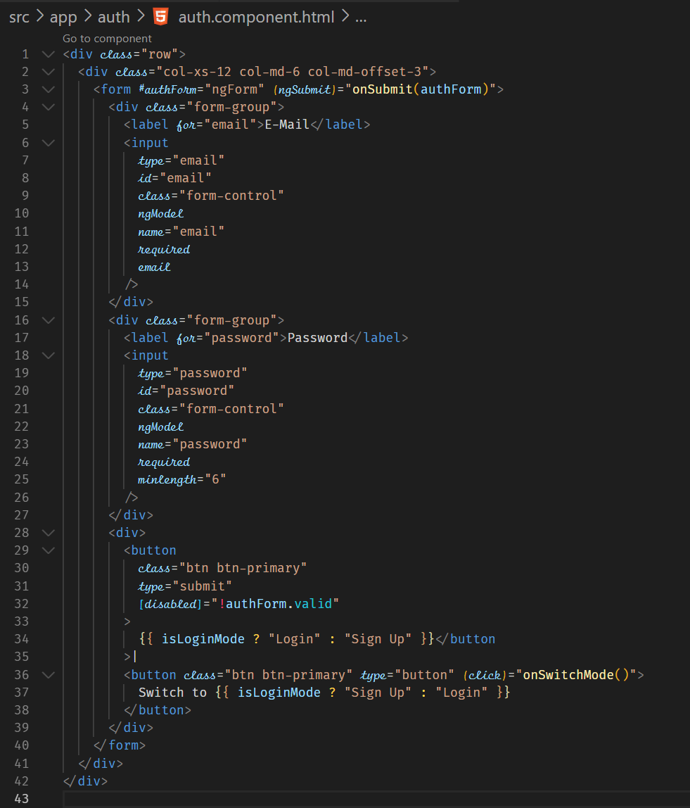

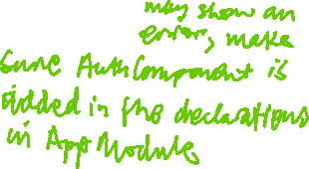

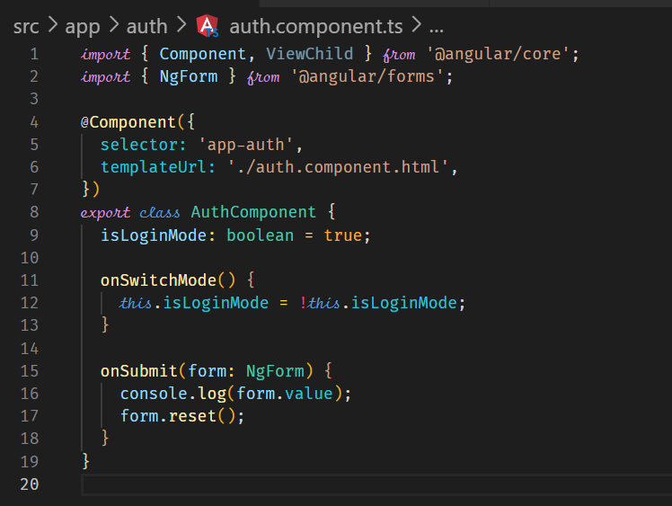

**Preparing the Backend**

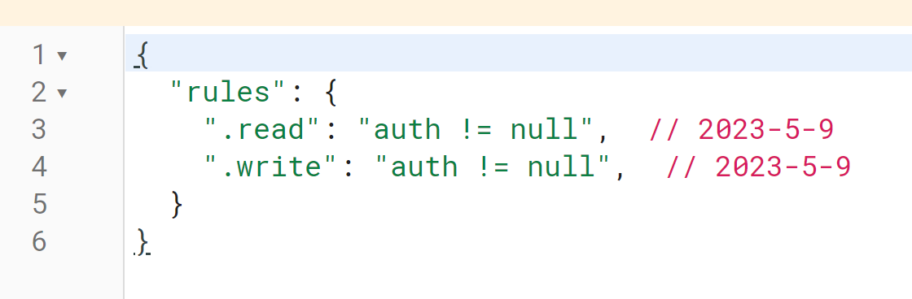

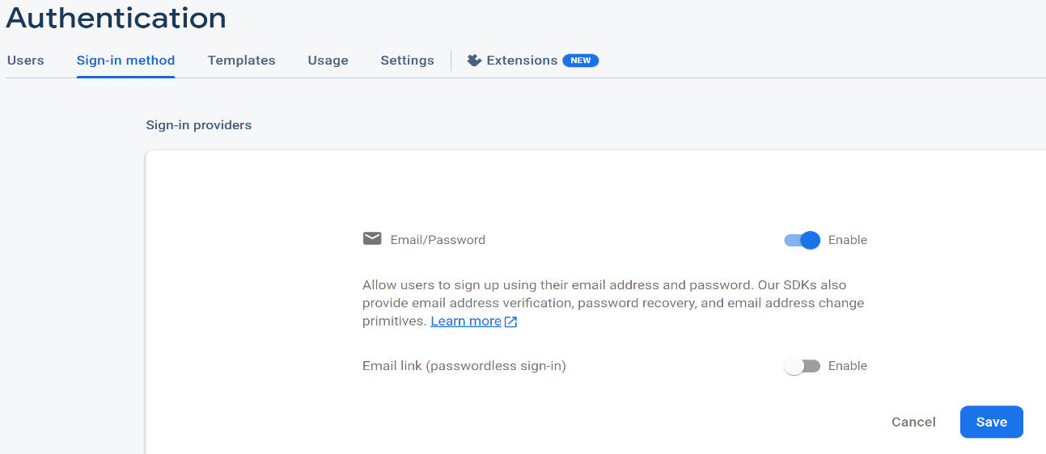

**Preparing the Signup Request**

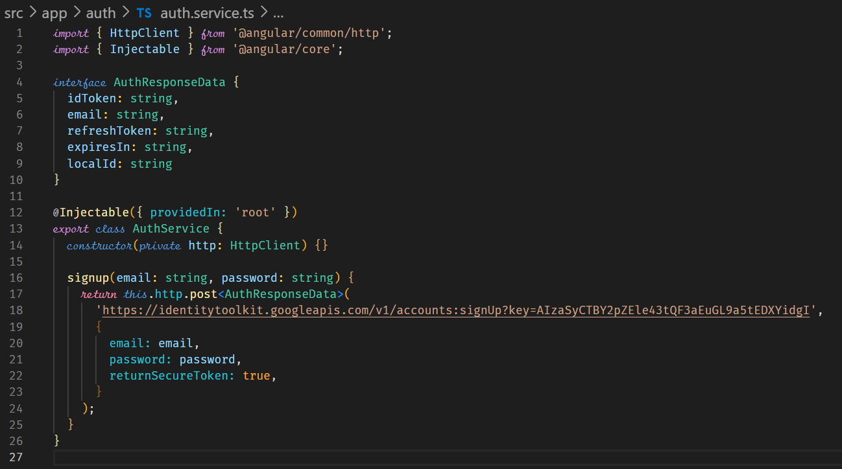

**Sending the Signup Request**

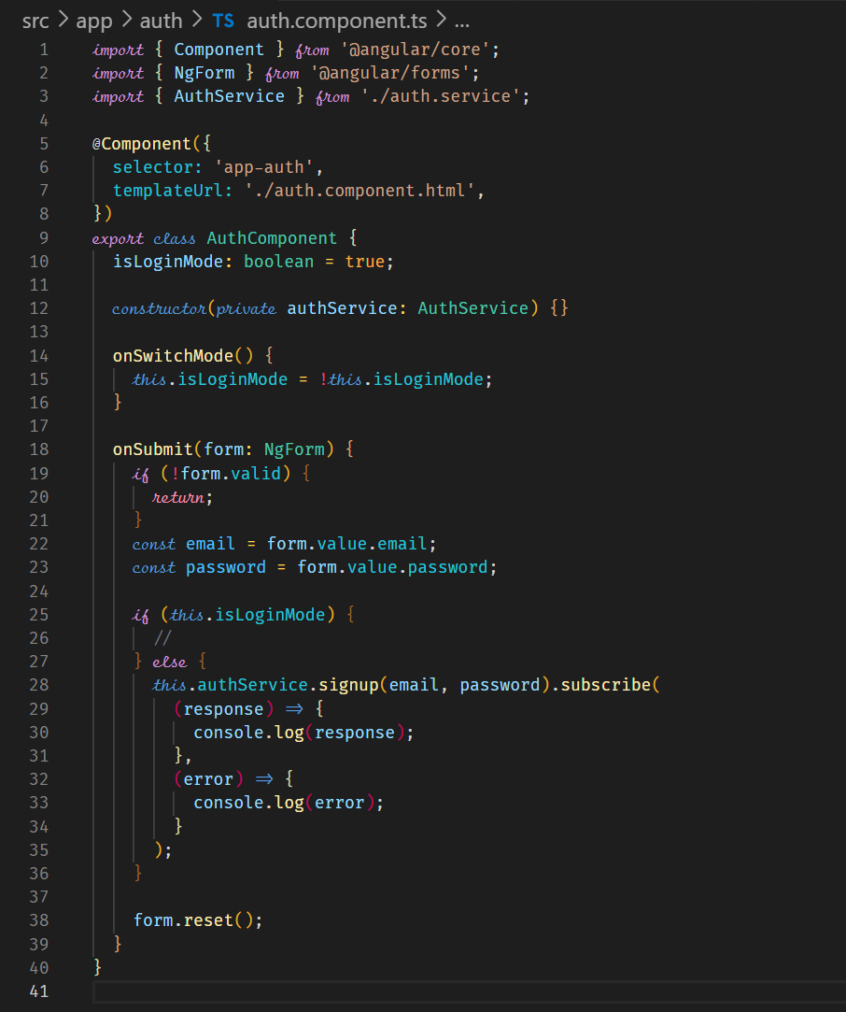



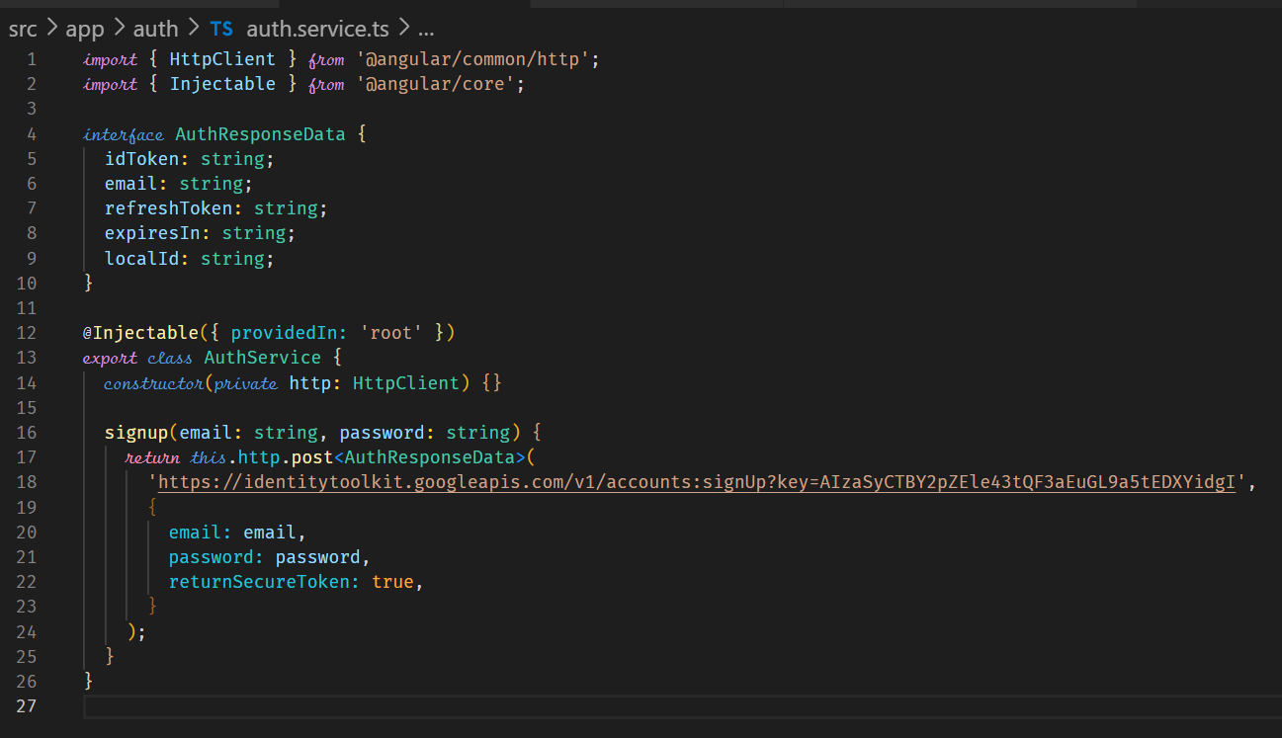



**Adding a Loading Spinner and Error Handling Logic**

We can have a Loading Spinner and display error messages for user experience. Loading spinner code can be found at <https://loading.io/css/>

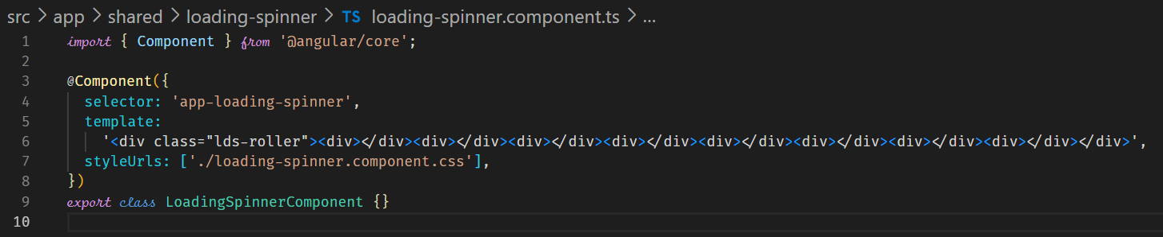

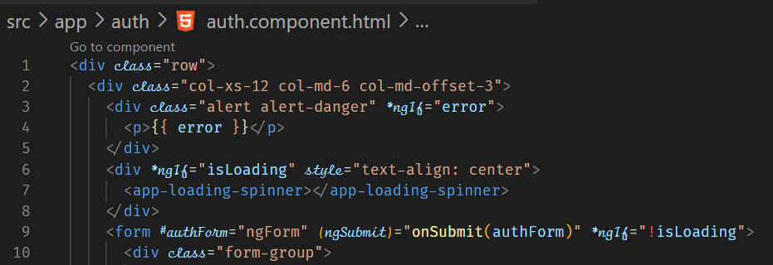



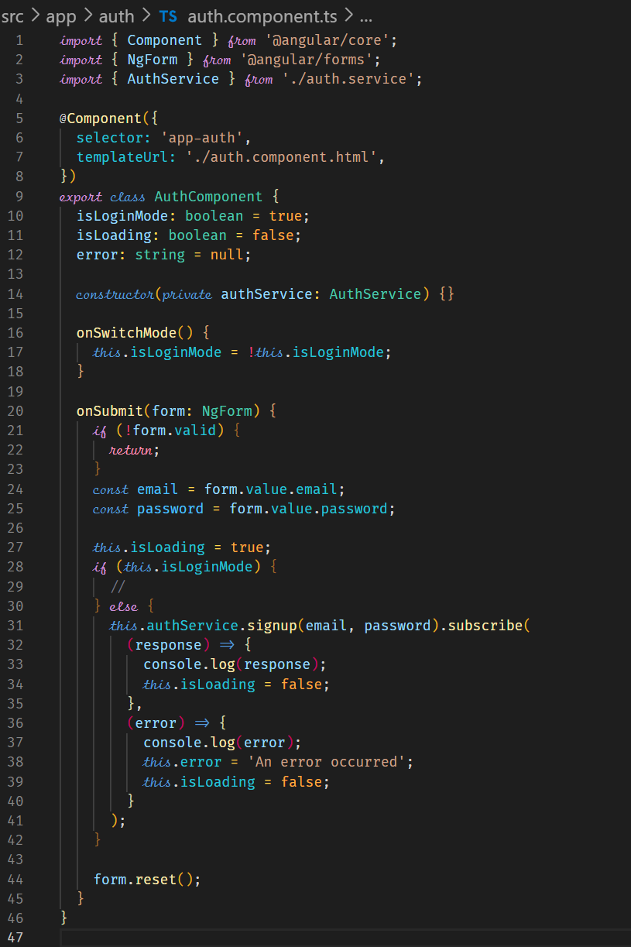



**Improving Error Handling**

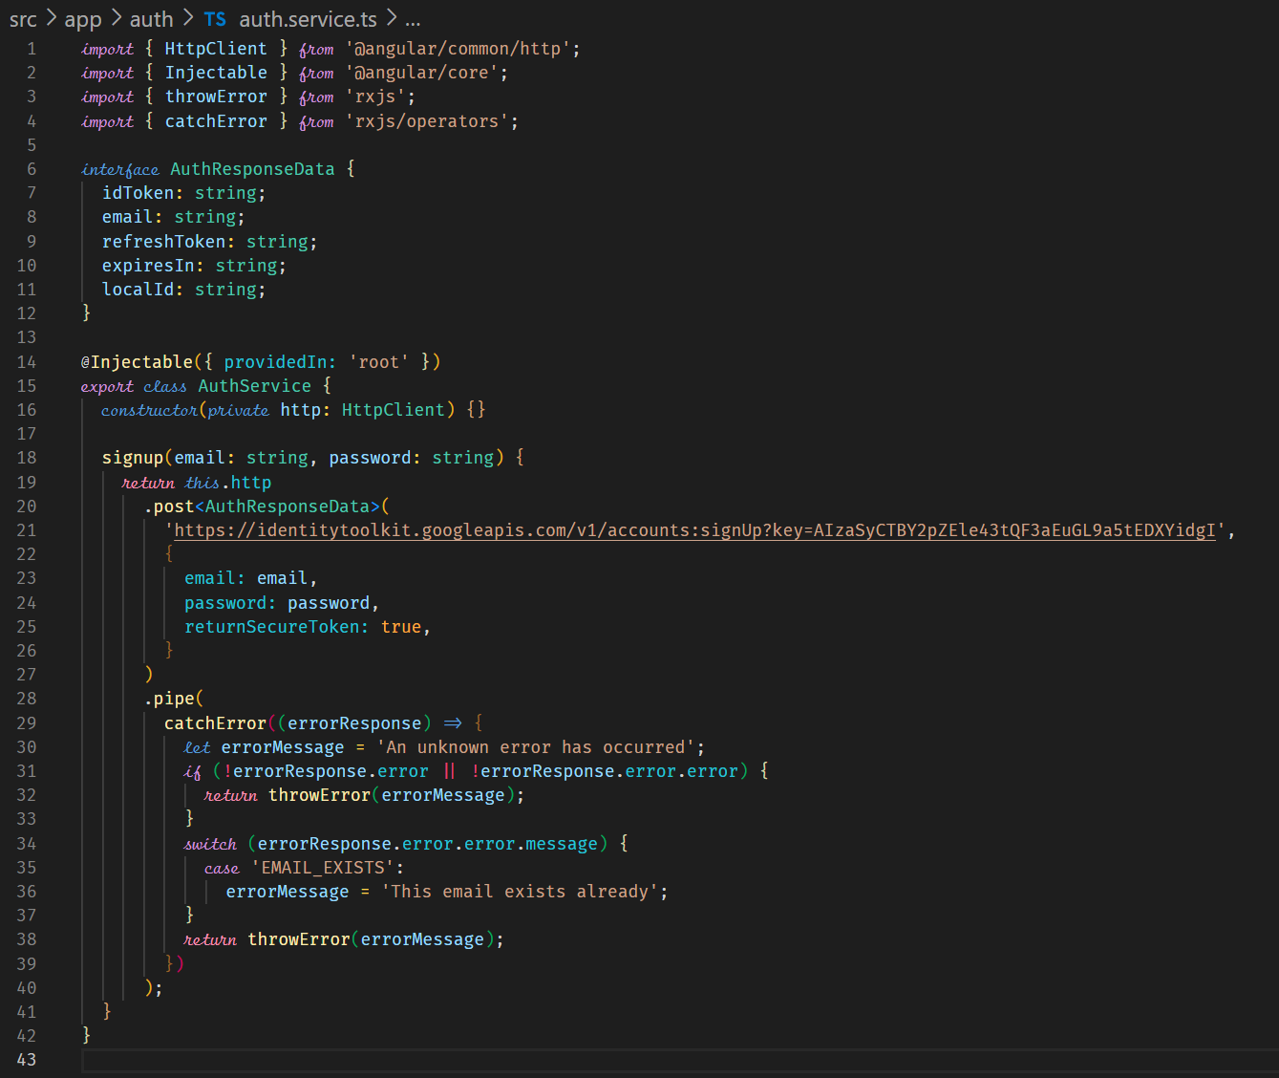



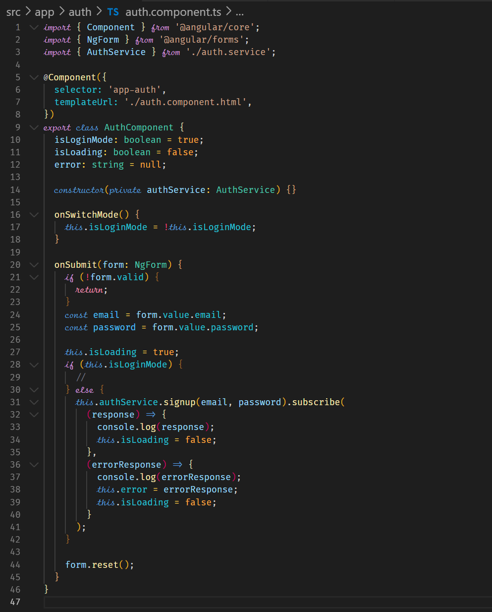



**Sending Login request and Error Handling Improvement**

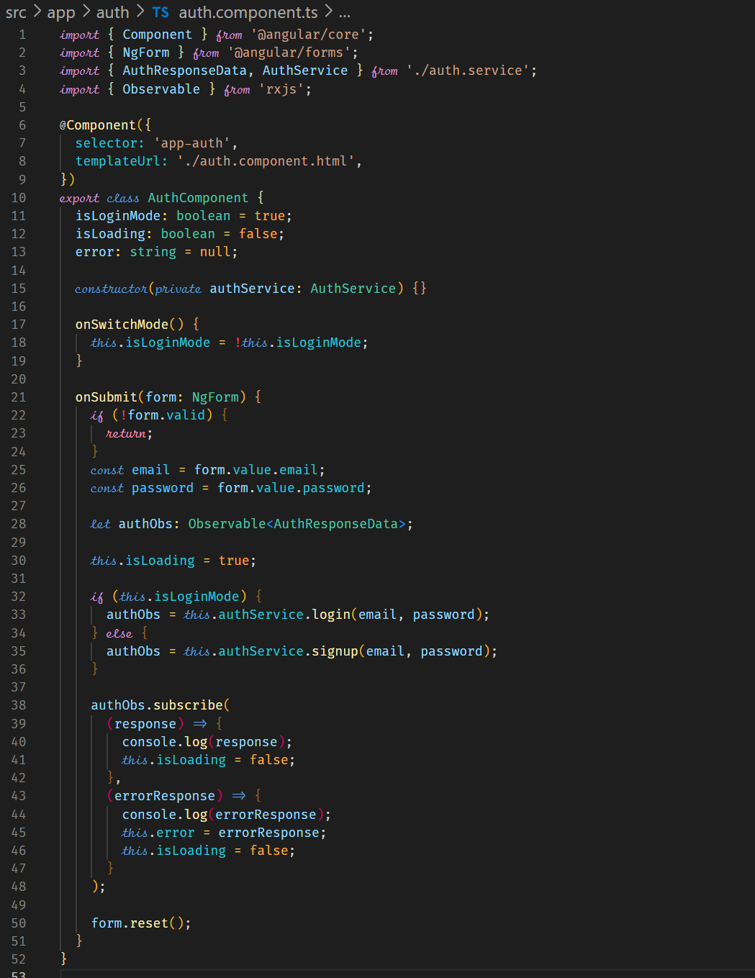



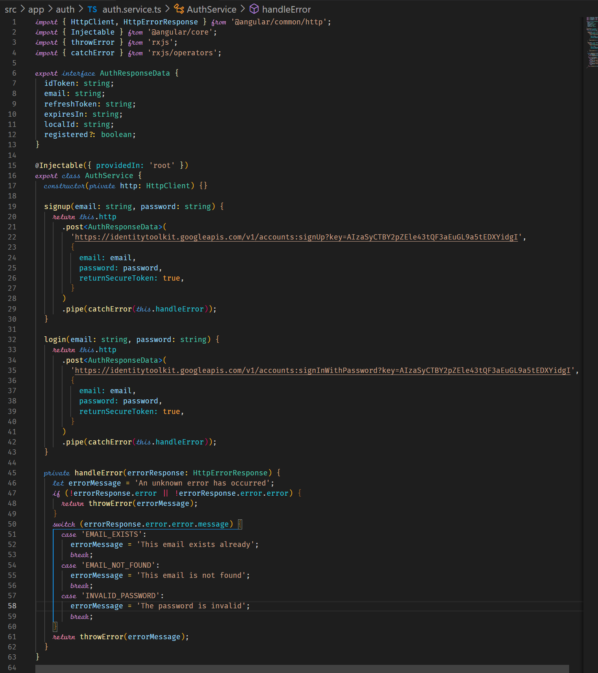



**Creating and Storing the User Data**

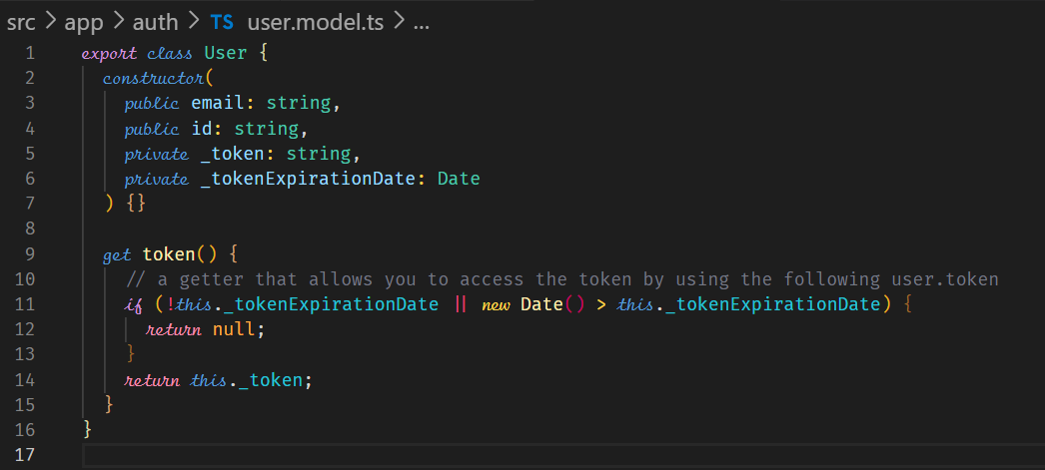



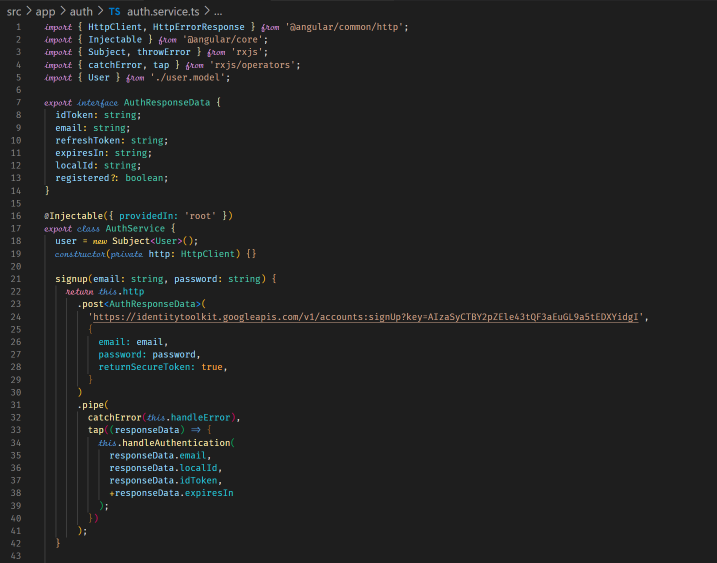

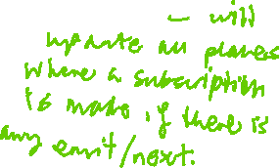

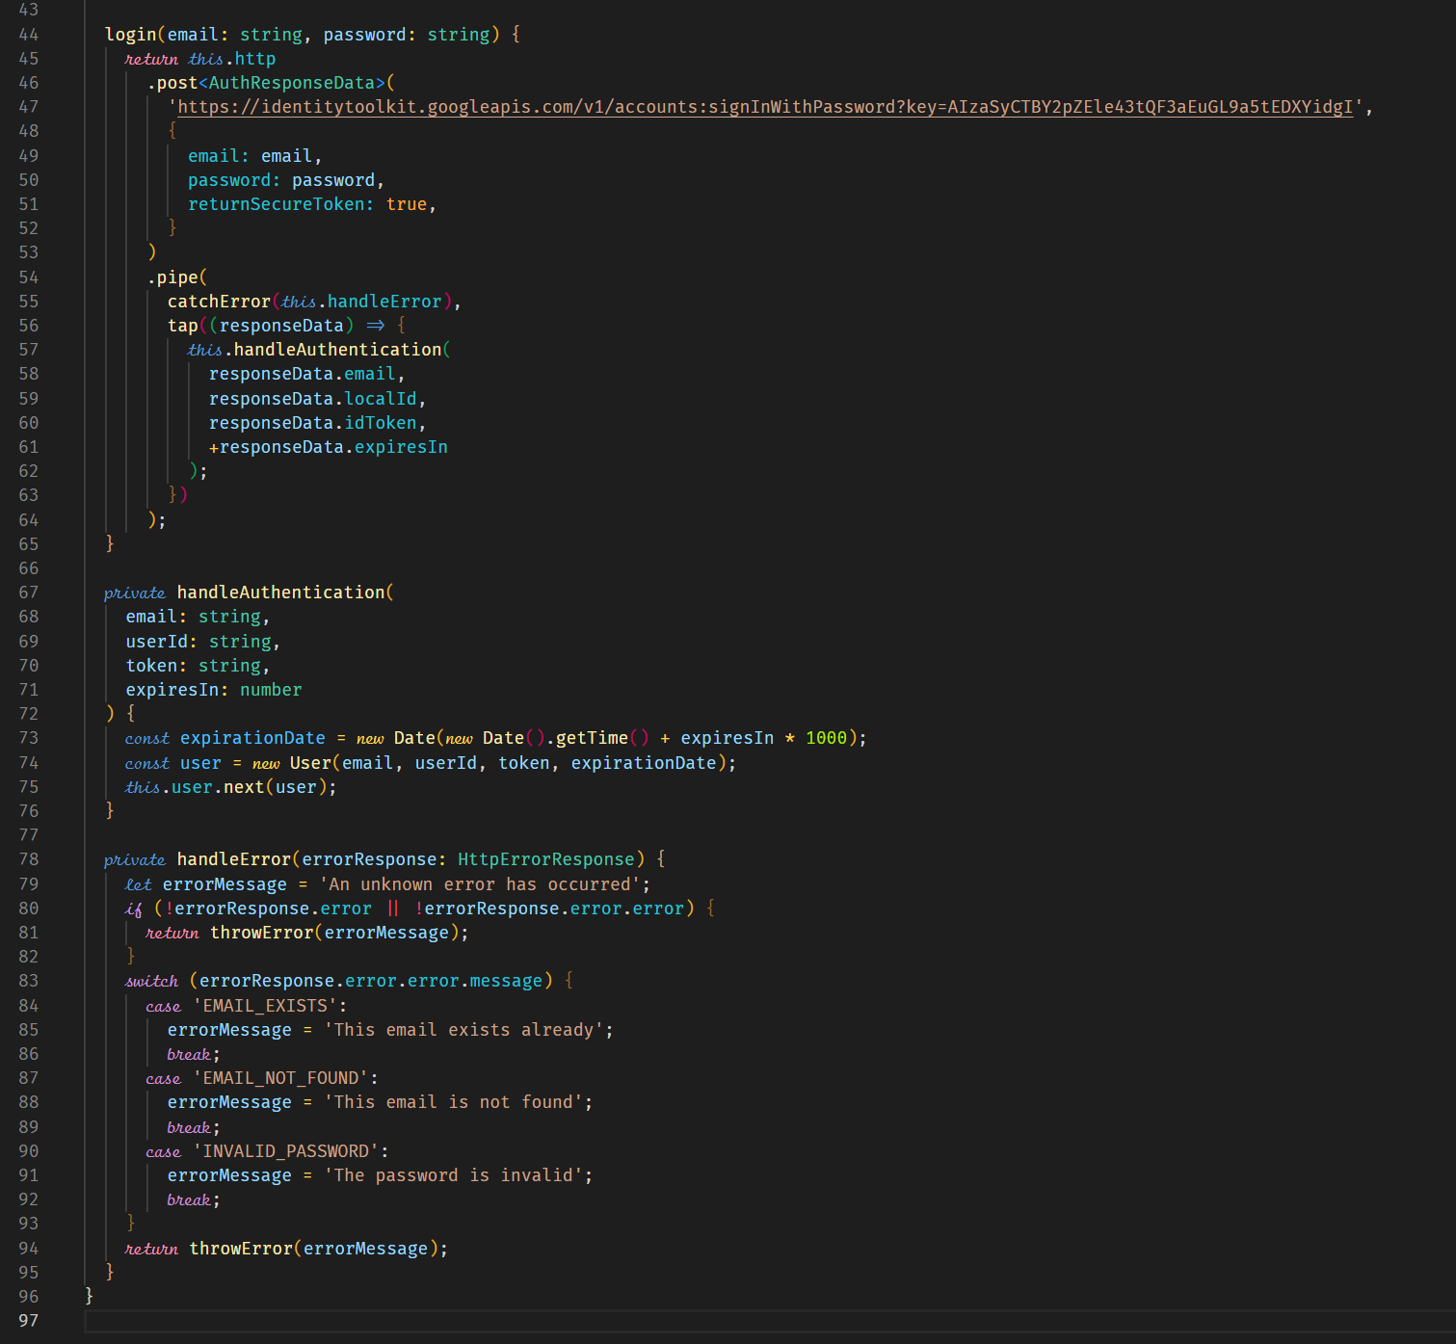



**Reflecting the Auth State in the UI**

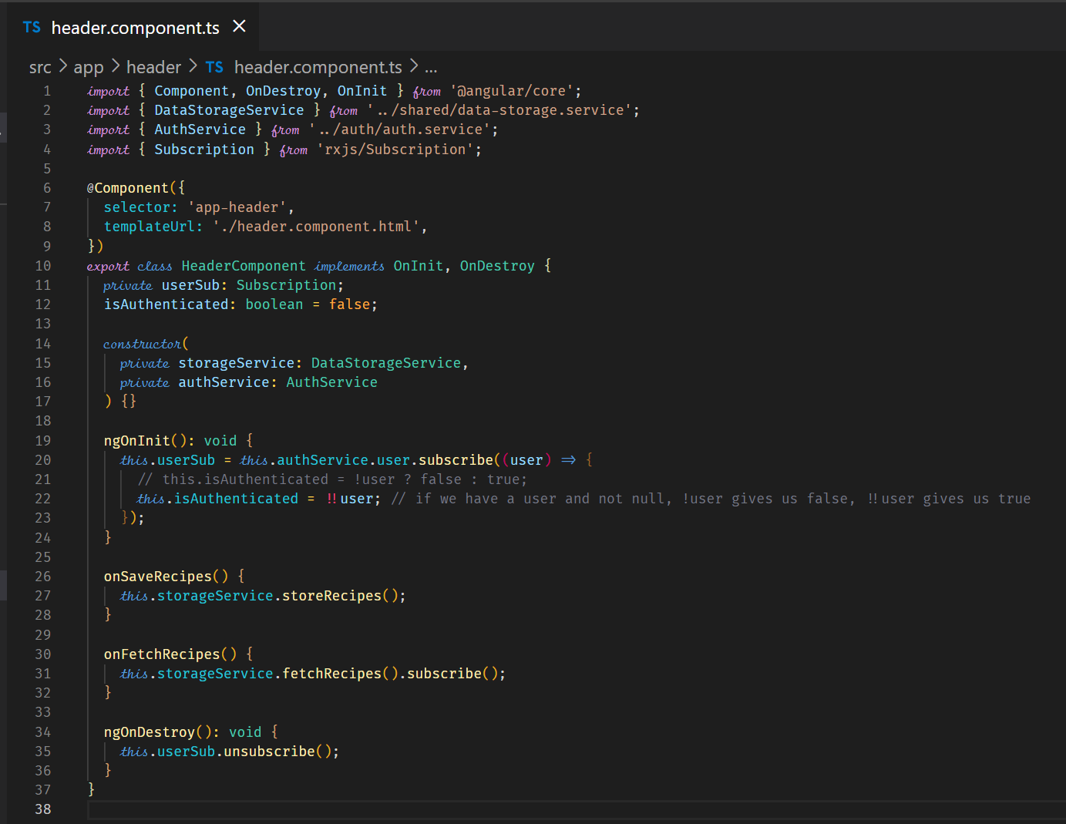



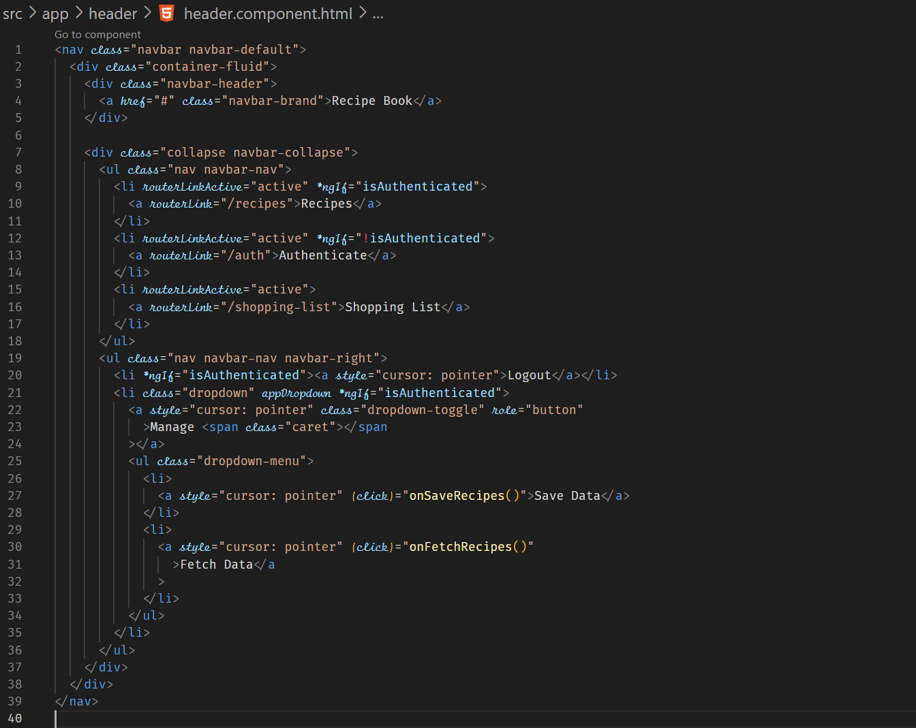



**Adding Token to Outgoing Requests**

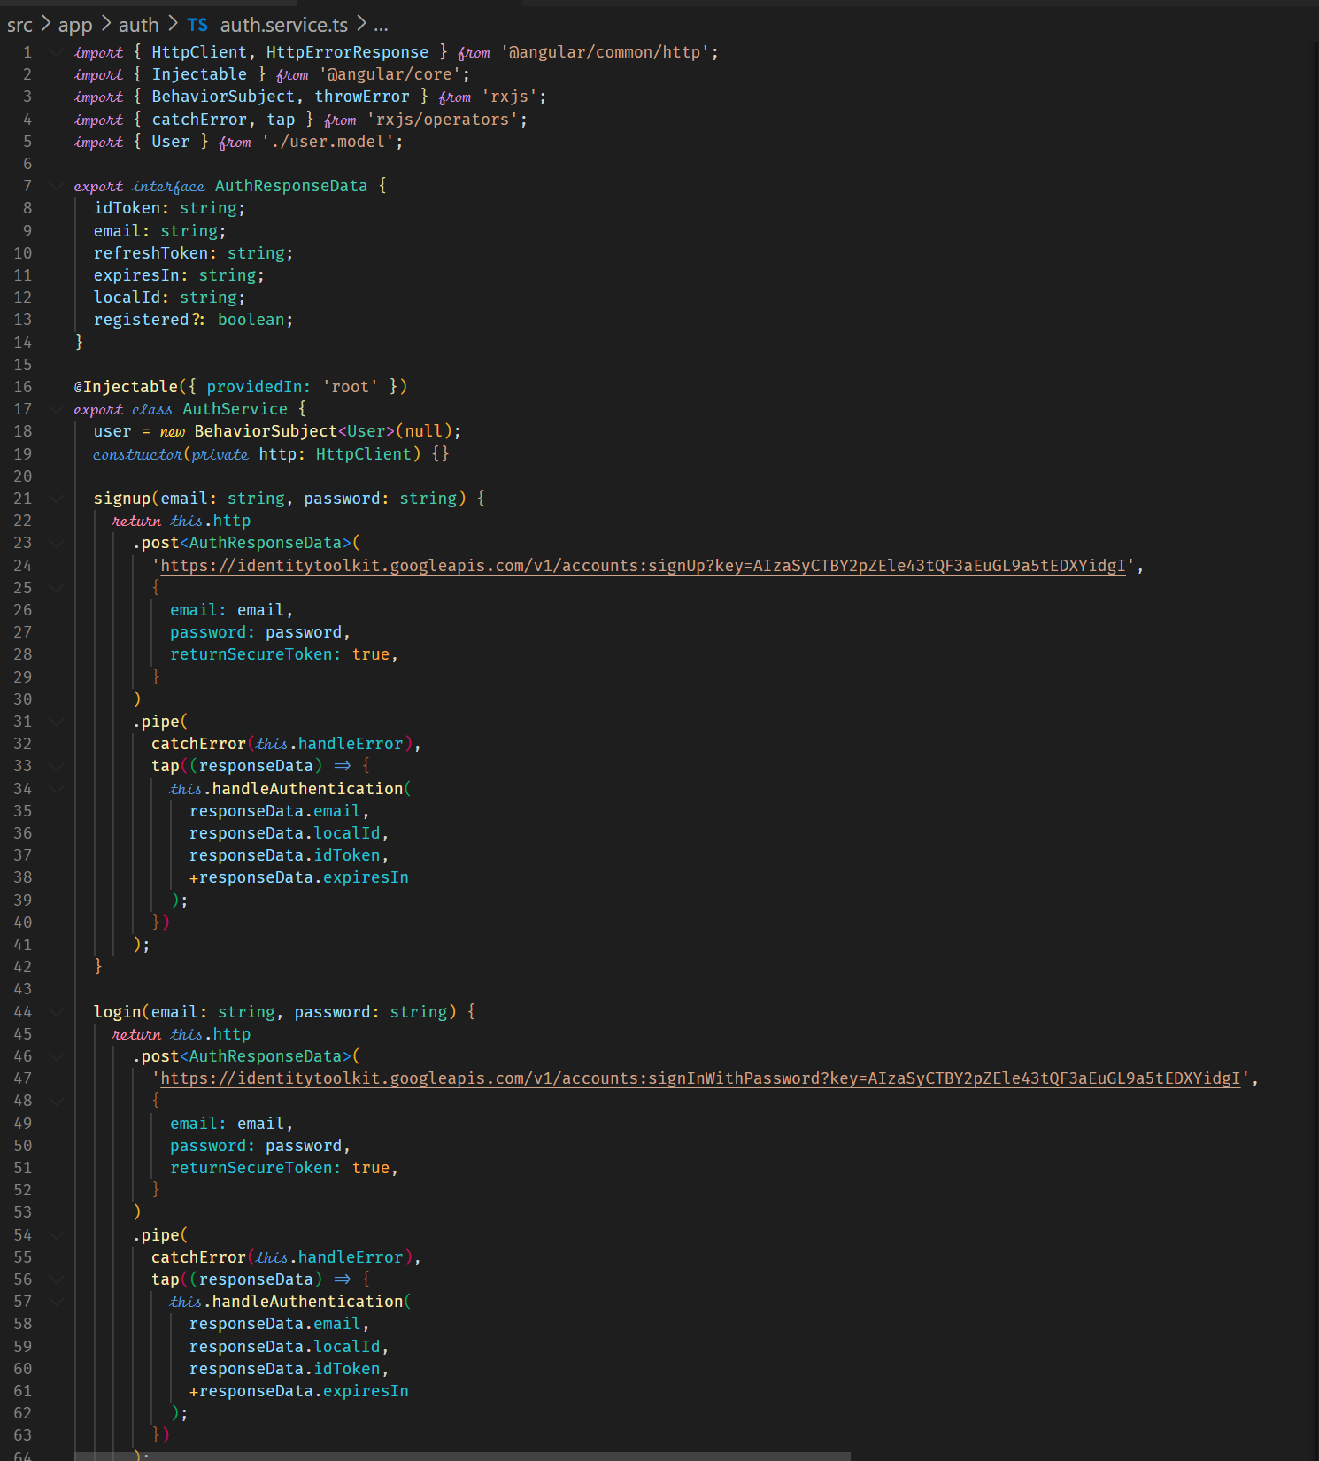

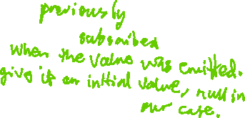

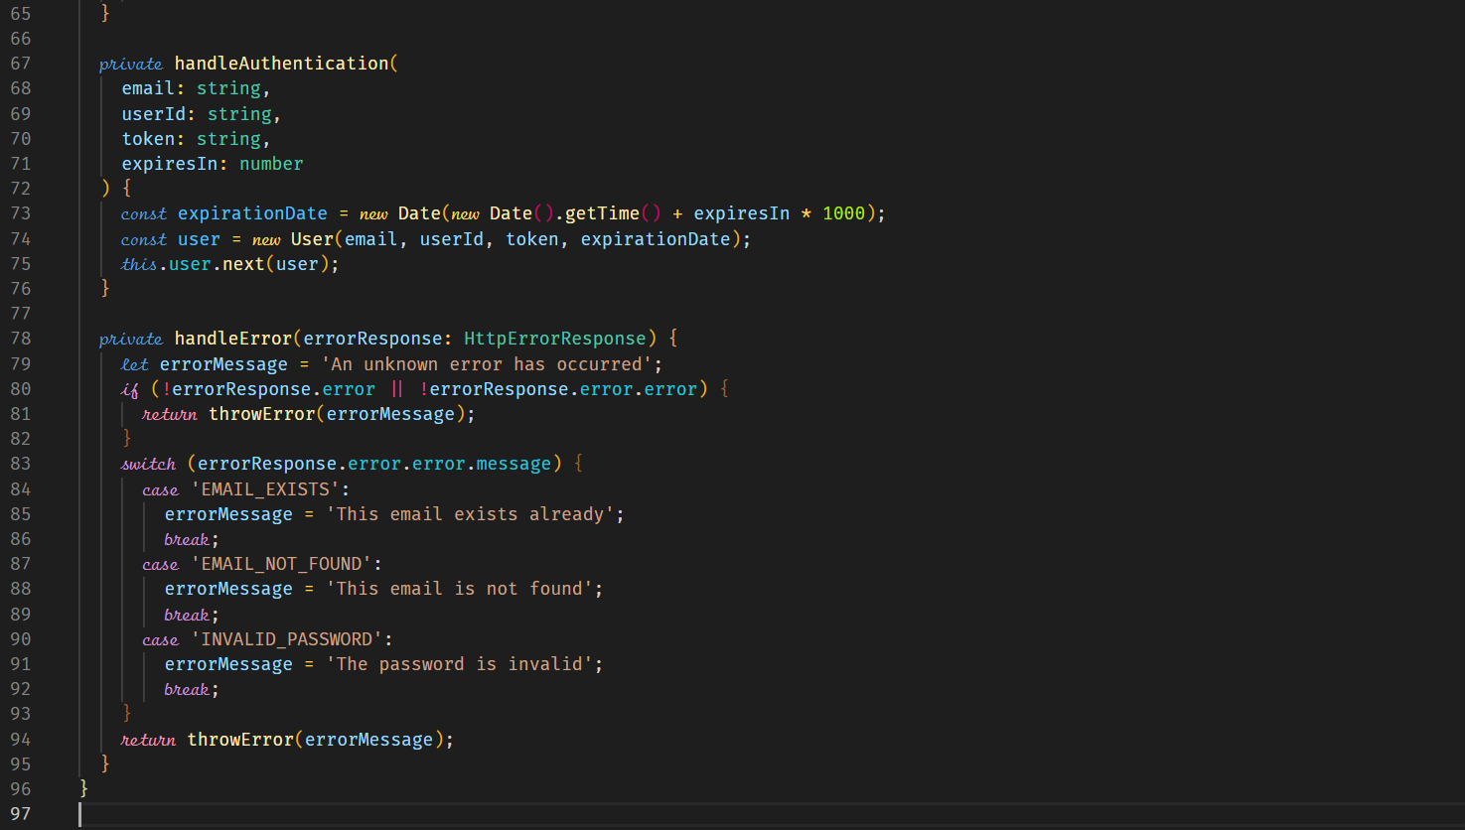

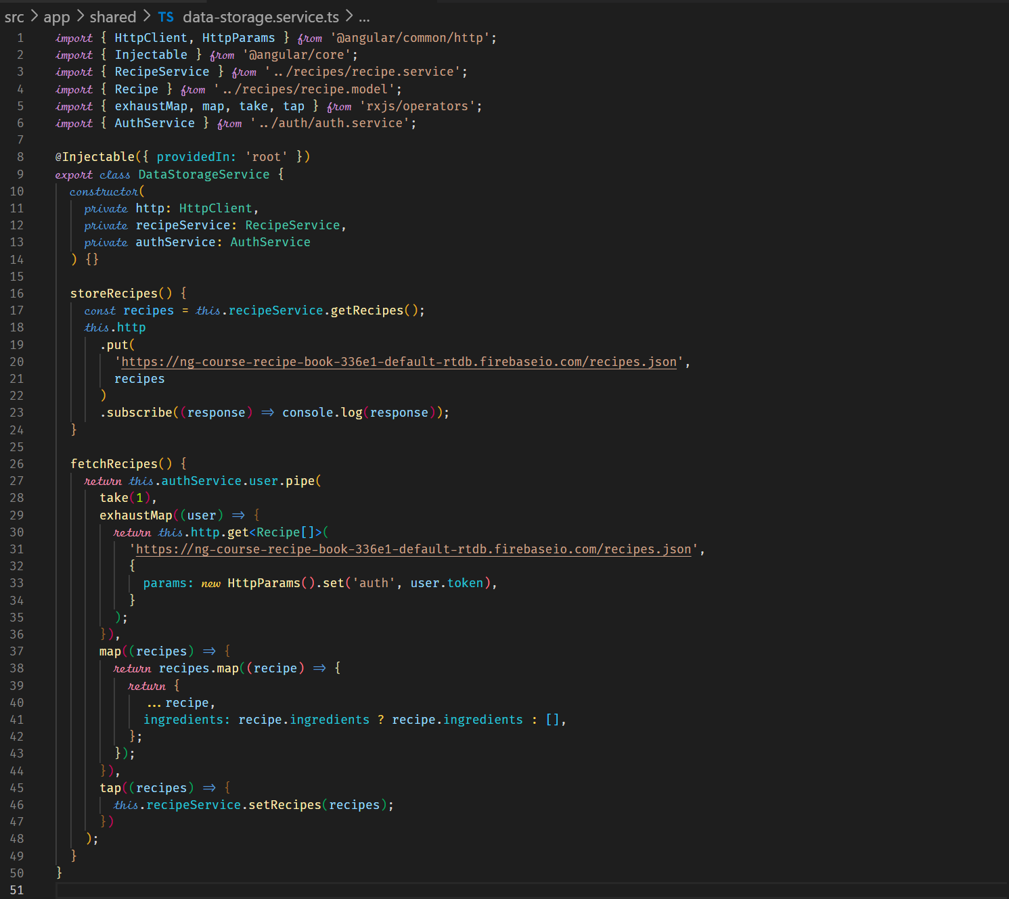



**Attaching the Token with an Interceptor**

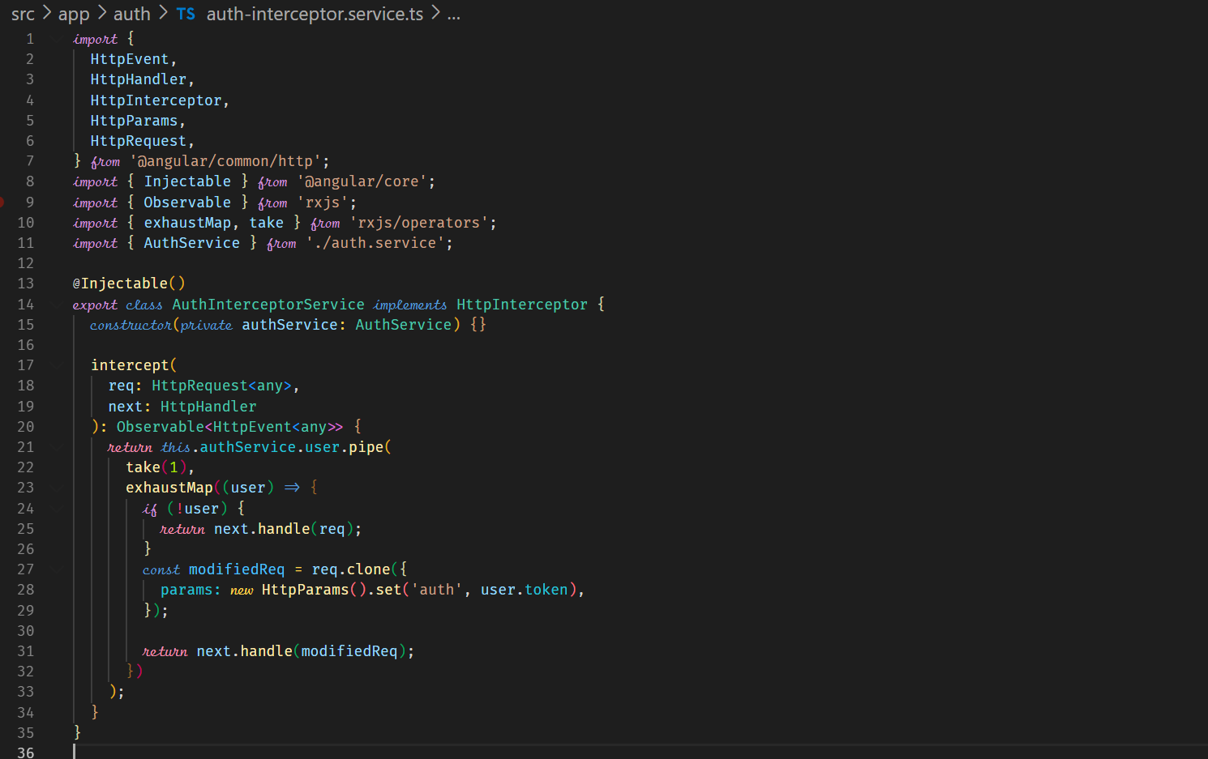



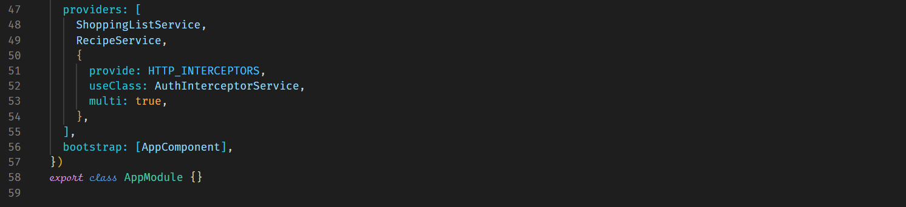



**Adding Logout**





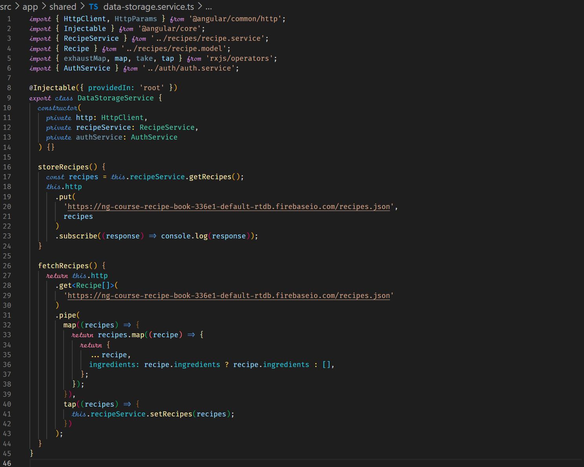

**Adding-Auto Login**

Storing user information in localstorage in the browser.

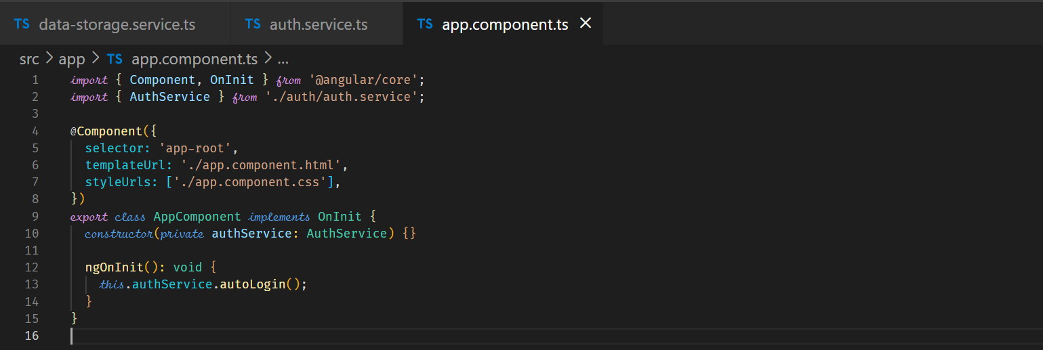

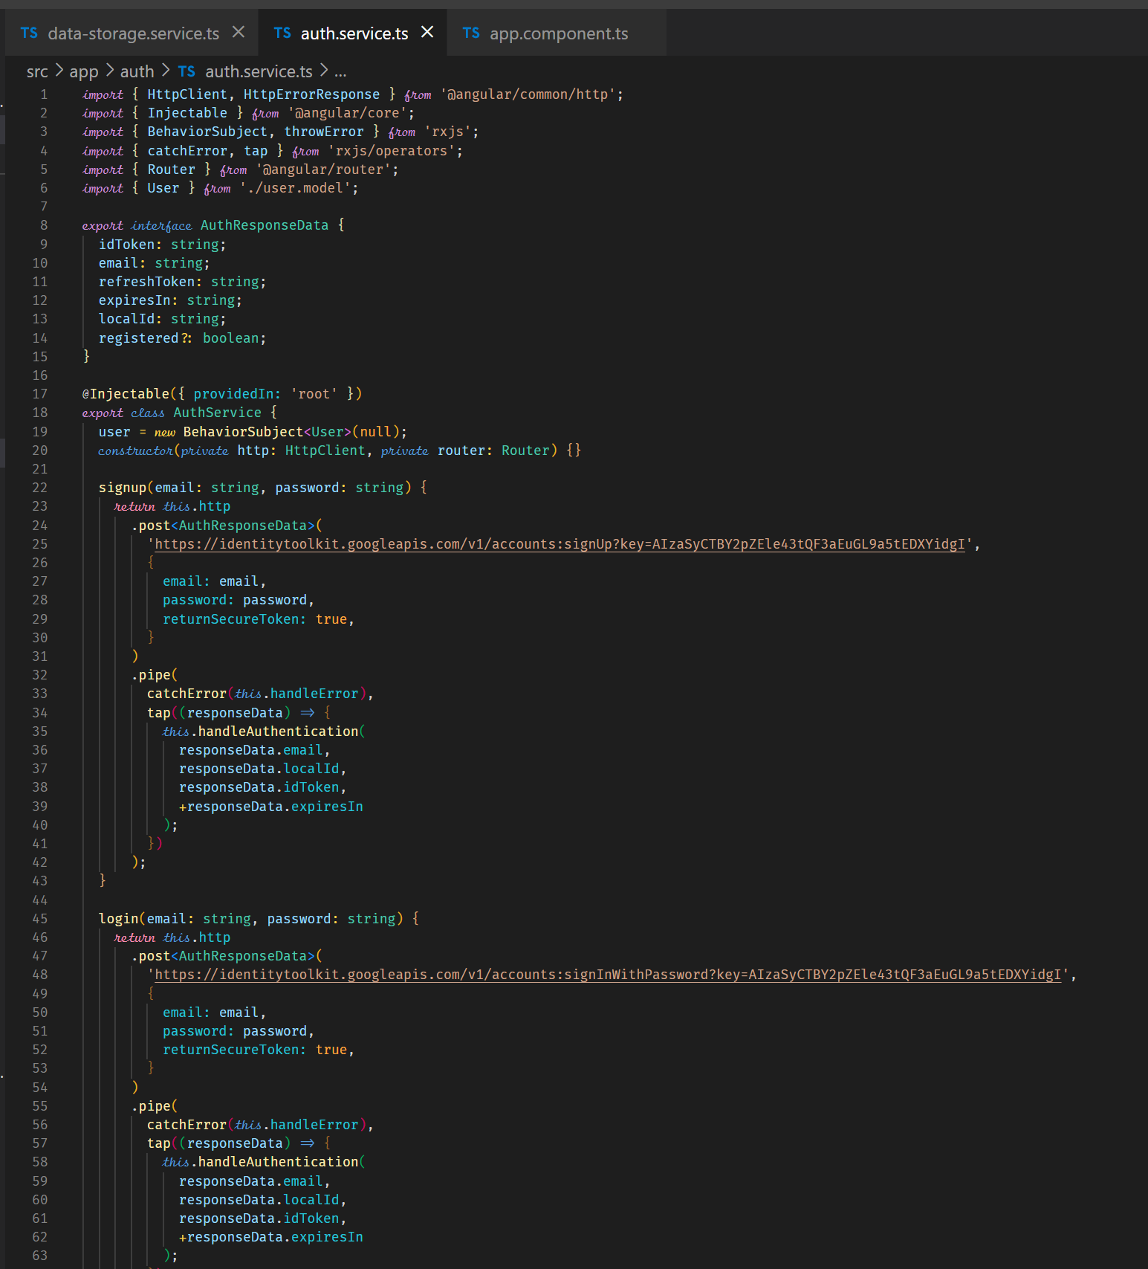

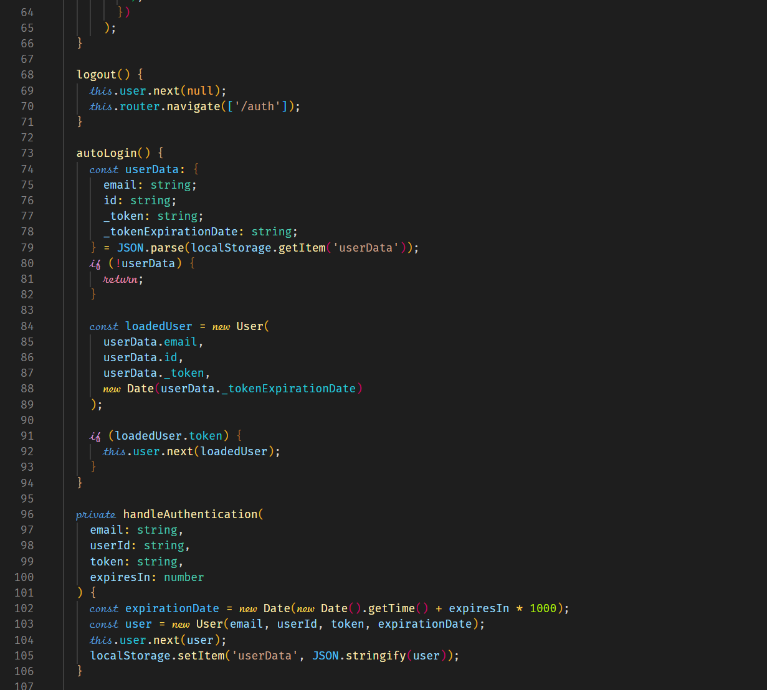



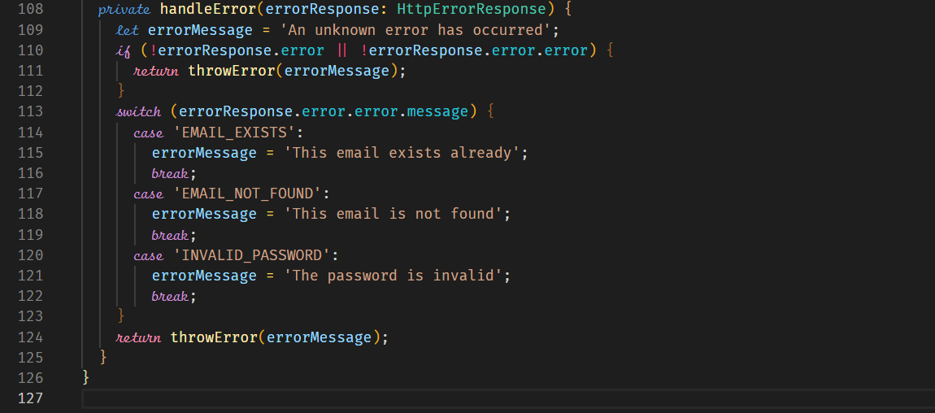

**Adding Auto-Logout**

In the AuthService, the following code should be added.

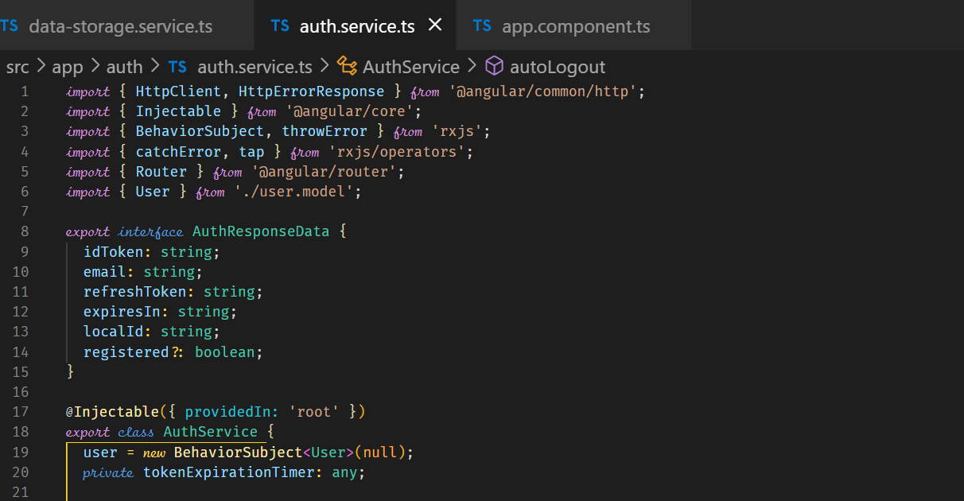



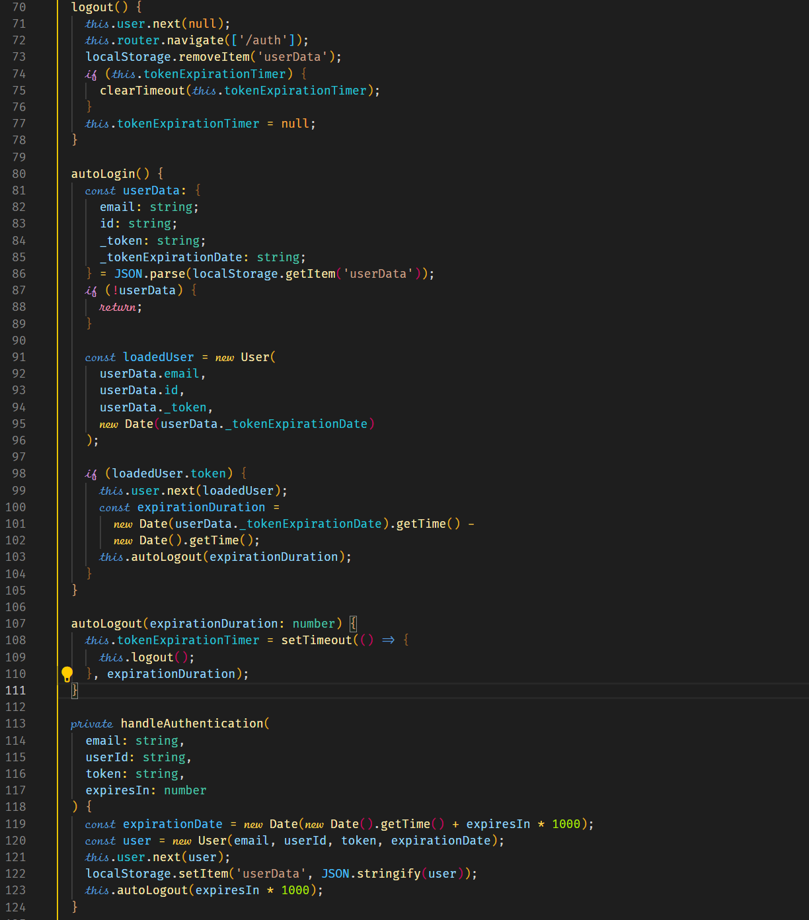



**Adding an Auth Guard**

We can prevent users visiting certain routes by using a guard if the user is not authenticated.

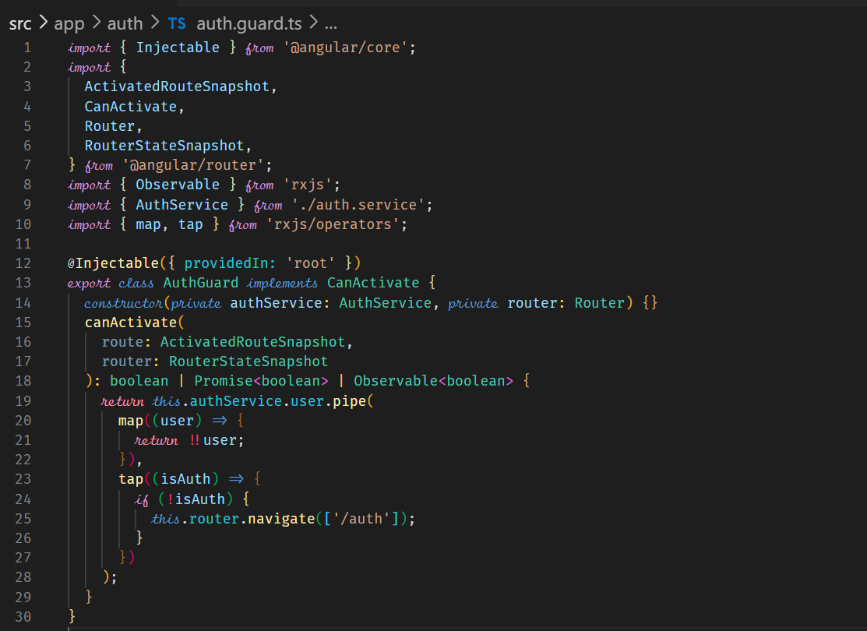



The above code can fail in some edge case this could lead to multiple redirects that can interfere with each other. Therefore, the following implementation should be done.

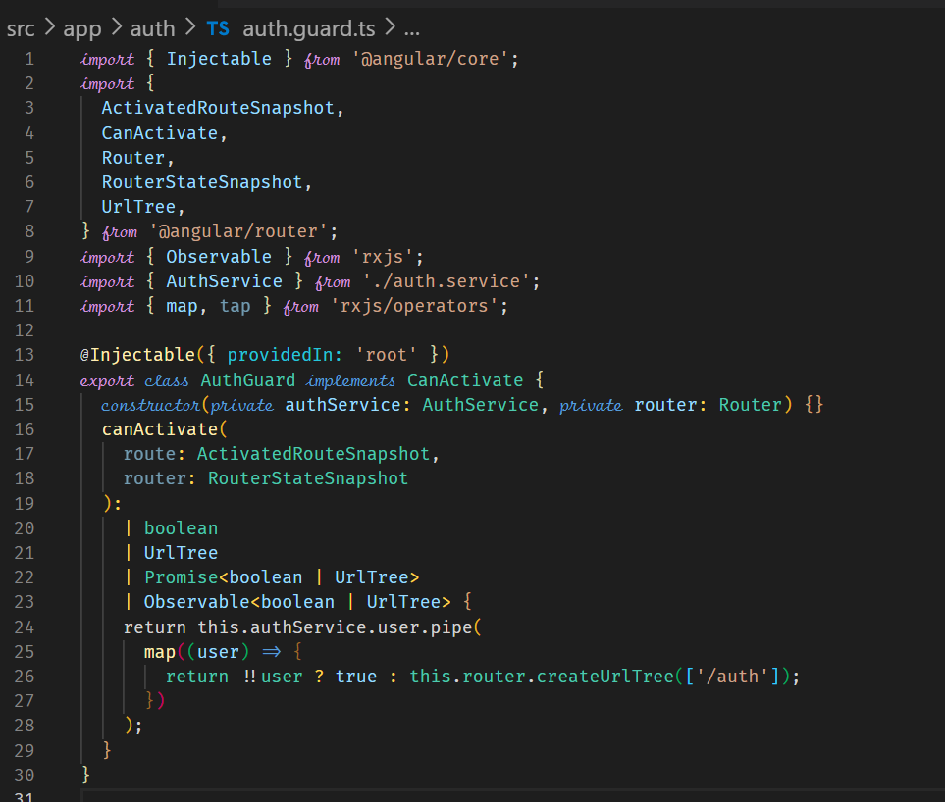



The following even makes the code more foolproof by unsubscribing after taking the first user. No further listening takes place.

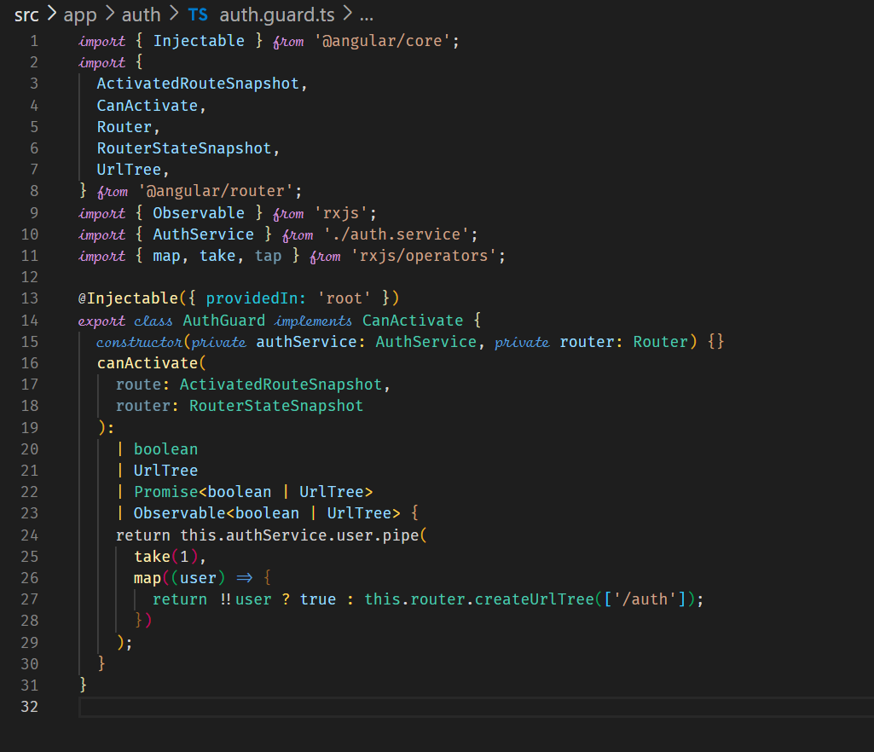

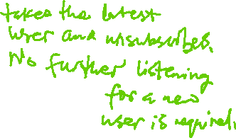

**Dynamic Component**

This is a way to create modal dialog or alerts that is loaded as an overlay on the screen.

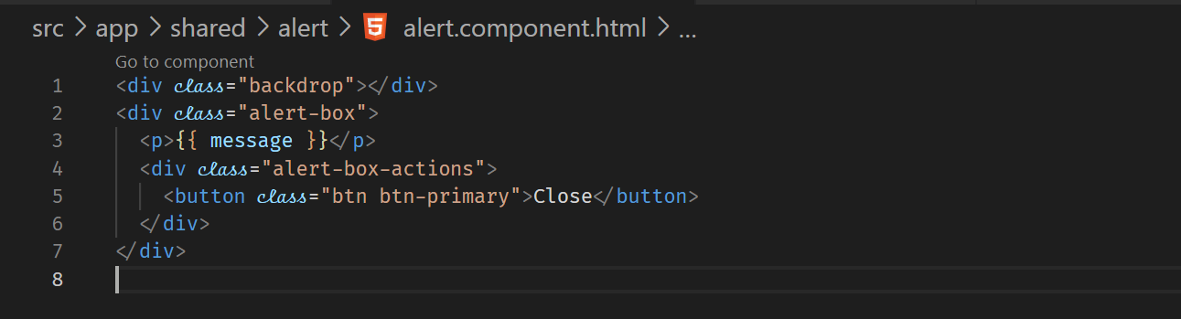

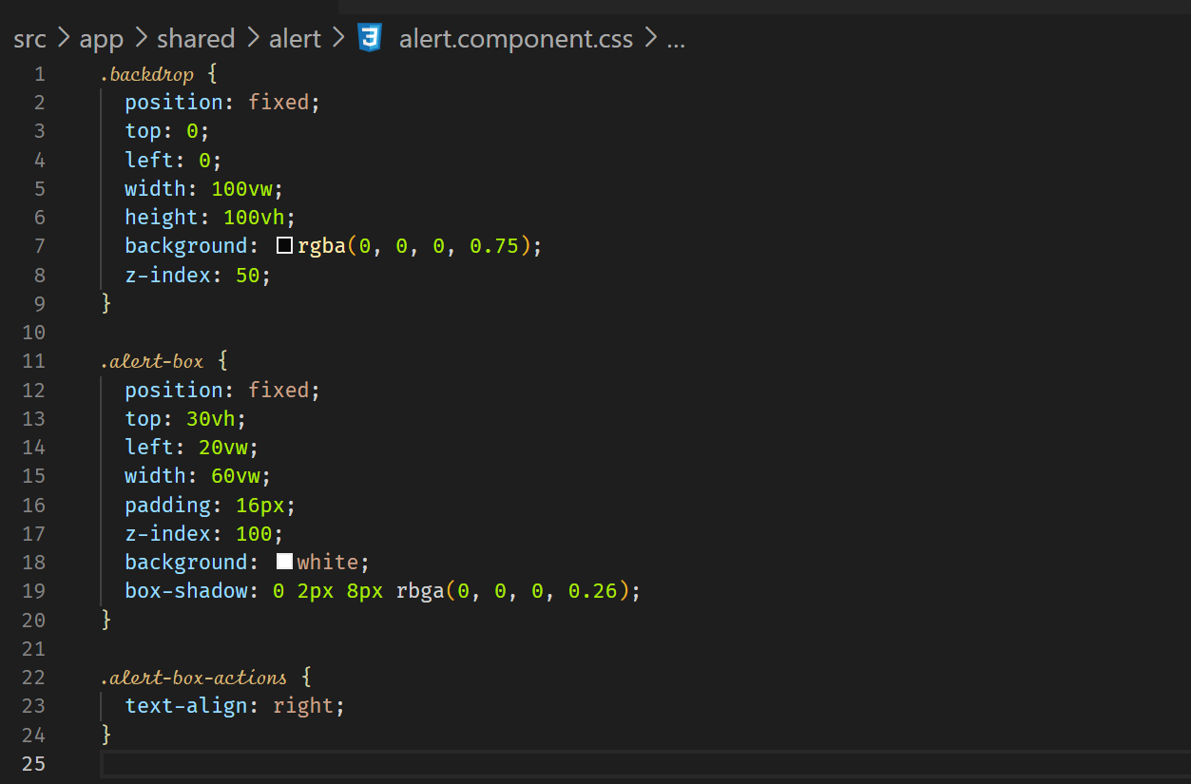

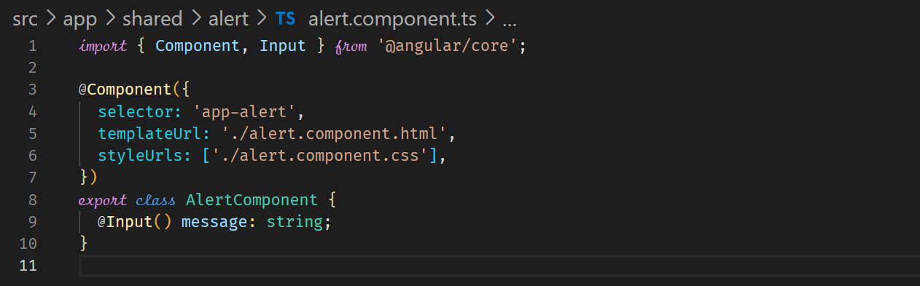

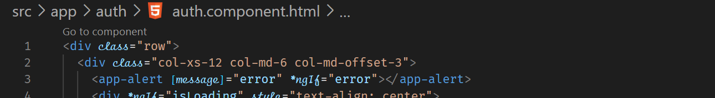

**Close button**

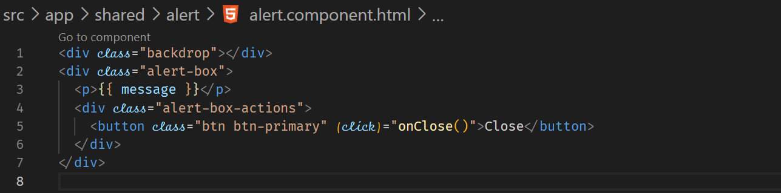



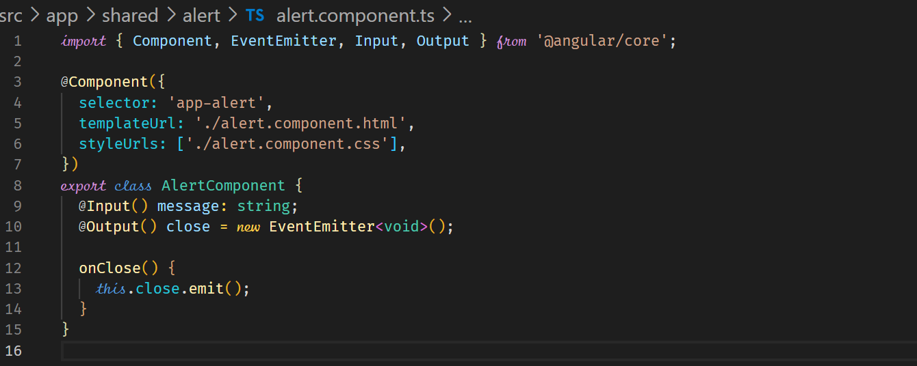



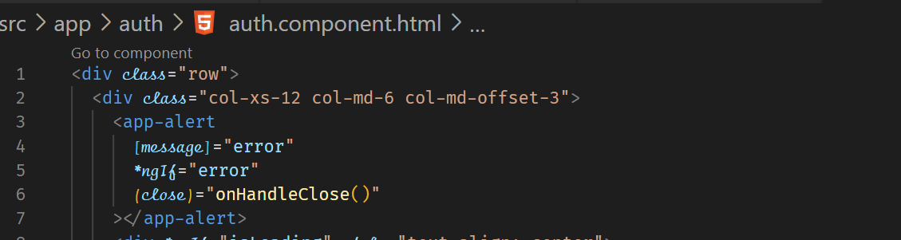



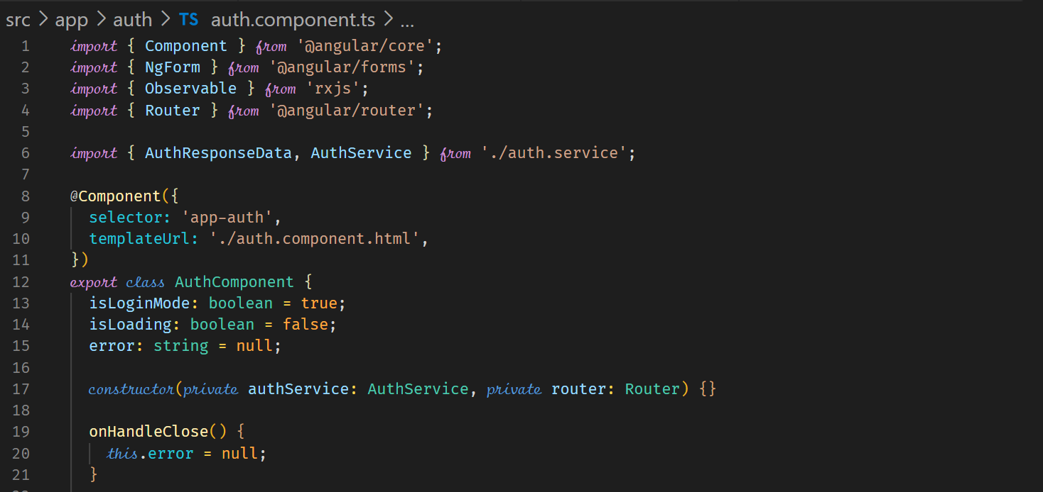

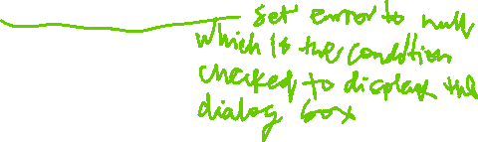

**Angular Modules and Optimizing Angular Apps**

To improve performance, we can split the AppModule into ProductsModule and OrdersModule. Both ProductsModule and OrdersModule are called Feature Module.

ProductsModule

AppModule

AppComponent

AppModule

ProductListComponent

AppComponent



HighlightDirective

OrdersComponent

OrdersModule

ProductComponent

ProductListComponent

HighlightDirective

OrdersComponent

ProductComponent



A feature module is a class with the NgModule decorator that groups together component, directives, pipes that are used in a certain feature area of your application.

Splitting the application into odules helps in performance and also helps in maintenance. For big application, you can quickly identify the areas of your application.

In our applications, we can logically divide our application into three feature areas, namely Recipes, Shopping and Auth.

The Headers and Shared components belong to the AppModule.

**RecipesModule**

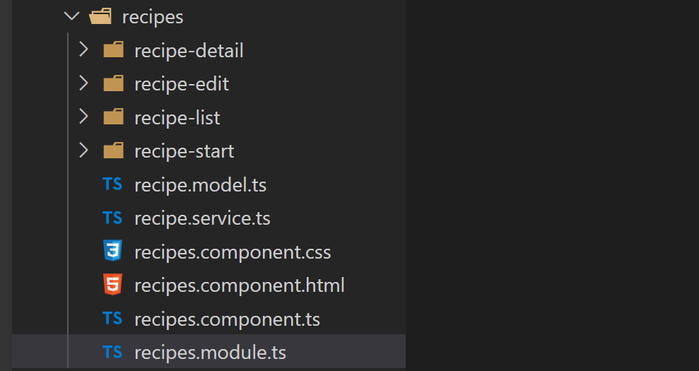



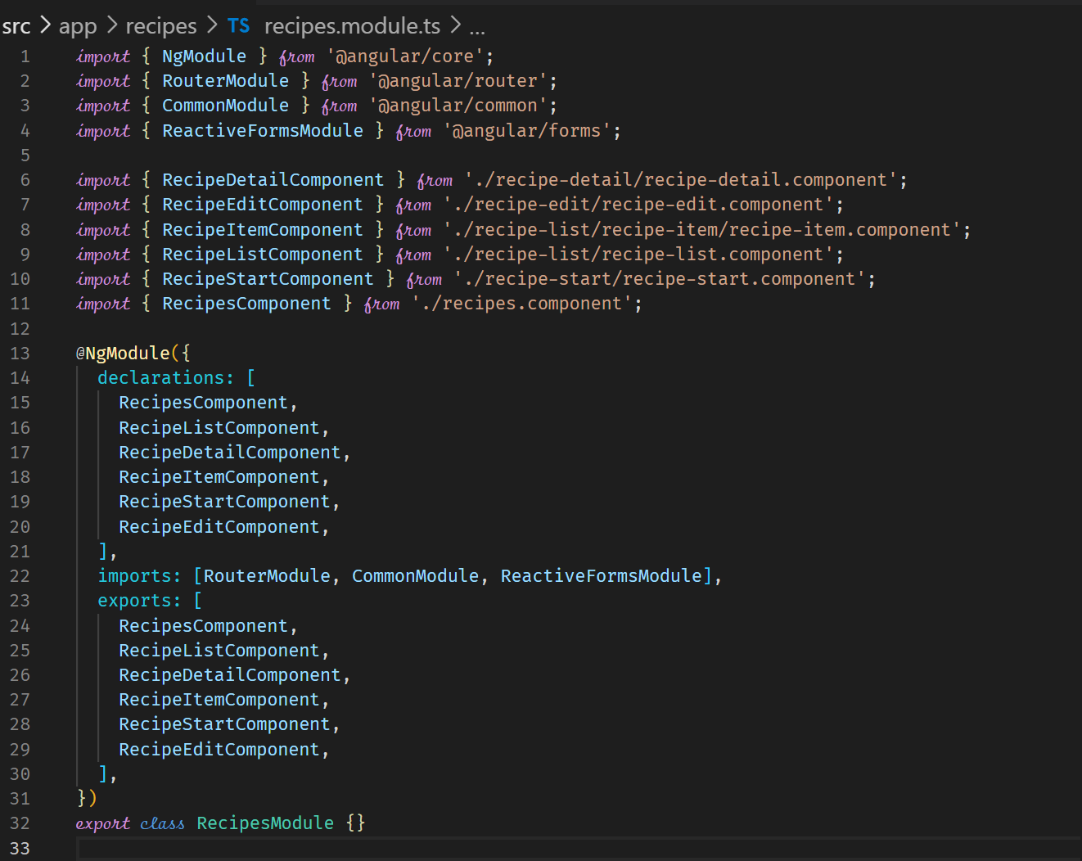

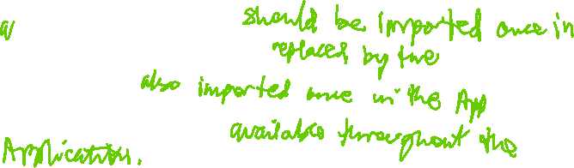

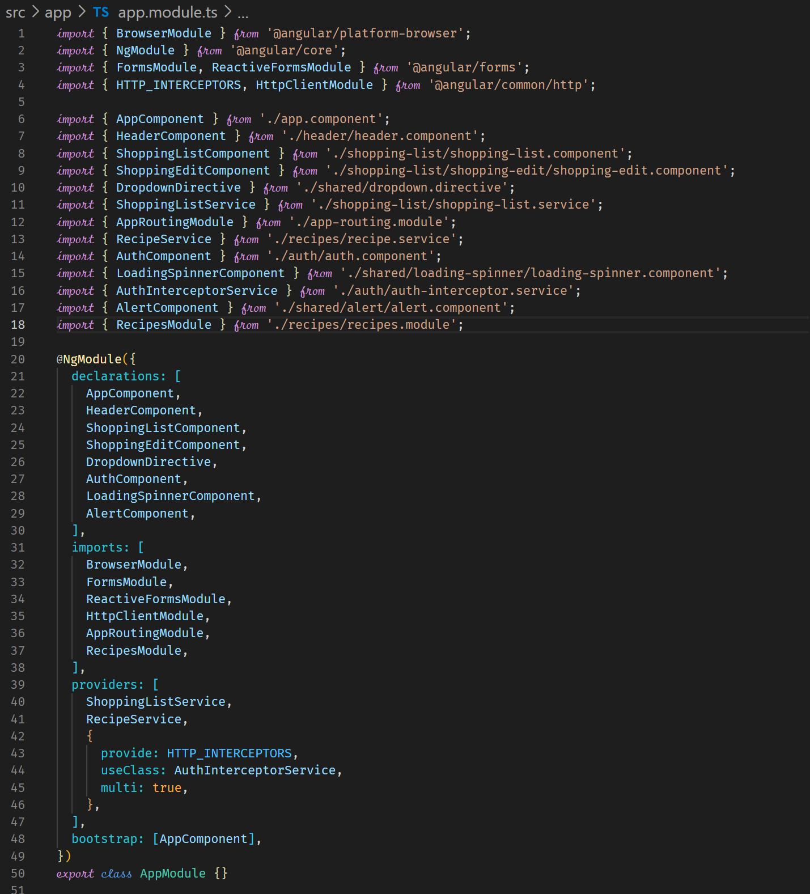



**Adding Routes to Feature Modules**

We can move routes related configurations to feature components to the feature.

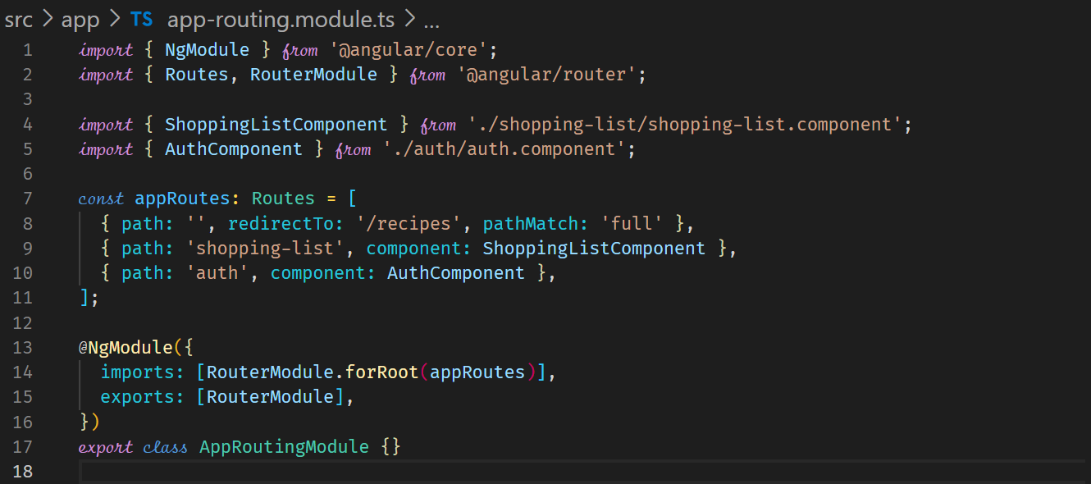



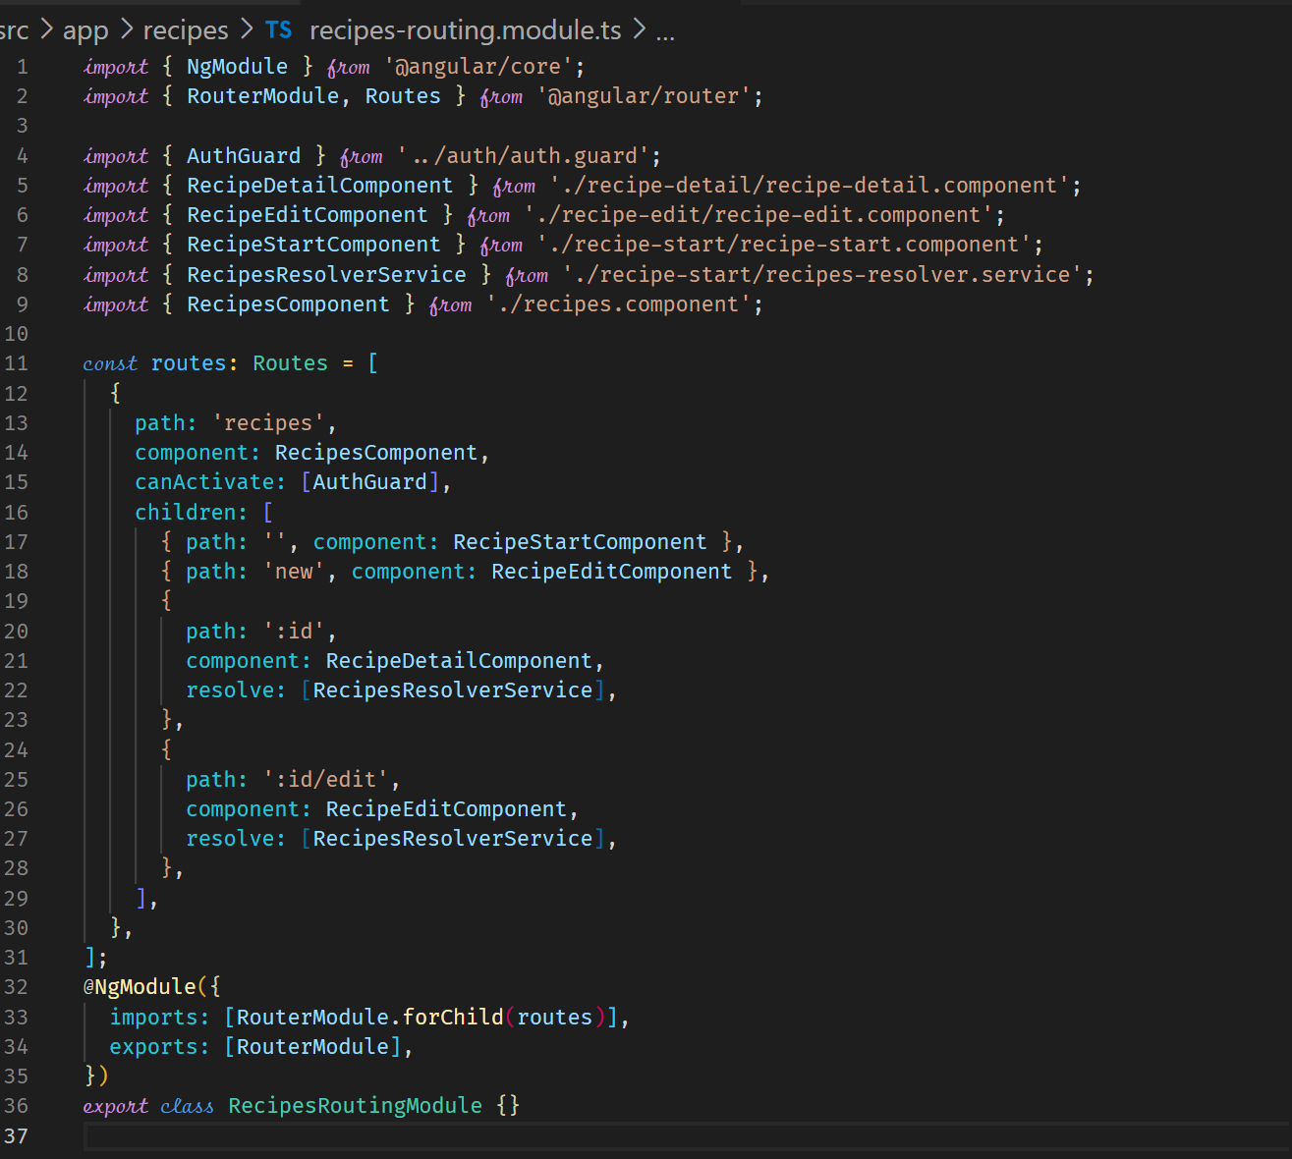



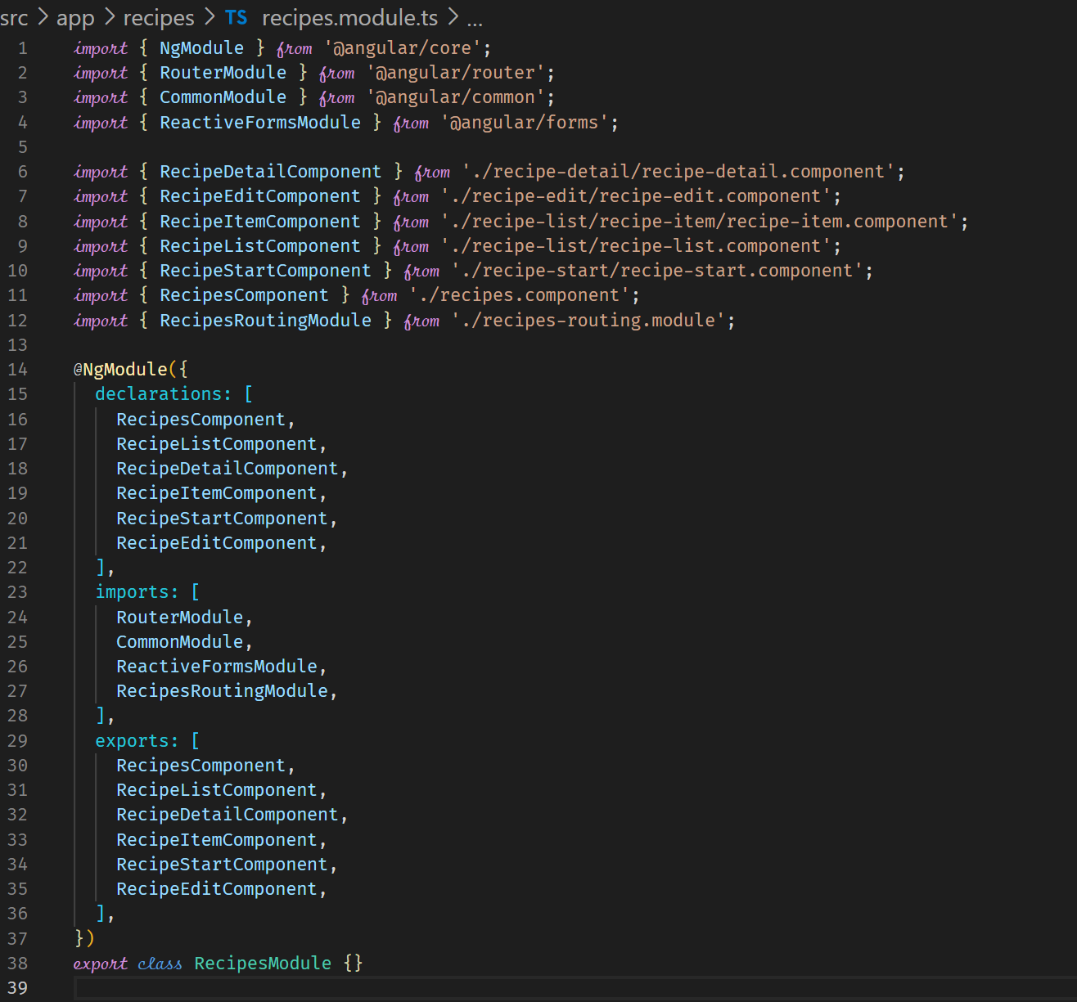



**Component Declarations**

All the components in the declarations property that are defined in the RecipesRoutingModule need not be in the exports array property of the RecipesModule.

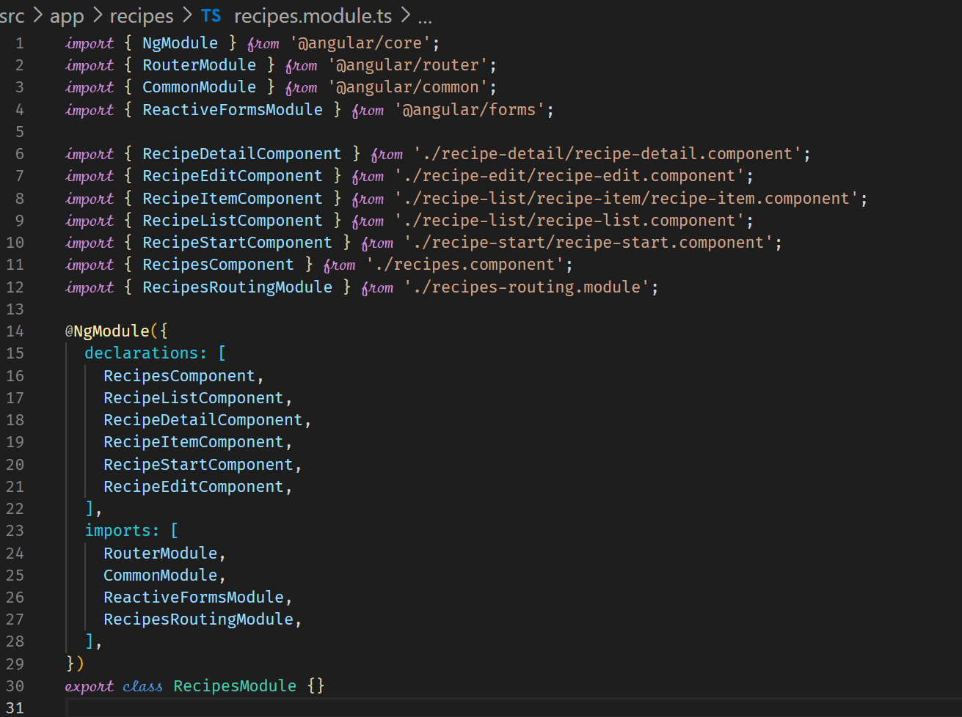



ShoppingListModule

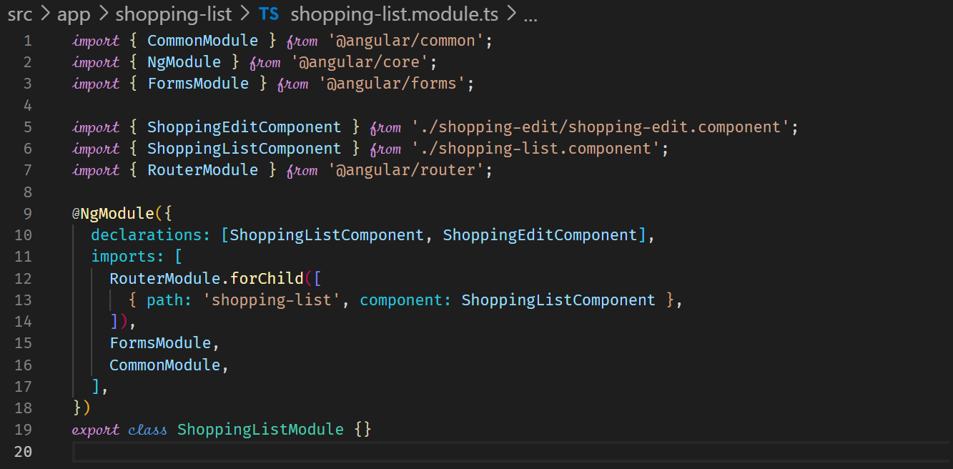



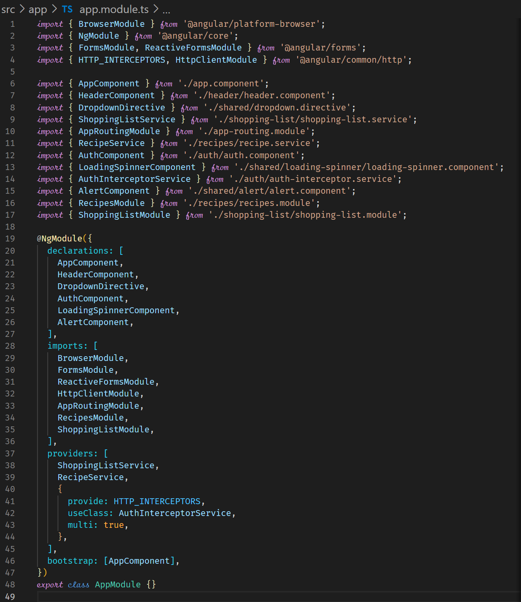



**Understanding Shared Modules**



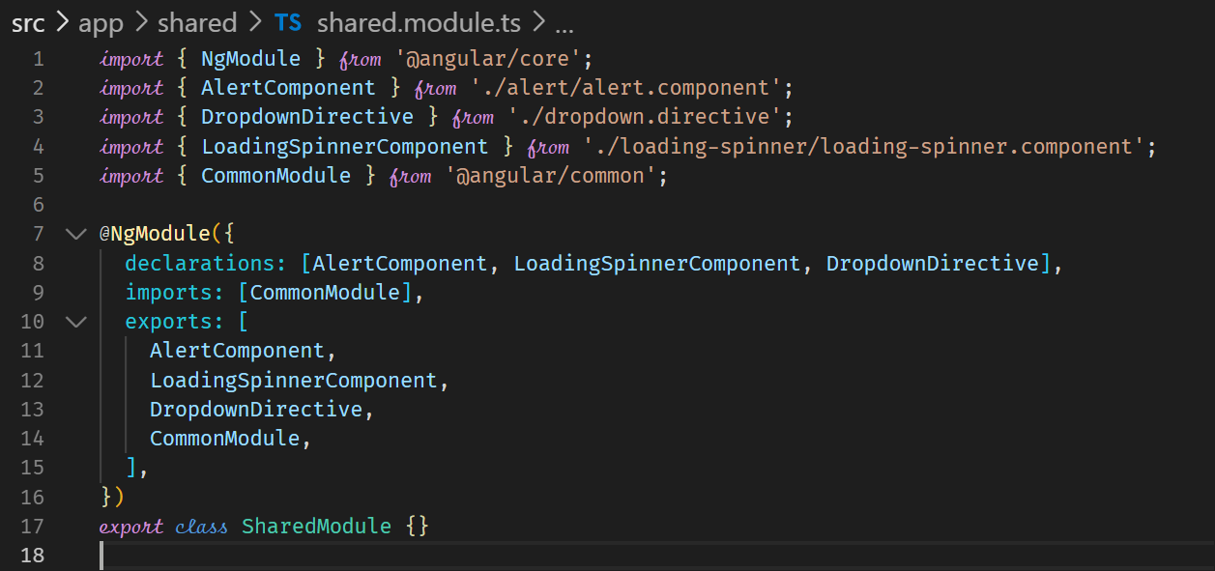



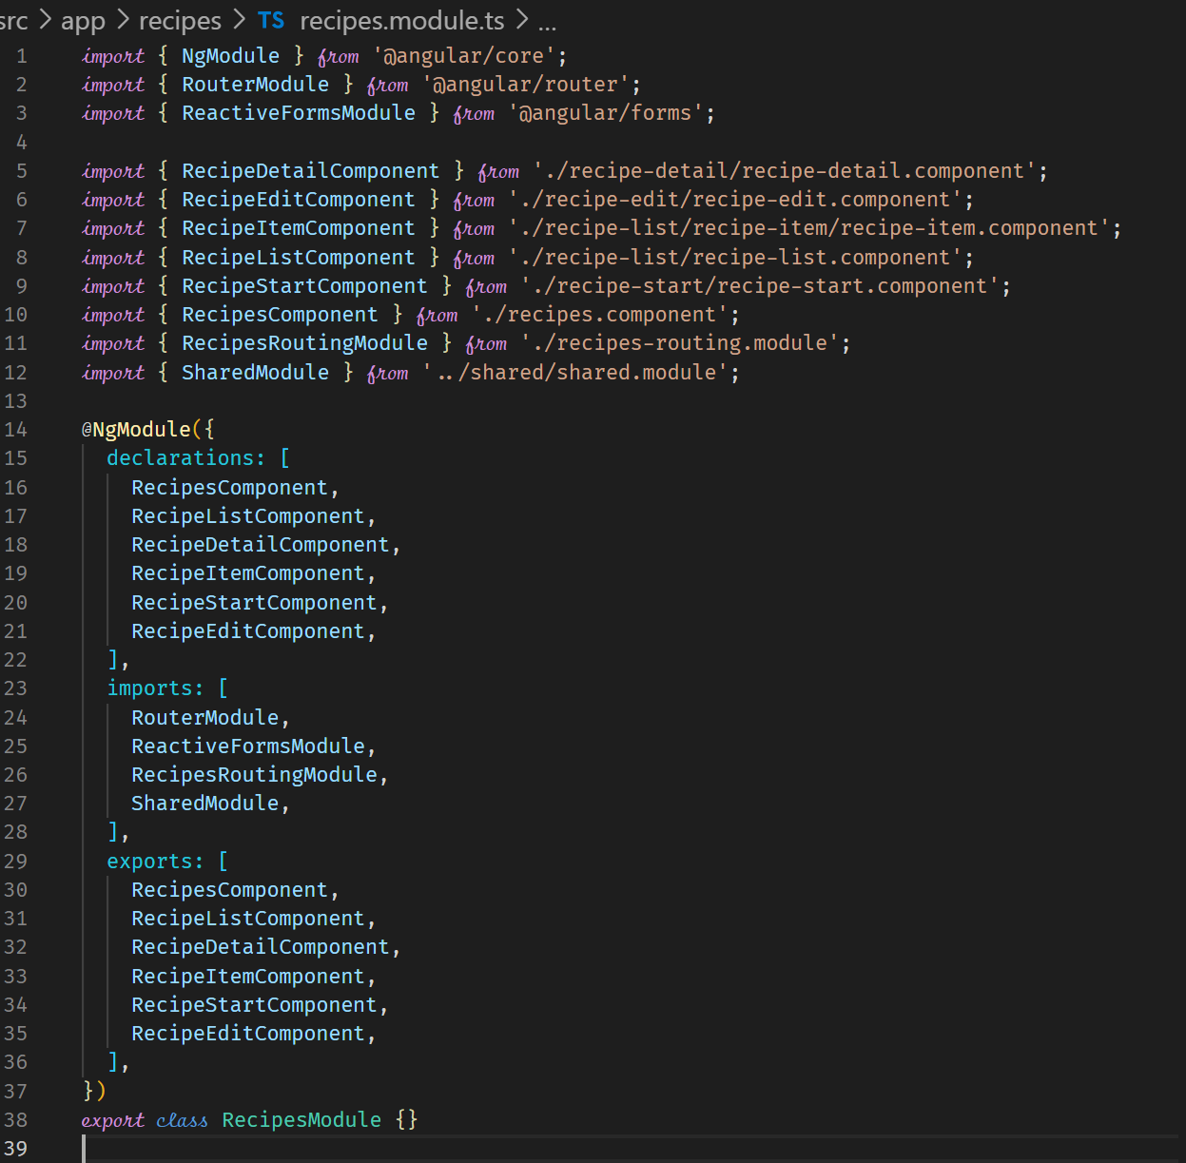



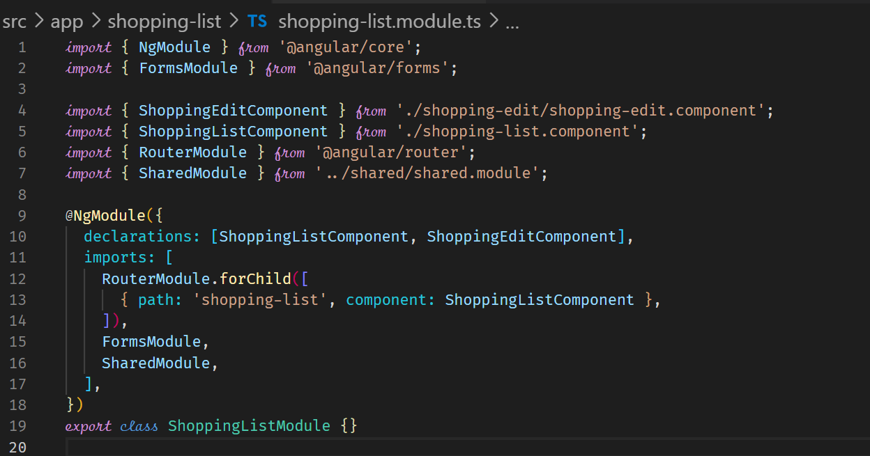



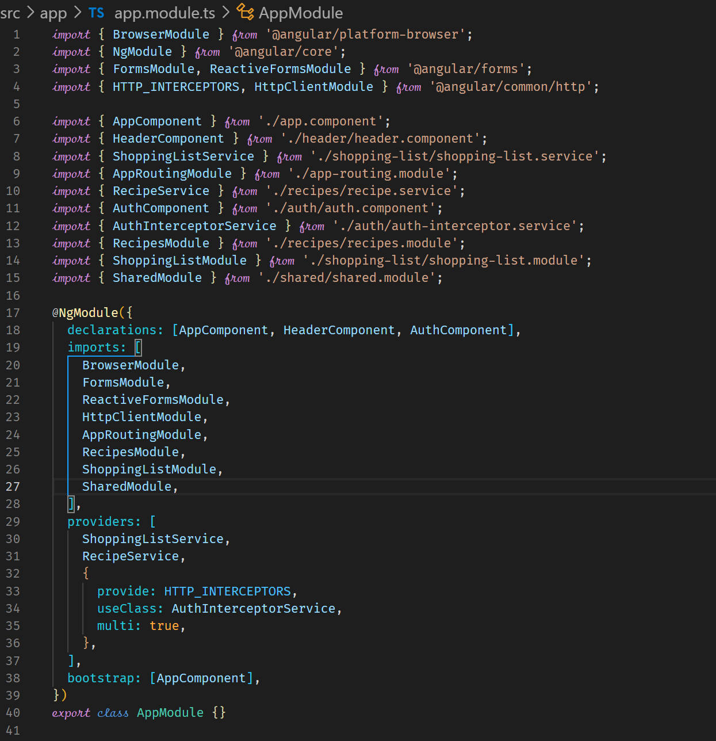



**Understanding the Core Module**

Or: providedIn

CoreModule

AppModule

AppModule

ProductsService

AppComponent

AppComponent

ProductsService

AnalyticsService

CoreModule

AnalyticsService

Services can be moved from the AppModule into the CoreModule. The CoreModule would then be added to the AppModule. The alternative to this is to use providedIn in the @Injectable() directive which means you don’t need to use the providers array in the AppModule.

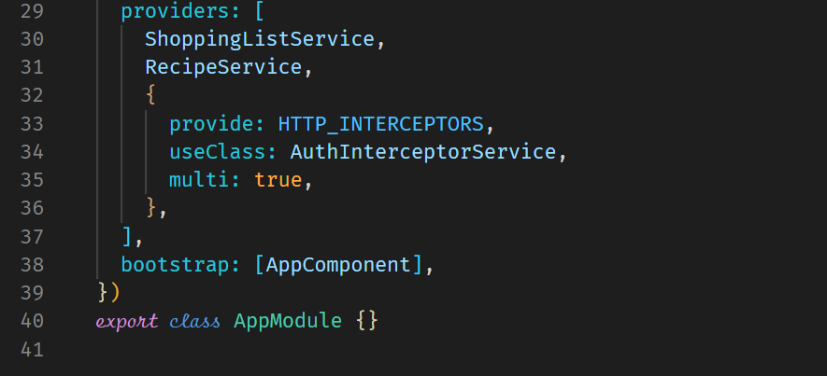







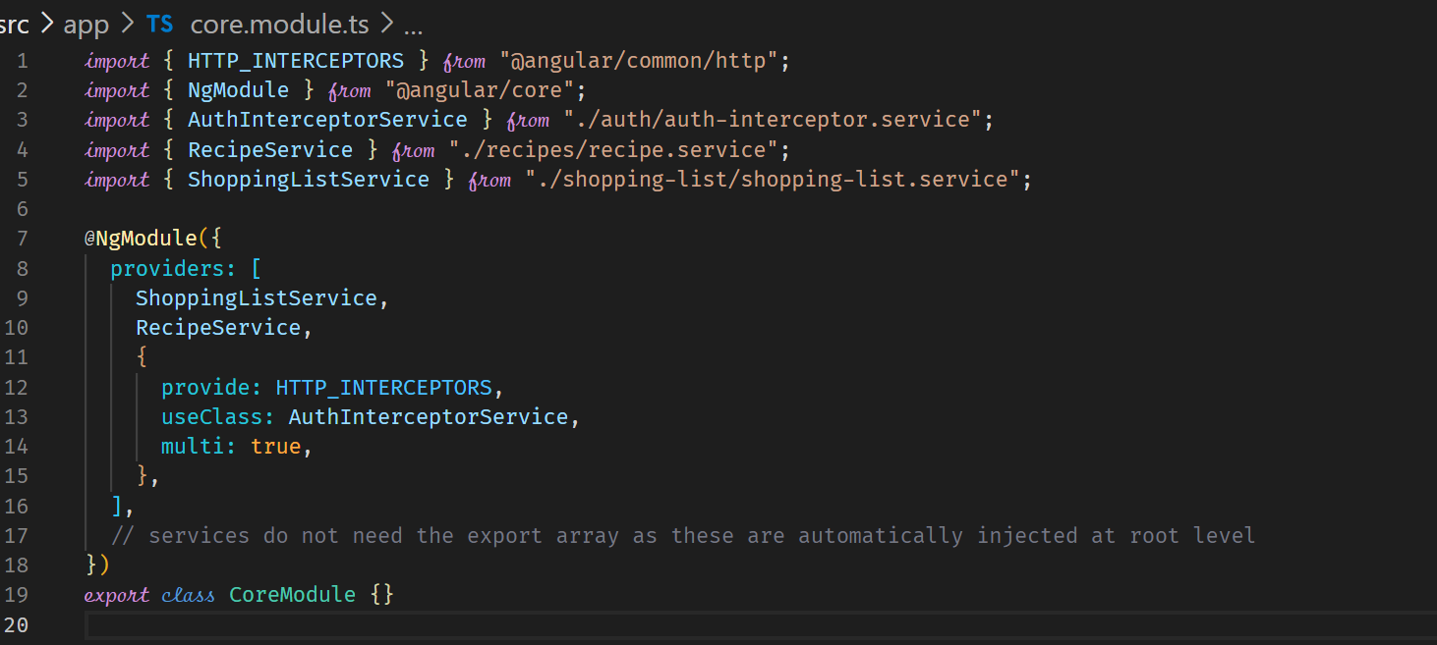

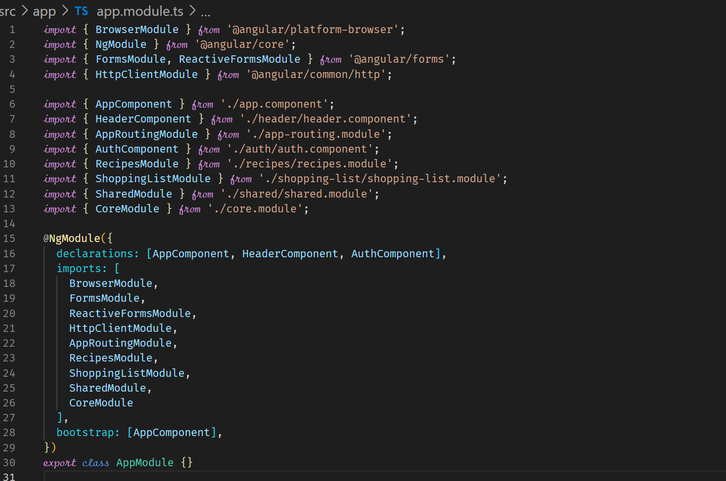



**Adding an Auth Feature Module**

We can also outsource the Auth related features to a Feature module.

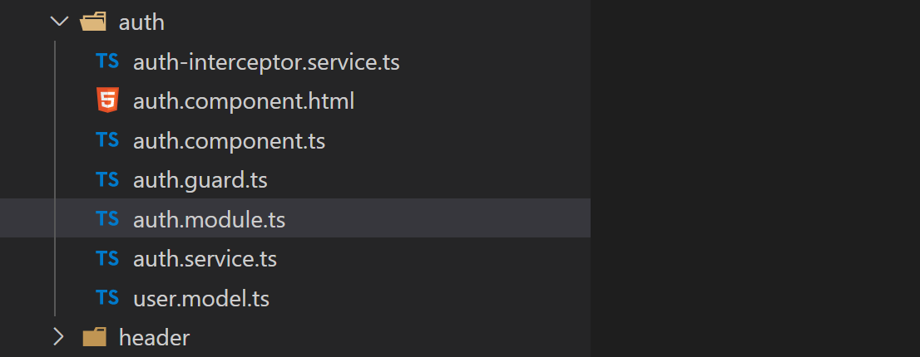

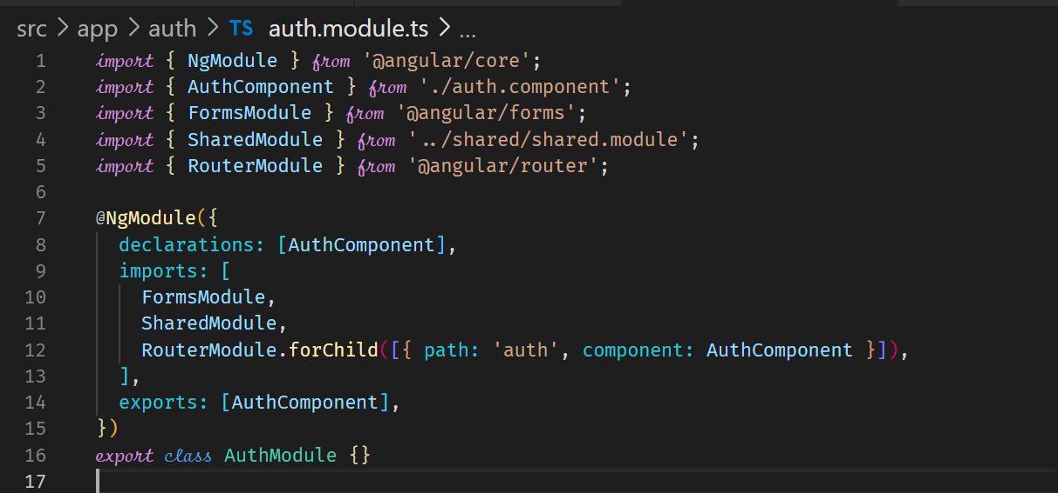

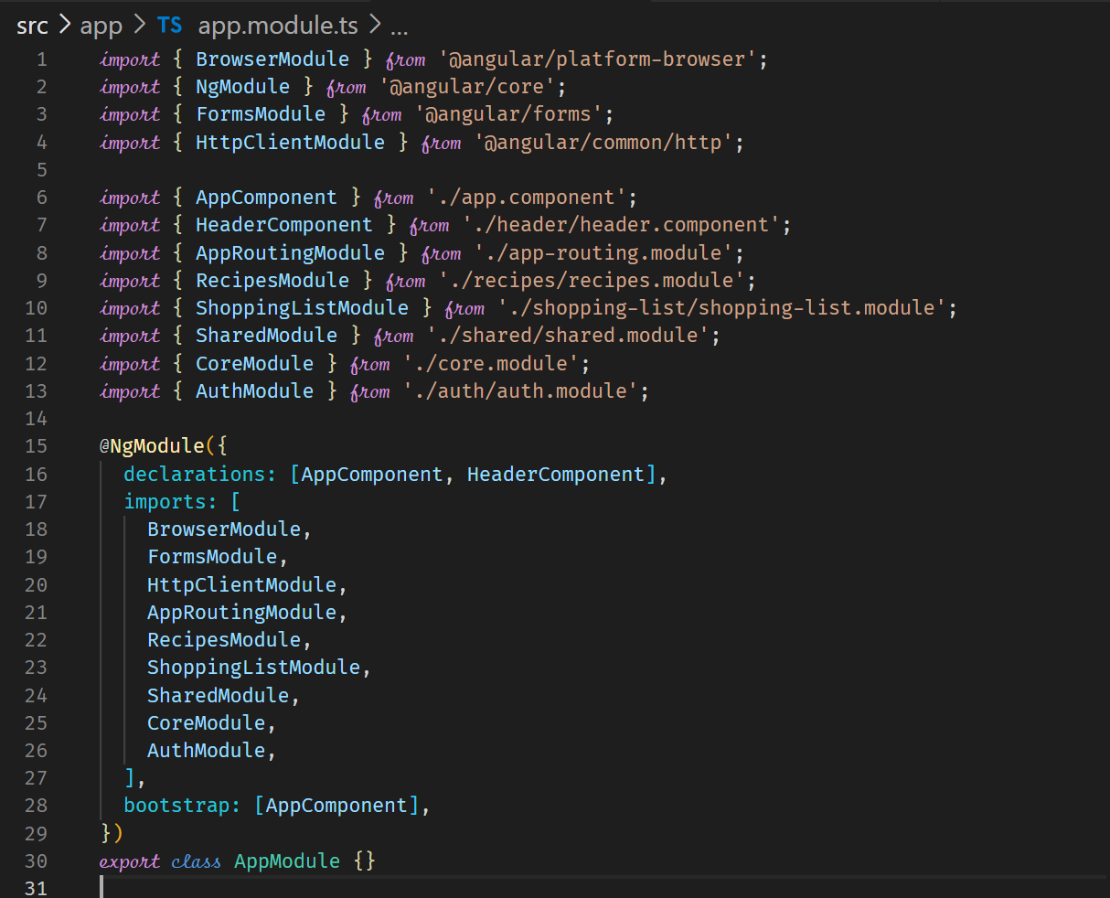

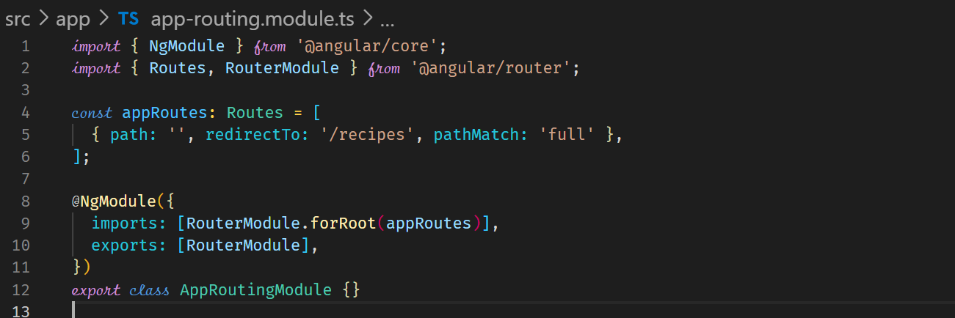

**Lazy Loading**

Improves performance as components are loaded on demand, that is when users click the related routes. File sizes are also reduced since the application is split into bundles specified through the loadChildren property of the Routes. This significant improves performance. **For lazy loading to work, your feature module needs to bring its own routes using the forChild in the routing module of the feature.**

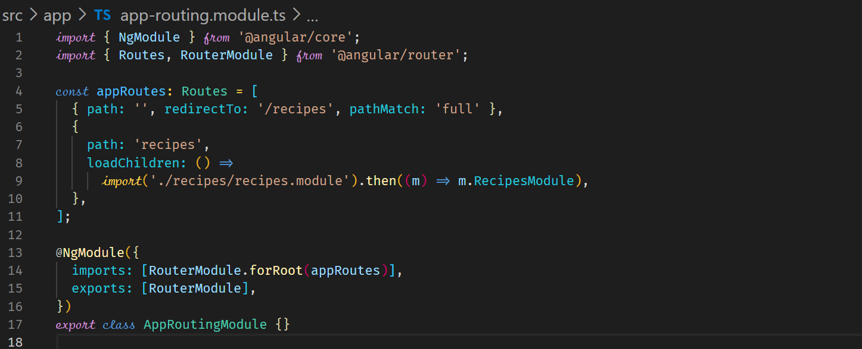



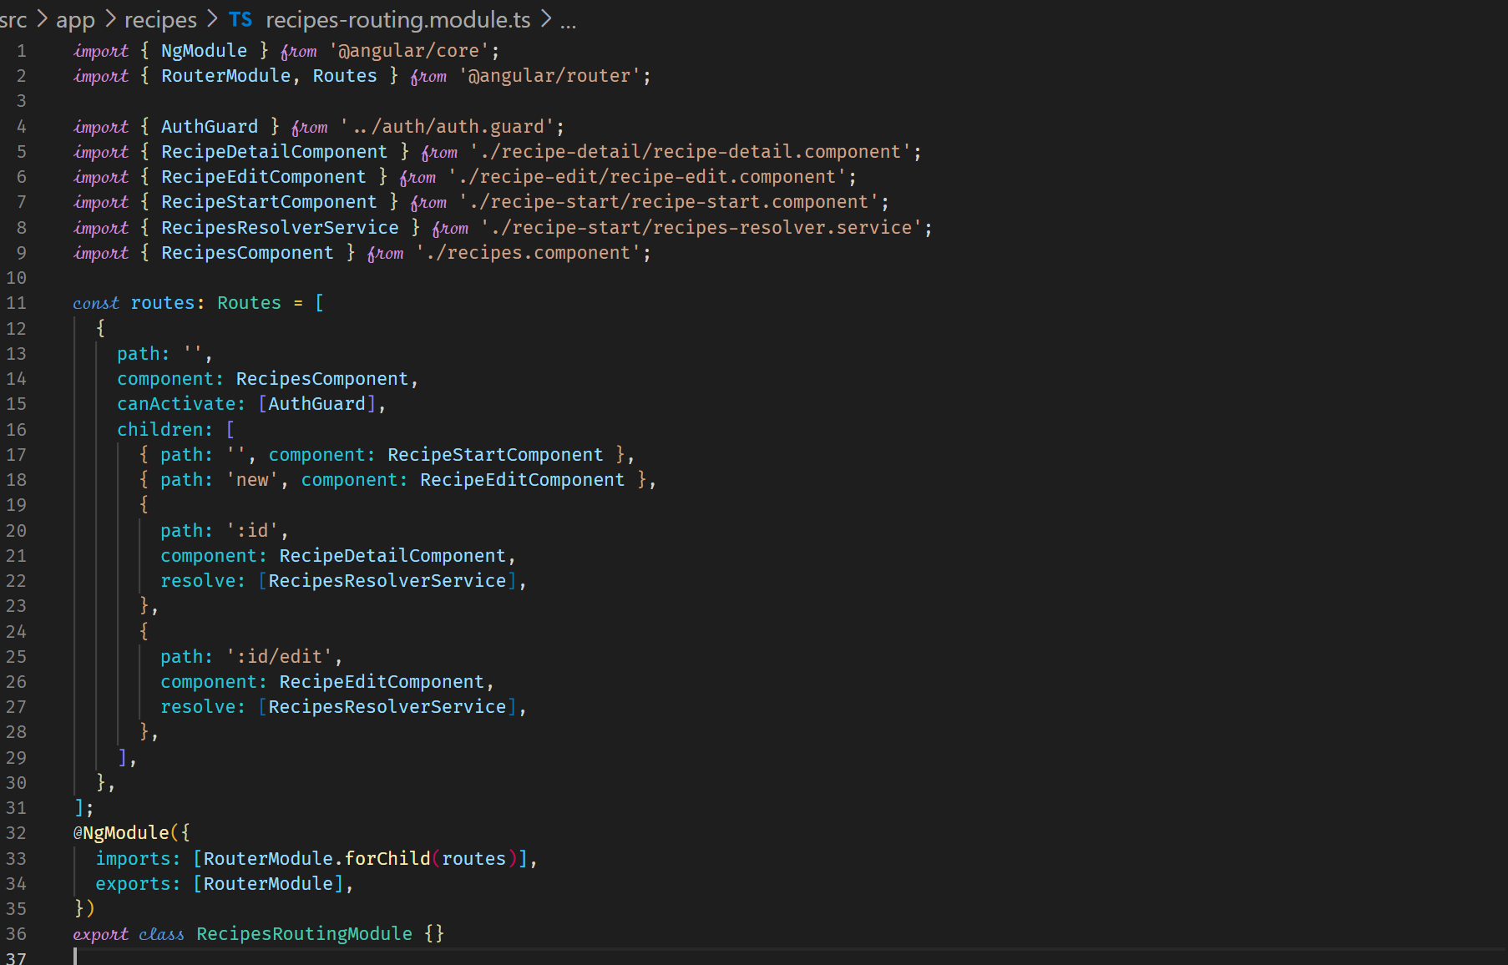

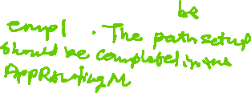

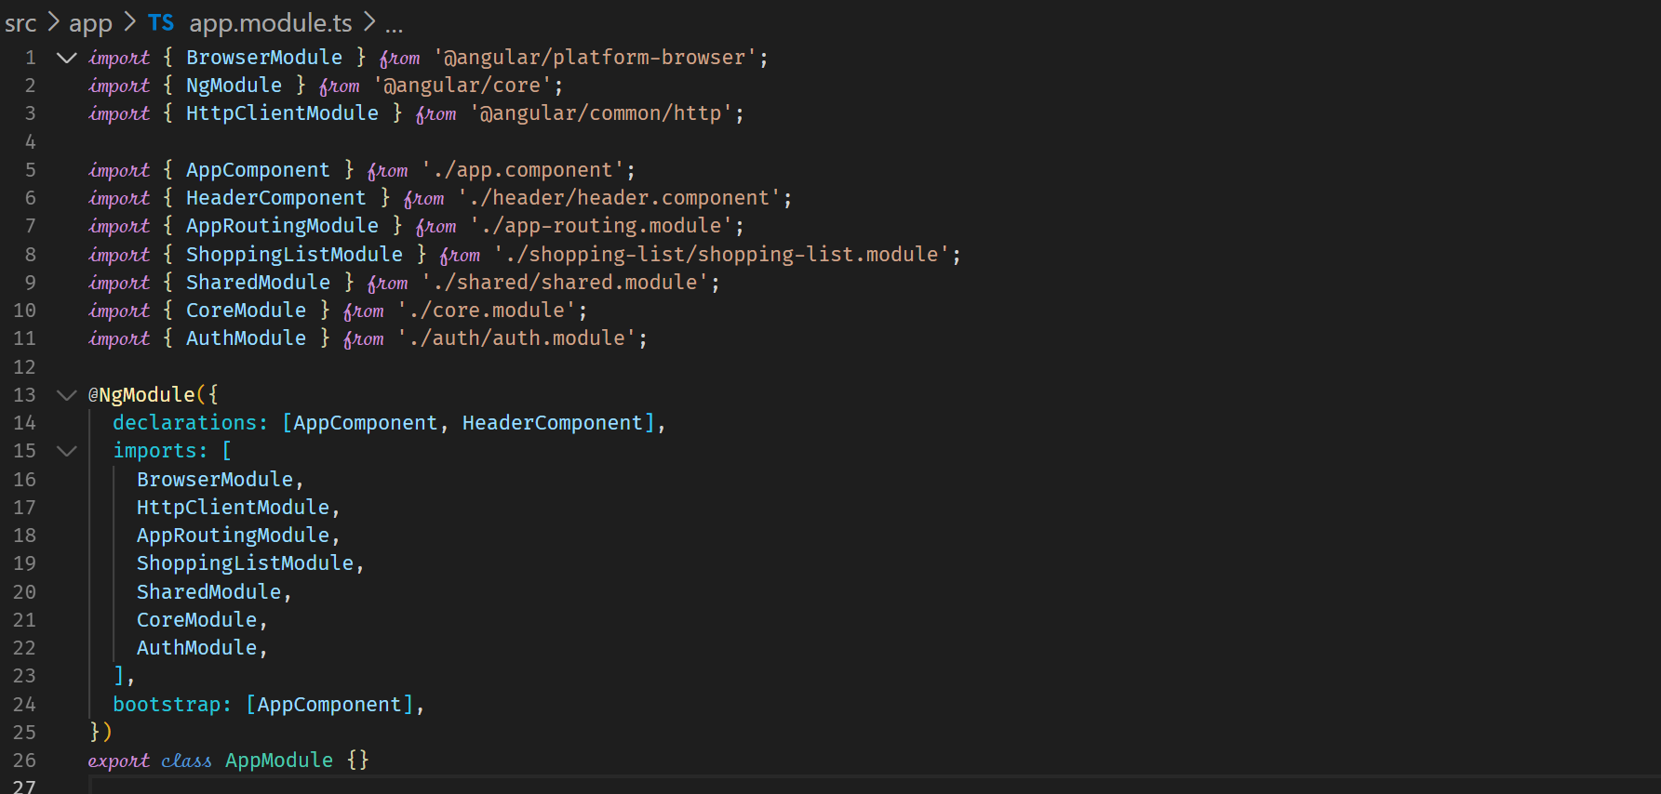



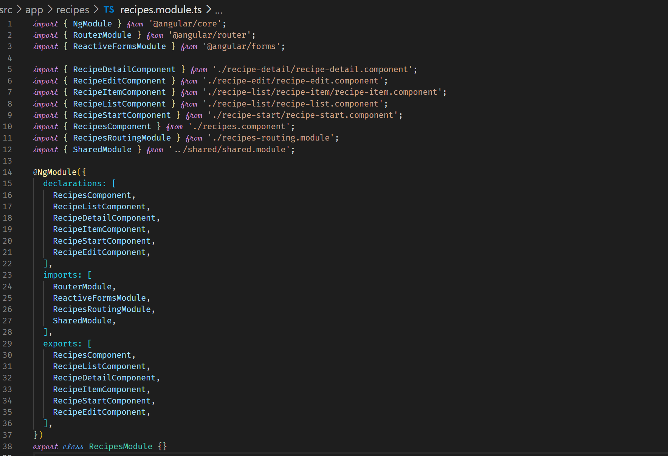



**More Lazy Loading for Auth and ShoppingList components**

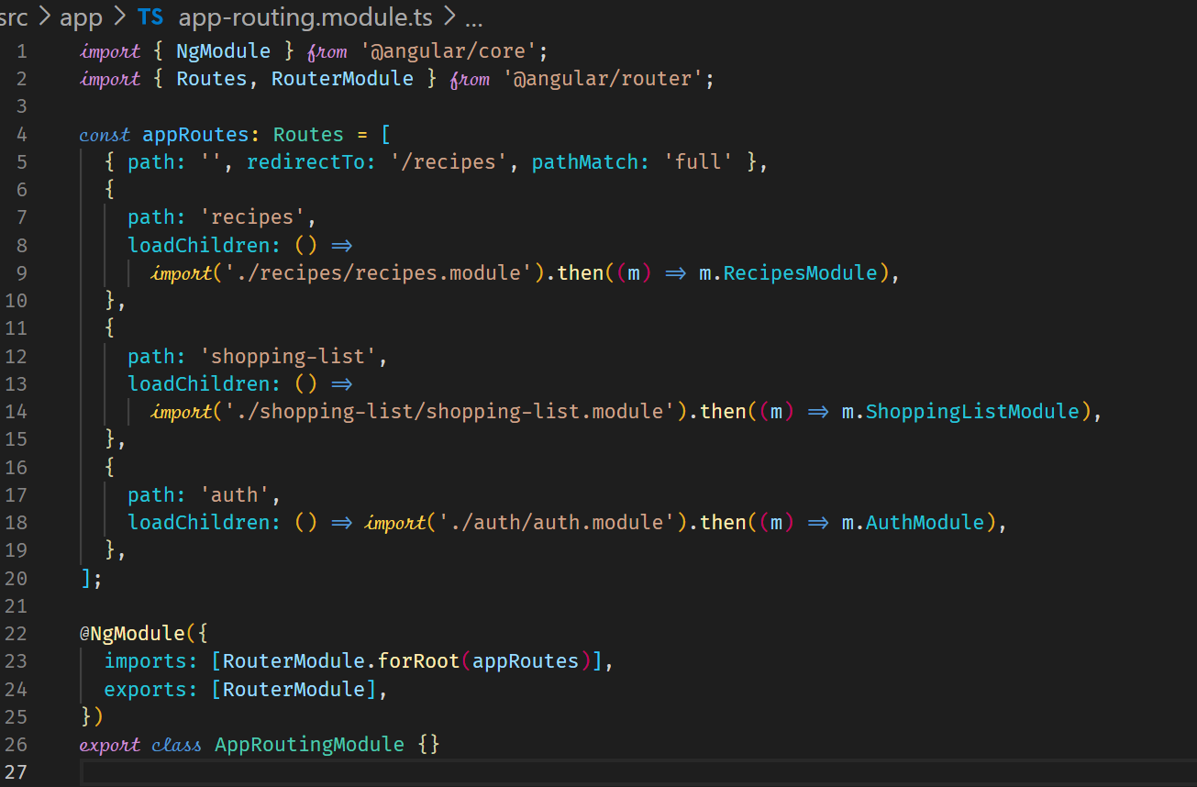



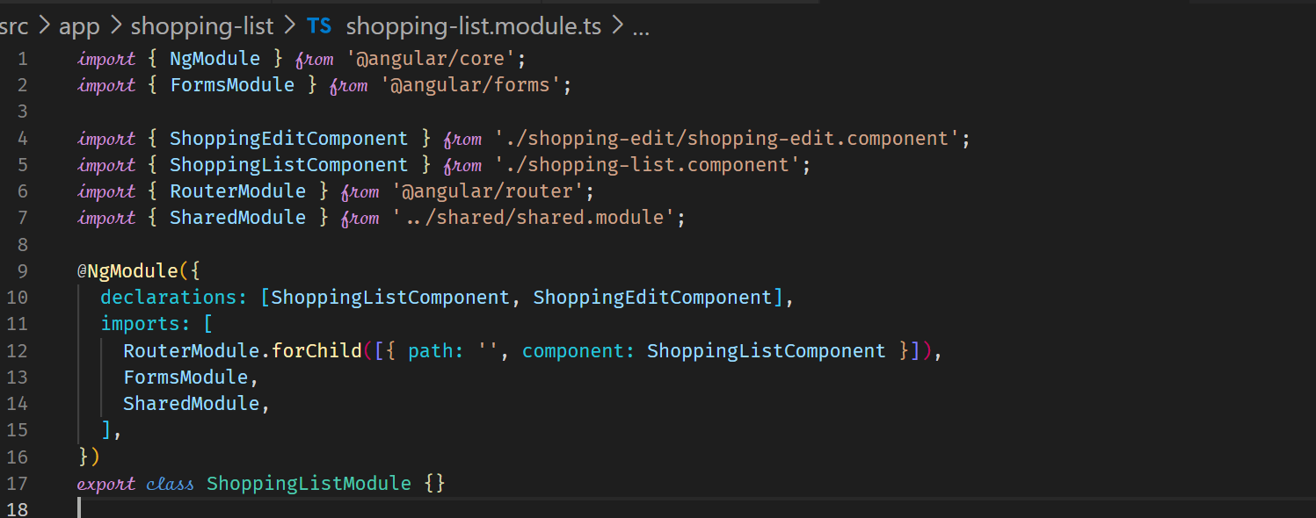



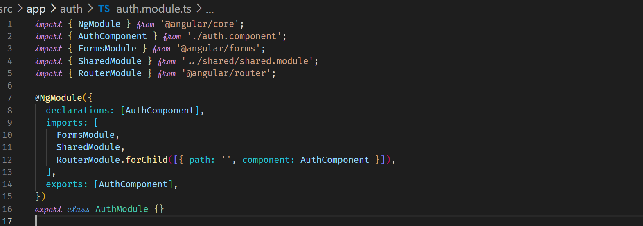

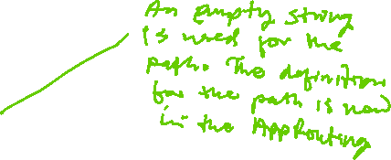

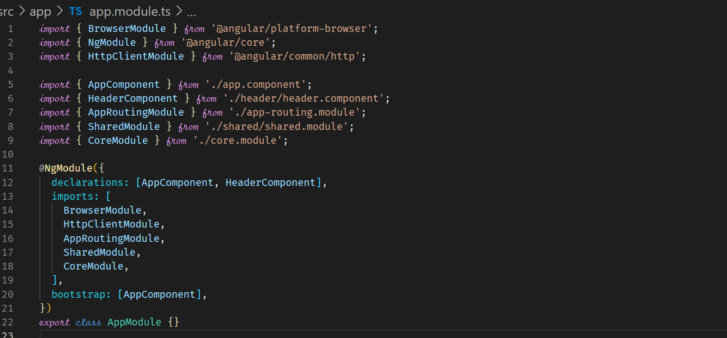



**Preloading Lazy-Loaded Code**

The bundles can be preloaded. This can improve response times. So, when we are on a page, the components that can be navigated to are preloaded.

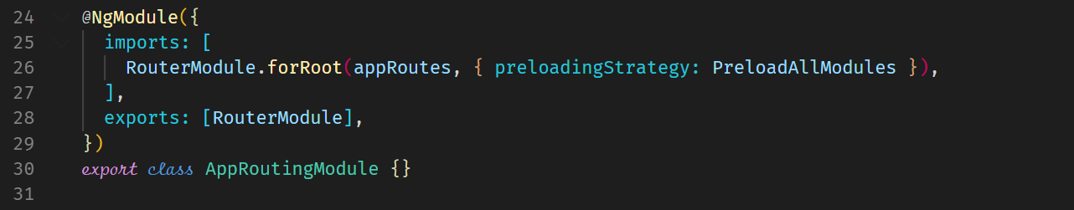



**Preloaded modules in the network tab**

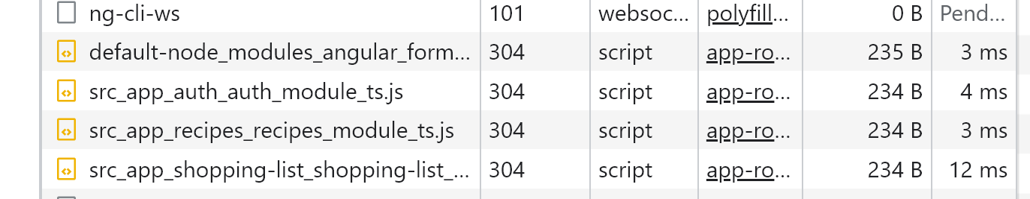

**Services & Modules**

|  |  |  |  |
| --- | --- | --- | --- |
| AppModule | AppComponent  (or other Components) | Eager-loaded Module | Lazy-loaded Module |
| Service available  app-wide | Service available in component-tree | Service available app-wide | Service available in loaded module |
| Use root injector | Use component-specific injector | Use root injector | Use child injector |
| Should be the default | Use if service is only relevant for component tree | Avoid this! | Use if service should be scoped to loaded module |

**Loading Services Differently**

As shown by the above table, the recommended way of loading services is to use @Injectable({providedIn: ‘root’})

**@Injectable({providedIn: ‘root’}) to load services**

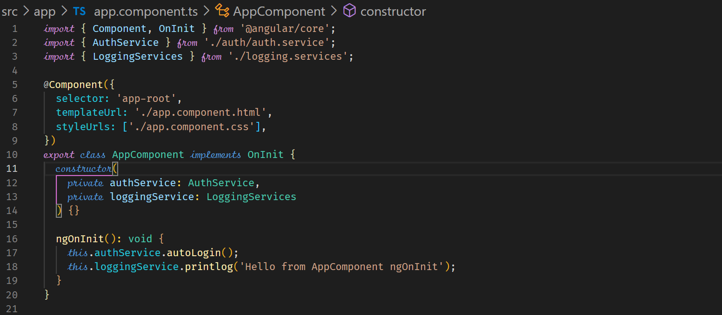

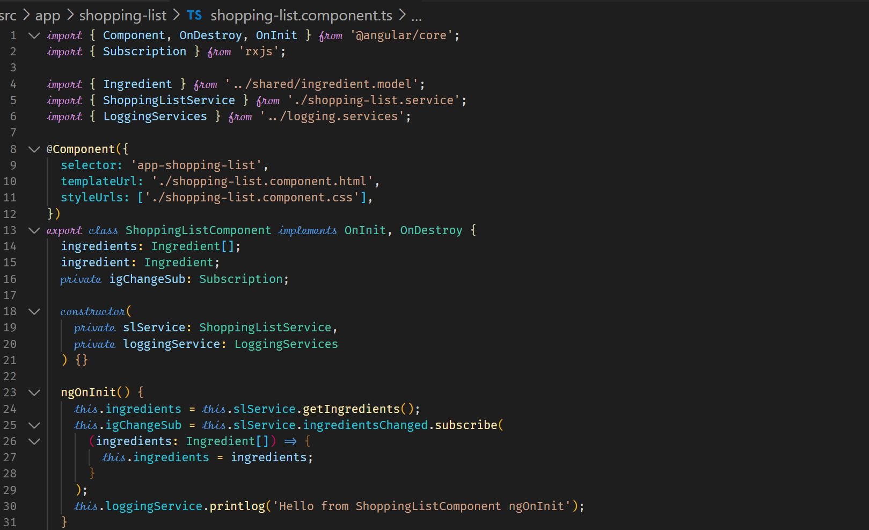

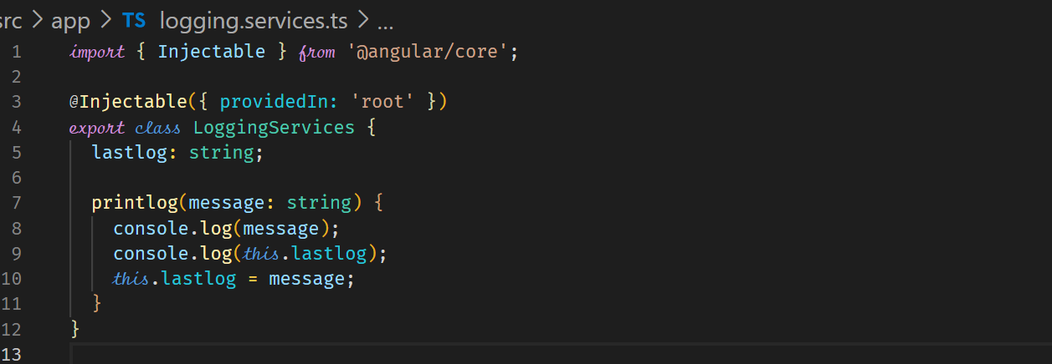



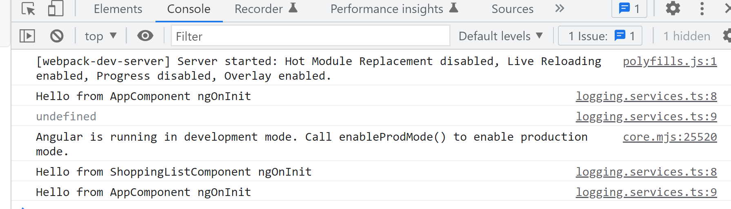



**Using providers property in the AppModule**

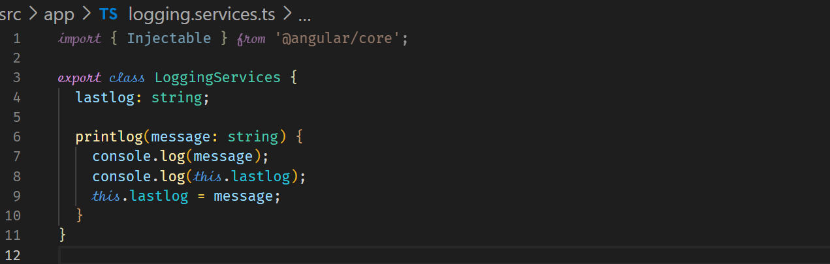



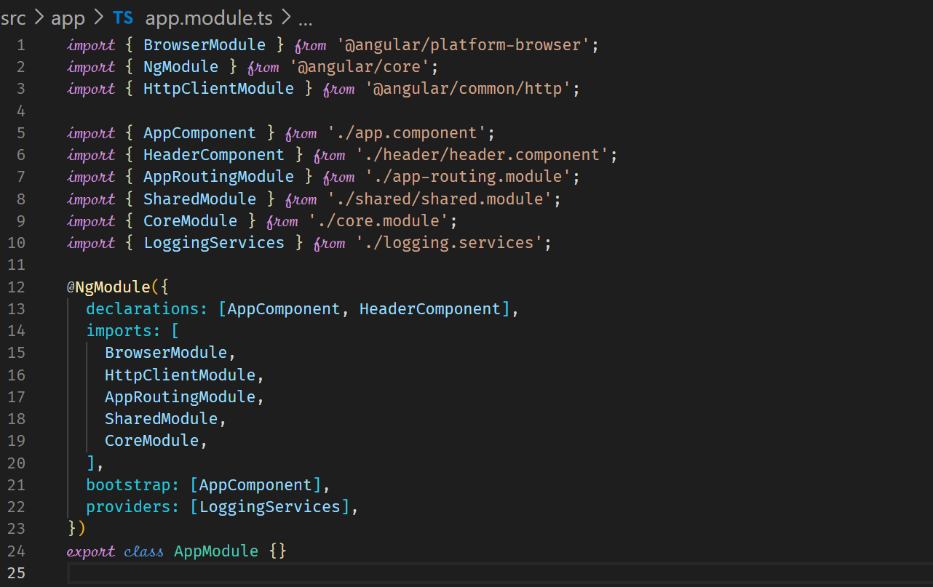



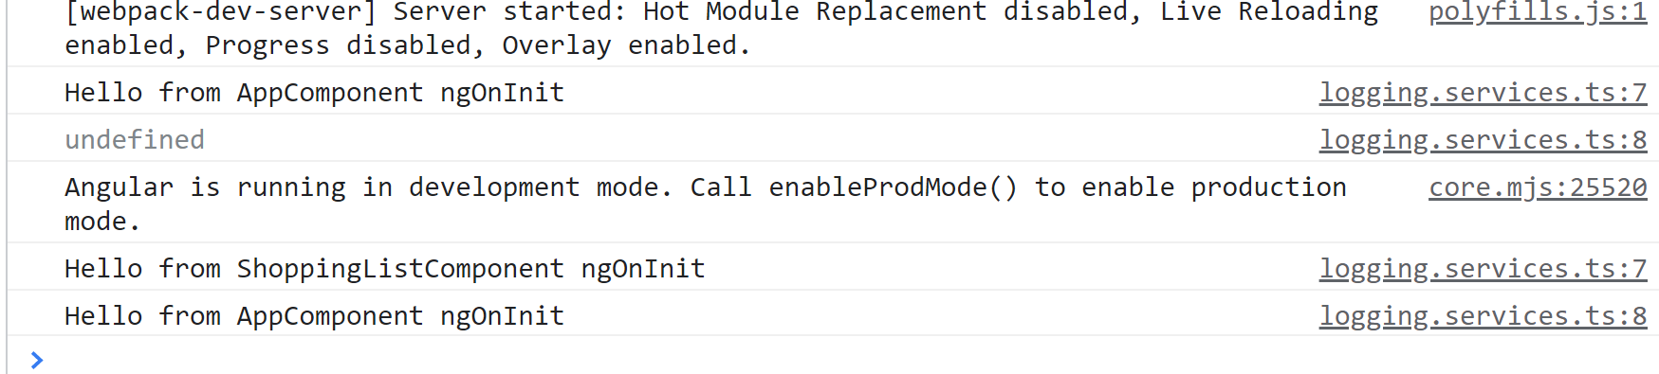



**Using a Service that is injected in an eagerly loaded module**

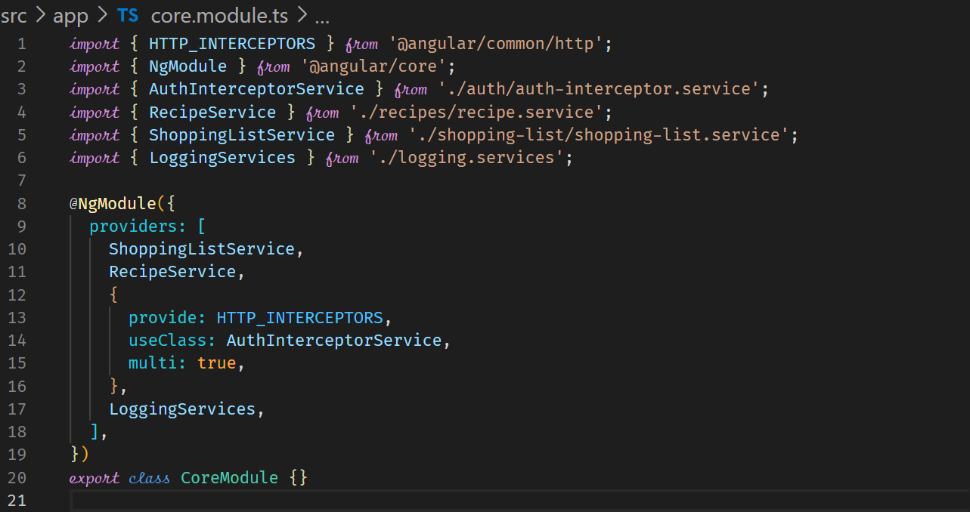



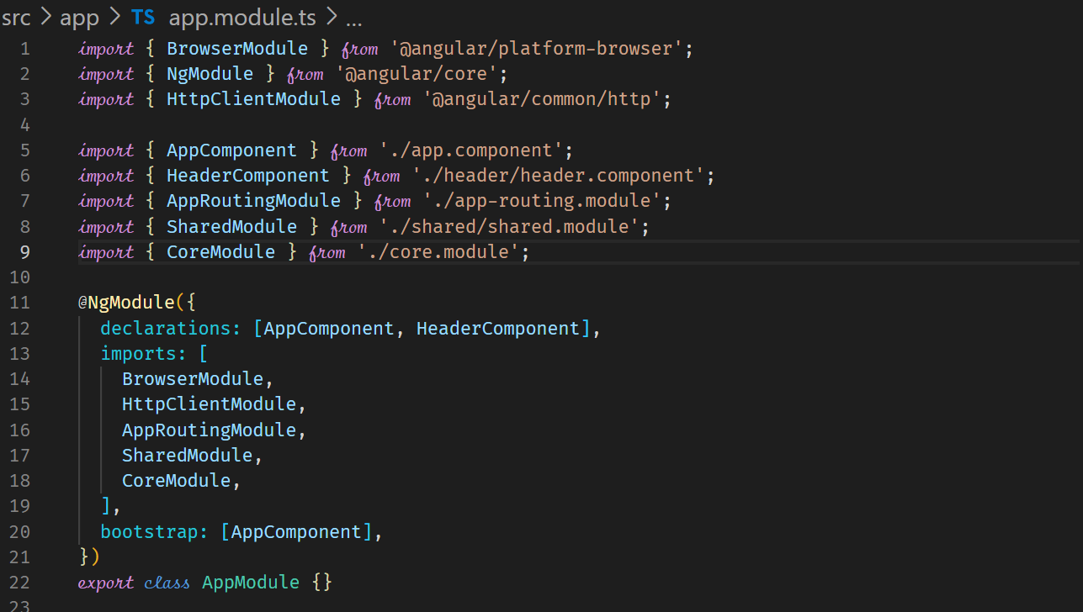



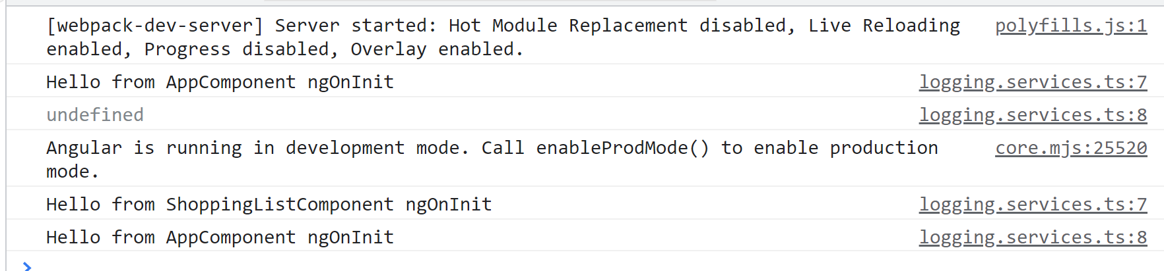



**Using providers array in a lazily loaded component**

**In general think twice when providing a service in any other module other than the AppModule.**

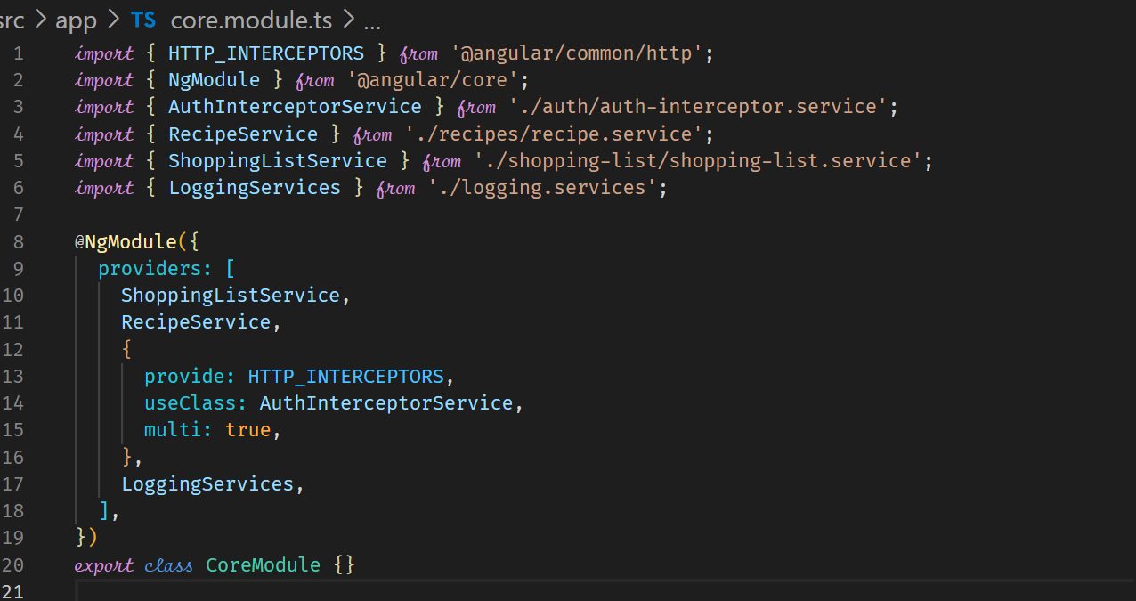

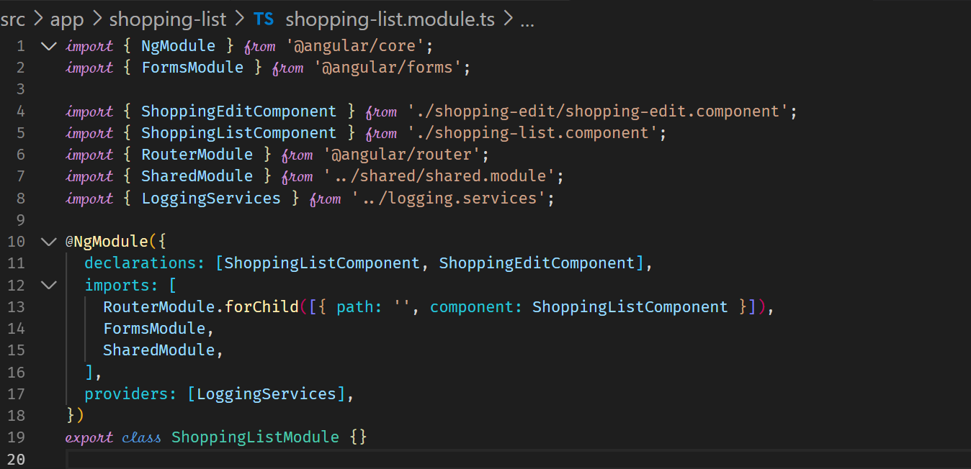

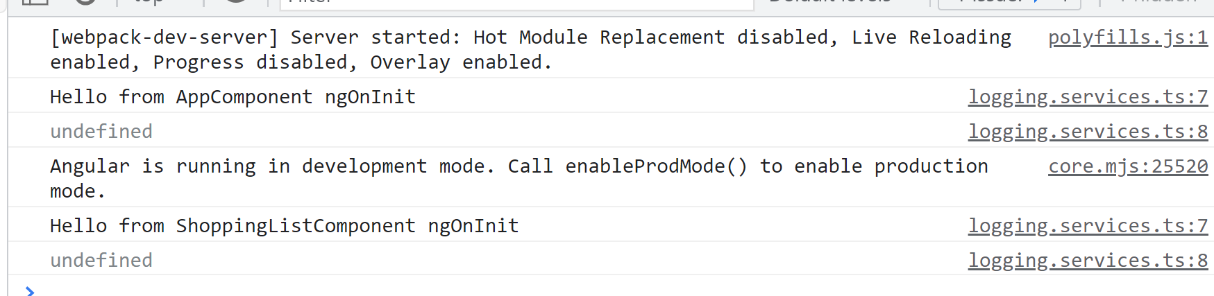



**Loading services via a Shared Module**

Loading a services via a shared module can be problematic because it depends on where the shared module is used. If the shared module is used in a lazily loaded component, then the service is created as a new instance of the service.

If the shared module is used in an eagerly loaded module, then the service will be created as a singleton.

**As a rule of thumb, use @Injectable({providedIn: ‘root’}) or in the providers array of the AppModule.**

**Deployment**

**Deployment Preparation**

Use and check environment variables

Polish and test code

ng build

ng build - -prod

Deploy build artifacts (generated files) to static host (static host can run only HTML, JS, CSS)

**Using Environment Variables**

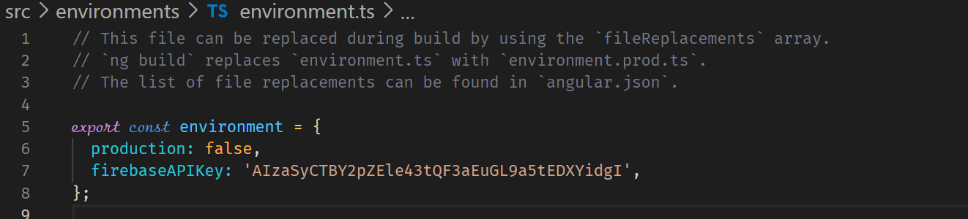

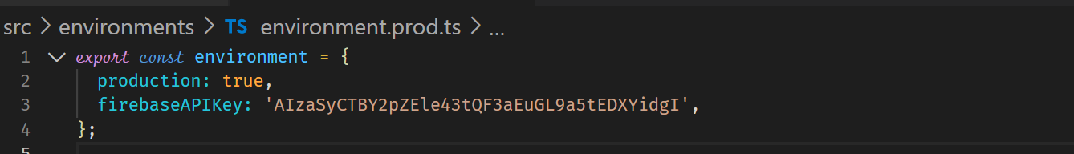

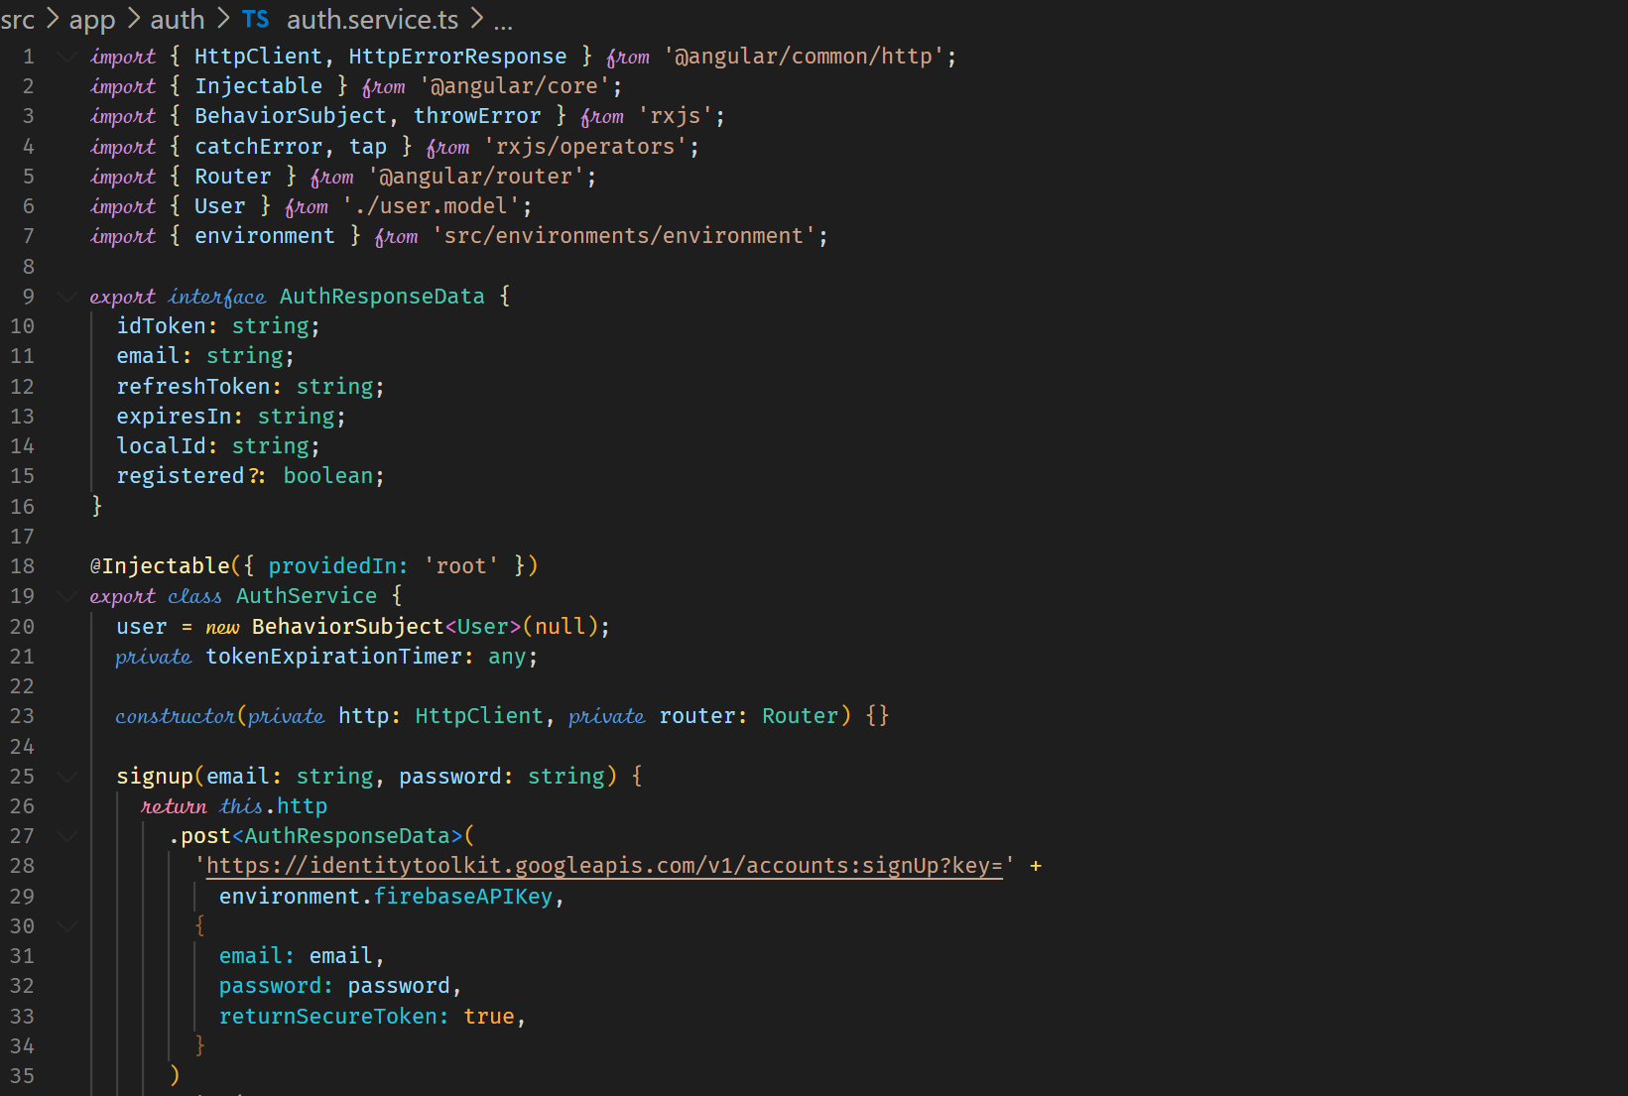

**Deploying Angular Applications**

ng build

**Deploy to static host**

Google for static website hosts

You can also host on firebase

Install Firebase CLI

npm install -g firebase-tools

firebase login

firebase init – this command requires you to be in your project folder

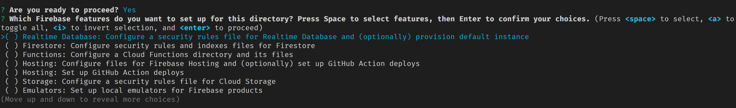

Select Hosting: Configure files for firebase hosting

Select the firebase project

public directory – enter dist/<directory name>

Configure as a single-page app (rewrite all urls to /index.html) – choose Y to ensure all request sent to the backend are redirected to the index.html. The reason is that by default the server handles all incoming requests. So by redirecting all the requests to the index.html, our application router takes over.

Setup automatic builds and deploy with github – No

File dist/first-app/index.html already exists. Overwrite – No

Then run

firebase deploy

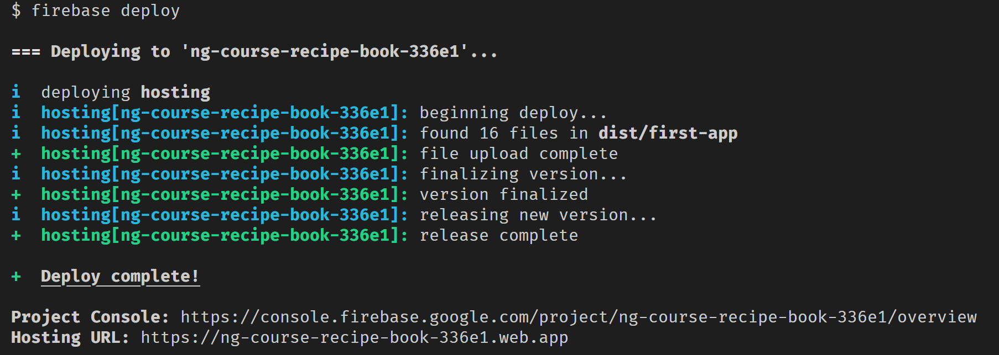

**Standalone Components**

Normal Component

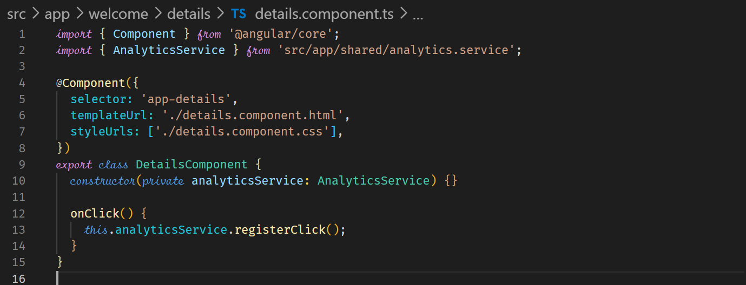

Standalone Component

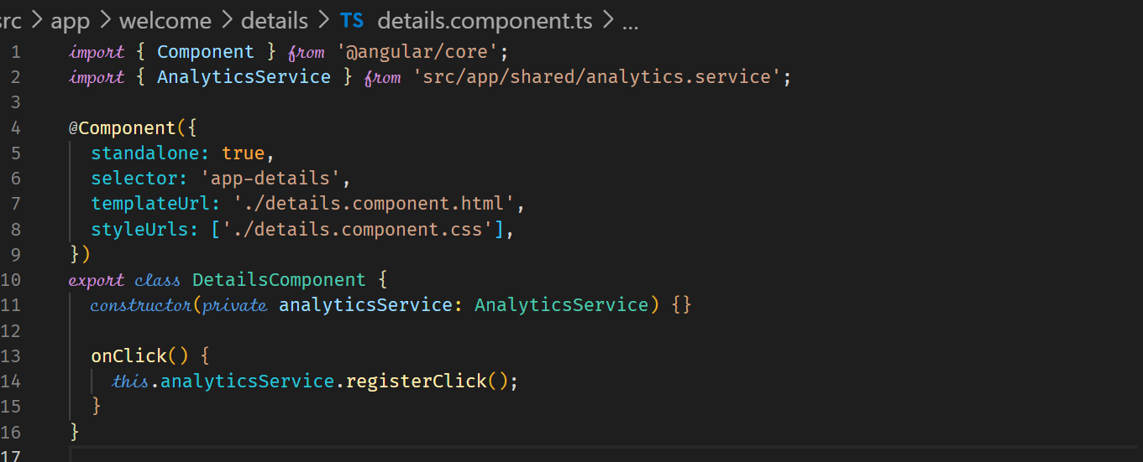



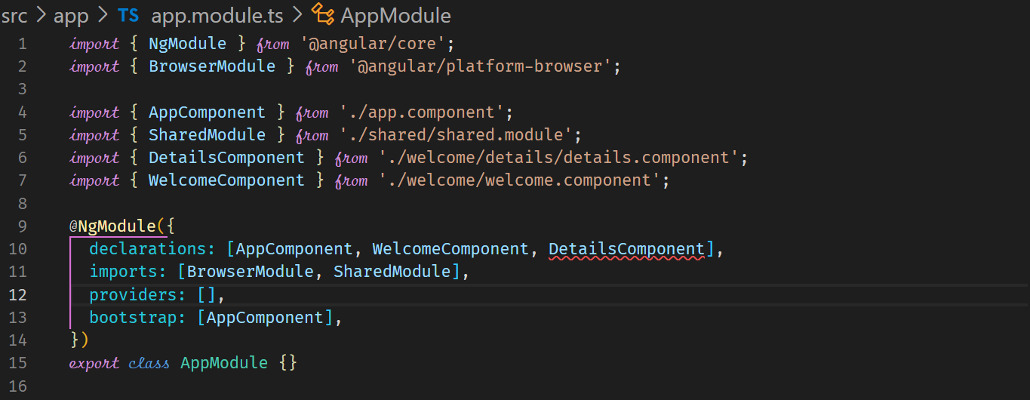



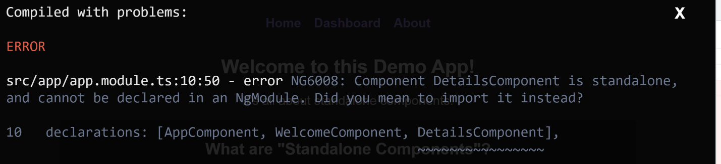



To fix the error, we need to amend the component that is using the standalone component to include an imports property in the @Component declarative.

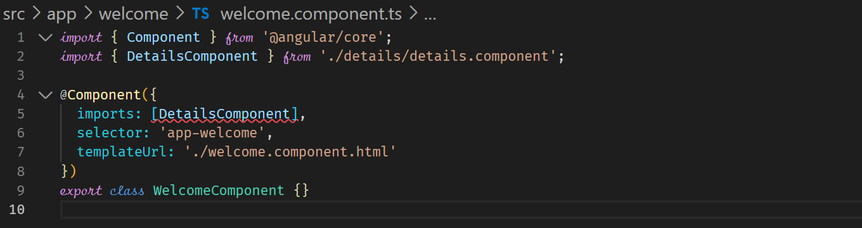



There is a different way to handle the above problem. The good thing is that Standalone components can be combined with NgModule so that there is smooth migration to Standalone components. You do not have to re-write your entire application.

The solution is to add the standalone components to the imports property of the NgModule in the AppModule without changing the WelcomeComponent until we are ready to change the WelcomeComponent to a standalone component.

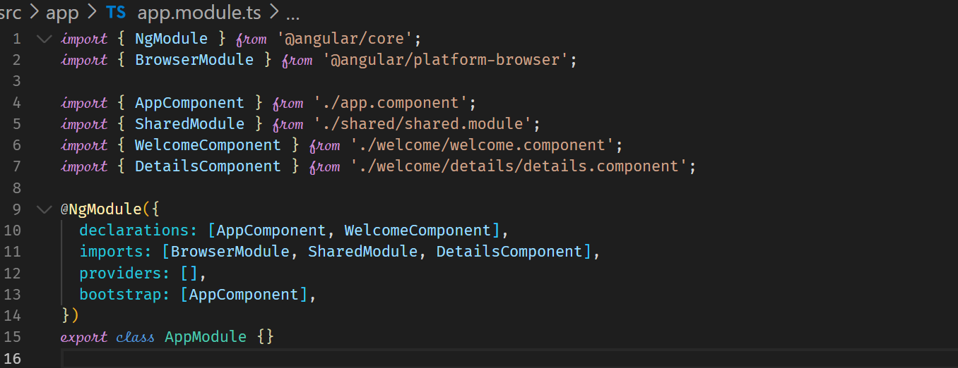



This fixes the problem but the HighlightDirective which is in the SharedModule is no longer working in the DetailsComponent template.

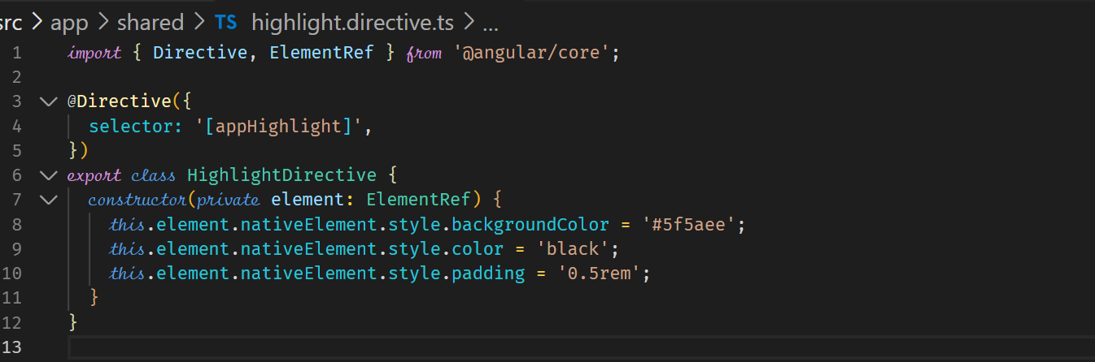

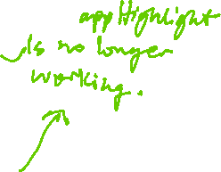

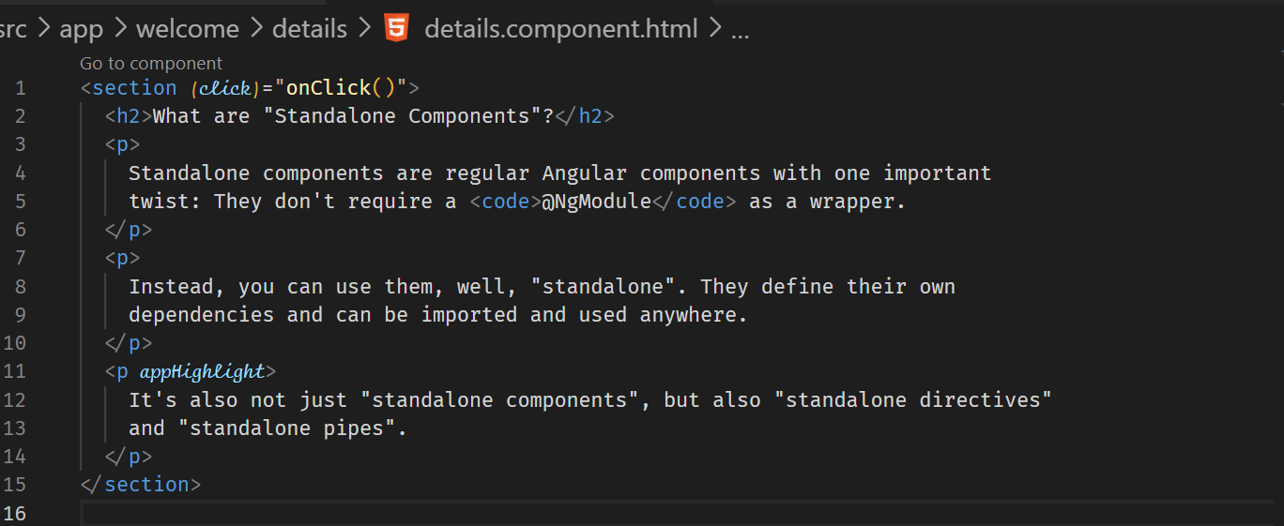



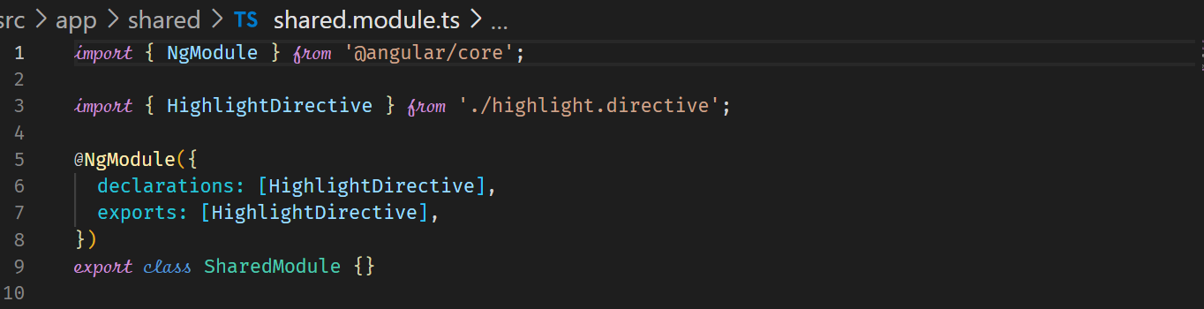

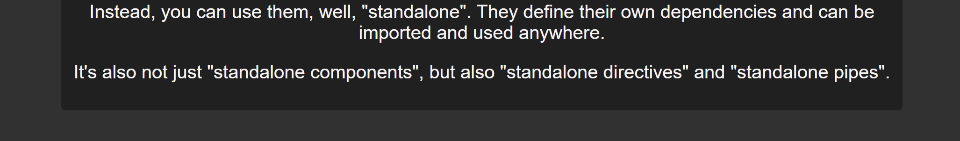

We need to fix the code break, so that the output is highlighted. There are two possible solutions.

* We can turn the HighlightDirective into a standalone directive because standalone directives can be imported into any component including standalone components.
* We can also import the SharedModule into the DetailsComponent where the HighlightDirective is used.

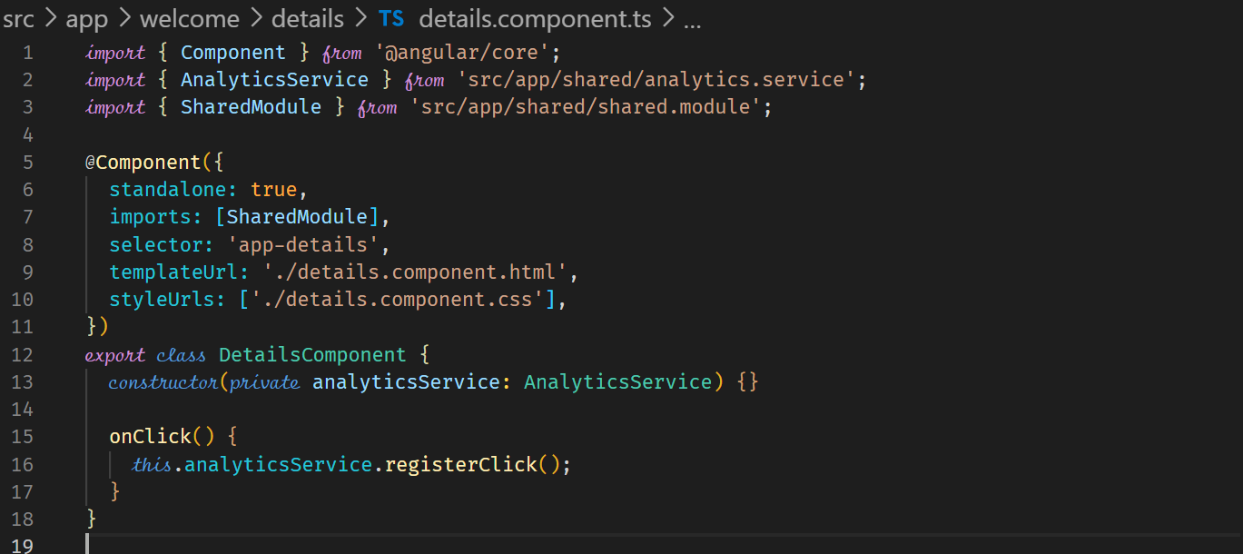



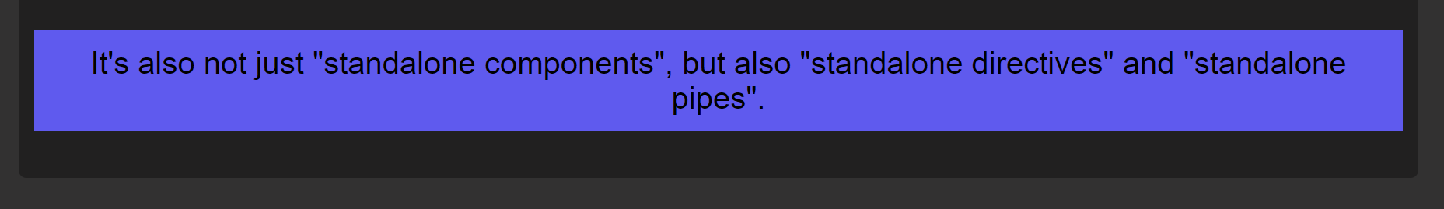

Since the other components are not using the SharedModule, we can remove it from the AppModule.

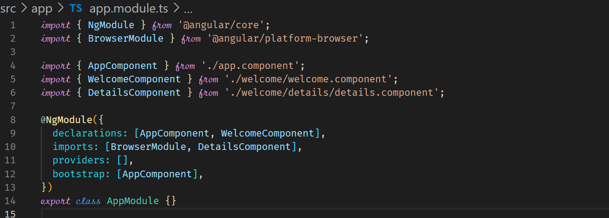



**Standalone Directives & Connecting Building Blocks**

Directives can also be standalone as well as pipes.

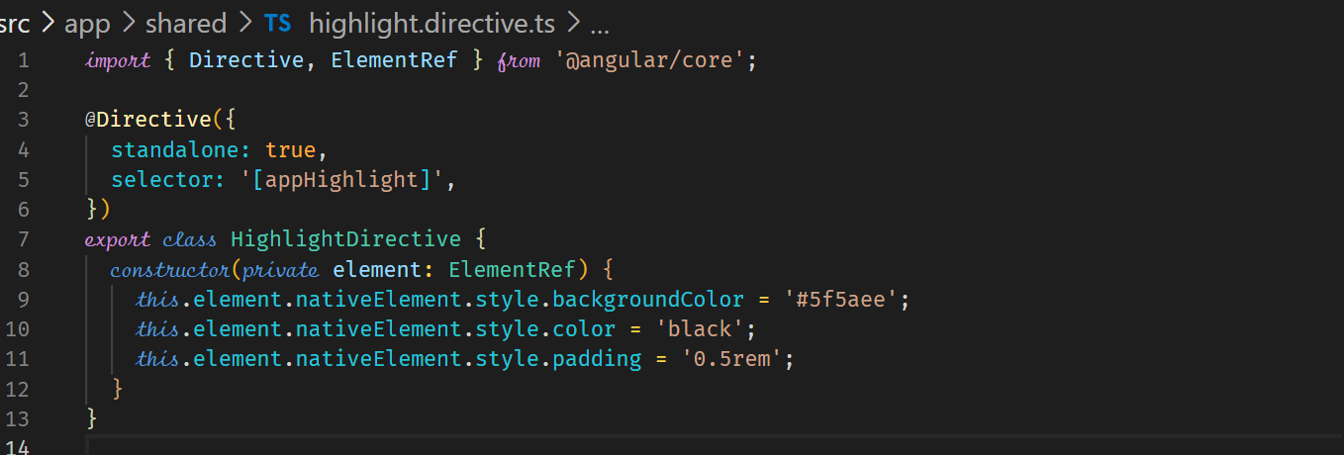



We will remove the SharedModule as this is no longer required because it only had the HighlightDirective.

Since we need the HighlightDirective in the DetailsComponent, we need to have it in the imports property of the @Component.

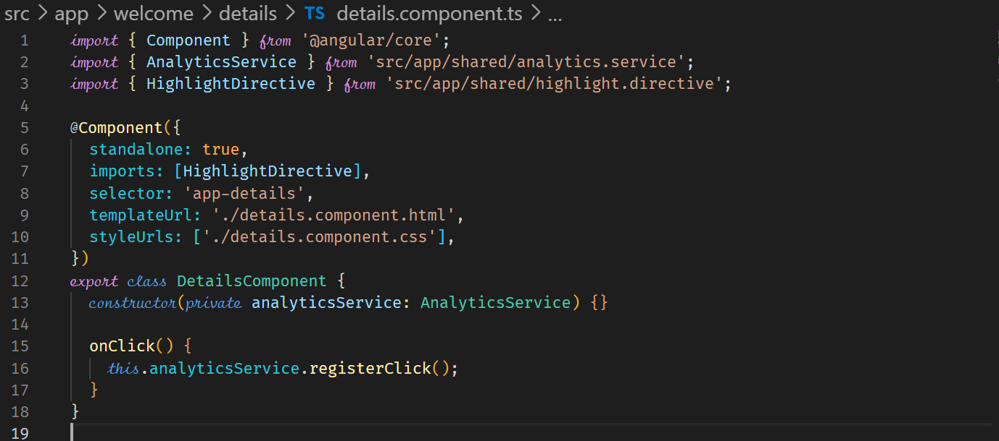



**Migrating Another Component**

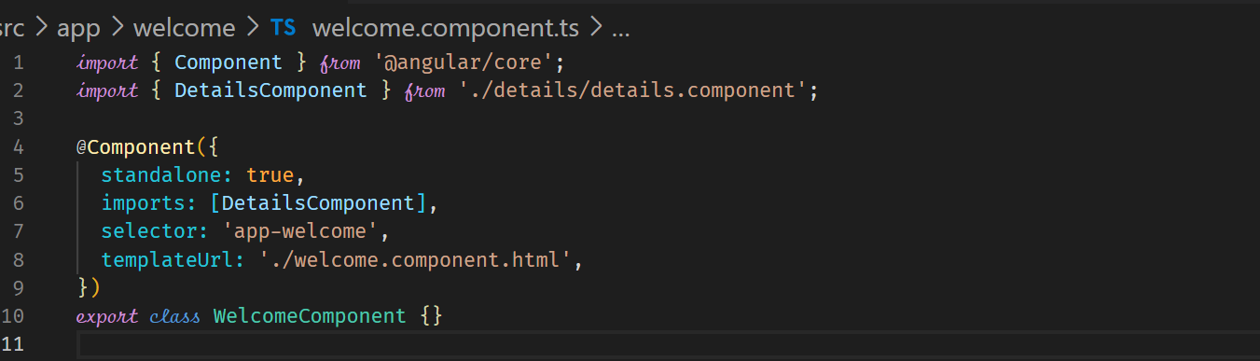



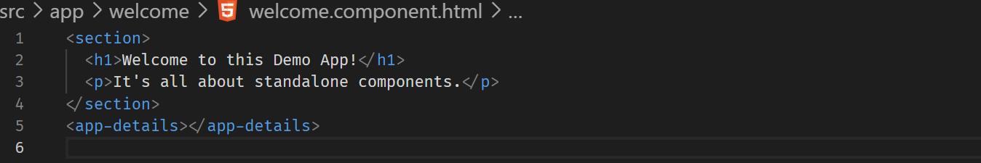



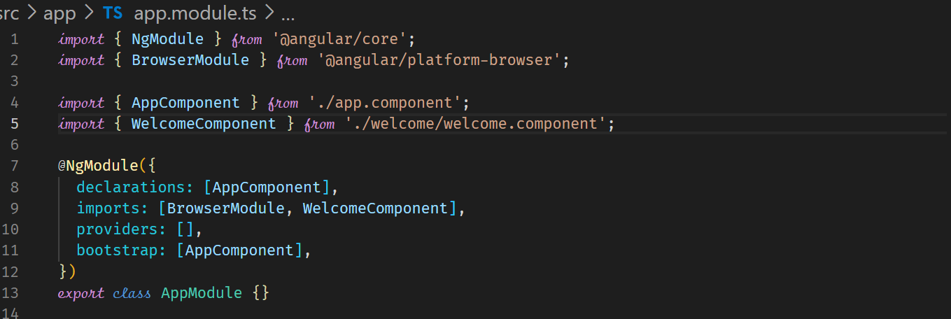

**Migrating the Root Component (AppComponent)**

Migrating the root component will allow us to get rid of the AppModule.

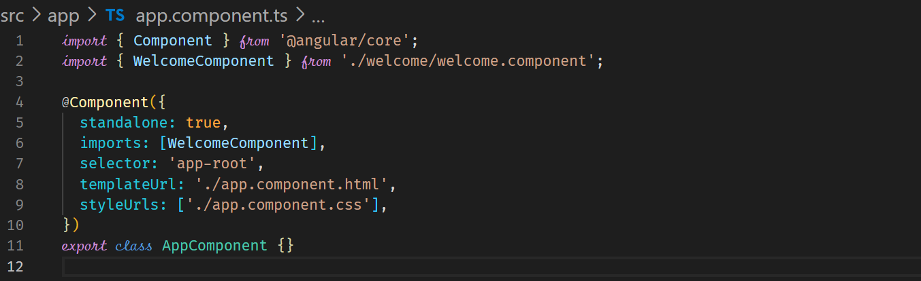



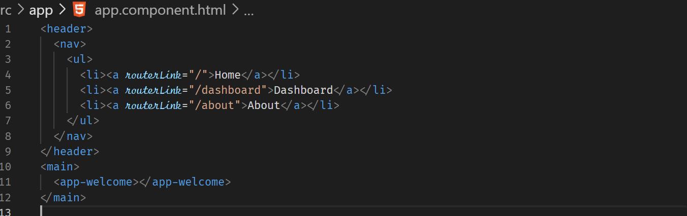



We need to change how the application is started in the main.ts file. Instead of bootstrapping from the AppModule, we need to bootstrap from the AppComponent.

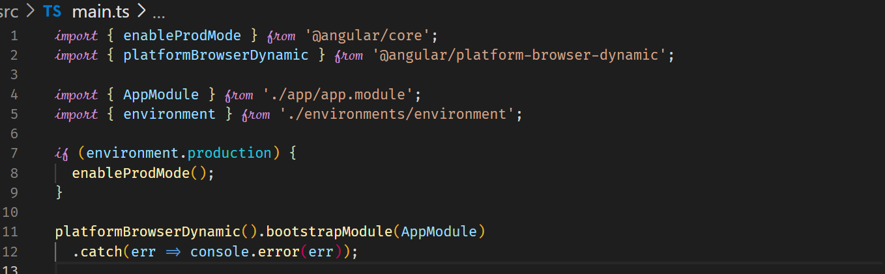

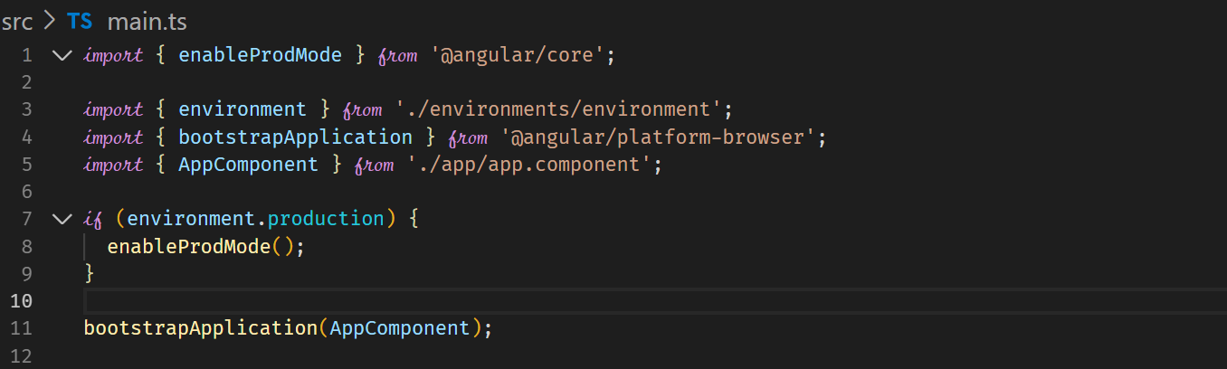



We can now delete the AppModule

**Services and Standalone Components**

The equivalence of having a providers array in @NgModule for the AppModule, where a service is globally available is as follows

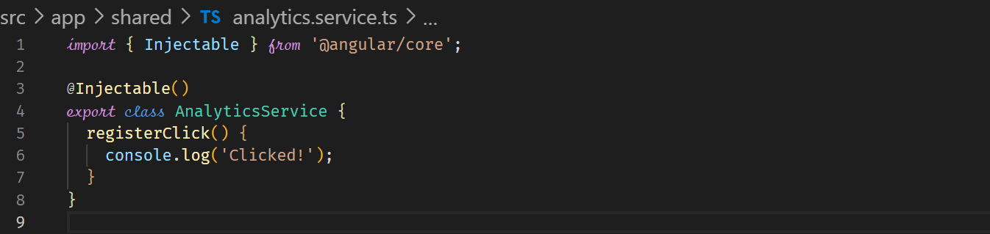



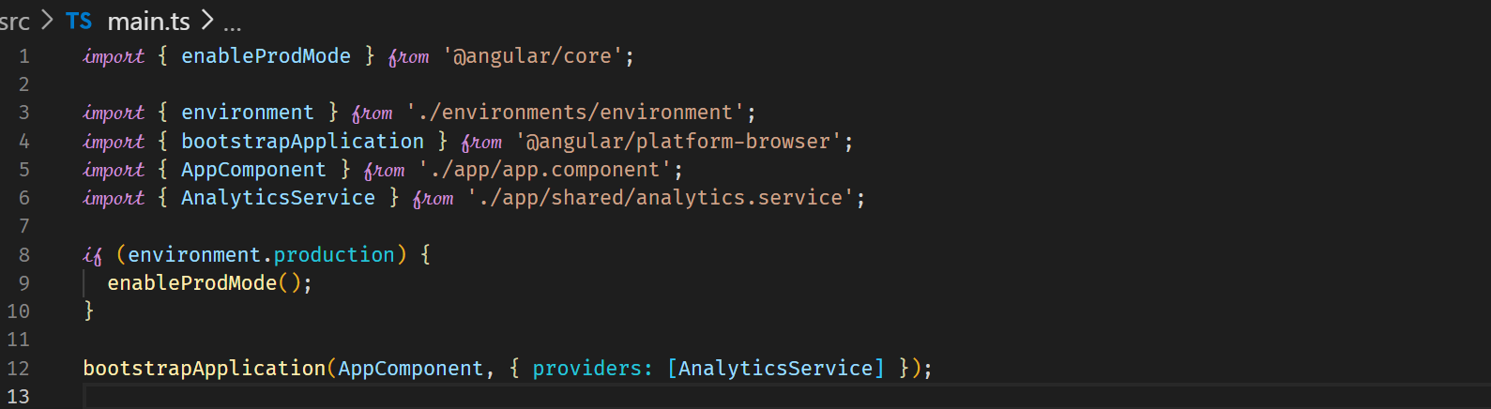



The best method remains that of using the providedIn: ‘root’ syntax when a service class is created.

**Routing with Standalone Components**

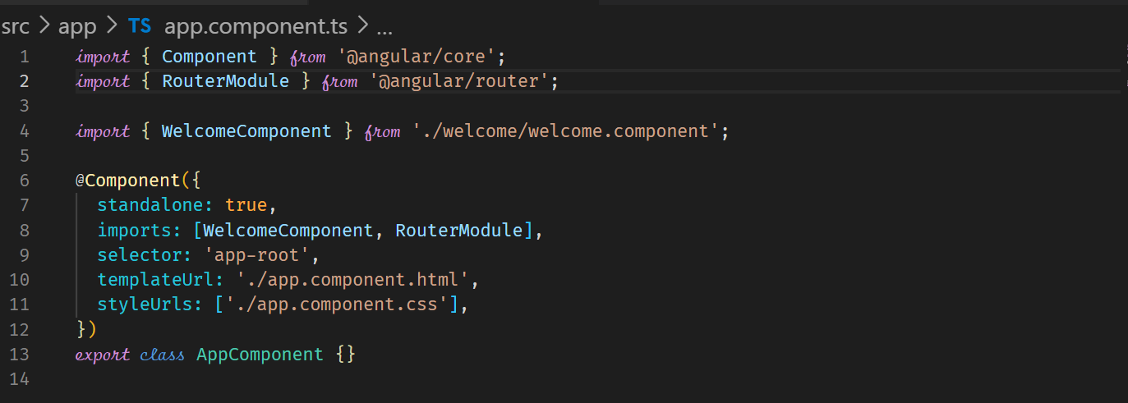



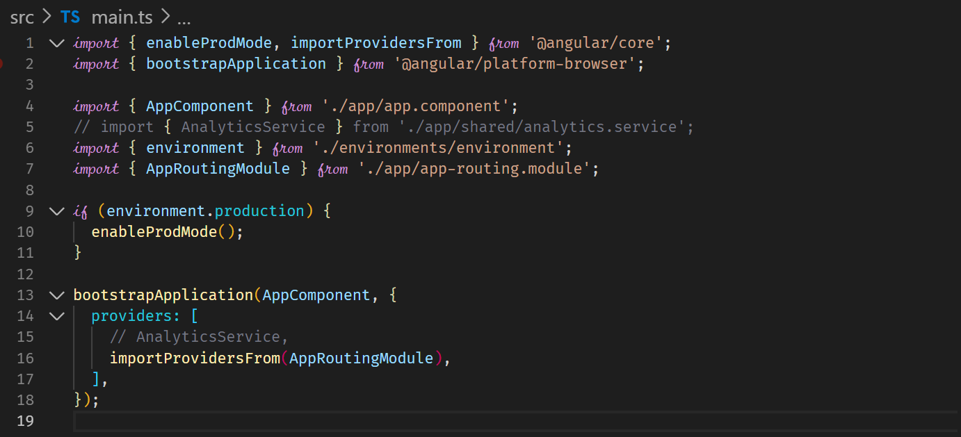



**Lazy Loading and Migration of Router Components to Standalone**

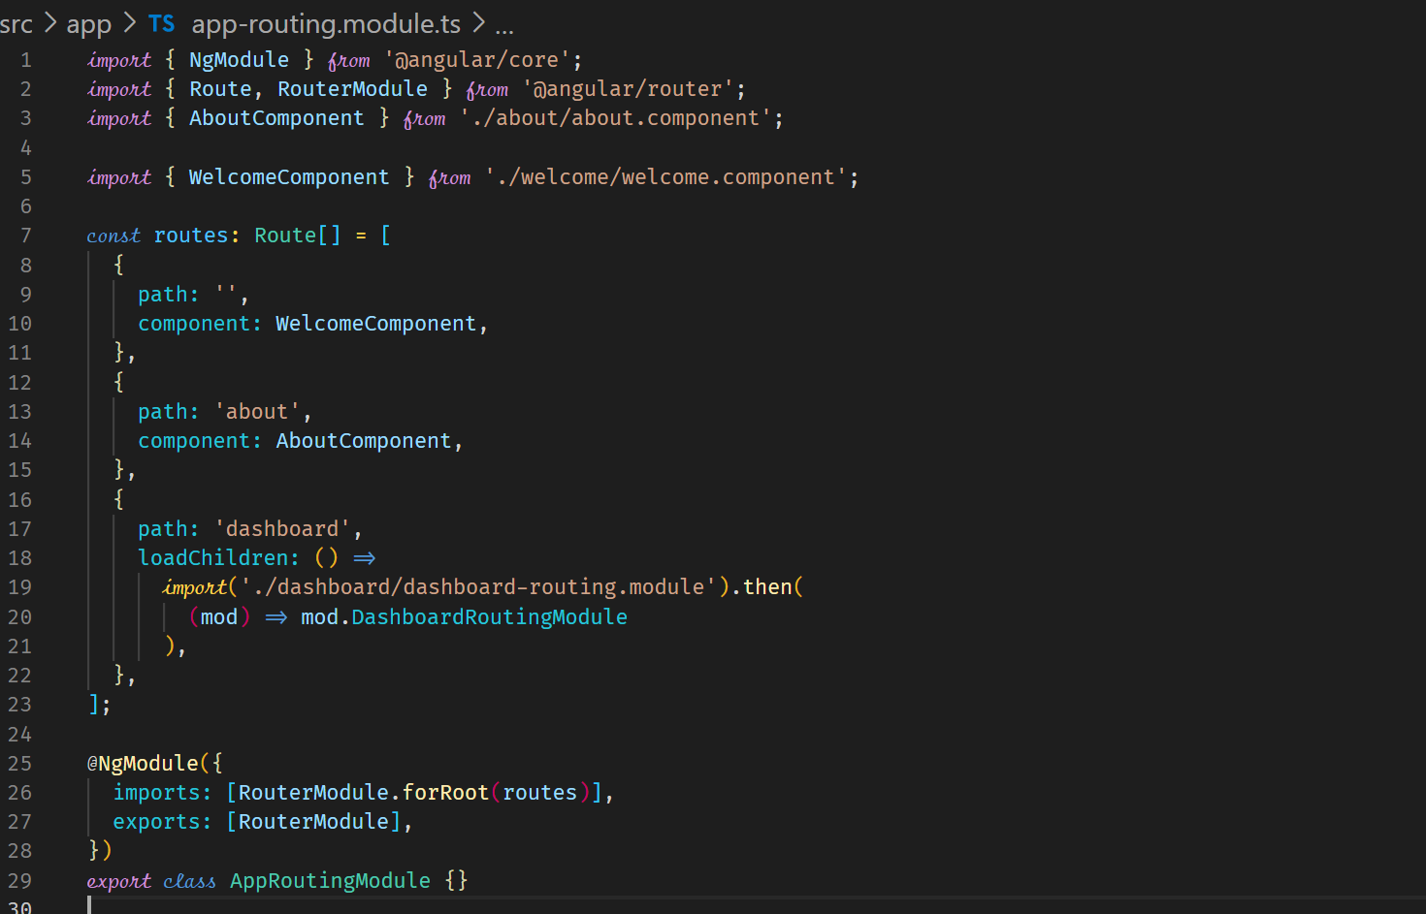



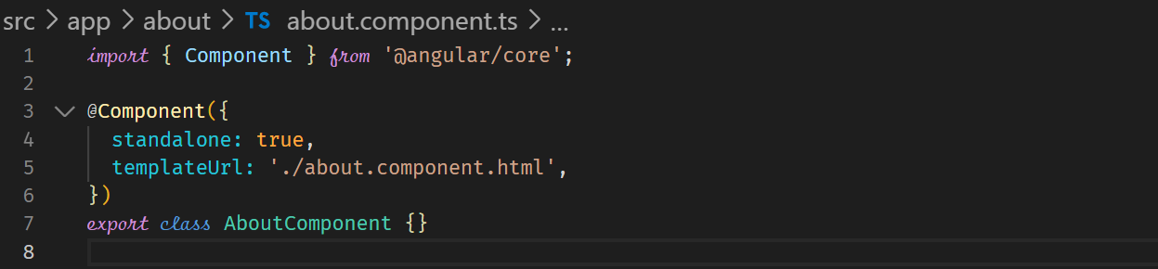

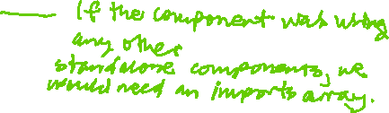

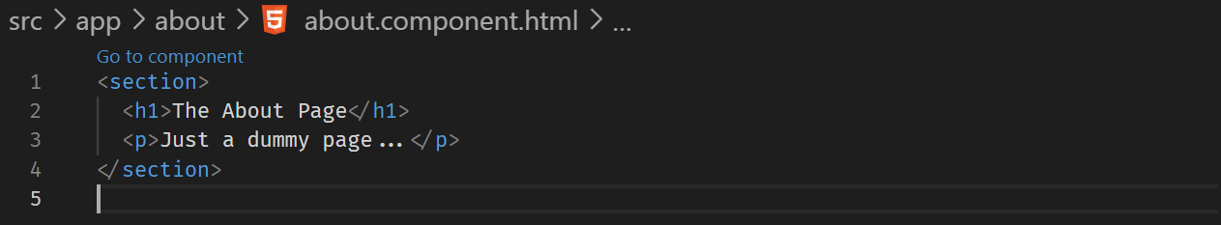



**Lazy Loading the Standalone Component in the route**

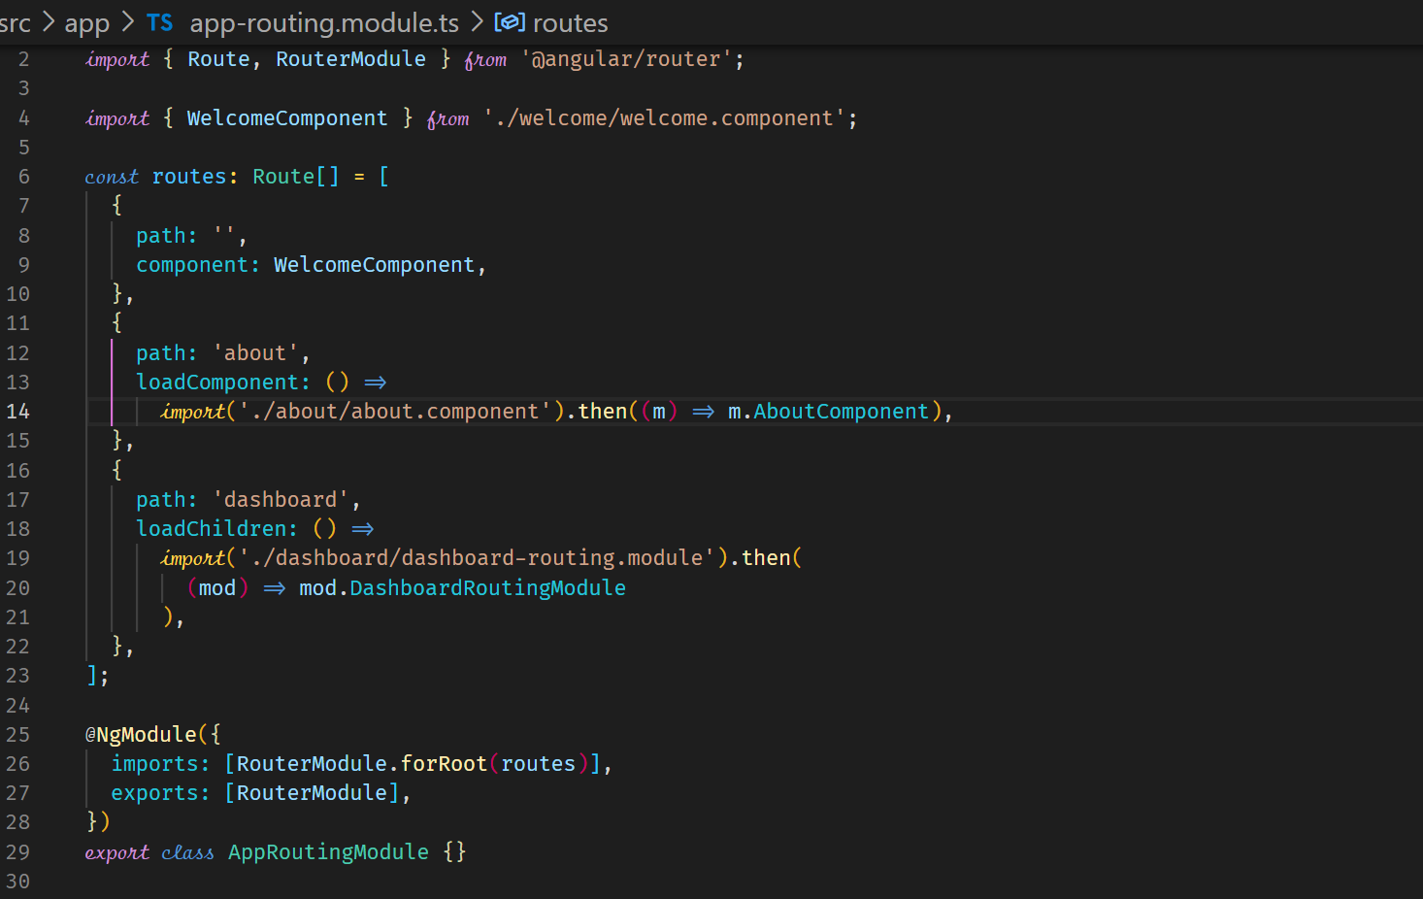



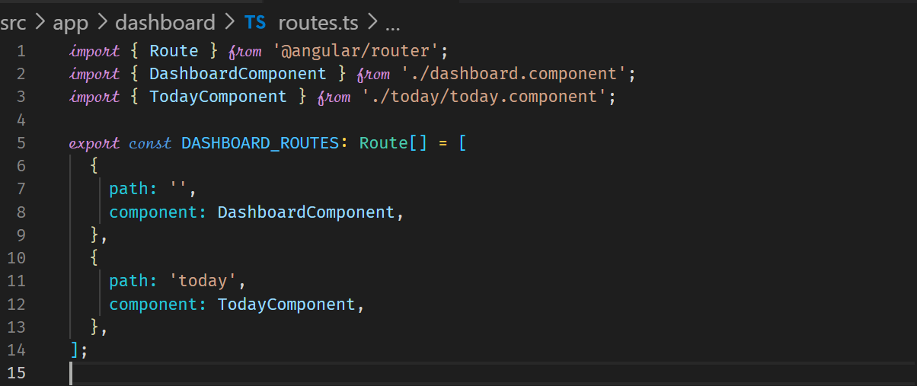



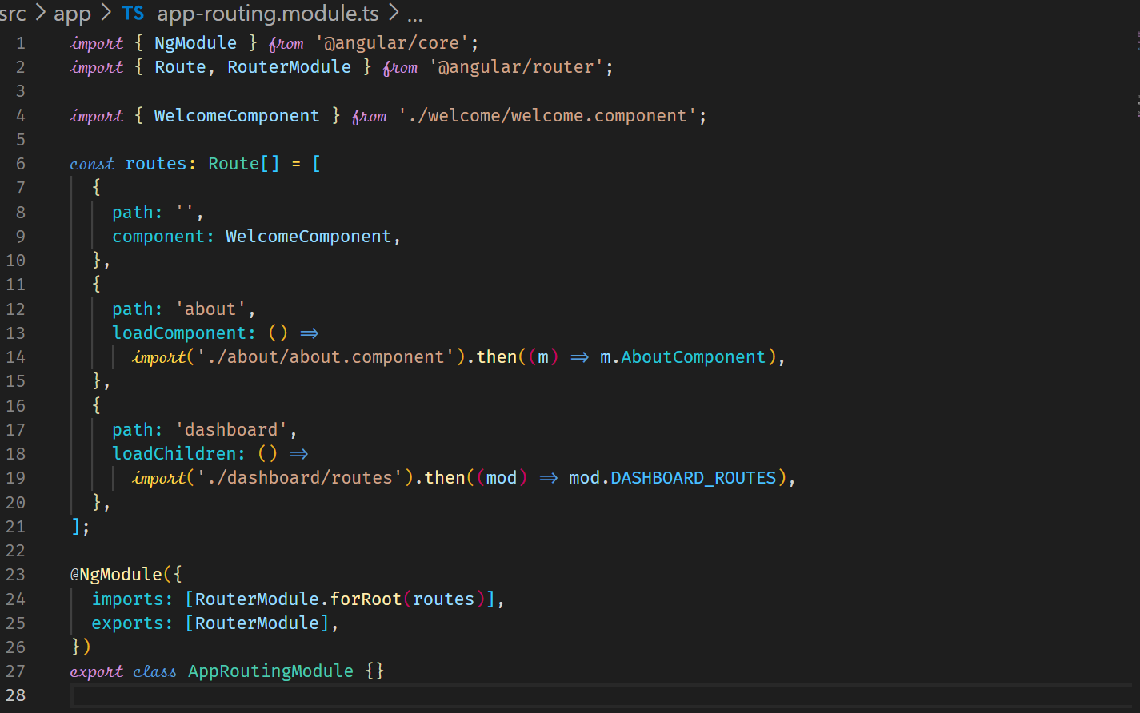



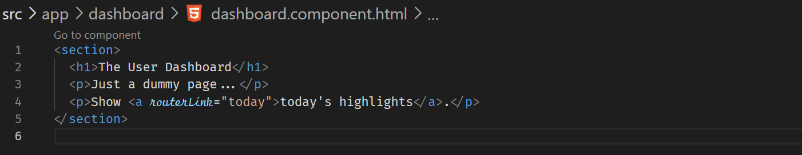



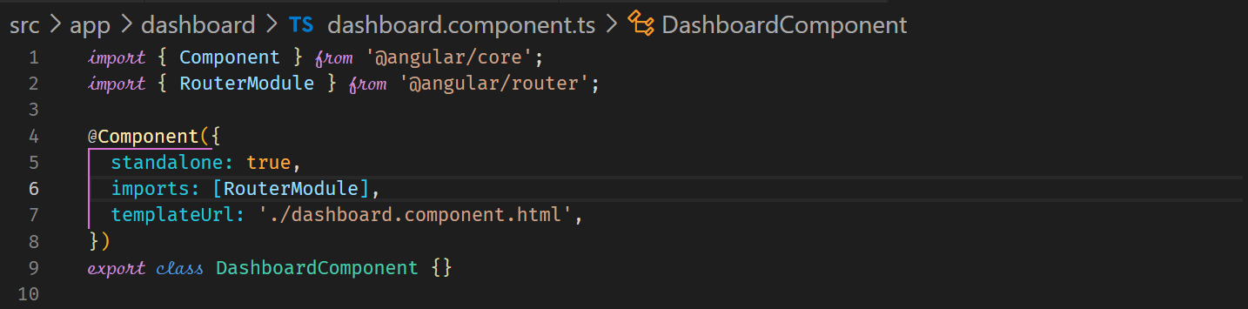



**NgRx**

**What is application state?**

In Angular, the application state refers to the overall data and state of the application at a specific moment. It includes information such as user inputs, selections, and the current state of components and services. The application state determines how the user interface (UI) appears and behaves.

In Angular applications, the application state is typically managed using the concept of a centralized state management system. This can be achieved by using a state management library like NgRx or implementing a custom state management solution.

The application state is typically stored in a data structure called a store. The store is a single source of truth that holds the entire state of the application. It is immutable, meaning that the state cannot be modified directly. Instead, changes to the application state are made by dispatching actions.

Actions are plain JavaScript objects that describe an intention to change the state. They are dispatched by components or services and are handled by reducers. Reducers are pure functions that receive the current state and an action as input and produce a new state based on the action.

By managing the application state in a centralized store, Angular applications can have a predictable and consistent data flow. Components can subscribe to the store and receive updates whenever the state changes. This allows for efficient communication between different parts of the application and facilitates the development of scalable and maintainable code.

Overall, the application state in Angular refers to the data and state of the application at a specific moment, and managing it effectively is essential for building robust and interactive applications.

Redux

Redux is a popular state management library that is commonly used with JavaScript frameworks and libraries such as React and Angular. It provides a predictable and centralized way to manage application state, making it easier to develop complex applications with consistent data flow.

Redux follows the principles of Flux, which is an architectural pattern for building client-side web applications. It introduces a unidirectional data flow, where data flows in a single direction through the application, making it easier to understand and reason about.

The key concepts in Redux are as follows:

1. **Store**: The store is a JavaScript object that holds the entire application state. It is immutable, meaning that the state cannot be changed directly. Instead, to update the state, you dispatch actions.
2. **Actions**: Actions are plain JavaScript objects that describe an intention to change the state. They typically have a type property that defines the type of action being performed. Actions can also carry additional data, known as payload, which provides information necessary to update the state.
3. **Reducers**: Reducers are pure functions that receive the current state and an action as input, and return a new state. They define how the state should be updated based on the action type. Reducers should not perform any side effects or modify the existing state. Instead, they create and return a new state object.
4. **Dispatch**: Dispatch is a function provided by Redux that allows you to send actions to the store. When an action is dispatched, it triggers the corresponding reducer function, which updates the state accordingly.
5. **Selectors**: Selectors are functions that extract specific pieces of data from the state. They provide a way to access the store state in a structured manner, making it easier to retrieve and use the required data in components.

By using Redux, developers can achieve a centralized and predictable state management system. It simplifies the process of managing complex application states, as it provides clear rules and patterns for updating and accessing the state. Additionally, Redux works well with the concept of immutable data, making it easier to track changes and optimize application performance.

It's worth noting that while Redux is often associated with React, it can be used with other JavaScript frameworks and libraries, including Angular, as mentioned earlier. **There are Angular-specific libraries like NgRx that provide similar functionality to Redux and integrate well with Angular's ecosystem.**

Redux

Receive State

Reduces / Combines State

Dispatch

Sent to

Saves reduced State (immutably)

Receive State

Components

Services

Actions

Reducers

Store

Application State

NgRx

Receive State

Reduces / Combines State

Dispatch

Sent to

Saves reduced State (immutably)

Receive State

Components

Services

Actions

Reducers

Store

Application State

New Action

Listen

Side Effects

(do something, eg. Http)

Differences to “normal” Redux

1. Deeply integrated into Angular
2. Uses RxJS
3. Uses TypeScript

**Getting Started with Reducers**

Install

npm install –save @ngrx/store